DFT Study on the Mechanism of Manganese(II)-Catalyzed Destruction of Oxalic Acid in Nitric Acid Systems
Lei Li, Xiaoteng Zhang, Zixuan Liu, Siwen Yuan, Xuefeng Hou, Yantao Hu, Sifan Li, Ran Jia, Jian Wang, Jing Ma

Supporting Information
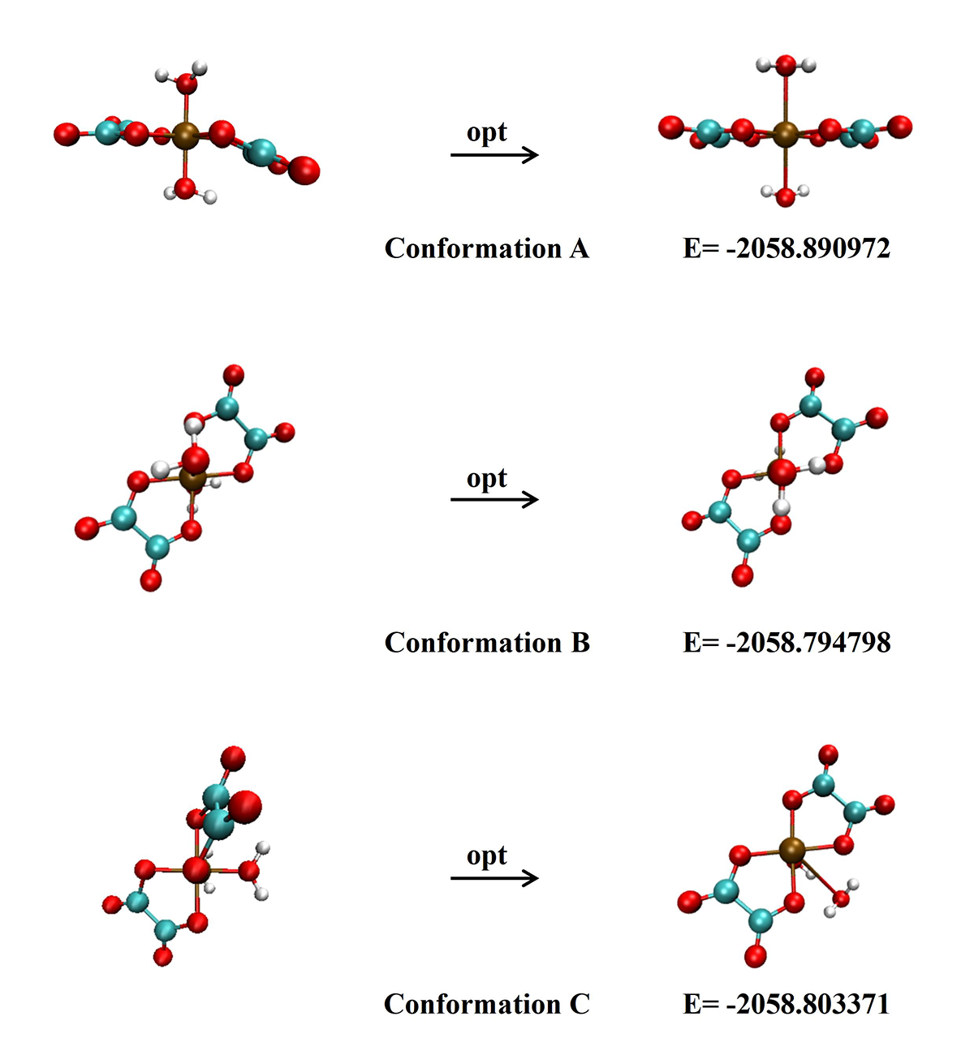
Fig. S1 Three conformations for [Mn(H₂O)₂(C₂O₄)₂]–, left column, initial geometries; right column, optimized geometries. Energy in Hartree.

Considering key factors like ligand spatial arrangement and steric effects, we proposed three potential conformations (A, B, and C) for the key intermediate, [Mn(H₂O)₂(C₂O₄)₂]–. Following structural optimization (Fig. S1), a comparison of their relative energies revealed conformation A to be the most stable (lowest energy). Consequently, all subsequent simulations were performed using this most stable conformation.

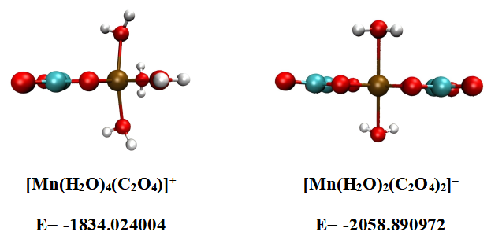
Fig. S2 Left column is the optimized conformation for [Mn(H₂O)₄(C₂O₄)]⁺ and the right column is the optimized conformation for [Mn(H₂O)₂(C₂O₄)₂]–. Energy in Hartree.

Table S1 The coordination energy of trivalent manganese hexa-coordinated oxalate (with 1 and 2 oxalate groups) complexes.
Coordination Equation | Coordination Equation /(kcal/mol)
[Mn(H₂O)₆]³⁺+C₂O₄²⁻→[Mn(H₂O)₄(C₂O₄)]⁺+2H₂O | -15.21
[Mn(H₂O)₆]³⁺+2C₂O₄²⁻→[Mn(H₂O)₂(C₂O₄)₂]⁻+4H₂O | -145.96

Computational results indicate that the bis(oxalate) complex, [Mn(H₂O)₂(C₂O₄)₂]–, is more stable than its mono(oxalate) counterpart, [Mn(H₂O)₄(C₂O₄)]⁺. As seen in Fig. S2, the former exhibits lower energy, greater structural stability, and reduced steric hindrance. This is consistent with coordination energy calculations for oxalate binding to the [Mn(H₂O)₆]³⁺ cation, which confirm the thermodynamic advantage of the bis(oxalate) species (Table S1). Complexes with three or more oxalate ligands were excluded from consideration due to steric limitations.

