Electronic Structure Engineering and Photocatalytic Potential of MA2N4 Two-Dimensional Materials: A First-Principles Perspective
Dan Hong∗, ª, Qi-Jun Liu ^{c}, Tao Jiang ª, Hui Liu ª, Zheng-Tang Liu ^{d}, Yu-Lan Ren ∗∗,^{b}
ª School of Intelligent Medicine, Chengdu University of Traditional Chinese Medicine, Chengdu 611137, China
^{b} School of Chinese Classics, Chengdu University of Traditional
Chinese Medicine, Chengdu 610075, China
^{c} School of Physical Science and Technology, Southwest Jiaotong University, Key Laboratory of Advanced Technologies of Materials, Ministry of Education of China, Chengdu 610031, People’s Republic of China
^{d} State Key Laboratory of Solidification Processing, Northwestern Polytechnical University, Xi’an 710072, People’s Republic of China
Correspondence about the paper at the following address and e-mail address:
Dan Hong E-mail: 18382927860@163.com
Yu-Lan Ren E-mail: renxg2468@163.com
School of Intelligent Medicine, School of Chinese Classics, Chengdu University of Traditional Chinese Medicine, Chengdu 611137, China

1. Band structures and density of states
The calculated electronic properties (including band structures and density of states) by HSE06 for MA₂N₄ (M= Ti, Zr, Hf, V, Nb, Ta, Cr, Mo and W, A is Si) are depicted in Figure S1. It can be seen that the minimum of conduction band (CBM) and maximum of valence band (VBM) VSi₂N₄, NbSi₂N₄ and TaSi₂N₄ all through the Fermi level, implying that the metallic properties of them. All the rest of materials have band gaps, and which are all indirect band gaps. On the whole, the band gaps of VI group are smaller than the IV group materials, which can be contributed to more extra d electrons in the outermost shell of VI group metal. It can be seen from the partial density of states (PDOS) that the CBM and VBM are mainly made up by the d orbitals of the metal elements, and there are little contributions of electrons from A and N elements.
Moreover, we classify the 9 original materials (exclude the VSi₂N₄, NbSi₂N₄ and TaSi₂N₄ by considering the characteristics of their band gaps) according to the size of their band gap, which as follows: small band gap (CrSi₂N₄ with 0.522 eV), big band gap (MoSi₂N₄ with 2.61 eV, WSi₂N₄ with 2.16 eV, TiSi₂N₄ with 2.907 eV, ZrSi₂N₄ with 2.532 eV and HfSi₂N₄ with 3.101 eV) to investigate their specific photoelectric performance. Firstly, we calculate and plot the optical spectra of the polycrystalline for the origin 6 materials in Figure S2. It can be observed that the reflectivity is arranged from high to low as CrSi₂N₄, MoSi₂N₄, TiSi₂N₄, WSi₂N₄, ZrSi₂N₄ and HfSi₂N₄, and the absorption coefﬁcient, ranked by the list from the high to low, is CrSi₂N₄, ZrSi₂N₄, MoSi₂N₄, TiSi₂N₄, WSi₂N₄ and HfSi₂N₄. Therein, the approximate absorption coefﬁcients for MoSi₂N₄, TiSi₂N₄, WSi₂N₄ can be attributed to the closer values of their band gap. Due to the smallest band gap, the reflectivity and absorption coefﬁcient of CrSi₂N₄ are the highest in these 6 original materials, respectively. Nevertheless, HfSi₂N₄ owns the minimum reflectivity and absorption coefﬁcient, which corresponds to the greatest band gap. Hence, it can be intuitively understood that CrSi₂N₄ and HfSi₂N₄ have the minimum and maximum transmissivity, respectively. The band gaps of the remaining 4 materials range from 2.16 to 2.907 eV, meaning a certain part of the 4 materials is transparent in the visible light (VIS) region and which is consistent with the analysis of the reflectivity and absorption coefficient.
2. Effective masses of carriers
Effective masses of the 6 original materials were calculated, which are depicted in Figure S3. It can be seen that CrSi₂N₄, MoSi₂N₄ and WSi₂N₄ exhibit the lighter hole and electron effective mass corresponding to the higher curvature of band structures that can be seen in Figure S1, which suggests a strong capacity of hole and electron mobility. The remaining TiSi₂N₄, ZrSi₂N₄, and HfSi₂N₄ have a more localized band distribution near the Fermi level, resulting in a greater effective mass. Thus, the carrier mobility and electrical conductivity of VI group are superior to those of IV group. Moreover, the greater discrepancy between m_{h}/m_{e} and 1, the greater the difference in electron-hole mobility, indicating a lower recombination rate of electron-hole pairs. It can be observed that CrSi₂N₄, MoSi₂N₄ and WSi₂N₄ also generally have more excellent m_{h}/m_{e} value than other three materials, reflecting the lower recombination rate of electron-hole pairs for them. The more preeminent carrier mobility and carrier recombination, which suggests CrSi₂N₄, MoSi₂N₄ and WSi₂N₄ not only have better electrical conductivity (which can be effectively applied in transparent conductive device), but also can be reasonably used in photocatalysts.
To sum up, CrSi₂N₄ has excellent conductivity with the unsatisfactory transparency in visible light range yet. MoSi₂N₄ and WSi₂N₄ have certain transparency with promising conductivity and degradation ability, making them can be effectively applied in transparent conductive devices and photocatalysts. Although HfSi₂N₄ owns the splendid transparency, the imperfect carrier effective mass makes it difficult to as an n-type transparent electrical device, it can be considered as a potential p-type transparent conductive material yet. Moreover, it also can be reasonably used as a photocatalyst. TiSi₂N₄ and ZrSi₂N₄ have weaker photocatalytic properties than HfSi₂N₄, but they still can be used as photocatalysts and they also can be considered as the potential for making p-type conductors.
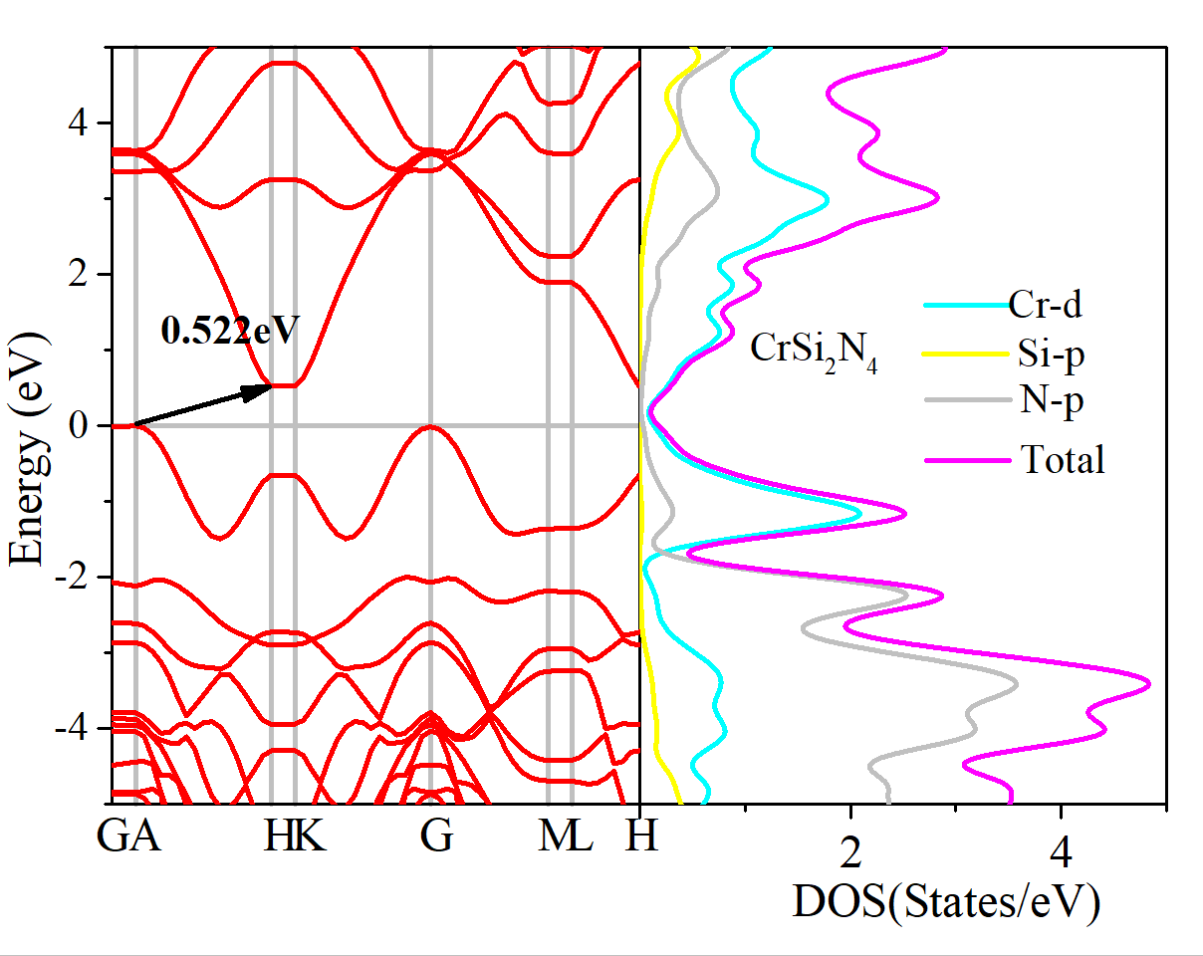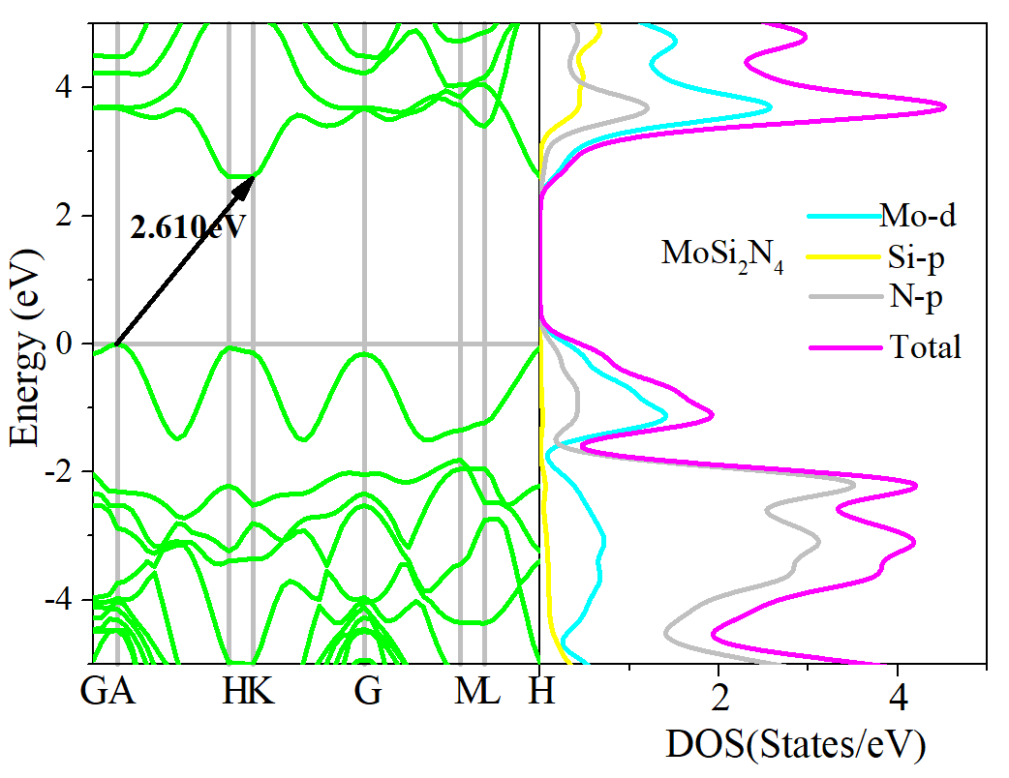
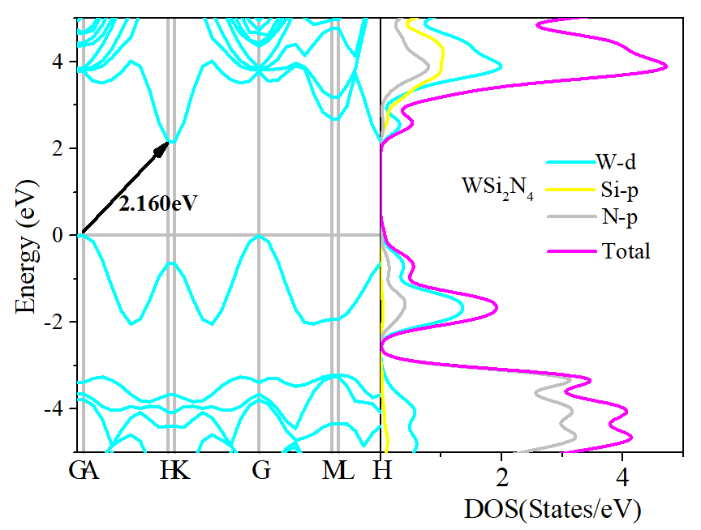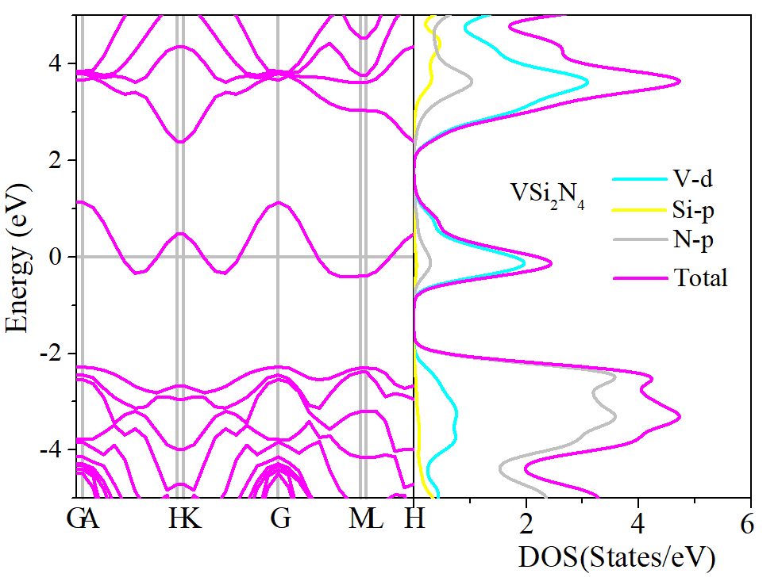
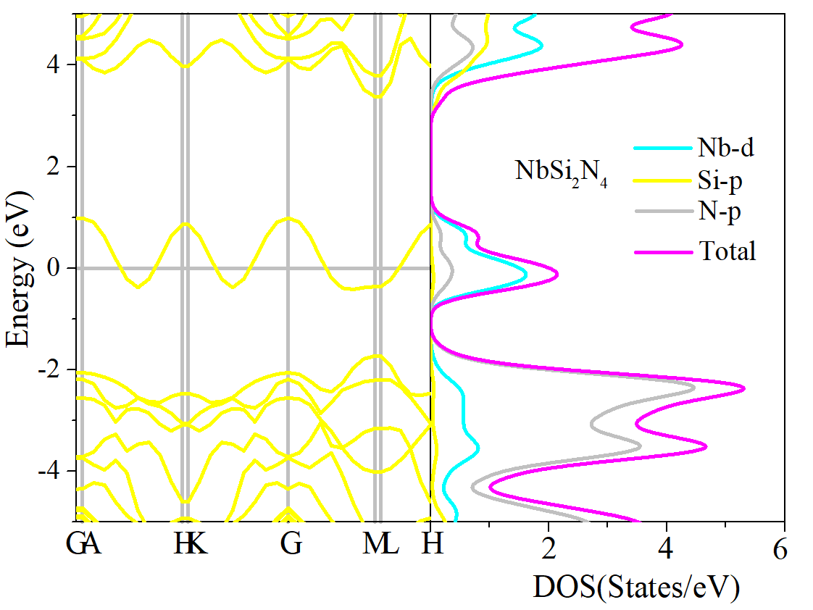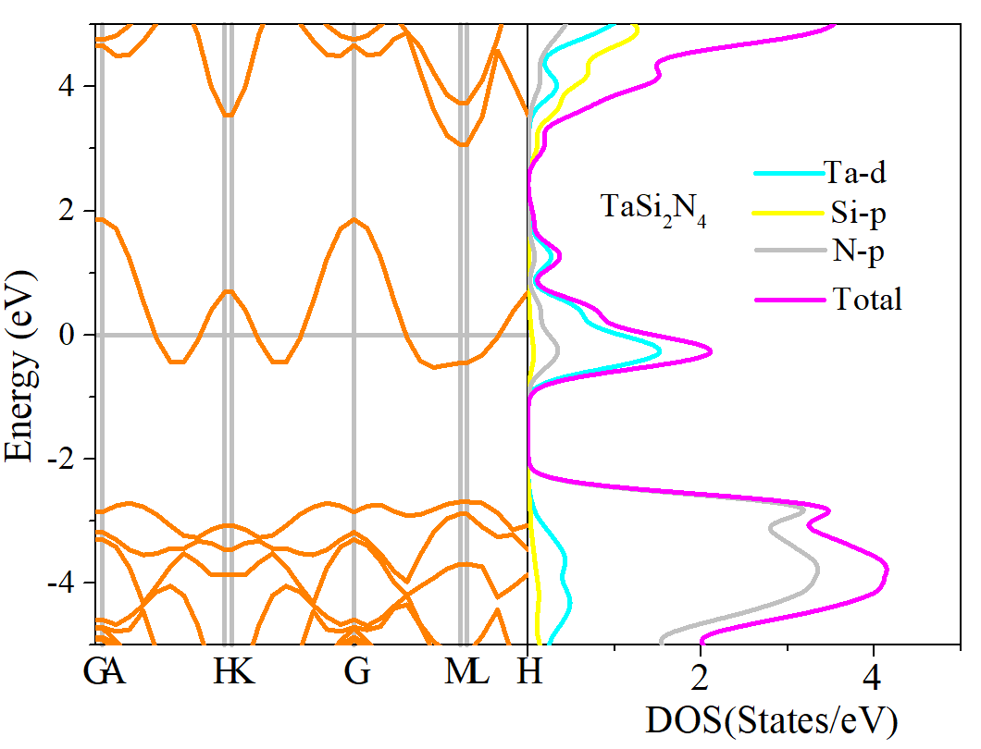
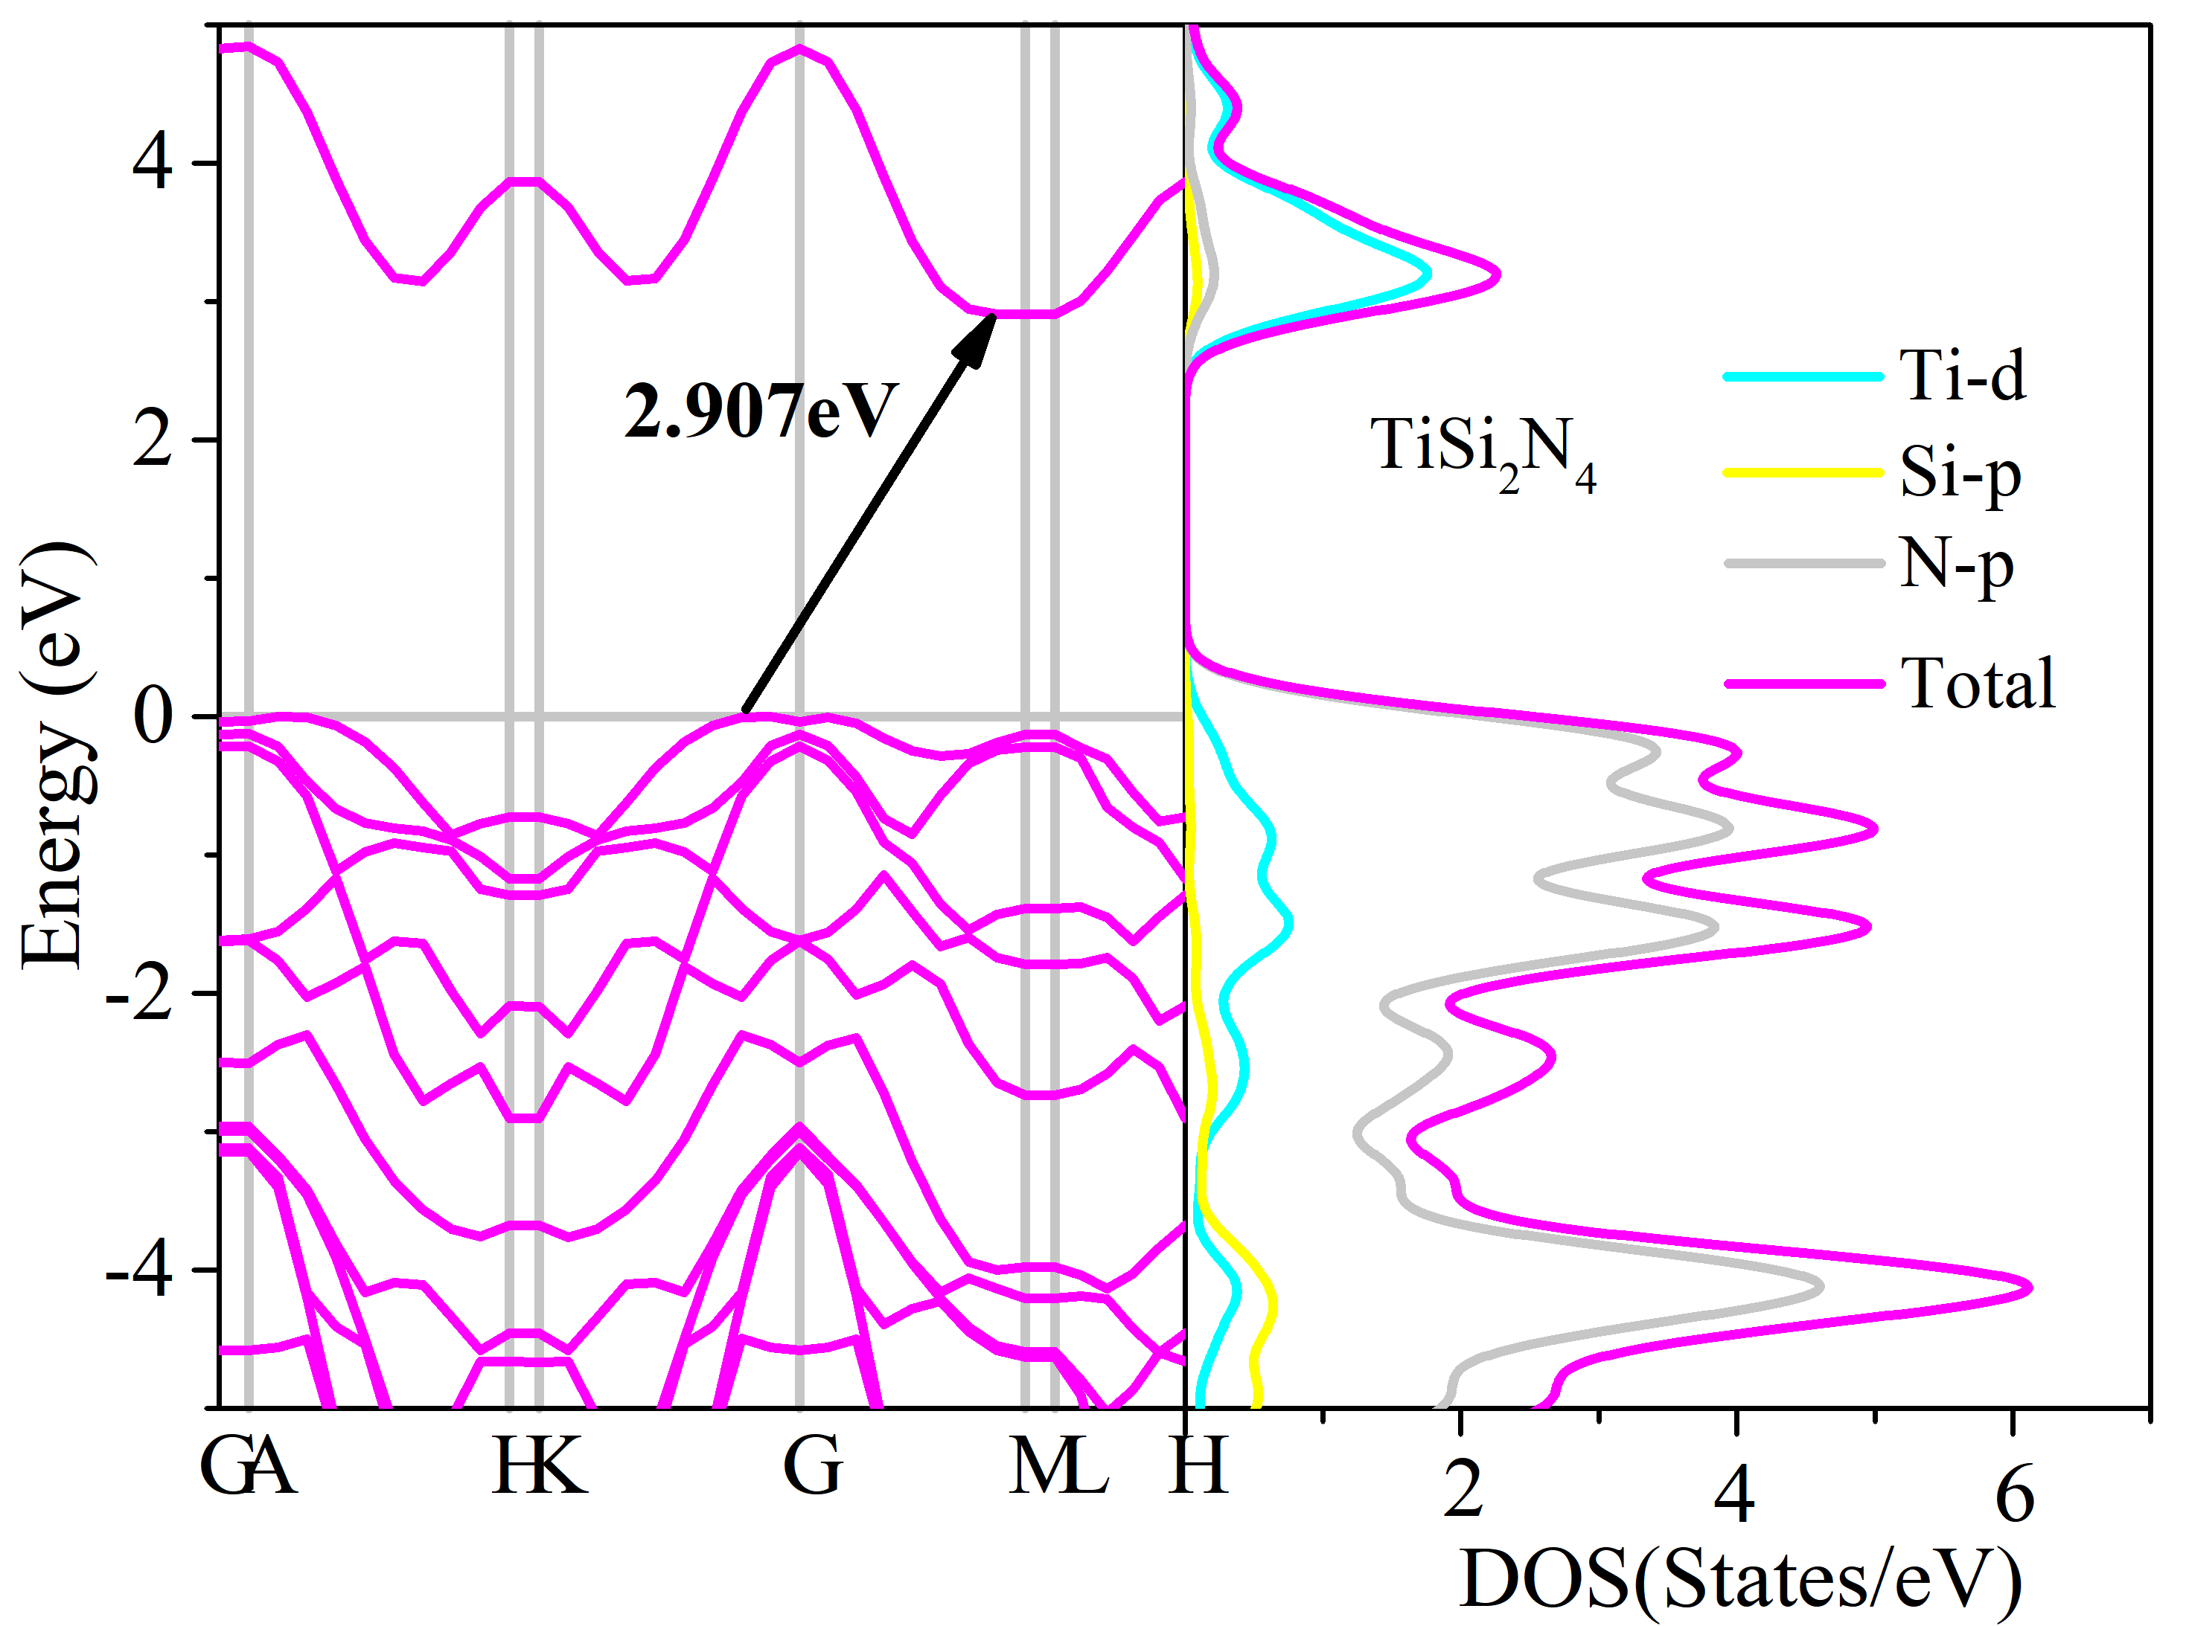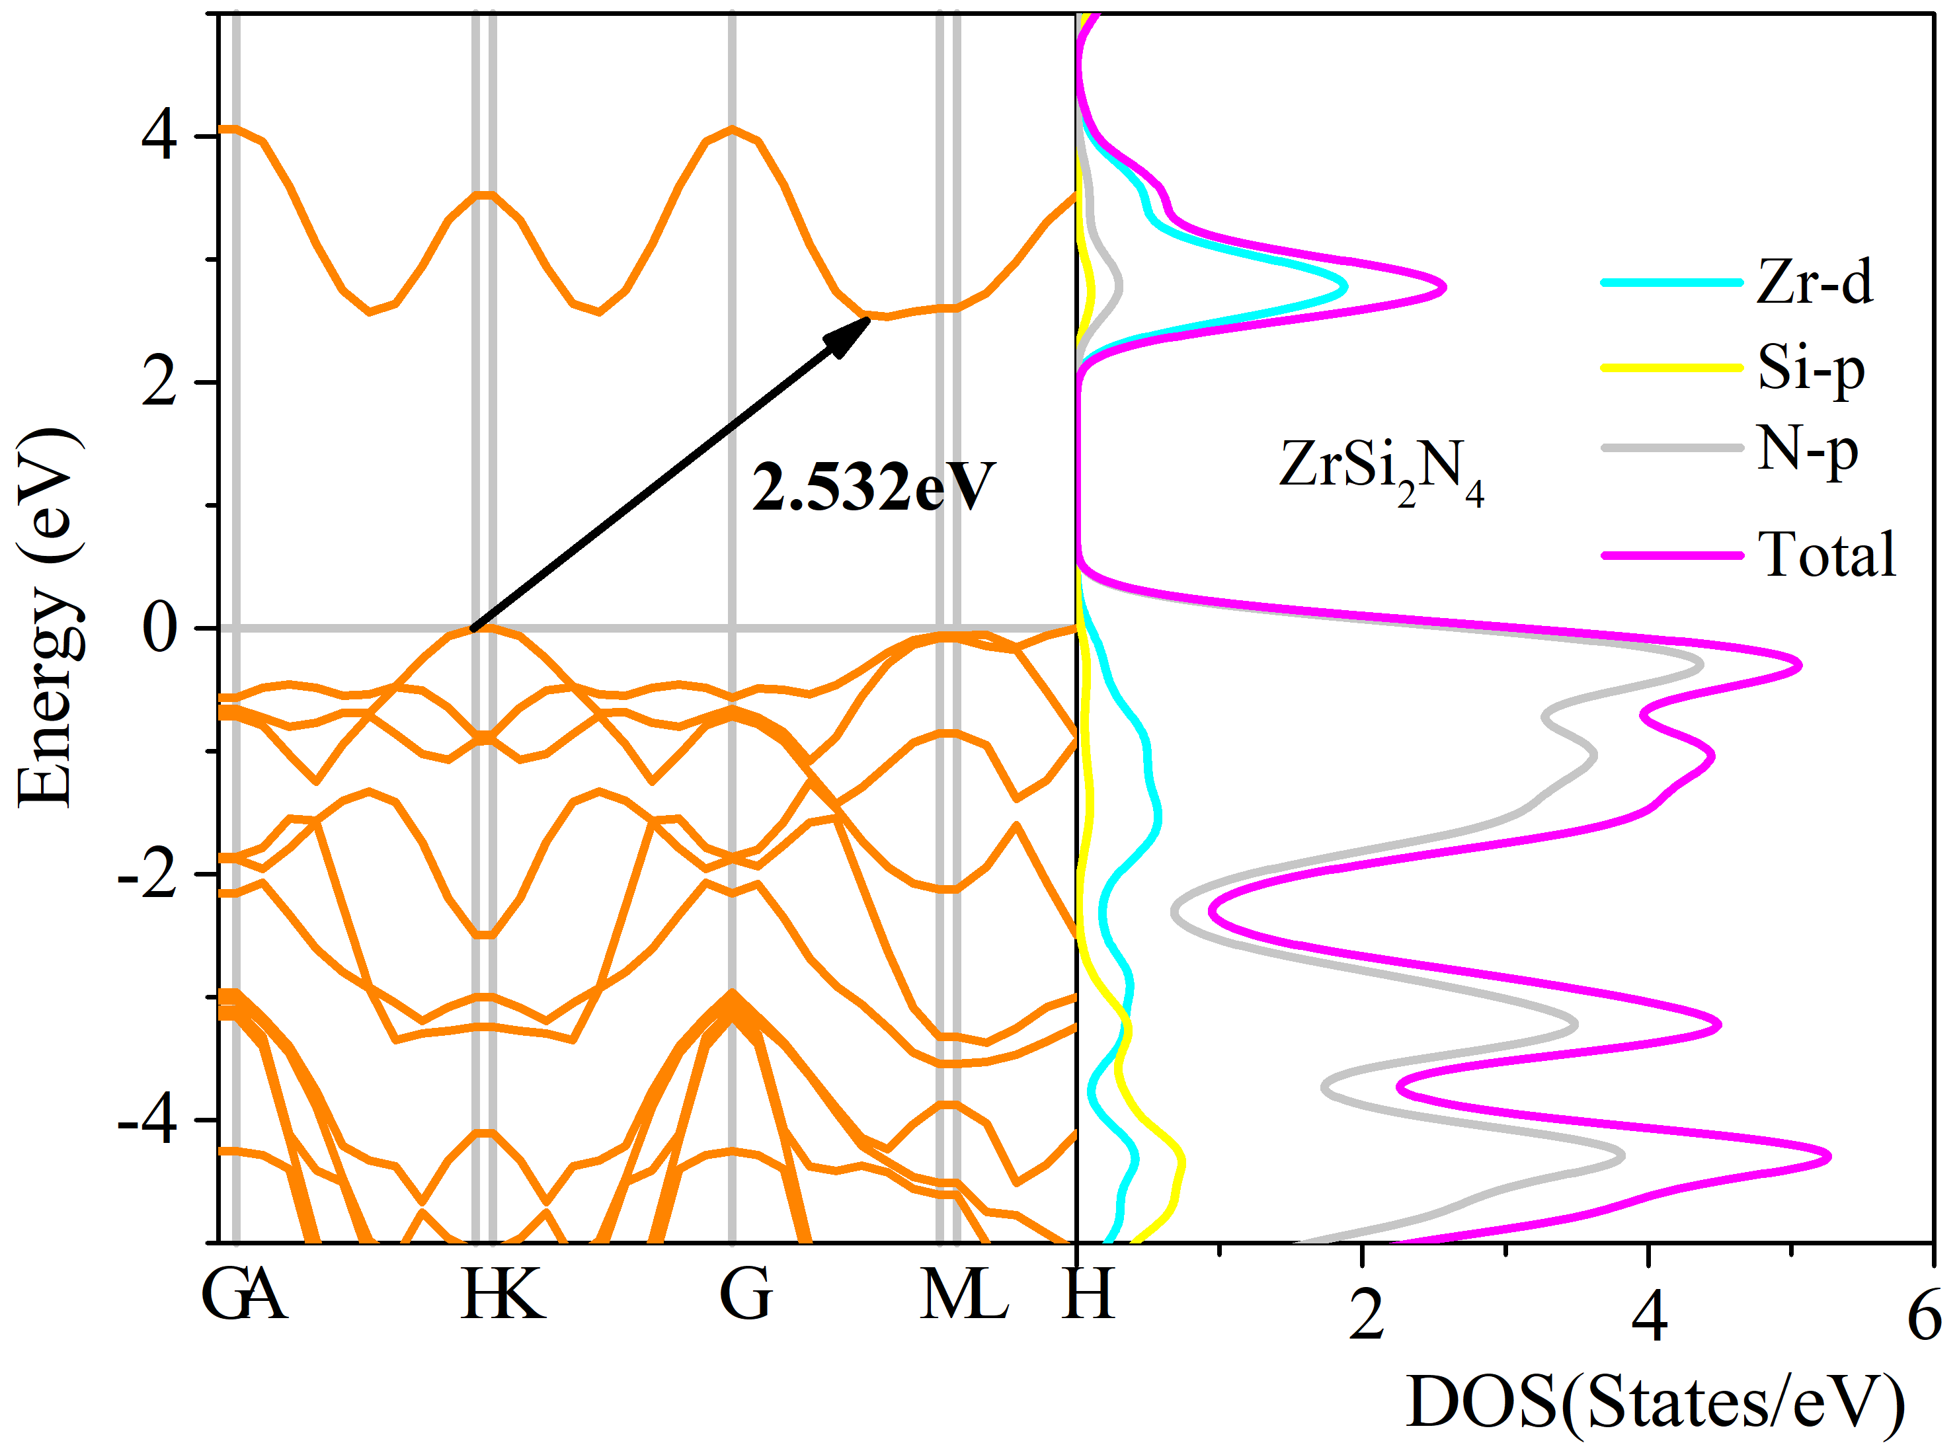
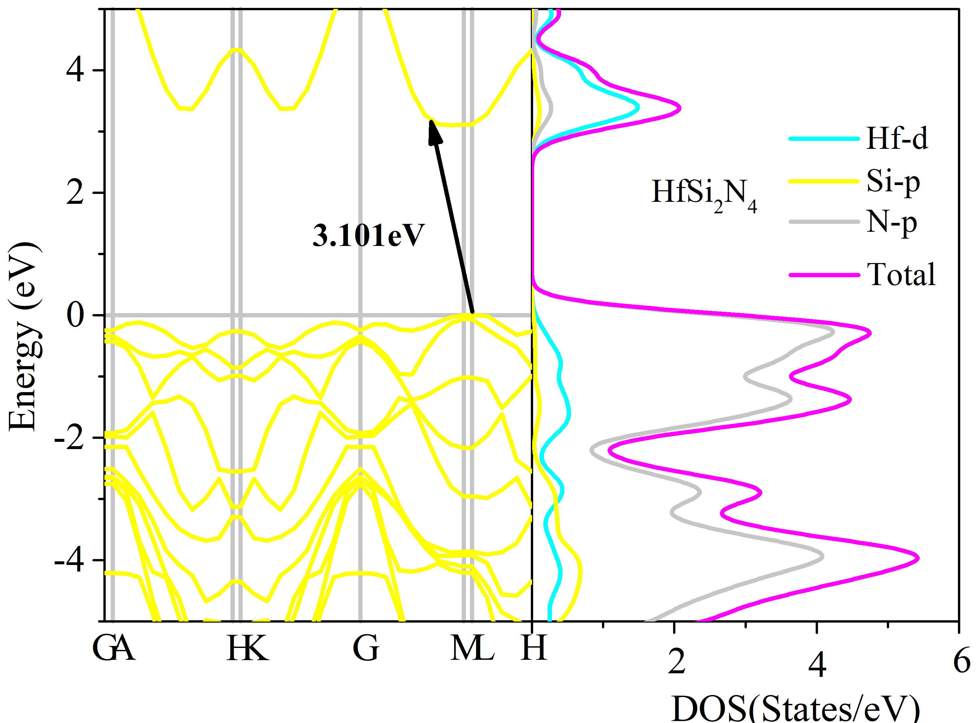
Figure S1 The calculated band structures and density of states for MA₂N₄ by HSE06, therein, M= Ti, Zr, Hf, V, Nb, Ta, Cr, Mo and W, A is Si.

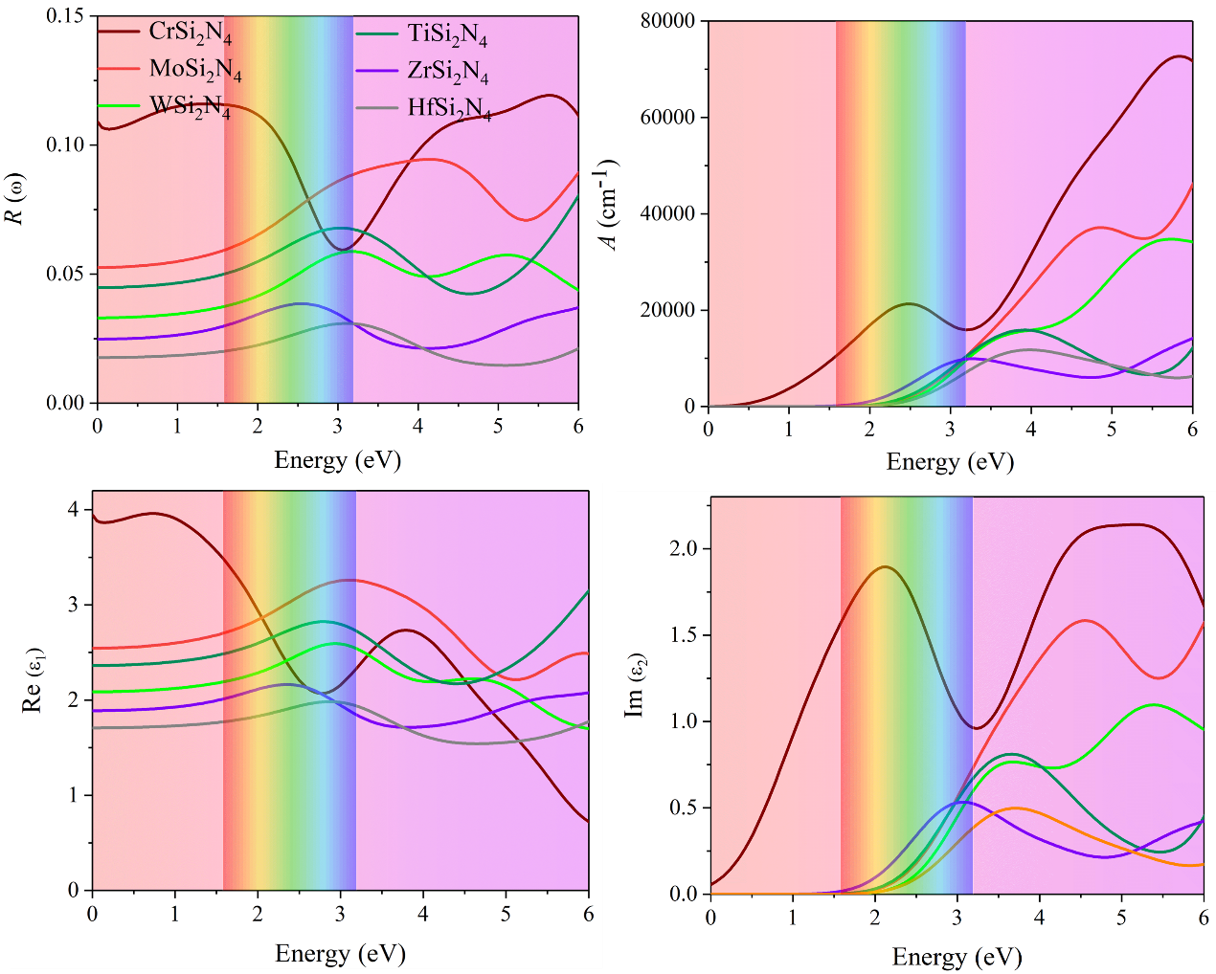
Figure S2 Reflectivity, absorption coefﬁcient, Imaginary and real parts of the dielectric function for 6 original materials by HSE06.

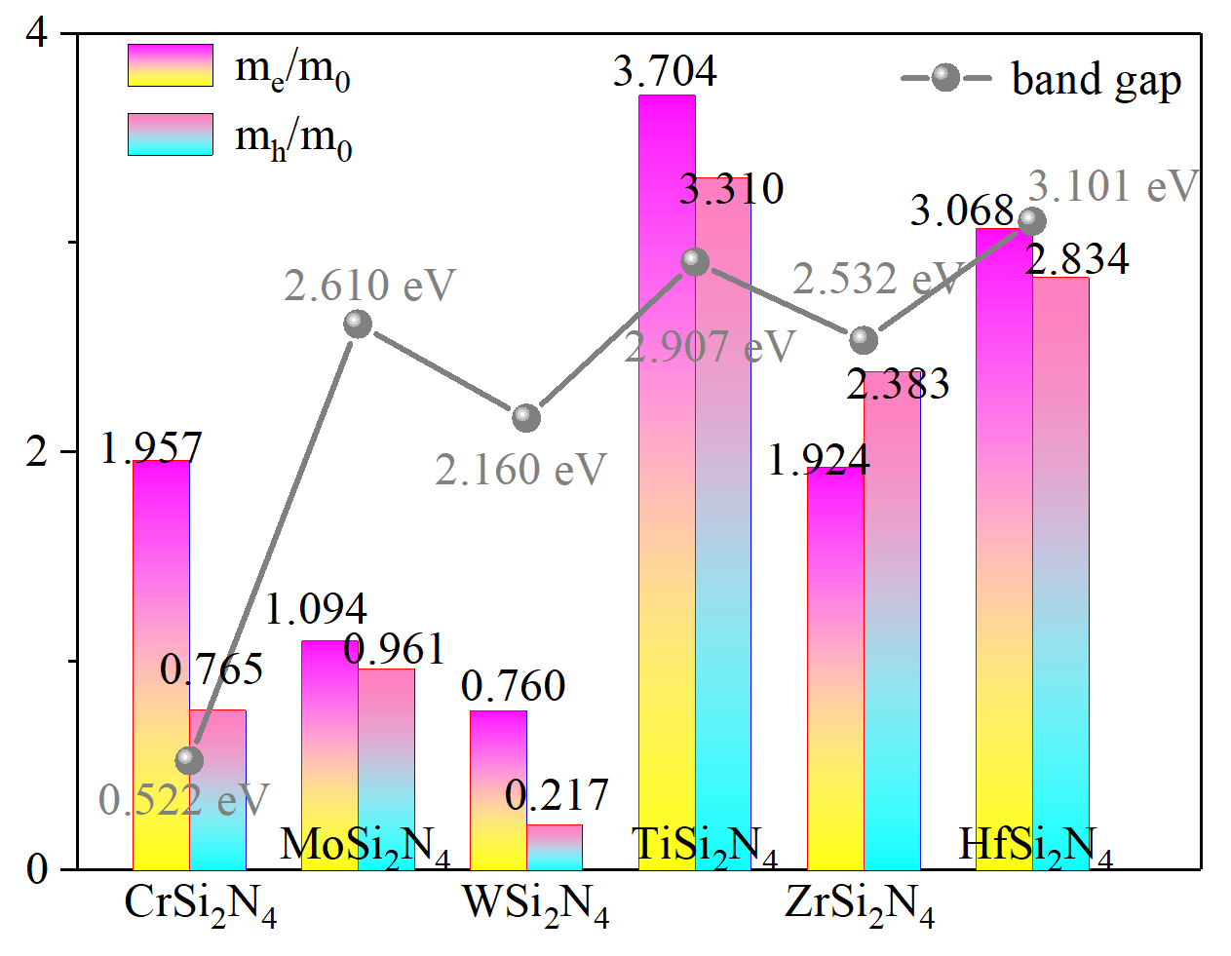
Figure S3. The calculated effective mass with band gaps of 6 original materials.

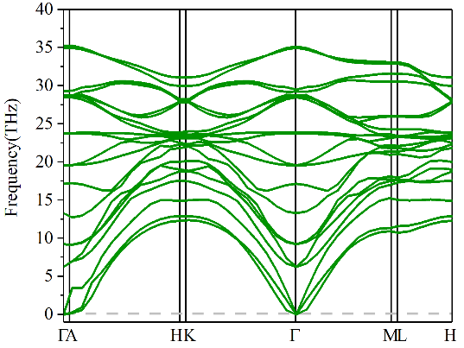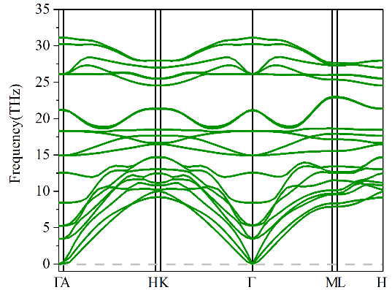
(a) CrC₂N₄ (b) CrC₂N₄
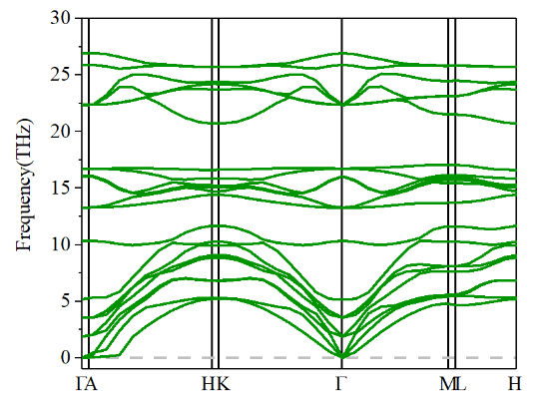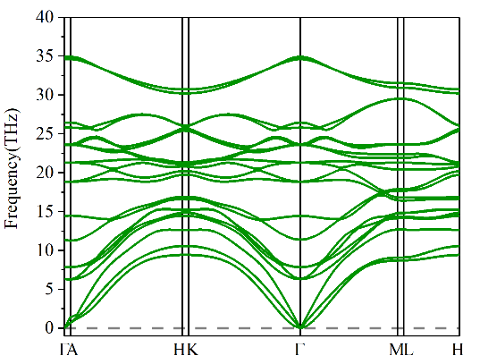
(c) CrGe₂N₄ (d) MoC₂N₄
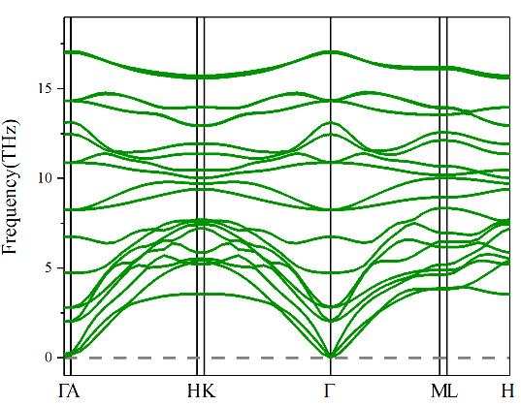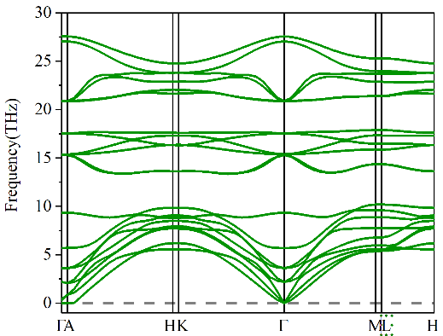
(e) MoSi₂N₄ (f) MoGe₂N₄
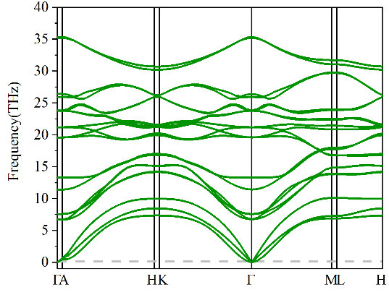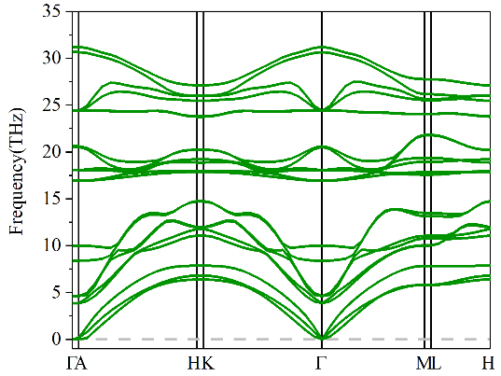
(g) WC₂N₄ (h) WSi₂N₄
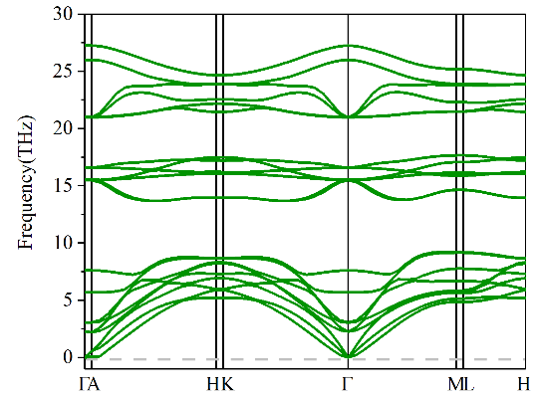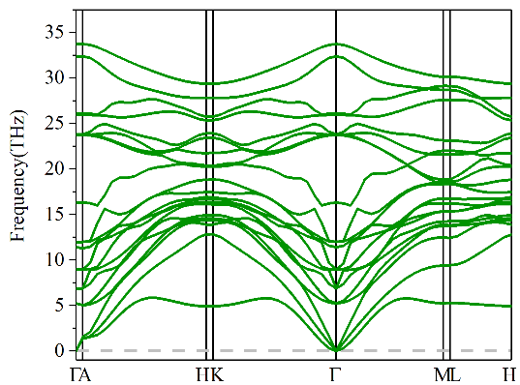
(i) WGe₂N₄ (j) TiC₂N₄
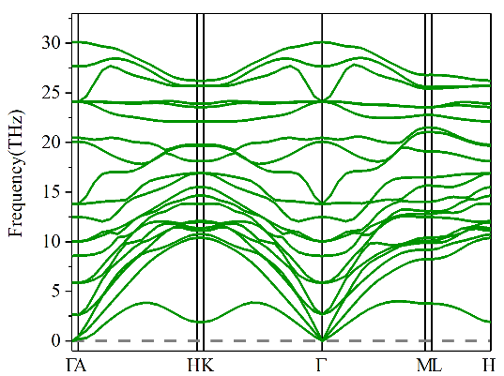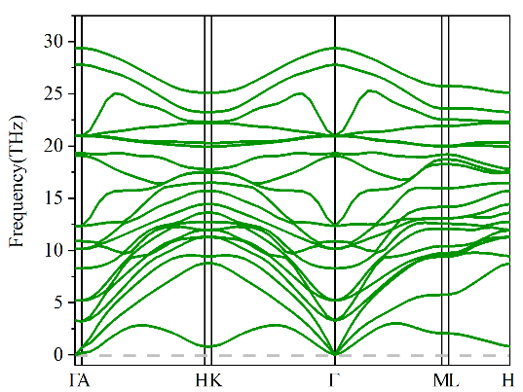
(k) TiSi₂N₄ (l) ZrSi₂N₄
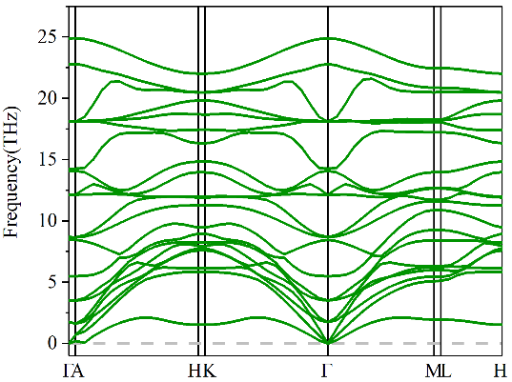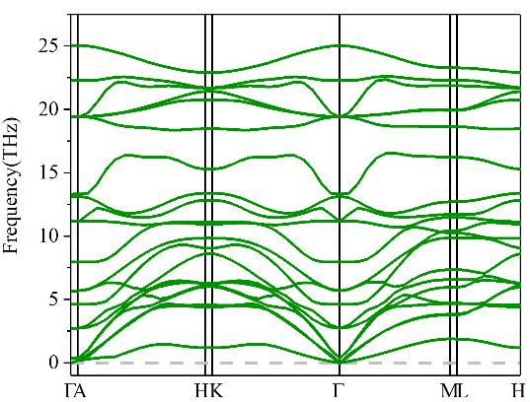
(m) ZrGe₂N₄ (n) ZrSn₂N₄
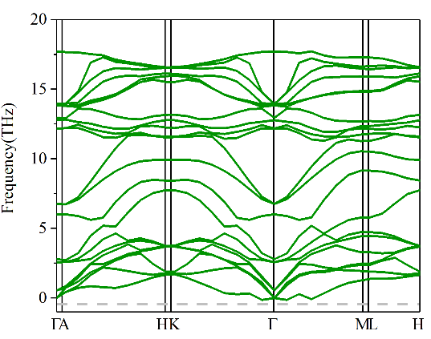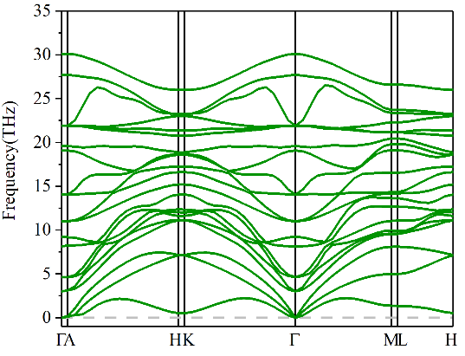
(o) ZrPb₂N₄ (p) HfSi₂N₄
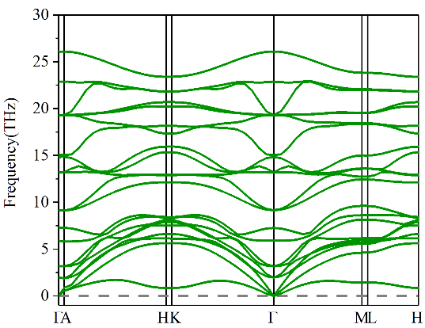
(q) HfGe₂N₄
Figure S4 The calculated phonon spectra of 17 kinds of MA₂N₄.

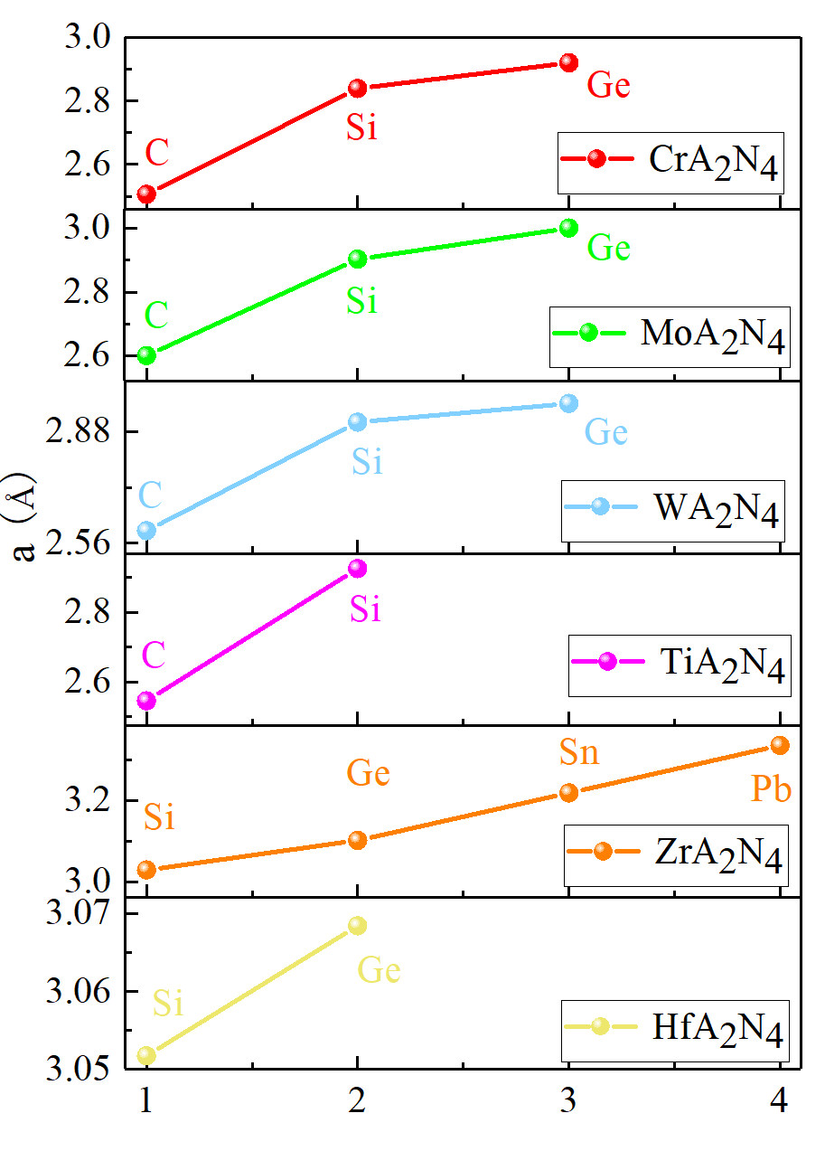
Figure S5. The calculated lattice parameter for CrA₂N₄, MoA₂N₄, WA₂N₄, TiA₂N₄, ZrA₂N₄ and HfA₂N₄.
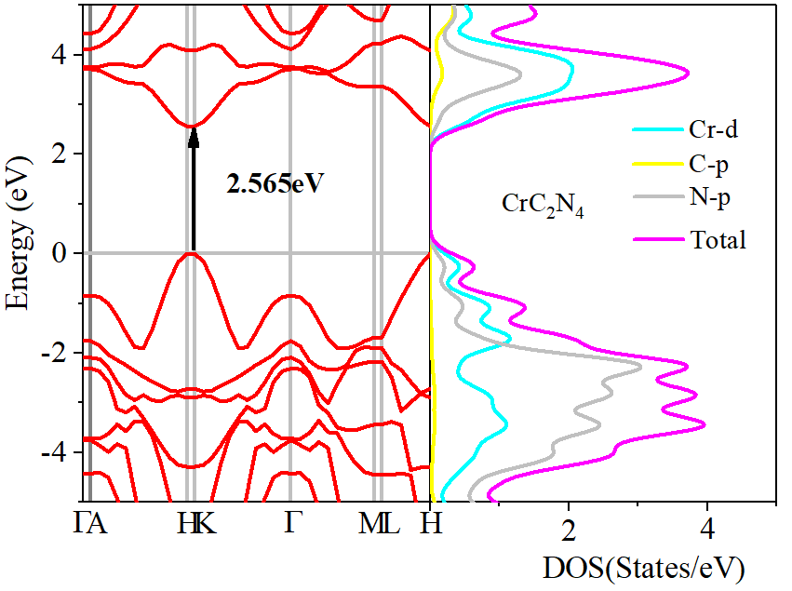
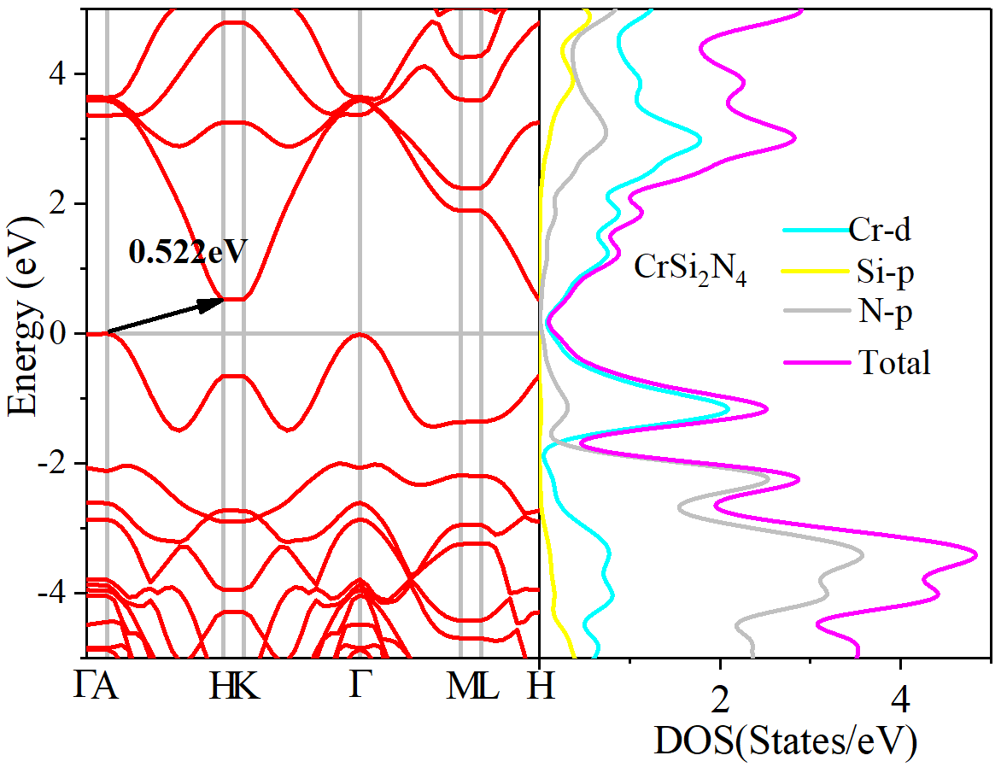
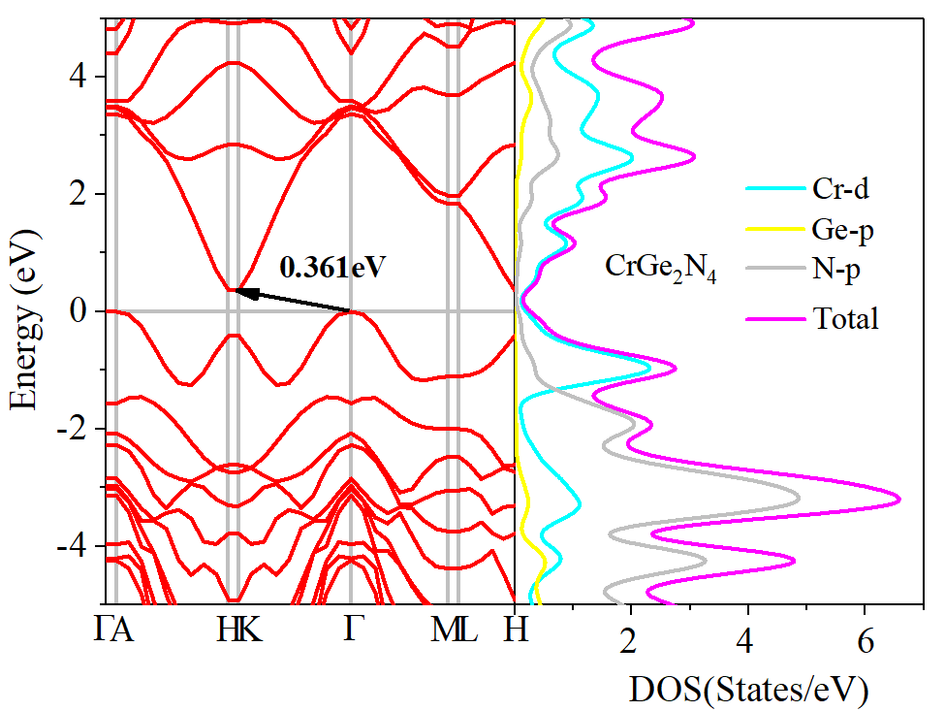
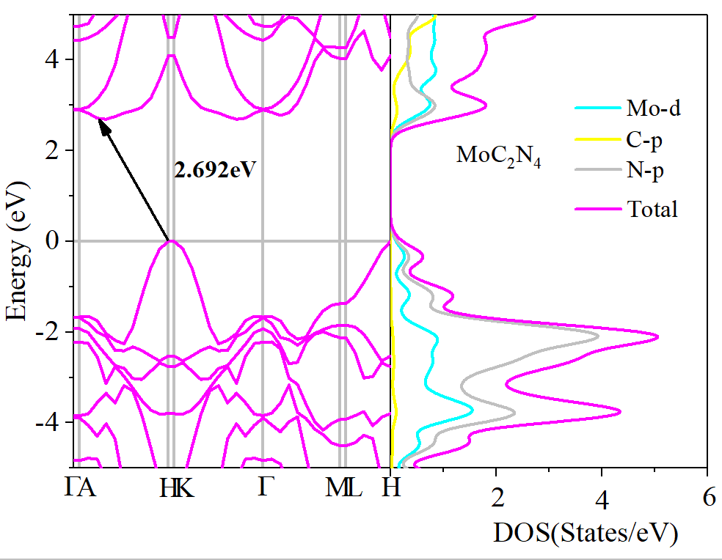
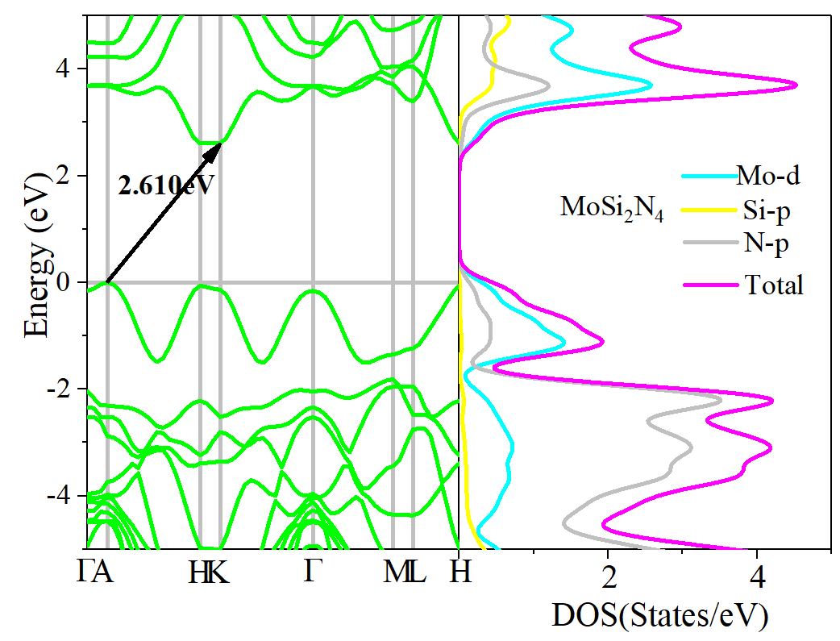
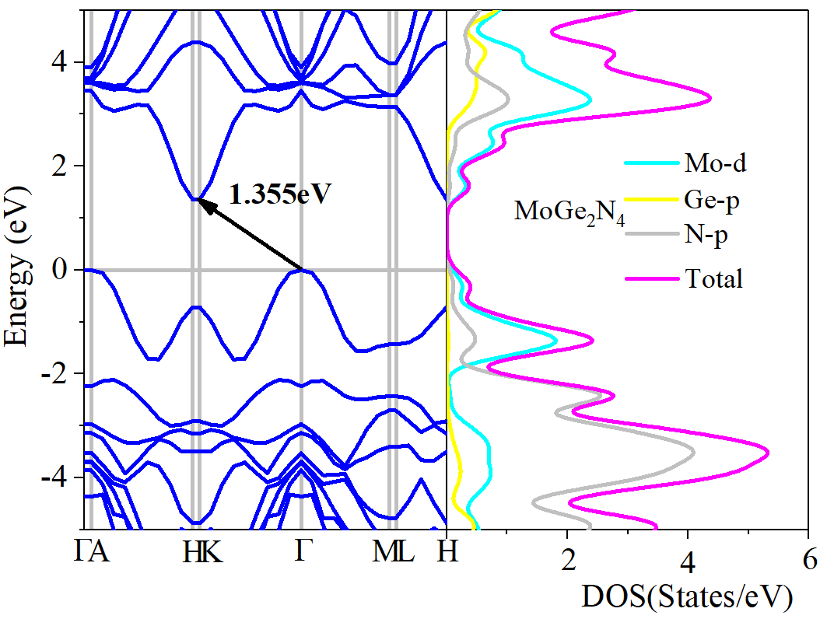
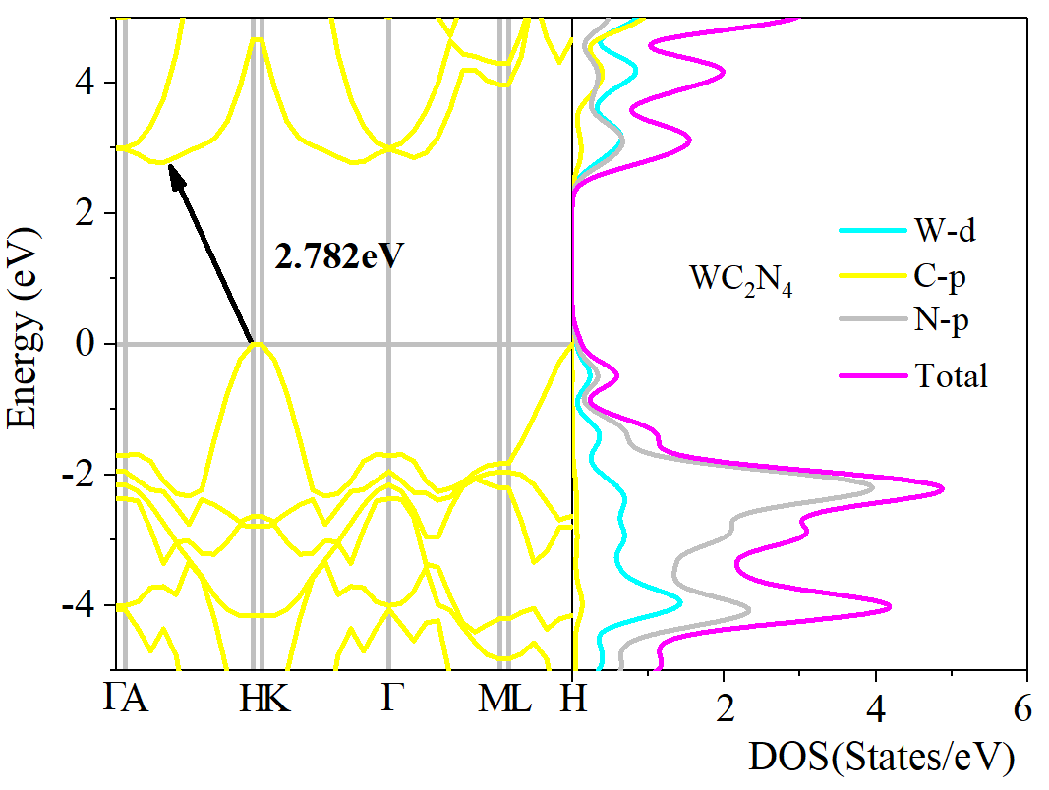
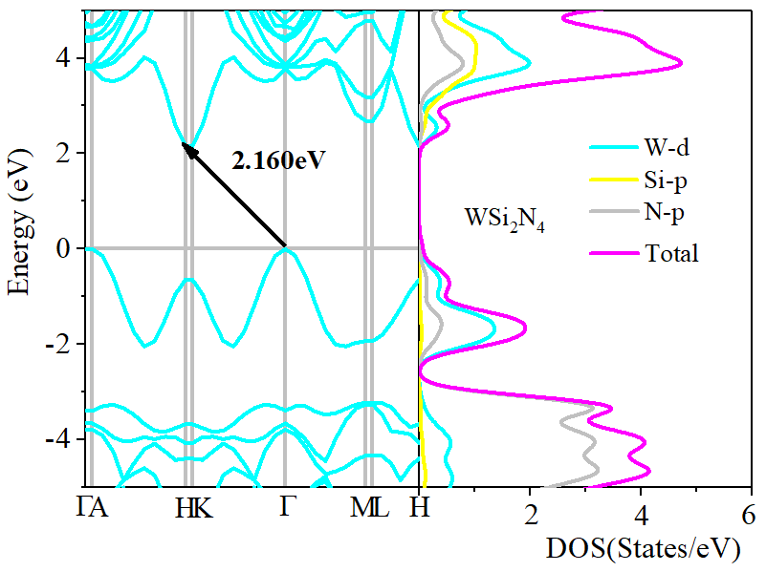
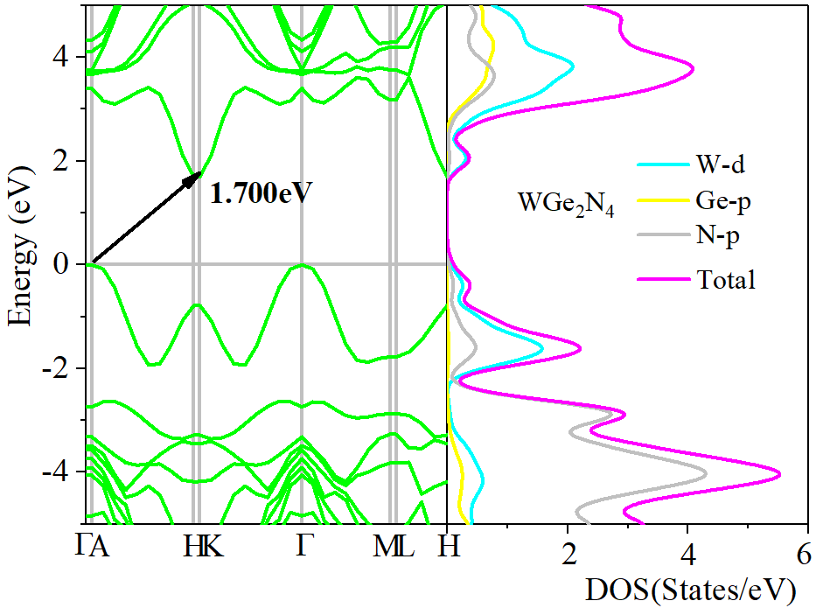
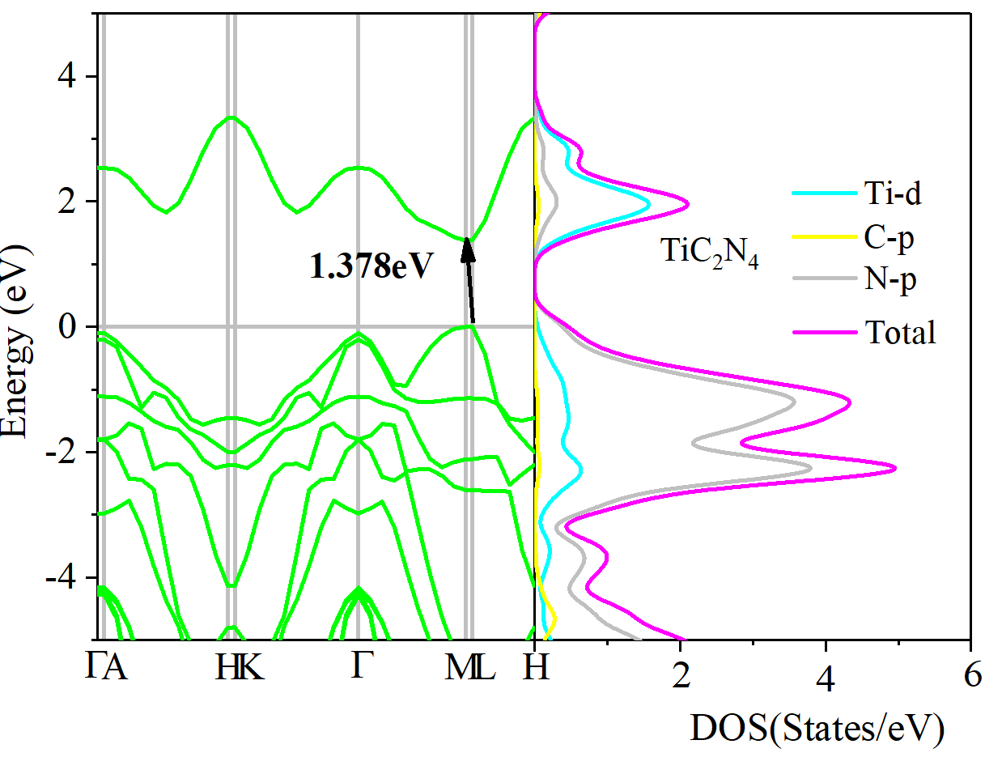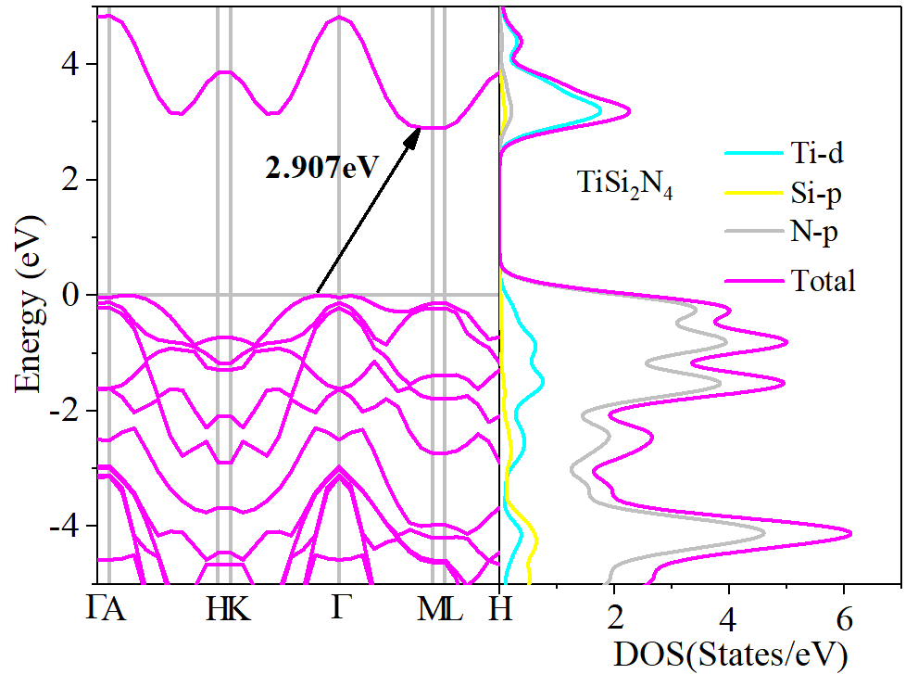

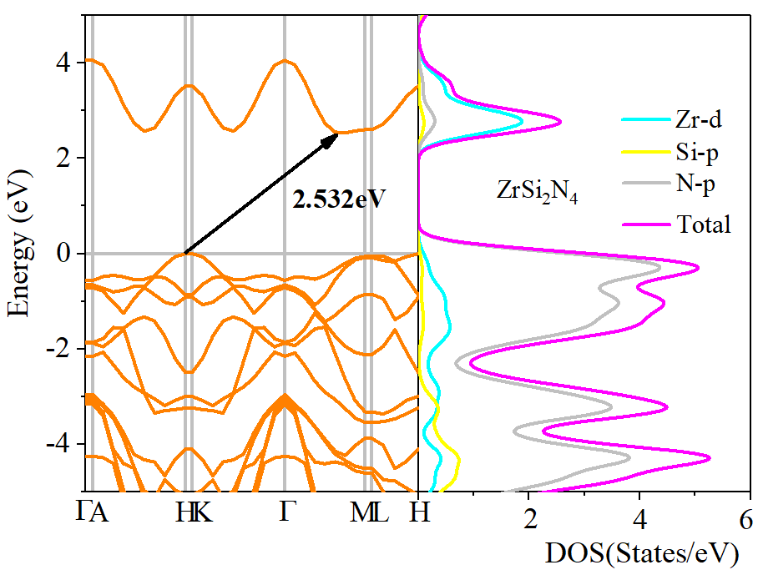
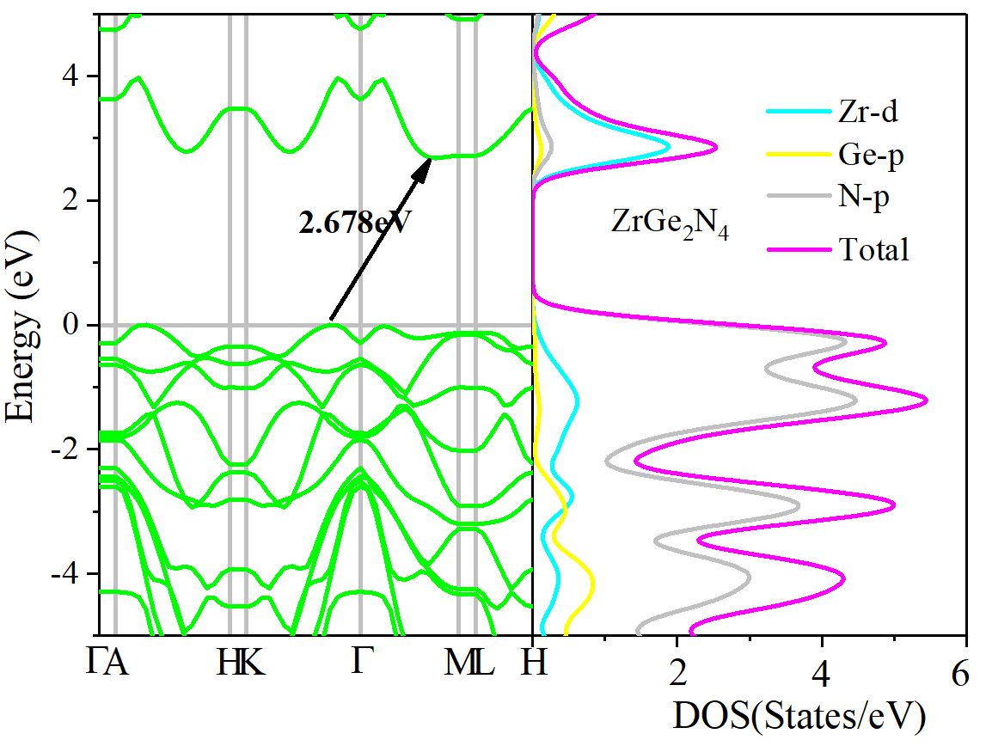
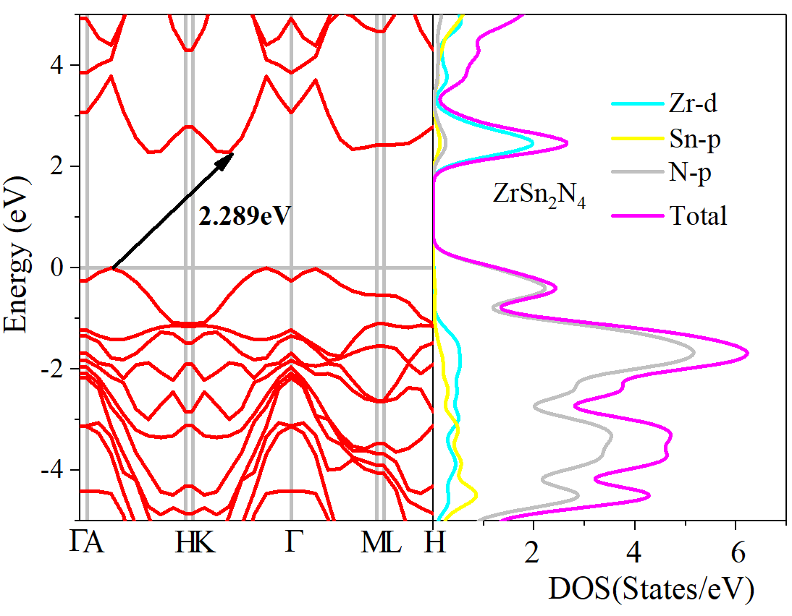
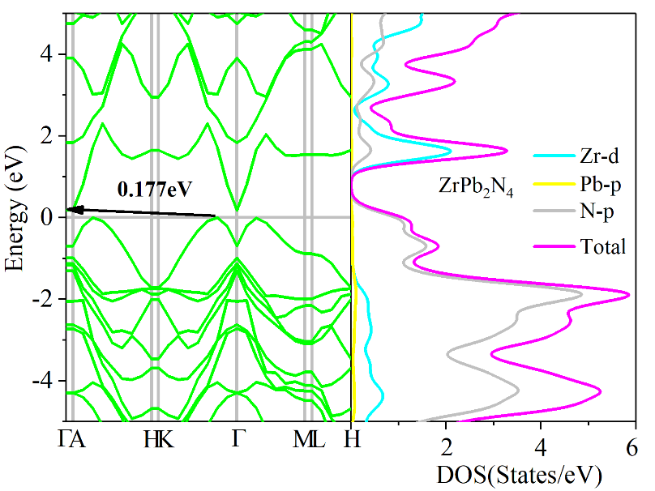

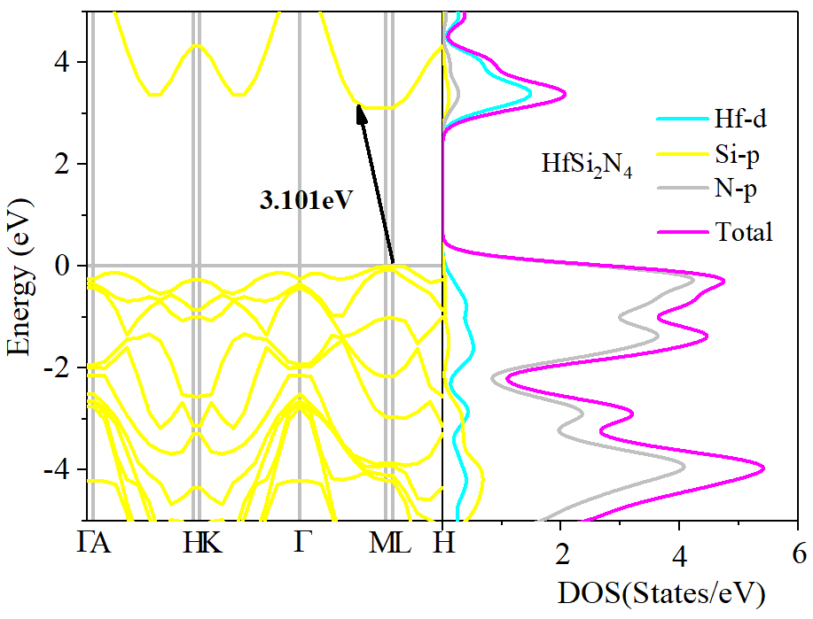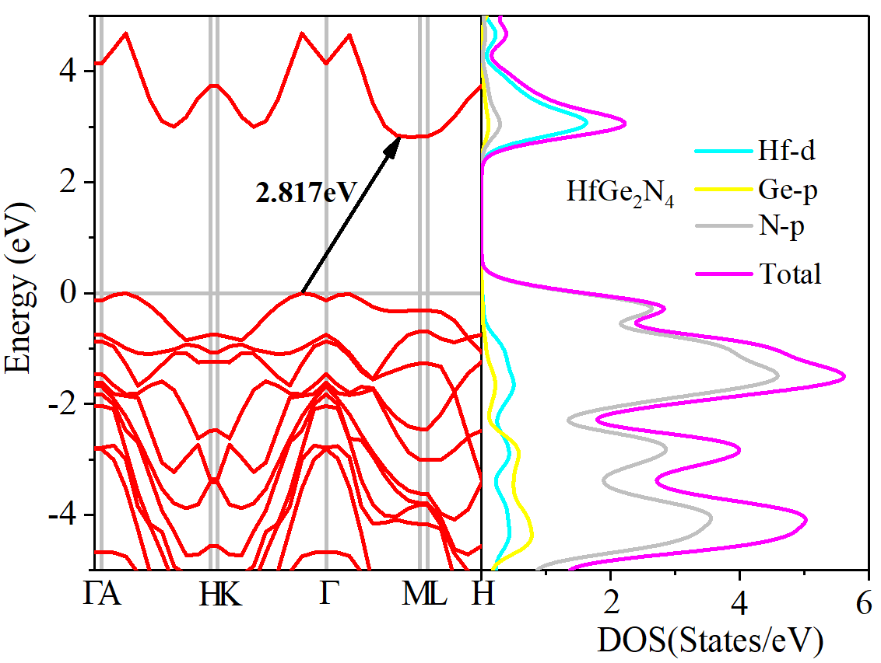
Figure S6. The calculated band structures and density of states of A-site-substituted MA₂N₄.

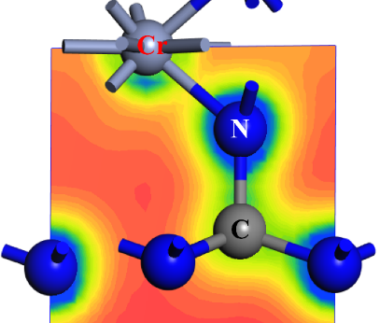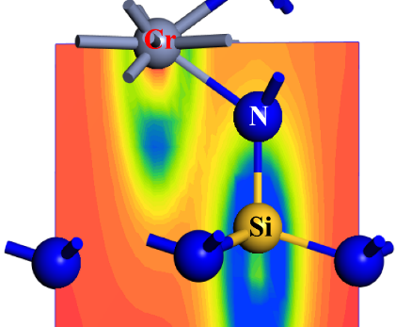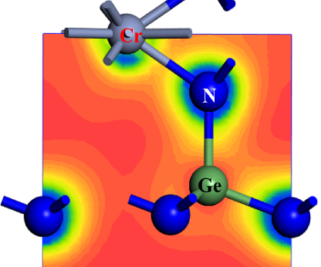
(a)
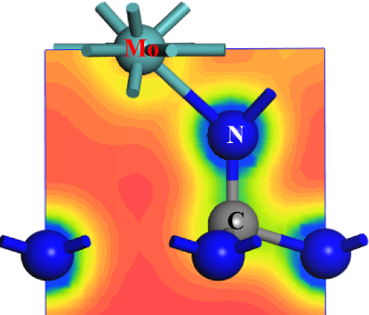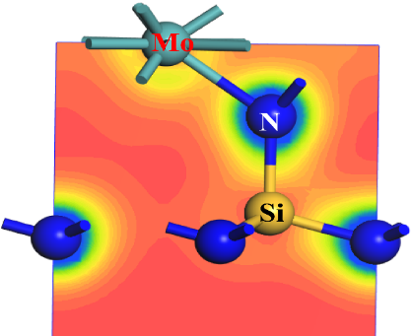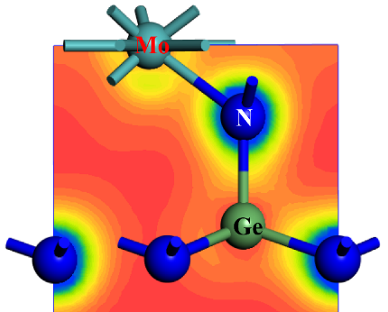
(b)
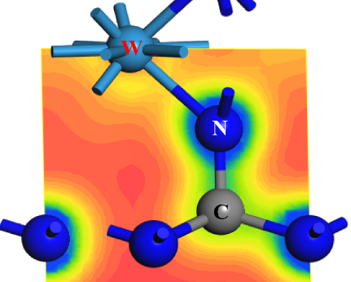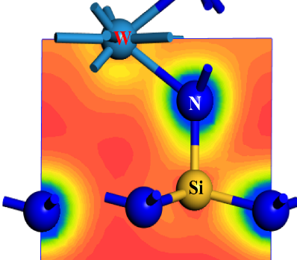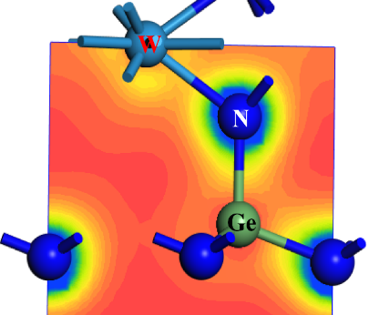
(c)
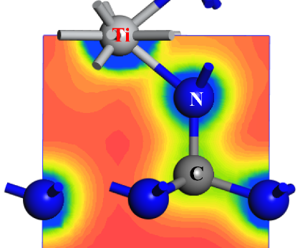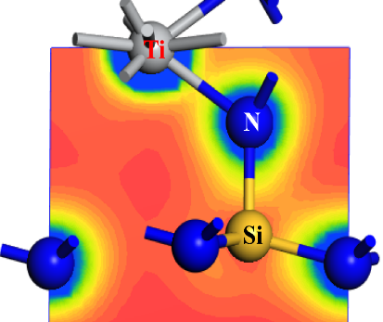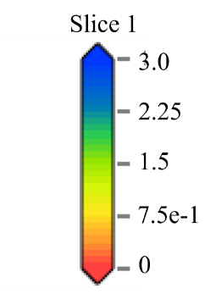
(d)
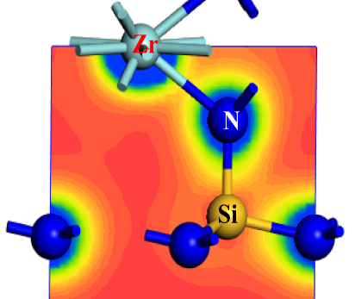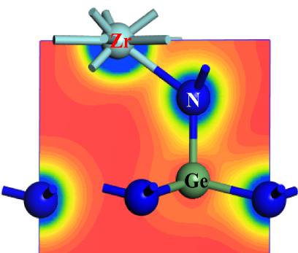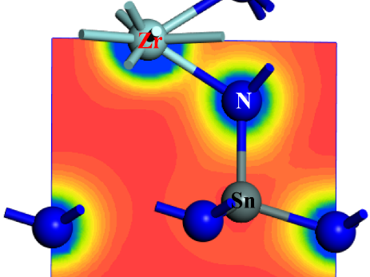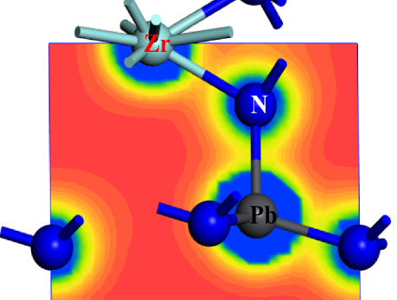
(e)

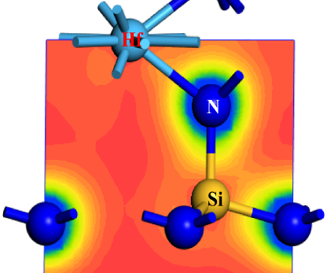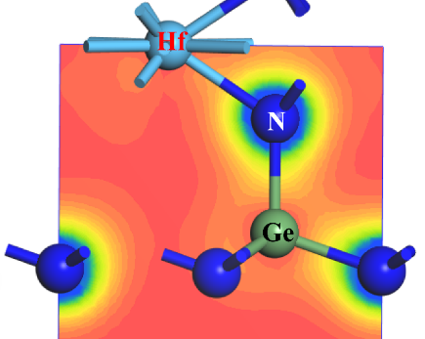
(f)
Figure S7. The partial charge density of (111) plane for CrA₂N₄ (a), MoA₂N₄ (b), WA₂N₄ (c), TiA₂N₄ (d), ZrA₂N₄ (e) and HfA₂N₄ (f).

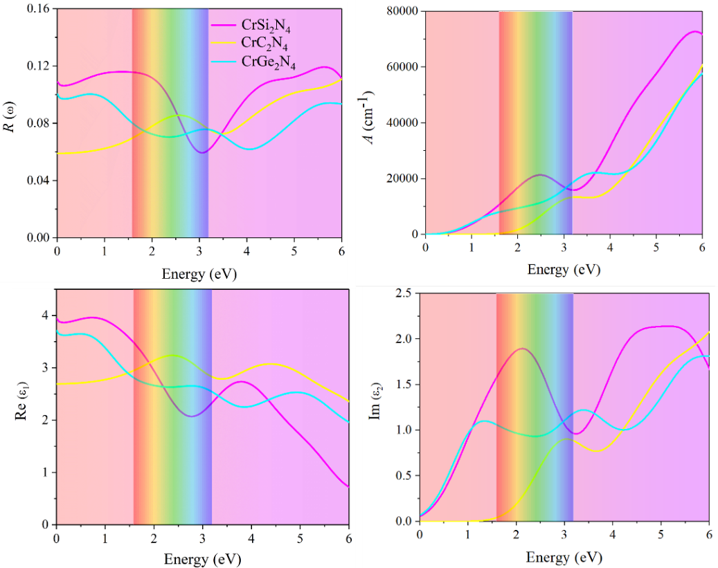
(a)
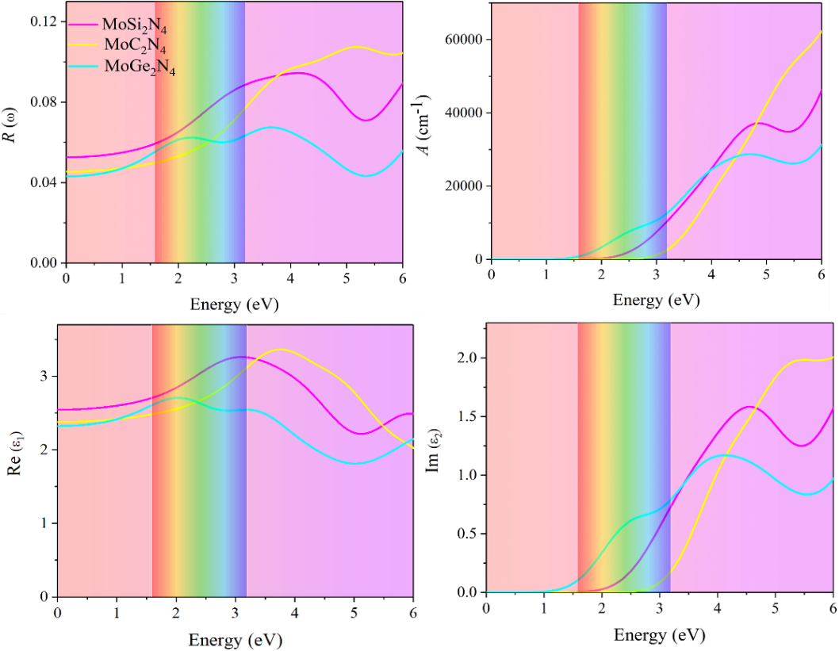
(b)
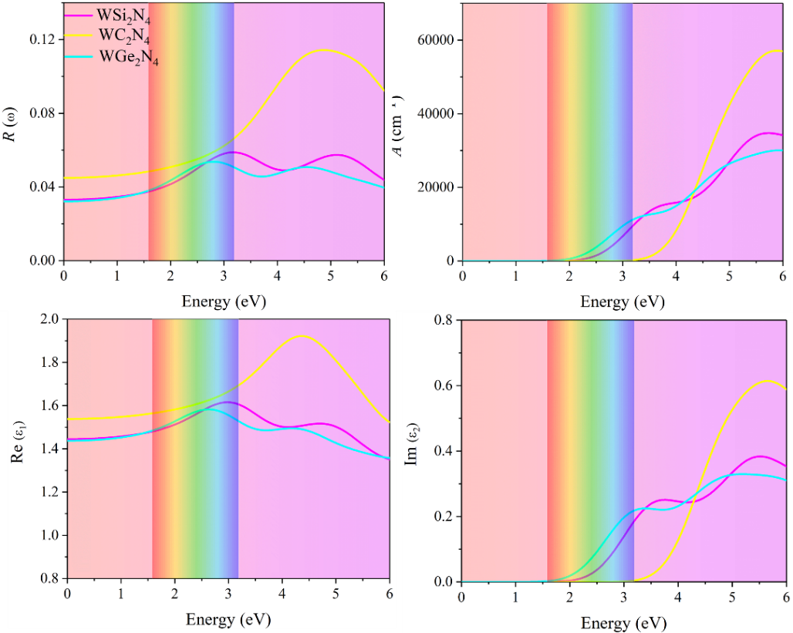
(c)
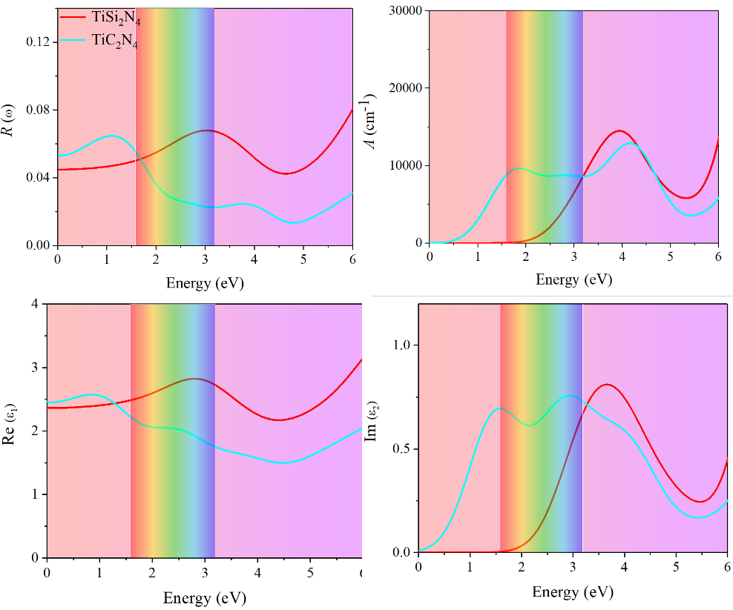
(d)
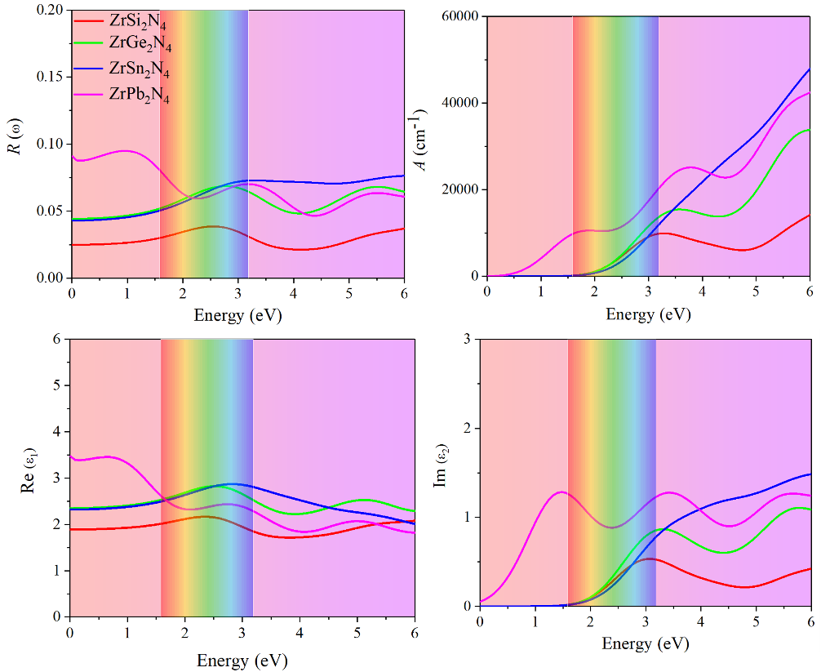
(e)
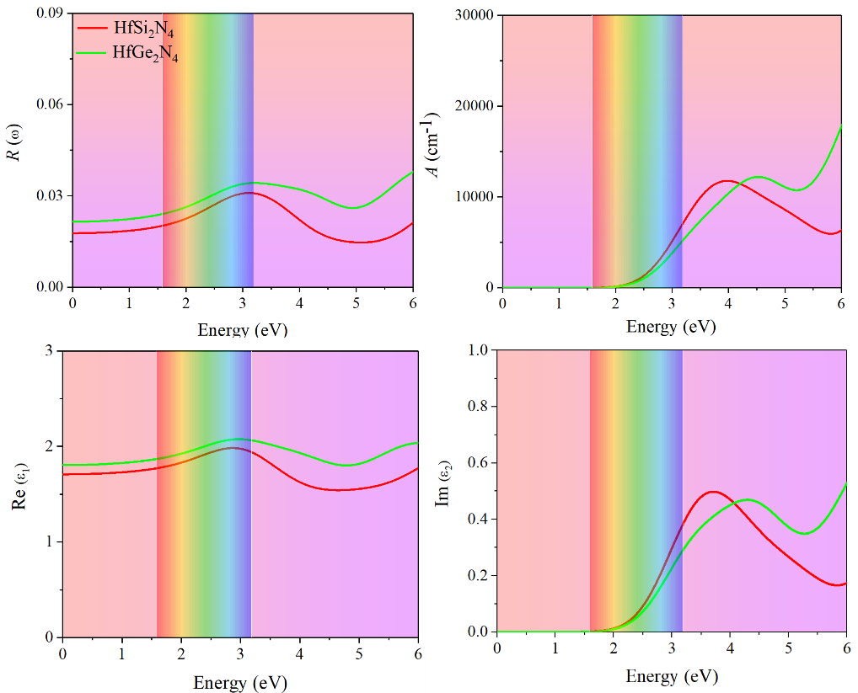
(f)
Figure S8. The calculated reffectivity, absorption coefffcient (α), complex dielectric function of CrA₂N₄ (a), MoA₂N₄ (b), WA₂N₄ (c), TiA₂N₄ (d), ZrA₂N₄ (e) and HfA₂N₄ (f).
Table S1. The calculated lattice parameters and band gaps by GGA-PBE and HSE06 for MSi₂N₄ (M= Ti, Zr, Hf, V, Nb, Ta, Cr, Mo and W).
MA₂N₄ |  | Lattice parameters (Å) | E_{g}  (GGA-PBE)  (eV) | E_{g}  (HSE06)  (eV)
TiSi₂N₄ | This work | 2.926  2.932 [35]  2.93 [36] | 1.649  1.61 [35]  1.62 [37] | 2.907  2.74 [35]
ZrSi₂N₄ | This work | 3.028  3.022[35]  3.04 [36] | 1.622  1.56 [35]  1.15 [39] | 2.532  2.94 [35]  2.73 [39]
HfSi₂N₄ | This work | 3.052  3.022 [35]  3.02 [36] | 1.364  1.77 [35]  1.61 [38]  1.03 [39] | 3.101  3.25 [35]  3.02 [39]
VSi₂N₄ | This work | 2.877  2.883 [35] | Half-metal | Half-metal
NbSi₂N₄ | This work | 2.961  2.965 [35] | metal  metal [35] | metal
TaSi₂N₄ | This work | 2.993  2.967 [35] | metal  metal [35] | metal
CrSi₂N₄ | This work | 2.839  2.844 [35]  2.84 [36] | 0.511  0.49 [35] | 0.522  0.99 [35]
MoSi₂N₄ | This work | 2.902  2.909 [35]  2.91 [36]  2.94 [10] | 1.754  1.72 [35]  1.78 [40]  1.94 [10] | 2.610  2.21 [35]  2.22 [42]  2.298 [43]
WSi₂N₄ | This work | 2.907  2.912 [35]  2.91 [35] | 2.094  2.19 [35]  2.00 [40] | 2.160  2.51 [35]  2.68 [41]  2.56 [42]  2.608 [43]

Table S2. The calculated bond populations of the screened materials mentioned above.
Materials | Bond | Population | Length
CrC₂N₄ | C-N1 | 0.61 | 1.444
CrC₂N₄ | C-N2 | 2.22 | 1.527
CrC₂N₄ | Cr-N1 | 1.09 | 1.862
CrSi₂N₄ | Si-N1 | 0.43 | 1.718
CrSi₂N₄ | Si-N2 | 2.00 | 1.723
CrSi₂N₄ | Cr-N1 | 1.19 | 1.957
CrGe₂N₄ | Ge-N1 | 0.43 | 1.838
CrGe₂N₄ | Ge-N2 | 1.91 | 1.794
CrGe₂N₄ | Cr-N1 | 1.22 | 2.023
MoC₂N₄ | C-N1 | 0.66 | 1.416
MoC₂N₄ | C-N2 | 2.18 | 1.569
MoC₂N₄ | Mo-N1 | 1.04 | 2.021
MoSi₂N₄ | Si-N1 | 0.47 | 1.729
MoSi₂N₄ | Si-N2 | 2.05 | 1.745
MoSi₂N₄ | Mo-N1 | 1.20 | 2.102
MoGe₂N₄ | Ge-N1 | 0.46 | 1.833
MoGe₂N₄ | Ge-N2 | 1.94 | 1.822
MoGe₂N₄ | Mo-N1 | 1.21 | 2.108
WC₂N₄ | C-N1 | 0.65 | 1.399
WC₂N₄ | C-N2 | 2.18 | 1.568
WC₂N₄ | W-N1 | 1.10 | 2.012
WSi₂N₄ | Si-N1 | 0.47 | 1.719
WSi₂N₄ | Si-N2 | 2.02 | 1.714
WSi₂N₄ | W-N1 | 1.27 | 2.050
WGe₂N₄ | Ge-N1 | 0.53 | 1.824
WGe₂N₄ | Ge-N2 | 1.89 | 1.816
WGe₂N₄ | W-N1 | 1.24 | 2.090
TiC₂N₄ | C-N1 | 0.57 | 1.511
TiC₂N₄ | C-N2 | 2.22 | 1.547
TiC₂N₄ | Ti-N1 | 1.03 | 1.900
TiSi₂N₄ | Si-N1 | 0.45 | 1.722
TiSi₂N₄ | Si-N2 | 2.01 | 1.708
TiSi₂N₄ | Ti-N1 | 1.22 | 2.009
ZrSi₂N₄ | Si-N1 | 0.42 | 1.671
ZrSi₂N₄ | Si-N2 | 2.12 | 1.759
ZrSi₂N₄ | Zr-N1 | 1.11 | 2.140
ZrGe₂N₄ | Ge-N1 | 0.49 | 1.794
ZrGe₂N₄ | Ge-N2 | 1.99 | 1.838
ZrGe₂N₄ | Zr-N1 | 1.10 | 2.175
ZrSn₂N₄ | Sn-N1 | 0.36 | 1.933
ZrSn₂N₄ | Sn-N2 | 1.85 | 1.935
ZrSn₂N₄ | Zr-N1 | 1.17 | 2.183
ZrPb₂N₄ | Pb-N1 | 0.23 | 1.977
ZrPb₂N₄ | Pb-N2 | 1.36 | 2.006
ZrPb₂N₄ | Zr-N1 | 1.12 | 2.217
HfSi₂N₄ | Si-N1 | 0.45 | 1.721
HfSi₂N₄ | Si-N2 | 2.09 | 1.760
HfSi₂N₄ | Hf-N1 | 1.46 | 2.082
HfGe₂N₄ | Ge-N1 | 0.44 | 1.840
HfGe₂N₄ | Ge-N2 | 1.94 | 1.858
HfGe₂N₄ | Hf-N1 | 1.42 | 2.112

Table S3 The calculated bond populations Mulliken charges of the screened materials mentioned above.
Materials |  | Charge (e)
CrC₂N₄ | Cr | 1.05
CrC₂N₄ | C | 0.43
CrC₂N₄ | N1 | -0.60
CrC₂N₄ | N2 | -0.36
CrSi₂N₄ | Cr | 0.96
CrSi₂N₄ | Si | 1.85
CrSi₂N₄ | N1 | -0.92
CrSi₂N₄ | N2 | -1.40
CrGe₂N₄ | Cr | 0.94
CrGe₂N₄ | Ge | 1.57
CrGe₂N₄ | N1 | -0.83
CrGe₂N₄ | N2 | -1.21
MoC₂N₄ | Mo | 1.15
MoC₂N₄ | C | 0.45
MoC₂N₄ | N1 | -0.65
MoC₂N₄ | N2 | -0.37
MoSi₂N₄ | Mo | 1.04
MoSi₂N₄ | Si | 1.84
MoSi₂N₄ | N1 | -0.96
MoSi₂N₄ | N2 | -1.39
MoGe₂N₄ | Mo | 1.06
MoGe₂N₄ | Ge | 1.57
MoGe₂N₄ | N1 | -0.90
MoGe₂N₄ | N2 | -1.21
WC₂N₄ | W | 1.29
WC₂N₄ | C | 0.46
WC₂N₄ | N1 | -0.73
WC₂N₄ | N2 | -0.37
WSi₂N₄ | W | 1.20
WSi₂N₄ | Si | 1.93
WSi₂N₄ | N1 | -1.06
WSi₂N₄ | N2 | -1.47
WGe₂N₄ | W | 1.24
WGe₂N₄ | Ge | 1.58
WGe₂N₄ | N1 | -0.95
WGe₂N₄ | N2 | -1.25
TiC₂N₄ | Ti | 1.17
TiC₂N₄ | C | 0.43
TiC₂N₄ | N1 | -0.67
TiC₂N₄ | N2 | -0.35
TiSi₂N₄ | Ti | 1.14
TiSi₂N₄ | Si | 1.94
TiSi₂N₄ | N1 | -1.03
 | N2 | -1.48
ZrSi₂N₄ | Zr | 1.30
ZrSi₂N₄ | Si | 1.88
ZrSi₂N₄ | N1 | -1.12
ZrSi₂N₄ | N2 | -1.41
ZrGe₂N₄ | Zr | 1.33
ZrGe₂N₄ | Ge | 1.58
ZrGe₂N₄ | N1 | -1.02
ZrGe₂N₄ | N2 | -1.23
ZrSn₂N₄ | Zr | 1.30
ZrSn₂N₄ | Sn | 1.81
ZrSn₂N₄ | N1 | -1.06
ZrSn₂N₄ | N2 | -1.40
ZrPb₂N₄ | Zr | 1.41
ZrPb₂N₄ | Pb | 1.32
ZrPb₂N₄ | N1 | -0.97
ZrPb₂N₄ | N2 | -1.05
HfSi₂N₄ | Hf | 1.44
HfSi₂N₄ | Si | 1.83
HfSi₂N₄ | N1 | -1.15
HfSi₂N₄ | N2 | -1.40
HfGe₂N₄ | Hf | 1.49
HfGe₂N₄ | Ge | 1.48
HfGe₂N₄ | N1 | -1.07
HfGe₂N₄ | N2 | -1.16

Table S4 The calculated m_{h}/m_{e} for CrA₂N₄, MoA₂N₄, WA₂N₄, TiA₂N₄, ZrA₂N₄ and HfA₂N₄.
Materials | m_{h}/m_{e} | $$\left|\text{m}\text{h}\text{/m}\text{e}\text{-1}\right|$$
CrC₂N₄ | 1.924 | 0.924
CrSi₂N₄ | 0.391 | 0.609
CrGe₂N₄ | 0.426 | 0.574
MoC₂N₄ | 3.329 | 2.329
MoSi₂N₄ | 0.878 | 0.122
MoGe₂N₄ | 0.438 | 0.562
WC₂N₄ | 1.640 | 0.640
WSi₂N₄ | 0.286 | 0.714
WGe₂N₄ | 0.496 | 0.504
TiC₂N₄ | 2.066 | 1.066
TiSi₂N₄ | 0.460 | 0.119
ZrSi₂N₄ | 1.238 | 0.238
ZrGe₂N₄ | 1.520 | 0.520
ZrSn₂N₄ | 0.471 | 0.529
ZrPb₂N₄ | 0.361 | 0.639
HfSi₂N₄ | 0.924 | 0.076
HfGe₂N₄ | 1.236 | 0.236

∗ Corresponding author. E-mail: 18382927860@163.com ∗∗ Corresponding author. E-mail: renxg2468@163.com

