Performance Comparison of Negative Sample Sampling Strategies
We evaluated and compared the performance of four negative sampling strategies on three datasets based on a unified five-fold cross-validation framework.
- Random uniform sampling (RUS): The method involves sampling from all unknown associations with equal probability.
- STEAL​: STEAL employs a prototype-based pseudo-labeling strategy for negative sampling: positive instances are first clustered via k-means to derive representative prototypes, after which unlabeled instances are assigned pseudo-labels based on their similarity to these prototypes, rather than being directly designated as negatives [1];
- Paz-Ruza et al. adopt a Jaccard KNN-based reliable negative selection strategy: for each unlabeled instance, the proportion of unlabeled neighbors within its k-top-nearest neighbors (quantified via Jaccard similarity) is computed, and instances exceeding a preset threshold are selected as reliable negatives [2];
- PUCL: PUCL utilizes a distance-thresholding reliable negative selection strategy: for each unlabeled instance, the average KNN distance to the positive instance set is calculated, and instances with distances surpassing a preset threshold are isolated as reliable negatives [3].
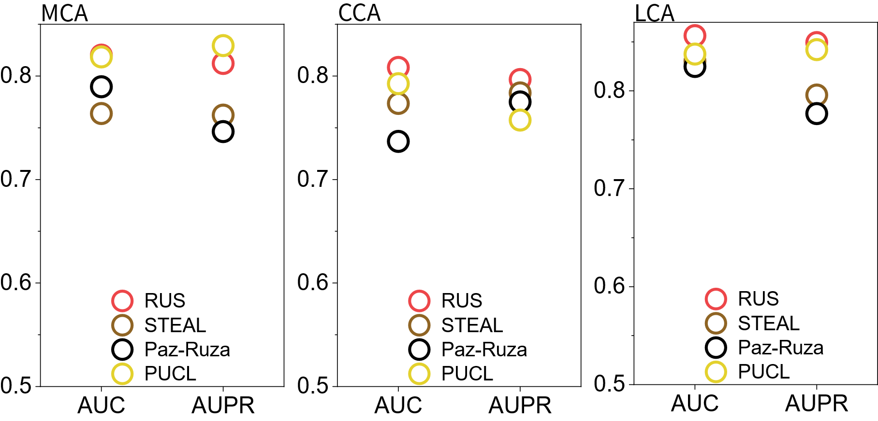
Figure 1 The performance of NISINTR under different negative sample sampling strategies.
The RUS strategy achieved the highest AUC and AUPR values across all three Tasks. Particularly in the AUC metric, which is more sensitive to the ratio of positive to negative samples and false negatives, RUS was consistently leading. This indicates that, under the current data scale and task setting, unbiased sampling that makes as few assumptions as possible about unknown associations is the strategy for obtaining reliable and robust model performance. Its excellent AUPR value also indirectly suggests that, in the current 1:1 balanced experimental setting, potential false negative label noise has not significantly disrupted model learning.

Renference
[1] P. Mignone, G. Pio, and M. Ceci, “Distributed Heterogeneous Transfer Learning,” Big Data Research, vol. 37, Aug. 2024, doi: 10.1016/j.bdr.2024.100456.
[2] J. Paz-Ruza, A. A. Freitas, A. Alonso-Betanzos, and B. Guijarro-Berdiñas, “Positive-Unlabelled learning for identifying new candidate Dietary Restriction-related genes among ageing-related genes,” Comput. Biol. Med., vol. 180, Sep. 2024, doi: 10.1016/j.compbiomed.2024.108999.
[3] B. Peng and A. Billard, “Positive-Unlabeled Constraint Learning for Inferring Nonlinear Continuous Constraints Functions From Expert Demonstrations,” IEEE Robot. Autom. Lett., vol. 10, no. 2, pp. 1593–1600, 2025, doi: 10.1109/LRA.2024.3522756.

