Supplementary Information
Investigating the removal efficiency of methylene blue dye and the reusability of NaBO₃ modified biomass ash geopolymer

Table S1 Proportion materials for BAG, H₂O₂@BAG, and NaBO₃@BAG preparation.
Sample  name | BA ª  (%wt) | H₂O₂ ^{b}  (%wt) | NaBO₃ ^{c}  (%wt) | L/B ^{d} | Conc. NaOH ^{e}  (M) | NS/NH ^{f} | T (C°) ^{g}
BAG | 100 | 0 | 0 | 0.6 | 12.5 | 1 | 60
0.5 wt% H₂O₂@BAG | 99.50 | 0.50 | 0 | 0.6 | 12.5 | 1 | 60
0.75 wt% H₂O₂@BAG | 99.25 | 0.75 | 0 | 0.6 | 12.5 | 1 | 60
1 wt% H₂O₂@BAG | 99.00 | 1.00 | 0 | 0.6 | 12.5 | 1 | 60
0.5 wt% NaBO₃@BAG | 99.50 | 0 | 0.50 | 0.6 | 12.5 | 1 | 60
0.75 wt% NaBO₃@BAG | 99.25 | 0 | 0.75 | 0.6 | 12.5 | 1 | 60
1 wt% NaBO₃@BAG | 99.00 | 0 | 1.00 | 0.6 | 12.5 | 1 | 60
ª Biomass ash
^{b} Hydrogen peroxide
^{c} Sodium perborate
^{d} Ratio of alkaline solution to biomass ash
^{e} Concentration of NaOH
^{f} Ratio of Na₂SiO₃ to NaOH
^{g} Curing temperature

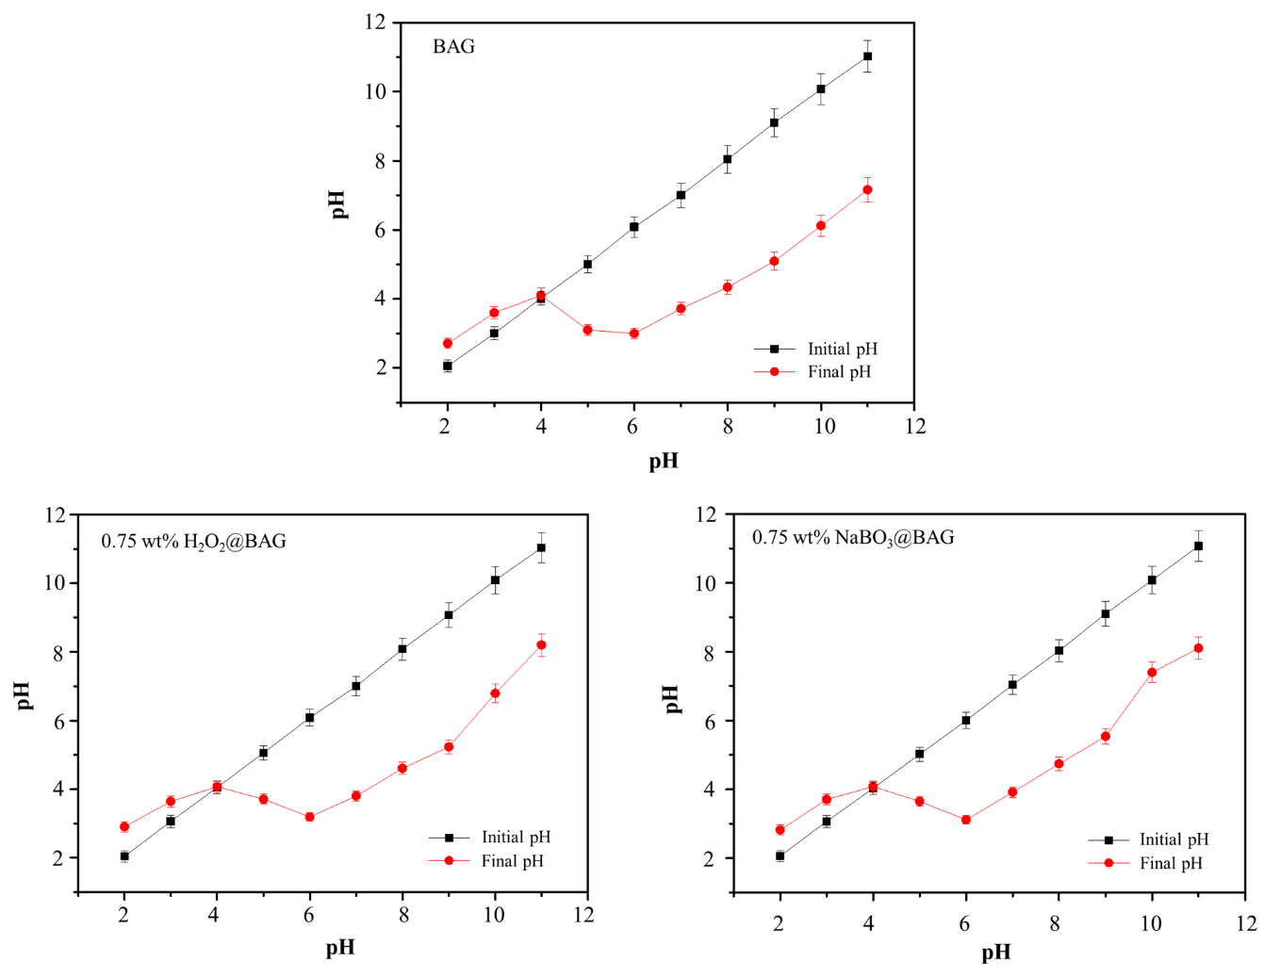
Fig. S1 Determination of the point of zero charges (pH_{pzc}) of the BAG, 0.75 wt% H₂O₂@BAG, and 0.75 wt% NaBO₃@BAG materials

