Note: This supporting information for electronic publication
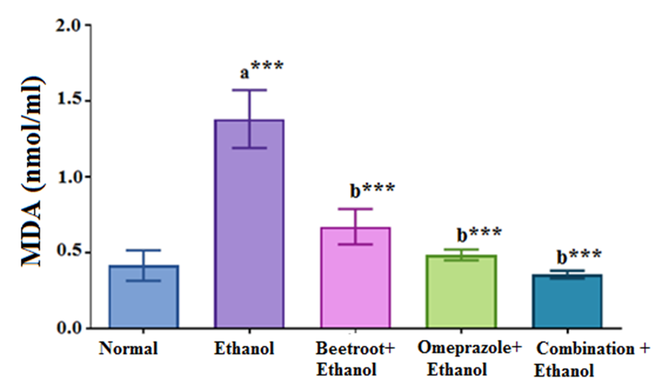
Fig. S1: Influence of beetroot extract and/or omeprazole on serum malondialdehyde (MDA) in ethanol ulcerated rats. Values are expressed as mean ± SEM of 10 rats. a: significance versus normal group; b: significance versus ethanol group, ***P< 0.0001.
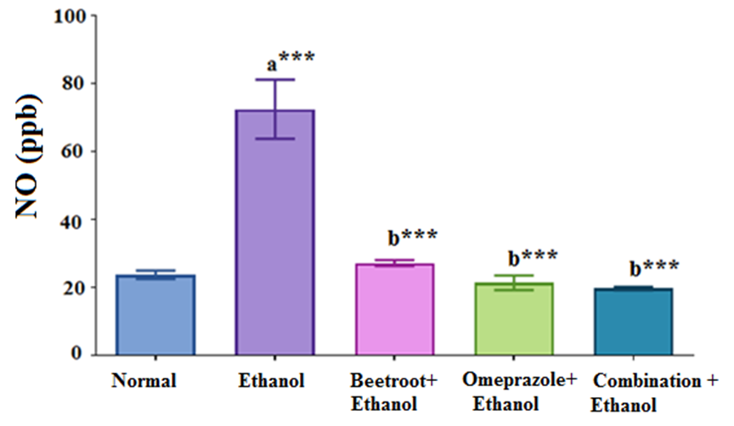
Fig. S2: Influence of beetroot extract and/or omeprazole on serum nitric oxide (NO) in ethanol ulcerated rats. Values are expressed as mean ± SEM of 10 rats. a: significance versus normal group; b: significance versus ethanol group, ***P<0.0001.
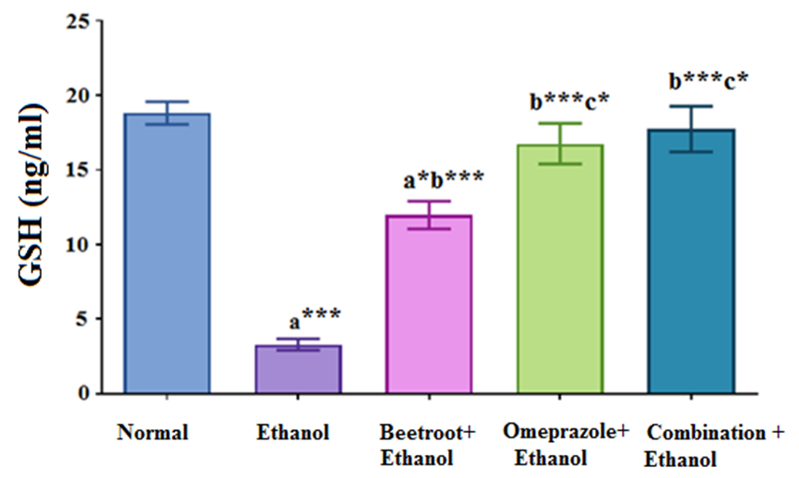
Fig. S3: Influence of beetroot extract and/or omeprazole on serum Glutathione (reduced form) (GSH) in ethanol ulcerated rats. Values are expressed as mean ± SEM of 10 rats. a: significance versus normal group; b: significance versus ethanol group; c: significance versus ethanol +beetroot, ***P<0.0001, *P<0.050.
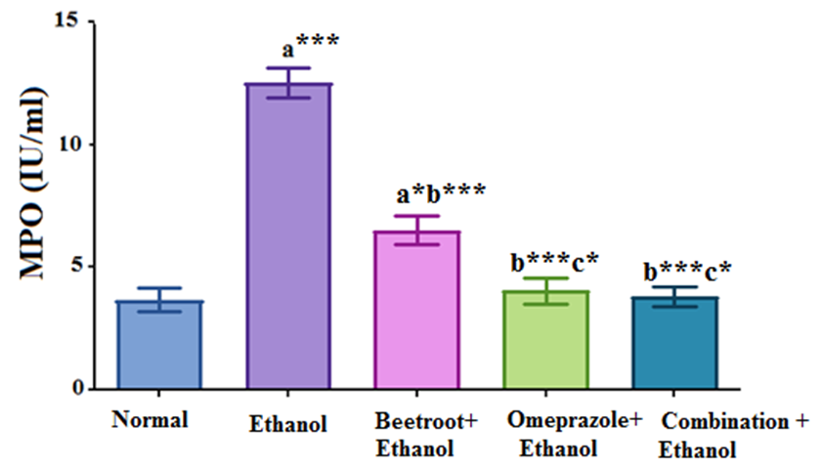
Fig. S4: Influence of beetroot extract and/or omeprazole on serum myeloperoxidase (MPO) activity in ethanol ulcerated rats. Values are expressed as mean ± SEM of 510 rats. a: significance versus normal group; b: significance versus ethanol group; c: significance versus ethanol +beetroot, ***P<0.0001, *P<0.050.

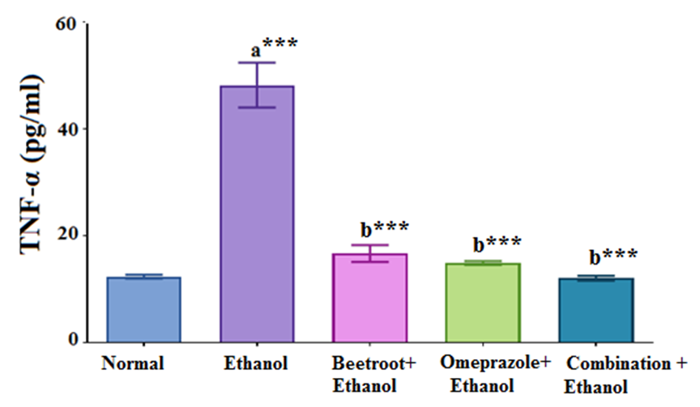
Fig. S5: Influence of beetroot extract and/or omeprazole on serum tumor necrosis factor- α (TNF-α) in ethanol ulcerated rats. Values are expressed as mean ± SEM of 10 rats. a: significance versus normal group; b: significance versus ethanol group, ***P<0.0001.
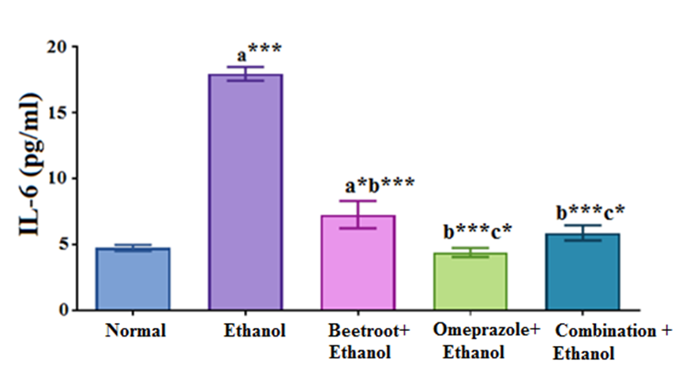
Fig. S6: Influence of beetroot extract and/or omeprazole on serum interleukin- 6 (IL-6) in ethanol ulcerated rats. Values are expressed as mean ± SEM of 10 rats. a: significance versus normal group; b: significance versus ethanol group; c: significance versus ethanol +beetroot, ***P<0.0001, *P<0.050.

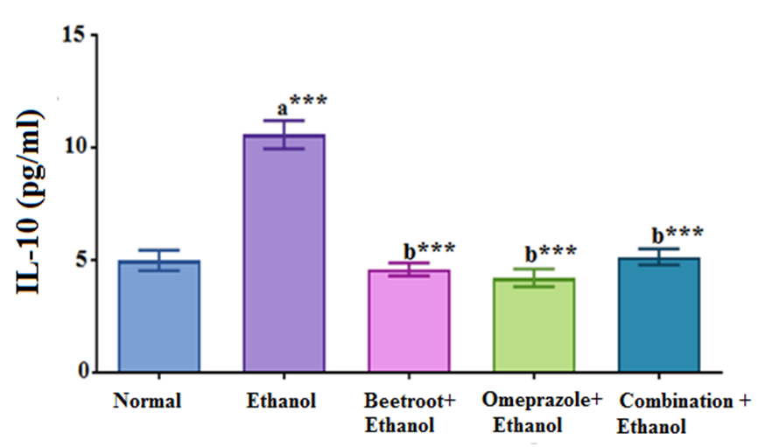
Fig. S7: Influence of beetroot extract and/or omeprazole on serum interleukin- 10 (IL-10) in ethanol ulcerated rats. Values are expressed as mean ± SEM of 10 rats. a: significance versus normal group; b: significance versus ethanol group, ***P<0.0001.
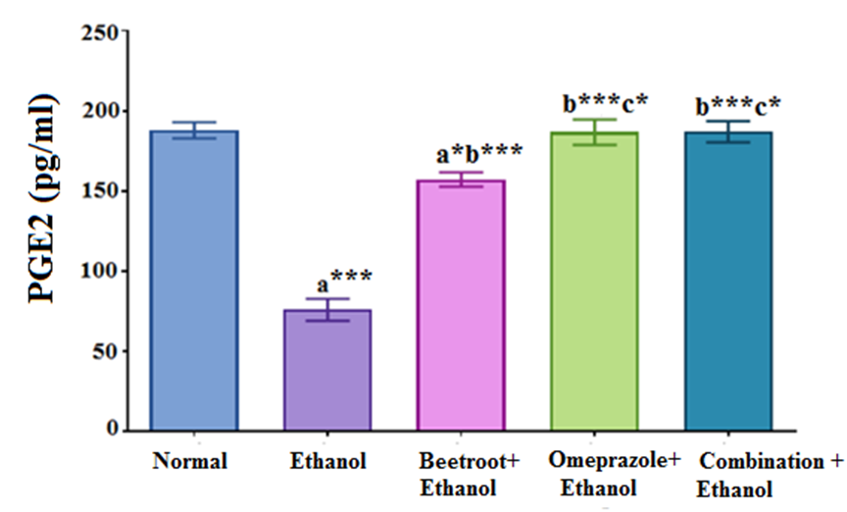
Fig. S8: Influence of beetroot extract and/or omeprazole on the level of serum prostaglandin E2 (PGE2) in ethanol ulcerated rats. Values are expressed as mean ± SEM of 10 rats. a: significance versus normal group; b: significance versus ethanol group; c: significance versus ethanol +beetroot, ***P<0.0001, *P<0.050.

