Supplementary Materials
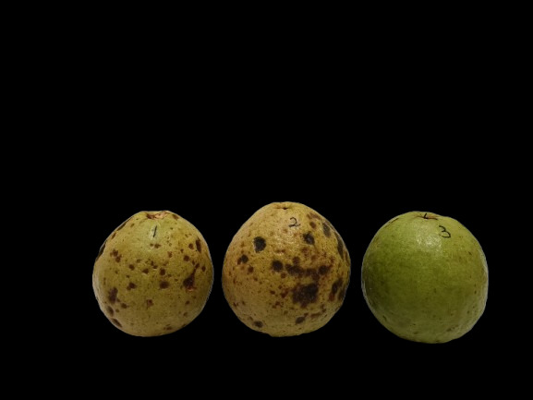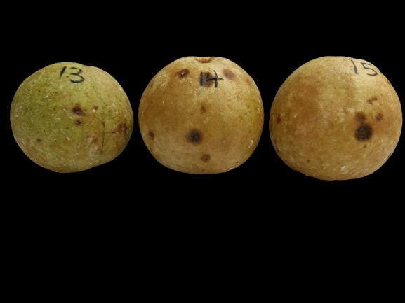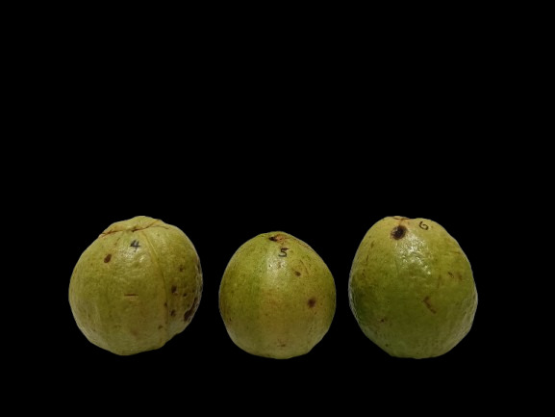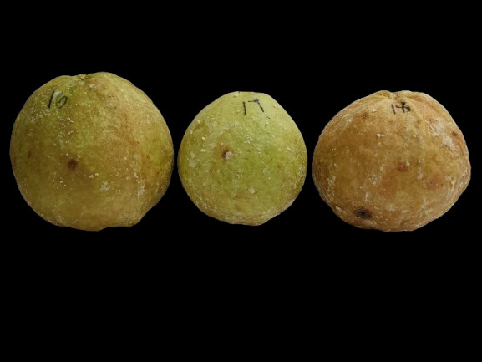
(A)
(C)
(D)
(B)
Fig. S1. Physical appearance of guavas with different treatments on day 5 under ambient conditions, (A) 1% beeswax coating; (B) 5% beeswax coating; (C) 1% coconut oil coating; (D) 5% coconut oil coating. The guavas that were subjected to a single coating of either beeswax or coconut oil deteriorated quickly when applied at 1% only. When the concentration was increased to 5%, the rate of decay decreased; however, the guavas developed a waxy texture and an opaque appearance with white depositions. Additionally, the lipid component did not mix well in the emulsion without the assistance of gum Arabic, which provided emulsifying properties.
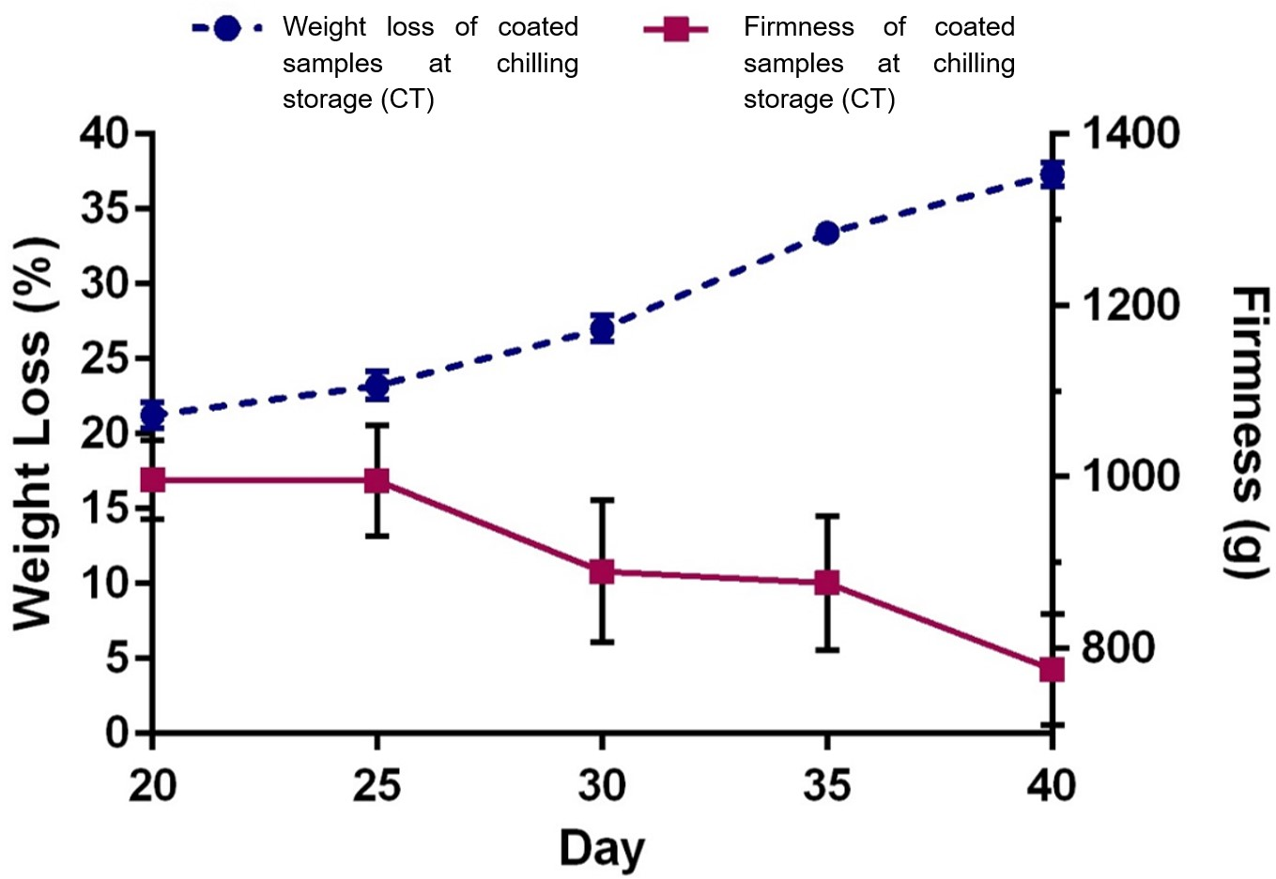
Fig. S2. Changes in weight loss and firmness from Day 20 until Day 40 for coated samples at chilling storage (CT). The trends for weight loss and firmness are inversely related. As weight loss occurred, firmness diminished, a typical trait observed in fruits as they ripened. Water loss led to shrinkage and softening, hence the decline in firmness.
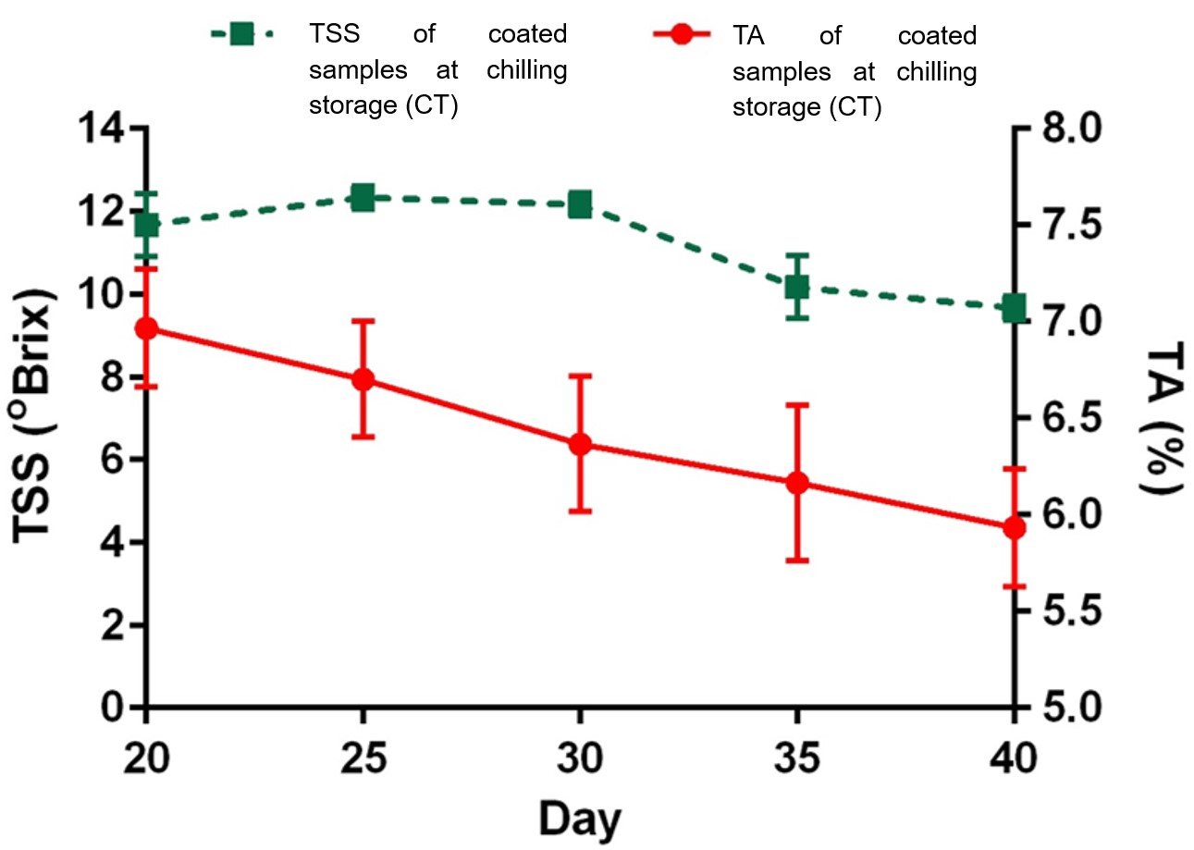
Fig. S3. Changes in TSS and TA from Day 20 until Day 40 for coated samples at chilling storage (CT). TSS value fluctuated with no significant changes within this period whereas TA values showed a noticeable decline. A reduction in acidity indicated ripening, while consistent sugar levels could imply minimal breakdown of sugars during this period.

Table S1.
Physicochemical Analyses
Physicochemical Analyses | Day | Mean ± SD |  | p-value | Mean ± SD |  | p-value
Physicochemical Analyses | Day | AT | AC | p-value | CT | CC | p-value
Weight Loss (%) | 0 | 0 | 0 | none | 0 | 0 | none
 | 1 | 0.64 ± 0.52 | 3.32 ± 0.60 | 0.0046 | 0.35 ± 0.06 | 1.65 ± 0.10 | 0.00018
 | 2 | 1.50 ± 0.52 | 5.58 ± 0.49 | 0.0006 | 0.77 ± 0.10 | 2.57 ± 0.12 | 0.000042
 | 3 | 2.33 ± 0.58 | 8.34 ± 0.80 | 0.0007 | 1.79 ± 0.46 | 3.16 ± 0.14 | 0.028
 | 4 | 3.21 ± 0.76 | 9.97 ± 0.86 | 0.0006 | 2.69 ± 0.87 | 4.43 ± 0.90 | 0.074
 | 5 | 3.50 ± 0.99 | 13.31 ± 0.91 | 0.0002 | 3.66 ± 0.61 | 6.06 ± 0.51 | 0.007
 | 6 | 4.33 ± 0.73 | 16.21 ± 0.90 | 0.00008 | 4.09 ± 0.55 | 7.59 ± 0.86 | 0.0066
 | 7 | 5.02 ± 0.64 | 17.43 ± 0.88 | 0.00008 | 4.60 ± 0.53 | 8.57 ± 0.88 | 0.0051
Firmness (g) | 0 | 1818.38 ± 41.25 | 1729.47 ± 66.04 | 0.133 | 1934.33 ± 66.71 | 1987.44 ± 67.47 | 0.823
 | 1 | 1671.81 ± 70.96 | 1523.82 ± 70.69 | 0.063 | 1899.73 ± 85.98 | 1879.73 ± 82.60 | 0.786
 | 2 | 1257.94 ± 79.22 | 1072.64 ± 60.07 | 0.035 | 1828.84 ± 77.98 | 1749.97 ± 85.91 | 0.305
 | 3 | 1056.79 ± 67.45 | 974.45 ± 81.93 | 0.253 | 1790.38 ± 51.26 | 1655.70 ± 69.64 | 0.059
 | 4 | 1013.52 ± 73.39 | 696.21 ± 79.89 | 0.007 | 1683.49 ± 75.70 | 1453.96 ± 76.29 | 0.021
 | 5 | 808.81 ± 79.23 | 582.77 ± 70.96 | 0.022 | 1667.49 ± 67.15 | 1314.85 ± 82.45 | 0.005
 | 6 | 660.60 ± 85.52 | 485.81 ± 50.82 | 0.050 | 1565.02 ± 77.21 | 1128.27 ± 84.69 | 0.003
 | 7 | 556.15 ± 58.87 | 415.12 ± 85.58 | 0.087 | 1420.72 ± 37.76 | 968.78 ± 57.61 | 0.001
TSS (ºBx) | 0 | 6.17 ± 0.29 | 6.33 ± 0.29 | 0.5185 | 5.83 ± 0.76 | 5.83 ± 0.29 | 1.00
 | 1 | 6.50 ± 0.50 | 7.33 ± 0.29 | 0.0824 | 6.33 ± 0.29 | 6.33 ± 0.58 | 1.00
 | 2 | 7.33 ± 0.58 | 9.00 ± 0.87 | 0.0586 | 6.50 ± 0.50 | 6.67 ± 0.29 | 0.65
 | 3 | 7.50 ± 0.50 | 9.17 ± 0.76 | 0.0419 | 7.00 ± 0.50 | 7.00 ± 0.50 | 1.00
 | 4 | 8.00 ± 0.50 | 9.33 ± 0.29 | 0.0248 | 7.17 ± 0.29 | 7.33 ± 0.29 | 0.52
 | 5 | 8.17 ± 0.58 | 9.67 ± 0.58 | 0.0335 | 7.33 ± 0.29 | 7.67 ± 0.29 | 0.23
 | 6 | 8.33 ± 0.29 | 10.67 ± 0.29 | 0.0006 | 7.50 ± 0.00 | 7.83 ± 0.29 | 0.18
 | 7 | 8.50 ± 0.00 | 11.00 ± 0.87 | 0.0377 | 8.00 ± 0.50 | 8.50 ± 0.87 | 0.45
TA (%) | 0 | 0.20 ± 0.03 | 0.23 ± 0.04 | 0.2784 | 0.36 ± 0.02 | 0.27 ± 0.03 | 0.0124
 | 1 | 0.21 ± 0.03 | 0.25 ± 0.01 | 0.1238 | 0.38 ± 0.04 | 0.31 ± 0.03 | 0.0691
 | 2 | 0.27 ± 0.03 | 0.42 ± 0.02 | 0.0022 | 0.41 ± 0.01 | 0.41 ± 0.02 | 0.8350
 | 3 | 0.30 ± 0.02 | 0.49 ± 0.02 | 0.0013 | 0.44 ± 0.03 | 0.41 ± 0.04 | 0.4576
 | 4 | 0.36 ± 0.04 | 0.41 ± 0.01 | 0.1175 | 0.45 ± 0.04 | 0.51 ± 0.01 | 0.1095
 | 5 | 0.39 ± 0.02 | 0.36 ± 0.01 | 0.1007 | 0.47 ± 0.04 | 0.60 ± 0.02 | 0.0196
 | 6 | 0.37 ± 0.01 | 0.27 ± 0.00 | 0.0008 | 0.53 ± 0.04 | 0.69 ± 0.01 | 0.0104
 | 7 | 0.36 ± 0.01 | 0.22 ± 0.02 | 0.0005 | 0.61 ± 0.04 | 0.74 ± 0.02 | 0.0231
AC = control samples at ambient storage; AT = coated samples at ambient storage; CC = control samples at chilling storage; CT = coated samples at chilling storage; The results presented are the means of triplicate observations ± standard deviation.

