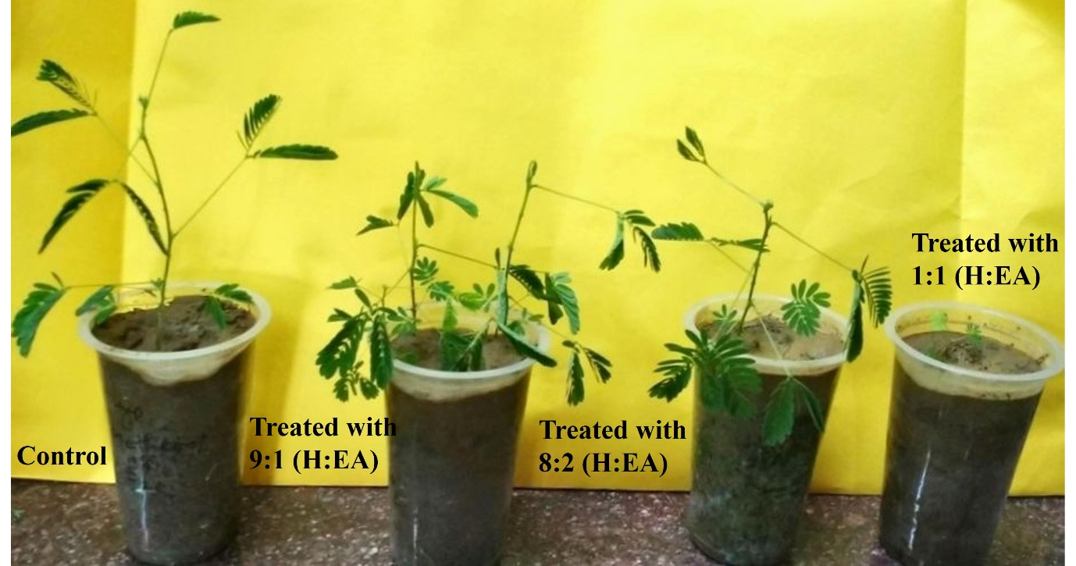

Supplementary Figure 1- Effect of different allelochemical fractions on Mimosa seedlings' growth.

