High variability in spore infectivity and factors influencing native arbuscular mycorrhizal fungi diversity in Côte d’Ivoire cacao rhizospheres

Main contents
Supplementary table

Table S1 Average value of climate variables downloaded from TerraClim databases

Study areas | Precipitation (mm) | Soil moisture | Temperature (°C)
Adzopé | 1344.23±121.14ab | 128.18±10.40a | 27.38±0.33a
Agnibilékrou | 1219.35±149.49bc | 64.03±10.11b | 27.36±0.34a
Azaguié | 1235.02±97.41bc | 69.99±7.73bc | 27.44±0.29a
Biankouma | 1598.49±196.49d | 159.83±18.46d | 25.22±0.28b
Blé | 1280.67±143.60ac | 85.13±10.72c | 26.77±0.26c
Bonon | 1124.78±150.20c | 78.07±22.82bc | 26.77±0.25c
Soubré | 1438.61±161.22ad | 158.39±15.93d | 26.71±0.30c
p-value | < 0.001*** | < 0.001*** | < 0.001***

Values represent means ± standard errors. Significance levels: p < 0.001*** (very highly significant). p-value = probability of error associated with Tukey test

Table S2 Soil chemical properties of cocoa plantations at seven study areas in Côte d'Ivoire (n = number of cocoa fields sampled per areas) and their statistical significance
Soil chemical properties | Adzopé  (n = 10) | Agnibilékrou  (n = 8) | Azaguié  (n = 9) | Biankouma  (n = 10) | Blé  (n = 9) | Bonon  (n = 10) | Soubré  (n = 10) | p_value
pH | 5.45±0.8 | 5.12±0.52 | 5.72±0.67 | 5.4±0.84 | 5.67±0.66 | 5.3±0.92 | 5.35±0.71 | 0.67^{ns}
P (g/kg) | 7.21±2.12ab | 7.41±1.48ab | 8.63±1.95a | 4.90±4.13b | 6.62±2.77ab | 6.57±1.3ab | 7.69±1.75ab | 0.05*
K⁺ (%) | 5.26±1.42 | 2.84±2.13 | 6.3±4.46 | 3.58±2.35 | 5.57±7.53 | 2.93±0.97 | 6.97±4.75 | 0.149^{ns}
Fe (%) | 41.6±10.96ab | 39.48±14.6ab | 29.09±8.28b | 48.73±9.18a | 33.79±12.09b | 40.28±5.54ab | 31.01±10.06b | <0.01**
Ca²⁺ (%) | 4.16±1.74 | 4.02±2.01 | 2.33 ± 1.06 | 5.06±5.06 | 5.19±3.5 | 3.81±1.31 | 3.22±1.80 | 0.294^{ns}
Al (%) | 5.38±0.94ab | 6.09±3.07ab | 5.00±1.29b | 7.87±2.32a | 6.71±1.55ab | 4.19±1.74b | 5.51±1.36ab | <0.01**
Mn (g/kg) | 4.44±4.61bc | 8.92±4.62ab | 2.75±1.67c | 9.78±6.61ab | 10.86±3.28a | 9.25±2.2ab | 4.26±3.4bc | <0.001***
Cu (g/kg) | 0.66±0.22bc | 0.64±0.22bc | 0.34±0.14c | 1.33±0.52a | 0.43±0.26c | 0.82±0.21b | 0.36±0.11c | <0.001***
Zn (g/kg) | 1.27±1.6ab | 0.87±0.33b | 0.57±0.24b | 1.06±0.36b | 0.70±0.37b | 2.16±0.84a | 0.55±0.32b | <0.001***
Cr (g/kg) | 1.02±0.17a | 0.75±0.18abc | 0.63±0.18bc | 0.57±0.36bc | 0.46±0.11c | 0.68±0.12bc | 0.79±0.15ab | <0.001***
Pb (g/kg) | 0.22±0.07b | 0.30±0.08b | 0.23±0.13b | 0.58±0.3a | 0.42±0.21ab | 0.23±0.04b | 0.35±0.23ab | <0.001***
Values represent means ± standard errors. Significance levels: *p < 0.05 (statistically significant); **p < 0.01 (highly significant); ***p < 0.001 (very highly significant); ns: not significant (p > 0.05). Soil properties are abbreviated as follows: pH (hydrogen potential), P (phosphorus), K⁺ (potassium), Fe (iron), Ca²⁺ (calcium), Al (aluminum), Mn (manganese), Pb (lead), Cu (copper), Zn (zinc), and Cr (chromium). p_value represents error probability associated with Tukey’s post hoc test.

Table S3 Mean relative abundance (%) of AMF families in cacao plots across the study areas

AMF Families | Adzope | Agnibilekrou | Azaguie | Biankouma | Ble | Bonon | Soubre | p_value
Acaulosporaceae | 27.69±9.54 | 28.98±8.2 | 21.38±8.03 | 26.98±10.4 | 31.69±8.16 | 19.61±7.79 | 28.5±6.38 | 0.001***
Ambisporaceae | 0.2±1.12 | 0.42±1.35 | 0.99 ± 2.03 | 1.24±2.86 | 0±0 | 1.37±4.45 | 0.64±1.39 | 0.21ns
Archaeosporaceae | 1.08±2.3 | 3.47±8.41 | 0±0 | 0.24±0.93 | 0±0 | 0±0 | 0.1 ± 0.56 | 0.001***
Dentiscutataceae | 0±0 | 0.76±2.06 | 1.01±2.49 | 0.48±1.68 | 0±0 | 0±0 | 0±0 | 0.05*
Diversisporaceae | 0±0 | 0±0 | 0.37±1.92 | 0±0 | 3.34±4.08 | 4.77±7.48 | 0.75±1.75 | 0.001***
Entrophosparaceae | 5.93 ± 6.36 | 2.72±3.73 | 4.69±5.66 | 0.82±2.38 | 1.09±2.68 | 0.37±1.55 | 1.83±2.55 | 0.001***
Gigasporaceae | 4.78±5.84 | 3.02±3.72 | 6.26±7.53 | 5.07±5.37 | 8.76±7.1 | 9.78±7.88 | 5.83±4.4 | 0.001***
Glomeraceae | 49.93±10.01 | 49.68±11.42 | 54.72±11.62 | 54.91±15.76 | 48.81±12.63 | 58.31±13.35 | 50.05±12.25 | 0.05*
Pacisporaceae | 0±0 | 0.55±1.61 | 0±0 | 0±0 | 0.38±1.98 | 1.31 ± 5.1 | 0.34±1.04 | 0.253ns
Paraglomeraceae | 0±0 | 0±0 | 0.67±2.4 | 0.4±2.18 | 2.25±4.06 | 3.03±5.08 | 0±0 | 0.001***
Racocetraceae | 0±0 | 0±0 | 2.04±3.42 | 0.27 ± 1.49 | 2.75±3.87 | 1.44±3.76 | 0.34±1.11 | 0.001***
Sacculosporaceae | 2.4 ± 3.95 | 1.89±3 | 1.34±2.63 | 2.07±3.58 | 0±0 | 0±0 | 4.65±8.69 | 0.001***
Scutellosporaceae | 4.78±5.84 | 3.02±3.72 | 6.26±7.53 | 5.07±5.37 | 8.76±7.1 | 9.78±7.88 | 5.83±4.4 | 0.001***

Table S4 α diversity of arbuscular mycorrhizal fungi within study areas

Study areas | Simpson index | Pielou index
Adzope | 0.69 ± 0.012^{b} | 0.64 ± 0.035^{c}
Agnibilekrou | 0.69 ± 0.020^{b} | 0.63 ± 0.056^{c}
Azaguie | 0.68 ± 0.015^{b} | 0.64 ± 0.03^{c}
Biankouma | 0.69 ± 0.02^{b} | 0.64 ± 0.06^{c}
Ble | 0.73 ± 0.05ª | 0.88 ± 0.06^{b}
Bonon | 0.74 ± 0.07ª | 0.92 ± 0.06ª
Soubre | 0.68 ± 0.02^{b} | 0.61 ± 0.04^{c}
p_value | < 0.001*** | < 0.001***
Values represent means ± standard errors. Significance levels: p < 0.001 (very highly significant). p-value = probability of error associated with Tukey test

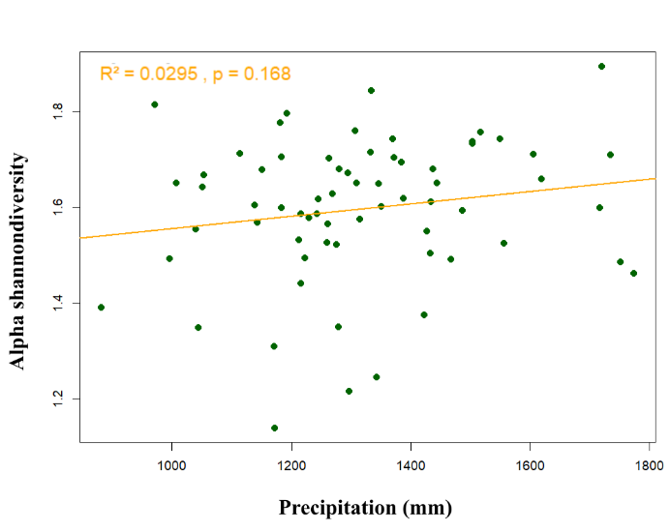
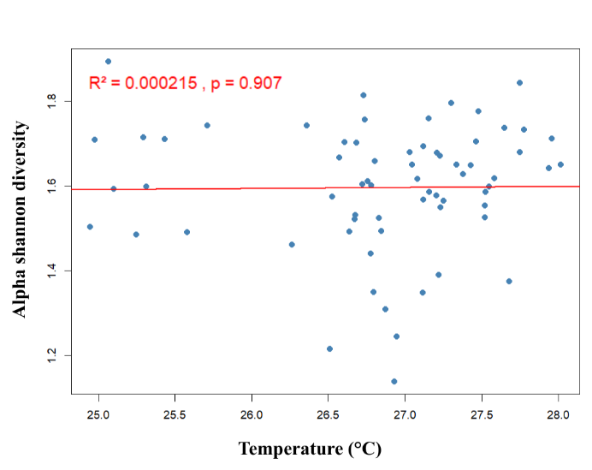
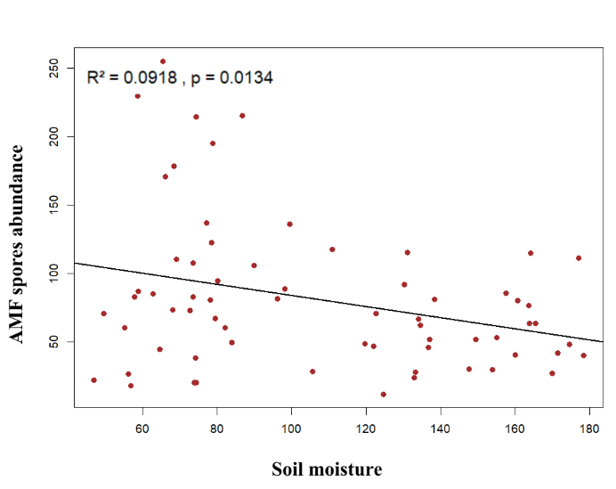
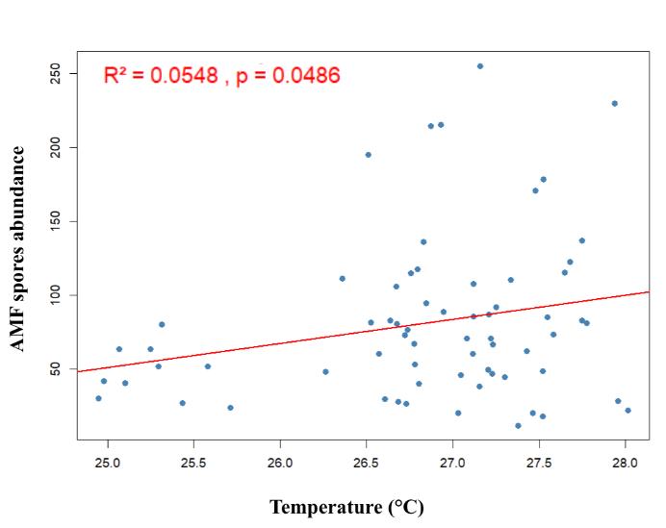
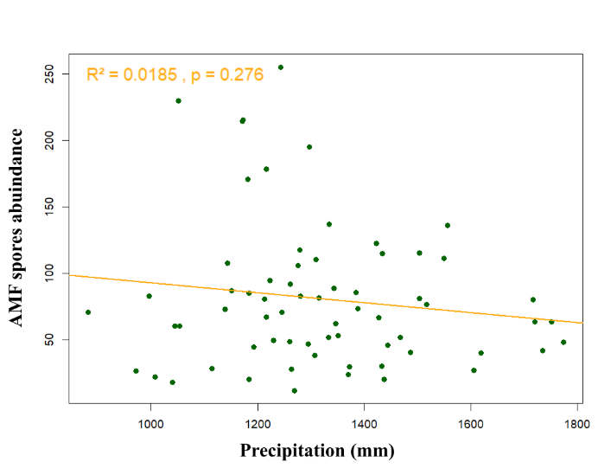
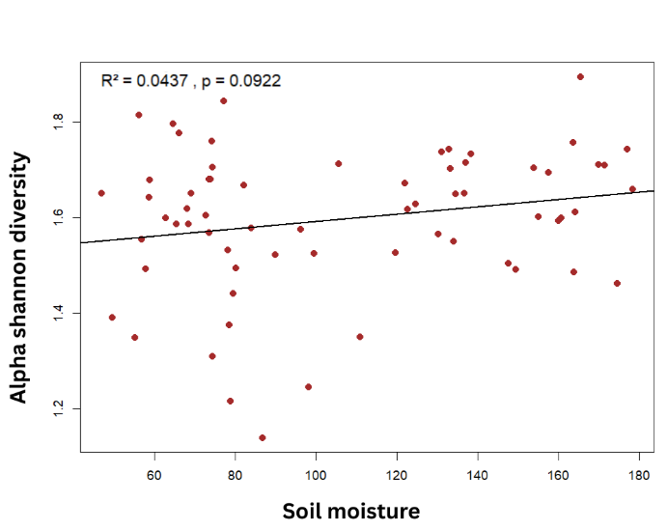
Supplementary figure

Fig. S1 Relationship between climatic variables (temperature, precipitation, and soil moisture), spore abundance, and alpha diversity (Shannon index) of AMF. The regression coefficient and significance level are shown on each graph. p-values in bold indicate whether the regression is significant or non-significant

