Supporting Information

Synergistic radio frequency and blue light: a green preservation strategy for fresh chinese medicicinal herbs via oxidase suppression and bioactive compound stabilization
Long Zhu¹, Jingtian, Liu¹, Hongliang, Qian¹, Yan Liu², Youyi, Miao², Chongjiang Cao^{1,}*
*Correspondence:
Chongjiang Cao
ccj33@163.com
¹ Department of Food Nutrition and Safety/National R&D Center for Chinese Herbal Medicine Processing, College of Engineering, China Pharmaceutical University, Nanjing, 211198, China.
² Institute of Agricultural Mechanization, Ministry of Agriculture and Rural Affairs, Nanjing, 210014, China

Material and methods
Reagents
Absolute ethanol, anhydrous sodium carbonate, ferrous sulfate heptahydrate, oxalic acid dihydrate, and salicylic acid were purchased from Sinopharm Chemical Reagent Co., Ltd. (Shanghai, China). Gallic acid, and aluminum chloride hexahydrate were obtained from Aladdin Biochemical Technology Co., Ltd. (Shanghai, China). Folin-Ciocalteu reagent was obtained from Shanghai Yuanye Bio-Technology Co., Ltd. (Shanghai, China). Sodium hydroxide, n-butanol, 30% hydrogen peroxide, phenol, concentrated sulfuric acid, perchloric acid, and 2,4-dinitrophenylhydrazine were purchased from Nanjing Reagent Co., Ltd. (Nanjing, China). Thiourea, L(+)-Ascorbic acid, sodium nitrite, guaiacol, catechol, and phosphoric acid were purchased from Shanghai Titan Scientific Co., Ltd. (Shanghai, China). L-Glucose, rutin, chlorogenic acid, protocatechuic acid, caffeic acid, and peimine were obtained from Shanghai Bide Pharmatech Ltd. (Shanghai, China).
Instruments and equipment
HGJL-RFSA50 Radiofrequency combined with LED irradiation equipment was designed by the College of Engineering, China Pharmaceutical University, and manufactured by Wuxi Xuzhou Intelligent Technology Co., Ltd. (Wuxi, China). KQ-250DE Numerical control ultrasonic cleaner (Kunshan, China). Analytical mill (Batch mill) (Guangzhou, China). M2 Multifunctional microplate reader (Shanghai, China). UV-1200 UV-Vis spectrophotometer (Shanghai, China). 900 SERIES Ultra-low temperature freezer (Thermo, Shanghai, China). TGL-16M High-speed refrigerated centrifuge (Changsha, China). Colorimeter CS-280 (Hangzhou, China). SMS TA.XT Texture analyzer (Godalming, UK). HWM-508 Constant temperature and humidity chamber (Ningbo, China).
Optimization of RF-L treatment conditions
An orthogonal experimental design was employed, utilizing browning index L-value and tissue firmness as evaluation metrics. A two-factor, five-level orthogonal array (L₂₅(5⁶)) was used to optimize the electrode distance (10–50 cm) and treatment time (1–5 min) (Table S1). Under controlled experimental conditions, all combinations were systematically tested. This study evaluated the impact of varying electrode distances and treatment times on the preservation effect of A. lappa, providing a foundation for subsequent research on synergistic RF-L preservation.
Determination of tissue firmness
Tissue firmness was measured using a TA-XT texture analyzer. A cylindrical flat-ended stainless steel probe with a diameter of 2 mm (P/2 probe) was employed to penetrate the A. lappa root surface. The probe descended at a speed of 1.00 mm/s to a penetration depth of 10 mm. Firmness was defined as the average force (in Newtons, N) required for the probe to penetrate the sample within 3–4 seconds. Five A. lappa roots were tested per treatment group, with results averaged and expressed in Newtons (N).
Determination of browning degree
Browning degree was quantified by measuring color parameters using a CS-280 colorimeter. The L* value (indicating lightness) was recorded at five distinct points on each fresh-cut burdock sample to assess browning levels.

Table S1. Orthogonal experimental design (L₂₅(5⁶)) for RF-L treatment parameter optimization in Arctium lappa.
Test number | Electrode distance (cm) | Treatment time (min) | L value( Mean ± SD) |  | Organizational hardness ( Mean ± SD, N)
1 | 10 | 1 |  | 66.85 ± 0.32 | 358.74 ± 5.21
2 | 10 | 2 |  | 68.92 ± 0.28 | 372.65 ± 4.83
3 | 10 | 3 |  | 67.33 ± 0.35 | 362.18 ± 3.97
4 | 10 | 4 |  | 65.87 ± 0.41 | 351.43 ± 6.12
5 | 10 | 5 |  | 65.23 ± 0.29 | 347.92 ± 5.44
6 | 20 | 1 |  | 72.14 ± 0.36 | 412.56 ± 4.75
7 | 20 | 2 |  | 74.28 ± 0.33 | 438.72 ± 5.31
8 | 20 | 3 |  | 70.65 ± 0.39 | 401.83 ± 4.62
9 | 20 | 4 |  | 68.76 ± 0.42 | 382.47 ± 3.89
10 | 20 | 5 |  | 66.54 ± 0.31 | 367.25 ± 6.03
11 | 30 | 1 |  | 75.63 ± 0.38 | 456.82 ± 4.81
12 | 30 | 2 |  | 76.89 ± 0.29 | 478.25 ± 5.17
13 | 30 | 3 |  | 73.42 ± 0.34 | 438.71 ± 4.33
14 | 30 | 4 |  | 70.85 ± 0.41 | 412.64 ± 5.98
15 | 30 | 5 |  | 68.17 ± 0.37 | 386.53 ± 4.27
16 | 40 | 1 |  | 76.45 ± 0.35 | 482.36 ± 5.22
17 | 40 | 2 |  | 77.26 ± 0.22 | 495.23 ± 4.15
18 | 40 | 3 |  | 74.88 ± 0.31 | 467.85 ± 4.68
19 | 40 | 4 |  | 72.53 ± 0.39 | 438.74 ± 5.41
20 | 40 | 5 |  | 69.42 ± 0.43 | 406.32 ± 4.92
21 | 50 | 1 |  | 73.85 ± 0.34 | 462.17 ± 5.03
22 | 50 | 2 |  | 75.14 ± 0.28 | 481.45 ± 4.87
23 | 50 | 3 |  | 72.67 ± 0.37 | 445.32 ± 5.14
24 | 50 | 4 |  | 69.78 ± 0.42 | 412.83 ± 4.65
25 | 50 | 5 |  | 67.25 ± 0.39 | 378.65 ± 5.29

*Note: RF power: 3 kW (40.68 MHz); Blue LED power: 0.05 kW; Sample batch: 1.5 kg.*

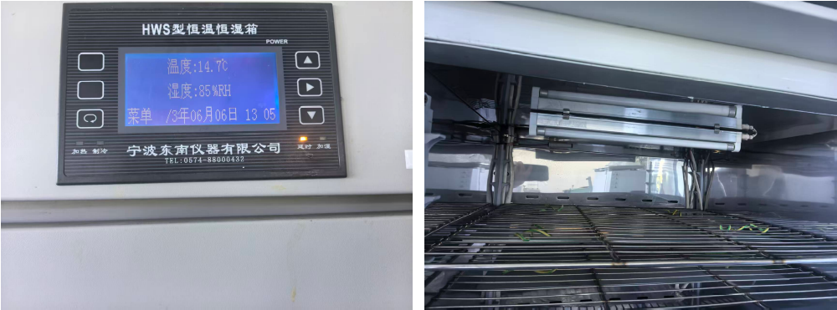

Fig. S1 Physical picture of constant temperature and humidity chamber (15 ℃, 85%)

Medicinal material | Measurement position | Temperature (°C)
A. lappa roots | Surface | 38.7 ± 1.2
A. lappa roots | Core | 36.8 ± 0.9
Lily bulbs | Surface | 37.5 ± 0.7
Lily bulbs | Core | 35.4 ± 1.0
Fritillary bulbs | Surface | 37.1 ± 0.5
Fritillary bulbs | Core | 35.2 ± 0.8
Table S2. Maximum surface and core temperatures of medicinal materials during RF-
L treatment

Table S3. Comparative energy consumption analysis of RF-L vs. Conventional refrigeration
Parameter | RF-L treatment | Conventional refrigeration
Equipment specifications | RF system (40.68 MHz, 3 kW) + Blue LED (0.05 kW) | Standard cold storage system
Processing protocol | 2 min per batch (1.5 kg capacity) | 8-day storage at 15°C/85% RH
Specific energy consumption | 0.102 kW·h/kg | 1.5 kW·h/kg
*Note: Energy ratio calculated as (0.102 kW·h/kg ÷ 1.5 kW·h/kg) × 100 = 6.8%. Time conversion: 2 min = 0.033 h.*

