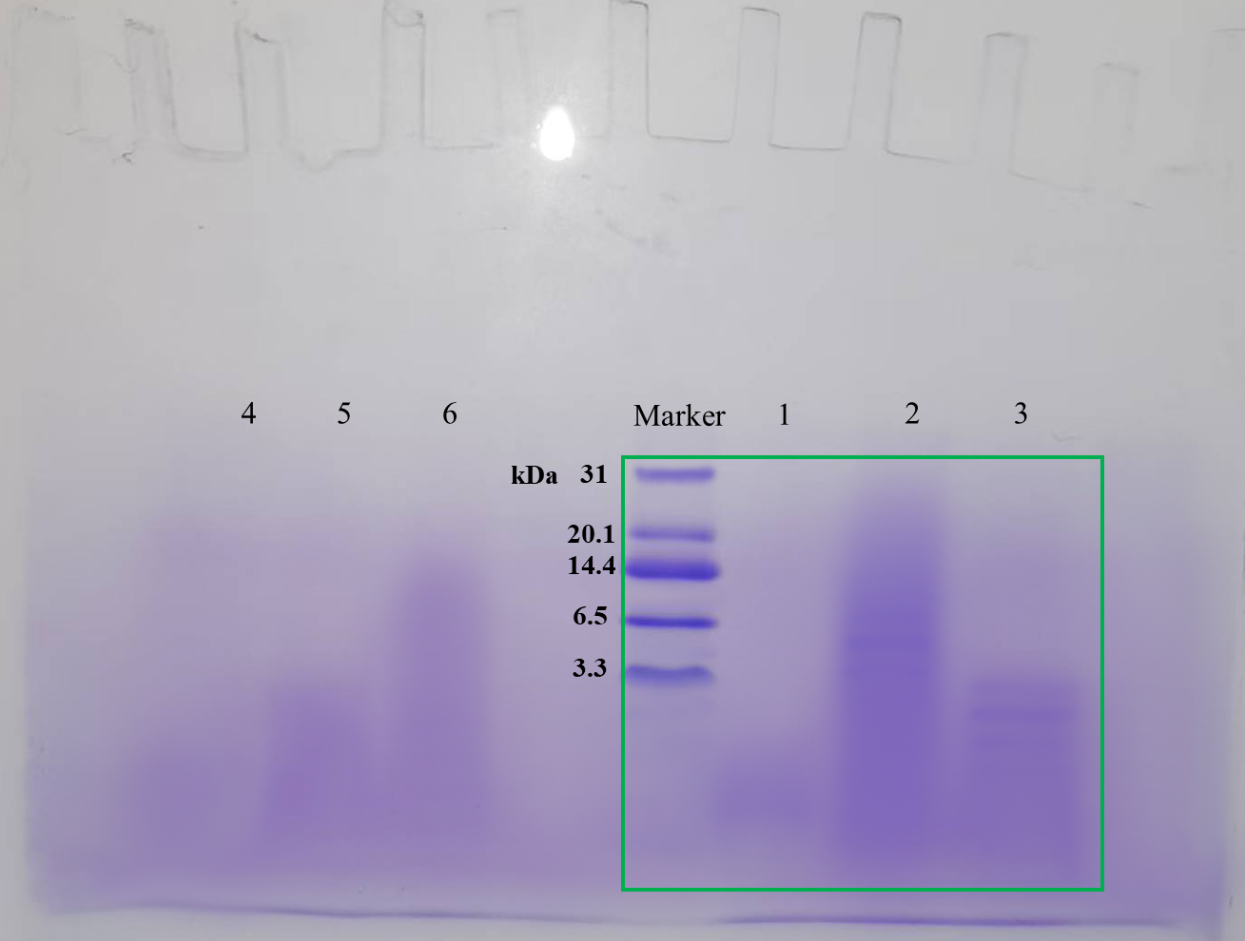

Fig.S4 Raw gel of Tricine-SDS-PAGE.
1: F3 at a concentration of 10 mg/mL; 2: crude extracts of douchi antioxidant peptides at a concentration of 10 mg/mL; 3: the fraction with a MW＜3 kDa at a concentration of 10 mg/mL; 4: F3 at a concentration of 5 mg/mL; 5: the fraction with a MW＜3 kDa at a concentration of 5 mg/mL; 6: crude extracts of douchi antioxidant peptides at a concentration of 5 mg/mL.

