Table 1 Results of orthogonal experiments
Sample | Considerations |  |  |  | Oil yield | Sensory score
Sample | A(Time/h) | B（Salt addition/%） | C（Spice additions/%） | D（baijiu additions/  %） | Oil yield | Sensory score
1 | 1（48） | 1（2%） | 1（0.1） | 1（2%） | 8.96 | 76
2 | 1 | 2（3%） | 2（0.2） | 2（3%） | 14.48 | 82
3 | 1 | 3（4%） | 3（0.3） | 3（4%） | 11.88 | 61
4 | 2（72） | 1 | 2 | 3 | 10.82 | 84
5 | 2 | 2 | 3 | 1 | 13.67 | 69
6 | 2 | 3 | 1 | 2 | 14.47 | 64
7 | 3（96） | 1 | 3 | 2 | 12.9 | 71
8 | 3 | 2 | 1 | 1 | 14.12 | 75
9 | 3 | 3 | 2 | 3 | 15.62 | 66
Oil yield (%) |  | K1 | 35.32 | 32.68 | 37.55 | 38.25
 |  | K2 | 38.96 | 42.27 | 40.92 | 41.85
 |  | K3 | 42.64 | 41.97 | 38.45 | 36.82
 |  | k1 | 11.77 | 10.89 | 12.52 | 12.75
 |  | k2 | 12.99 | 14.09 | 13.64 | 13.95
 |  | k3 | 14.21 | 13.99 | 12.82 | 12.27
 |  | R | 2.44 | 3.20 | 1.12 | 1.68
Order of priority |  | B>A>D>C
Optimum level |  | A₃B₂C₂D₂
Sensory score |  | K1 | 218 | 231 | 215 | 211
 |  | K2 | 216 | 226 | 231 | 216
 |  | K3 | 212 | 190 | 200 | 220
 |  | k1 | 72.77 | 77.03 | 71.60 | 70.20
 |  | k2 | 72.00 | 75.20 | 77.10 | 72.13
 |  | k3 | 70.73 | 63.27 | 66.80 | 73.17
 |  | R | 2.03 | 13.77 | 10.30 | 2.97
Order of priority |  | B>C>D>A
Optimum level |  | A₁B₁C₂D₃

Table 2 Validation experiments
Number | Time/h | Salt content/% | Spice content /mL | baijiu content /% | Sensory score
1 | 72 | 2 | 0.2 | 4 | 84±1.23
2 | 48 | 2 | 0.2 | 4 | 86±1.35
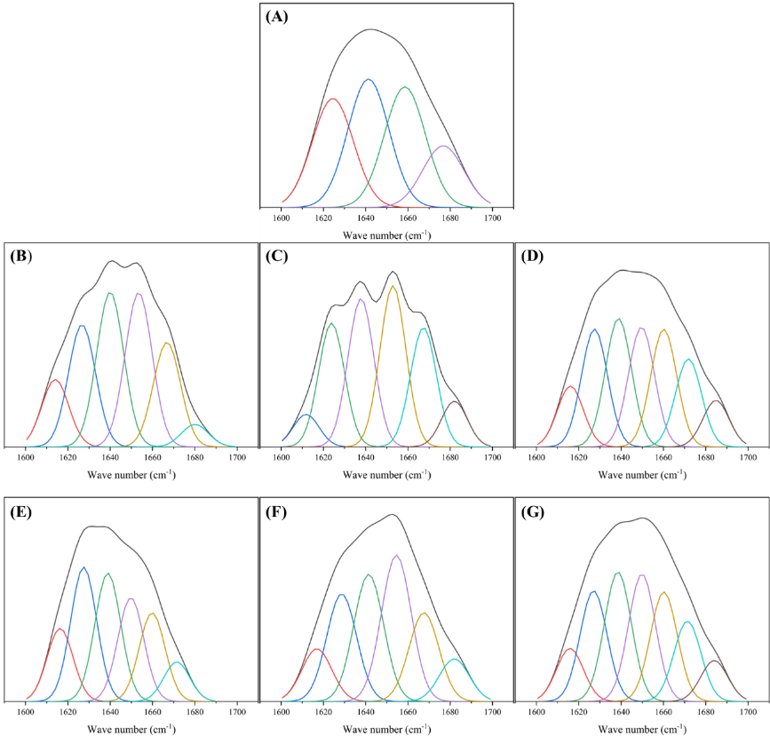
Attached Fig. 1 Fitted curves of FTIR under different protease treatment conditions. (A-G in the figure denote: K, S0, SP, N0, NP, J0, JP, respectively).
Note: K denotes the salted egg yolk powder in the blank control group. Samples without enzyme treatment but with pH adjustment were used as pH controls and labeled S0 (acidic), N0 (neutral), and J0 (alkaline). Samples with corresponding protease treatment at each pH condition were referred to as the enzymatic groups and designated SP (acidic protease), NP (neutral protease), and JP (alkaline protease)

