Supplementary Materials for

Proinflammatory Keratinocytes Drive a Novel Mouse Model of Autoimmunity with Systemic and Cutaneous Lupus Erythematosus
Authors: Jingru Tian^{1,2,3,4*†}, Liqing Shi^{1,2,3†}, Dingyao Zhang^{5,6}, Xu Yao^{1,4}, Jun Lu^{6,7,8,9,10}, Ming Zhao^{1,2,3*}, and Qianjin Lu^{1,2,3*}

* Correspondence should be addressed to:
Qianjin Lu, 12 Jiangwangmiao Street, Xuanwu, Nanjing, Jiangsu, China 210042.
Telephone: 025-85478999; Fax: 025-85414477;

Email: qianlu5860@pumcderm.cams.cn

Ming Zhao, 12 Jiangwangmiao Street, Xuanwu, Nanjing, Jiangsu, China 210042.
Telephone: 025-85478999; Fax: 025-85414477;
Email: zhaoming307@126.com

Jingru Tian, 12 Jiangwangmiao Street, Xuanwu, Nanjing, Jiangsu, China 210042.
Telephone: 025-85478999; Fax: 025-85414477;
Email: jingru.tian@pumcderm.cams.cn

The PDF file includes:
Figs. S1-6
Table. S1

Fig. S1.
Fig. S1. Keratinocyte-intrinsic PPARγ reduction drives the spontaneous development of an SLE-like phenotype in vivo.
(A) Schematic illustration of the SLE model in which the level of keratinocyte-intrinsic PPARγ was decreased systemically. Tamoxifen (TAM) (1 mg per dose) or vehicle was administered intraperitoneally from Day 1 to Day 5 to C57BL/6 (C57), Pparg^{fl/fl} (Ctrl), and Pparg^{fl/fl};Krt5^{creERT2/+} (KO) mice. The kidney, skin and spleen were harvested on Day 11. (B) Representative images of mice from a representative experiment and graph showing dermatitis clinical scores. Images were acquired on the same day. (C) Representative images of the histological examination of prothorax skin on Day 11. (D) Urine protein levels were quantified on the indicated days after TAM or vehicle injection. (n = 5-15 per group). (E) Representative images of glomerular IgG deposition in mice on Day 11. (F) The levels of anti-double-stranded DNA antibody (left panel) and antinuclear antibody (right panel) in the peripheral blood of mice on Day 11. Error bars represent SDs, and center values indicate means. Two-tailed unpaired Student’s t-tests were used. *p < 0.05; **p < 0.01; ***p < 0.001; ****p < 0.0001. Data are representative of two or more independent experiments.

Fig. S2.
Fig. S2. CLE-like phenotype in mice does not involve systemic manifestations
(A) Body weight measured on indicated days (n = 6-11 per group). (B) Urine protein levels quantified (left) and qualified (right) on indicated days (n = 5-6 per group). (C) Representative histological images of kidneys and glomeruli, with a graph showing glomerular diameter ratio on Day 17. (D) Representative images of glomerular IgG deposition on Day 17. (E) Levels of anti-double-stranded DNA (left) and antinuclear antibodies (right) in peripheral blood on Day 17. (F) Graph showing spleen index (spleen weight [mg] to body weight [g] ratio) (n=5-7). Error bars represent SDs, and center values indicate means. Comparisons between two groups were performed using a two-tailed unpaired Student's t-test, and multiple group comparisons were analyzed using one-way ANOVA. *p < 0.05; **p < 0.01; ***p < 0.001; ****p < 0.0001; ns: not significant. Data are representative of two or more independent experiments.

Fig. S3.

Fig. S3. Cyclophosphamide treatment effectively alleviates the SLE-like phenotype
(A) Schematic illustration of the SLE model treated with CTX via intraperitoneal injection. CTX (50mg/kg) or vehicle was administered intraperitoneally on Days 6 and 13, while 4-OHT was applied topically to both ears of Pparg^{fl/fl};Krt5^{creERT2/+} (KO) mice from Days 1 to 5. (B) Representative images of treated mice on Day 17. (C) Quantification of urine protein levels on indicated days (n = 3 or 8 per group). (D) Levels of anti-double-stranded DNA antibodies (left) and antinuclear antibodies (right) in peripheral blood (n = 3 or 8 per group). (E) Representative images of glomerular IgG deposition. (F) Representative histological images of skin, kidneys, and glomeruli. Error bars represent SDs, and center values indicate means. Two-tailed unpaired Student’s t-tests were used. *p < 0.05; **p < 0.01; ***p < 0.001; ****p < 0.0001. Data are representative of two or more independent experiments.

Fig. S4.
Fig. S4. Topical steroid treatment effectively alleviates the CLE-like phenotype
(A) Schematic illustration of the CLE model treated with GC topically. GC was applied topically to single ear of Pparg^{fl/fl};Krt5^{creERT2/+} (KO) mice every 2 days from Day 10, while 4-OHT was applied topically from Days 1 to 5. (B) Representative images of treated mice on Day 14 and Day 22. (C) Graph of dermatitis clinical scores on Days 14 and 22. (D) Graph of skin biopsy scores on Day 22. (E) Histological analysis of ear skin. (F) Images of IgG deposition in the skin basement membrane zone. (G) Body weight measured on indicated days (n = 6-11 per group). (H) Urine protein levels quantified (left) and qualified (right) on indicated days (n = 7 per group). (I) Levels of anti-double-stranded DNA antibodies (left) and antinuclear antibodies (right) in peripheral blood on Day 22 (n = 7 per group). Error bars represent SDs, and center values indicate means. Two-tailed unpaired Student’s t-tests were used. *p < 0.05; **p < 0.01; ***p < 0.001; ****p < 0.0001; ns: not significant. Data are representative of two or more independent experiments.

Fig. S5.
Fig. S5. IFNβ protein level in skin and kidney tissues of mice.
Representative western blot images showing IFNβ protein expression in skin lesions and kidney tissues and quantitative analysis of IFNβ protein levels normalized to β-actin (n = 3). Error bars represent SDs, and center values indicate means. Multiple group comparisons were analyzed using one-way ANOVA. *p < 0.05; **p < 0.01; ***p < 0.001; ns: not significant. Data are representative of two or more independent experiments.

Fig. S6.
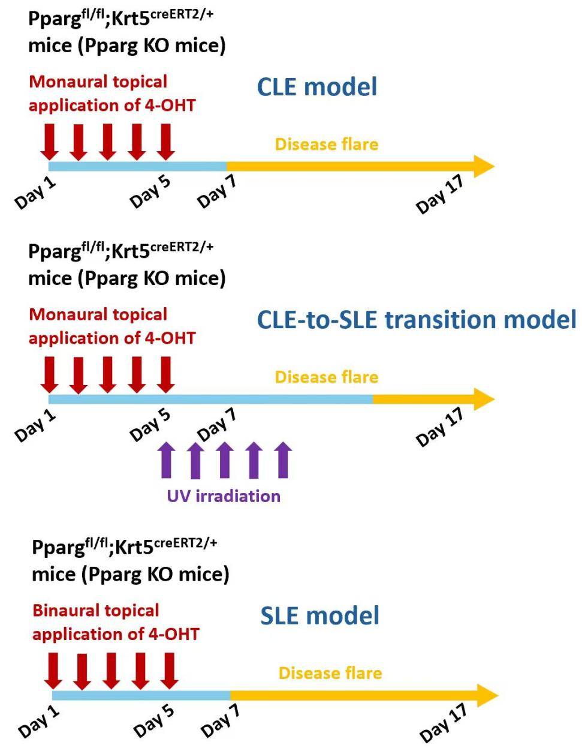
Figure S6. Schematic flowchart of the experimental design for CLE, SLE, and induced SLE models.
CLE model (top): Pparg^{fl/fl};Krt5^{creERT2/+} mice were treated with topical 4-OHT on one ear once daily for 5 consecutive days. Disease onset occurred approximately on day 7 after the initiation of 4-OHT application, and the mice remained in an active disease phase from day 7 to day 17. CLE-to-SLE transition model (middle): Pparg^{fl/fl};Krt5^{creERT2/+} mice were treated with topical 4-OHT on one ear once daily for 5 consecutive days, followed by daily UV irradiation for five days beginning on day 5 after 4-OHT application. From days 14 to 17, the mice developed systemic autoimmune phenotypes resembling SLE. SLE model (bottom): Pparg^{fl/fl};Krt5^{creERT2/+} mice were treated with topical 4-OHT on both ears once daily for 5 consecutive days. Disease onset occurred approximately on day 7 after the initiation of 4-OHT application, and the mice remained in an active disease phase from day 7 to day 17.

Table S1. Clinical characteristics of patients and healthy volunteers.
No. | Gender | SLEDAI | CLASI | EASI | PASI | Age | Skin lesion location | Course of disease (years)
SLE1 | Male | 6 | N/A | N/A | N/A | 58 | Face | 10
SLE2 | Female | 7 | N/A | N/A | N/A | 49 | Upper limbs | 25
SLE3 | Female | 5 | N/A | N/A | N/A | 36 | Face | 3
SLE4 | Female | 10 | N/A | N/A | N/A | 41 | Scalp | 20
SLE5 | Female | 6 | N/A | N/A | N/A | 54 | Upper limbs | 22
SLE6 | Female | 5 | N/A | N/A | N/A | 32 | Upper limbs | 15
CLE1 | Female | N/A | 8 | N/A | N/A | 34 | Face | 5
CLE2 | Female | N/A | 6 | N/A | N/A | 41 | Face | 15
CLE3 | Female | N/A | 6 | N/A | N/A | 29 | Upper limbs | 9
CLE4 | Female | N/A | 5 | N/A | N/A | 33 | Face | 4
CLE5 | Female | N/A | 11 | N/A | N/A | 39 | Scalp | 8
AD1 | Male | N/A | N/A | 10 | N/A | 12 | Back | 2
AD2 | Male | N/A | N/A | 8 | N/A | 20 | Upper limbs | 6
AD3 | Female | N/A | N/A | 6 | N/A | 35 | Back | 5
AD4 | Female | N/A | N/A | 25 | N/A | 14 | Back | 1
AD5 | Female | N/A | N/A | 17 | N/A | 25 | Abdomen | 3
AD6 | Female | N/A | N/A | 7 | N/A | 41 | Lower limbs | 4
PSO1 | Male | N/A | N/A | N/A | 22 | 45 | Upper limbs | 25
PSO2 | Male | N/A | N/A | N/A | 16 | 34 | Upper limbs | 18
PSO3 | Male | N/A | N/A | N/A | 10 | 28 | Lower limbs | 9
PSO4 | Female | N/A | N/A | N/A | 32 | 24 | Abdomen | 2
PSO5 | Female | N/A | N/A | N/A | 9 | 16 | Abdomen | 4
HC1 | Female | N/A | N/A | N/A | N/A | 34 | Face | N/A
HC2 | Male | N/A | N/A | N/A | N/A | 33 | Face | N/A
HC3 | Male | N/A | N/A | N/A | N/A | 24 | Face | N/A
HC4 | Female | N/A | N/A | N/A | N/A | 35 | Upper limbs | N/A
HC5 | Female | N/A | N/A | N/A | N/A | 31 | Scalp | N/A
HC6 | Female | N/A | N/A | N/A | N/A | 43 | Face | N/A
SLEDAI: Systemic Lupus Erythematosus Disease Activity Index; CLASI: Cutaneous Lupus Erythematosus Disease Area and Severity Index; EASI: Eczema Area and Severity Index; PASI: Psoriasis Area and Severity Index; N/A: not applicable.

