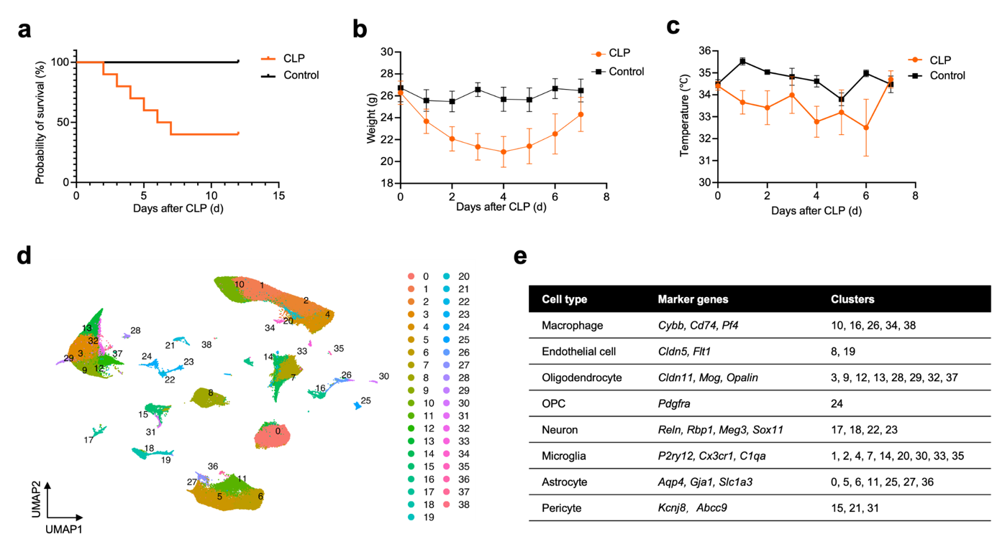
Fig. S1 Validation of acute CLP-induced sepsis and cell cluster annotation in hippocampal scRNA-seq data. a Kaplan-Meier survival curve showing survival rates in sham-operated controls and CLP-treated mice over 14 days post-surgery. b Body weight changes in sham-operated controls and CLP-treated mice measured daily for 7 days post-surgery. c Rectal temperature measurements in sham-operated controls and CLP-treated mice recorded daily for 7 days post-surgery. d UMAP visualization of all hippocampal cells from sham and CLP mice at 6 months post-infection, colored by cell cluster number. e Table summarizing the marker genes and corresponding cluster identities for each major hippocampal cell type.
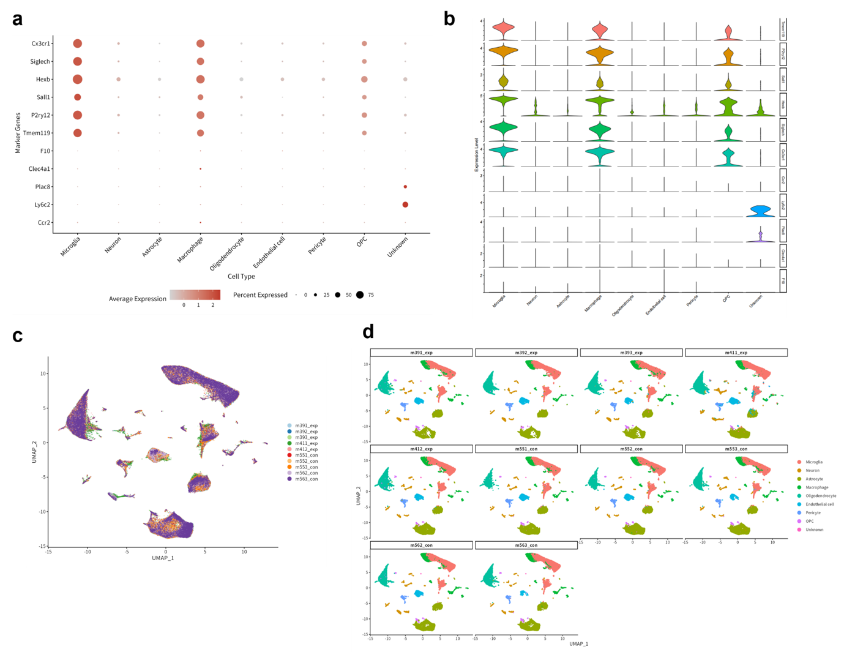
Fig. S2 Single-cell RNA sequencing quality control, marker gene expression, and sample-level distribution. a Dot plot showing the expression of canonical marker genes used for identifying major cell types across all integrated scRNA-seq data. Marker genes include microglia-specific markers (Cx3cr1, Siglech, Hexb, Sall1, P2ry12, Tmem119) and macrophage-specific markers (F10, Clec4a1, Plac8, Ly6c2, Ccr2), as well as markers for other cell types (neurons, astrocytes, oligodendrocytes, endothelial cells, pericytes, OPCs). Dot size represents the percentage of cells expressing the gene; color intensity indicates the average normalized expression level. b Violin plots showing the expression level distributions of key marker genes across all identified cell clusters, further validating the specificity of cell type annotations. c UMAP visualization of the integrated single-cell dataset, colored by individual biological replicate (samples m391_exp to m563_con). d Split UMAP plots showing the distribution of annotated cell types within each individual biological sample (m391_exp, m392_exp, m393_exp, m411_exp, m412_exp [CLP group, n = 5]; m551_con, m552_con, m553_con, m562_con, m563_con [control group, n = 5]). Data are presented as scRNA-seq visualizations derived from n = 5 CLP mice and n = 5 control mice (total n = 10 biological samples).

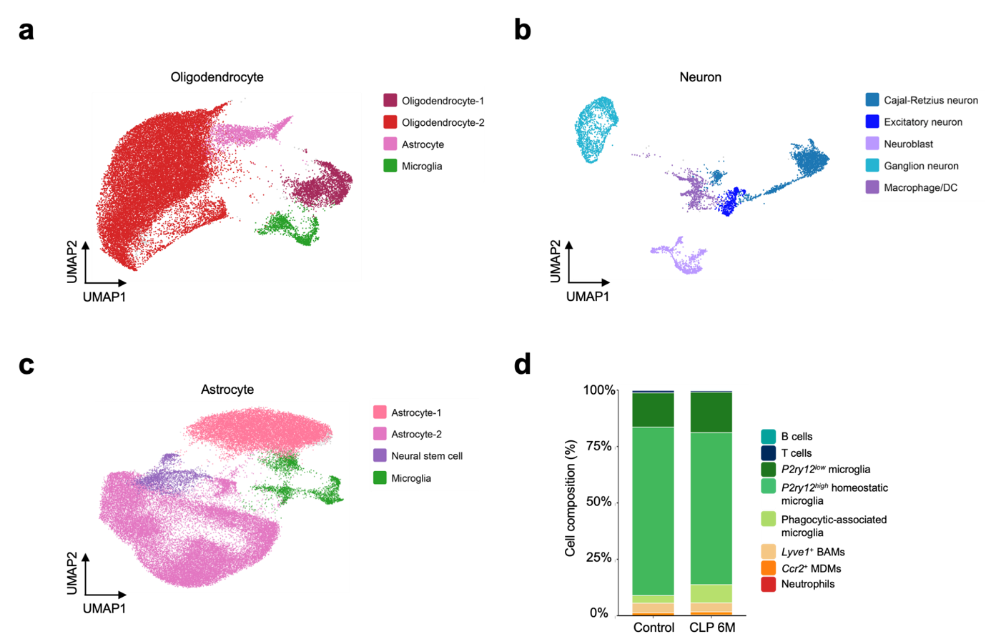
Fig. S3 Subclustering of major hippocampal cell populations and changes in immune subpopulation composition after CLP-induced sepsis. a UMAP visualization highlighting the oligodendrocyte population. b UMAP visualization highlighting the neuronal population. c UMAP visualization highlighting the astrocyte population. d Stacked bar chart comparing the proportional composition of microglial and macrophage subpopulations between control and 6 months post-CLP groups within the hippocampal immune compartment.

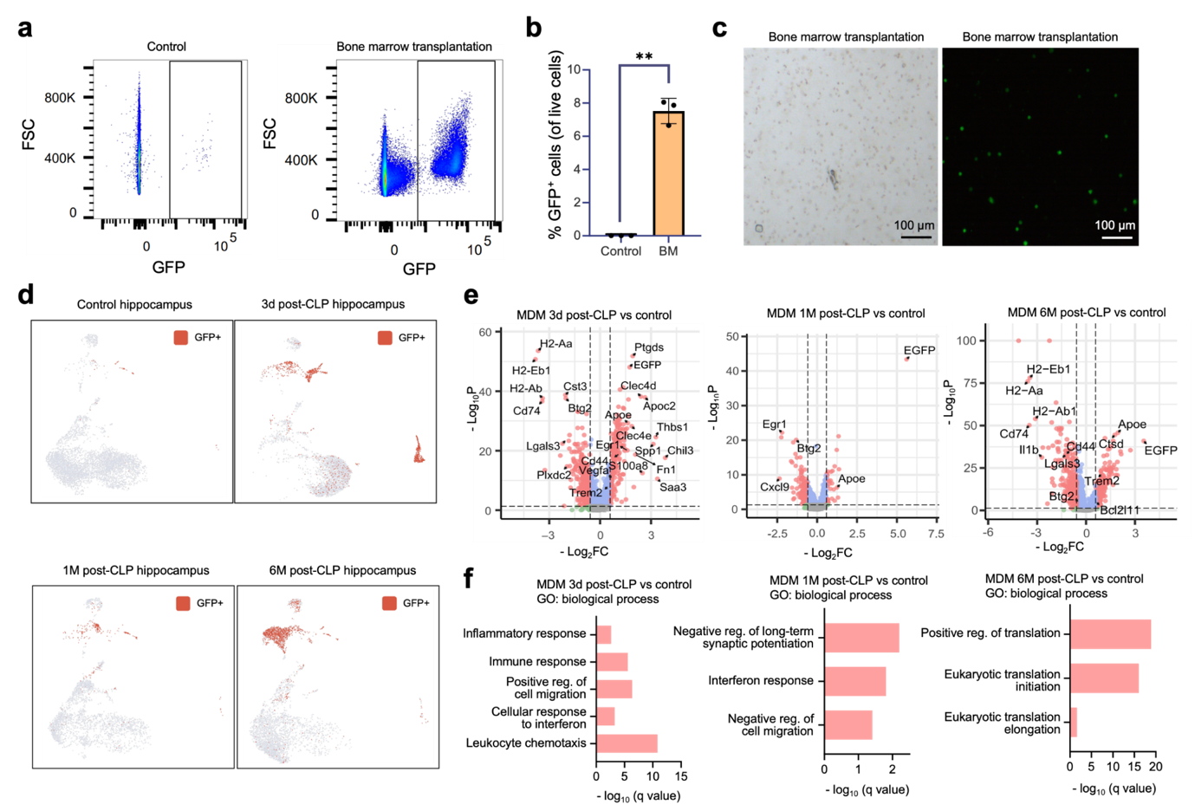
Fig. S4 Validation of bone marrow chimerism and temporal transcriptional profiling of GFP⁺ infiltrating macrophages after CLP. a Representative flow cytometry plots showing GFP⁺ cell populations in peripheral blood from control (non-transplanted) mice and bone marrow-transplanted mice. b Quantification of GFP⁺ cells (as a percentage of total live cells) in peripheral blood from control and bone marrow-transplanted (BM) mice. c Representative blood smear from bone marrow-transplanted mice showing the bright-field image (left panel) and the presence of GFP⁺ cells (green, right panel). Scale bar: 100 μm. d Representative UMAP plots of reclustered microglial and macrophage populations showing the distribution of GFP⁺ cells in the control hippocampus and at 3 days, 1 month, and 6 months after CLP. e Volcano plots showing DEGs in GFP⁺ MDMs at 3 days, 1 month, and 6 months after CLP relative to controls. Red dots indicate upregulated genes, blue dots indicate downregulated genes, and gray dots indicate genes below the indicated fold-change threshold. Selected genes are labeled. f GO enrichment analysis of biological processes associated with differentially expressed genes in GFP⁺ MDMs at each time point. Data are presented as mean ± SEM (n = 3 mice per group). Experiments were independently repeated 3 times with similar results. Statistical comparisons were performed using one-way ANOVA or unpaired Student’s t-test. *p < 0.05, **p < 0.01, ***p < 0.001; ns, not significant.

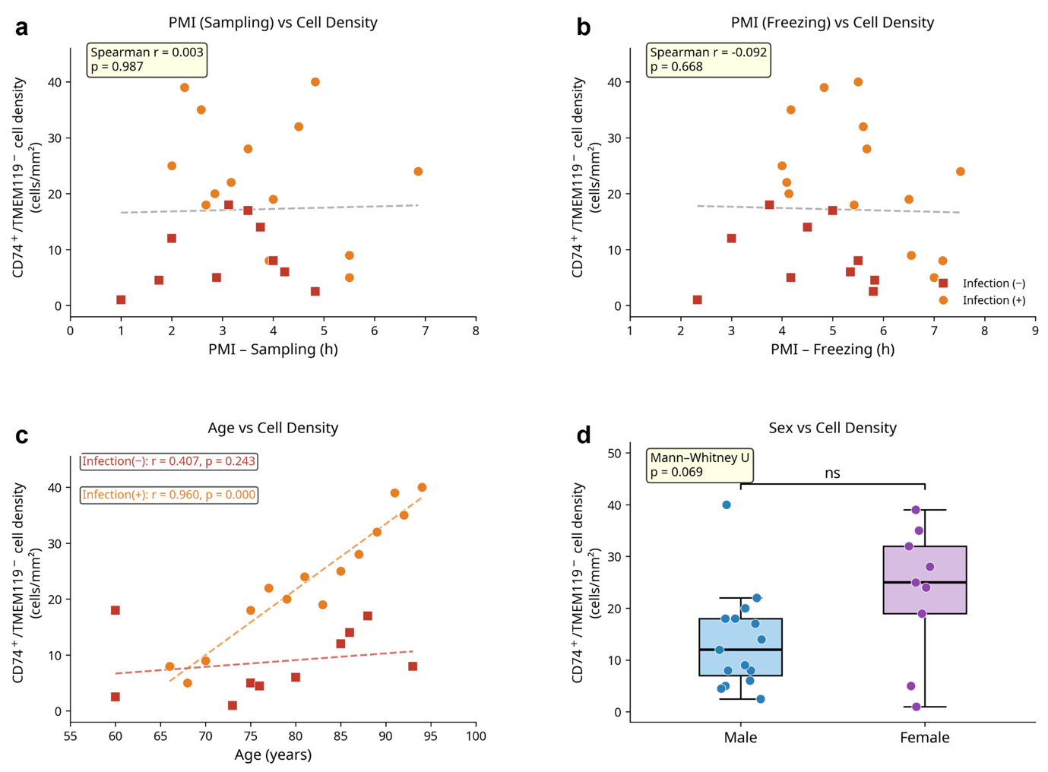
Fig. S5 Correlation analysis of postmortem interval (PMI), age, and sex with infiltrating macrophage density in human hippocampal tissues. a Scatter plot showing the correlation between sampling PMI (hours from death to tissue sampling) and CD74⁺/TMEM119⁻ cell density (cells/mm²) across all human subjects, stratified by infection history (Infection [−], red squares; Infection [+], orange circles). Statistical analysis was performed using Spearman’s rank correlation (r = 0.003, p = 0.987), indicating no significant association between sampling PMI and infiltrating macrophage density. The dashed line represents the overall linear regression trend. b Scatter plot showing the correlation between freezing PMI (hours from death to tissue freezing) and CD74⁺/TMEM119⁻ cell density (cells/mm²) across all human subjects, stratified by infection history. Statistical analysis was performed using Spearman’s rank correlation (r = −0.092, p = 0.668), indicating no significant association between freezing PMI and infiltrating macrophage density. The dashed line represents the overall linear regression trend. c Scatter plot showing the correlation between donor age (years) and CD74⁺/TMEM119⁻ cell density (cells/mm²), stratified by infection history. A significant positive correlation was observed in the Infection (+) group (orange dashed regression line; Pearson r = 0.960, p < 0.001), but not in the Infection (−) group (red dashed regression line; Pearson r = 0.407, p = 0.243). d Box plot comparing CD74⁺/TMEM119⁻ cell density between male (blue) and female (purple) donors across all subjects. The central line indicates the median; box edges represent the interquartile range (IQR); whiskers extend to 1.5 × IQR; individual data points are overlaid. Statistical analysis was performed using the Mann-Whitney U test (p = 0.069; ns, not significant), indicating no significant sex difference in infiltrating macrophage density. Data are presented as individual data points with linear regression lines (a–c) or as box plots with individual data points overlaid (d) (n = 24 subjects).

