Table S1 - Associations between dairy intake (total and subtypes) and self-reported sleep duration (N=23,480) ^{ǂ}
 | Bivariate Model
 | Tertiles of total dairy intake*
 | First | Second | Third
 | OR (95% CI) | OR (95% CI) | OR (95% CI) | P-trend
Total dairy
Short <7h | 1 | 0.87 (0.79, 0.96) | 0.83 (0.75, 0.93) | 0.001
Reference (7-9h) | Ref. | Ref. | Ref. | Ref.
Long ≥9h | 1 | 0.90 (0.79, 1.03) | 0.84 (0.73, 0.96) | 0.010
Milk
Short <7h | 1 | 0.88 (0.79, 0.99) | 0.81 (0.73, 0.90) | <0.001
Reference (7-9h) | Ref. | Ref. | Ref. | Ref.
Long ≥9h | 1 | 1.09 (0.93, 1.27) | 0.91 (0.77, 1.07) | 0.232
Yogurt
Short <7h | 1 | 0.72 (0.62, 0.83) | 0.69 (0.59, 0.82) | <0.0001
Reference (7-9h) | Ref. | Ref. | Ref. | Ref.
Long ≥9h | 1 | 0.9 (0.72, 1.13) | 0.83 (0.64, 1.08) | 0.126
Cheese
Short <7h | 1 | 1 (0.9, 1.12) | 1.02 (0.91, 1.14) | 0.796
Reference (7-9h) | Ref. | Ref. | Ref. | Ref.
Long ≥9h | 1 | 0.99 (0.85, 1.15) | 0.92 (0.78, 1.08) | 0.278
Fermented
Short <7h | 1 | 0.96 (0.87, 1.07) | 0.95 (0.85, 1.07) | 0.393
Reference (7-9h) | Ref. | Ref. | Ref. | Ref.
Long ≥9h | 1 | 1.03 (0.88, 1.19) | 0.89 (0.76, 1.05) | 0.177
High fat
Short <7h | 1 | 0.97 (0.86, 1.09) | 1.03 (0.87, 1.22) | 0.625
Reference (7-9h) | Ref. | Ref. | Ref. | Ref.
Long ≥9h | 1 | 1.03 (0.92, 1.15) | 1 (0.86, 1.15) | 0.959
Low fat
Short <7h | 1 | 0.72 (0.62, 0.84) | 0.65 (0.57, 0.73) | <0.001
Reference (7-9h) | Ref. | Ref. | Ref. | Ref.
Long ≥9h | 1 | 0.78 (0.65, 0.93) | 0.76 (0.64, 0.9) | <0.001
OR = odds ratio, CI = confidence interval
^{ǂ}Associations of dairy products on sleep duration are estimated using survey-weighted polytomous logistic regression
*Sex-specific cut-offs for total dairy were 1.15 and 2.22 cup-eq/d in males and 0.95 and 1.77 cup-eq/d in females. Cut-offs for milk were 0.26 and 0.96 cup-eq/d in males and 0.23 and 0.79 cup-eq/d in females. Cut-offs for cheese were 0.39 and 1.12 cup-eq/d in males and 0.29 and 0.80 cup-eq/d in females. Cut-offs for yogurt were 0 and 0.32 cup-eq/d in males and 0 and 0.30 cup-eq/d in females. Cut-offs for fermented dairy were 0.45 and 1.21 cup-eq/d for males and 0.37 and 0.89 cup-eq/d in females. Cut-offs for high-fat dairy were 0.18 and 0.89 cup-eq/d in males and 0.13 and 0.67 cup-eq/d in females. Cut-offs for low-fat dairy were 0 and 0.69 cup-eq/d in males and 0 and 0.50 cup-eq/d in females.
Table S2 - Associations between dairy intake (total and subtypes) and self-reported trouble sleeping (N=23,480)
 | Bivariate Model
 | Tertiles of total dairy intake*
 | First | Second | Third
 | OR (95% CI) | OR (95% CI) | OR (95% CI) | P-trend
Total dairy
No | Ref. | Ref. | Ref. | Ref.
Yes | 1 | 0.9 (0.8, 1.01) | 0.91 (0.8, 1.04) | 0.171
Milk
No | Ref. | Ref. | Ref. | Ref.
Yes | 1 | 1.09 (0.96, 1.24) | 0.99 (0.88, 1.12) | 0.850
Yogurt
No | Ref. | Ref. | Ref. | Ref.
Yes | 1 | 0.99 (0.85, 1.15) | 1.04 (0.89, 1.21) | 0.720
Cheese
No | Ref. | Ref. | Ref. | Ref.
Yes | 1 | 0.98 (0.88, 1.09) | 0.93 (0.81, 1.06) | 0.268
Fermented
No | Ref. | Ref. | Ref. | Ref.
Yes | 1 | 0.98 (0.88, 1.08) | 0.93 (0.81, 1.06) | 0.261
High fat
No | Ref. | Ref. | Ref. | Ref.
Yes | 1 | 0.9 (0.81, 0.99) | 0.89 (0.79, 1.01) | 0.059
Low fat
No | Ref. | Ref. | Ref. | Ref.
Yes | 1 | 1.1 (0.95, 1.26) | 1.01 (0.88, 1.15) | 0.651

OR = odds ratio, CI = confidence interval
*Sex-specific cut-offs for total dairy were 1.15 and 2.22 cup-eq/d in males and 0.95 and 1.77 cup-eq/d in females. Cut-offs for milk were 0.26 and 0.96 cup-eq/d in males and 0.23 and 0.79 cup-eq/d in females. Cut-offs for cheese were 0.39 and 1.12 cup-eq/d in males and 0.29 and 0.80 cup-eq/d in females. Cut-offs for yogurt were 0 and 0.32 cup-eq/d in males and 0 and 0.30 cup-eq/d in females. Cut-offs for fermented dairy were 0.45 and 1.21 cup-eq/d for males and 0.37 and 0.89 cup-eq/d in females. Cut-offs for high-fat dairy were 0.18 and 0.89 cup-eq/d in males and 0.13 and 0.67 cup-eq/d in females. Cut-offs for low-fat dairy were 0 and 0.69 cup-eq/d in males and 0 and 0.50 cup-eq/d in females.

Table S3 - Associations between dairy intake and objective sleep measures (N=4,972) ^{ǂ}
 | Bivariate Model
 | Tertiles of total dairy intake*
 | First | Second | Third
 | ß (95% CI) | ß (95% CI) | ß (95% CI) | P-trend
Total Sleep Time
Total dairy | 1 | 0.06 (-0.04, 0.16) | 0.03 (-0.08, 0.14) | 0.568
Milk | 1 | 0.01 (-0.08, 0.1) | -0.04 (-0.13, 0.05) | 0.372
Yogurt | 1 | 0.1 (-0.07, 0.26) | 0.15 (0.02, 0.27) | 0.010
Cheese | 1 | 0.16 (0.05, 0.26) | 0.21 (0.1, 0.32) | 0.001
Fermented | 1 | 0.14 (0.04, 0.25) | 0.2 (0.1, 0.3) | 0.001
High fat | 1 | 0.05 (-0.09, 0.19) | 0.03 (-0.11, 0.17) | 0.685
Low fat | 1 | 0.15 (0.02, 0.28) | 0.03 (-0.08, 0.14) | 0.198
Midpoint
Total dairy | 1 | -0.2 (-0.34, -0.05) | 0.01 (-0.14, 0.16) | 0.852
Milk | 1 | -0.11 (-0.29, 0.08) | -0.19 (-0.35, -0.03) | 0.030
Yogurt | 1 | -0.04 (-0.22, 0.15) | -0.21 (-0.36, -0.06) | 0.023
Cheese | 1 | -0.02 (-0.18, 0.14) | 0.26 (0.08, 0.43) | 0.007
Fermented | 1 | -0.07 (-0.19, 0.06) | 0.15 (-0.01, 0.32) | 0.072
High fat | 1 | 0.16 (0, 0.31) | 0.07 (-0.11, 0.25) | 0.492
Low fat | 1 | -0.17 (-0.36, 0.01) | -0.25 (-0.44, -0.06) | 0.009
WASO
Total dairy | 1 | -0.01 (-0.06, 0.05) | -0.07 (-0.1, -0.03) | 0.001
Milk | 1 | -0.02 (-0.07, 0.02) | -0.03 (-0.08, 0.02) | 0.195
Yogurt | 1 | -0.07 (-0.15, 0.01) | -0.09 (-0.14, -0.05) | <0.001
Cheese | 1 | -0.04 (-0.09, 0.01) | -0.03 (-0.09, 0.02) | 0.251
Fermented | 1 | -0.04 (-0.09, 0.01) | -0.05 (-0.1, 0) | 0.060
High fat | 1 | -0.03 (-0.08, 0.03) | -0.03 (-0.09, 0.03) | 0.285
Low fat | 1 | -0.03 (-0.1, 0.03) | -0.07 (-0.13, -0.01) | 0.031
Sleep Efficiency
Total dairy | 1 | 0.2 (-0.42, 0.82) | 0.78 (0.33, 1.24) | 0.002
Milk | 1 | 0.28 (-0.27, 0.83) | 0.19 (-0.38, 0.77) | 0.523
Yogurt | 1 | 0.97 (-0.03, 1.98) | 1.24 (0.69, 1.78) | <0.001
Cheese | 1 | 0.82 (0.16, 1.47) | 0.85 (0.22, 1.49) | 0.013
Fermented | 1 | 0.7 (0.01, 1.4) | 0.98 (0.36, 1.6) | 0.004
High fat | 1 | 0.42 (-0.18, 1.02) | 0.49 (-0.39, 1.18) | 0.315
Low fat | 1 | 0.69 (-0.09, 1.47) | 0.83 (0.02, 1.65) | 0.029
ß = beta, CI = confidence interval, SD = standard deviation, WASO = wake after sleep onset
^{ǂ}Associations are estimated using survey-weighted linear regression
*Sex-specific cut-offs for total dairy were 1.22 and 2.30 cup-eq/d in males and 0.99 and 1.79 cup-eq/d in females. Cut-offs for milk were 0.25 and 0.95 cup-eq/d in males and 0.24 and 0.73 cup-eq/d in females. Cut-offs for cheese were 0.45 and 1.19 cup-eq/d in males and 0.32 and 0.85 cup-eq/d in females. Cut-offs for yogurt were 0 and 0.32 cup-eq/d in males and 0 and 0.30 cup-eq/d in females. Cut-offs for fermented dairy were 0.51 and 1.30 cup-eq/d for males and 0.39 and 0.98 cup-eq/d in females. Cut-offs for high-fat dairy were 0.24 and 0.94 cup-eq/d in males and 0.12 and 0.66 cup-eq/d in females. Cut-offs for low-fat dairy were 0 and 0.69 cup-eq/d in males and 0 and 0.50 cup-eq/d in females.

Table S4 - Associations between dairy intake and objective sleep regularity measures (N=4,972)^{ǂ}
 | Bivariate Model
 | Tertiles of total dairy intake*
 | First | Second | Third
 | ß (95% CI) | ß (95% CI) | ß (95% CI) | P-trend
Total Sleep Time SD
Total dairy | 1 | 0.003 (-0.05, 0.04) | -0.02 (-0.11, 0.07) | 0.674
Milk | 1 | -0.08 (-0.14, -0.01) | -0.03 (-0.1, 0.04) | 0.461
Yogurt | 1 | -0.15 (-0.22, -0.08) | -0.15 (-0.26, -0.03) | 0.006
Cheese | 1 | -0.03 (-0.1, 0.04) | -0.01 (-0.1, 0.08) | 0.797
Fermented | 1 | -0.03 (-0.1, 0.04) | -0.03 (-0.11, 0.05) | 0.458
High fat | 1 | -0.02 (-0.08, 0.04) | 0.05 (-0.04, 0.13) | 0.290
Low fat | 1 | -0.15 (-0.21, -0.08) | -0.13 (-0.23, -0.04) | <0.001
Midpoint SD
Total dairy | 1 | -0.04 (-0.13, 0.05) | -0.05 (-0.14, 0.05) | 0.346
Milk | 1 | -0.08 (-0.15, 0) | 0.004 (-0.08, 0.07) | 0.925
Yogurt | 1 | -0.11 (-0.27, 0.05) | -0.25 (-0.36, -0.14) | <0.001
Cheese | 1 | 0.01 (-0.09, 0.1) | 0.007 (-0.09, 0.1) | 0.937
Fermented | 1 | 0.06 (-0.03, 0.14) | -0.03 (-0.11, 0.06) | 0.553
High fat | 1 | -0.07 (-0.18, 0.05) | 0.03 (-0.08, 0.14) | 0.576
Low fat | 1 | -0.14 (-0.24, -0.04) | -0.23 (-0.33, -0.12) | <0.001
Sleep Regularity Index
Total dairy | 1 | 1.93 (0.66, 3.2) | 1.77 (0.62, 2.91) | 0.005
Milk | 1 | 1.1 (-0.43, 2.63) | 1.32 (-0.36, 3.01) | 0.134
Yogurt | 1 | 3.32 (1.53, 5.11) | 4.35 (2.48, 6.22) | <0.001
Cheese | 1 | 0.58 (-0.77, 1.92) | 0.8 (-0.87, 2.46) | 0.356
Fermented | 1 | 0.37 (-1.27, 2) | 1.44 (-0.18, 3.06) | 0.091
High fat | 1 | 0.57 (-1.02, 2.16) | 0.18 (-1.27, 1.63) | 0.818
Low fat | 1 | 3.35 (1.63, 5.07) | 3.85 (2.07, 5.62) | <0.001
ß = beta, CI = confidence interval, SD = standard deviation, WASO = wake after sleep onset
^{ǂ}Associations are estimated using survey-weighted linear regression
*Sex-specific cut-offs for total dairy were 1.22 and 2.30 cup-eq/d in males and 0.99 and 1.79 cup-eq/d in females. Cut-offs for milk were 0.25 and 0.95 cup-eq/d in males and 0.24 and 0.73 cup-eq/d in females. Cut-offs for cheese were 0.45 and 1.19 cup-eq/d in males and 0.32 and 0.85 cup-eq/d in females. Cut-offs for yogurt were 0 and 0.32 cup-eq/d in males and 0 and 0.30 cup-eq/d in females. Cut-offs for fermented dairy were 0.51 and 1.30 cup-eq/d for males and 0.39 and 0.98 cup-eq/d in females. Cut-offs for high-fat dairy were 0.24 and 0.94 cup-eq/d in males and 0.12 and 0.66 cup-eq/d in females. Cut-offs for low-fat dairy were 0 and 0.69 cup-eq/d in males and 0 and 0.50 cup-eq/d in females.

Table S5 - Associations between dairy intake (total and subtypes) and multidimensional sleep score (N=4,972)
 | Bivariate Model
 | Tertiles of total dairy intake*
 | First | Second | Third
 | OR (95% CI) | OR (95% CI) | OR (95% CI) | P-trend
Total dairy
Adequate sleep | Ref. | Ref. | Ref. | Ref.
Poor sleep | 1 | 0.74 (0.58, 0.95) | 0.87 (0.65, 1.17) | 0.338
Milk
Adequate sleep | Ref. | Ref. | Ref. | Ref.
Poor sleep | 1 | 1 (0.80, 1.25) | 0.94 (0.75, 1.19) | 0.607
Yogurt
Adequate sleep | Ref. | Ref. | Ref. | Ref.
Poor sleep | 1 | 0.72 (0.54, 0.97) | 0.51 (0.37, 0.71) | <0.0001
Cheese
Adequate sleep | Ref. | Ref. | Ref. | Ref.
Poor sleep | 1 | 0.73 (0.57, 0.94) | 0.85 (0.64, 1.12) | 0.235
Fermented
Adequate sleep | Ref. | Ref. | Ref. | Ref.
Poor sleep | 1 | 0.73 (0.55, 0.96) | 0.78 (0.6, 1.00) | 0.051
High fat
Adequate sleep | Ref. | Ref. | Ref. | Ref.
Poor sleep | 1 | 0.76 (0.62, 0.94) | 0.94 (0.72, 1.23) | 0.654
Low fat
Adequate sleep | Ref. | Ref. | Ref. | Ref.
Poor sleep | 1 | 0.57 (0.43, 0.76) | 0.65 (0.51, 0.83) | <0.0001
OR = odds ratio, CI = confidence interval
*Sex-specific cut-offs for total dairy were 1.22 and 2.30 cup-eq/d in males and 0.99 and 1.79 cup-eq/d in females. Cut-offs for milk were 0.25 and 0.95 cup-eq/d in males and 0.24 and 0.73 cup-eq/d in females. Cut-offs for cheese were 0.45 and 1.19 cup-eq/d in males and 0.32 and 0.85 cup-eq/d in females. Cut-offs for yogurt were 0 and 0.32 cup-eq/d in males and 0 and 0.30 cup-eq/d in females. Cut-offs for fermented dairy were 0.51 and 1.30 cup-eq/d for males and 0.39 and 0.98 cup-eq/d in females. Cut-offs for high-fat dairy were 0.24 and 0.94 cup-eq/d in males and 0.12 and 0.66 cup-eq/d in females. Cut-offs for low-fat dairy were 0 and 0.69 cup-eq/d in males and 0 and 0.50 cup-eq/d in females.

Table S6 - Associations between energy-adjusted dairy intake (total and subtypes) and self-reported sleep duration (N=23,480)^{ǂ}
 | Multivariate Modelª
 | OR (95% CI) | P
Total dairy
Short <7h | 0.98 (0.93, 1.03) | 0.461
Reference (7-9h) | Ref. | Ref.
Long ≥9h | 0.96 (0.90, 1.02) | 0.190
Milk
Short <7h | 0.96 (0.90, 1.03) | 0.238
Reference (7-9h) | Ref. | Ref.
Long ≥9h | 0.96 (0.88, 1.06) | 0.423
Yogurt
Short <7h | 0.94 (0.66, 1.34) | 0.740
Reference (7-9h) | Ref. | Ref.
Long ≥9h | 0.85 (0.50, 1.42) | 0.528
Cheese
Short <7h | 1 (0.94, 1.07) | 0.967
Reference (7-9h) | Ref. | Ref.
Long ≥9h | 0.97 (0.89, 1.05) | 0.442
Fermented
Short <7h | 1.01 (0.94, 1.07) | 0.876
Reference (7-9h) | Ref. | Ref.
Long ≥9h | 0.98 (0.90, 1.06) | 0.59
High fat
Short <7h | 1.02 (0.96, 1.09) | 0.584
Reference (7-9h) | Ref. | Ref.
Long ≥9h | 0.97 (0.89, 1.06) | 0.453
Low fat
Short <7h | 1 (0.90, 1.11) | 0.968
Reference (7-9h) | Ref. | Ref.
Long ≥9h | 1.03 (0.85, 1.23) | 0.782
OR = odds ratio, CI = confidence interval
^{ǂ}Associations of dairy products on sleep duration are estimated using survey-weighted polytomous logistic regression
ªModel was adjusted for age (continuous), sex (male, female), poverty index ratio (≤1.30, 1.31-3.50, ≥3.50), marital status (married/living with partner, separated/widowed/divorced, never married), education (less than high school, high school/GED, Some college, College and above), race/ethnicity (Mexican American, Other Hispanic, Non-Hispanic White, Non-Hispanic Black, Other), energy intake (kcal/day, continuous), alcohol consumption (never, former, current drinker), smoking status (never, former, current smoker), physical activity (sedentary, low, moderate, high), BMI (continuous), depression (yes/no), HEI-2015 (continuous), total sugar (g/d, continuous), saturated fat (g/d, continuous)

Table S7 - Associations between energy-adjusted dairy intake (total and subtypes) and self-reported trouble sleeping (N=23,480)
 | Multivariate Modelª
 | OR (95% CI) | P
Total dairy
No | Ref. | Ref.
Yes | 0.98 (0.92, 1.03) | 0.354
Milk
No | Ref. | Ref.
Yes | 0.99 (0.93, 1.06) | 0.868
Yogurt
No | Ref. | Ref.
Yes | 0.79 (0.55, 1.14) | 0.209
Cheese
No | Ref. | Ref.
Yes | 0.99 (0.92, 1.06) | 0.759
Fermented
No | Ref. | Ref.
Yes | 0.99 (0.92, 1.06) | 0.771
High fat
No | Ref. | Ref.
Yes | 0.96 (0.89, 1.04) | 0.305
Low fat
No | Ref. | Ref.
Yes | 1.04 (0.93, 1.16) | 0.483
OR = odds ratio, CI = confidence interval
ªModel was adjusted for age (continuous), sex (male, female), poverty index ratio (≤1.30, 1.31-3.50, ≥3.50), marital status (married/living with partner, separated/widowed/divorced, never married), education (less than high school, high school/GED, Some college, College and above), race/ethnicity (Mexican American, Other Hispanic, Non-Hispanic White, Non-Hispanic Black, Other), energy intake (kcal/day, continuous), alcohol consumption (never, former, current drinker), smoking status (never, former, current smoker), physical activity (sedentary, low, moderate, high), BMI (continuous), depression (yes/no), HEI-2015 (continuous), total sugar (g/d, continuous), saturated fat (g/d, continuous)

Table S8 - Associations between energy-adjusted dairy intake (total and subtypes) and objective sleep measures (N=4,972) ^{ǂ}
 | Multivariate Modelª
 | ß (95% CI) | P
Total Sleep Time
Total dairy | -0.01 (-0.05, 0.02) | 0.491
Milk | -0.03 (-0.08, 0.02) | 0.283
Yogurt | 0.04 (-0.20, 0.28) | 0.75
Cheese | 0.04 (-0.03, 0.11) | 0.233
Fermented | 0.05 (-0.02, 0.12) | 0.157
High fat | -0.005 (-0.06, 0.05) | 0.869
Low fat | -0.06 (-0.15, 0.03) | 0.193
Midpoint
Total dairy | 0.03 (-0.03, 0.09) | 0.277
Milk | -0.01 (-0.11, 0.09) | 0.84
Yogurt | -0.04 (-0.33, 0.24) | 0.754
Cheese | 0.11 (0.03, 0.20) | 0.012
Fermented | 0.10 (-0.003, 0.18) | 0.058
High fat | 0.02 (-0.09, 0.13) | 0.732
Low fat | 0.007 (-0.12, 0.13) | 0.908
WASO
Total dairy | -0.01 (-0.02, 0.004) | 0.145
Milk | -0.01 (-0.03, 0.01) | 0.31
Yogurt | 0.06 (-0.04, 0.16) | 0.222
Cheese | -0.006 (-0.03, 0.02) | 0.657
Fermented | -0.003 (-0.03, 0.02) | 0.803
High fat | -0.008 (-0.03, 0.01) | 0.477
Low fat | -0.006 (-0.05, 0.04) | 0.802
Sleep Efficiency
Total dairy | 0.06 (-0.10, 0.21) | 0.447
Milk | 0.04 (-0.27, 0.34) | 0.81
Yogurt | -1.03 (-2.12, 0.07) | 0.066
Cheese | 0.18 (-0.12, 0.48) | 0.237
Fermented | 0.14 (-0.16, 0.43) | 0.347
High fat | 0.03 (-0.29, 0.35) | 0.854
Low fat | -0.12 (-0.77, 0.53) | 0.707
ß = beta, CI = confidence interval, WASO = wake after sleep onset
^{ǂ}Associations are estimated using survey-weighted linear regression
ªModel was adjusted for age (continuous), sex (male, female), poverty index ratio (≤1.30, 1.31-3.50, ≥3.50), marital status (married/living with partner, separated/widowed/divorced, never married), education (less than high school, high school/GED, Some college, College and above), race/ethnicity (Mexican American, Other Hispanic, Non-Hispanic White, Non-Hispanic Black, Other), energy intake (kcal/day, continuous), alcohol consumption (never, former, current drinker), smoking status (never, former, current smoker), physical activity (sedentary, low, moderate, high), BMI (continuous), depression (yes/no), HEI-2015 (continuous), total sugar (g/d, continuous), saturated fat (g/d, continuous)

Table S9 - Associations between energy-adjusted dairy intake (total and subtypes) and objective sleep regularity measures (N=4,972)^{ǂ}
 | Multivariate Modelª
 | ß (95% CI) | P
Total Sleep Time SD
Total dairy | 0.002 (-0.04, 0.04) | 0.908
Milk | -0.004 (-0.04, 0.03) | 0.805
Yogurt | 0.11 (-0.02, 0.23) | 0.102
Cheese | -0.03 (-0.09, 0.04) | 0.393
Fermented | -0.02 (-0.09, 0.04) | 0.447
High fat | 0.03 (-0.01, 0.07) | 0.128
Low fat | 0.04 (-0.03, 0.10) | 0.266
Midpoint SD
Total dairy | -0.01 (-0.04, 0.02) | 0.539
Milk | 0.01 (-0.04, 0.07) | 0.614
Yogurt | -0.05 (-0.20, 0.11) | 0.553
Cheese | -0.04 (-0.09, 0.008) | 0.097
Fermented | -0.04 (-0.09, 0.005) | 0.082
High fat | -0.004 (-0.04, 0.03) | 0.834
Low fat | -0.04 (-0.10, 0.03) | 0.26
Sleep Regularity Index
Total dairy | -0.001 (-0.45, 0.44) | 0.996
Milk | 0.27 (-0.47, 1.01) | 0.467
Yogurt | 0.37 (-3.69, 4.42) | 0.855
Cheese | -0.12 (-0.68, 0.45) | 0.671
Fermented | 0.08 (-0.55, 0.71) | 0.798
High fat | -0.01 (-0.85, 0.82) | 0.976
Low fat | -0.47 (-1.78, 0.85) | 0.475
ß = beta, CI = confidence interval, SD = standard deviation
^{ǂ}Associations are estimated using survey-weighted linear regression
ªModel was adjusted for age (continuous), sex (male, female), poverty index ratio (≤1.30, 1.31-3.50, ≥3.50), marital status (married/living with partner, separated/widowed/divorced, never married), education (less than high school, high school/GED, Some college, College and above), race/ethnicity (Mexican American, Other Hispanic, Non-Hispanic White, Non-Hispanic Black, Other), energy intake (kcal/day, continuous), alcohol consumption (never, former, current drinker), smoking status (never, former, current smoker), physical activity (sedentary, low, moderate, high), BMI (continuous), depression (yes/no), HEI-2015 (continuous), total sugar (g/d, continuous), saturated fat (g/d, continuous)
Table S10 - Associations between energy-adjusted dairy intake (total and subtypes) and multidimensional sleep score (N=4,972)
 | Multivariate Modelª
 | OR (95% CI) | P
Total dairy
Adequate sleep | Ref. | Ref.
Poor sleep | 0.96 (0.86, 1.08) | 0.459
Milk
Adequate sleep | Ref. | Ref.
Poor sleep | 1.04 (0.87, 1.24) | 0.683
Yogurt
Adequate sleep | Ref. | Ref.
Poor sleep | 0.86 (0.47, 1.58) | 0.618
Cheese
Adequate sleep | Ref. | Ref.
Poor sleep | 0.97 (0.87, 1.08) | 0.57
Fermented
Adequate sleep | Ref. | Ref.
Poor sleep | 0.94 (0.84, 1.05) | 0.252
High fat
Adequate sleep | Ref. | Ref.
Poor sleep | 1.05 (0.87, 1.26) | 0.598
Low fat
Adequate sleep | Ref. | Ref.
Poor sleep | 1.13 (0.96, 1.34) | 0.13
OR = odds ratio, CI = confidence interval
ªModel was adjusted for age (continuous), sex (male, female), poverty index ratio (≤1.30, 1.31-3.50, ≥3.50), marital status (married/living with partner, separated/widowed/divorced, never married), education (less than high school, high school/GED, Some college, College and above), race/ethnicity (Mexican American, Other Hispanic, Non-Hispanic White, Non-Hispanic Black, Other), energy intake (kcal/day, continuous), alcohol consumption (never, former, current drinker), smoking status (never, former, current smoker), physical activity (sedentary, low, moderate, high), BMI (continuous), depression (yes/no), HEI-2015 (continuous), total sugar (g/d, continuous), saturated fat (g/d, continuous)

Table S11 - Associations between dairy intake (total and subtypes), excluding sweet dairy products, and objective sleep measures (N=4,972) ^{ǂ}
 | Multivariate Modelª
 | Tertiles of total dairy intake*
 | First | Second | Third
 | ß (95% CI) | ß (95% CI) | ß (95% CI) | P-trend
Total Sleep Time
Total dairy | 1 | -0.04 (-0.14, 0.06) | -0.1 (-0.23, 0.03) | 0.139
Milk | 1 | -0.04 (-0.11, 0.1) | -0.08 (-0.18, 0.03) | 0.149
Yogurt | 1 | 0.02 (-0.14, 0.17) | -0.01 (-0.16, 0.14) | 0.926
Cheese | 1 | 0.08 (-0.03, 0.19) | 0.13 (-0.02, 0.27) | 0.097
Fermented | 1 | 0.07 (-0.05, 0.19) | 0.14 (-0.02, 0.30) | 0.078
High fat | 1 | -0.01 (-0.16, 0.13) | -0.04 (-0.21, 0.13) | 0.632
Low fat | 1 | 0.05 (-0.09, 0.19) | -0.12 (-0.21, -0.03) | 0.041
Midpoint
Total dairy | 1 | -0.09 (-0.23, 0.06) | 0.003 (-0.17, 0.18) | 0.989
Milk | 1 | -0.07 (-0.28, 0.14) | -0.04 (-0.22, 0.14) | 0.655
Yogurt | 1 | 0.02 (-0.03, 0.45) | -0.14 (-0.34, 0.06) | 0.608
Cheese | 1 | -0.06 (-0.23, 0.1) | 0.15 (-0.04, 0.33) | 0.141
Fermented | 1 | -0.06 (-0.23, 0.11) | 0.09 (-0.09, 0.28) | 0.336
High fat | 1 | 0.19 (0.03, 0.36) | 0.04 (-0.15, 0.24) | 0.597
Low fat | 1 | 0.06 (-0.11, 0.22) | 0.06 (-0.18, 0.30) | 0.573
WASO
Total dairy | 1 | 0.01 (-0.04, 0.05) | -0.01 (-0.05, 0.03) | 0.623
Milk | 1 | -0.02 (-0.07, 0.03) | -0.007 (-0.07, 0.05) | 0.810
Yogurt | 1 | -0.03 (-0.12, 0.05) | -0.03 (-0.09, 0.03) | 0.265
Cheese | 1 | -0.02 (-0.08, 0.03) | -0.01 (-0.08, 0.05) | 0.664
Fermented | 1 | -0.01 (-0.07, 0.04) | -0.001 (-0.07, 0.07) | 0.970
High fat | 1 | -0.01 (-0.07, 0.05) | -0.01 (-0.08, 0.06) | 0.752
Low fat | 1 | 0.03 (-0.04, 0.09) | -0.02 (-0.09, 0.04) | 0.702
Sleep Efficiency
Total dairy | 1 | -0.15 (-0.69, 0.39) | -0.15 (-0.64, 0.34) | 0.524
Milk | 1 | 0.14 (-0.46, 0.75) | -0.19 (-0.88, 0.50) | 0.569
Yogurt | 1 | 0.55 (-0.36, 1.46) | 0.25 (-0.53, 1.03) | 0.314
Cheese | 1 | 0.46 (-0.2, 1.11) | 0.54 (-0.26, 1.33) | 0.184
Fermented | 1 | 0.31 (-0.39, 1.01) | 0.33 (-0.51, 1.17) | 0.417
High fat | 1 | 0.10 (-0.55, 0.75) | 0.009 (-0.78, 0.79) | 0.974
Low fat | 1 | -0.30 (-1.19, 0.60) | 0.05 (-0.83, 0.92) | 0.902

ß = beta, CI = confidence interval, WASO = wake after sleep onset
^{ǂ}Associations are estimated using survey-weighted linear regression
ªModel was adjusted for age (continuous), sex (male, female), poverty index ratio (≤1.30, 1.31-3.50, ≥3.50), marital status (married/living with partner, separated/widowed/divorced, never married), education (less than high school, high school/GED, Some college, College and above), race/ethnicity (Mexican American, Other Hispanic, Non-Hispanic White, Non-Hispanic Black, Other), energy intake (kcal/day, continuous), alcohol consumption (never, former, current drinker), smoking status (never, former, current smoker), physical activity (sedentary, low, moderate, high), BMI (continuous), depression (yes/no), HEI-2015 (continuous), total sugar (g/d, continuous), saturated fat (g/d, continuous)
*Sex-specific cut-offs for total dairy were 1.18 and 2.26 cup-eq/d in males and 0.95 and 1.73 cup-eq/d in females. Cut-offs for milk were 0.24 and 0.92 cup-eq/d in males and 0.23 and 0.69 cup-eq/d in females. Cut-offs for cheese were 0.45 and 1.19 cup-eq/d in males and 0.32 and 0.85 cup-eq/d in females. Cut-offs for yogurt were 0 and 0.29 cup-eq/d in males and 0 and 0.30 cup-eq/d in females. Cut-offs for fermented dairy were 0.49 and 1.27 cup-eq/d for males and 0.37 and 0.91 cup-eq/d in females. Cut-offs for high-fat dairy were 0.22 and 0.93 cup-eq/d in males and 0.11 and 0.66 cup-eq/d in females. Cut-offs for low-fat dairy were 0 and 0.69 cup-eq/d in males and 0 and 0.50 cup-eq/d in females.

Table S12 - Associations between dairy intake (total and subtypes), excluding sweet dairy products, and objective sleep regularity measures (N=4,972) ^{ǂ}
 | Multivariate Modelª
 | Tertiles of total dairy intake*
 | First | Second | Third
 | ß (95% CI) | ß (95% CI) | ß (95% CI) | P-trend
Total Sleep Time SD
Total dairy | 1 | 0.01 (-0.05, 0.06) | -0.02 (-0.10, 0.07) | 0.694
Milk | 1 | -0.06 (-0.13, -0.01) | 0.00005 (-0.08, 0.08) | 0.983
Yogurt | 1 | -0.05 (-0.14, 0.03) | -0.003 (-0.17, 0.16) | 0.799
Cheese | 1 | -0.04 (-0.12, 0.04) | -0.09 (-0.19, 0.01) | 0.100
Fermented | 1 | -0.05 (-0.13, 0.03) | -0.09 (-0.19, 0.01) | 0.082
High fat | 1 | -0.03 (-0.08, 0.02) | 0.02 (-0.05, 0.08) | 0.683
Low fat | 1 | -0.03 (-0.11, 0.05) | 0.01 (-0.08, 0.11) | 0.930
Midpoint SD
Total dairy | 1 | 0.03 (-0.07, 0.13) | -0.08 (-0.18, 0.01) | 0.091
Milk | 1 | -0.04 (-0.12, 0.04) | 0.07 (-0.02, 0.15) | 0.105
Yogurt | 1 | -0.02 (-0.14, 0.10) | -0.12 (-0.26, 0.02) | 0.146
Cheese | 1 | -0.03 (-0.12, 0.07) | -0.16 (-0.28, -0.05) | 0.012
Fermented | 1 | -0.005 (-0.11, 0.10) | -0.18 (-0.29, -0.06) | 0.003
High fat | 1 | -0.07 (-0.18, 0.04) | -0.007 (-0.13, 0.11) | 0.864
Low fat | 1 | 0.005 (-0.11, 0.12) | 0.004 (-0.13, 0.14) | 0.943
Sleep Regularity Index
Total dairy | 1 | 0.31 (-1.10, 1.71) | 0.68 (0.59, 1.96) | 0.285
Milk | 1 | 0.80 (-0.71, 2.31) | -0.02 (-1.62, 1.58) | 0.973
Yogurt | 1 | -0.13 (-2.56, 2.29) | 0.97 (-1.39, 3.33) | 0.491
Cheese | 1 | -0.06 (-1.51, 1.38) | 0.98 (-0.58, 2.55) | 0.248
Fermented | 1 | -0.02 (-1.47, 1.43) | 1.45 (-0.14, 3.05) | 0.081
High fat | 1 | 0.23 (-1.14, 1.60) | 0.45 (-0.61, 1.5) | 0.395
Low fat | 1 | 0.002 (-2.20, 2.21) | -0.48 (-2.20, 1.24) | 0.534

ß = beta, CI = confidence interval, SD = standard deviation
^{ǂ}Associations are estimated using survey-weighted linear regression
ªModel was adjusted for age (continuous), sex (male, female), poverty index ratio (≤1.30, 1.31-3.50, ≥3.50), marital status (married/living with partner, separated/widowed/divorced, never married), education (less than high school, high school/GED, Some college, College and above), race/ethnicity (Mexican American, Other Hispanic, Non-Hispanic White, Non-Hispanic Black, Other), energy intake (kcal/day, continuous), alcohol consumption (never, former, current drinker), smoking status (never, former, current smoker), physical activity (sedentary, low, moderate, high), BMI (continuous), depression (yes/no), HEI-2015 (continuous), total sugar (g/d, continuous), saturated fat (g/d, continuous)
*Sex-specific cut-offs for total dairy were 1.18 and 2.26 cup-eq/d in males and 0.95 and 1.73 cup-eq/d in females. Cut-offs for milk were 0.24 and 0.92 cup-eq/d in males and 0.23 and 0.69 cup-eq/d in females. Cut-offs for cheese were 0.45 and 1.19 cup-eq/d in males and 0.32 and 0.85 cup-eq/d in females. Cut-offs for yogurt were 0 and 0.29 cup-eq/d in males and 0 and 0.30 cup-eq/d in females. Cut-offs for fermented dairy were 0.49 and 1.27 cup-eq/d for males and 0.37 and 0.91 cup-eq/d in females. Cut-offs for high-fat dairy were 0.22 and 0.93 cup-eq/d in males and 0.11 and 0.66 cup-eq/d in females. Cut-offs for low-fat dairy were 0 and 0.69 cup-eq/d in males and 0 and 0.50 cup-eq/d in females.

Table S13 - Associations between dairy intake (total and subtypes) and self-reported sleep duration among participants with information on shiftwork status, NHANES 2005-2010 (N=4,405)
 | Multivariate Modelª
 | Tertiles of total dairy intake*
 | First | Second | Third
 | OR (95% CI) | OR (95% CI) | OR (95% CI) | P-trend
Total dairy
Long ≥7h | Ref. | Ref. | Ref. | Ref.
Short <7h | 1 | 0.69 (0.56, 0.86) | 0.61 (0.46, 0.86) | 0.001
Milk
Long ≥7h | Ref. | Ref. | Ref. | Ref.
Short <7h | 1 | 0.71 (0.53, 0.95) | 0.71 (0.53, 0.94) | 0.020
Yogurt
Long ≥7h | Ref. | Ref. | Ref. | Ref.
Short <7h | 1 | 1.01 (0.74, 1.38) | 0.84 (0.56, 1.26) | 0.430
Cheese
Long ≥7h | Ref. | Ref. | Ref. | Ref.
Short <7h | 1 | 0.97 (0.79, 1.19) | 0.90 (0.72, 1.11) | 0.303
Fermented
Long ≥7h | Ref. | Ref. | Ref. | Ref.
Short <7h | 1 | 0.90 (0.75, 1.08) | 0.82 (0.66, 1.03) | 0.089
High fat
Long ≥7h | Ref. | Ref. | Ref. | Ref.
Short <7h | 1 | 1.14 (0.95, 1.36) | 0.87 (0.71, 1.07) | 0.197
Low fat
Long ≥7h | Ref. | Ref. | Ref. | Ref.
Short <7h | 1 | 0.83 (0.59, 1.16) | 0.69 (0.52, 0.91) | 0.011
OR = odds ratio, CI = confidence interval
ªModel was adjusted for age (continuous), sex (male, female), poverty index ratio (≤1.30, 1.31-3.50, ≥3.50), marital status (married/living with partner, separated/widowed/divorced, never married), education (less than high school, high school/GED, Some college, College and above), race/ethnicity (Mexican American, Other Hispanic, Non-Hispanic White, Non-Hispanic Black, Other), energy intake (kcal/day, continuous), alcohol consumption (never, former, current drinker), smoking status (never, former, current smoker), physical activity (sedentary, low, moderate, high), BMI (continuous), depression (yes/no), HEI-2015 (continuous), total sugar (g/d, continuous), saturated fat (g/d, continuous), shiftwork (yes/no)
*Sex-specific cut-offs for total dairy were 1.21 and 2.27 cup-eq/d in males and 1.02 and 1.90 cup-eq/d in females. Cut-offs for milk were 0.29 and 1.03 cup-eq/d in males and 0.29 and 0.90 cup-eq/d in females. Cut-offs for cheese were 0.39 and 1.14 cup-eq/d in males and 0.30 and 0.80 cup-eq/d in females. Cut-offs for yogurt were 0 and 0.32 cup-eq/d in males and 0 and 0.30 cup-eq/d in females. Cut-offs for fermented dairy were 0.45 and 1.22 cup-eq/d for males and 0.37 and 0.89 cup-eq/d in females. Cut-offs for high-fat dairy were 0.23 and 1.00 cup-eq/d in males and 0.14 and 0.71 cup-eq/d in females. Cut-offs for low-fat dairy were 0 and 0.69 cup-eq/d in males and 0 and 0.50 cup-eq/d in females.
Table S14 - Associations between dairy intake (total and subtypes) and self-reported trouble sleeping among participants with information on shiftwork status, NHANES 2005-2010 (N=4,405)
 | Multivariate Modelª
 | Tertiles of total dairy intake*
 | First | Second | Third
 | OR (95% CI) | OR (95% CI) | OR (95% CI) | P-trend
Total dairy
No | Ref. | Ref. | Ref. | Ref.
Yes | 1 | 0.91 (0.69, 1.21) | 0.93 (0.69, 1.26) | 0.638
Milk
No | Ref. | Ref. | Ref. | Ref.
Yes | 1 | 1.10 (0.81, 1.50) | 0.96 (0.69, 1.33) | 0.766
Yogurt
No | Ref. | Ref. | Ref. | Ref.
Yes | 1 | 0.88 (0.58, 1.32) | 1.16 (0.81, 1.67) | 0.551
Cheese
No | Ref. | Ref. | Ref. | Ref.
Yes | 1 | 1.16 (0.89, 1.52) | 0.94 (0.65, 1.36) | 0.763
Fermented
No | Ref. | Ref. | Ref. | Ref.
Yes | 1 | 1.12 (0.87, 1.45) | 0.96 (0.66, 1.38) | 0.821
High fat
No | Ref. | Ref. | Ref. | Ref.
Yes | 1 | 0.98 (0.78, 1.25) | 0.85 (0.61, 1.17) | 0.317
Low fat
No | Ref. | Ref. | Ref. | Ref.
Yes | 1 | 1.07 (0.77, 1.5) | 1.08 (0.76, 1.54) | 0.633
OR = odds ratio, CI = confidence interval
ªModel was adjusted for age (continuous), sex (male, female), poverty index ratio (≤1.30, 1.31-3.50, ≥3.50), marital status (married/living with partner, separated/widowed/divorced, never married), education (less than high school, high school/GED, Some college, College and above), race/ethnicity (Mexican American, Other Hispanic, Non-Hispanic White, Non-Hispanic Black, Other), energy intake (kcal/day, continuous), alcohol consumption (never, former, current drinker), smoking status (never, former, current smoker), physical activity (sedentary, low, moderate, high), BMI (continuous), depression (yes/no), HEI-2015 (continuous), total sugar (g/d, continuous), saturated fat (g/d, continuous), shiftwork (yes/no)
*Sex-specific cut-offs for total dairy were 1.21 and 2.27 cup-eq/d in males and 1.02 and 1.90 cup-eq/d in females. Cut-offs for milk were 0.29 and 1.03 cup-eq/d in males and 0.29 and 0.90 cup-eq/d in females. Cut-offs for cheese were 0.39 and 1.14 cup-eq/d in males and 0.30 and 0.80 cup-eq/d in females. Cut-offs for yogurt were 0 and 0.32 cup-eq/d in males and 0 and 0.30 cup-eq/d in females. Cut-offs for fermented dairy were 0.45 and 1.22 cup-eq/d for males and 0.37 and 0.89 cup-eq/d in females. Cut-offs for high-fat dairy were 0.23 and 1.00 cup-eq/d in males and 0.14 and 0.71 cup-eq/d in females. Cut-offs for low-fat dairy were 0 and 0.69 cup-eq/d in males and 0 and 0.50 cup-eq/d in females.

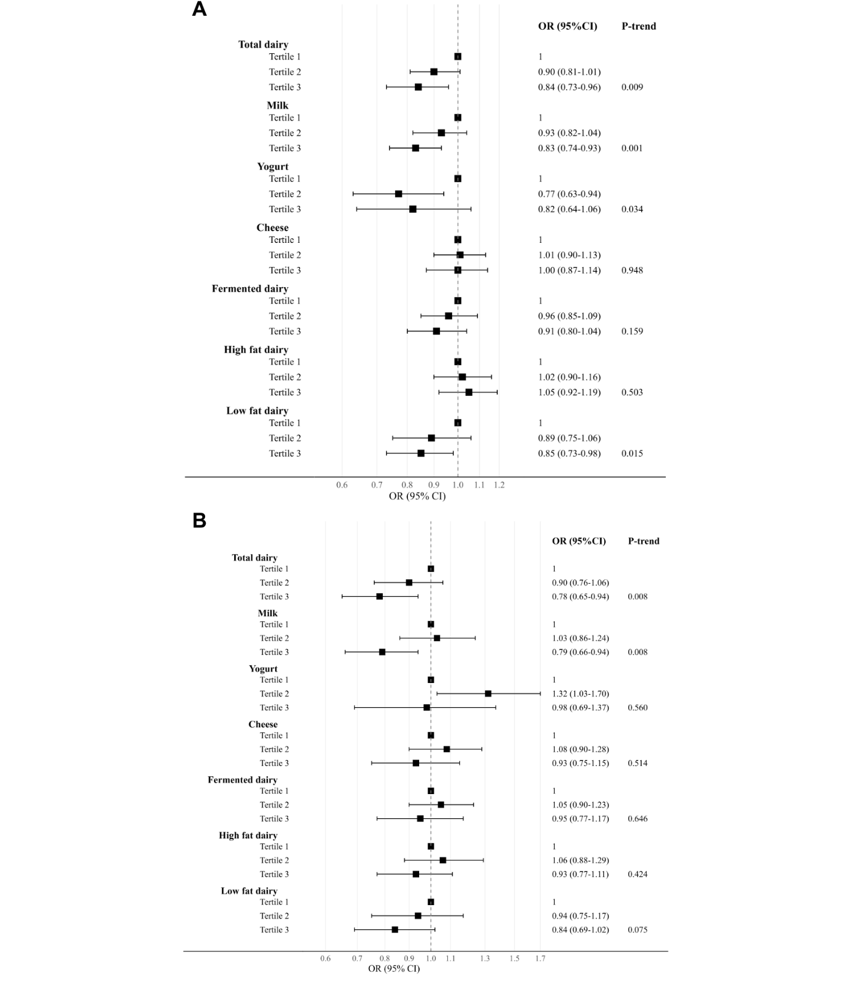
Figure S1 - Associations between dairy intake (total and subtypes), excluding sweet dairy products, and self-reported sleep duration (N=23,480)

(A) ORs (95% CIs) for associations between dairy products, excluding sweet dairy products, and short sleep duration, estimated using survey-weighted polytomous logistic regression. (B) ORs (95% CIs) for associations between dairy products, excluding sweet dairy products, and long sleep duration, estimated using survey-weighted polytomous logistic regression. All models were adjusted for age (continuous), sex (male, female), poverty index ratio (≤1.30, 1.31-3.50, ≥3.50), marital status (married/living with partner, separated/widowed/divorced, never married), education (less than high school, high school/GED, Some college, College and above), race/ethnicity (Mexican American, Other Hispanic, Non-Hispanic White, Non-Hispanic Black, Other), energy intake (kcal/day, continuous), alcohol consumption (never, former, current drinker), smoking status (never, former, current smoker), physical activity (sedentary, low, moderate, high), BMI (continuous), depression (yes/no), HEI-2015 (continuous), total sugar (g/d, continuous), saturated fat (g/d, continuous). Sex-specific cut-offs for total dairy were 1.13 and 2.16 cup-eq/d in males and 0.91 and 1.72 cup-eq/d in females. Cut-offs for milk were 0.23 and 0.77 cup-eq/d in males and 0.23 and 0.79 cup-eq/d in females. Cut-offs for cheese were 0.39 and 1.12 cup-eq/d in males and 0.29 and 0.80 cup-eq/d in females. Cut-offs for yogurt were 0 and 0.29 cup-eq/d in males and 0 and 0.30 cup-eq/d in females. Cut-offs for fermented dairy were 0.42 and 1.17 cup-eq/d for males and 0.34 and 0.86 cup-eq/d in females. Cut-offs for high-fat dairy were 0.18 and 0.87 cup-eq/d in males and 0.12 and 0.65 cup-eq/d in females. Cut-offs for low-fat dairy were 0 and 0.69 cup-eq/d in males and 0 and 0.50 cup-eq/d in females. OR = odds ratio, CI = confidence interval.

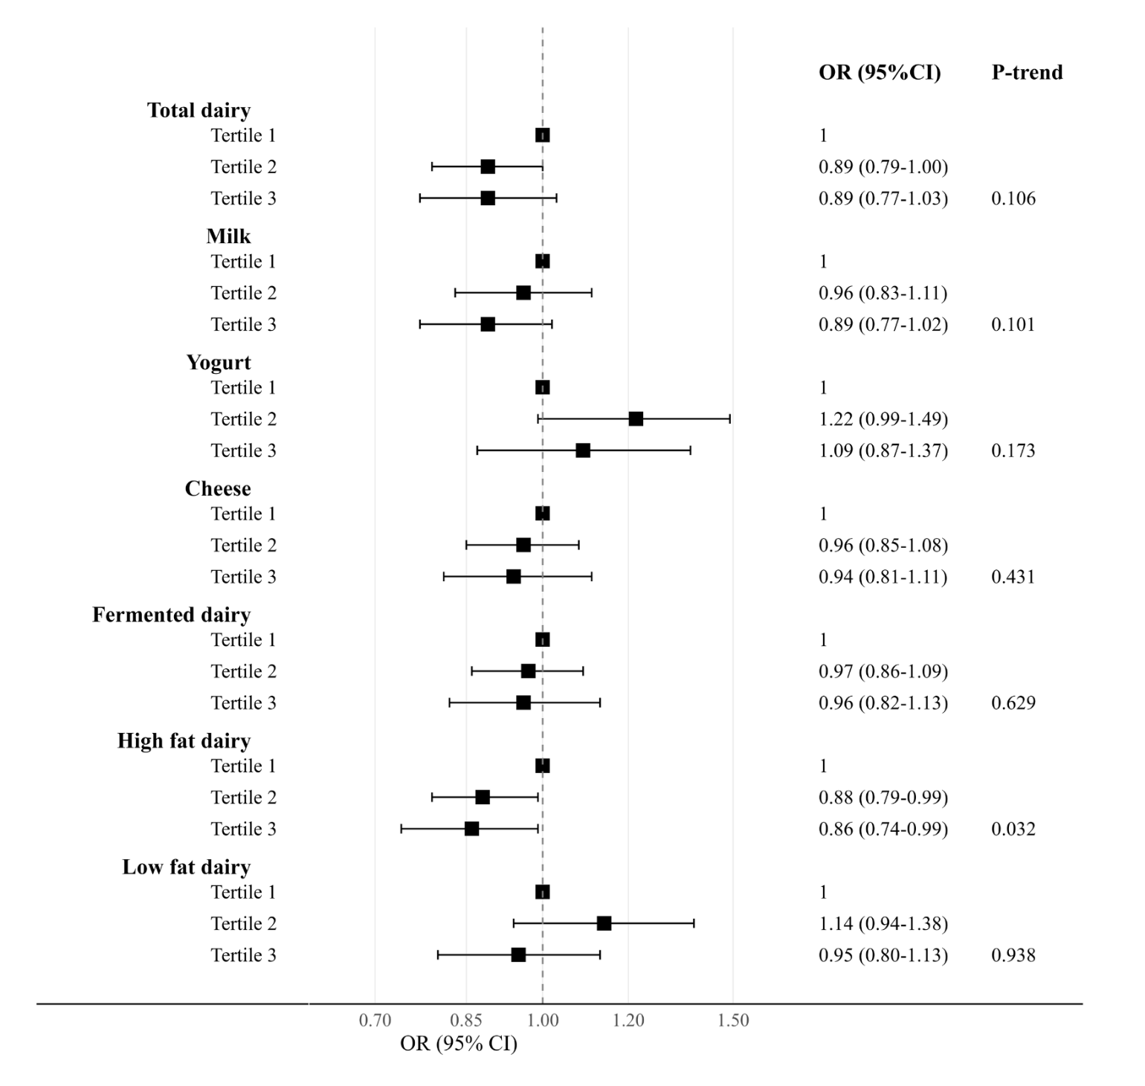
Figure S2 - Associations between dairy intake (total and subtypes), excluding sweet dairy products, and self-reported trouble sleeping (N=23,480)

ORs (95% CIs) for associations between dairy products, excluding sweet dairy products, and self-reported trouble sleeping. All models were adjusted for age (continuous), sex (male, female), poverty index ratio (≤1.30, 1.31-3.50, ≥3.50), marital status (married/living with partner, separated/widowed/divorced, never married), education (less than high school, high school/GED, Some college, College and above), race/ethnicity (Mexican American, Other Hispanic, Non-Hispanic White, Non-Hispanic Black, Other), energy intake (kcal/day, continuous), alcohol consumption (never, former, current drinker), smoking status (never, former, current smoker), physical activity (sedentary, low, moderate, high), BMI (continuous), depression (yes/no), HEI-2015 (continuous), total sugar (g/d, continuous), saturated fat (g/d, continuous). Sex-specific cut-offs for total dairy were 1.13 and 2.16 cup-eq/d in males and 0.91 and 1.72 cup-eq/d in females. Cut-offs for milk were 0.23 and 0.77 cup-eq/d in males and 0.23 and 0.79 cup-eq/d in females. Cut-offs for cheese were 0.39 and 1.12 cup-eq/d in males and 0.29 and 0.80 cup-eq/d in females. Cut-offs for yogurt were 0 and 0.29 cup-eq/d in males and 0 and 0.30 cup-eq/d in females. Cut-offs for fermented dairy were 0.42 and 1.17 cup-eq/d for males and 0.34 and 0.86 cup-eq/d in females. Cut-offs for high-fat dairy were 0.18 and 0.87 cup-eq/d in males and 0.12 and 0.65 cup-eq/d in females. Cut-offs for low-fat dairy were 0 and 0.69 cup-eq/d in males and 0 and 0.50 cup-eq/d in females. OR = odds ratio, CI = confidence interval.

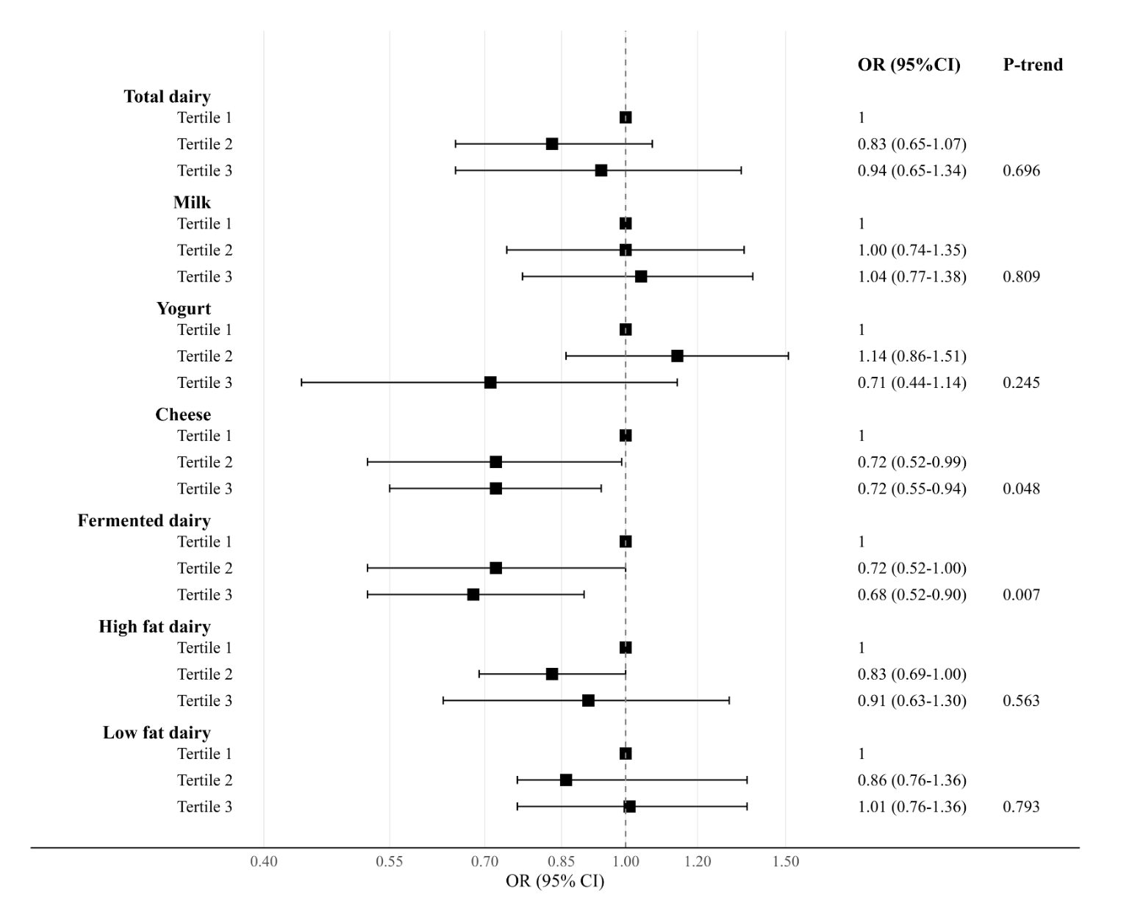
Figure S3 - Associations between dairy intake (total and subtypes), excluding sweet dairy products, and multidimensional sleep score (N=4,972)

ORs (95% CIs) for associations between dairy products, excluding sweet dairy products, and multidimensional sleep score. All models were adjusted for age (continuous), sex (male, female), poverty index ratio (≤1.30, 1.31-3.50, ≥3.50), marital status (married/living with partner, separated/widowed/divorced, never married), education (less than high school, high school/GED, Some college, College and above), race/ethnicity (Mexican American, Other Hispanic, Non-Hispanic White, Non-Hispanic Black, Other), energy intake (kcal/day, continuous), alcohol consumption (never, former, current drinker), smoking status (never, former, current smoker), physical activity (sedentary, low, moderate, high), BMI (continuous), depression (yes/no), HEI-2015 (continuous), total sugar (g/d, continuous), saturated fat (g/d, continuous). Sex-specific cut-offs for total dairy were 1.18 and 2.26 cup-eq/d in males and 0.95 and 1.73 cup-eq/d in females. Cut-offs for milk were 0.24 and 0.92 cup-eq/d in males and 0.23 and 0.69 cup-eq/d in females. Cut-offs for cheese were 0.45 and 1.19 cup-eq/d in males and 0.32 and 0.85 cup-eq/d in females. Cut-offs for yogurt were 0 and 0.29 cup-eq/d in males and 0 and 0.30 cup-eq/d in females. Cut-offs for fermented dairy were 0.49 and 1.27 cup-eq/d for males and 0.37 and 0.91 cup-eq/d in females. Cut-offs for high-fat dairy were 0.22 and 0.93 cup-eq/d in males and 0.11 and 0.66 cup-eq/d in females. Cut-offs for low-fat dairy were 0 and 0.69 cup-eq/d in males and 0 and 0.50 cup-eq/d in females. OR = odds ratio, CI = confidence interval.

