TITLE: Combination Treatment for Chronic Insomnia Disorder in Adults: An American Academy of Sleep Medicine systematic review, meta-analysis, and GRADE assessment
JOURNAL: Journal of Clinical Sleep Medicine
AUTHOR INFORMATION:
Daniel J. Buysse, MD 0000-0002-3288-1864
Department of Psychiatry, School of Medicine, University of Pittsburgh, Pittsburgh, Pennsylvania, USA

J. Todd Arnedt, Ph.D 0000-0002-5084-9331
Department of Psychiatry, Michigan Medicine, University of Michigan, Ann Arbor, Michigan, USA

Luis Buenaver, PhD, CBSM, DBSM 0009-0009-9292-879X
Department of Psychiatry and Behavioral Sciences, Johns Hopkins School of Medicine, Baltimore, Maryland, USA

Judy L. Chang, MD, FAASM, D, ABSM 0009-0009-9674-6563
San Jose Military Entrance Processing Station, Mountain View, California, USA

Julio Fernandez-Mendoza, PhD, CBSM, DBSM 0000-0001-9584-6161
Penn State Health Sleep Research & Treatment Center, Department of Psychiatry & Behavioral Health, Pennsylvania State University College of Medicine, Hershey, Pennsylvania, USA

Salma I. Patel, MD, MPH, FACP, FAASM 0000-0003-0900-043X
Mel and Enid Zuckerman College of Public Health, The University of Arizona;
College of Medicine-Tucson, BIO5 Institute, and Sarver Heart Center, The University of Arizona; Banner University Medical Center, Tucson, Arizona, USA

Eric S. Zhou, PhD 0000-0003-1038-8961
Department of Psychiatry, Harvard Medical School; Department of Supportive Oncology, Dana-Farber Cancer Institute; Department of Neurology, Boston Children’s Hospital, Boston, Massachusetts, USA

Yngve Falck-Ytter, MD, AGAF 0000-0002-4688-3211
Case Western Reserve University, Cleveland, Ohio; Department of Gastroenterology and Hepatology, Veterans Affairs Northeast Ohio Healthcare System, Cleveland, Ohio, USA

Suzanne Hyer, PhD, RN 0000-0003-4800-2366
American Academy of Sleep Medicine, Darien, Illinois, USA

Uzma Kazmi, MPH 0000-0002-1794-5073
Formerly at the American Academy of Sleep Medicine, Darien, Illinois, USA

Mandeep Singh, MBBS, MD, MSc, FRCPC 0000-0002-3393-8586
Department of Anesthesia and Pain Management, University Health Network, University of Toronto, Ontario, Canada. Department of Anesthesiology, Women's College Hospital, Toronto, Ontario, Canada
Emerson M. Wickwire, PhD 0000-0002-2858-7742
University of Maryland School of Medicine, Division of Pulmonary, Critical Care, and Sleep Medicine, Baltimore, MD; University of Maryland School of Medicine, Department of Psychiatry, Baltimore, Maryland, USA

CORRESPONDING AUTHOR:
Daniel J. Buysse, MD, BuysseDJ@upmc.edu

Combination Treatment of Chronic Insomnia Disorder in Adults Supplemental Materials

All Literature Search Terms
PubMed:
"Sleep Initiation and Maintenance Disorders"[MeSH Terms] OR “insomnia”[All Fields] NOT ("Insomnia, Fatal Familial"[MeSH Terms]) AND "behavior therapy"[MeSH Terms] OR "behaviour therapy"[All Fields] OR "behavior therapy"[All Fields] OR "psychotherapy"[MeSH Terms] OR "psychotherapy"[All Fields] OR "psychotherap*"[All Fields] OR "biofeedback, psychology"[MeSH Terms] OR "biofeedback"[All Fields] OR "psychology biofeedback"[All Fields] OR “body monitoring”[All Fields] OR “BBTI”[All Fields] OR “brief behavioral”[All Fields] OR “behavioral treatment”[All Fields] OR "Cognitive Behavioral Therapy"[MeSH Terms] OR "cognitive therapy"[All Fields] OR "cognitive behaviour therapy"[All Fields] OR "cognitive behavior therapy"[All Fields] OR "cognitive behavior therapies"[All Fields] OR "cognitive behavioral therapy for insomnia"[All Fields] OR “CBT-I”[All Fields] OR “CBT-Insomnia”[All Fields] OR "sleep retraining"[All Fields] OR “mindfulness”[MeSH Terms] OR “mindfulness”[All Fields] OR “multicomponent behavioral therapy”[All Fields] OR "relaxation therapy"[MeSH Terms] OR "relaxation therapy"[All Fields] OR "relaxation therapies"[All Fields] OR "abdominal breathing"[All Fields] OR “deep breathing”[All Fields] OR “progressive muscle relaxation”[All Fields] OR "imagery"[All Fields] OR "Imagery, Psychotherapy"[MeSH Terms] OR "imagery training"[All Fields] OR “guided imagery”[All Fields] OR "autogenic training"[MeSH Terms] OR "autogenic training"[All Fields] OR “desensitization relaxation”[All Fields] OR "paradoxical intention"[All Fields] OR "sleep hygiene"[MeSH Terms] OR "sleep restriction"[All Fields] OR "stimulus control"[All Fields] OR "Sleep Deprivation"[MeSH Terms] OR “sleep compression” [All Fields] OR “sleep strategies”[All Fields] OR "Meditation"[MeSH Terms] AND "hypnotics and sedatives"[MeSH Terms] OR "sleep aid"[All Fields] OR “pharmacology”[MeSH Terms] OR “drug therapy”[MeSH Terms] OR "Benzodiazepines"[MeSH Terms] OR "zopiclone" [Supplementary Concept] OR "eszopiclone"[MeSH Terms] OR "zaleplon"[Supplementary Concept] OR "zolpidem"[Supplementary Concept] OR "triazolam"[MeSH Terms] OR "temazepam"[MeSH Terms] OR "estazolam"[MeSH Terms] OR "quazepam" [Supplementary Concept] OR "flurazepam"[MeSH Terms] OR "oxazepam"[MeSH Terms] OR "Clonazepam"[MeSH Terms] OR "Lorazepam"[MeSH Terms] OR "Mirtazapine"[MeSH Terms] OR “Nortriptyline"[MeSH Terms] OR "Amitriptyline"[MeSH Terms] OR "doxepin"[MeSH Terms] OR "trazodone"[MeSH Terms] OR "Orexin Receptor Antagonists"[MeSH Terms] OR "suvorexant"[Supplementary Concept] OR "lemborexant"[Supplementary Concept] OR "daridorexant"[Supplementary Concept] OR "orexin receptor antagonist"[All Fields] OR "ramelteon"[Supplementary Concept] OR "tasimelteon"[Supplementary Concept] OR “melatonin”[MeSH Terms] OR "diphenhydramine"[MeSH Terms] OR "Gabapentin"[MeSH Terms] OR "Pregabalin"[MeSH Terms] OR "paroxetine"[MeSH Terms] OR "trimipramine"[MeSH Terms] OR "quetiapine fumarate"[MeSH Terms] OR "Clozapine"[MeSH Terms] OR "Olanzapine"[MeSH Terms] OR "Lurasidone Hydrochloride"[MeSH Terms] AND ("humans"[Mesh]) AND (English[Language]))
PsychINFO:
( MM "Sleep Wake Disorder*" OR “sleep disturb*” MM "Insomnia" OR insomnia ) AND ( MM "behavior* therapy" OR "behaviour therapy” OR "behavior* therapy “OR MM "psychotherapy" OR "psychotherapy” OR "psychotherap*"OR MM "biofeedback, psychology" OR "biofeedback” OR "psychology biofeedback “OR “body monitoring” OR “BBTI” OR “brief behavioral” OR “behavioral treatment” OR MM "Cognitive Behavioral Therapy" OR "cognitive therapy” OR "cognitive behaviour therapy" OR "cognitive behavior therapy" OR "cognitive behavior therapies" OR "cognitive behavioral therapy for insomnia" OR “CBT-I” OR “CBT-Insomnia” OR "sleep retraining" OR MM “mindfulness” OR “mindfulness” OR “multicomponent behavioral therapy” OR MM "relaxation therapy" OR "relaxation therapy" OR "relaxation therapies" OR "abdominal breathing" OR “deep breathing” OR “progressive muscle relaxation” OR "imagery" OR MM "Imagery, Psychotherapy" OR "imagery training" OR “guided imagery” OR MM "autogenic training" OR "autogenic training" OR “desensitization relaxation ”OR "paradoxical intention" OR MM "sleep hygiene" OR "sleep restriction" OR "stimulus control" OR MM "Sleep Deprivation" OR “sleep compression” OR “sleep strategies” OR MM "Meditation" OR "adjunct*" ) AND ( MM "hypnotic* and sedative*" OR "sedative*"OR "sleep aid*" OR MM “pharmacology” OR “pharmacotherapy” MM “drug therapy” OR "Benzodiazepine*" OR "zopiclone” OR "eszopiclone" OR "zaleplon” OR "zolpidem” OR "triazolam” OR "temazepam” OR "estazolam" OR "quazepam" OR "flurazepam” OR "oxazepam” OR "Clonazepam” OR "Lorazepam” OR "Mirtazapine” OR “Nortriptyline” OR "Amitriptyline” OR "doxepin” OR "trazodone” OR "Orexin Receptor Antagonists” OR "suvorexant” OR "Lemborexant” OR "daridorexant" OR "orexin receptor antagonist “OR "ramelteon" OR "tasimelteon" OR “melatonin” OR "diphenhydramine" OR "Gabapentin" OR "Pregabalin" OR "paroxetine” OR "trimipramine” OR "quetiapine fumarate” OR "Clozapine” OR "Olanzapine” OR "Lurasidone Hydrochloride")

Exclusion Criteria
Exclusion criteria are applied during the abstract review of all retrieved publications. Studies that meet any of the exclusion criteria are rejected from the systematic review.

- Publication
  - Book and book chapters
  - Conference abstracts
  - Dissertations
  - Editorials
  - Letters to the editor
  - Methods papers
  - Case reports or case series
  - Single case design or pilot
  - Observational studies: longitudinally/cross-sectionally examines the effect(s) of the intervention

- Study population
- Animal research

- Language
  - Non-English

- Patients
  - Did not undergo treatment for insomnia
  - Pediatric population only

- Study Objective
  - Main study objective is NOT evaluating the comparative effectiveness of combined therapies for insomnia

Inclusion Criteria
Inclusion criteria are applied during the full publication review of all publications that were not rejected during the abstract review. Studies that meet all inclusion criteria will be accepted as evidence to use in the systematic review.

- Outcomes of interest (study must address at least one of the critical and important outcomes)
  - Insomnia symptom severity
  - Remission rates
  - Responder rates
  - Sleep quality
  - Sleep continuity (SE, SOL, WASO, EMA, NWAK)
  - Daytime sleepiness/ sedation
  - Daytime function (cognitive symptoms, mood symptoms, physical symptoms, e.g., fatigue, pain, headaches)
  - Treatment side effects
  - Total sleep time
  - Quality of Life

- Publication type
- RCTs:
  - Intervention vs placebo
  - Intervention vs no treatment
  - Intervention vs standard care/usual care
  - Intervention vs sham
- Systematic reviews and meta-analysis

- Insomnia diagnosis (must meet at least 1)
- Use of any of the 3 diagnostic systems, regardless of version: Diagnostic and Statistical Manual of Mental Disorders (DSM), International Classification of Sleep Disorders (ICSD), Research Diagnostic Criteria (RDC)
- Use of validated sleep instruments with a threshold for baseline severity.
- Insomnia complaints with quantitative objective/subjective threshold
- Other sleep complaints/criteria/symptoms that would require adjudication

- Interventions (must include at least 1 from each category)

Behavioral-Psychological
- CBT-I
- Cognitive therapy
- Intensive sleep retraining
- Mindfulness
- Relaxation therapy (e.g., Abdominal breathing, Imagery training, Autogenic training)
- Paradoxical intention therapy
- Sleep hygiene education
- Sleep restriction therapy
- Stimulus control therapy
- Brief therapy(s) for insomnia
- Biofeedback

Pharmacological
- Benzodiazepine receptor agonist drugs (benzodiazepine and non-benzodiazepine agents)
- Dual orexin receptor antagonist drugs
- Sedating antidepressant drugs (e.g., trazodone, doxepin, amitriptyline)
- Sedating antihistamine drugs (e.g., diphenhydramine, doxylamine)
- Melatonin
- Melatonin receptor agonist drugs
- Other drugs used to treat insomnia (e.g., gabapentin, pregabalin, sedating antipsychotic agents)
- Other pharmacologically active agents used to treat insomnia (e.g., cannabis, herbal, naturopathic).

Abbreviations:
BAI – Beck Anxiety Inventory
BDI – Beck Depression Inventory
BT – Behavioral therapy
CBT-I – Cognitive behavioral therapy - insomnia
CI – Confidence interval
CMT – Clinically meaningful threshold
ESS – Epworth Sleepiness Scale
ISI – Insomnia Severity Index
GRADE – Grading of Recommendations, Assessment, Development and Evaluation
MD – Mean difference
PCT – Pharmacological treatment
PICO – Patient, intervention, comparator, outcome
PSG – Polysomnography
PSQI – Pittsburgh Sleep Quality Index
PSWQ - Pennsylvania State Worry Questionnaire
RCT – Randomized controlled trial
SD – Standard deviation
SE – Sleep efficiency
SF-36 –36-Item Short Form Survey
SII – Sleep Impairment Index
SL or SOL – Sleep latency, sleep onset latency
SMD – Standardized mean difference
TST – Total sleep time
WASO – Wake after sleep onset

Table S1. Characteristics of included studies
Source | Intervention groups (randomized n, completed n) | Drug dosage/frequency^ | Delivery format | Treatment duration (# of sessions) | Insomnia duration, mean years (SD) | Mean age | Female (%) | Co-morbidity | PICO addressed
El-Solh, 2025 (USA) | BBTI + eszopiclone (randomized =26, completed =24) BBTI (randomized =27, completed =23) | 2 mg nightly | in-person | 6 weeks (4) | 9.7(6.2), overall | Combination 48(7.3); BBTI alone 48.4(9.3) | Combination 16%; BBTI alone 11% | 11% with mild OSA, 21% with moderate OSA, 68% with severe OSA | 2
Huang, 2017 (Taiwan) | Biofeedback + zolpidem (randomized =17, completed =10) zolpidem (randomized =14, completed =4) acupuncture + zolpidem* (randomized =18, completed =7) | 10 mg nightly | in person | 3 weeks (3) | Not reported | Combination: 57.94 (16.44)  PCT alone: 53.4 (17.0) Acupuncture combination: 59.89 (12.65) | Combination 64.7%  PCT alone 42.9% Acupuncture 72.2% | - | 1
Jacobs, 2004 (USA) | CBT-I + zolpidem (randomized =18, completed 13) CBT (randomized =15, completed =14) zolpidem (randomized =15, completed =13) placebo (randomized =15, completed =14) | 10 mg nightly | in person, telephone | 8 weeks (4) | Combination 9.6(8.9); CBT alone 10.2(9.1); PCT alone 9.8(7.8); Placebo 8.9(8.5) | Combination 49.1(9.6); CBT alone 47.1 (8.1); PCT alone 45.4(9.3); Placebo 46.6(10.1) | Combination 66.6%; CBT alone 66.6%; PCT alone 73%; Placebo 73% | - | 1, 2
Katofsky, 2012 (Germany) | CBT-I + lormetazepam (randomized =51, completed =41) lormetezapam (randomized =45, completed =39) | 2 mg nightly | self-administered | 6 weeks (6) | 6.25(7.12), overall | 51.5(12.5), overall | 77.5% overall | 50% of the total sample reported at least 1 comorbid medical disorder | 1
Mao, 2017 (China) | CBT-I + zolpidem (randomized =26, completed =26) zolpidem (randomized =27, completed =27) placebo (randomized =31, completed =31) | 10 mg nightly | in person | 16 weeks (8) | 0.6 - 25 range | Combination 43.27 (12.03) ; PCT alone 45.04 (7.79) | Combination 84.6% PCT alone 74% | Almost all patients had received additional diagnoses of depression or anxiety or both, but they were secondary to insomnia | 1
Milby, 1993 (USA) | BT + triazolam (randomized =8, completed =8) triazolam (randomized =7, completed =7) | 0.25 mg nightly | in person | 3 weeks (6) | >/= 6 months | Male 35 (6.13) Female 30.4(5.68) | 53% overall | - | 1
Morin, 2003 (USA) | CBT + temazepam (randomized =20, completed =19) temazepam (randomized =20, completed =17) placebo (randomized =20, completed =18) | 7.5 - 30 mg nightly | in person | 8 weeks (8) | Combination 20.0(23.1) PCT alone 15.4 (15.5); Placebo 17.8(15.5) | Combination 65.2(6.9); PCT alone 64.1 (6.4); Placebo 64.9(7.1) | Combination 68.4%; PCT alone 52.9%; Placebo 66.7% | - | 1
Morin, 1999 (USA) | CBT + temazepam (randomized =20, completed =19) CBT (randomized =18, completed =18) temazepam (randomized =20, completed =17) placebo (randomized =20, completed =18) | 7.5 - 30 mg nightly | in person | 8 weeks (8) | Combination 20(23.1); CBT alone 16.2(14.8); PCT alone 15.4(15.5); Placebo 17.8(15.5) | Combination 65.2(6.9); CBT alone 64.4(7.5); PCT alone 64.1(6.4); Placebo 64.9(7.1) 65(6.9) overall | Combination 68.4%; CBT alone 72.2%; PCT alone 52.9%; Placebo 66.7% 64% overall | - | 1, 2
Morin, 2009 (Canada) | CBT + zolpidem (randomized =80, completed =80) CBT (randomized =80, completed =80) | 10 mg nightly | in person | 6 weeks (6) | Combination 15.3(11.9) CBT alone17.5 (15.2) | Combination 48.8(9.7) CBT alone 51.7(10.8) | Combination 58.8% CBT alone 62.5% | reported most common: anxiety, cardiovascular condition | 2
Morin, 2016 (Canada) | CBT + zolpidem (randomized =80, completed =80) CBT (randomized =80, completed =80) | 10 mg nightly | in person | 6 weeks (6) | Combination 15.3(11.9) CBT alone 17.5 (15.2) | Combination 48.8(9.7) CBT alone 51.7(10.8) | Combination 58.8% CBT alone 62.5% | - | 2
Rosen 2000 (USA) | Muscle relaxation + estazolam (randomized =12, completed =9) guided imagery + estazolam (randomized =14, completed =12) estazolam control (randomized =15, completed =11) | 1 mg nightly | in person | 4 weeks (7) | Combination (muscle relaxation) 9.7(8.4) Combination (guided imagery) 15.3(12.2) Control 6.4(4.5) years | Combination (muscle relaxation) 48.1(12.5) Combination (guided imagery) 49(11.7) Control 46.8(8.3) | muscle relaxation 67% guided imagery 58% control 73% | - | 1
Vallieres, 2005 (Canada) | sequencing of CBT + zopiclone (randomized =11, completed 10) CBT (randomized =6, completed =6) | 3.75 - 7.5 mg nightly | in person | 10 weeks (5 or 10) | >/= 6 months | 41.6 (5.7) overall | 58.8% overall | - | 1, 2
Wang, 2014 (China) | Psychotherapy + estazolam (randomized =45, completed =40) estazolam (randomized =45, completed =38) | 1 - 2 mg nightly | in person | 4 weeks (8) | 10.3 (10) overall | 52.6 (10.2) overall | 65.4% overall | - | 2
Wu, 2006 (China) | CBT + temazepam (randomized =19, completed =18) CBT (randomized =19, completed =19) temazepam (randomized =20, completed =17) placebo (randomized =19, completed 17) | 7.5 - 30 mg nightly | in person | 8 weeks (16) | Not reported | 38(12) overall | 53.2% overall | - | 1, 2
Zavesicka, 2008 (Czech Republic) | CBT + trazodone (randomized =10, completed =10) CBT (randomized =10, completed =10) | 100 mg nightly | in person | 8 weeks (8) | Combination 11.2(6.9) CBT alone 10.1(7.5) | Combination 46.1(12) CBTalone 48.6(13.7) 47.4(12.6) overall | Combination 70% CBT alone 80% 75% overall | - | 2
^ - does not include tapering doses per study protocols; # - number; * - acupuncture group not included in meta-analysis

PICO 1: In adults with chronic insomnia disorder, what are the benefits and harms of combination treatment compared to pharmacological treatment alone?

Table S2. Summary of Findings
Outcomes | Anticipated absolute effects (95% CI) |  | Relative effect  (95% CI) | № of participants  (studies) | Certainty of the evidence  (GRADE) | Comments
Outcomes | Risk with PCT alone | Risk with CBT-I + pharmacological
Global insomnia severity measures*  [ISI, SII, PSQI]  CMT: PSQI = -1 point | - | SMD 0.67 lower  (0.97 lower to 0.36 lower) | - | 178  (4 RCTs)^{1,2,3,4} | ⨁⨁◯◯  Low^{a,b,c} | PSQI = -2.5 points lower [95% CI -3.64, -1.35]. PSQI scale ranges from 0, no sleep disturbances, to 21, more acute sleep disturbances.
Sleep continuity*  [SE, SL, WASO; diary]  CMT: SE = +3.5%; SL = -7 min; WASO = -7 min | - | SMD 0.31 lower  (0.61 lower to 0.02 lower) | - | 177  (4 RCTs)^{2,4,5,6} | ⨁⨁◯◯  Low^{a,b,c,d} | SE = 3.5% higher [95% CI 0.23, 6.89]  SL = -7.6 minutes lower [95% CI -15.01, -0.49]  WASO = -13.9 minutes lower [95% CI -27.4, -0.9]
Daytime outcomes*  [BDI, PHQ-9, PHQ-15, PSWQ]  CMT: BDI = -2.5 points | - | SMD 0.31 lower  (0.64 lower to 0.03 higher) | - | 143  (3 RCTs)^{1,3,4} | ⨁⨁◯◯  Low^{a,b,c,d} | BDI = -1.5 points lower [95% CI -3.16, 0.15]. BDI scale ranges from 0, minimal depression, to 63 severe depression.
Total sleep time  [diary]  CMT: TST = +10 minutes | The mean total sleep time (CST: +10 minutes) was 375 minutes | MD 15.48 minutes lower  (43.63 lower to 12.67 higher) | - | 177  (4 RCTs)^{2,4,5,6} | ⨁⨁◯◯  Low^{a,b,c,e}
Treatment side effects  Morning sleepiness  [Adverse effects questionnaire]  No CMT |  | 20 more per 100  (6 fewer to 46 more) | RR 2.68  (0.62 to 11.56) | 36  (1 RCT)⁷ | ⨁◯◯◯  Very low ^{a,b,c,f} | Number of patients reporting morning sleepiness during treatment

*Critical for decision making

Explanations
a. Participants and investigators delivering CBT intervention lacked blinding in most studies
b. It was unclear if allocation was concealed in most studies
c. Small sample size (<200 participants)
d. The 95% confidence interval includes both no effect and the possibility for important benefit
e. The 95% confidence interval is consistent with both important benefit and harm
f. Small number of events leading to wide confidence intervals
References
1.Vallières, A., Morin, C. M., Guay, B.. Sequential combinations of drug and cognitive behavioral therapy for chronic insomnia: an exploratory study.Behav Res Ther; 2005.
2.Morin, C. M., Colecchi, C., Stone, J., Sood, R., Brink, D.. Behavioral and pharmacological therapies for late-life insomnia: a randomized controlled trial.Jama; 1999.
3.Mao, Hongjing, Ji, Yutian, Xu, You, Tang, Guangzheng, Yu, Zhenghe, Xu, Lianlian, Shen, Chanchan, Wang, Wei. Group cognitive–behavioral therapy in insomnia: A cross-sectional case-controlled study. Neuropsychiatric Disease and Treatment; 2017.
4.Katofsky, I., Backhaus, J., Junghanns, K., Rumpf, H. J., Hüppe, M., von Eitzen, U., Hohagen, F.. Effectiveness of a cognitive behavioral self-help program for patients with primary insomnia in general practice - a pilot study. Sleep Med; 2012.
5.Wu, R., Bao, J., Zhang, C., Deng, J., Long, C.. Comparison of sleep condition and sleep-related psychological activity after cognitive-behavior and pharmacological therapy for chronic insomnia.Psychother Psychosom; 2006.
6.Jacobs, G. D., Pace-Schott, E. F., Stickgold, R., Otto, M. W.. Cognitive behavior therapy and pharmacotherapy for insomnia: a randomized controlled trial and direct comparison. Arch Intern Med; 2004.
7.Morin, C. M., Bastien, C. H., Brink, D., Brown, T. R.. Adverse effects of temazepam in older adults with chronic insomnia. Hum Psychopharmacol; 2003.

Critical outcomes
Figure S1. Combination: CBT-I + pharmacological vs pharmacological alone, Global insomnia severity measures
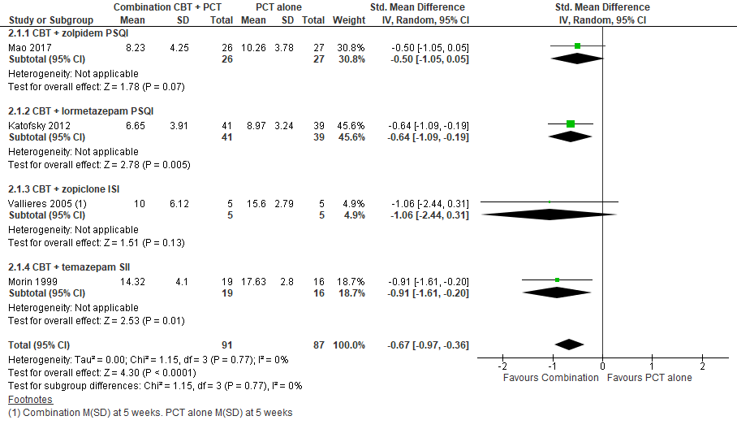
PSQI – Pittsburgh Sleep Quality Index (range 0-21) and SII - Sleep impairment Index (range 7-35) higher scores indicate more severe insomnia. The weighted average of the post intervention standard deviations of PSQI across Mao 2017 and Katofsky 2012 is 3.75. Re-expressed as a PSQI scale, the posttreatment mean PSQI score in the combination group was -2.5 points lower [95% CI -3.64, -1.35] compared to pharmacological treatment alone.

Figure S2. Combination: CBT-I + pharmacological vs pharmacological alone, Sleep continuity, diary
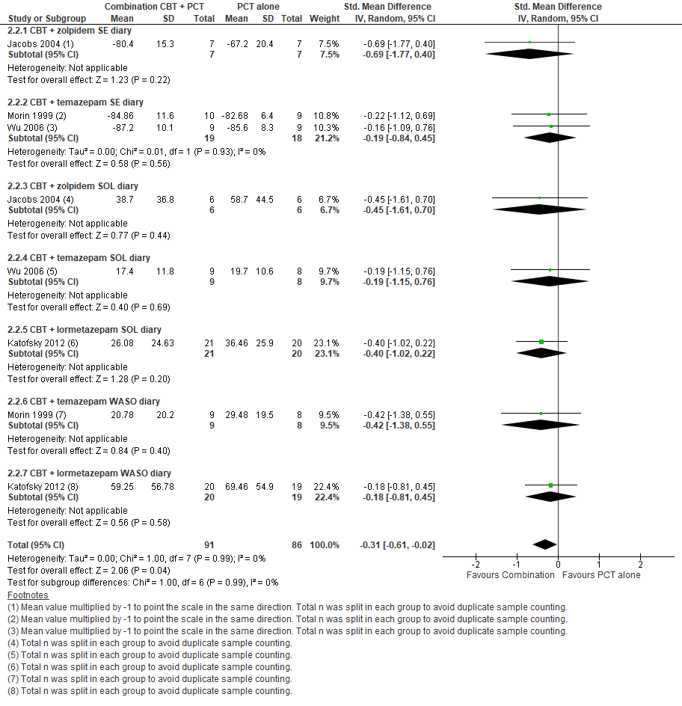
Sleep continuity, diary measured: SE – sleep efficiency; SOL – sleep onset latency; WASO – wake after sleep onset. The weighted average of the post intervention standard deviations of 1) SE across Jacobs 2004, Morin 1999, Wu 2006 is 11.3; 2) SOL across Katofsky 2012 and Wu 2006 is 24.6; 3) WASO across Katofsky 2012 and Morin 1999 is 44.9. Re-expressed as a SE measure, the posttreatment mean in the combination group was 3.5% higher [95% CI 0.23, 6.89] compared to pharmacological treatment alone. Re-expressed as a SL measure, the posttreatment mean in the combination group was -7.6 minutes lower [95% CI -15.01, -0.49] compared to pharmacological treatment alone. Re-expressed as a WASO measure, the posttreatment mean in the combination group was -13.9 minutes lower [95% CI -27.4, -0.9] compared to pharmacological treatment alone.

Figure S3. Combination: CBT-I + pharmacological vs pharmacological alone, Daytime outcomes, patient-reported
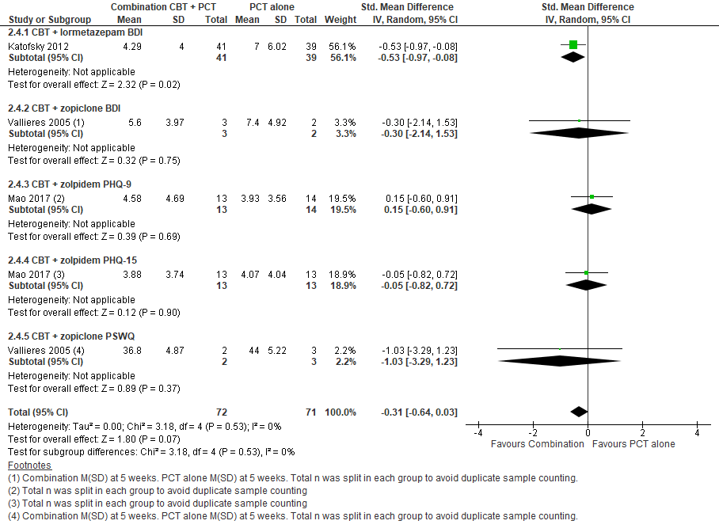
BDI (range 0-63), Patient Health Questionnaire PHQ-9 (range 0-27), PHQ-15 (range 0-30), PSWQ (range 16-80) > higher scores indicate worsening symptoms. The weighted average of the post intervention standard deviations of Katofsky 2012 and Vallieres 2005 is 4.93. Re-expressed as a BDI scale, the posttreatment mean BDI score in the combination group was -1.5 points lower [95% CI -3.16, 0.15] compared to pharmacological treatment alone.

Important outcomes
Figure S4. Combination: CBT-I + pharmacological vs pharmacological alone, Total sleep time, diary
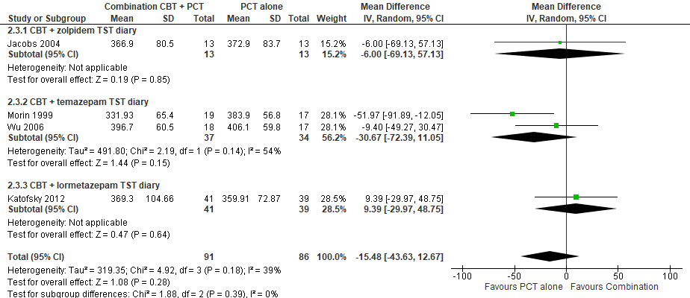 MD - 15.48 minutes [95% CI -43.63, 12.67]

Figure S5. Combination: CBT-I + pharmacological vs pharmacological alone, Treatment side effects: Morning sleepiness, Adverse event questionnaire
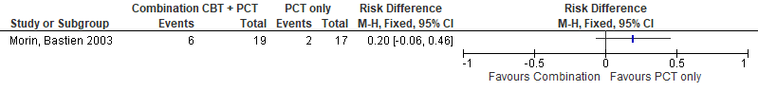
Morning sleepiness, Adverse effects questionnaire - Number of patients reporting this side effect during treatment

Figure S6. Combination: CBT-I + pharmacological vs pharmacological alone, Treatment side effects
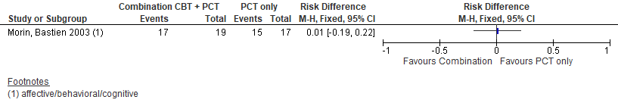
Represents the proportion of participants reporting at least one side effect during treatment. Affective/behavioral/cognitive effects (e.g., daytime residual sedation, lethargy, drowsiness)

Figure S7. Combination: CBT-I + pharmacological vs pharmacological alone, Treatment side effects
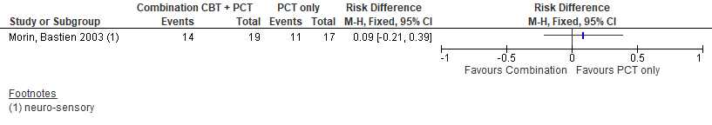
Neuro-sensory motor effects (e.g., headache, impaired coordination)

Figure S8. Combination: CBT-I + pharmacological vs pharmacological alone, Treatment side effects
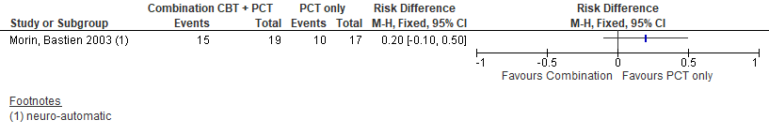
Neuro-autonomic effects (e.g., blurred vision, dizziness)

Figure S9. Combination: CBT-I + pharmacological vs pharmacological alone, Treatment side effects
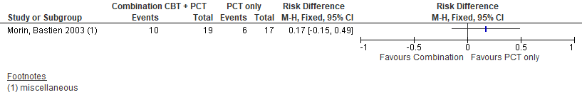
Miscellaneous (e.g., nightmares, loss of libido)

Objective measures
Figure S10. Combination: CBT-I + pharmacological vs pharmacological alone, Sleep continuity, PSG
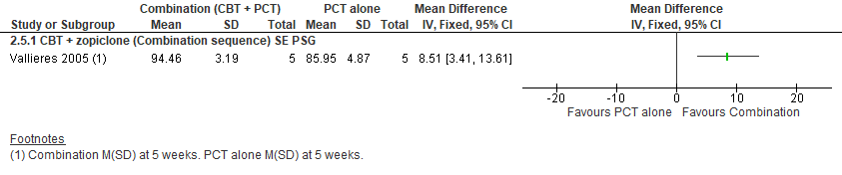
MD 8.51 [95% CI 3.41, 13.61; CMT = 2.5%]

Figure S11. Combination: CBT-I + pharmacological vs pharmacological alone, Total sleep time, PSG
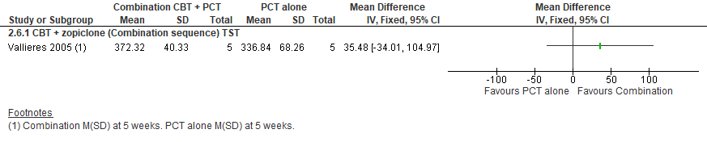
MD 35.48 [95% CI -34.01, 104.97; CMT = 10 minutes]

PICO 2: In adults with chronic insomnia disorder, what are the benefits and harms of combination treatment compared to behavioral-psychological treatment alone?

Table S3. Summary of Findings
Outcomes | Anticipated absolute effects (95% CI) |  | № of participants  (studies) | Certainty of the evidence  (GRADE) | Comments
Outcomes | Risk with CBT-I alone | Risk with CBT-I + pharmacological | № of participants  (studies) | Certainty of the evidence  (GRADE)
Global insomnia severity measures*  [ISI, SII]  CMT: ISI = -2 points | - | SMD 0.1 SD higher  (0.17 lower to 0.37 higher) | 228  (4 RCTs)^{1,2,3,4} | ⨁⨁⨁◯  Moderate^{a,b} | ISI = 0.45 points higher [95% CI -0.77, 1.67]. ISI scale ranges from 0, no insomnia, to 28, severe insomnia.
Sleep continuity*  [SE, SL, WASO; diary]  CMT: SE = +3.5%; SL = -7 min; WASO = -7 min | - | SMD 0.11 SD lower  (0.35 lower to 0.13 higher) | 261  (4 RCTs)^{3,4,5,6} | ⨁⨁◯◯  Low^{a,b,c} | SE = 1.28% higher [95% CI -1.51, 4.06]  SL = -2.63 minutes lower [95% CI -8.37, 3.11]  WASO = -4.48 minutes lower [95% CI -14.25, 5.29]
Daytime outcomes*  [BAI, BDI, MFI, PSWQ, SF-36]  CMT: BDI = -2.5 points | - | SMD 0.39 SD higher  (0.1 higher to 0.68 higher) | 191  (3 RCTs)^{1,2,7} | ⨁⨁⨁◯  Moderate^{a,b} | BDI = 2.1 points higher [95% CI 0.54, 3.67]. BDI scale ranges from 0, minimal depression, to 63 severe depression.
Total sleep time  [diary]  CMT: TST = +10 minutes | The mean total sleep time was 345.7 minutes | MD 13.81 minutes higher  (6.78 lower to 34.41 higher) | 261  (4 RCTs)^{3,4,5,6} | ⨁⨁◯◯  Low^{a,b,c}

*Critical for decision making

Explanations
a. It was unclear if allocation was concealed in most studies
b. Participants and investigators delivering CBT intervention lacked blinding in most studies
c. The 95% confidence interval includes both no effect and the possibility for important benefit

References
1.Zavesicka, L., Brunovsky, M., Horacek, J., Matousek, M., Sos, P., Krajca, V., Höschl, C.. Trazodone improves the results of cognitive behaviour therapy of primary insomnia in non-depressed patients.Neuro Endocrinol Lett; 2008.
2.Vallières, A., Morin, C. M., Guay, B.. Sequential combinations of drug and cognitive behavioral therapy for chronic insomnia: an exploratory study.Behav Res Ther; 2005.
3.Morin, C. M., Vallières, A., Guay, B., Ivers, H., Savard, J., Mérette, C., Bastien, C., Baillargeon, L.. Cognitive behavioral therapy, singly and combined with medication, for persistent insomnia: a randomized controlled trial.Jama; 2009.
4.Morin, C. M., Colecchi, C., Stone, J., Sood, R., Brink, D.. Behavioral and pharmacological therapies for late-life insomnia: a randomized controlled trial.Jama; 1999.
5.Wu, R., Bao, J., Zhang, C., Deng, J., Long, C.. Comparison of sleep condition and sleep-related psychological activity after cognitive-behavior and pharmacological therapy for chronic insomnia.Psychother Psychosom; 2006.
6.Jacobs, G. D., Pace-Schott, E. F., Stickgold, R., Otto, M. W.. Cognitive behavior therapy and pharmacotherapy for insomnia: a randomized controlled trial and direct comparison. Arch Intern Med; 2004.
7.Morin, C. M., Beaulieu-Bonneau, S., Bélanger, L., Ivers, H., Sánchez Ortuño, M., Vallières, A., Savard, J., Guay, B., Mérette, C.. Cognitive-behavior therapy singly and combined with medication for persistent insomnia: Impact on psychological and daytime functioning.Behav Res Ther; 2016.

Critical outcomes
Figure S12. Combination: CBT-I + pharmacological vs CBT-I alone, Global insomnia severity measures
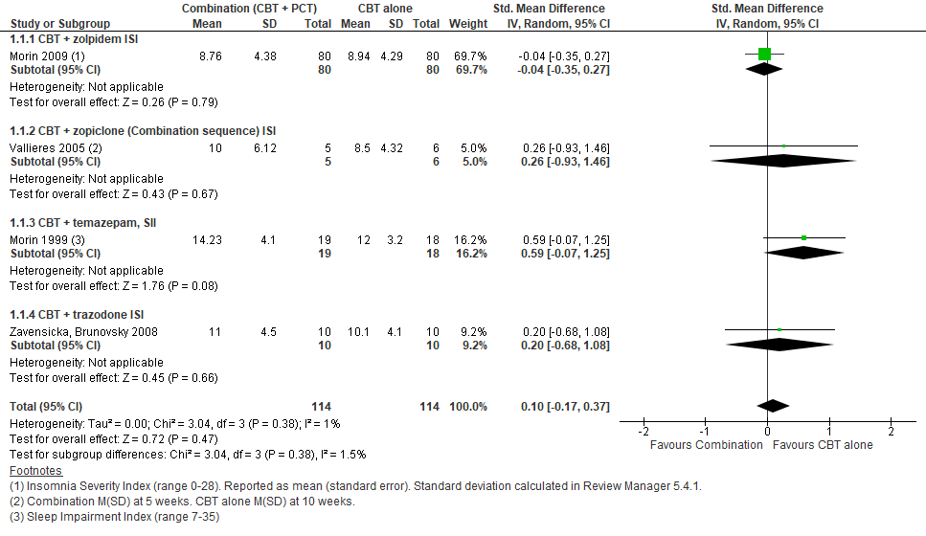
ISI (range 0-28) and SII (range 7-35) higher scores indicate more severe insomnia. The weighted average of the post intervention standard deviations of ISI across Morin 2009, Valleries 2005, and Zavensicka 2008 is 4.5. Re-expressed as an ISI scale, the posttreatment mean ISI score in the combination group was 0.45 points higher (95% CI -0.77 to 1.67) compared to CBT-I alone.

Figure S13. Combination: CBT-I + pharmacological vs CBT-I alone, Sleep continuity, diary
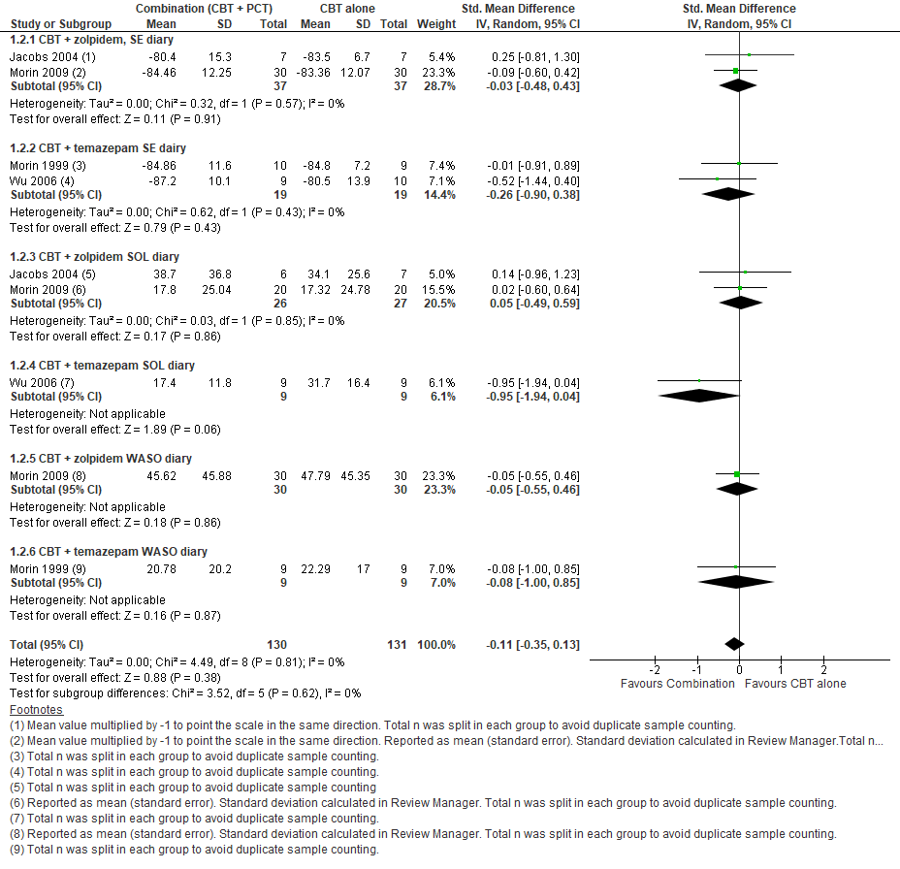
Sleep continuity, diary measured: SE, SOL, WASO. The weighted average of the post intervention standard deviations of 1) SE across Jacobs 2004, Morin 2009, Morin 1999, Wu 2006 is 11.6; 2) SOL across Jacobs 2004, Morin 2009, and Wu 2006 is 23.9; 3) WASO across Morin 2009 and Morin 1999 is 40.7. Re-expressed as a SE measure, the posttreatment mean in the combination group was 1.28% higher (95% CI -1.51 to 4.06) compared to CBT-I alone.- inverted]. Re-expressed as a SOL measure the posttreatment mean in the combination group was -2.63 minutes lower (95% CI -8.37 to 3.11) compared to CBT-I alone. Re-expressed as a WASO measure, the posttreatment mean in the combination group was -4.48 minutes lower (95% CI -14.25 to 5.29) compared to CBT-I alone.

Figure S14. Combination: CBT-I + pharmacological vs CBT-I alone, Daytime outcomes, patient-reported
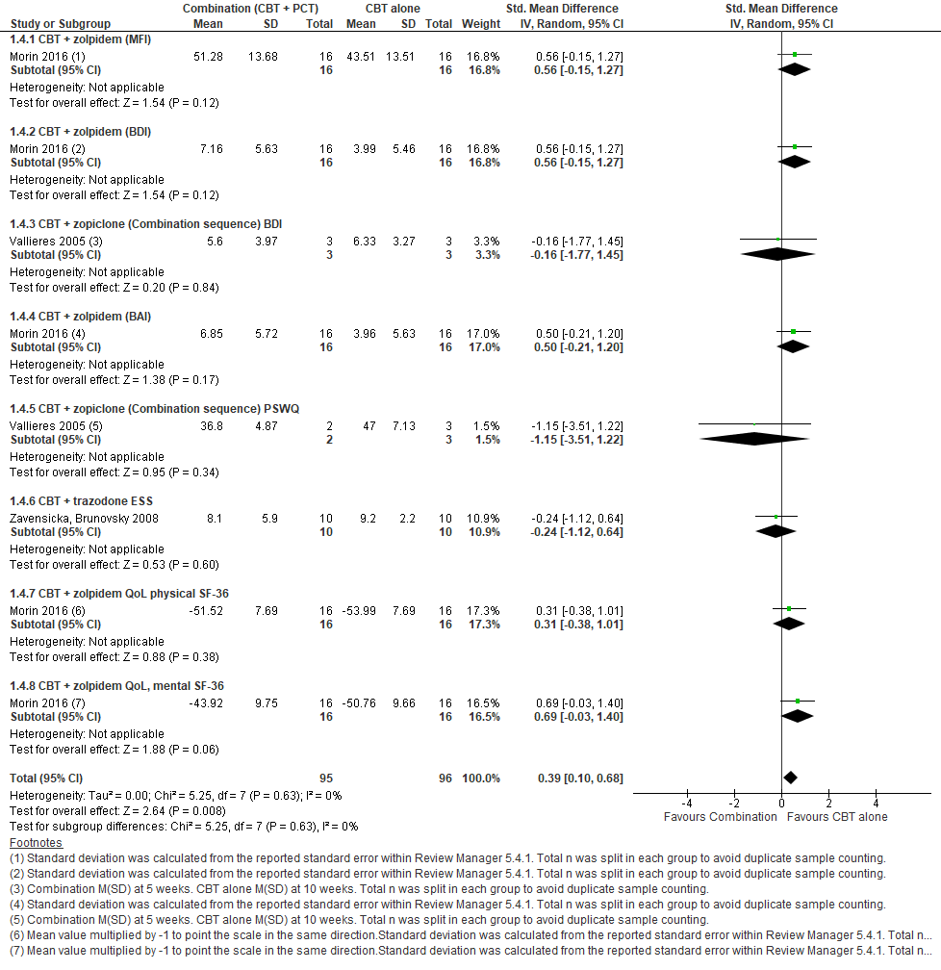
Daytime outcomes measured fatigue, depression, anxiety, quality of life with : MFI – Multidimensional Fatigue Inventory (range 20-100), BAI (range 0-63), BDI (range 0-63), PSWQ (range 16-80), ESS (range 0-24) > higher scores indicate worsening symptoms. SF-36 physical (range 0-100), SF-36 mental (range 0-100) > higher scores indicate improvement in symptoms. The weighted average of post intervention standard deviations of the BDI across Morin 2016 and Vallieres 2005 was 5.4. Re-expressed as a BDI scale, the posttreatment mean BDI score in the combination group was 2.1 points higher (95% CI 0.54 to 3.67) compared to CBT-I alone.

Important outcomes
Figure S15. Combination: CBT-I + pharmacological vs CBT-I alone, Total sleep time, diary
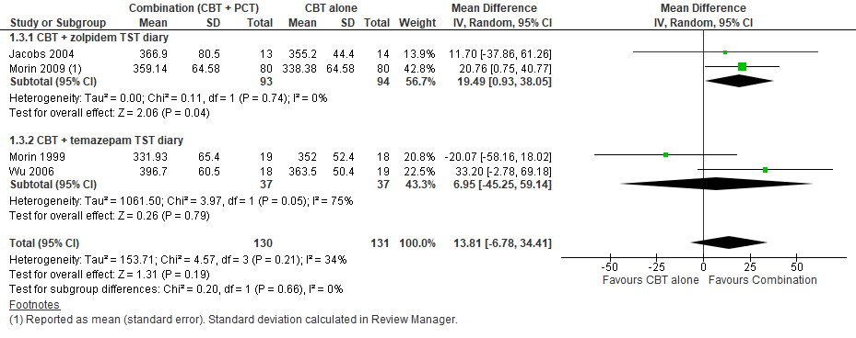
MD 13.81 minutes [95% CI -6.78, 34.41]

Objective measures
Figure S16. Combination: CBT-I + pharmacological vs CBT-I alone, Sleep continuity, PSG
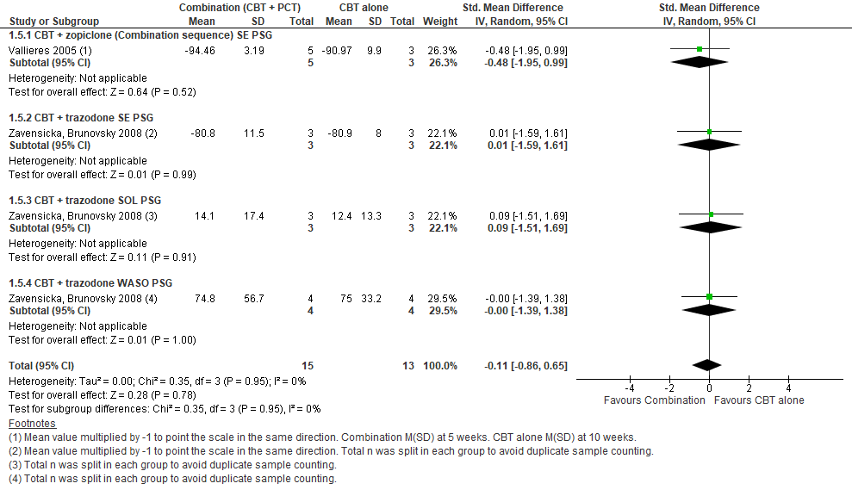
The weighted average of the post intervention standard deviations of 1) SE across Vallieres 2005 and Zavensicka 2008 is 8.7; 2) SOL across Zavensicka 2008 is 15.4; 3) WASO across Zavensicka 2008 is 44.95. Re-expressed as a SE measure, there was a posttreatment mean increase of 0.96% [95% CI -5.66, 9.48; CMT = 2.5%] (inverted) Re-expressed as a SL measure, there was a posttreatment mean reduction of -1.69 minutes [95% CI -13.2, 10.01; CMT = 5 minutes] Re-expressed as a WASO measure, there was posttreatment mean reduction of -4.95 minutes [95% CI -38.66, 29.2; CMT = 5 minutes].

Figure S17. Combination: CBT-I + pharmacological vs CBT-I alone, Total sleep time, PSG
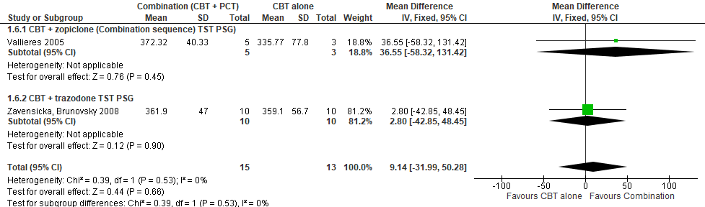
MD 9.14 [95% CI -31.99, 50.28; CMT = 10 minutes]

Other combination therapy interventions

BT + pharmacological vs pharmacological alone
Figure S18. Combination: BT + pharmacological vs pharmacological alone, Sleep quality, diary rating scale
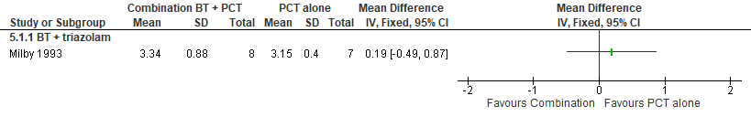
BT + triazolam. Daily Sleep Questionnaire: Restedness Score (range of 1-4; a lower score indicates more restedness). CMT = 0.5 points.

Figure S19. Combination: BT + pharmacological vs pharmacological alone, Sleep latency, diary 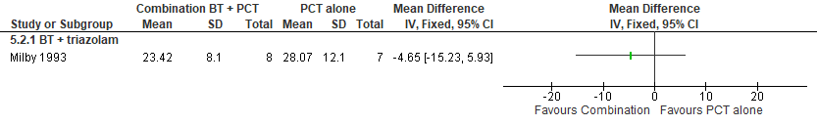
BT + triazolam. Daily Sleep Questionnaire: Sleep onset latency.

Figure S20. Combination: BT + pharmacological vs pharmacological alone, Total Sleep Time, diary 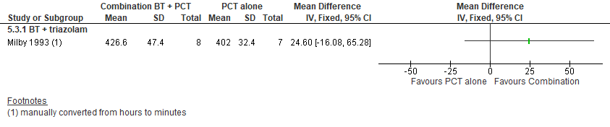
BT + triazolam. Daily Sleep Questionnaire: Total sleep time.

Biofeedback + pharmacological vs pharmacological alone
Figure S21. Combination: Biofeedback + pharmacological vs pharmacological alone, PSQI
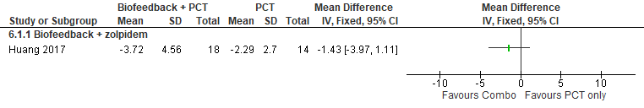
Biofeedback + zolpidem. PSQI – Pittsburgh Sleep Quality Index (score range 0-21, higher scores indicate more acute sleep disturbances)

Figure S22. Combination: Biofeedback + pharmacological vs pharmacological alone, Remission rate, PSQI 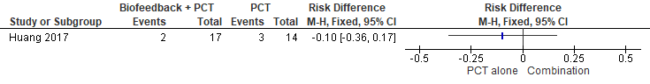
Biofeedback + zolpidem. Remission defined as PSQI ≤ 5. Combination 11% - zolpidem alone 21% = (10% difference). CMT: ≥ 5% difference in remission rate between groups (defined as PSQI < 5 points)

Psychotherapy + pharmacological vs pharmacological alone
Figure S23. Combination: Psychotherapy + pharmacological vs pharmacological alone, Sleep quality, PSQI
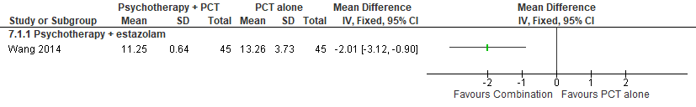
Psychotherapy + estazolam

Figure S24. Combination: Psychotherapy + pharmacological vs pharmacological alone, Sleep latency, PSG
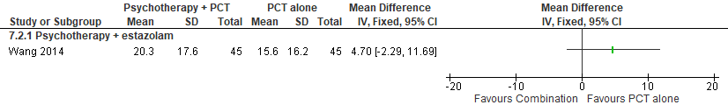
Psychotherapy + estazolam. CMT = 5 minutes.

Figure S25. Combination: Psychotherapy + pharmacological vs pharmacological alone, Sleep efficiency, PSG
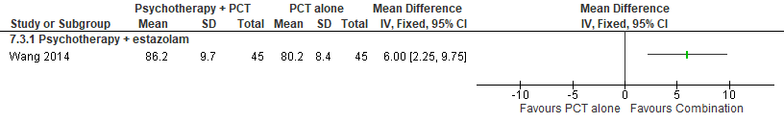
Psychotherapy + estazolam. CMT = 2.5%.

Figure S26. Combination: Psychotherapy + pharmacological vs pharmacological alone, Number of night wakings, PSG
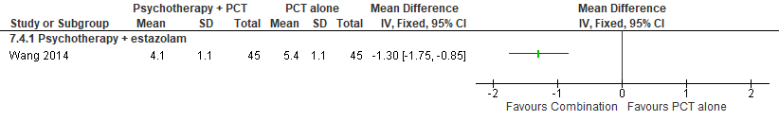
Psychotherapy + estazolam. CMT = 0.2 SMD.

Figure S27. Combination: Psychotherapy + pharmacological vs pharmacological alone, Total sleep time, PSG
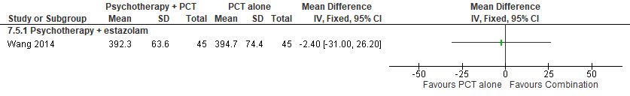
Psychotherapy + estazolam. CMT = 10 minutes.

Relaxation + pharmacological vs pharmacological alone
Figure S28. Combination: Relaxation + pharmacological vs pharmacological alone, Sleep latency, diary
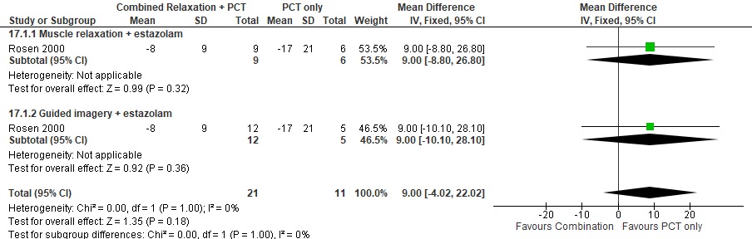
Relaxation + estazolam. Change from baseline to posttreatment mean and standard deviation reported. The number of participants in the PCT only group were split to avoid double counting the comparator group participants.

Figure S29. Combination: Relaxation + pharmacological vs pharmacological alone, Wake after sleep onset, diary
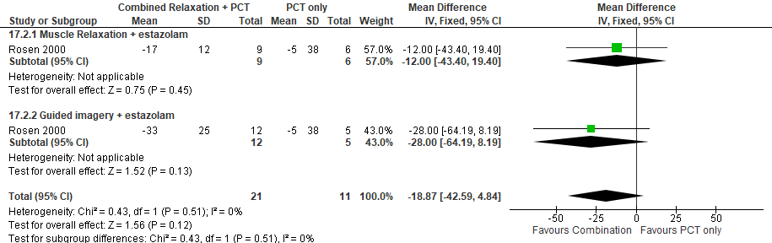
Relaxation + estazolam. Change from baseline to posttreatment mean and standard deviation reported. The number of participants in the PCT only group were split to avoid double counting the comparator group participants.

Figure S30. Combination: Relaxation + pharmacological vs pharmacological alone, Sleep efficiency, diary
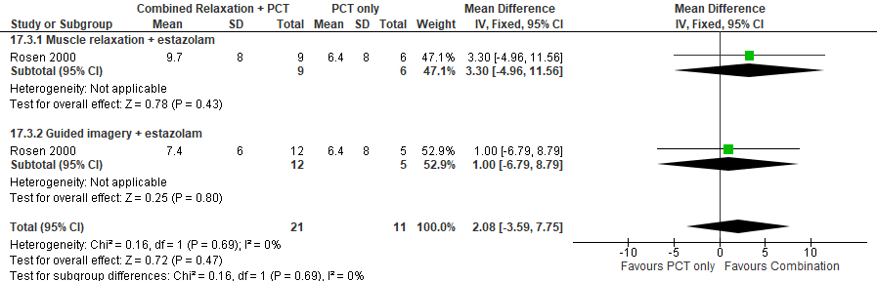
Relaxation + estazolam. Change from baseline to posttreatment mean and standard deviation reported. The number of participants in the PCT only group were split to avoid double counting the comparator group participants.

Figure S31. Combination: Relaxation + pharmacological vs pharmacological alone, Number of night wakings, diary
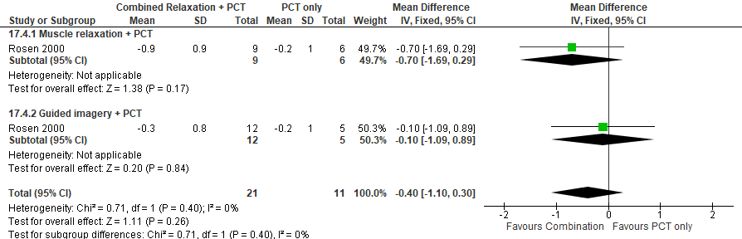
Relaxation + estazolam. Change from baseline to posttreatment mean and standard deviation reported. The number of participants in the PCT only group were split to avoid double counting the comparator group participants. CMT = 0.5 SMD.

Figure S32. Combination: Relaxation + pharmacological vs pharmacological alone, Total sleep time, diary
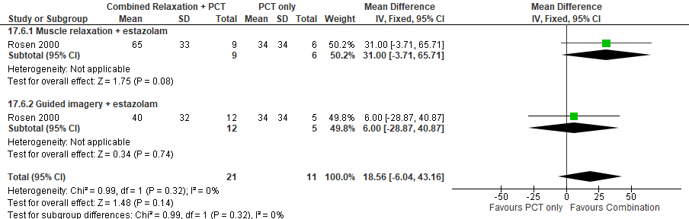
Relaxation + estazolam. Change from baseline to posttreatment mean and standard deviation reported. The number of participants in the PCT only group were split to avoid double counting the comparator group participants.

Figure S33. Combination: Relaxation + pharmacological vs pharmacological alone, Treatment side effects
Study | Relaxation + estazolam
Rosen 2000 | 3 subjects discontinued due to medication side effects (daytime fatigue, headaches). Treatment arm was not identified
Rosen 2000 | 6 subjects were withdrawn due to psychological difficulties or noncompliance with the study protocol. Treatment arm was not identified
Rosen 2000 | Total 9/41 subjects

BBTI + pharmacological vs BBTI alone
Figure S34. Combination: BBTI + pharmacological vs BBTI alone, Global insomnia severity measures
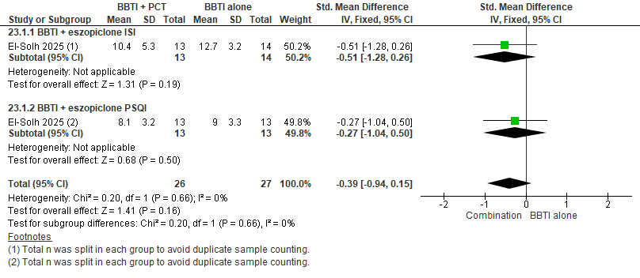
BBTI + eszopiclone. ISI (range 0-28). The weighted average of the post intervention standard deviations of ISI is 4.2. Re-expressed as an ISI scale, the posttreatment mean ISI score in the combination group was -1.63 points lower (95% CI -3.9, 0.63) compared to BBTI alone.

Figure S35. Combination: BBTI + pharmacological vs BBTI alone, Daytime outcomes, patient-reported
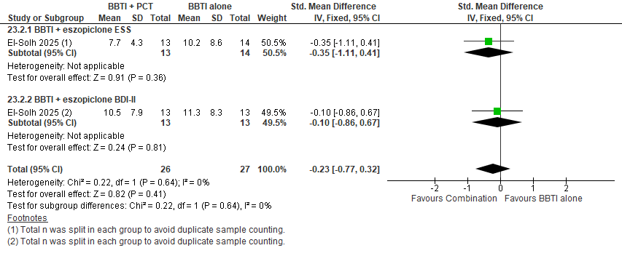
BBTI + eszopiclone. Daytime outcomes measured fatigue and depression. BDI (range 0-63), ESS (range 0-24) > higher scores indicate worsening symptoms. The weighted average of post intervention standard deviations of the BDI was 8.1. Re-expressed as a BDI scale, the posttreatment mean BDI score in the combination group was -1.86 points lower (95% CI -6.24, 2.59) compared to BBTI alone.

Figure S36. Combination: BBTI + pharmacological vs BBTI alone, Remission rate, ISI
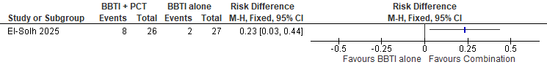
BBTI + eszopiclone. Remission defined as ISI score was < 8. Combination 30% - BBTI alone 7% = 23% difference.

Figure S37. Combination: BBTI + pharmacological vs BBTI alone, Response rate, ISI
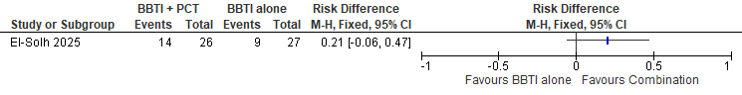
BBTI + eszopiclone. Response rate defined as an ISI change score (compared with baseline) of >7 points. Combination 54% - BBTI alone 33% = 21% difference.

Figure S38. Combination: BBTI + pharmacological vs BBTI alone, Sleep continuity, actigraphy
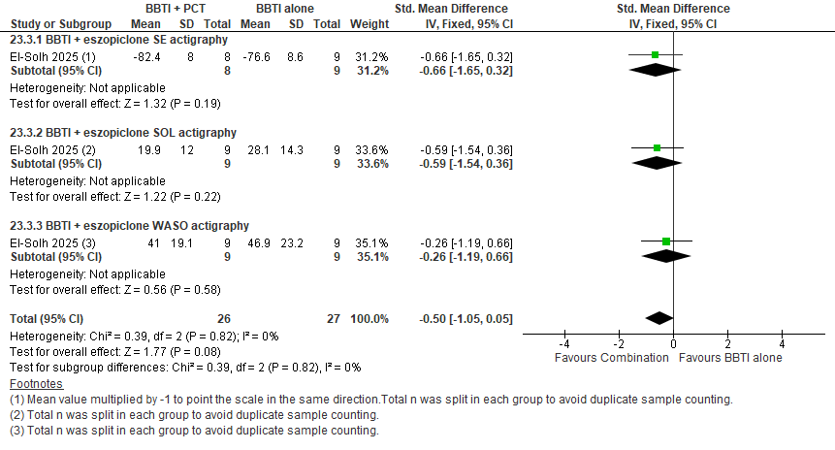
BBTI + eszopiclone. The weighted average of the post intervention standard deviations of 1) SE is 8.3; 2) SOL is 13.2; 3) WASO is 21.2. Re-expressed as a SE measure, there was a posttreatment mean increase of 4.2% [95% CI 8.7, - 0.42; CMT = 2.5%] (inverted) Re-expressed as a SL measure, there was a posttreatment mean reduction of -6.6 minutes [95% CI -13.9, 0.66; CMT = 5 minutes] Re-expressed as a WASO measure, there was posttreatment mean reduction of -10.6 minutes [95% CI -22.3, 1.06; CMT = 5 minutes].

Figure S39. Combination: BBTI + pharmacological vs BBTI alone, Total sleep time, actigraphy
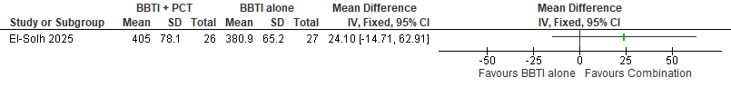
BBTI + eszopiclone. CMT = 10 minutes.

CBT-I + pharmacological vs placebo
Figure S40. Combination: CBT-I + pharmacological vs placebo, Global insomnia severity measures
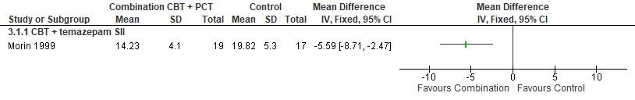
SII - Sleep impairment Index (range 7-35) higher scores indicate more severe insomnia.
Figure S41. Combination: CBT-I + pharmacological vs placebo, Sleep continuity, diary
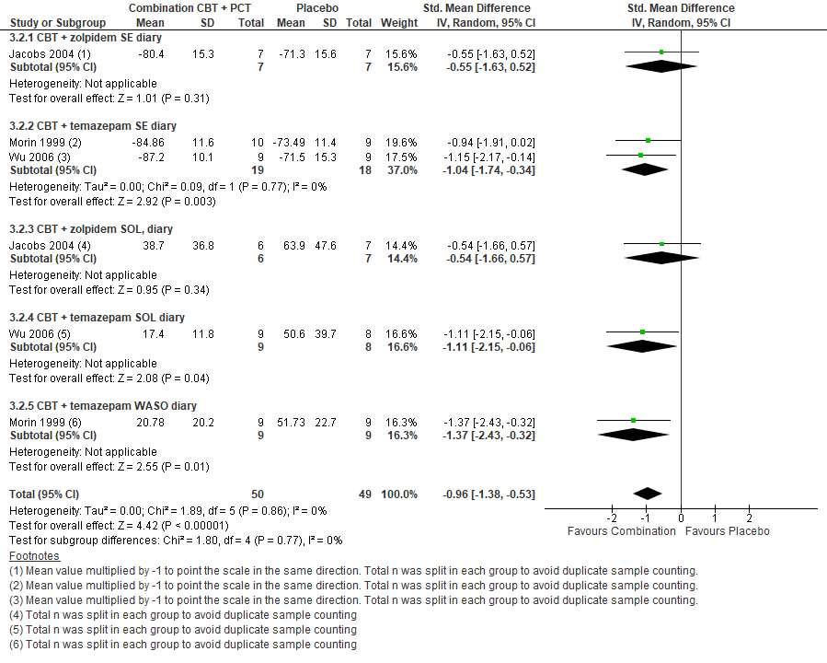
Re-expressed as a SE measure, the posttreatment mean in the combination group was 12.4% higher [95% CI 6.84, 17.8] compared to placebo. Re-expressed as a SL measure, the posttreatment mean in the combination group was -31.4 lower [95% CI -45.13, -17.33] compared to placebo. Re-expressed as a WASO measure, the posttreatment mean in the combination group was -20.5 lower [95% CI -29.53, -11.34] compared to placebo.
Figure S42. Combination: CBT-I + pharmacological vs placebo, Total sleep time, diary
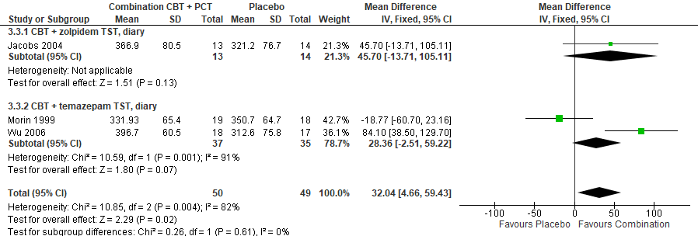
MD 32.04 minutes [95% CI 4.66, 59.43]

