SUPPLEMENTAL MATERIAL

Management of shift work disorder: an American Academy of Sleep Medicine systematic review, meta‑analysis, and GRADE assessment

All Literature Search Terms
(("sleep disorders, circadian rhythm"[MeSH Terms] AND "shift"[All Fields]) OR "shift work type" OR "shiftwork" OR "shiftwork disorder" OR "shiftwork sleep disorder" OR "shift work disorder" OR "shiftwork tolerance" OR "shift work tolerance" AND "english"[All Fields] ] AND ("1900/01/01"[PDAT] : "2020/10/01"[PDAT]) NOT "Editorial"[Publication Type] NOT "Letter"[Publication Type] NOT "Comment"[Publication Type] NOT "Case Reports"[Publication Type] NOT "Biography"[Publication Type] NOT "Review"[Publication Type]

("shiftwork" or "shiftwork disorder" or "shift work" or "shift work disorder" or "circadian rhythm disorder" or "CRSWD") AND (("bright light therapy" or "light therapy")) Filters: Humans

("shift work" OR "shiftwork" OR "shiftwork disorder" OR "shift work sleep disorder" OR "circadian rhythm disorder" or "CRSWD" OR "daytime sleep") AND ("cognitive behav* therap*" or "cognitive therap*" or "behav* therap*" or "CBT" or "CBT-I" or "ICBT") Filters: Humans

("shift work" OR "shiftwork" OR "shiftwork disorder" OR "shift work sleep disorder" OR "circadian rhythm disorder" or "CRSWD" OR "daytime sleep") AND (("clockwise" or "clockwise shift*") OR (counterclockwise or "counterclockwise shift*")) Filters: Humans

("shift work" OR "shiftwork" OR "shiftwork disorder" OR "shift work sleep disorder" OR "circadian rhythm disorder" or "CRSWD" OR "daytime sleep") AND ("timed diet" or "timed eating" or "timed meals" or "planned meals") Filters: Humans

Exclusion Criteria
Exclusion criteria are applied during the abstract review of all retrieved publications. Studies that met any of the exclusion criteria were rejected from the systematic review.

- Publication type
- Conference abstracts
- Editorials
- Review
- Methods
- Study type
- Animal research
- Case reports
- Case series
- Language non-English
- Diagnosis Sleep/wake symptoms NOT related to shift work will revisit for not using a diagnosis
- Patient population < 18 years of age
- Main study objective is NOT evaluating the efficacy/effectiveness of shift work treatments
- Does NOT include one of the following interventions of interest:
- Planned Sleep Schedules/ naps
- Timed Light and/or dark Exposure
- Timed Melatonin or other chronobiotic Administration
- Sleep Promoting Medications (e.g., Benzodiazepines, Benzodiazepine receptor agonists), or substances
- Stimulant Medications/ wake promoting medications, OTC, caffeine
- Timed Physical Activity/Exercise
- Diet and Meal Timing
- Combination Treatments
- CBT-I or Sleep hygiene
- Planned work schedule

Inclusion Criteria
Inclusion criteria are applied during the full publication review of all publications that were not rejected during the abstract review. Studies that meet all inclusion criteria will be accepted as evidence to use in the systematic review.

- Outcomes of interest (must meet at least 1)
  - Excessive sleepiness
  - total sleep time
  - sleep quality
  - circadian adaptation
  - quality of life
  - mental health
  - cognitive/ work performance
  - accident risk
- Publication type
  - RCTs:
    - intervention vs. attention control
    - intervention vs placebo
    - intervention vs standard of care
    - intervention vs waitlist
    - intervention vs intervention
  - Observational studies: longitudinally/cross-sectionally examines the effect(s) of the intervention
- Patients: Shift work disorder diagnosis (must meet at least 1)
  - Use of any of the 3 diagnostic systems, regardless of version: DSM-, ICSD, ICD-10
  - Use of validated sleep instruments in combination with quantitative objective/subjective measure
  - Other sleep complaints/criteria/symptoms that would require adjudication
- Interventions (must include at least 1)
- Planned Sleep Schedules/ naps
- Timed Light Exposure /dark
- Timed Melatonin or other chronobiotic Administration
- Sleep Promoting Medications (e.g., Benzodiazepines, Benzodiazepine receptor agonists) or substances
- Stimulant or wake-promoting medications, or other alerting agents, prescription or OTC
- Timed Physical Activity/Exercise
- Diet and Meal Timing
- Combination Treatments
- CBT-I or Sleep hygiene
- Planned work schedule

Abbreviations:
AASM -- American Academy of Sleep Medicine
ANAM- Automated neuropsychological assessment metrics
BDI – Beck depression inventory
CES-D – Center for Epidemiologic Studies Depression scale
CMT – Clinically Meaningful Threshold
CGI – Clinical Global Impressions Scale
CGI-I – Clinical Global Impressions-Improvement Scale
COI – conflict of interest
CPG – Clinical practice guideline
DLMO – Dim light melatonin onset
DSST – Digit symbol substitution test
EEG – Electroencephalogram
ESS – Epworth Sleepiness Scale
FDA – U.S. Food and Drug Administration
GAF – Global Assessment of Functioning
GRADE – Grading of Recommendations, Assessment, Development and Evaluation
GSDS – General Sleep Disturbance Scale
ISI – insomnia severity index
KSS – Karolinska sleepiness scale
MADRS – Montgomery-Åsberg depression rating scale
MAT- Memory and attention test
MSLT – Multiple sleep latency test
MWT – Maintenance of wakefulness test
PICO – Patient, intervention, comparator, outcome
POMS-A – Profile of moods-adolescent
PSG – Polysomnography
PSQI – Pittsburgh sleep quality index
PVT – Psychomotor vigilance test
RAND-PCS – physical component of the RAND-36
RAT – Remote associate’s test
RCT – Randomized controlled trial
SCI-90 – symptom check list 90
SD – Standard deviation
SF-36 – Short form 36 health questionnaire
SOL – Sleep onset latency
SMD – Standardized mean-difference
SR – Systematic review
SSI – Standard shiftwork index
SSS – Stanford sleepiness scale
TIB – Time in bed
TF – Task force
TST – Total sleep time
WASO – Wake after sleep onset
WHO-5 – world health organization- five well-being index

Table S0: Language Description
CPG Language | SR Language | Description
Clinically meaningful | Clinically meaningful | The point estimate and the entire 95% CI were all above the CMT
Potentially clinically meaningful | May have had a clinically meaningful | The point estimate was above the CMT; however, the 95% CI crossed the CMT
- | While not clinically meaningful | The point estimate was below the CMT; however, the 95% CI crossed the CMT
- | Little to no difference | The point estimate and the 95% CI fell in the no effect zone (between the CMTs)
- | Failed to show, or exclude either benefits or harms | The 95% CI crossed both CMTs
- | May [improve/worsen/increase, decrease] | The TF did not set a CMT, so clinical meaningfulness could not be noted

Table S1. Outcome tools for cognitive performance
Additional Cognitive Performance Tests
ANAM  - mean reaction time  Choice reaction time task  Coding task  - Number of correct substitutions  Conner’s continuous performance test  - Attentiveness  - No. of commission errors  - No. of omission errors  - Reaction time  Risk taking  Delayed word recall  Flight simulator  - Deviation from altitude flight  - Deviation from the velocity flight envelope  Difficulty in concentrating at work  Divided attention test  DSST  Dual task  - control losses  Four-choice serial reaction time  Free recall memory assessments  GO/NOGO  Grammatical reasoning test  - response time  Head steadiness  - percent of time off target  Karolinska sleep diary  - reduced performance  Letter cancellation task  - trials without false alarms | Mackworth clock vigilance task  MAT  Mistakes/near misses/accidents during the night shift  Power of attention test  Quality of episodic secondary memory  PVT  - number of lapses/errors  - reaction time  - speed  RAT  Running memory continuous performance task  SALT  - Correct Responses (%)  - Correction time (s)  - Empty items (%)  - Nonfaulty items (%)  - Time to respond  Serial simple reaction time test  Simple reaction time  Switching task  - Mannequin  - mannequin (throughput)  - Math  - Math (throughput)  Torrance test of creative thinking  Two-Letter Memory and Search Test  - reaction time  Visuo-spatial discrimination  Wilkinson four choice test  - reaction time (throughput)

PICO 1: Adults with shiftwork disorder

Symptoms of excessive sleepiness

Armodafinil

Summary of Findings (GRADE)
Table S2. Armodafinil in adults with shiftwork disorder
References: Black 2010, Czeisler 2009, Drake 2014, Erman 2011, Erman 2012, Howard 2014, Schwartz 2010
Outcomes [Tool] | Certainty of the evidence  (GRADE) | Absolute Difference  Armodafinil vs Control | No of Participants  (studies)
Excessive sleepiness or alertness  [MSLT]ª | ⨁⨁⨁⨁  HIGH | The mean difference in the armodafinil group was  4.5 minutes higher (1.83 higher to 7.17 higher) compared to control | 280  (3 RCTs)
Excessive sleepiness or alertness  [KSS]^{b} | ⨁⨁⨁◯  MODERATE^{c} | The mean difference in the armodafinil group was  0.99 points lower (1.32 lower to 0.65 lower) compared to control | 612  (3 RCTs)
Excessive sleepiness or alertness  [CGI-C]ª | ⨁⨁⨁⨁  HIGH | The risk ratio in the armodafinil group was 1.36 (1.15 to 1.61) with an absolute risk of 204 more per 1,000 (85 fewer to 346 more) compared to control | 510  (2 RCTs)
Accident risk  [Standard deviation of lateral position]^{b} | ⨁⨁◯◯  LOW^{d,e} | The mean difference in the armodafinil group was  0.5 meters lower (1.02 lower to 0.02 higher) compared to control | 40  (1 RCT)
Accident risk  [off-road deviations]^{b} | ⨁⨁◯◯  LOW^{c,d} | The mean difference in the armodafinil group was  5.19 deviations fewer (14.29 fewer to 3.91 more) compared to control | 40  (1 RCT)
Accident risk  [Sleep diary (commute home), mistakes made, near misses]^{b} | ⨁⨁⨁◯  MODERATE^{d,f} | The risk ratio in the armodafinil group was 0.62 (0.40 to 0.96) with an absolute risk of 205 fewer per 1,000 (324 fewer to 22 fewer) compared to control | 110  (1 RCT)
Cognitive performance^{e}  [Multiple tests]^{g} | ⨁⨁⨁◯  MODERATE^{d} | Armodafinil improves cognitive performance in the following outcome tools: DSST, RAT, free recall memory assessments, divided attention test, power of attention test quality of episodic secondary memory, delayed word recall, simple reaction time, and mistakes/near misses/accidents during the night shift. Studies included: Drake 2014 (n=40), Howard 2014 (n=24), and Czeisler 2009 (n=215) | (3 RCTs)
Serious adverse events^{b,g} | ⨁⨁⨁◯  MODERATE^{c} | The risk ratio in the armodafinil group was 0.60 (0.08 to 4.54) with an absolute risk of 3 fewer per 1,000 (6 fewer to 23 more) compared to control | 616  (2 RCTs)
Adverse events leading to withdrawal^{b,g} | ⨁⨁⨁◯  MODERATE^{c} | The risk ratio in the armodafinil group was 2.65 (0.94 to 7.49) with an absolute risk of 27 more per 1,000 (1 fewer to 105 more) compared to control | 616  (2 RCTs)
- Higher values favor the intervention
- Lower values favor the intervention
- Imprecision due to 95% CI crossing the CMT
- Imprecision due to small sample size (<200 participants)
- Imprecision due to 95% CI crossing the null
- Risk of bias due to selective reporting of the outcome
- CMT was not established by the TF

Study Characteristics
Table S3. Armodafinil in adults with shiftwork disorder
Study Citation | Study Design | Number of Participants (% Female) | Age: mean (SD) or range | Population | Intervention (dose) | Comparator | Time of Intervention Delivery | Duration of Follow-up
Black 2010 | non-RCT | 113 (42) | 42.7 (9.89) | SWD | Armodafinil (250 mg) | Baseline | 30-60 min before night shift, no later than 23:00 | 12 months
Czeisler 2009 | RCT | 245 (47) | Armodafinil: 38.9 (10.8)  Placebo: 40.3 (10.8) | SWD | Armodafinil (150 mg) | Placebo | Before each night shift and no later than 23:00 | 12 weeks
Drake 2014 | RCT | 20 (85) | 42.7 (8.7) | SWD | Armodafinil (150 mg) | Placebo | 23:45 | 1 night
Erman 2011 | RCT | 383 (46) | Armodafinil: 36.7 (10.7)  Placebo: 36.1 (10.8) | SWD | Armodafinil (150 mg) | Placebo | 30-60 min before night shift, no later than 23:00 | 6 weeks
Erman 2012 | RCT | 383 (46) | 18 to 65 | SWD | Armodafinil (150 mg) | Placebo | administered 30 to 60 minutes before the start of the night shift and no later than 11 PM | 6 weeks
Howard 2014 | RCT, crossover | 12 (54) | 33.75 (8.57) | SWD | Armodafinil (150 mg) | Placebo | Beginning of night shift | 1 night
Schwartz 2010 | non-RCT | 108 (36) | 39.6 ± 10.9 | SWD | Armodafinil (150 mg) | Baseline | 1 h before the start of the night shift but no later than 23:00 | 12 months

Critical Outcomes
Figure S1. Armodafinil vs placebo (Excessive Sleepiness, MSLT) [CMT = 1.0 min] RCT (SWD)
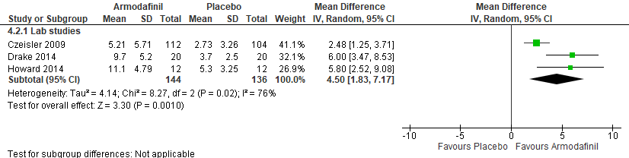
*Czeisler 2009: data from final visit, data extracted from Figure 2A, SEM converted to SD
Drake 2014: SEM converted to SD

Figure S2. Armodafinil vs placebo (Excessive Sleepiness, KSS) [CMT = 1.0 pt] RCT (SWD)
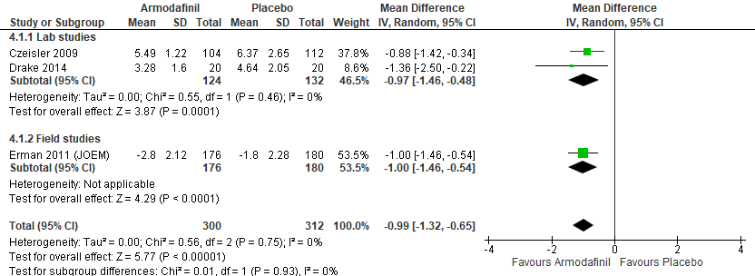
* Czeisler 2009: data from final visit, data extracted from Figure 3A, SEM converted to SD
Drake 2014: data pooled across all timepoints excluding baseline
Erman 2011 (JOEM): data from final visit, change from baseline data analyzed, SEM converted to SD

Figure S3. Armodafinil vs placebo (Excessive Sleepiness, CGI-C) [CMT = Not Established] RCT (SWD)
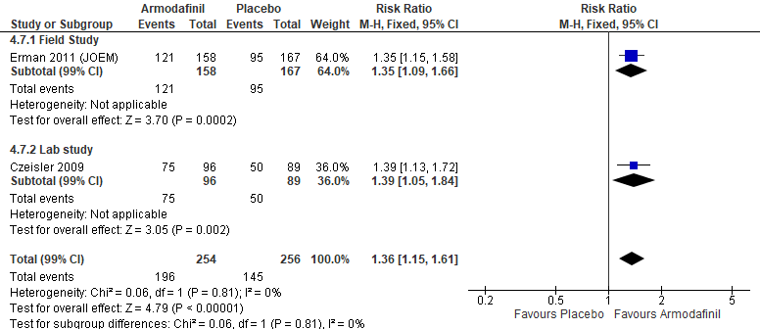
* Czeisler 2009: data from 12-weeks
Erman 2011 (JOEM): total events was calculated from percent improvement provided by the authors

Table S4. Armodafinil vs placebo (Excessive Sleepiness, CGI-C) [CMT = 1.0 pt or 50% responders] Non-randomized study (SWD)
Study | Study Design | Associated Disorder(s) | Outcome Tool | Study duration | Total no. of subjects | No. of subjects improved | Dosage | % of subjects with improved sleepiness
Black 2010 | Open-label extension study | Shiftwork Disorder | Excessive Sleepiness or Alertness (CGI-C) | 12 months | 105 | 92 | 250 mg | 88%
Schwartz 2010 | Open-label study | Shiftwork Disorder | Excessive Sleepiness or Alertness (CGI-C) | 12 months | 99 | 98 | 100  - 250 mg | 98%

Figure S4. Armodafinil vs placebo (Accident Risk, standard deviation of lateral position (SDLP)) [CMT = any improvement] RCT (SWD)
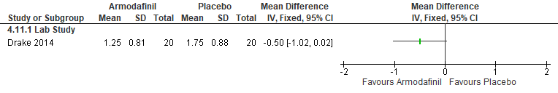
*Drake 2014: data received from authors, data averaged across the time points

Figure S5. Armodafinil vs placebo (Accident Risk, number of off-road deviation) [CMT = any improvement] RCT (SWD)
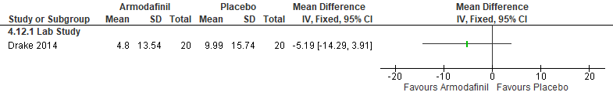
*Drake 2014: data received from authors, data averaged across the time points

Figure S6. Armodafinil vs placebo (Accident Risk, sleep diary during the commute home (number of mistakes, near misses, or accidents)) [CMT = any improvement] RCT (SWD)
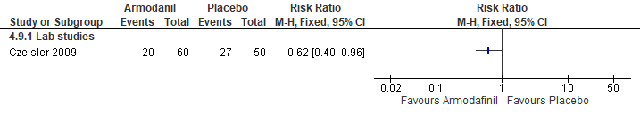*Czeisler 2009: commute home data used, change from baseline data converted to number of mistakes, near misses, or accidents

Figure S7. Armodafinil vs placebo (Sleep diary of mistakes, near misses, or accidents during the night shift) [CMT = Not Established] RCT (SWD)
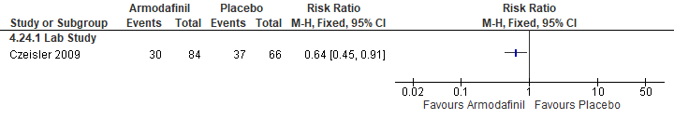*Czeisler 2009: during night shift data used, change from baseline data converted to number of mistakes, near misses, or accidents

Figure S8. Armodafinil vs placebo (Cognitive Performance, DSST number correct) [CMT = Not Established] RCT (SWD)
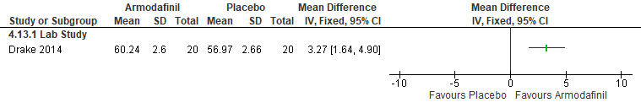
*Drake 2014: data averaged across 0100-0830 timepoints

Figure S9. Armodafinil vs placebo (Cognitive Performance, RAT) [CMT = Not Established] RCT (SWD)
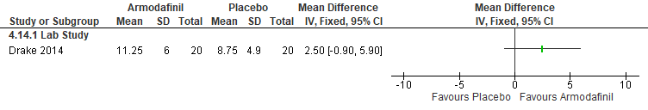

Figure S10. Armodafinil vs placebo (Cognitive Performance, free recall memory assessments) [CMT = Not Established] RCT (SWD)
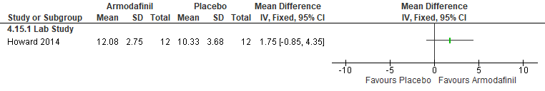

Figure S11. Armodafinil vs placebo (Cognitive Performance, Divided attention test -peripheral reaction time) [CMT = Not Established] RCT (SWD)
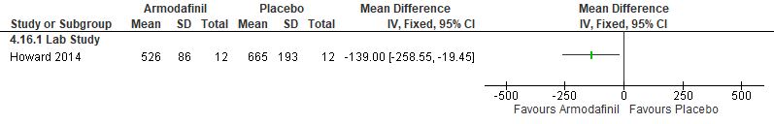

Figure S12. Armodafinil vs placebo (Cognitive Performance, Divided attention test -central reaction time) [CMT = Not Established] RCT (SWD)
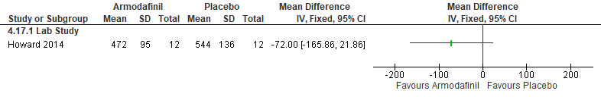
Figure S13. Armodafinil vs placebo (Cognitive Performance, Power of attention test) [CMT = Not Established] RCT (SWD)
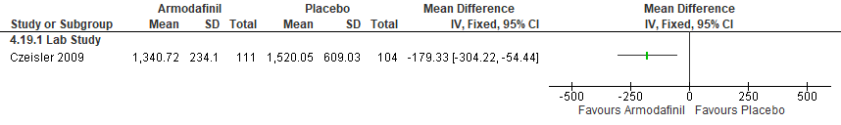
*Czeisler 2009: data from final visit, data extracted from Figure 3G, SEM converted to SD.

Figure S14. Armodafinil vs placebo (Cognitive Performance, quality of episodic secondary memory) [CMT = Not Established] RCT (SWD)
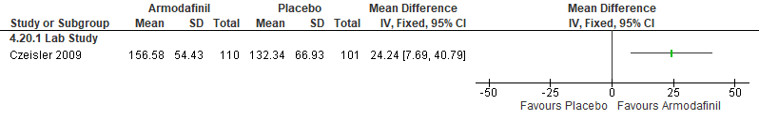
*Czeisler 2009: data from final visit, data extracted from Figure 3C, SEM converted to SD.

Figure S15. Armodafinil vs placebo (Cognitive Performance, delayed word recall (% correct)) [CMT = Not Established] RCT (SWD)
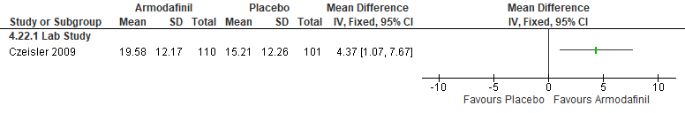
*Czeisler 2009: data from final visit, data extracted from Figure 3E, SEM converted to SD.

Figure S16. Armodafinil vs placebo (Cognitive Performance, simple reaction time) [CMT = Not Established] RCT (SWD)
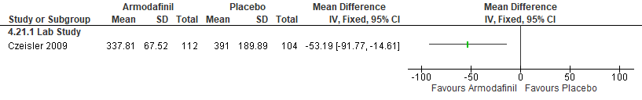
*Czeisler 2009: data from final visit, data extracted from Figure 3I, SEM converted to SD.

Important Outcomes
Figure S17. Armodafinil vs placebo (Total Sleep Time, PSG) [CMT =15 min] RCT (SWD)
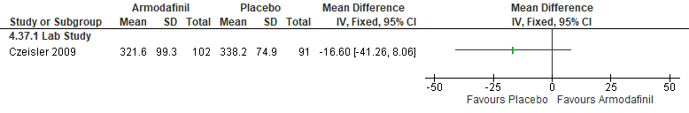
*Czeisler 2009: Daytime sleep measured.

Figure S18. Armodafinil vs placebo (Mental health, Global Assessment of Functioning (GAF)) [CMT = Not Established] RCT (SWD)
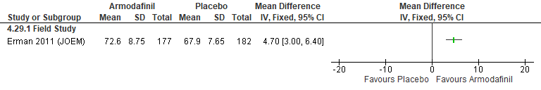
*Erman 2012: SEM converted to SD.

Figure S19. Armodafinil vs placebo (Quality of Life, modified Sheehan Disability Scale) [CMT = Not Established] RCT (SWD)
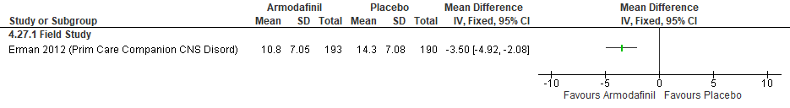*Erman 2012: SEM converted to SD.

Figure S20. Armodafinil vs placebo (Quality of Life, FOSQ-10) [CMT = Not Established] RCT (SWD)
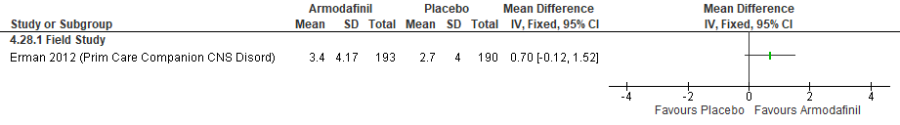
*Erman 2012: SEM converted to SD.

Figure S21. Armodafinil vs placebo (WASO, PSG) [CMT = 20 min] RCT (SWD)
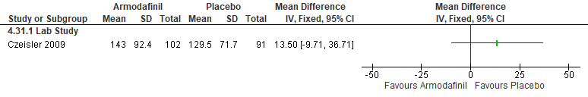
*Czeisler 2009: Daytime sleep measured.

Figure S22. Armodafinil vs placebo (Sleep Latency, PSG) [CMT = 20 min] RCT (SWD)
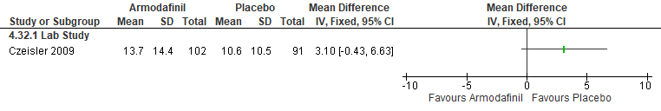
*Czeisler 2009: Daytime sleep measured.

Figure S23. Armodafinil vs placebo (Sleep Efficiency, PSG) [CMT = 10%] RCT (SWD)
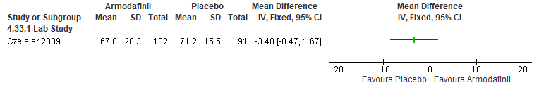
*Czeisler 2009: Daytime sleep measured.

Figure S24. Armodafinil vs placebo (Serious Adverse Events) [CMT = Not Established] RCTs (SWD)
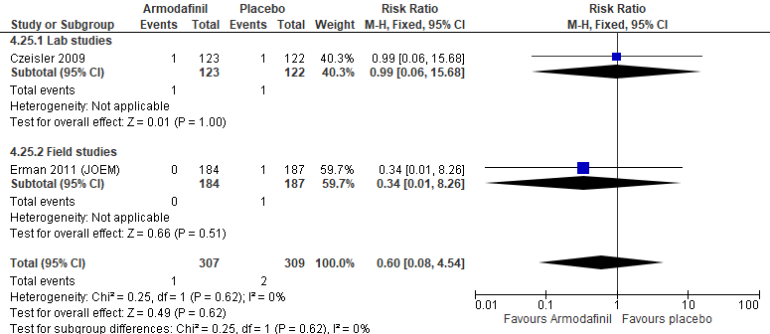

Figure S25. Armodafinil vs placebo (Adverse Events leading to withdrawal) [CMT = Not Established] RCT (SWD)
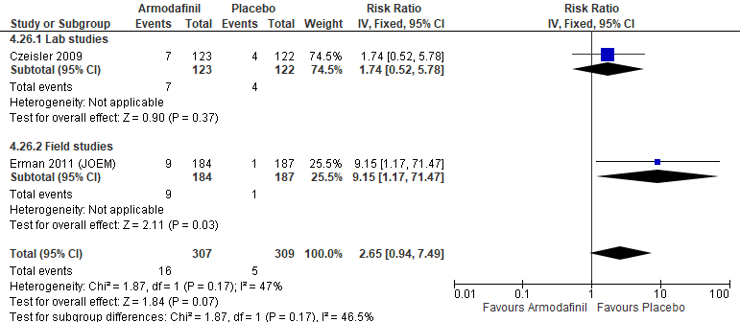

Modafinil

Summary of Findings (GRADE)
Table S5. Modafinil in adults with shiftwork disorder
References: Czeisler 2005, Dagan 2006, Walsh 2004, Gill 2006, Brun 1998
Outcomes [Tool] | Certainty of the evidence  (GRADE) | Absolute Difference  Modafinil vs Control | No of Participants  (studies)
Excessive sleepiness or alertness  [MSLT]ª | ⨁⨁◯◯  LOW^{b,c} | The mean difference in the modafinil group was  1.4 minutes higher (0.42 higher to 2.38 higher) compared to control | 182  (1 RCT)
Excessive sleepiness or alertness  [KSS]^{d} | ⨁⨁◯◯  LOW^{b,c} | The mean difference in the modafinil group was  1.1 points lower (1.69 lower to 0.51 lower) compared to control | 183  (1 RCT)
Excessive sleepiness or alertness  [CGI-C]^{a,e} | ⨁⨁⨁◯  MODERATE^{b} | The risk ratio in the modafinil group was 2.08 (1.57 to 2.78) with an absolute risk of 387 more per 1,000 (204 more to 637 more) compared to control | 193  (1 RCT)
Excessive sleepiness or alertness  [SSS]^{d} | ⨁⨁◯◯  LOW^{b,f} | The mean difference in the modafinil group was  0.7 points lower (0.86 lower to 0.54 lower) compared to control | 48  (1 RCT)
Excessive sleepiness or alertness  [MWT]ª | ⨁◯◯◯  VERY LOW^{b,f,g} | The mean difference in the modafinil group was  5.2 minutes higher (0.67 lower to 11.07 higher) compared to control | 32  (1 RCT)
Excessive sleepiness or alertness  [VAS: Difficulty attending lecture]^{d} | ⨁⨁⨁◯  MODERATE^{b} | The mean difference in the modafinil group was  23.64 mm lower (40.4 lower to 6.88 lower) compared to control | 50  (1 RCT)
Accident risk  [Electronic diary]^{d} | ⨁⨁⨁⨁  HIGH | The risk ratio in the modafinil group was 0.54 (0.38 to 0.78) with an absolute risk of 247 fewer per 1,000 (333 fewer to 118 fewer) compared to control | 204  (1 RCT)
Accident risk  [VAS: Difficulty driving home]^{d} | ⨁⨁◯◯  LOW^{b,g} | The mean difference in the modafinil group was  10.29 mm lower (25.52 lower to 4.94 higher) compared to control | 50  (1 RCT)
Cognitive performance  [PVT lapses]^{d} | ⨁⨁◯◯  LOW^{b} | The mean difference in the modafinil group was 6.38 lapses fewer (11.65 fewer to 1.11 fewer) compared to control | 135  (1 RCT)
Cognitive performance  [PVT lapses]^{d} | ⨁⨁◯◯  LOW^{b,f} | The mean difference in the modafinil group was 12.12 lapses fewer (22.44 fewer to 1.80 fewer) compared to control | 32  (1 RCT)
Cognitive performance^{g}  [multiple tests] | ⨁⨁◯◯  LOW^{b,f,g} | Modafinil improves cognitive performance in the following outcome tools: Number of correct substitutions during coding task, grammatical reasoning test response time, deviation from altitude flight, and deviation from the velocity flight envelope. Studies included: Gill 2006 (n=50), Brun 1998 (n=16), and Dagan 2006 (n=48) | (3 RCTs)
- Higher values favor the intervention
- Imprecision due to small sample size (<200 participants)
- Imprecision due to 95% CI crossing the CMT
- Lower values favor the intervention
- CMT was not established by the TF
- Indirectness is due to the fact that participants included in the studies are healthy individuals. The effect in adults with SWD may be different.
- Imprecision due to 95% CI crossing the null

Study Characteristics
Table S6. Modafinil in adults with shiftwork disorder
Study Citation | Study Design | Number of Participants (% Female) | Age (range) | Population | Intervention (dose/intensity) | Comparator | Time of Intervention Delivery | Duration of Follow-up
Brun 1998 | RCT, crossover | 8 (0) | 27–54 | Healthy participants | Modafinil (300 mg) | Placebo | 22:00 and 08:00 | 2 nights
Czeisler 2005 | RCT | 204 (39) | 18-60 | SWD | Modafinil (200 mg) | Placebo | 30-60 min before night shift | 3 months
Dagan 2006 | RCT, crossover | 24 (0) | 25 –31 | Healthy participants | Modafinil (200 mg) | Placebo | 23:00 | 1 night
Gill 2006 | RCT, crossover | 25 (20) | 27–54 | Shift workers without SWD diagnosis | Modafinil (200 mg) | Placebo | between 6:30 AM and 7:30 AM | 1 day
Walsh 2004 | RCT | 32 (47) | 18-55 | Healthy participants | Modafinil (200 mg) | Placebo | 22:00 | 4 nights

Critical Outcomes
Figure S26. Modafinil vs Placebo (Excessive Sleepiness, MSLT) [CMT= 1min] RCT (SWD)
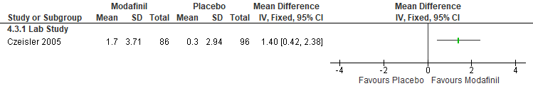
*Czeisler 2005:. SEM converted to SD, change from baseline data used

Figure S27. Modafinil vs Placebo (Excessive Sleepiness, KSS) [CMT= 1pt] RCT (SWD)
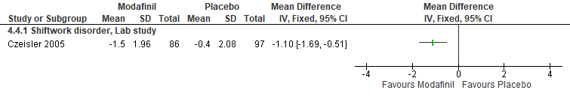 *Czeisler 2005: change score from baseline to final used. SEM converted to SD

Figure S28. Modafinil vs Placebo (Excessive Sleepiness, CGI-C) [CMT = Not Established] RCT (SWD)
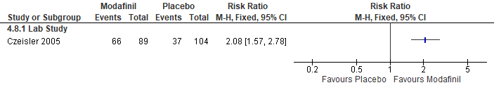
*Czeisler 2005: Treated as a dichotomous result, participants counted as improved if they were at least minimally improved on the CGI-C test at the final visit (data in supplementary appendix table 2)

Figure S29. Modafinil vs Placebo (Excessive Sleepiness, SSS) [CMT= 1pt] RCT (Healthy participants)
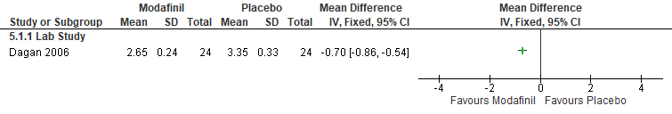
*Dagan 2006:data extracted from the Figure 2C

Figure S30. Modafinil vs Placebo (Excessive Sleepiness, MWT) [CMT= 2 min] RCT (Healthy participants)
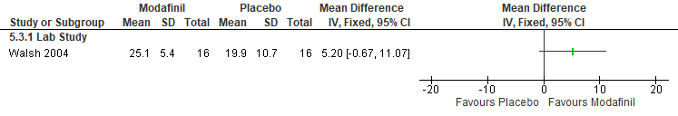
*Walsh 2004: nightshift 4 data

Figure S31. Modafinil vs Placebo (Excessive Sleepiness, VAS: difficulty attending lecture after taking pill) [CMT = Not Established] RCT (Shift workers without SWD diagnosis)
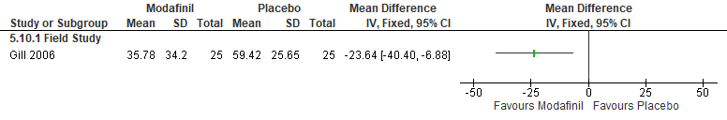
*Gill 2006: VAS scale, lower is better. Data was extracted from Figure 2A; SEM converted to SD

Figure S32. Modafinil vs Placebo (Accident Risk, E-diary- patients reporting accidents or near accidents) [CMT= any decrease] RCT (SWD)
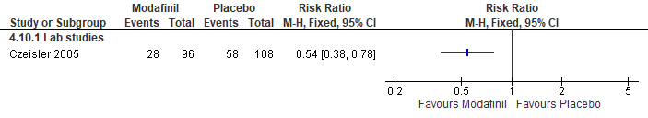
*Czeisler 2005: Patients reporting accidents or near accidents during the commute home

Figure S33. Modafinil vs Placebo (Accident Risk, VAS: difficulty driving home) [CMT= any improvement] RCT (Shift workers without SWD diagnosis)
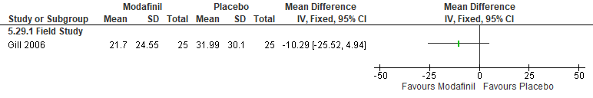 *Gill 2006: VAS scale, lower is better. Data was extracted from Figure 2C; SEM converted to SD

Figure S34. Modafinil vs Placebo (Cognitive Performance, PVT lapses) [CMT= 1 lapse] RCT (SWD)
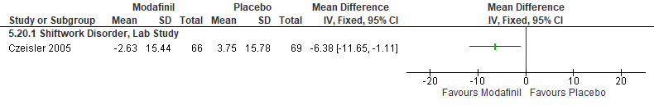*Czeisler 2005: Change from baseline data. SD calculated from p value

Figure S35. Modafinil vs Placebo (Cognitive Performance, PVT lapses) [CMT= 1 lapse] RCT (Healthy participants)
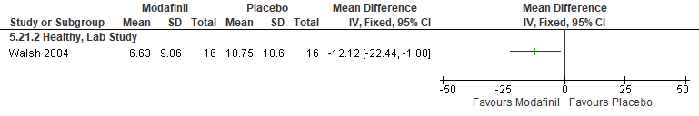
*Walsh 2004: data from nightshift 4, data extracted from Figure 3, SEM converted to SD

Figure S36. Modafinil vs Placebo (Cognitive Performance, number of correct substitutions during coding task) [CMT = Not Established] RCT (Shift workers without SWD diagnosis)
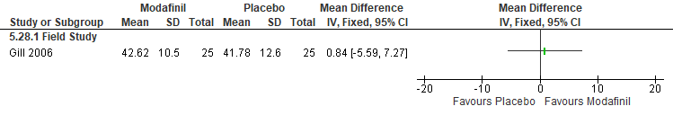*Gill 2006: Data was extracted from Figure 3; SEM converted to SD.

Figure S37. Modafinil vs Placebo (Cognitive Performance, grammatical reasoning test response time (%of scores of baseline conditions)) [CMT = Not Established] RCT (Healthy participants)
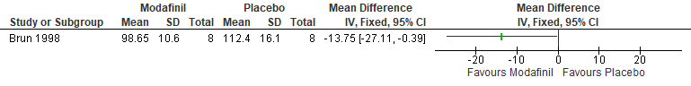
*Brun 1998: data averaged across the night for both the first 3 minutes and the next 3 minutes of each testing session, data extracted from Figure 2, SEM converted to SD

Figure S38. Modafinil vs Placebo (Cognitive Performance, deviation from altitude flight) [CMT = Not Established] RCT (Healthy participants)
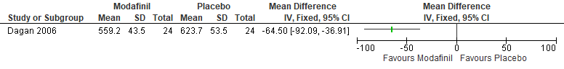
*Dagan 2006: data extracted from the figure 2b

Figure S39. Modafinil vs Placebo (Cognitive Performance, deviation from the velocity flight envelope (5am+7am)) [CMT = Not Established] RCT (Healthy participants)
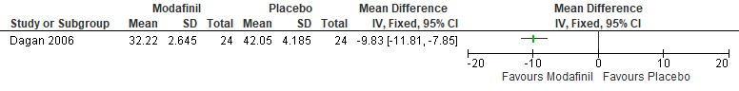
*Dagan 2006: data extracted from the figures 2e and 2g, data for 5 am and 7 am pooled

Important Outcomes
Figure S40. Modafinil vs Placebo (Total Sleep Time, PSG) [CMT= 15 min] RCT (SWD)
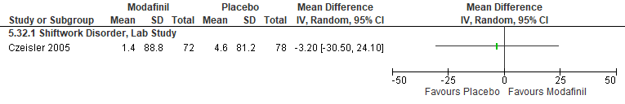
*Czeisler 2005: change from baseline data

Figure S41. Modafinil vs Placebo (Total Sleep Time, PSG) [CMT= 15 min] RCT (Healthy participants)
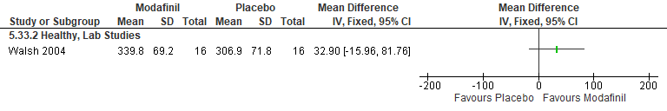
*Walsh 2004: day sleep on day 4, after 8-hour night shift

Figure S42. Modafinil vs Placebo (Sleep Latency, PSG) [CMT= 20 min] RCT (SWD)
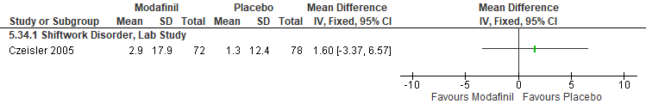
*Czeisler 2005: change from baseline data

Figure S43. Modafinil vs Placebo (Sleep Latency, PSG) [CMT= 20 min] RCT (Healthy participants)
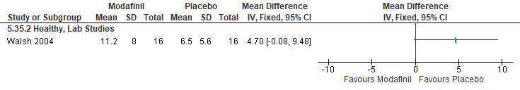
*Walsh 2004: data from day sleep on day 4

Figure S44. Modafinil vs Placebo (Sleep Efficiency, PSG) [CMT= 10%] RCT (SWD)
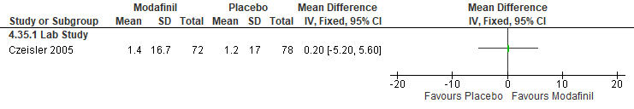

Figure S45. Modafinil vs Placebo (Sleep Efficiency, PSG) [CMT= 10%] RCT (Healthy)
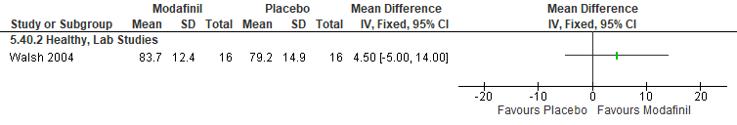
*Walsh 2004: data from day sleep on day 4

Figure S46. Modafinil vs Placebo (Sleep Efficiency, sleep diary) [CMT= 10%] RCT (SWD)
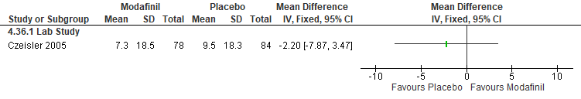

Acute bright light

Summary of Findings (GRADE)
Table S7. Acute bright light in adults with shiftwork disorder
 | References: Bjorvatn 1999, Kakooei 2010, Lowden 2004, Lowden 2012, Griepentrog 2018, Yoon 2002, Babkoff 2002, Costa 1995, Costa 1993, Badia 1991, Campbell 1990, Campbell 1995, Dawson 1991, Wright 1997, Ruger 2006, Weisgerber 2017, Leproult 1997, Figueiro 2016, Daurat 2000 (bio signals), Foret 1998, Huang 2013, Lammers-vanderHoist 2021, Leppamaki 2003, Horowitz 2001
 | Outcomes [Tool] | Certainty of the evidence  (GRADE) | Absolute Difference  Acute bright light vs Control | No of Participants  (studies)
 | Excessive sleepiness or alertness  [KSS]ª | ⨁⨁◯◯  LOW^{b,c} | The mean difference in the acute bright light group was  0.02 points more (0.40 fewer to 0.43 more) compared to control | 104  (2 RCTs)
 | Excessive sleepiness or alertness  [KSS]ª | ⨁◯◯◯  VERY LOW^{b,c,d} | The mean difference in the acute bright light group was  0.22 points fewer (0.48 fewer to 0.04 more) compared to control | 37  (2 non-RCTs)
 | Excessive sleepiness or alertness  [KSS]ª | ⨁◯◯◯  VERY LOW^{b,c,d,e} | The mean difference in the acute bright light group was  0.73 points fewer (1.43 fewer to 0.02 fewer) compared to control | 62  (2 RCTs)
 | Excessive sleepiness or alertness  [SSS]ª | ⨁◯◯◯  VERY LOW^{b,c,e} | The mean difference in the acute bright light group was 0.42 points fewer (0.92 fewer to 0.08 more) compared to control | 86  (1 RCT)
 | Excessive sleepiness or alertness  [SSS]ª | ⨁◯◯◯  VERY LOW^{b,c,d} | The mean difference in the acute bright light group was 0.04 points fewer (0.53 fewer to 0.45 more) compared to control | 54  (2 RCTs)
 | Excessive sleepiness or alertness  [VAS (alertness)]^{f,g} | ⨁⨁◯◯  LOW^{b,c} | The mean difference in the acute bright light group was  28.13 higher (14.71 higher to 41.55 higher) compared to control | 36  (1 RCT)
 | Excessive sleepiness or alertness  [VAS (alertness)]^{f,g} | ⨁◯◯◯  VERY LOW^{b,c,d,h} | The mean difference in the acute bright light group was  5.51 mm higher (7.33 lower to 18.35 higher) compared to control | 27  (1 RCT)
 | Excessive sleepiness or alertness  [VAS (ratings of arousal)]^{f,g} | ⨁◯◯◯  VERY LOW^{b,c,e} | The mean difference in the acute bright light group was  7.7 lower (21.64 lower to 6.24 higher) compared to control | 22  (1 RCT)
 | Excessive sleepiness or alertness  [VAS (Fatigue]^{f,g} | ⨁◯◯◯  VERY LOW^{b,c,d,h} | The mean difference in the acute bright light group was  1.00 lower (0.38 lower to 2.38 higher) compared to control | 24  (1 RCT)
 | Excessive sleepiness or alertness  [Fatigue rating scale]^{a,f} | ⨁◯◯◯  VERY LOW^{b,c,e} | The mean difference in the acute bright light group was  0.9 more (3.14 fewer to 4.94 more) compared to control | 30  (1 RCT)
 | Excessive sleepiness or alertness  [Seven point scale]^{a,f} | ⨁◯◯◯  VERY LOW^{b,c,h} | The mean difference in the acute bright light group was  0.5 higher (0.57 lower to 1.57 higher) compared to control on night one and 0.4 lower (1.63 lower to 0.83 higher) on night two. | 30  (1 RCT)
Excessive sleepiness or alertness  [MWT]^{g} |  | ⨁◯◯◯  VERY LOW^{b,c,d} | The mean difference in the acute bright light group was  2.58 minutes more (0.35 more to 4.81 more) compared to control | 39  (2 RCTs)
Excessive sleepiness or alertness  [RTSW]^{g} |  | ⨁⨁◯◯  LOW^{c,d} | The mean difference in the acute bright light group was 5.09 minutes more (2.70 more to 7.47 more) compared to control | 76  (2 RCTs)
Excessive sleepiness or alertness  [EEG]^{f} |  | ⨁◯◯◯  VERY LOW^{c,d,e} | Alertness was measured by EEG and reported Alpha, Beta, and Theta power in participants receiving bright light vs no bright light. | (1 RCT)
Excessive sleepiness or alertness  [GADS]^{f,g} |  | ⨁◯◯◯  VERY LOW^{b,c,d} | The mean difference in the acute bright light group was  0.02 lower (0.12 lower to 0.08 higher) compared to control | 16  (2 RCTs)
Accident risk  [Variability of Lane Position]ª |  | ⨁◯◯◯  VERY LOW^{b,c,d,e} | The mean difference in the acute bright light group was  0 variability (0.05 fewer to 0.05 more) compared to control | 38  (1 RCT)
Accident risk  [Total number of accidents/ incidents]ª |  | ⨁◯◯◯  VERY LOW^{b,c,d,e} | The mean difference in the acute bright light group was  8.98 lower (22.39 lower to 4.43 higher) compared to control | 38  (1 RCT)
Accident risk  [Steering Wheel Movements]ª |  | ⨁◯◯◯  VERY LOW^{b,c,d,e} | The mean difference in the acute bright light group was  4.09 movements fewer (9.14 fewer to 0.96 more) compared to control | 38  (1 RCT)
 | Sleep quality  [Sleep quality index]^{f,g} | ⨁◯◯◯  VERY LOW^{b,c,e} | The mean difference in the acute bright light group was  0 (0.28 lower to 0.28 higher)) compared to control | 36  (1 RCT)
 | Cognitive performance  [PVT lapses]ª | ⨁◯◯◯  VERY LOW^{b,c,d,e} | The mean difference in the acute bright light group was 2.50 lapses fewer (6.31 fewer to 1.31 more) compared to control. | 17  (1 RCT)
 | Cognitive performance  [multiple tests]^{f} | ⨁◯◯◯  VERY LOW^{b,d,h} | The evidence is very uncertain about the effect of bright light on cognitive performance. 10 studies reported on the effect of bright light on cognitive performance using the following tests: PVT reaction time, Choice reaction time, Visuo-spatial discrimination, letter cancellation task, dual task, Wilkinsons four choice, switching tasks, GO/NOGO, MAT, and SALT. The following studies were analyzed: Figueiro 2016, Griepentrog 2018, Lammers-vanderHolst 2021, Weisgerber 2017, Wright 1997, Babkoff 2002, Campbell 1990, Costa 1993, Foret 1998, Bjorvatn 1999, and Dawson 1995 | (11 RCTs)
 | Cognitive performance  [Reduced performance]^{a,f} | ⨁◯◯◯  VERY LOW^{b,c} | The mean difference in the acute bright light group was 10.40% lower (18.14 lower to 2.66 lower) compared to control. | 36  (1 non-RCT)
- Lower values favor the intervention
- Risk of bias due to lack of blinding
- Imprecision due to small sample size (<200 participants)
- Indirectness is due to the fact that participants included in the studies are healthy individuals. The effect in adults with SWD may be different.
- Imprecision due to 95% CI crossing the CMT
- CMT was not established by the TF
- Higher values favor the intervention
- Imprecision due to the 95% CI crossing the null

Study Characteristics
Table S8. Acute bright light in adults with shiftwork disorder
Study Citation | Study Design | Number of Participants (% Female) | Age (years) | Population | Intervention (dose/intensity) | Comparator | Time of Intervention Delivery | Duration of Follow-up
Babkoff 2002 | RCT, crossover | 12 (42) | 24.6 | Shift workers without SWD diagnosis | Bright light (3,000 lux) | Dim light (-20-50 Iux) and placebo | light exposure from 01:30-02:30 | 1 day
Badia 1991 | RCT | 19 (0) | 18 to 32 | Healthy participants | Bright light (5,000 - 10,000 lux) | Dim light (50 lux) | Continuous light during the night (23:00-08:00) | 1 day
Bjorvatn 1999 | non-RCT | 7 (0) | 38.9 | Shift workers without SWD diagnosis | Bright light (10,000 lux) | Normal light (20-700 lux) | 30 min between 03:30-05:30 during the first night at the platform | 1 day
Campbell 1990 | RCT | 25 (60) | 22.0 ± 2.6 | Healthy participants | Bright light (10-20 lux, 100 lux or 1000 lux) | dim ambient light (10-20 lux) | 23:00 to 07:00 on second simulated night shift | 3 nights
Campbell 1995 | RCT | 26 (27) | 49.1 ± 6.4 | Healthy participants | Bright light (>4,000 lux)  Bright light (1,000 lux) | dim light (<100 lux) | 4-hour pulse of bright light from 24:00 to 04:00 on night shift one  Exposure lasted for duration of the night shift on night shifts two and three | 3 nights
Costa 1993 | non-RCT, crossover | 15 (100) | 23.4 (range 21-29) | Shift workers without SWD diagnosis | Bright Light (2350 lux) | normal light (100 lux) | 4 x 20min during the night shift (before work and every 2hrs while working) | 2 nights
Costa 1995 | non-RCT, crossover | 15 (100) | 23.4 (range 21-29) | Shift workers without SWD diagnosis | Bright Light (2350 lux) | normal light (100 lux) | 4 x 20min during the night shift (before work and every 2hrs while working) | 2 nights
Daurat 2000 (Bio Signals) | RCT, crossover | 4 | 19–25 | Healthy participants | Bright light (2,000 lux) | Dim lux (<50 lux) | 20:00 to 08:00 in Experiment A  20:00–00:00 or 04:00–08:00 in Experiment B | 1 night
Dawson 1991 | RCT | 13 (46) | 21.2 ± 3.1 | Healthy participants | bright light (6,000 lux) | normal ambient room illumination (150-200 lux) | 24:00-04:00 on the first night shift | 1 night
Figueiro 2016 | RCT, crossover | 17 (53) | 22.5 years ± 5.9 | Healthy participants | white light goggles (361 + 4 lux) | dim light (<5 lux) | 19:00-21:00, 23:00-01:00, or 03:00-05:00 (120 min for each session) | 1 night
Foret 1998 | RCT | 8 (0) | 19-23 | Healthy participants | bright light (700-1,000 lux) | dim light (50 lux) | 20:00 - 08:00 | 1 night
Griepentrog 2018 | RCT, crossover | 31 (71) | 29 (IQR 26-32) | Shift workers without SWD diagnosis | Bright light (10,000 lux) | Ambient light (300 lux) | 19:00-05:00 | 4 weeks
Horowitz 2001 | RCT | 27 (74) | 26.99 ± 6.22 | Healthy participants | Bright light (2,500 lux) | room light (150 lux) | 23:00-05:00 | 3 nights
Huang 2013 | RCT | 92 (100) | 30.2 ± 4.5 (bright light)  30.3 ± 4.7 (control) | Shift workers without SWD diagnosis | Bright light (7,000-10,000 lux) | normal illumination (100-400 lux) | 23:00-00:00 | ≥ 10 days
Kakooei 2010 | RCT | 34 (100) | 27 | Shift workers without SWD diagnosis | bright light (4,500 lux) | dim light (300 lux) | 21:15–22:00 and 3:15–4:00 | 30 days
Lammers-van der Holst 2021 | RCT | 29 (52) | 27.7 ± 6.3 | Healthy participants | bright light (~8,000, ~2,500 and ~1,250 lux) | 103 lux | 23:00-07:00 (alternating 30 min intervals) | 4 weeks
Leppamaki 2003 | non-RCT | 86 (100) | 39.2 ±7.8 | Shift workers without SWD diagnosis | bright light (5000 lux) | Baseline | 20 minutes, between 22:00 - 23:00, 24:00 - 01:00, 02:00 - 03:00, and 04:00 - 05:00 | 6 weeks
Leproult 1997 | non-RCT | 17 (0) | 20-30 years | Healthy participants | bright light (2,000-5,000 lux) | Baseline | 3-h period of exposure to 5000 lux was bracketed by 30 min of exposure to 2000-2500 lux
Lowden 2004 | RCT, crossover | 18 (6) | 36.2 (3.0) | Shift workers without SWD diagnosis | bright light (2,500 lux) | Normal illumination (300 lx) | all breaks (20 min) during night work | 4 weeks
Lowden 2012 | non-RCT | 30 (7) | 47.2 (13.7) | Shift workers without SWD diagnosis | Dynamic lighting system: white/blue strong light (745 lux), moderate yellow light (700 lux), weak yellow light (650 lux) | weak yellow light (200 lux) | 0:00-02:00 on night 1, 0:00-01:00 on night 2 | 1 week
Ruger 2006 | RCT, crossover | 12 (0) | 21.8 (SD 1.9) | Healthy participants | bright light (5,000 lux) | dim light (10 lux) | 00:00-04:00 | 3 days
Weisgerber 2017 | RCT, crossover | 21 (29) | 22.8 ± 4 | Healthy participants | bright light (5600 lux) | dim light (35 lux) | 45 minutes after six hours of sleep deprivation | 1 night
Wright 1997 | RCT | 46 (0) | 18–25 y | Healthy participants | Bright Light-Placebo (2500 lux/200 mg sugar)  Dim Light-Caffeine (≤100 lux/200 mg caffeine)  Bright Light-Caffeine (2500 lux/200 mg caffeine) | Dim Light-Placebo (≤100 lux/200 mg sugar) | bright light from 20.00 to 08.00 hours  Caffeine at 20.00 and 02.00 hours each night | 2 nights
Yoon 2002 | RCT, crossover | 12 (100) | 21-24 | Shift workers without SWD diagnosis | Bright light (4,000-6,000 lux )  Sunglasses | room light followed by 1 hr exposure to sunlight or 10,000 lux from 08:30-09:30 | Bright light from 01:00 to 05:00  Sunglasses on the drive home (08:30-09:30) | 4 days

Critical Outcomes
Figure S47. Bright Light vs Control (Excessive Sleepiness, KSS) [CMT = 1 pts] RCT (Shift workers without SWD diagnosis)
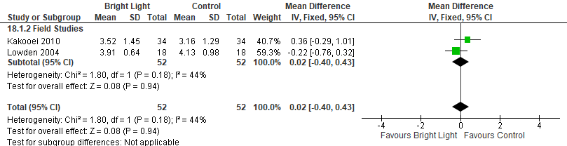
*Lowden 2004: data averaged over 3 weeks.

Figure S48. Bright Light vs Control (Excessive Sleepiness, KSS) [CMT = 1 pts] non-randomized studies (Shift workers without SWD diagnosis)
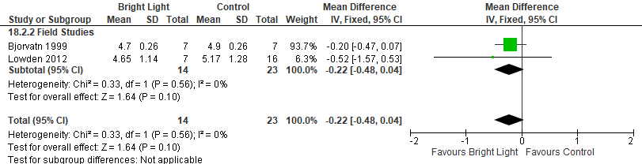
*Bjorvatn 1999: data reported at the platform
Lowden 2012: data extracted from Figure 2, pooled average from 3 nights; SEM converted to SD.

Figure S49. Bright Light vs Control (Excessive Sleepiness, KSS) [CMT = 1 pts] RCTs (Healthy participants)
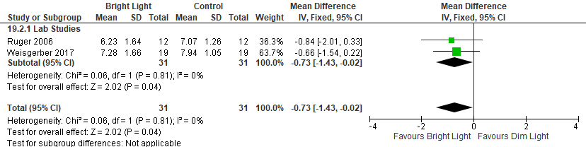 *Weisgerber 2017: SEM converted SD. KSS data from post-light and post-drive extracted from Figure 3A and averaged.
Ruger 2006: data extracted from Figure 3B, averaged across the night (24:00-5:00), SEM converted to SD

Figure S50. Bright Light vs Control (Excessive Sleepiness, SSS) [CMT = 1 pt] RCT (Shift workers without SWD diagnosis)
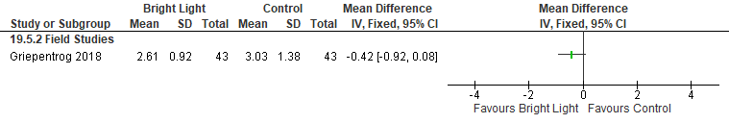 *Griepentrog 2018: Data extracted from Figure 3, SEM converted to SD

Figure S51. Bright Light vs Control (Excessive Sleepiness, SSS) [CMT = 1 pt] RCT (Healthy participants)
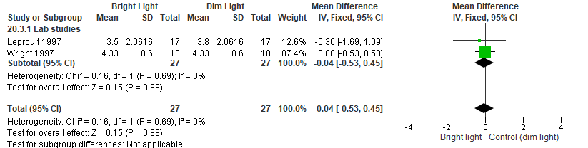 *Wright 1997: SEM converted SD.
Leproult 1997: data extracted from Figure 3, averaged across all timepoints, SEM converted to SD

Figure S52. Bright Light vs Control (Excessive Sleepiness, VAS – Alertness) [CMT = Not Established] RCT (Shift workers without a SWD diagnosis)
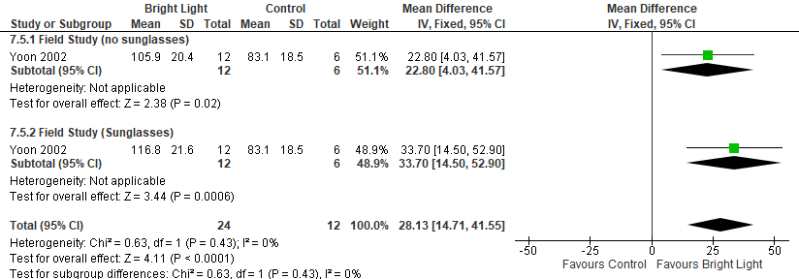*Yoon 2002: Data from Days 2-3, percent alertness compared with average of total 12 study days as 100%). control, n=12 participants were halved as to not double count
Figure S53. Bright Light vs Control (Excessive Sleepiness, VAS (Alertness)) [CMT = Not Established] RCT (healthy participants)
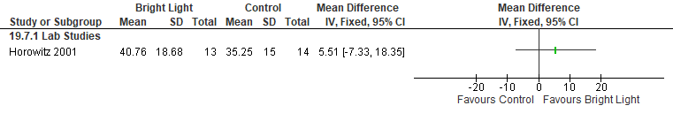 *Horowitz 2001: 100 mm=alert, data extracted from Figure 3A, night one data analyzed

Figure S54. Bright Light vs Control (Excessive Sleepiness, VAS - Rating of Arousal) [CMT = Not Established] RCT (shift workers without a diagnosis of SWD)
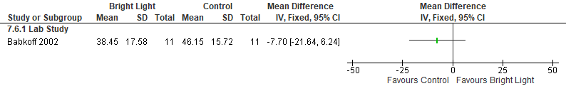*Babkoff 2002: Data extracted from graph (0230-0830); SEM converted to SD. Higher value represents higher arousal.

Figure S55. Bright Light vs Control (Excessive Sleepiness, VAS (Fatigue)) [CMT = Not Established] RCT (healthy participants)
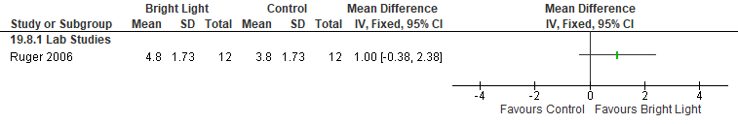
Ruger 2006: VAS fatigue=The scale consists of 18 items relating to the subjective experience of fatigue

Figure S56. Bright Light vs Control (Excessive Sleepiness, Fatigue Ratings) [CMT = Not Established] RCT (shift workers without a diagnosis of SWD)
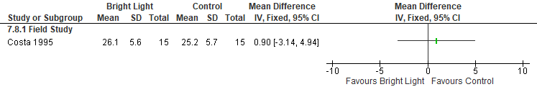
*Costa 1995: First night of bright light, overall fatigue (5 min to 35 max).

Figure S57. Bright Light vs Control (Excessive Sleepiness, seven-point scale first night) [CMT = Not Established] RCT (shift workers without a diagnosis of SWD)
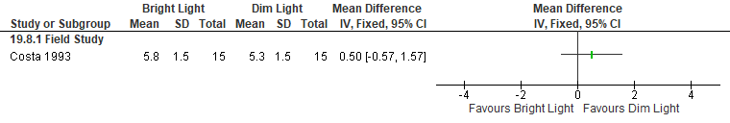 *Costa 1993: data from the end of first night

Figure S58. Bright Light vs Control (Excessive Sleepiness, seven-point scale second night) [CMT = Not Established] RCT (shift workers without a diagnosis of SWD)
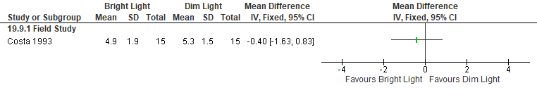 *Costa 1993: data from the end of second night

Figure S59. Bright Light vs Control (Excessive Sleepiness, MWT) [CMT = +2.0 min] RCTs (Healthy participants)
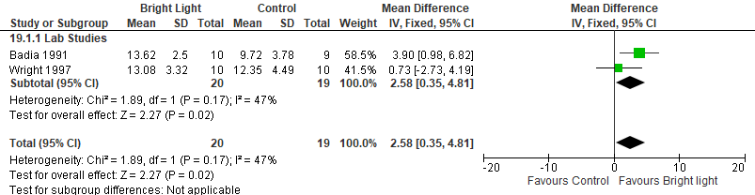
*Wright 1997: Night 1 data extracted from graph and averaged across the 4 naps (acute); SEM converted to SD.
Badia 1991: data extracted from figure 6, averaged across the blocks, SEM converted to SD

Figure S60. Bright Light vs Control (Excessive Sleepiness, RTSW) [CMT = +2.0 min] RCTs (Healthy participants)
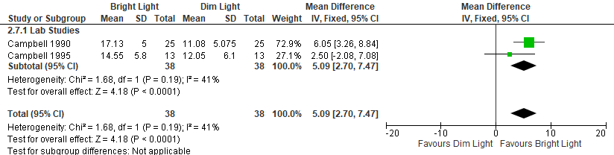* Campbell 1995: data extracted from Figure 3, night shift 2, data averaged across the night, SEM converted to SD

Figure S61. Bright Light vs Control (Excessive Sleepiness, EEG-Alpha) [CMT = Not Established] RCT (Healthy participants)
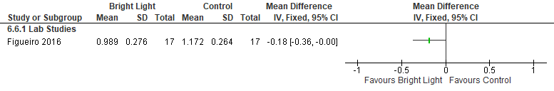*Figueiro 2016: White Light- 361±4 lux, Dim Light < 5 lux. Cross-over study (acceptable washout period). SEM converted to SD.

Figure S62. Bright Light vs Control (Excessive Sleepiness, EEG-Beta) [CMT = Not Established] RCT (Healthy participants)
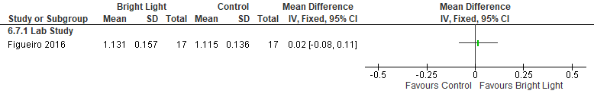
*Figueiro 2016: White Light- 361±4 lux, Dim Light < 5 lux. Cross-over study (acceptable washout period). SEM converted to SD.

Figure S63. Bright Light vs Control (Excessive Sleepiness, EEG-Theta) [CMT = Not Established] RCT (Healthy participants)
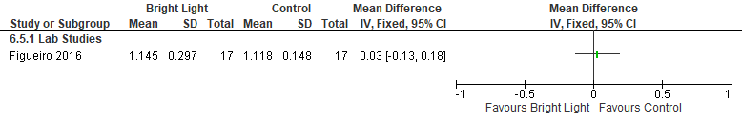*Figueiro 2016: White Light- 361±4 lux, Dim Light < 5 lux. Cross-over study (acceptable washout period). SEM converted to SD.

Figure S64. Bright Light vs Control (Excessive Sleepiness, GADS) [CMT =Not Established] RCT
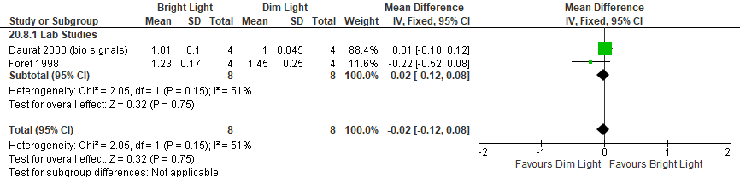
*Daurat 2000: data extracted from Figure 2, data averaged across the night, data from experiment A used
Foret 1998: 2000-2400 vs 400-800, data extracted from the graph, data averaged across the night 1

Figure S65. Bright Light vs Control (Accident Risk, Variability of Lane Position) [CMT = any decrease] RCT (Healthy participants)
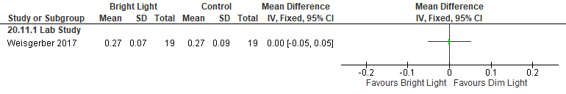
*Weisgerber 2017: BL-5600 lux, dim light <50 lux, Crossover study, all participants in both arms, acceptable washout period. Data averaged across laps; SEM converted SD

Figure S66. Bright Light vs Control (Accident Risk, Number of Accidents) [CMT =any decrease] RCT (Healthy participants)
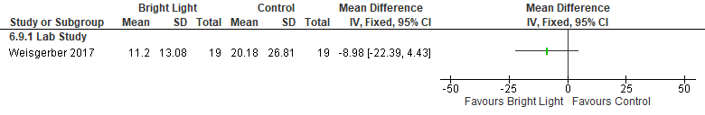
*Weisgerber 2017: BL-5600 lux, dim light <50 lux, Crossover study (acceptable washout period). Data extracted from graph (total number of accidents and incidents); SEM converted SD for study.

Figure S67. Bright Light vs Control (Accident Risk, Steering Wheel Movements) [CMT = any decrease] RCT (Healthy participants)
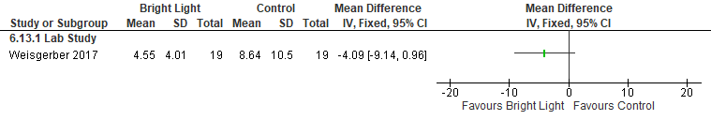
*Weisgerber 2017: BL-5600 lux, dim light <50 lux, Crossover study, all participants in both arms, acceptable washout period.
Data extracted from graphs and averaged across laps; SEM converted SD for stud

Figure S68. Bright Light vs Control (Sleep Quality, sleep quality index) [CMT = Not Established] RCT (Shift workers without a diagnosis of SWD)
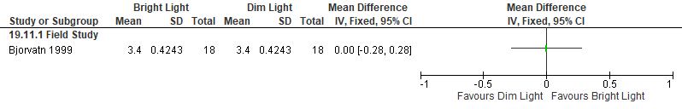

Figure S69. Bright Light vs Control (Cognitive Performance, PVT lapses) [CMT = 1 lapse] RCT (Healthy participants)
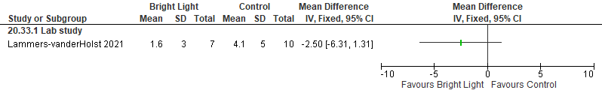

Figure S70. Bright Light vs Control (Cognitive Performance, GO/NOGO Normalized Reaction Time) [CMT = Not Established] RCT (Healthy participants)
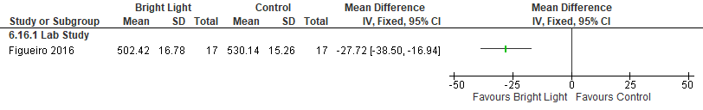
*Figueiro 2016: White Light 361±4 lux, Dim Light < 5 lux. Crossover study (acceptable washout period). SEM converted to SD, extracted from graphs.

Figure S71. Bright Light vs Control (Cognitive Performance, GO/NOGO 10% Best throughput) [CMT = Not Established] RCT (Healthy participants)
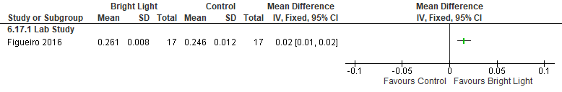
*Figueiro 2016: White Light 361±4 lux, Dim Light < 5 lux. Crossover study (acceptable washout period). SEM converted to SD, extracted from graphs.

Figure S72. Bright Light vs Control (Cognitive Performance, GO/NOGO 10% Worst throughput) [CMT = Not Established] RCT (Healthy participants)
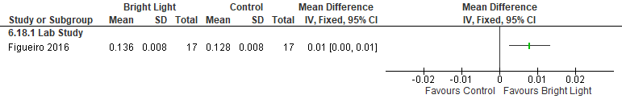
*Figueiro 2016: White Light 361±4 lux, Dim Light < 5 lux. Crossover study (acceptable washout period). SEM converted to SD, extracted from graphs.

Figure S73. Bright Light vs Control (Cognitive Performance, PVT mean reaction time, msec) [CMT = Not Established] RCT (Shift workers without SWD diagnosis)
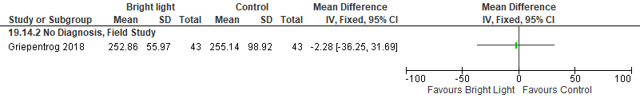
Griepentrog 2018: Bright Light (1500-2000 lux). Ambient Light (300 lux). RCT. Crossover, all participants split counted in both arms (acceptable washout period). Data extracted from graph; mean & SD calculated from median, range, and sample size using Hozo et al 2005 calculation.

Figure S74. Bright Light vs Control (Cognitive Performance, PVT mean reaction time, msec) [CMT = Not Established] RCT (Healthy participants)
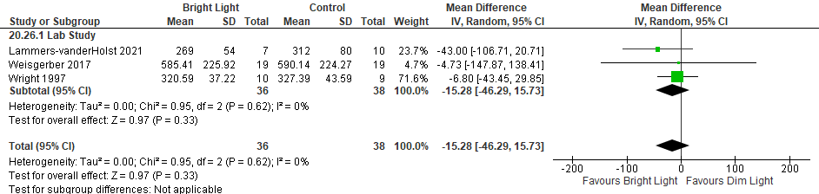
* Weisgerber 2017: BL 5600 lux, dim light <50 lux, Crossover study, all participants in both arms, acceptable washout period. SEM converted SD for study, data (post-light and post-drive) extracted from graph and averaged.
Wright 1997: Modified-PVT. BL-2500 lux, dim light<100 lux, data averaged across night 1; data extracted from graph; SEM converted to SD.

Figure S75. Bright Light vs Control (Cognitive Performance, Choice Reaction Time) [CMT = Not Established] RCT (shift workers without a diagnosis of SWD)
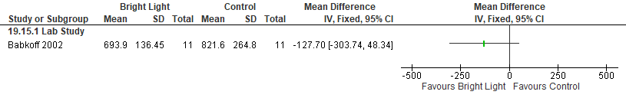
*Babkoff 2002: Bright Light (3000 lux for 1 hr from 0130-0230). Dim Light (~20-50 lux). Testing took place in dim light (<50 lux). Crossover (acceptable washout period). Data extracted from graph; SEM converted to SD.

Figure S76. Bright Light vs Control (Cognitive Performance, Wilkinson Four Choice Reaction Time (Throughput)) [CMT = Not Established] RCT (Healthy participants)
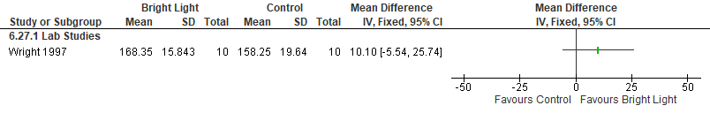
*Wright 1997: BL-2500 lux, dim light<100 lux, data averaged across night 1; SEM converted SD for study.

Figure S77. Bright Light vs Control (Cognitive Performance, Wilkinson Four Choice Reaction Time (percent improvement)) [CMT = Not Established] RCT (Healthy participants)
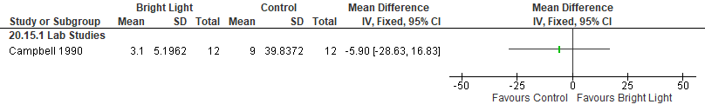*Campbell 1990: data extracted from the graph. SEM converted to SD, data presented as percent improvement

Figure S78. Bright Light vs Control (Cognitive Performance, Response Time to More Difficult Visuo-spatial Discrimination) [CMT = Not Established] RCT (shift workers without a diagnosis of SWD)
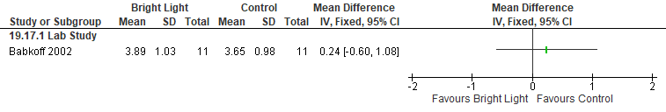
*Babkoff 2002: Bright Light (3000 lux for 1 hr from 0130-0230). Dim Light (~20-50 lux). Testing took place in dim light (<50 lux). Crossover (acceptable washout period). Data extracted from graph; SEM converted to SD, msec converted to sec.

Figure S79. Bright Light vs Control (Cognitive Performance, Response Time to Less Difficult Visuo-spatial Discrimination) [CMT = Not Established] RCT (Shift workers without a diagnosis of SWD)
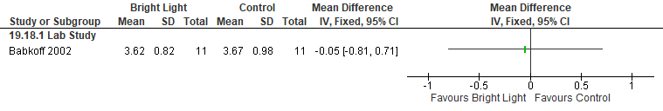
*Babkoff 2002: Bright Light (3000 lux for 1 hr from 0130-0230). Dim Light (~20-50 lux). Testing took place in dim light (<50 lux). Crossover (acceptable washout period). Data extracted from graph; SEM converted to SD, msec converted to sec.

Figure S80. Bright Light vs Control (Cognitive Performance, Letter Cancellation Task with no false alarms) [CMT = Not Established] RCT (Shift workers without a diagnosis of SWD)
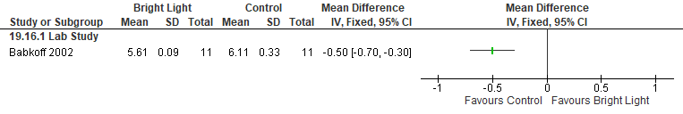
*Babkoff 2002: Bright Light (3000 lux for 1 hr from 0130-0230). Dim Light (~20-50 lux). Testing took place in dim light (<50 lux). Crossover (acceptable washout period). Data extracted from graph; SEM converted to SD.

Figure S81. Bright Light vs Control (Cognitive Performance, Search and Memory test (Reaction time)) [CMT = Not Established] RCT (Shift workers without a diagnosis of SWD)
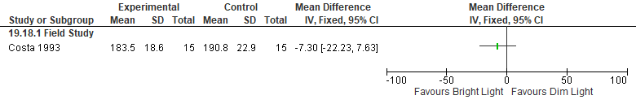 *Costa 1993: end of shift, first night, no diagnosis

Figure S82. Bright Light vs Control (Cognitive Performance, Search and Memory test (Reaction time)) [CMT = Not Established] RCT (Shift workers without a diagnosis of SWD)
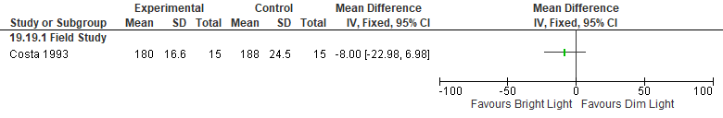*Costa 1993: end of shift, second night, no diagnosis

Figure S83. Bright Light vs Control (Cognitive Performance, Search and Memory test (Score)) [CMT = Not Established] RCT (Shift workers without a diagnosis of SWD)
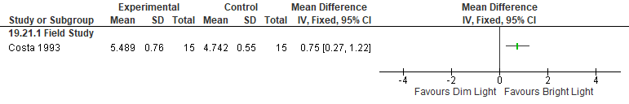*Costa 1993: end of shift, first night, no dx

Figure S84. Bright Light vs Control (Cognitive Performance, Search and Memory test (Score)) [CMT = Not Established] RCT (Shift workers without a diagnosis of SWD)
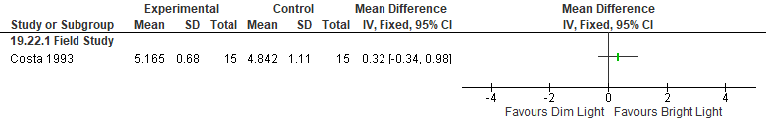*Costa 1993: end of shift, second night

Figure S85. Bright Light vs Control (Cognitive Performance, Search and memory test 3) [CMT = Not Established] RCT (Healthy participants)
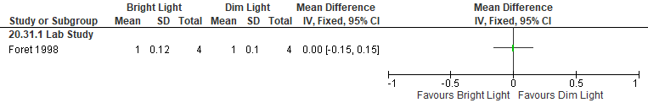
*Foret 1998: data extracted from the graph, night one averaged across the night, SEM converted to SD

Figure S86. Bright Light vs Control (Cognitive Performance, Search and memory test 5) [CMT = Not Established] RCT (Healthy participants)
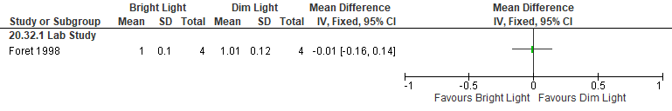*Foret 1998: data extracted from the graph, night one averaged across the night, SEM converted to SD

Figure S87. Bright Light vs Control (Cognitive Performance, Reduced performance (%)) [CMT = Not Established] RCT (shift workers without a diagnosis of SWD)
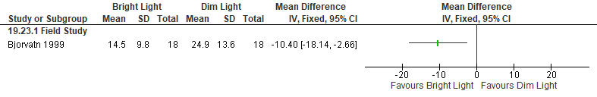

Figure S88. Bright Light vs Control (Cognitive Performance, Dual Task control losses) [CMT = Not Established] RCT (Healthy participants)
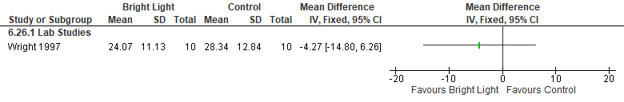
*Wright 1997: BL-2500 lux, dim light<100 lux, data averaged across night 1; SEM converted SD for study.

Figure S89. Bright Light vs Control (Cognitive Performance, Manikin (percent improvement)) [CMT = Not Established] RCT (Healthy participants)
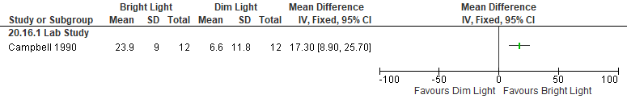*Campbell 1990: data extracted from the graph. SEM converted to SD, data presented as percent improvement

Figure S90. Bright Light vs Control (Cognitive Performance, Switching Task- Mannequin Throughput) [CMT = Not Established] RCT (Healthy participants)
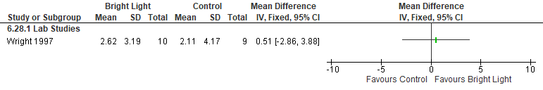
*Wright 1997: BL-2500 lux, dim light<100 lux, data averaged across night 1, data reported as change from baseline
SEM converted SD for study.

Figure S91. Bright Light vs Control (Cognitive Performance, Switching Task- Math Throughput) [CMT = Not Established] RCT (Healthy participants)
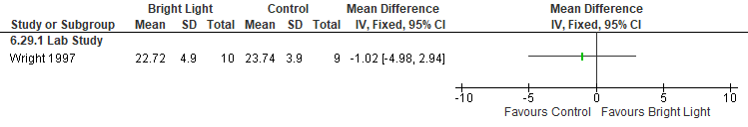
*Wright 1997: BL-2500 lux, dim light<100 lux, data averaged across night 1; SEM converted SD for study.

Figure S92. Bright Light vs Control (Cognitive Performance, Average tracking score in MAT tracking task) [CMT = Not Established] RCT (Healthy participants)
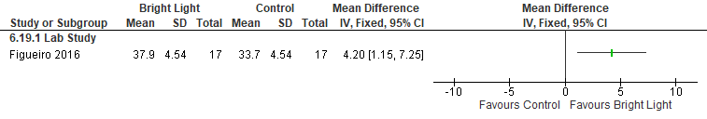
*Figueiro 2016: White Light 361±4 lux, Dim Light < 5 lux. Crossover study, all participants in both arms, acceptable washout period. SEM converted to SD.

Figure S93. Bright Light vs Control (Cognitive Performance, Night 1 % Correct SALT) [CMT = Not Established] RCT (Healthy participants)
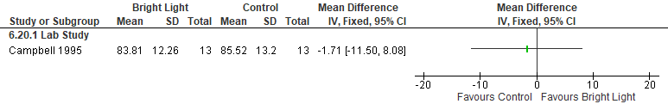
*Campbell 1995: BL >5000 lux (during the first 4 hours of NS1), dim light- <100 lux; Night 1 data was the average of timepoint during 2300- 0700 (acute). SEM converted to SD, extracted from graphs.

Figure S94. Bright Light vs Control (Cognitive Performance, Night 1 Time to respond SALT) [CMT = Not Established] RCT (Healthy participants)
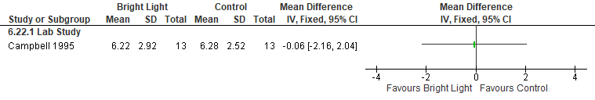
*Campbell 1995: BL >5000 lux (during the first 4 hours of NS1), dim light <100 lux; Night 1 data was the average of timepoint during 2300- 0700 (acute). SEM converted to SD, extracted from graphs.

Figure S95. Bright Light vs Control (Cognitive Performance, Logical Reasoning (percent improvement)) [CMT = Not Established] RCT (Healthy participants)
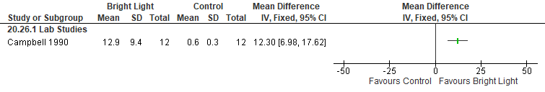 Campbell 1990: data extracted from the graph. SEM converted to SD, data presented as percent improvement

Figure S96. Bright Light vs Control (Cognitive Performance, Posner S-D AT Reaction Time (msec)) [CMT = Not Established] RCT (Healthy participants)
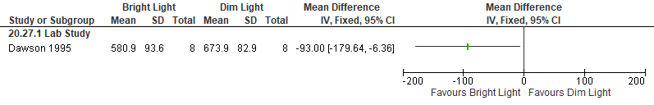 *Dawson 1995: data extracted from graph, SEM converted to SD, data from night shift 1 used

Figure S97. Bright Light vs Control (Cognitive Performance, Posner Variability (msec)) [CMT = Not Established] RCT (Healthy participants)
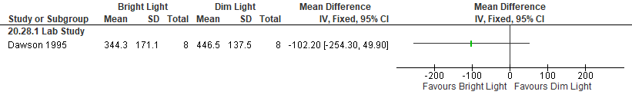*Dawson 1995: data extracted from graph, SEM converted to SD, data from night shift 1 used

Figure S98. Bright Light vs Control (Cognitive Performance, Manikin Reaction Time (msec)) [CMT = Not Established] RCT (Healthy participants)
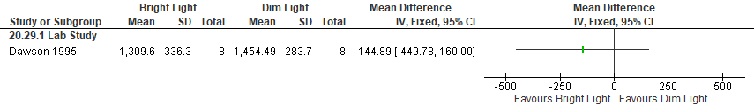*Dawson 1995: data extracted from graph, SEM converted to SD, data from night shift 1 used

Figure S99. Bright Light vs Control (Cognitive Performance, Manikin Throughput (msec)) [CMT = Not Established] RCT (Healthy participants)
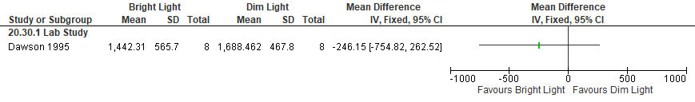*Dawson 1995: data extracted from graph, SEM converted to SD, data from night shift 1 used

Figure S100. Bright Light vs Control (Cognitive Performance, Simple reaction time) [CMT = Not Established] RCT
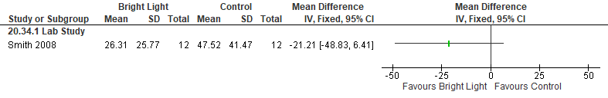

Important Outcomes
Figure S101. Bright Light vs Control (Total Sleep Time, Sleep Diary) [CMT = 15 min] non-RCT (shift workers without a diagnosis of SWD)
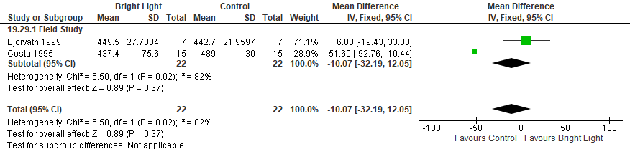 *Costa 1995: Hours converted to minutes. Length of sleep between first- and second-night shifts.
Bjorvatn 1999: SEM converted to SD, at the platform data used

Figure S102. Bright Light vs Control (Total Sleep Time, Actigraphy) [CMT = 15 min] RCT (shift workers without a diagnosis of SWD)
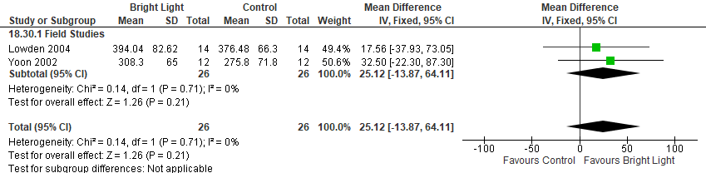
*Yoon 2002: Data averaged from 3 days, cross-over study (acceptable washout period), BL was 4-hour nocturnal light exposure of 4,000-6,000 lux.
Lowden 2004: Bright Light (2500 lux) or Normal light (300 lux) during their self-determined breaks during a night shift. Crossover, acceptable washout period. Data extracted from the graph and averaged; SEM converted to SD.

Figure S103. Bright Light vs Control (Total Sleep Time, Actigraphy) [CMT = 15 min] non-RCT (shift workers without a diagnosis of SWD)
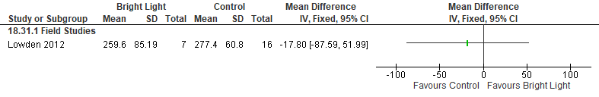 Lowden 2012: Bright light (650- 745 lux); pooled average from 3 nights. Control light (200 lux, weak yellow color); SEM converted to SD; hours converted to minutes

Figure S104. Bright Light vs Control (Mental Health, HADS) [CMT = Not Established] RCT (shift workers without a diagnosis of SWD)
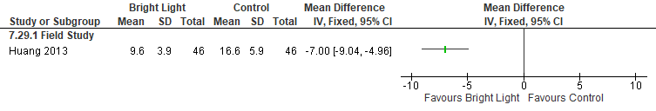
*Huang 2013: Bright light (7,000-10,000 lux for ≥ 30 min); Evening shift exposure took place between 19:30 and 20:30, while night shift exposure occurred between 23:00 and midnight. Higher scores on HADS indicate more severe impairment; used total score. No Dx.

Figure S105. Bright Light vs Control (Mental Health, Scale for shift-work complaints) [CMT = Not Established] non-RCT (shift workers without a diagnosis of SWD)
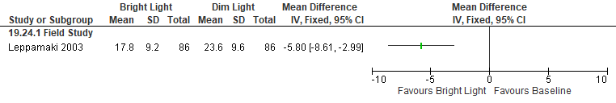

Figure S106. Bright Light vs Control (Mental Health, seven-point scale) [CMT = Not Established] RCT (shift workers without a diagnosis of SWD)
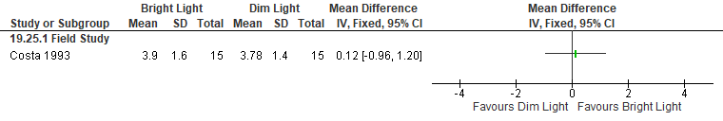*Costa 1993: end of shift, first night

Figure S107. Bright Light vs Control (Mental Health, seven-point scale) [CMT = Not Established] RCT (shift workers without a diagnosis of SWD)
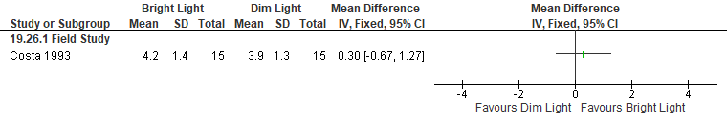*Costa 1993: end of shift, second night

Figure S108. Bright Light vs Control (Quality of life, Karolinska sleep diary) [CMT = Not Established] non-RCT (shift workers without a diagnosis of SWD)
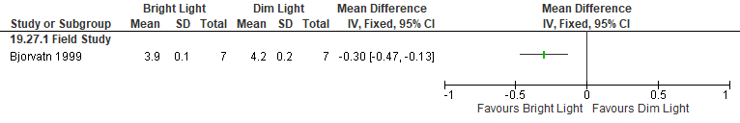 *Bjorvatn 1999: SEM converted to SD, at the platform data used, (1, very good; 9, very bad)

Figure S109. Bright Light vs Control (Disease severity, ISI) [CMT = 8] RCT (shift workers without a diagnosis of SWD)
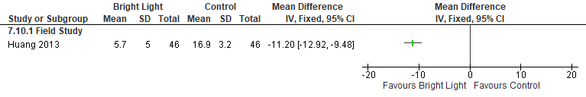
*Huang 2013: Nurses with ISI >14. Bright light (7,000-10,000 lux for ≥ 30 min) 19:30- 20:30 (for evening shift) or 23:00- midnight (for night shift); ISI= insomnia severity index, lower is better.

Figure S110. Bright Light vs Control (WASO, Karolinska sleep diary) [CMT = Not Established] non-RCT (shift workers without a diagnosis of SWD)
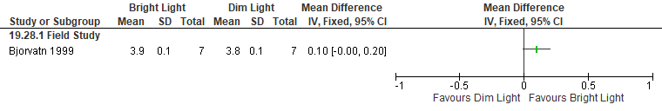 *Bjorvatn 1999: SEM converted to SD, at the platform data used, (1, many hours; 4, a few; 5, not awake), No dx

Figure S111. Bright Light vs Control (Wake After Sleep Onset, EEG) [CMT= 20 min], RCTs (Healthy participants)
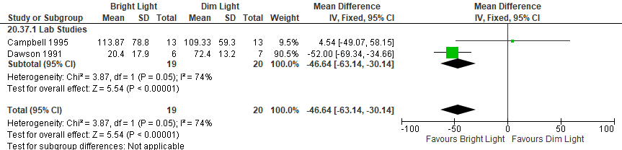

Figure S112. Bright Light vs Control (Sleep Latency, Karolinska sleep diary) [CMT = 20 min] RCT (shift workers without a diagnosis of SWD)
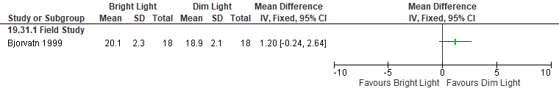

Figure S113. Bright Light vs Control (Sleep Latency, Actigraphy) [CMT = 15 min] RCT (shift workers without a diagnosis of SWD)
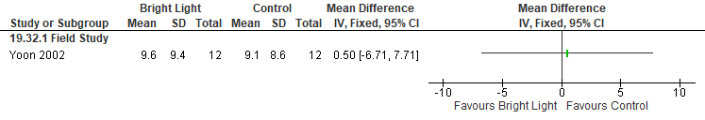

Figure S114. Bright Light vs Control (Sleep Latency, PSG/EEG) [CMT= 20 min], RCTs (Healthy participants)
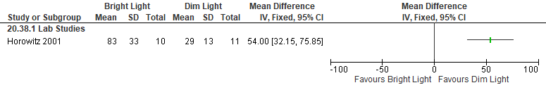 Horowitz 2001: free sleep, SD of sleep start, hours converted to minutes, healthy

Figure S115. Bright Light vs Control (Sleep Efficiency, Actigraphy) [CMT = 10%] RCT (shift workers without a diagnosis of SWD)
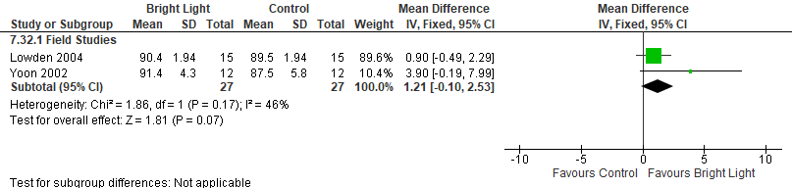
*Yoon 2002: Data from Days 2-3, cross-over study (acceptable washout period), BL was 4-hour nocturnal light exposure of 4,000-6,000 lux.
Lowden 2004: Bright Light (2500 lux) or Normal light (300 lux) during their self-determined breaks during a night shift.
Crossover, all participants counted in both arms (acceptable washout period). SEM converted to SD.

Figure S116. Bright Light vs Control (Sleep Efficiency, EEG) [CMT= 10%], RCTs (Healthy participants)
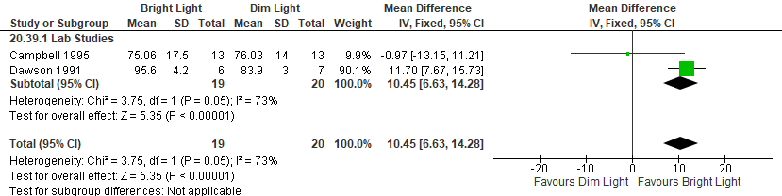

Caffeine

Summary of Findings (GRADE)
Table S9. Caffeine in adults with shiftwork disorder
References: Schweitzer 2006, Wright 1997, Dagan 2006, Muehlbach 1995, McHill 2014, Babkoff 2002, Carrier 2007, Centofanti 2020
Outcomes [Tool] | Certainty of the evidence  (GRADE) | Absolute Difference  Caffeine vs Control | No of Participants  (studies)
Excessive sleepiness or alertness  [MWT]ª | ⨁◯◯◯  VERY LOW^{b,c,d} | The mean difference in the caffeine group was  1.81 minutes more (0.13 more to 3.50 more) compared to control | 53  (2 RCTs)
Excessive sleepiness or alertness  [SSS]^{e} | ⨁⨁◯◯  LOW^{b,c} | The mean difference in the caffeine group was 0.82 points lower (0.97 lower to 0.66 lower) compared to control | 68  (2 RCTs)
Excessive sleepiness or alertness  [KSS]^{e} | ⨁◯◯◯  VERY LOW^{b,c,d} | The mean difference in the caffeine group was 1.40 points lower (2.60 lower to 0.20 lower) compared to control | 33  (1 RCT)
Excessive sleepiness or alertness  [MSLT]a | ⨁◯◯◯  VERY LOW^{b,c,d} | The mean difference in the caffeine group was 3.25 minutes higher (0.37 higher to 6.13 higher) compared to control | 30  (1 RCT)
Excessive sleepiness or alertness  [VAS (arousal)]^{a,f} | ⨁⨁◯◯  LOW^{c,g} | The mean difference in the caffeine group was  0.35 more (13.51 fewer to 14.21 more) compared to control | 22  (1 RCT)
Excessive sleepiness or alertness  [VAS (alertness)]^{a,f} | ⨁⨁◯◯  LOW^{b,c} | The mean difference in the caffeine group was  14.12 higher (6.58 higher to 21.65 higher) compared to control | 60  (2 RCTs)
Excessive sleepiness or alertness  [Samn Perelli Fatigue Scale]^{e,f} | ⨁⨁◯◯  LOW^{b,c} | The mean difference in the caffeine group was  1.62 lower (3.13 lower to 0.11 lower) compared to control | 12  (1 RCT)
Cognitive performance  [PVT lapses] ^{e} | ⨁◯◯◯  VERY LOW^{b,c,d} | The mean difference in the caffeine group was  3.20 lapses fewer (5.53 fewer to 0.88 fewer) compared to control | 45  (2 RCTs)
Cognitive performance  [multiple tests] ^{f} | ⨁⨁◯◯  LOW^{b,d} | The evidence suggests caffeine increases cognitive performance slightly. 4 studies reported on the effect of caffeine on cognitive performance using the following tests: Torrance test of creative thinking, PVT mean reaction time, dual task, switching task, Wilkinson four choice reaction time, SALT, and a Flight simulator. The following studies were analyzed: Wright 1997, Muehlbach 1995, Dagan 2006, Babkoff 2002 | (4 RCTs)
- Higher values favor the intervention
- Indirectness is due to the fact that participants included in the studies are healthy individuals. The effect in adults with SWD may be different.
- Imprecision due to small sample size (<200 participants)
- Imprecision due to 95% CI crossing the CMT
- Lower values favor the intervention
- CMT was not established by the TF
- Imprecision due to 95% CI crossing the null

Study Characteristics
Table S10. Caffeine in adults with shiftwork disorder
Study Citation | Study Design | Number of Participants (% Female) | Age in years | Population | Intervention (intensity) | Comparator | Time of Intervention Delivery | Duration of Follow-up
Babkoff 2002 | RCT, crossover | 12 (42) | 19-36 (Av: 24.6) | Shift workers without SWD diagnosis | Caffeine (200 mg) | placebo | caffeine or placebo given at 01:40 | 1 day
Carrier 2007 | RCT, crossover | 17 (59) | 37.2 ±3.5 | Shift workers without SWD diagnosis | caffeine (200 mg) | Placebo | 1 capsule (100mg) 3h prior to bedtime and 2nd capsule (100mg) 1 hr prior to bedtime | 1 night
Centofanti 2020 | RCT, crossover | 6 (67) | 21–36 y | Healthy participants | caffeine (200 mg) and nap (30 min) | Placebo and no nap | 3:30
Dagan 2006 | RCT, crossover | 24 (0) | 25 –31 | Healthy participants | Modafinil (200 mg)  Caffeine (200 mg) | Placebo | 23:00 | 1 night
McHill 2014 | RCT | 30 (3) | 21.6 ± 3.5 | Healthy participants | Caffeine (200 mg) | Placebo | 5 hours before daytime sleep | 1 night
Muehlbach 1995 | RCT | 30 (47) | 24.3 | Healthy participants | Caffeine (2 mg/kg) | Placebo | between 01:20 and 01:50 | 5 nights
Schweitzer 2006 | RCT | 68 (53) | 31.3 | Healthy participants | caffeine (4 mg/kg) | placebo | caffeine taken 30 minutes prior to night shifts | 4 nights
Wright 1997 | RCT | 46 (0) | 18–25 y | Healthy participants | Dim Light-Caffeine (≤100 lux/200 mg caffeine) | Dim Light-Placebo (≤100 lux/200 mg sugar) | bright light from 20.00 to 08.00 hours  Caffeine at 20.00 and 02.00 hours each night | 2 nights

Critical Outcomes
Figure S117. Caffeine vs Placebo (Excessive Sleepiness, MWT) [CMT = 2 min] RCT (Healthy participants)
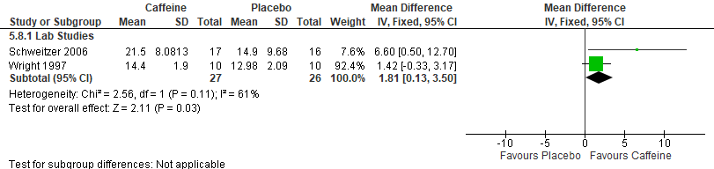
*Wright 1997: 200 mg caffeine was administered at 2000 and 0200. MWT data averaged over first night. SEM converted to SD.
Schweitzer 2006: 4 mg/kg of caffeine taken 30 minutes prior to night shifts. MWT data night one study. Data extracted from graph; SEM converted to SD.

Figure S118. Caffeine vs Placebo (Excessive Sleepiness, SSS) [CMT = 1pt] RCT (Healthy participants)
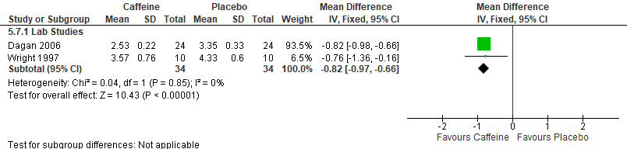*Dagan 2006: 200 mg of caffeine administered at 23:00 h, data extracted from the figure, SSS
Wright 1997: 200 mg total caffeine was administered at 100 mg at 20:00 h and 100 mg at 02:00 h. Used SSS data on first night. SEM converted to SD.

Figure S119. Caffeine vs Placebo (Excessive Sleepiness, KSS) [CMT= 1pt] RCT (Healthy participants)
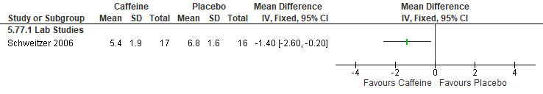
Schweitzer 2006: 4 mg/kg of caffeine taken 30 minutes prior to night shifts. KSS data only available on night 1.

Figure S120. Caffeine vs Placebo (Excessive Sleepiness, MSLT) [CMT= 1 min] RCT (Healthy participants)
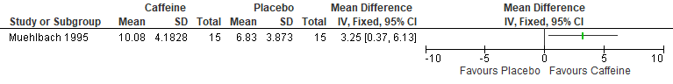
*Muehlbach 1995: Caffeine group received a mean of 142 mg (range: 98-197 mg) of caffeine at each nightly administration (2220 and 0120 hours), SEM converted to SD, data extracted from figure, data from night one.

Figure S121. Caffeine vs Placebo (Excessive Sleepiness/Alertness, VAS-arousal) [CMT = Not Established] RCT (Shift workers without SWD diagnosis)
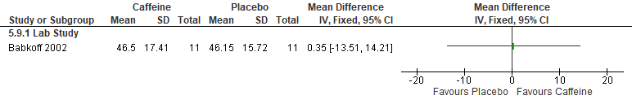*Babkoff 2002: 200 mg caffeine given at 0140. Higher values mean higher arousal. Crossover study, acceptable washout period. Data extracted from graph (0230- end of shift); SEM converted to SD.

Figure S122. Caffeine vs Placebo (Excessive Sleepiness, VAS-Alertness) [CMT = Not Established] RCT (Healthy participants)
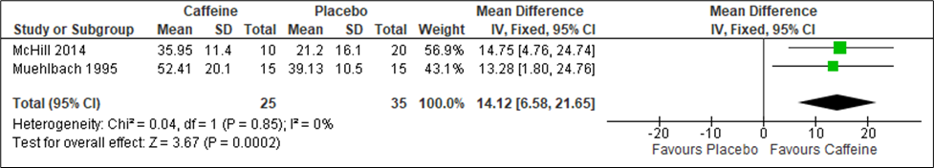
*Muehlbach 1995: Caffeine group received a mean of 142 mg (range: 98-197 mg) of caffeine at each nightly administration (2220 and 0120 hours), SEM converted to SD, data extracted from figure, data from night one.

Figure S123. Caffeine vs Placebo (Excessive Sleepiness, Samn Perelli Fatigue Scale) [CMT = Not Established] RCT (Healthy participants)
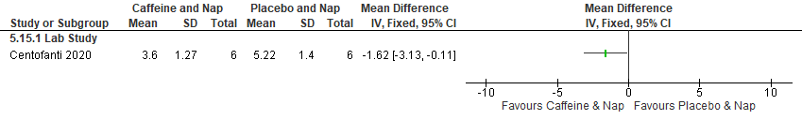*Centofanti 2020: Caffeine give at 0325 (and 30 min nap at 0330). SP Fatigue Scale, higher numbers represent sleepier. Crossover study, acceptable washout period. Data extracted from graph (post-nap 0400-0445); SEM converted to SD.

Figure S124. Caffeine vs Placebo (Cognitive Performance, PVT lapses) [CMT = 1 lapse] RCTs (Healthy participants)
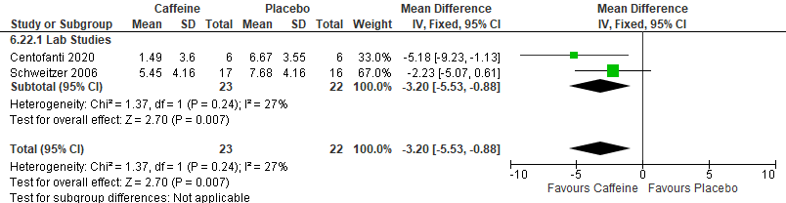*Centofanti 2020: Caffeine give at 0325 (and 30 min nap at 0330). Crossover study, acceptable washout period. Data extracted from graph (post-nap 0400-0445); SEM converted to SD.
Schweitzer 2006: 4 mg/kg of caffeine taken 30 minutes prior to night shifts. Use PVT lapse ave (night 4). Data extracted from graph; SEM converted to SD.

Figure S125. Caffeine vs Placebo (Cognitive Performance, Torrance test of creative thinking (verbal/ figural)) [CMT = Not Established] RCT (Healthy participants)
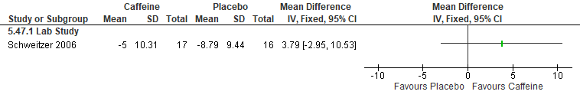*Schweitzer 2006: 4 mg/kg of caffeine taken 30 minutes prior to night shifts. Torrance test of creative thinking was measured by change from baseline for standard score for fluency. (There were no significant group effects for the Torrance test in flexibility or originality). Only night average was given. Data extracted from graph; SEM converted to SD.

Figure S126. Caffeine vs Placebo (Cognitive Performance, modified PVT (mean reaction time)) [CMT = Not Established] RCT (Healthy participants)
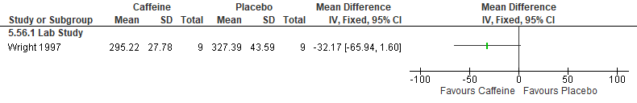
*Wright 1997: 200 mg caffeine was administered at 2000 and 0200. Cognitive performance data averaged over first night (0030-0630). Data extracted from graphs; SEM converted to SD.

Figure S127. Caffeine vs Placebo (Cognitive Performance, dual task (control losses)) [CMT = Not Established] RCT (Healthy participants)
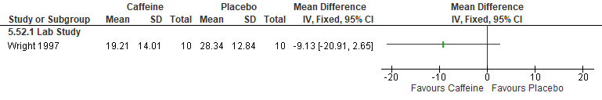
*Wright 1997: 200 mg caffeine was administered at 20:00 and 02:00. Cognitive performance data averaged over the first night (0030-0630). Data extracted from graphs; SEM converted to SD.

Figure S128. Caffeine vs Placebo (Cognitive Performance, switching task, mannequin (throughput- change from baseline)) [CMT = Not Established] RCT (Healthy participants)
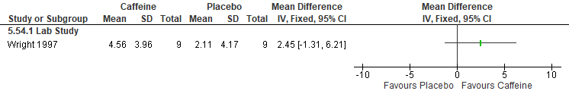
*Wright 1997: data averaged over the first night (0030-0630). Data extracted from graphs; SEM converted to SD.

Figure S129. Caffeine vs Placebo (Cognitive Performance, Wilkinson four choice reaction time (throughput)) [CMT = Not Established] RCT (Healthy participants)
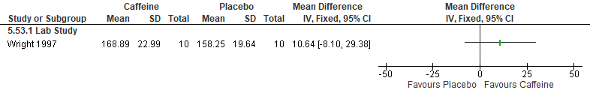
*Wright 1997: data averaged over the first night (00:30-06:30). Data extracted from graphs; SEM converted to SD.

Figure S130. Caffeine vs Placebo (Cognitive Performance, switching task- math (throughput)) [CMT = Not Established] RCT (Healthy participants)
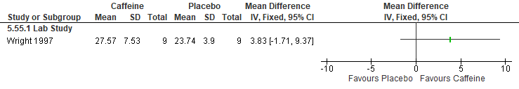
*Wright 1997: data averaged over the first night (0030-0630). Data extracted from graphs; SEM converted to SD.

Figure S131. Caffeine vs Placebo (Cognitive Performance, SALT (Correct Responses (%)) [CMT = Not Established] RCT (Healthy participants)
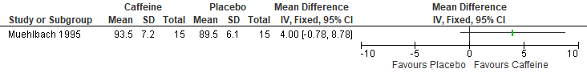
*Muehlbach 1995: data from night one

Figure S132. Caffeine vs Placebo (Cognitive Performance, SALT (Correction time (seconds)) [CMT = Not Established] RCT (Healthy participants)
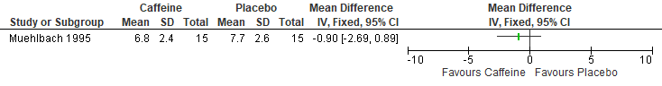*Muehlbach 1995: data from night one

Figure S133. Caffeine vs Placebo (Cognitive Performance, SALT (Nonfaulty items (%)) [CMT = Not Established] RCT (Healthy participants)
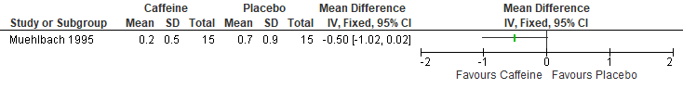
*Muehlbach 1995: data from night one

Figure S134. Caffeine vs Placebo (Cognitive Performance, SALT (Empty items (%)) [CMT = Not Established] RCT (Healthy participants)
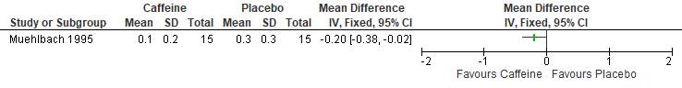*Muehlbach 1995: data from night one

Figure S135. Caffeine vs Placebo (Cognitive Performance, Flight Simulator (deviation from altitude)) [CMT = Not Established] RCT (Healthy participants)
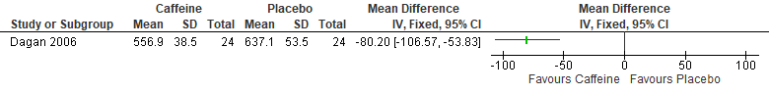
*Dagan 2006: data extracted from the figure

Figure S136. Caffeine vs Placebo (Cognitive Performance, Flight Simulator (deviation from velocity)) [CMT = Not Established] RCT (Healthy participants)
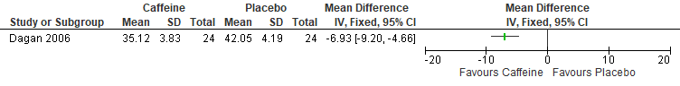*Dagan 2006: data extracted from the figure, 5 am and 7 am data pooled

Figure S137. Caffeine vs Placebo (Cognitive Performance, choice reaction time) [CMT = Not Established] RCT (Shift workers without SWD diagnosis)
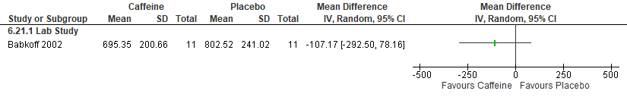*Babkoff 2002: 200 mg caffeine given at 0140. Choice reaction timed measured in milliseconds. Crossover study, acceptable washout period. Data extracted from graph (0230- end of shift); SEM converted to SD. Also, side note the visuo-spatial discrimination did not differ over treatment conditions.

Figure S138. Caffeine vs Placebo (Cognitive Performance, trials without false alarms during the letter cancellation task) [CMT = Not Established] RCT (Shift workers without SWD diagnosis)
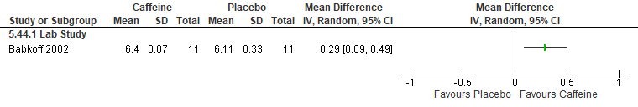 *Babkoff 2002: 200 mg caffeine given at 0140. Number of trials without false alarms measured during letter cancellation task. Crossover study, acceptable washout period. Data extracted from graph (only night average given); SEM converted to SD.

Important Outcomes

Figure S139. Caffeine vs Placebo (TST, PSG) [CMT= 15 min] RCT (Healthy participants)
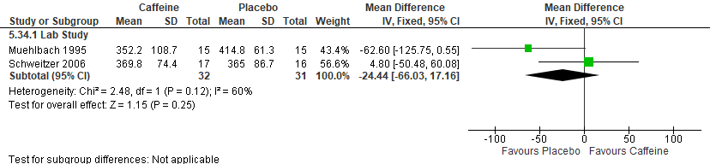
*Schweitzer 2006: 4 mg/kg of caffeine taken 30 minutes prior to night shifts. Data from night one
Muehlbach 1995: Caffeine group received a mean of 142 mg (range: 98-197 mg) of caffeine at each nightly administration (2220 and 0120 hours), data from night one.
Figure S140. Caffeine vs Placebo (Total Sleep Time, PSG) [CMT= 15 min] RCT (Shift workers without SWD diagnosis)
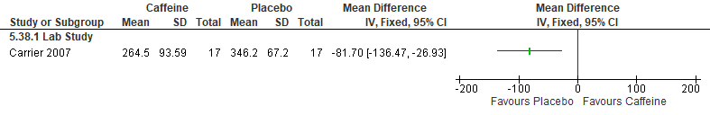
*Carrier 2007: Day sleep group (n=17) sleep deprived for 25 hrs and recovery sleep started in the morning, 1 hr after their habitual wake time. Caffeine given in 2 capsules, 1 capsule (100mg) 3h prior to bedtime and 2nd capsule (100mg) 1 hr prior to bedtime. Crossover, acceptable washout period. SEM converted to SD.

Figure S141. Caffeine vs Placebo (TST, Subjective Questionnaire) [CMT= 15 min] RCT (Healthy participants)
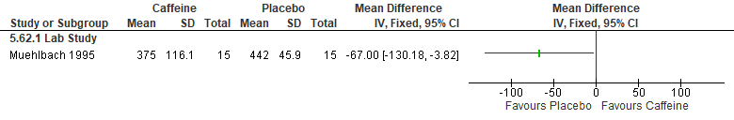
Muehlbach 1995: Caffeine group received a mean of 142 mg (range: 98-197 mg) of caffeine at each nightly administration (2220 and 0120 hours), data from night one

Figure S142. Caffeine vs Placebo (WASO, Subjective Questionnaire) [CMT= 20 min] RCT (Healthy participants)
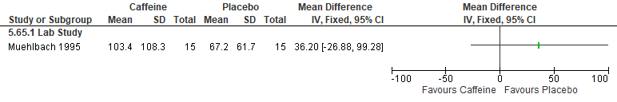 Muehlbach 1995: Caffeine group received a mean of 142 mg (range: 98-197 mg) of caffeine at each nightly administration (22:20 and 01:20 hours), data from night one

Figure S143. Caffeine vs Placebo (Sleep Latency, PSG) [CMT= 20 min] RCT (Healthy participants)
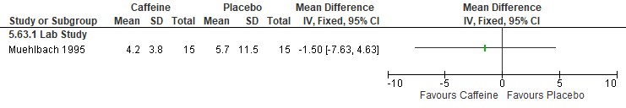 Muehlbach 1995: Caffeine group received a mean of 142 mg (range: 98-197 mg) of caffeine at each nightly administration (2220 and 0120 hours), data from night one

Figure S144. Caffeine vs Placebo (Sleep Latency, PSG) [CMT= 20 min] RCT (Shift workers without SWD diagnosis)
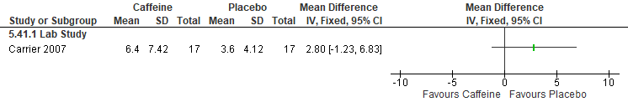
*Carrier 2007: Day sleep group (n=17) sleep deprived for 25 hrs and recovery sleep started in the morning, 1 hr after their habitual wake time. Caffeine given in 2 capsules, 1 capsule (100mg) 3h prior to bedtime and 2nd capsule (100mg) 1 hr prior to bedtime. Crossover, acceptable washout period. SEM converted to SD

Figure S145. Caffeine vs Placebo (Sleep Latency, Subjective Questionnaire) [CMT= 20 min] RCT (Healthy participants)
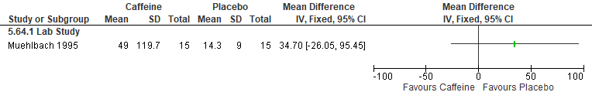 Muehlbach 1995: Caffeine group received a mean of 142 mg (range: 98-197 mg) of caffeine at each nightly administration (22:20 and 01:20 hours), data from night one

Figure S146. Caffeine vs Placebo (Sleep Efficiency, PSG) [CMT= 10%] RCT (Healthy participants)
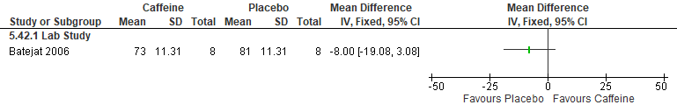*Batejat 2006: 300 mg caffeine given at midnight. Sleep efficiency index (%) measured by PSG during recovery sleep (0900-1500). Crossover, acceptable washout period. SEM converted to SD

Figure S147. Caffeine vs Placebo (Sleep Efficiency, PSG) [CMT= 10%] RCT (Shift workers without SWD diagnosis)
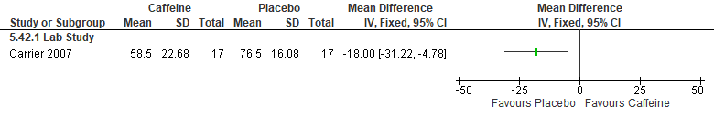*Carrier 2007: Day sleep group (n=17) sleep deprived for 25 hrs and recovery sleep started in the morning, 1 hr after their habitual wake time. Caffeine given in 2 capsules, 1 capsule (100mg) 3h prior to bedtime and 2nd capsule (100mg) 1 hr prior to bedtime. Crossover, acceptable washout period. SEM converted to SD

Clockwise rotating shift schedule

Summary of Findings (GRADE)
Table S11. Clockwise rotating shift schedule in adults with shiftwork disorder
References: Tucker 2000, Viitasalo 2008, Viitasalo 2015, Vangelova 2008, Shon 2016, DiMuzio 2021, Lavie 1992, Shiffer 2018, Cruz 2003 (Part 1), Cruz 2003 (Part II)
Outcomes [Tool] | Certainty of the evidence  (GRADE) | Absolute Difference  Clockwise shift vs Counterclockwise shift | No of Participants  (studies)
Excessive sleepiness or alertness  [KSS]ª | ⨁◯◯◯  VERY LOW^{b,c,d} | The mean difference in the clockwise shift was 1.45 points fewer (2.08 fewer to 0.83 fewer) compared to counterclockwise shift | 170  (2 non-RCTs)
Excessive sleepiness or alertness  [ESS]ª | ⨁◯◯◯  VERY LOW^{c,e} | The mean difference in the clockwise shift was 0.85 points fewer (1.93 fewer to 0.23 more) compared to counterclockwise shift | 166  (2 non-RCTs)
Excessive sleepiness or alertness  [SSS]ª | ⨁◯◯◯  VERY LOW^{c,d,f} | The mean difference in the clockwise shift was 1.2 points fewer (2.43 fewer to 0.03 more) compared to counterclockwise shift | 23  (1 non-RCT)
Excessive sleepiness or alertness  [morning questionnaire]^{g,h} | ⨁◯◯◯  VERY LOW^{c} | The mean difference in the clockwise shift was  17.3 higher (2.37 higher to 32.23 higher) compared to counterclockwise shift | 33  (1 non-RCT)
Excessive sleepiness or alertness  [Correct responses during Bakan Vigilance Task] ^{a,g} | ⨁◯◯◯  VERY LOW^{c,f,i} | The mean difference in the clockwise shift was 8.56 lower (28.02 lower to 10.9 higher) compared to counterclockwise shift | 23  (1 non-RCT)
Sleep quality  [Karolinska Sleep Diary]^{g,h} | ⨁◯◯◯  VERY LOW^{c,i} | The mean difference in the clockwise shift was  0.58 points higher (0.01 lower to 1.17 higher) compared to counterclockwise shift | 25  (1 non-RCT)
Sleep Quality  [PSQI]ª | ⨁⨁◯◯  LOW | The mean difference in the clockwise group was 0.6 lower (0.84 lower to 0.36 lower) compared to counterclockwise | 4750  (1 non-RCT)
Sleep quality  [Modified SSI]^{a,g} | ⨁◯◯◯  VERY LOWb^{,i} | The mean difference in the clockwise group was  0 (0.15 lower to 0.15 higher) compared to counterclockwise | 611  (1 non-RCT)
Cognitive performance  [multiple tests]^{g} | ⨁◯◯◯  VERY LOW^{c} | The evidence is very uncertain about the effect of clockwise shift rotation on cognitive performance. Cognitive performance was measured using mean reaction time on PVT, speed on PVT, fastest 10% on PVT, slowest 10% on PVT, and a subjective report on the difficulty concentrating at work. The studies included were DIMuzzio 2021 and Shiffer 2018 | (2 non-RCTs)
- Lower values favor the intervention
- There was unexplained inconsistency that was supported by nonoverlapping confidence intervals, high I2 values, and statistically significant heterogeneity of effect estimates.
- Imprecision due to small sample size (<200 participants)
- Imprecision due to the 95% CI crossing the CMT
- Risk of bias concerns due to lack of allocation concealment
- Indirectness is due to the fact that participants included in the studies are healthy individuals. The effect in adults with SWD may be different
- CMT was not established by the TF
- Higher values favor the intervention
- Imprecision due to the 95% CI crossing the null

Study Characteristics
Table S12. Clockwise rotating shift schedule in adults with shiftwork disorder
Study Citation | Study Design | Number of Participants (% Female) | Age in years | Population | Intervention | Comparator | Duration of Follow-up
Cruz 2003 (I) | non-RCT | 28 (57) | 41.2 | Healthy participants | Clockwise shift rotation | Counterclockwise shift rotation | 1 week
Cruz 2003 (II) | non-RCT | 28 (57) | 41.2 | Healthy participants | Clockwise shift rotation | Counterclockwise shift rotation | 1 week
Di Muzio 2021 | non-RCT | 144 (64) | 41.3 (0.8) | Shift workers without SWD diagnosis | Clockwise shift rotation | Counterclockwise shift rotation | 3 days
Lavie 1992 | non-RCT | 33 (27) | 28.3 ± 5.03 | Shift workers without SWD diagnosis | Clockwise shift rotation | Counterclockwise shift rotation | 20 days
Shiffer 2018 | non-RCT | 100 (100) | 30 ± 5.5 | Shift workers without SWD diagnosis | Clockwise shift rotation | Counterclockwise shift rotation | 6 days
Shon 2016 | non-RCT | 4750 (63) | 27.5 ± 4.4 | Shift workers without SWD diagnosis | Clockwise shift rotation | Counterclockwise shift rotation
Tucker 2000 | non-RCT | 611 (2) | 39.8 ± 0.85(SE) | Shift workers without SWD diagnosis | Clockwise shift rotation | Counterclockwise shift rotation | 28 days
Vangelova 2008 | non-RCT | 25 (68) | 48.3 ± 6.7 | Shift workers without SWD diagnosis | Clockwise shift rotation | Counterclockwise shift rotation | 2 weeks
Viitasalo 2008 | non-RCT | 84 (0) | 42.7 | Shift workers without SWD diagnosis | Clockwise shift rotation | Counterclockwise shift rotation | 8 months
Viitasalo 2015 | non-RCT | 319 (0) | not specified | Shift workers without SWD diagnosis | Clockwise shift rotation | Counterclockwise shift rotation | 2.5 years

Critical Outcomes
Figure S148. Clockwise rotating shift vs Counterclockwise rotating shift (Excessive Sleepiness, KSS) [CMT = 1 pt] Non-randomized studies (shift workers without SWD diagnosis)
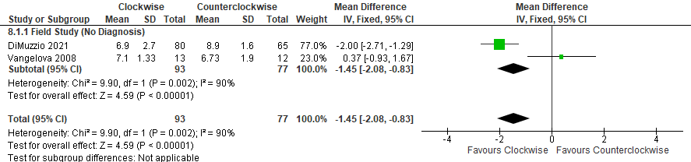
*Vangelova 2008: Data extracted from graph, averaged over Night Shift
DiMuzzio 2021: SEM converted to SD, data extracted from figure

Figure S149. Clockwise rotating shift vs Counterclockwise rotating shift (Excessive Sleepiness, ESS) [CMT = 2 pt] Non-randomized studies (Shift workers without SWD diagnosis)
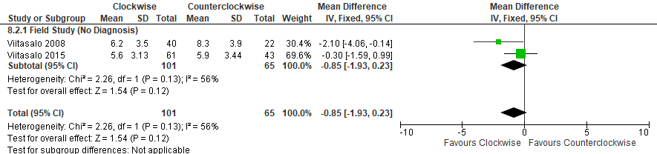
*Viitasalo 2008: Rapidly rotating (Forward/ CW) vs the old shift (Backward/ CCW).
Viitasalo 2015: both age groups (<45 yrs and >45 yrs were averaged together)

Figure S150. Clockwise rotating shift vs Counterclockwise rotating shift (Excessive Sleepiness, SSS) [CMT = 1 pt] Non-randomized study (Healthy participants)
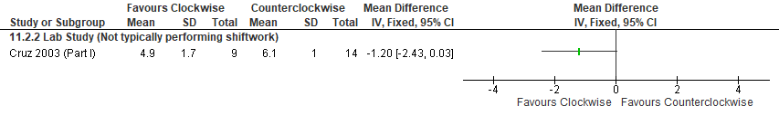
*Cruz 2003 (Part I): Clockwise vs Counterclockwise; SSS (higher is sleepier)

Figure S151. Clockwise rotating shift vs Counterclockwise rotating shift (Excessive Sleepiness, morning questionnaire) [CMT = Not Established] Non-randomized study (Shift workers without SWD diagnosis)
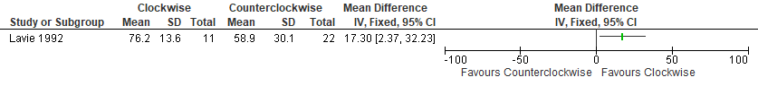

Figure S152. Clockwise rotating shift vs Counterclockwise rotating shift (Sleep Quality, Karolinska Sleep Diary: Sleep Qual Index) [CMT = Not Established] Non-randomized study (Shift workers without SWD diagnosis)
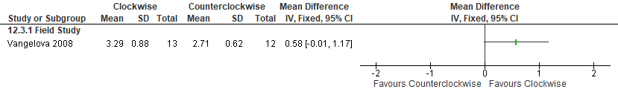*Vangelova 2008: CW (Forward) vs CCW (Backward) rotation. Sleep Quality Index (1= poor sleep, 5= no problems with sleep).

Figure S153. Clockwise rotating shift vs Counterclockwise rotating shift (Sleep Quality, PSQI) [CMT = 3 pts] Non-randomized study (Shift workers without SWD diagnosis)
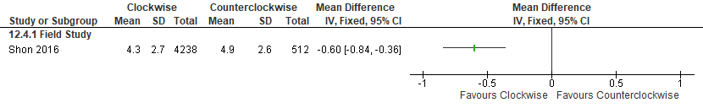

Figure S154. Clockwise rotating shift vs Counterclockwise rotating shift (Sleep Quality, Modified SSI) [CMT = Not Established] Non-randomized study (Shift workers without SWD diagnosis)
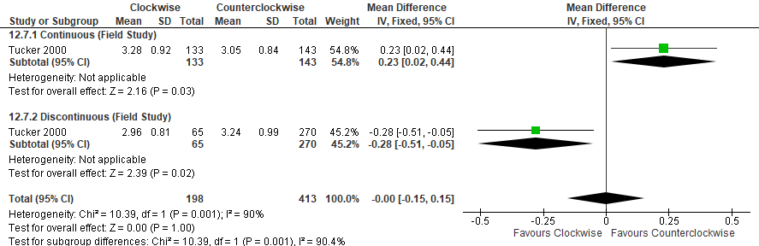*Tucker 2000: Adjusted means data used; SEM converted to SD. Higher scores may be associated with experiencing more sleep disturbances.

Figure S155. Clockwise rotating shift vs Counterclockwise rotating shift (Cognitive Performance, PVT (mean RT, ms)) [CMT = Not Established] Non-randomized study (Shift workers without SWD diagnosis)
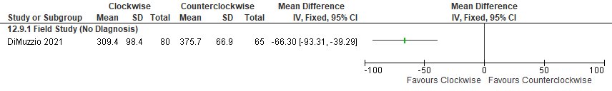 *DiMuzzio 2021: SEM converted to SD, data extracted from figure

Figure S156. Clockwise rotating shift vs Counterclockwise rotating shift (Cognitive Performance, PVT (speed,1/RT ms)) [CMT = Not Established] Non-randomized study (Shift workers without SWD diagnosis)
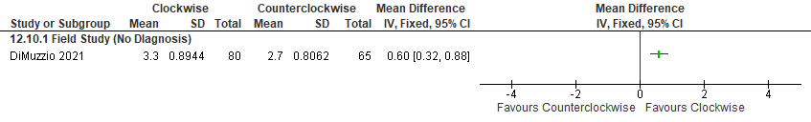*DiMuzzio 2021: SEM converted to SD, data extracted from figure

Figure S157. Clockwise rotating shift vs Counterclockwise rotating shift (Cognitive Performance, PVT (fastest 10%, RT in ms)) [CMT = Not Established] Non-randomized study (Shift workers without SWD diagnosis)
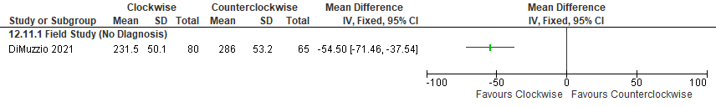*DiMuzzio 2021: SEM converted to SD, data extracted from figure

Figure S158. Clockwise rotating shift vs Counterclockwise rotating shift (Cognitive Performance, PVT (slowest 10%, RT in ms)) [CMT = Not Established] Non-randomized study (Shift workers without SWD diagnosis)
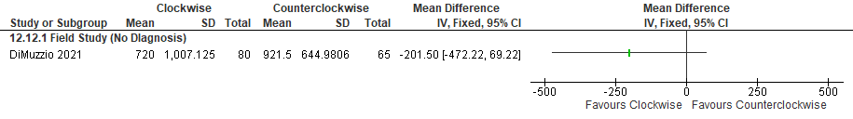*DiMuzzio 2021: SEM converted to SD, data extracted from figure

Figure S159. Clockwise rotating shift vs Counterclockwise rotating shift (Cognitive Performance, Difficulty in concentrating at work) [CMT = Not Established] Non-randomized study (Shift workers without SWD diagnosis)
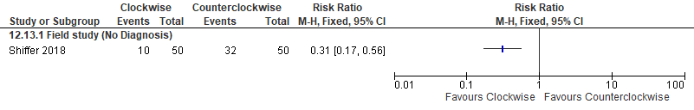

Figure S160. Clockwise rotating shift vs Counterclockwise rotating shift (Cognitive Performance, number of correct responses during the Bakan Vigilance Task) [CMT = Not Established] Non-randomized study (Healthy participants)
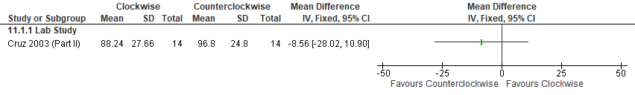

Important Outcomes
Figure S161. Clockwise rotating shift vs Counterclockwise rotating shift (Total Sleep Time, Revised SSI) [CMT = Not Established] Non-randomized study (Shift workers without SWD diagnosis)
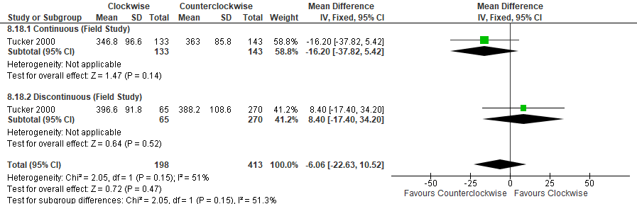
*Tucker 2000: Both CW (delaying) and CCW (advancing) on both continuous and discontinuous shifts. Adjusted means used (no other data available); SEM converted to SD. hours converted to minutes
Figure S162. Clockwise rotating shift vs Counterclockwise rotating shift (Total Sleep Time, Self-report) [CMT = 15 min] Non-randomized studies (Shift workers without SWD diagnosis)
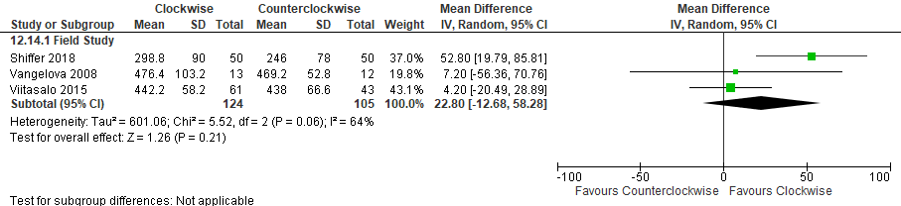
*Viitasalo 2015: CW (Forward) vs CCW (Backward) both were three-shift, both age groups (<45 yrs and >45 yrs were averaged together), hours converted to minutes
Vangelova 2008: CW (Forward) vs CCW (Backward) rotation, hours converted to minutes
Shiffer 2018: sleep duration after nightshift, hours converted to minutes

Figure S163. Clockwise rotating shift vs Counterclockwise rotating shift (Total Sleep Time, Actigraphy) [CMT = 15 min] Non-randomized study (Healthy participants)
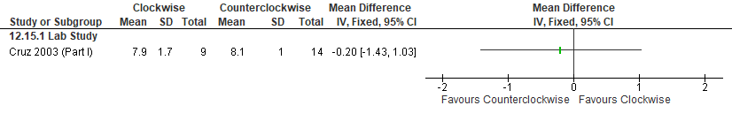

Figure S164. Clockwise rotating shift vs Counterclockwise rotating shift (Total Sleep Time, Actigraphy) [CMT = 15 min] Non-randomized study (Shift workers without SWD diagnosis)
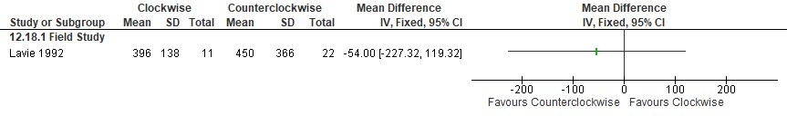
*Lavie 1992: Day 2 night data used, hours converted to minutes

Figure S165. Clockwise rotating shift vs Counterclockwise rotating shift (Mental Health, General health questionnaire) [CMT = Not Established] Non-randomized study (Shift workers without SWD diagnosis)
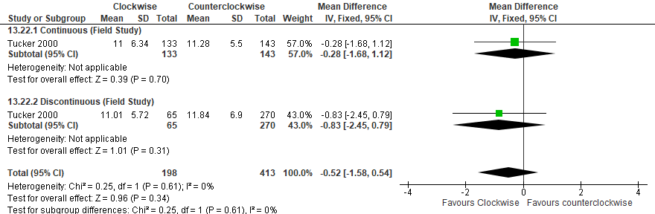
*Tucker 2000: Both CW (delaying) and CCW (advancing) on both continuous and discontinuous shifts. GHQ score, low score = high well-being. SEM converted to SD.

Figure S166. Clockwise rotating shift vs Counterclockwise rotating shift (Mental Health, Stress scale) [CMT = Not Established] Non-randomized study (Shift workers without SWD diagnosis)
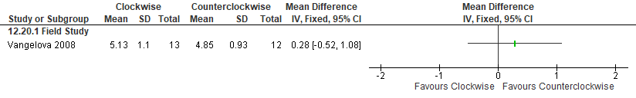
*Vangelova 2008: CW (Forward) vs CCW (Backward) rotation. Night shift data extracted from graph; timepoints (0000-0600) averaged. Stress scale (1= very low, to 9= very high).

Figure S167. Clockwise rotating shift vs Counterclockwise rotating shift (Sleep Onset Latency, Actigraphy) [CMT = 15 min] Non-randomized study (Shift workers without SWD diagnosis)
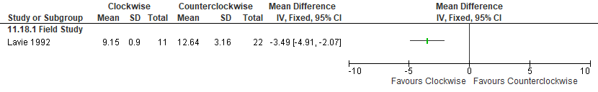*Lavie 1992: Night data used

Figure S168. Clockwise rotating shift vs Counterclockwise rotating shift (Sleep Efficiency, Actigraphy) [CMT = 10%] Non-randomized study (Shift workers without SWD diagnosis)
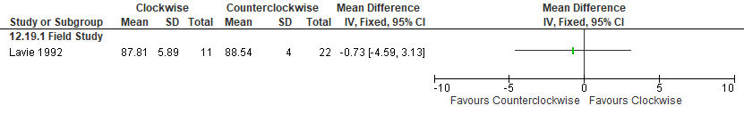*Lavie 1992: Night data used

Additional evidence on planned work schedule
The following data was not included in the decision-making process (S173-S176).
Figure S169. Planned Work Schedule (Fast CW) vs Control (CW) (Sleep Quality, VAS-sleep quality) [CMT = Not Established] Observational
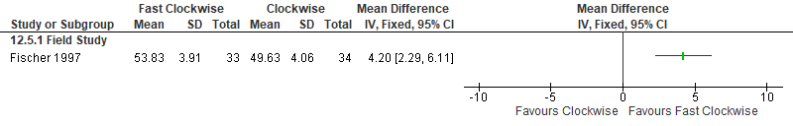
*Fischer 1997: Fast CW (faster forward) versus CW (Forward, slower rotation is the control). VAS (0= very bad sleep, 100= very good sleep).

Figure S170. Planned Work Schedule (Fast CW) vs Control (CW) (Total Sleep Time, Sleep diary) [CMT = 15 min] Observational
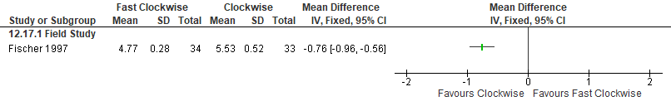
*Fischer 1997: Fast CW (faster forward) versus CW (Forward, slower rotation). Last night of night shifts, mean sleep duration (hours).
Figure S171. Planned Work Schedule (Alternate CCW) vs Control (Rotating CCW) (Sleep Quality, WHOQOL-BREF: how satisfied are you with your sleep) [CMT = Not Established] Observational
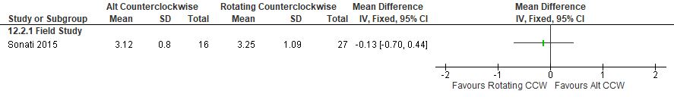*Sonati 2015: Alternate CCW shift versus rotating CCW (comparator). Scores based on a modified Likert scale, where 5= very satisfied.
Figure S172. Planned Work Schedule (Alternate CCW) vs Control (Rotating CCW) (Quality of Life, WHOQOL-BREF) [CMT = Not Established] Observational
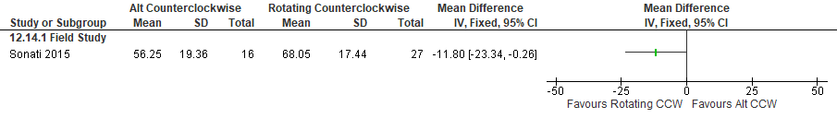
*Sonati 2015: Alternate CCW shift versus rotating CCW. Overall score used. Facets of WHO QoL pertaining to concentration, energy, and sleep satisfaction were assessed with a Likert scale (1-5, with 5 being very satisfied) and the overall score was transformed to a 0-100 scale (100 being very satisfied).

Naps prior to the first night shift

Summary of Findings (GRADE)
Table S13. Naps prior to the first night shift in adults with shiftwork disorder
References: Schweitzer 2006, Macchi 2002, Rosa 1993
Outcomes [Tool] | Certainty of the evidence  (GRADE) | Absolute Difference  Naps prior to the shift vs Control | No of Participants  (studies)
Excessive sleepiness or alertness  [MWT]ª | ⨁◯◯◯  VERY LOW^{b,c,d,e} | The mean difference in the nap group was 5.24 minutes higher (1.13 lower to 11.61 higher) compared to control | 33  (1 RCT)
Excessive sleepiness or alertness  [VAS-alertness]^{f,g} | ⨁◯◯◯  VERY LOW^{d,h} | The mean difference in the nap was 0.63 lower (1.35 lower to 0.09 higher compared to control | 16  (1 non-RCT)
Sleep quality  [9-point scale]^{a,f} | ⨁◯◯◯  VERY LOW^{d,h} | The mean difference in the nap group was 0.55 points lower (2.25 lower to 1.15 higher) compared to control | 18  (1 non-RCT)
Cognitive performance  [PVT lapses]^{f,g} | ⨁◯◯◯  VERY LOW^{b,c,d,e} | The mean difference in the nap group was 2.44 lapses fewer (4.63 fewer to 0.25 fewer) compared to control | 33  (1 RCT)
Cognitive performance  [Torrance of creative thinking]^{a,f} | ⨁◯◯◯  VERY LOW^{b,c,h} | The mean difference in the nap group was 0.65 units fewer (7.86 fewer to 6.56 more) compared to control | 33  (1 RCT)
Cognitive performance  [multiple tests]^{f} | ⨁◯◯◯  VERY LOW^{d,e} | The evidence suggests that planned naps result in little to no difference in cognitive performance including Four-choice serial reaction time (sec), Two-Letter Memory and Search Test, and Head Steadiness reported as percent of time off target. | 17  (1 non-RCT)
- Higher values favor the intervention
- Risk of bias concerns due to lack of allocation concealment
- Indirectness is due to the fact that participants included in the studies are healthy individuals. The effect in adults with SWD may be different
- Imprecision due to small sample size (<200 participants)
- Imprecision due to the 95% CI crossing the CMT
- CMT was not established by the TF
- Lower values favor the intervention
- Imprecision due to the 95% CI crossing the null

Study Characteristics
Table S14. Naps prior to the first night shift in adults with shiftwork disorder
Study Citation | Study Design | Number of Participants (% Female) | Age (years) | Population | Intervention (duration) | Comparator | Time of Intervention Delivery | Duration of Follow-up
Macchi 2002 | RCT, crossover | 8 (13) | 40.9 ± 2.1 (SE) | Shift workers without SWD diagnosis | Nap (3 hours) | No nap | 14:00 - 17:00 | 3 days
Rosa 1993 | non-RCT | 19 (0) | 25 to 59 | Shift workers without SWD diagnosis | Nap (2.11-2.20 hours) | No nap | Prior to the night shift | 5-7 days
Schweitzer 2006 | RCT | 68 (53) | 31.3 | healthy individuals | nap (2.5 hours) | No nap | nap from 19:30-22:00 plus placebo taken 30 minutes prior to night shifts; | 4 nights

Critical Outcomes
Figure S173. Naps prior to the first night shift vs Control (Excessive Sleepiness, MWT) [CMT =2 min] RCT (Healthy participants)
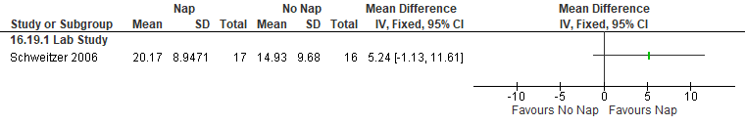
*Schweitzer 2006: Data (on night shift 1 averaged from 2345-0630) extracted from graph; SEM converted to SD.

Figure S174. Naps prior to the first night shift vs Control (Excessive Sleepiness, VAS-Alertness) [CMT = Not Established], non-randomized study (Healthy participants)
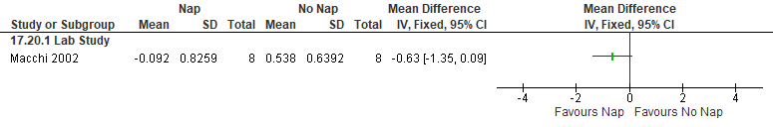
*Machhi 2002: z-scored data

Figure S175. Naps prior to the first night shift vs Control (Sleep Quality, 9-point scale) [CMT = Not Established] non-randomized study (Shift workers without SWD diagnosis)
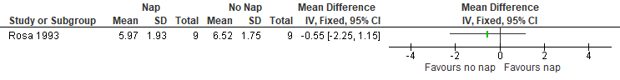*Rosa 1993: Data from First Night and other workdays were pooled, data extracted from figure.

Figure S176. Naps prior to the first night shift vs Control (Cognitive Performance, PVT lapses) [CMT = 1 lapse] RCT (Healthy participants)
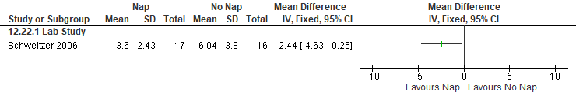*Schweitzer 2006: Data (on night shift 1 averaged from 2345-0630) extracted from graph; SEM converted to SD.

Figure S177. Naps prior to the first night shift vs Control (Cognitive Performance, Torrance test of creative thinking-fluency, mean change from baseline) [CMT = Not Established] RCT (Healthy participants)
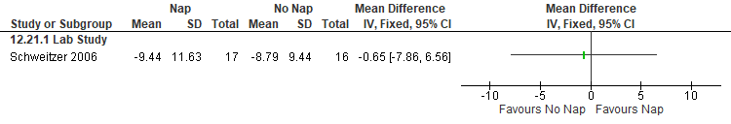
*Schweitzer 2006: Data extracted from graph; SEM converted to SD

Figure S178. Naps prior to the first night shift vs Control (Cognitive Performance, Four choice serial reaction time (sec)) [CMT = Not Established] non-randomized study (Healthy participants)
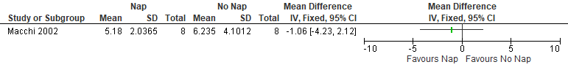
*Macchi 2002: data extracted from graph, SEM converted to SD, data averaged across the night

Figure S179. Naps prior to the first night shift vs Control (Cognitive Performance, Two-Letter Memory and Search Test (reaction time in sec)) [CMT = Not Established] non-randomized study (Healthy participants)
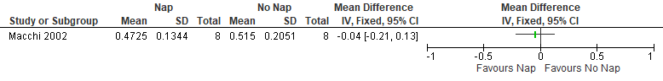
*Macchi 2002: data extracted from graph, SEM converted to SD, data averaged across the night

Figure S180. Naps prior to the first night shift vs Control (Cognitive Performance, Hand steadiness (percent time off target)) [CMT = Not Established] non-randomized study (Shift workers without SWD diagnosis)
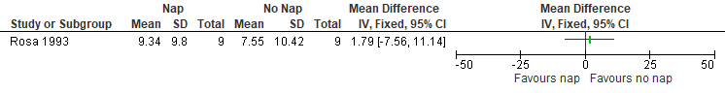
*Rosa 1993: Data from first half and second half of night shift were pooled

Important Outcomes
Figure S181. Naps prior to the first night shift vs Control (Total sleep time, Subjective) [CMT = 15 min] non-randomized studies (Healthy participants)
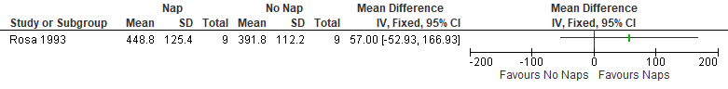
*Rosa 1993: 8-hour night shift, hours converted to minutes, nap time included

Diet and meal timing

Summary of Findings (GRADE)
Table S15. Diet and meal timing in adults with shiftwork disorder
References: Grant 2017, Gupta 2019, Gupta 2017, Qian 2022
Outcomes [Tool] | Certainty of the evidence  (GRADE) | Absolute Difference  Eating a snack or not eating vs Eating a full meal | No of Participants  (studies)
Excessive sleepiness or alertness  [KSS]ª | ⨁◯◯◯  VERY LOW^{b,c,d} | The mean difference in the snacking or not eating at night group was 3.24 points fewer (5.68 fewer to 0.80 fewer) compared to eating a full meal | 10  (1 RCT)
Excessive sleepiness or alertness  [SSS]ª | ⨁◯◯◯  VERY LOW^{b,c,d} | The mean difference in the snacking or not eating at night group was 0.79 points fewer (1.30 fewer to 0.27 fewer) compared to eating a full meal | 39  (1 RCT)
Accident risk  [Driving Simulator (% of time in safe zone)]^{e} | ⨁◯◯◯  VERY LOW^{b,c,f,g} | The mean difference in the snacking or not eating group was 5.49 percent higher (0.34 lower to 11.32 higher) compared to eating a full meal | 49  (2 RCTs)
Accident risk  [Driving Simulator (speed variability]ª | ⨁◯◯◯  VERY LOW^{b,c,f,g} | The mean difference in the snacking or not eating at night group was 1.92 km/h lower (3.92 lower to 0.08 higher) compared to eating a full meal | 49  (2 RCTs)
Accident risk  [Driving Simulator (lane variability)]ª | ⨁⨁◯◯  LOW^{b,c} | The mean difference in the snacking or not eating group was 0.06 meters fewer (0.11 fewer to 0.01 fewer) compared to eating a full meal | 49  (2 RCTs)
Cognitive performance  [PVT lapses]ª | ⨁⨁◯◯  LOW^{b,c} | The mean difference in the snacking or not eating group was 3.07 points fewer (4.21 fewer to 1.93 fewer) compared to eating a full meal | 49  (2 RCTs)
Cognitive performance  [multiple tests]^{h} | ⨁⨁◯◯  LOW^{b,c} | The evidence suggests that not eating (or snacking at night) results in little difference in cognitive performance tests (PVT, DSST, Choice Reaction Time Task, Running Memory continuous performance task). | 39  (3 RCTs)
- Lower values favor the intervention
- Indirectness is due to the fact that participants included in the studies are healthy individuals. The effect in adults with SWD may be different
- Imprecision due to small sample size (<200 participants)
- Imprecision due to the 95% CI crossing the CMT
- Higher values favor the intervention
- There was unexplained inconsistency that was supported by nonoverlapping confidence intervals, high I2 values, and statistically significant heterogeneity of effect estimates.
- Imprecision due to the 95% CI crossing the null
- CMT was not determined the TF

Study Characteristics
Table S16. Diet and meal timing in adults with shiftwork disorder
Study Citation | Study Design | Number of Participants (% Female) | Age (years) | Population | Intervention | Comparator | Time of Intervention Delivery | Duration of Follow-up
Grant 2017 | RCT | 13 (0) | 24.70 ± 5.55 | Healthy participants | No meal | Full meal | meal at 19:00, 01:30, and 07:00  meal at 19:00 and 07:00 and snacks at 09:30 and 14:10 | 4 nights
Gupta 2017 | RCT | 13 (0) | 24.70 ± 5.55 | Healthy participants | No meal | Full meal | meal at 19:00, 01:30, and 07:00  meal at 19:00 and 07:00 and snacks at 09:00 and 16:00 | 4 nights
Gupta 2019 | RCT | 39 (41) | 24.5 ± 5.0 | Healthy participants | Snack  No meal | Full meal | meal at 19:00, 0:30 and 07:00  meal at 19:00 and 07:00 and snacks at 0:30 and 17:00  Meal at 19:00 and 07:00 and snacks at 09:30 and 17:00 | 4 nights
Qian 2022 | RCT | 19 (37) | 26.5 ± 4.1 | Healthy participants | Daytime only meals | Daytime and Nighttime meals |  | 4 days

Critical Outcomes
Figure S182. Diet and Meal Timing vs Control (Excessive Sleepiness, KSS) [CMT = 1 pt] RCT (Healthy participants)
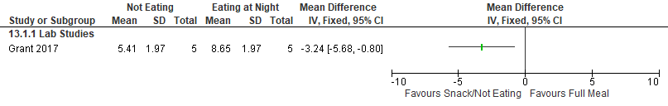
*Grant 2017: Night shift 4 (used 0400 timepoint). KSS; SEM converted to SD.

Figure S183 Diet and Meal Timing vs Control (Excessive Sleepiness, SSS) [CMT = 1 pt] RCT (Healthy participants)
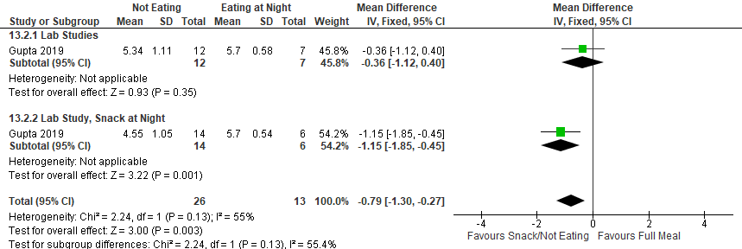
*Gupta 2019: (averaged 0130 & 0400 timepoints, across the 4-night shifts). Eating at night (n=13; halved the participants to not double count them in the total). SSS; SEM converted to SD.

Figure S184. Diet and Meal Timing vs Control (Accident Risk, % of time spent in safe zone, in driving simulator) [CMT = any increase] RCT (Healthy participants)
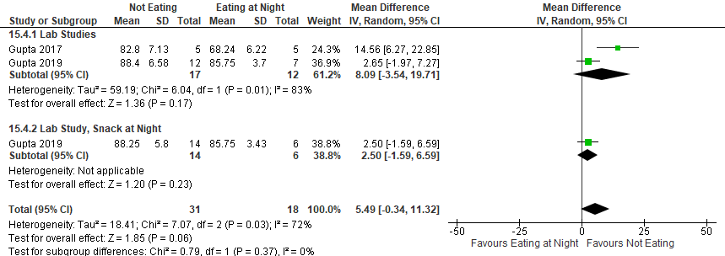
*Gupta 2017: used 0300 timepoint, across the 4 night shifts. SEM converted to SD.
Gupta 2019: (averaged 0130 & 0400 timepoints, on night shift 4). Eating at night (n=13; halved the participants to not double count them in the total). SEM converted to SD.

Figure S185. Diet and Meal Timing vs Control (Accident Risk, Speed variability (km/h), in driving simulator) [CMT = any decrease] RCT (Healthy participants)
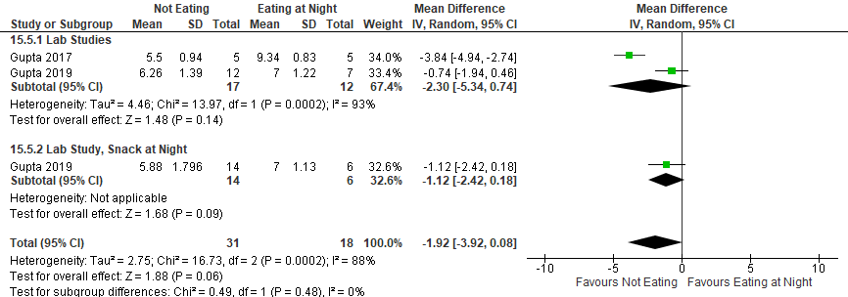
*Gupta 2017: used 0300 timepoint, across the 4 night shifts. SEM converted to SD.
Gupta 2019: (averaged 0130 & 0400 timepoints, on night shift 4). Eating at night (n=13; halved the participants to not double count them in the total). SEM converted to SD.

Figure S186. Diet and Meal Timing vs Control (Accident Risk, Lane variability (m, in driving simulator) [CMT = any decrease] RCT (Healthy participants)
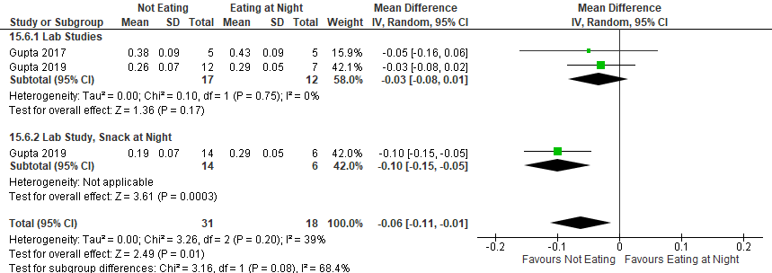
*Gupta 2017: used 0300 timepoint, across the 4 night shifts. SEM converted to SD.
Gupta 2019: (averaged 0130 & 0400 timepoints, on night shift 4). Eating at night (n=13; halved the participants to not double count them in the total). SEM converted to SD.

Figure S187. Diet and Meal Timing vs Control (Cognitive Performance, PVT lapses) [CMT = 1 lapse] RCT (Healthy participants)
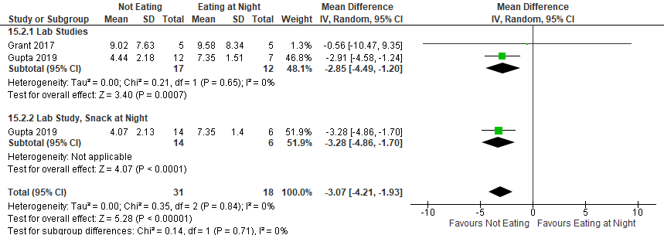
*Grant 2017: Night shift 4 (used 0400 timepoint). SEM converted to SD.
Gupta 2019: (averaged 0130 & 0400 timepoints, on night shift 4). Eating at night (n=13; halved the participants to not double count them in the total). SEM converted to SD.

Figure S188. Diet and Meal Timing vs Control (Cognitive Performance, PVT (mean reciprocal reaction time)) [CMT = Not Established] RCT (Healthy participants)
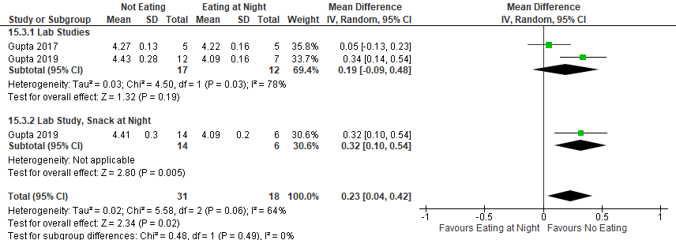
*Gupta 2017: used 0300 timepoint, across the 4 night shifts. SEM converted to SD.
Gupta 2019: (averaged 0130 & 0400 timepoints, on night shift 4). Eating at night (n=13; halved the participants to not double count them in the total). SEM converted to SD.

Figure S189. Diet and Meal Timing vs Control (Cognitive Performance, DSST, # correct) [CMT = Not Established] RCT (Healthy participants)
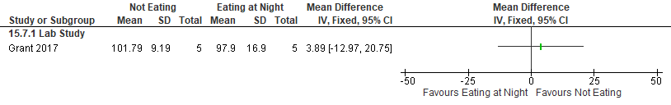
*Grant 2017: Night shift 4 (used 0400 timepoint). SEM converted to SD.

Figure S190. Diet and Meal Timing vs Control (Cognitive Performance, PVT (# errors)) [CMT = Not Established] RCT (Healthy participants)
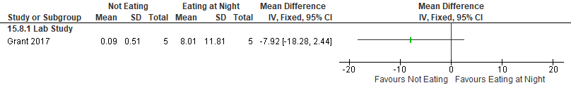
*Grant 2017: Night shift 4 (used 0400 timepoint). SEM converted to SD.

Figure S191. Diet and Meal Timing vs Control (Cognitive Performance, Choice reaction time task, throughput) [CMT = Not Established] RCT (Healthy participants)
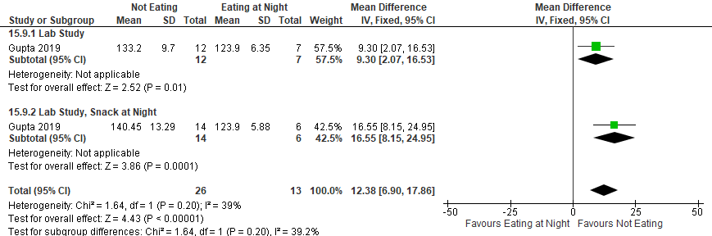
*Gupta 2019: (averaged 0130 & 0400 timepoints, on night shift 4). Eating at night (n=13; halved the participants to not double count them in the total). SEM converted to SD. Throughput (correct responses/ minute).

Figure S192. Diet and Meal Timing vs Control (Cognitive Performance, running memory continuous performance task, throughput) [CMT = Not Established] RCT (Healthy participants)
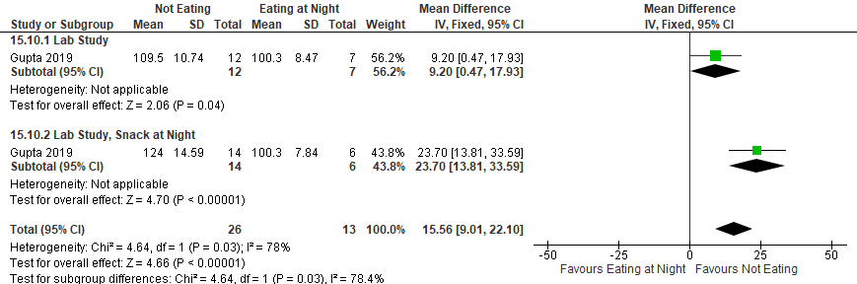
*Gupta 2019: (averaged 0130 & 0400 timepoints, on night shift 4). Eating at night (n=13; halved the participants to not double count them in the total). SEM converted to SD. Throughput (correct responses/ minute).

Important Outcomes
Figure S193. Diet and Meal Timing vs Control (Total Sleep Time (min), PSG or EEG) [CMT = 15 min] RCT (Healthy participants)
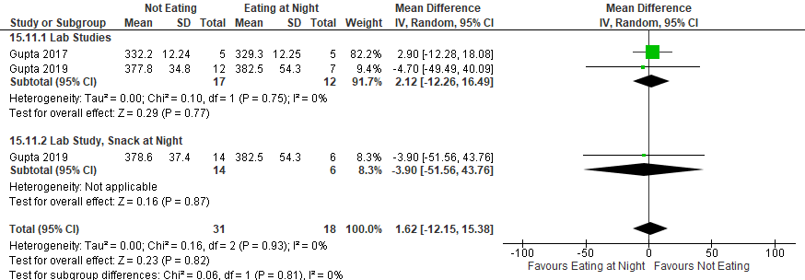
*Gupta 2017: Day sleep after Night shift 2 (only data available during intervention).
Gupta 2019: Day sleep after Night shift 3. Eating at night (n=13; halved the participants to not double count them in the total).

Figure S194. Diet and Meal Timing vs Control (Total Sleep Time, actigraphy) [CMT = 15 min] RCT (Healthy participants)
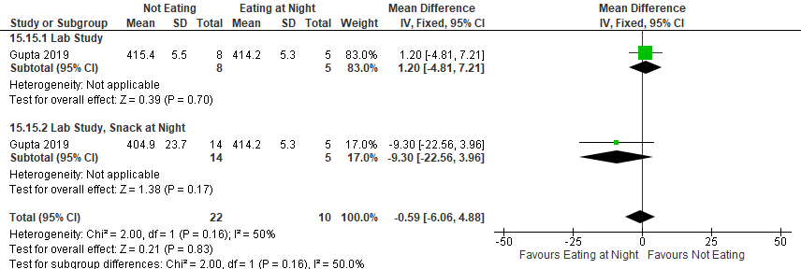
*Gupta 2019: Day sleep after Night shift 3. Eating at night (n=10; halved the participants to not double count them in the total)
Figure S195. Diet and Meal Timing vs Control (Mental Health, Depression-like Mood) [CMT = Not Established] RCT (Healthy participants)
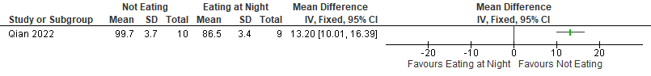 *Qian 2022: averaged across each timepoint and averaged across Days 2-4, data presented as % of baseline, higher numbers=less depression, data extracted from the graph

Figure S196. Diet and Meal Timing vs Control (Mental Health, Anxiety-like Mood) [CMT = Not Established] RCT (Healthy participants)
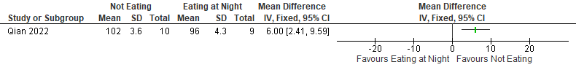 *Qian 2022: averaged across each timepoint and averaged across Days 2-4, data presented as % of baseline, higher numbers=less anxiety, data extracted from the graph

Figure S197. Diet and Meal Timing vs Control (WASO, PSG or EEG) [CMT = 20 min] RCT (Healthy participants)
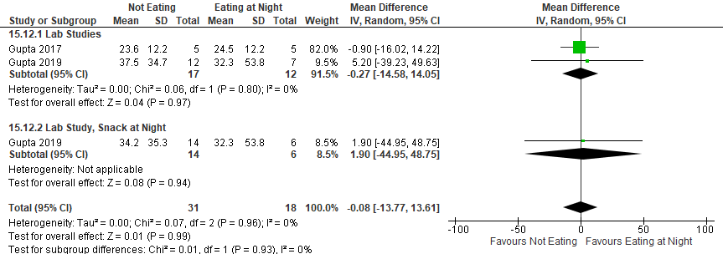
*Gupta 2017: Day sleep after Night shift 2 (only data available during intervention). Eating at night at 0130.
Gupta 2019: Day sleep after Night shift 3. Eating or Snack at night at 0030. Eating at night (n=13; halved the participants to not double count them in the total)

Figure S198. Diet and Meal Timing vs Control (Sleep Latency, PSG or EEG) [CMT = 20 min] RCT (Healthy participants)
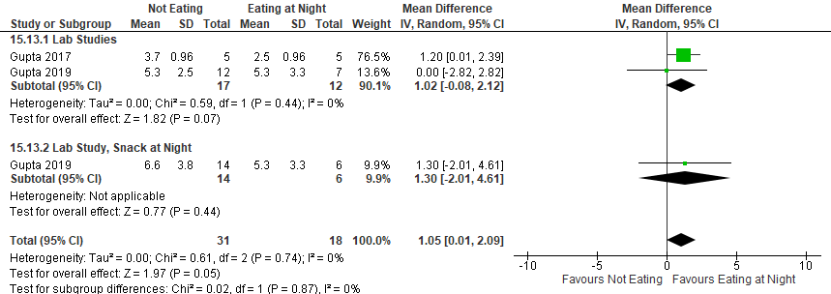*Gupta 2017: Day sleep after Night shift 2 (only data available during intervention).
Gupta 2019: Day sleep after Night shift 3. Eating at night (n=13; halved the participants to not double count them in the total)

Figure S199. Diet and Meal Timing vs Control (Sleep Latency, actigraphy) [CMT = 15 min] RCT (Healthy participants)
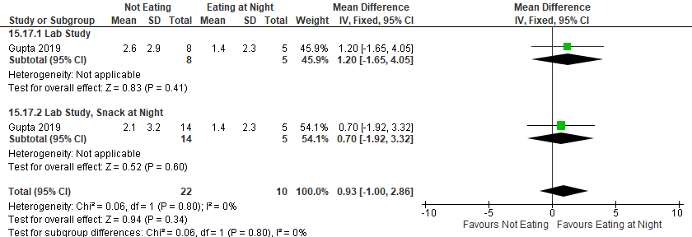
*Gupta 2019: Day sleep after Night shift 3. Eating at night (n=10; halved the participants to not double count them in the total)

Figure S200. Diet and Meal Timing vs Control (Sleep Efficiency, PSG or EEG) [CMT = 10%] RCT (Healthy participants)
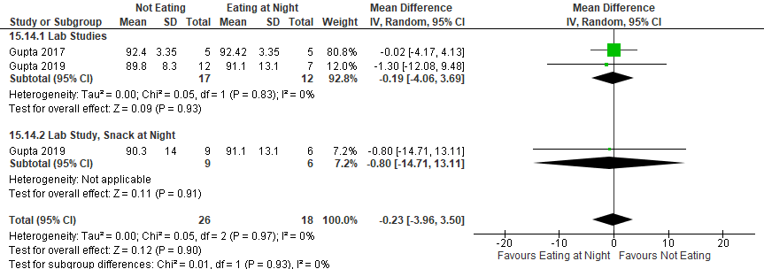*Gupta 2017: Day sleep after Night shift 2 (only data available during intervention).
Gupta 2019: Day sleep after Night shift 3. Eating at night (n=13; halved the participants to not double count them in the total)

Figure S201. Diet and Meal Timing vs Control (Sleep Efficiency, actigraphy) [CMT = 10%] RCT (Healthy participants)
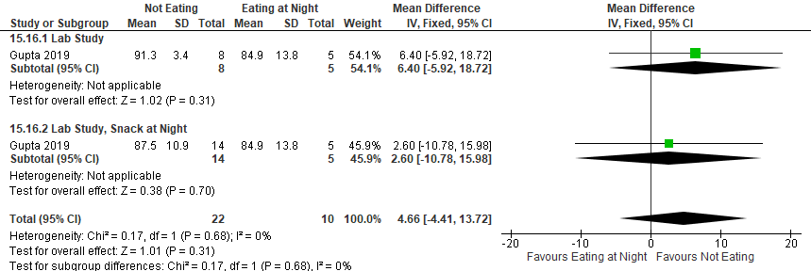
*Gupta 2019: Day sleep after Night shift 3. Eating at night (n=10; halved the participants to not double count them in the total)

Bright light and caffeine

Summary of Findings (GRADE)
Table S17. Bright light and caffeine in adults with shiftwork disorder
References: Babkoff 2002, Wright 1997,
Outcomes [Tool] | Certainty of the evidence  (GRADE) | Absolute Difference  Bright light and caffeine vs Control | No of Participants  (studies)
Excessive sleepiness or alertness  [VAS (sleepiness)]^{a,b} | ⨁◯◯◯  VERY LOW^{c,d,e} | The mean difference in the bright light and caffeine group was 6.71 higher (7.43 lower to 20.85 higher) compared to control | 22  (1 RCT)
Excessive sleepiness or alertness  [SSS]^{f} | ⨁◯◯◯  VERY LOW^{c,e,g,h} | The mean difference in the bright light and caffeine group was 1.77 points lower (2.87 lower to 0.67 lower) compared to control | 19  (1 RCT)
Excessive sleepiness or alertness  [MWT]ª | ⨁◯◯◯  VERY LOW^{c,e,g,h} | The mean difference in the bright light and caffeine group was 2.02 minutes more (1.48 more to 2.56 more) compared to control | 20  (1 RCT)
Cognitive performance  [multiple tests]^{b} | ⨁◯◯◯  VERY LOW ^{c,d,e,g} | The evidence (2 RCTs) is very uncertain about the effect of bright light and caffeine on cognitive performance (performance tests include choice reaction time, letter cancellation, PVT, Dual Task control losses, Switching Task- Mannequin and -Math, and Wilkinson Four choice reaction time). | (2 RCTs)
- Higher values favor the intervention
- CMT was not established by the TF
- Risk of bias concerns due to lack of blinding
- Imprecision due to the 95% CI crossing the null
- Imprecision due to small sample size (<200 participants)
- Lower values favor the intervention
- Indirectness is due to the fact that participants included in the studies are healthy individuals. The effect in adults with SWD may be different.
- Imprecision due to the 95% crossing the CMT

Study Characteristics
Table S18. Bright light and caffeine in adults with shiftwork disorder
Study Citation | Study Design | Number of Participants (% Female) | Age range (years) | Population | Intervention (dose/intensity) | Comparator | Time of Intervention Delivery | Duration of Follow-up
Babkoff 2002 | RCT, crossover | 12 (42) | 19-36 | Shift workers without SWD diagnosis | Bright light (3,000 lux) and caffeine (200 mg) | Dim light (20-50 Iux) and placebo | light exposure from 01:30-02:30  caffeine or placebo given at 01:40 | 1 day
Wright 1997 | RCT | 46 (0) | 18–25 | Healthy participants | Bright Light-Caffeine (2500 lux/200 mg caffeine) | Dim Light-Placebo (≤100 lux/200 mg sugar) | bright light from 20.00 to 08.00 hours  Caffeine at 20.00 and 02.00 hours each night | 2 nights

Critical Outcomes
Figure S202. Bright Light + Caffeine vs Dim-light +placebo (Excessive Sleepiness, VAS-sleepiness) [CMT = Not Established] RCT (Shift workers without a diagnosis of SWD)
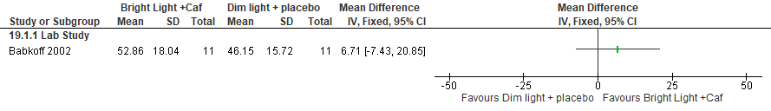
*Babkoff 2002: Data extracted from graph (0230-0830); SEM converted to SD. Higher value represents higher arousal

Figure S203. Bright Light + Caffeine vs Dim-Light + Caffeine (Excessive Sleepiness, VAS-sleepiness) [CMT = Not Established] RCT (Shift workers without a diagnosis of SWD)
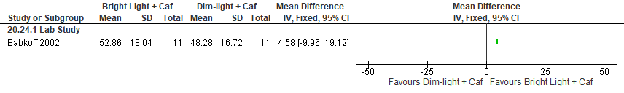
*Babkoff 2002: Data extracted from graph (0230-0830); SEM converted to SD. Higher value represents higher arousal

Figure S204. Bright Light + Caffeine vs Bright Light + Placebo (Excessive Sleepiness, VAS-sleepiness) [CMT = Not Established] RCT (Shift workers without a diagnosis of SWD)
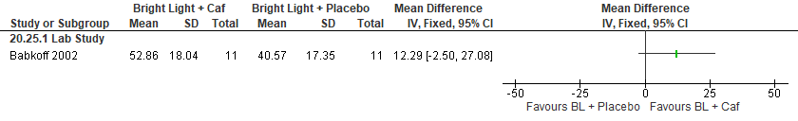
*Babkoff 2002: Data extracted from graph (0230-0830); SEM converted to SD. Higher value represents higher arousal.

Figure S205. Bright light + Caffeine vs Dim-light + Placebo (Excessive Sleepiness, SSS) [CMT = 1 pts] RCT (Healthy participants)
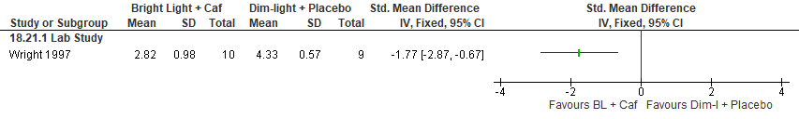

Figure S206. Bright light + Caffeine vs Dim-light + Caffeine (Excessive Sleepiness, SSS) [CMT = 1 pts] RCT (Healthy participants)
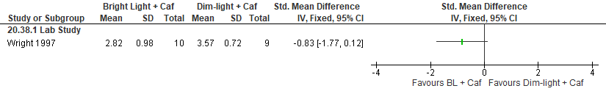

Figure S207. Bright light + Caffeine vs Bright Light + Placebo (Excessive Sleepiness, SSS) [CMT = 1 pts] RCT (Healthy participants)
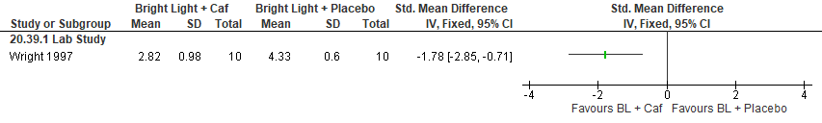*Wright 1997: Night 1 data used; SEM converted to SD.

Figure S208. Bright light + Caffeine vs Dim-light + Placebo (Excessive Sleepiness, Maintenance of Wakefulness Test) [CMT = 2 min] RCT (Healthy participants)
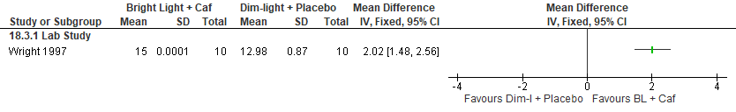

Figure S209. Bright light + Caffeine vs Dim-light + Caffeine (Excessive Sleepiness, Maintenance of Wakefulness Test) [CMT = 2 min] RCT (Healthy participants)
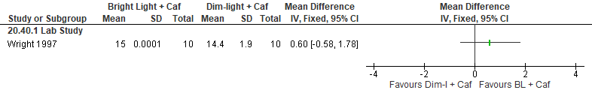

Figure S210. Bright light + Caffeine vs Bright Light + Placebo (Excessive Sleepiness, Maintenance of Wakefulness Test) [CMT = 2 min] RCT (Healthy participants)
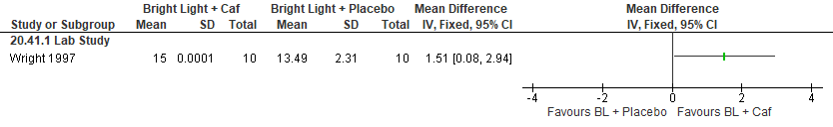 *Wright 1997: Used Night 1 data; SEM converted to SD.

Figure S211. Bright Light + Caffeine vs Dim-light + placebo (Cognitive Performance, choice reaction time) [CMT = Not Established] RCT (Shift workers without a diagnosis of SWD)
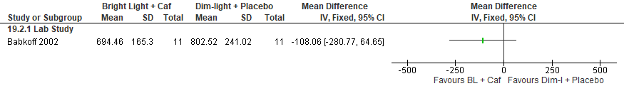
*Babkoff 2002: Data extracted from graph (0230-0830); SEM converted to SD.

Figure S212. Bright light + Caffeine vs Dim-light + Placebo (Cognitive Performance, letter cancellation (number of trials without a false alarm)) [CMT = Not Established] RCT (Shift workers without a diagnosis of SWD)
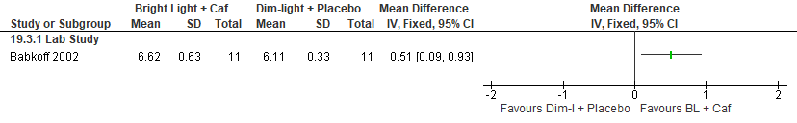
*Babkoff 2002: Data extracted from graph (0230-0830), SEM converted to SD.

Figure S213. Bright light + Caffeine vs Dim-light + Placebo (Cognitive Performance, PVT reaction time) [CMT = Not Established] RCT (Healthy participants)
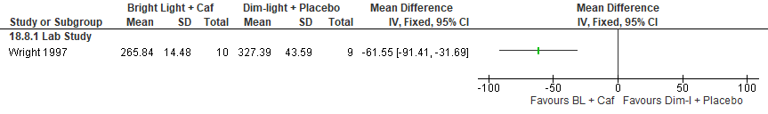
*Wright 1997: Data extracted (0030-0630 timepoints averaged); SEM converted to SD.

Figure S214. Bright light + Caffeine vs Dim-light + Placebo (Cognitive Performance, Dual task control losses) [CMT = Not Established] RCT (Healthy participants)
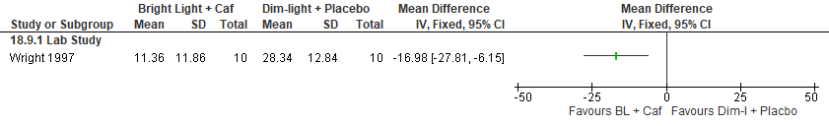
*Wright 1997: Data extracted (0030-0630 timepoints averaged); SEM converted to SD.

Figure S215. Bright light + Caffeine vs Dim-light + Placebo (Cognitive Performance, Switching Task- Mannequin throughput- change from baseline) [CMT = Not Established] RCT (Healthy participants)
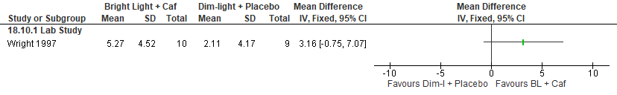
*Wright 1997: Data extracted (0030-0630 timepoints averaged); SEM converted to SD.

Figure S216. Bright light + Caffeine vs Dim-light + Placebo (Cognitive Performance, Wilkinson Four Choice Reaction Time) [CMT = Not Established] RCT (Healthy participants)
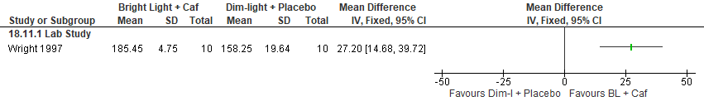
*Wright 1997: Data extracted (0030-0630 timepoints averaged); SEM converted to SD.

Figure S217. Bright light + Caffeine vs Dim-light + Placebo (Cognitive Performance, Switching Task-Math throughput) [CMT = Not Established] RCT (Healthy participants)
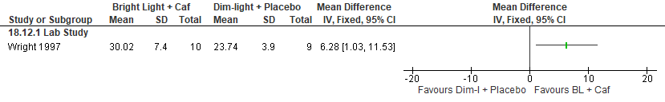
*Wright 1997: Data extracted (0030-0630 timepoints averaged); SEM converted to SD.

Important Outcomes
None

Nap and caffeine

Summary of Findings (GRADE)
Table S19. Nap and caffeine in adults with shiftwork disorder
References: Schweitzer 2006
Outcomes [Tool] | Certainty of the evidence  (GRADE) | Absolute Difference  Nap and caffeine vs Control | No of Participants  (studies)
Excessive sleepiness or alertness  [KSS]ª | ⨁◯◯◯  VERY LOW^{b,c,d} | The mean difference in the nap and caffeine group was 1.96 points lower (3.06 lower to 0.85 lower) compared to control | 111  (2 RCTs)
Excessive sleepiness or alertness  [MWT]^{e} | ⨁◯◯◯  VERY LOW^{b,c,d,f} | The mean difference in the nap and caffeine group was 7.12 min higher (0.45 higher to 13.79 higher) compared to control | 33  (1 RCT)
Cognitive performance  [PVT lapses]ª | ⨁◯◯◯  VERY LOW^{b,c,d,f,g} | The mean difference in the nap and caffeine group was 2.23 lapses fewer (4.53 fewer to 0.07 more) compared to control | 33  (1 RCT)
Cognitive performance  [multiple tests]^{h} | ⨁◯◯◯  VERY LOW^{b,c,g} | The evidence (2 RCTs) is very uncertain about the effect of naps and caffeine on cognitive performance (measured by PVT and Torrence Test of Creative thinking). | (2 RCTs)
- Lower values favor the intervention
- Risk of bias concerns due to lack of blinding
- Indirectness is due to the fact that participants included in the studies are healthy individuals. The effect in adults with SWD may be different
- Imprecision due to 95% CI crossing the CMT
- Higher values favor the intervention
- Imprecision due to small sample size (<200 participants)
- Imprecision due to 95% CI crossing the null
- CMT was not established by the TF

Study Characteristics
Table S20. Nap and caffeine in adults with shiftwork disorder
Study Citation | Study Design | Number of Participants (% Female) | Age (years) | Population | Intervention (duration /intensity) | Comparator | Time of Intervention Delivery | Duration of Follow-up
Schweitzer 2006 | Lab study: RCT  Field study: RCT, crossover | Lab Study: 68 (53)  Field Study: 53 (21) | Lab study: 31.3  Field study: 33.5 | Lab Study: healthy individuals  Field Study: shift workers without SWD diagnosis | (Lab) nap (2.5 hr) plus caffeine (4 mg/kg)  (Field) nap (2 hr) plus caffeine (300 mg) | placebo and no naps | (Lab) nap from 19:30-22:00 plus caffeine taken 30 minutes prior to night shifts;  (Field) nap prior to the night shift starting approximately 3-4 hours before shift | 4 nights

Critical Outcomes
Figure S218. Nap + Caffeine vs Control (Excessive Sleepiness, KSS) [CMT = 1 pt] RCT (Healthy participants)
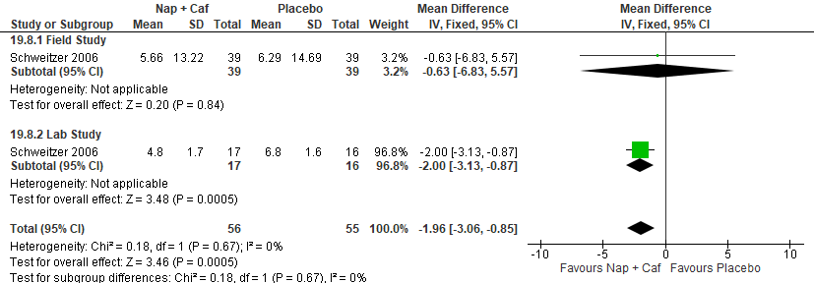
*Schweitzer 2006 (Field): KSS data from end of shift; SD calculated from p-value.
Schweitzer 2006 (lab): KSS data only available for night 1.

Figure S219. Nap + Caffeine vs Caffeine (Excessive Sleepiness, KSS) [CMT = 1 pt] RCT (Healthy participants)
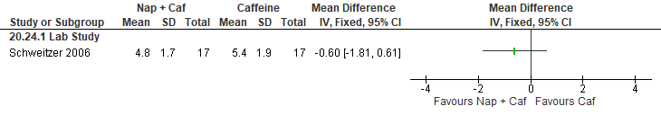*Schweitzer 2006 (lab): KSS data only available for night 1.

Figure S220. Nap + Caffeine vs Nap (Excessive Sleepiness, KSS) [CMT = 1 pt] RCT (Healthy participants)
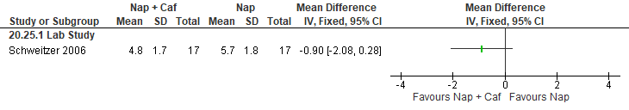
*Schweitzer 2006 (lab): KSS data only available for night 1.

Figure S221. Nap + Caffeine vs Control (Excessive Sleepiness, MWT) [CMT = 2 min] RCT (Healthy participants)
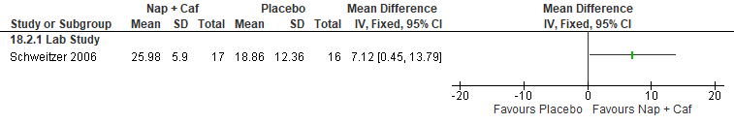
*Schweitzer 2006 (lab): MWT (data averaged and extracted from nightshift 2); SEM converted to SD.
Figure S222. Nap + Caffeine vs Caffeine (Excessive Sleepiness, MWT) [CMT = 2 min] RCT (Healthy participants)
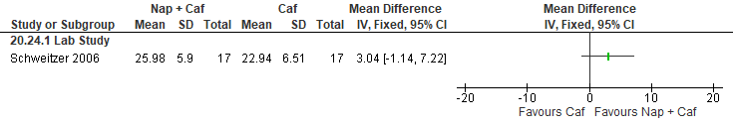*Schweitzer 2006 (lab): MWT (data averaged and extracted from nightshift 2); SEM converted to SD.
Figure S223. Nap + Caffeine vs Nap (Excessive Sleepiness, MWT) [CMT = 2 min] RCT (Healthy participants)
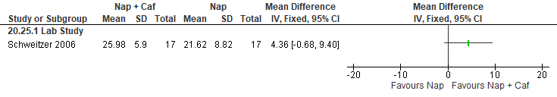
*Schweitzer 2006 (lab): MWT (data averaged and extracted from nightshift 2); SEM converted to SD.

Figure S224. Nap + Caffeine vs Control (Cognitive Performance, PVT lapses) [CMT = 1 lapse] RCT (Healthy participants)
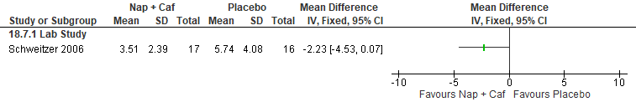
*Schweitzer 2006 (lab): PVT # of lapses by sq root transformed; SEM converted to SD.
Figure S225. Nap + Caffeine vs Caffeine (Cognitive Performance, PVT lapses) [CMT = 1 lapse] RCT (Healthy participants)
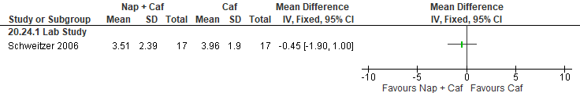*Schweitzer 2006 (lab): PVT # of lapses by sq root transformed; SEM converted to SD.
Figure S226. Nap + Caffeine vs Caffeine (Cognitive Performance, PVT lapses) [CMT = 1 lapse] RCT (Healthy participants)
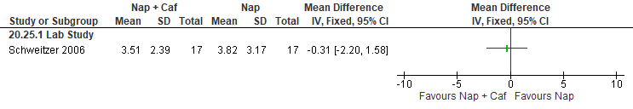*Schweitzer 2006 (lab): PVT # of lapses by sq root transformed; SEM converted to SD.

Figure S227. Nap + Caffeine vs Control (Cognitive Performance, PVT mean reaction time of the slowest 10%, reciprocally transformed) [CMT = Not Established] RCT (Shift workers without a SWD diagnosis)
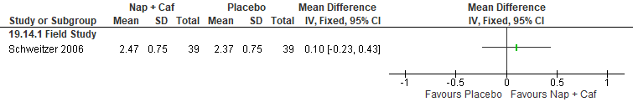*Schweitzer 2006 (Field): SEM converted to SD. PVT mean reaction times (reciprocally transformed).

Figure S228. Nap + Caffeine vs Control (Cognitive Performance, Torrance tests of creative thinking-verbal/ figural- fluency) [CMT = Not Established] RCT (Healthy participants)
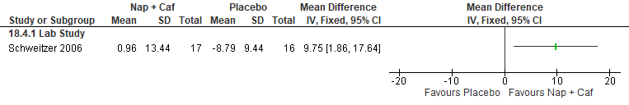
*Schweitzer 2006 (lab): Data extracted from graph; SEM converted to SD.
Figure S229. Nap + Caffeine vs Caffeine (Cognitive Performance, Torrance tests of creative thinking-verbal/ figural- fluency) [CMT = Not Established] RCT (Healthy participants)
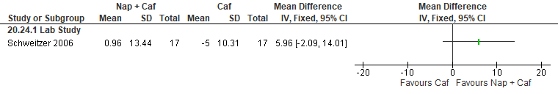*Schweitzer 2006 (lab): Data extracted from graph; SEM converted to SD.
Figure S230. Nap + Caffeine vs Nap (Cognitive Performance, Torrance tests of creative thinking-verbal/ figural- fluency) [CMT = Not Established] RCT (Healthy participants)
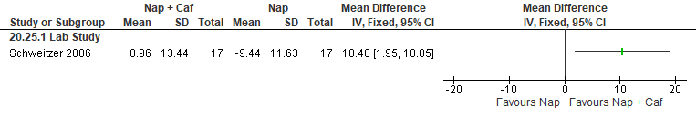*Schweitzer 2006 (lab): Data extracted from graph; SEM converted to SD.

Important Outcomes
Figure S231. Nap + Caffeine vs Control (Total Sleep Time, PSG or Actigraphy) [CMT = 15 min] RCT
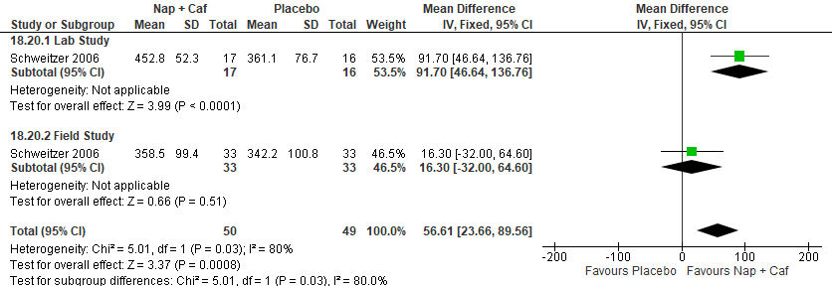
*Schweitzer 2006 (Field): (actigraphy data from day sleep 2 and nap 2).
Schweitzer 2006 (lab): PSG data (from day sleep 2 and nap 2).

Figure S232. Nap + Caffeine vs Caffeine (Total Sleep Time, PSG) [CMT = 15 min] RCT (Healthy participants)
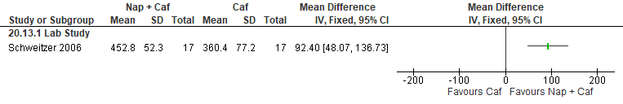
*Schweitzer 2006 (lab):. PSG data (from day sleep 2 and nap 2).

Figure S233. Nap + Caffeine vs Nap (Total Sleep Time, PSG) [CMT = 15 min] RCT (Healthy participants)
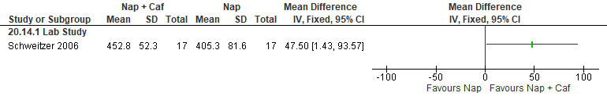*Schweitzer 2006 (lab): PSG data (from day sleep 2 and nap 2).

Figure S234. Nap + Caffeine vs Control (Total Sleep Time, Sleep Diary) [CMT = 15 min] RCT
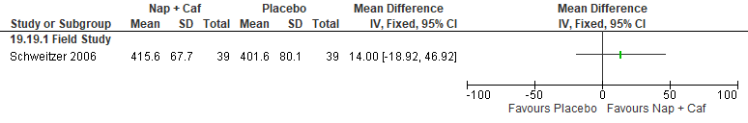

Symptoms of insomnia

CBT-I

Summary of Findings (GRADE)
Table S21. CBTI in adults with shiftwork disorder
References: Peter 2019, Lee 2014 Jarnefelt 2019, Jarnefelt 2014
Outcomes [Tool] | Certainty of the evidence  (GRADE) | Absolute Difference  CBT-I vs Control | No of Participants  (studies)
Excessive sleepiness or alertness  [ESS]ª | ⨁◯◯◯  VERY LOW^{b,c} | The mean difference in the CBT-I group was 1.17 points lower (3.04 lower to 0.70 lower) compared to control | 33  (1 non-RCT)
Sleep quality  [PSQI]ª | ⨁◯◯◯  VERY LOW^{b,c} | The mean difference in the CBT-I group was 1.84 points lower (3.38 lower to 0.31 lower) compared to control | 74  (2 non-RCTs)
Sleep quality  [SSI Sleep Disturbance]ª | ⨁◯◯◯  VERY LOW^{c} | The mean difference in the CBT-I group was 1.8 lower (3.46 lower to 0.14 lower) compared to control | 50  (1 non-RCT)
Sleep quality  [GSDS: Sleep Quality]ª | ⨁◯◯◯  VERY LOW^{c} | The mean difference in the CBT-I group was 0.89 lower (1.51 lower to 0.27 lower) compared to control | 50  (1 non-RCT)
Sleep quality  [Sleep diary (higher = worse)]ª | ⨁◯◯◯  VERY LOW^{b,c,d} | The mean difference in the CBT-I group was 0.15 points lower (0.48 lower to 0.18 higher) compared to control | 54  (1 RCT)
Sleep quality  [Sleep diary (lower = worse)]^{e} | ⨁◯◯◯  VERY LOW^{b,c,f} | The mean difference in the CBT-I group was 0 (0.21 lower to 0.21 higher) compared to control | 43  (1 non-RCT)
- Lower values favor the intervention
- Imprecision due to the 95% CI crossing the CMT
- Imprecision due to small sample size (<200 participants)
- Risk of bias concerns in the randomization of participants
- Higher values favor the intervention
- Risk of bias concerns in the selection of participants
- Imprecision due to the 95% CI crossing the null
- CMT was not established by the TF

Study Characteristics
Table S22. CBT-I in adults with shiftwork disorder
Study Citation | Study Design | Number of Participants (% Female) | Age in years | Population | Intervention (dose/intensity) | Comparator | Duration of Follow-up
Jarnefelt 2014 | non-RCT | 59 (50) | 43.5 ± 8.4 | Shift workers without SWD diagnosis | CBT-I | Baseline | 24 months
Jarnefelt 2019 | RCT | 83 (75) | 45 | SWD | Group-base CBT-I  self-help-based CBT-I | sleep hygiene | 6 months
Lee 2014 | non-RCT | 21 (95) | 45.5 ± 12.5 | SWD | Sleep Enhancement Training System for Shift Workers | Baseline | 4 weeks
Peter 2019 | non-RCT | 33 (77) | 44.7 ± 10.2 | SWD | online CBT-I face-to-face outpatient treatment | Baseline | 4 weeks

Critical Outcomes
Figure S235. CBT-I vs pre-CBT-I (Excessive sleepiness, ESS) [CMT = 2 pts] Non-randomized study (SWD)
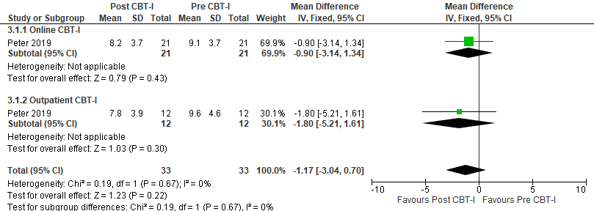

Figure S236. CBT-I vs pre-CBT-I (Sleep Quality, PSQI) [CMT = 3 pts] Non-randomized studies (SWD)
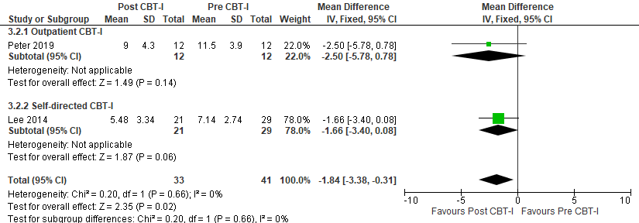
*Lee 2014: Data used from timepoints T2 (post control) compared to T3 (post intervention)

Figure S237. CBT-I vs pre-CBT-I (Sleep Quality, SSI sleep disturbance) [CMT = Not Established] Non-randomized study (SWD)
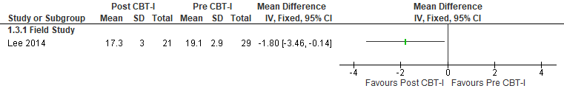
*Lee 2014: Data used from timepoints T2 (post control) compared to T3 (post intervention).

Figure S238. CBT-I vs pre-CBT-I (Sleep Quality, GSDS: Sleep Quality) [CMT = Not Established] Non-randomized study (SWD)
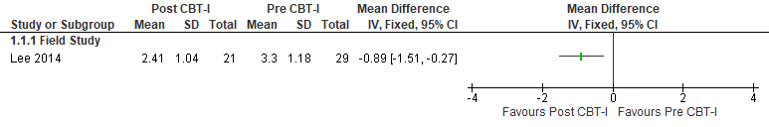
*Lee 2014: Data used from timepoints T2 (post control) compared to T3 (post intervention).

Figure S239. CBT-I vs Control (Sleep Quality, Sleep diary) [CMT = Not Established] RCT (SWD)
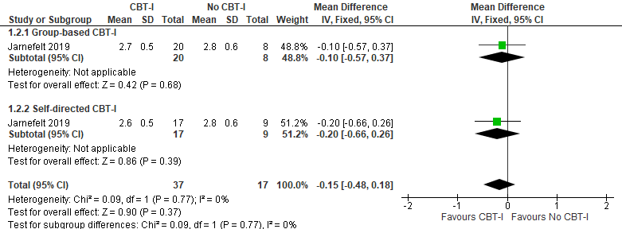*Jarnefelt 2019: Measurements taken from T2 (timepoint following the intervention), Restedness after sleep period 1(good)−5(poor). 3-arm study, control participants split (total n=17) to not double count.

Figure S240. CBT-I vs pre-CBT-I (Sleep Quality, Sleep diary) [CMT = Not Established] Non-randomized study (Shift workers without SWD diagnosis)
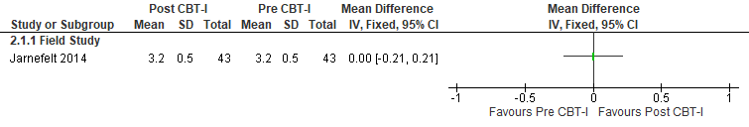
*Jarnefelt 2014: Total data analyzed, measurements from T1 (prior to CBT-I) and T2 (after CBT-I).

Important Outcomes
Figure S241. CBT-I vs pre-CBT-I (Total Sleep Time, Sleep diary) [CMT =15min] Non-randomized studies (SWD and shift workers without SWD diagnosis)
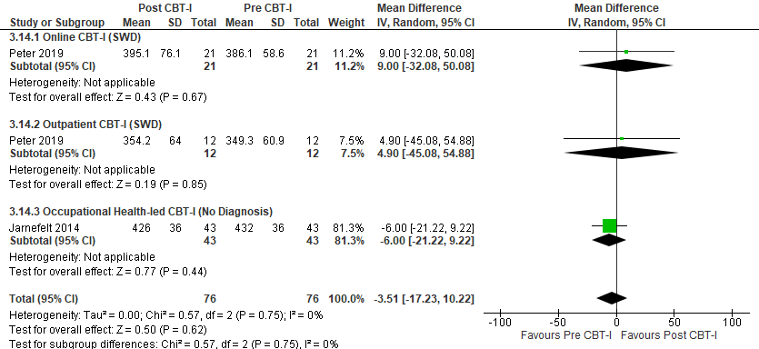*Peter 2019: Jarnefelt 2014: Total data analyzed, measurements from T1 (prior to CBT-I) and T2 (after CBT-I). TST (hours converted to minutes).

Figure S242. CBT-I vs pre-CBT-I (Total Sleep Time, Actigraphy) [CMT = 15min] Non-randomized study (SWD)
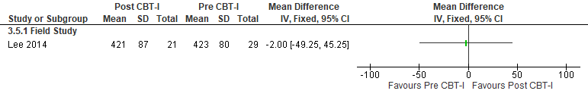*Lee 2014 data used from timepoints T2 (post control) compared to T3 (post intervention). Sleep during sleep periods.

Figure S243. CBT-I vs Control (Total Sleep Time, Actigraphy) [CMT = 15min] RCT (SWD)
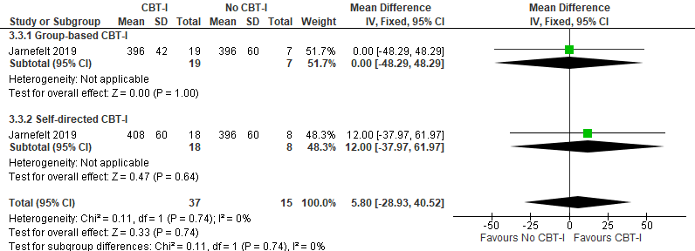*Jarnefelt 2019: Measurements taken from T2 (timepoint following the intervention). 3-arm study, control participants split (total n=15) to not double count.

Figure S244. CBT-I vs Control (Total Sleep Time, Sleep Diary) [CMT = 15min] RCT (SWD)
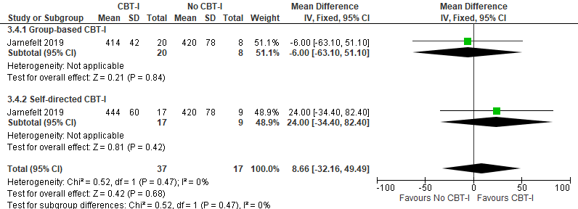*Jarnefelt 2019: Measurements taken from T2 (timepoint following the intervention). 3-arm study, control participants split (total n=17) to not double count.

Figure S245. CBT-I vs pre-CBT-I (Mental Health, Center for Epidemiologic Studies- Depression scale) [CMT = Not Established] Non-randomized study (SWD)
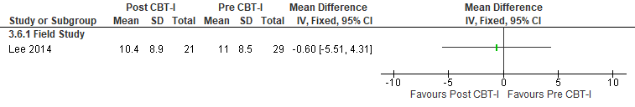
*Lee 2014 data used from timepoints T2 (post control) compared to T3 (post intervention).
Figure S246. CBT-I vs pre-CBT-I (Mental Health, SSI: Anxiety) [CMT = Not Established] Non-randomized study (SWD)
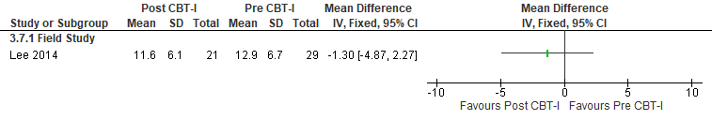
*Lee 2014: Data used from timepoints T2 (post control) compared to T3 (post intervention).

Figure S247. CBT-I vs pre-CBT-I (Mental Health, Beck Depression Inventory (BDI)-II) [CMT = Not Established] Non-randomized study (SWD)
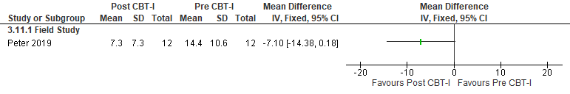
*Peter 2019: Pre/Post for outpatient only. Higher scores indicate worse depression.

Figure S248. CBT-I vs No CBT-I (Mental Health, Beck Depression Inventory) [CMT = Not Established] RCT (SWD)
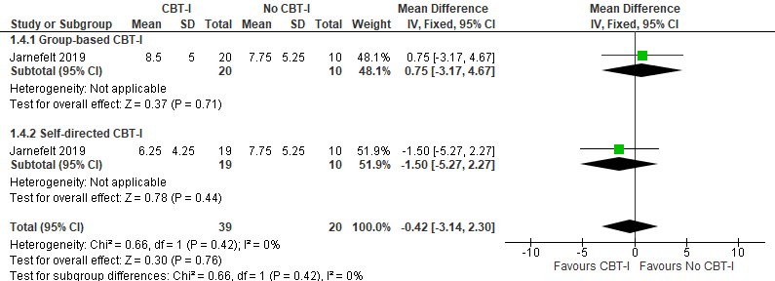*Jarnefelt 2019: Measurements taken from T2 (timepoint following the intervention). 3-arm study, control participants split (total n=20) to not double count. Higher scores indicate worse depression. Median and range data converted into Mean and SD using the formula in Hozo et al 2005 paper.

Figure S249. CBT-I vs pre-CBT-I (Mental Health, Montgomery–Åsberg Depression
Rating Scale (MARDS)) [CMT = Not Established] Non-randomized study (SWD)
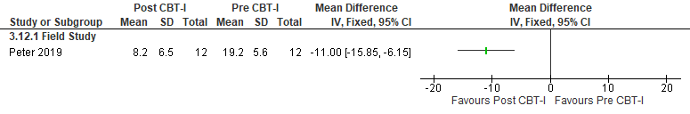
*Peter 2019: Pre/Post for outpatient only. Higher scores indicate worse depression.

Figure S250. CBT-I vs pre-CBT-I (Mental Health, SCI-90: Global Index) [CMT = Not Established] Non-randomized study (Shift workers without a SWD diagnosis)
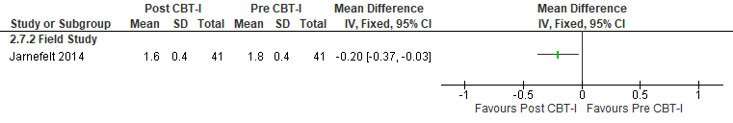
*Jarnefelt 2014: Total data analyzed, measurements from T1 (prior to CBT-I) and T2 (after CBT-I). Symptom Check List (SCL)-90, scale 1 (not bothered) to 5 (extremely bothered).

Figure S251. CBT-I vs pre-CBT-I (Mental Health, SCI-90: Depression Index) [CMT = Not Established] Non-randomized study (Shift workers without a SWD diagnosis)
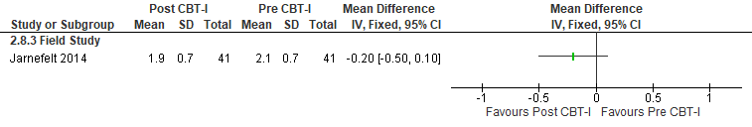
*Jarnefelt 2014: Total data analyzed, measurements from T1 (prior to CBT-I) and T2 (after CBT-I). Symptom Check List (SCL)-90, scale 1 (not bothered) to 5 (extremely bothered).

Figure S252. CBT-I vs pre-CBT-I (Mental Health, SCI-90: Anxiety Index) [CMT = Not Established] Non-randomized study (Shift workers without a SWD diagnosis)
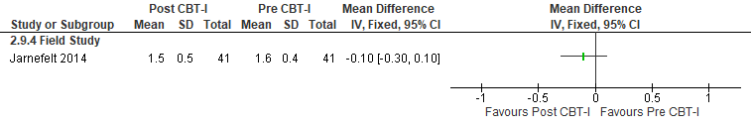
*Jarnefelt 2014: Total data analyzed, measurements from T1 (prior to CBT-I) and T2 (after CBT-I). Symptom Check List (SCL)-90, scale 1 (not bothered) to 5 (extremely bothered).

Figure S253. CBT-I vs pre-CBT-I (Circadian Alignment, Actigraphy) [CMT = Not Established] Non-randomized study (SWD)
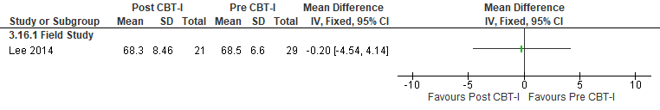
*Lee 2014: Data used from timepoints T2 (post control) compared to T3 (post intervention). Mesor, defined as the 24-hr adjusted mean activity level fitted to a cosinusoidal wave form, with higher values indicating more activity.

Figure S254. CBT-I vs pre-CBT-I (Quality of Life, WHO-5) [CMT = Not Established] Non-randomized study (SWD)
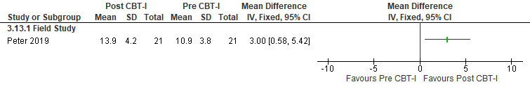
*Peter 2019: Pre/post online CBT only. WHO-5 lower score is worse.

Figure S255. CBT-I vs No CBT-I (Quality of Life, RAND-PCS) [CMT = Not Established] RCT (SWD)
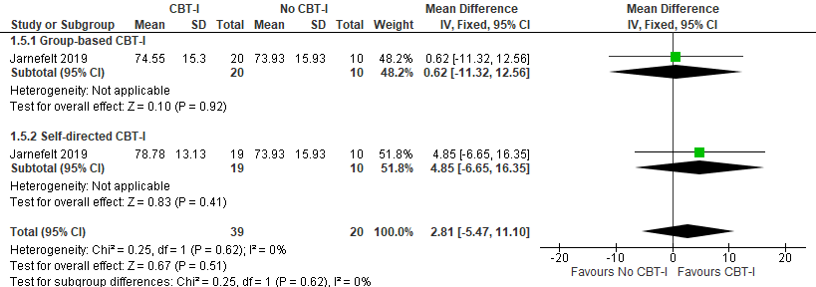*Jarnefelt 2019: Measurements taken from T2 (timepoint following the intervention). 3-arm study, control participants split (total n=20) to not double count. Median and range data converted into Mean and SD using the formula in Hozo et al 2005 paper.

Figure S256. CBT-I vs pre-CBT-I (Quality of Life, RAND-PCS) [CMT = Not Established] Non-randomized study (Shift workers without a SWD diagnosis)
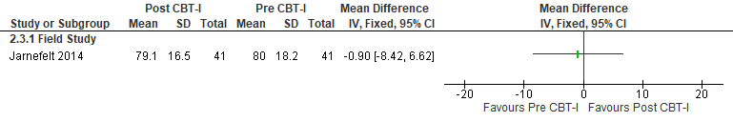
*Jarnefelt 2014: Total data analyzed, measurements from T1 (prior to CBT-I) and T2 (after CBT-I). RAND-PCS (physical component) higher score is better.
Figure S257. CBT-I vs No CBT-I (WASO, Sleep Diary) [CMT = 20 min] RCT (SWD)
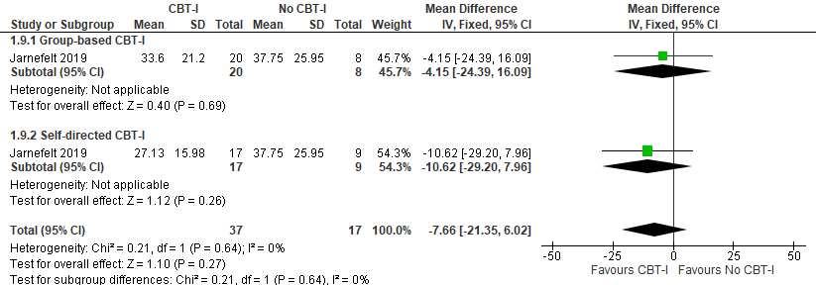*Jarnefelt 2019: Measurements taken from T2 (timepoint following the intervention). 3-arm study, control participants split (total n=17) to not double count. Median and range data converted into Mean and SD

Figure S258. CBT-I vs No CBT-I (WASO, Actigraphy) [CMT = 20 min] RCT (SWD)
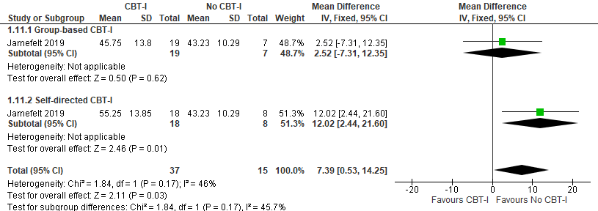*Jarnefelt 2019: Measurements taken from T2 (timepoint following the intervention). 3-arm study, control participants split (total n=15) to not double count. Median and range data converted into Mean and SD

Figure S259. CBT-I vs pre-CBT-I (Wake After Sleep Onset, Sleep Diary) [CMT = 20 min] Non-randomized study (Shift workers without a SWD diagnosis)
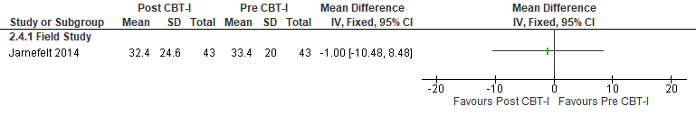
*Jarnefelt 2014: No diagnosis. Total data analyzed, measurements from T1 (prior to CBT-I) and T2 (after CBT-I).

Figure S260. CBT-I vs pre-CBT-I (Sleep Latency, PSQI: sleep onset latency) [CMT = 20 min] Non-randomized study (SWD)
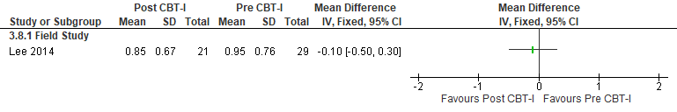
*Lee 2014: Data used from timepoints T2 (post control) compared to T3 (post intervention).

Figure S261. CBT-I vs pre-CBT-I (Sleep Latency, GSDS: sleep onset latency) [CMT = 20 min] Non-randomized study (SWD)
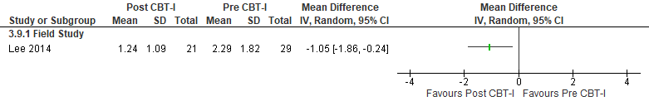*Lee 2014: Data used from timepoints T2 (post control) compared to T3 (post intervention).

Figure S262. CBT-I vs No CBT-I (Sleep Latency, Sleep Diary) [CMT = 20 min] RCT (SWD)
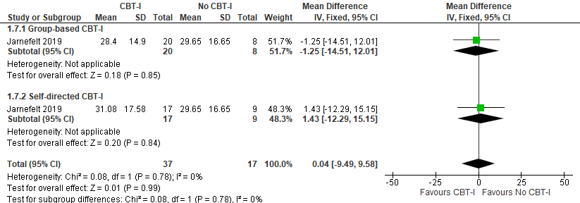*Jarnefelt 2019: Measurements taken from T2 (timepoint following the intervention). 3-arm study, control participants split (total n=17) to not double count. Median and range data converted into Mean and SD using the formula in Hozo et al 2005 paper.

Figure S263. CBT-I vs No CBT-I (Sleep Latency, Actigraphy) [CMT = 15 min] RCT (SWD)
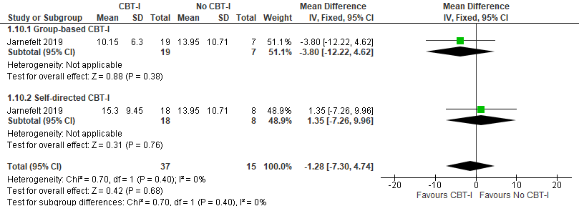*Jarnefelt 2019: Measurements taken from T2 (timepoint following the intervention). 3-arm study, control participants split (total n=15) to not double count. Median and range data converted into Mean and SD using the formula in Hozo et al 2005 paper.

Figure S264. CBT-I vs pre-CBT-I (Sleep Latency, Sleep Diary) [CMT = 20 min] Non-randomized study (Shift workers without a SWD diagnosis)
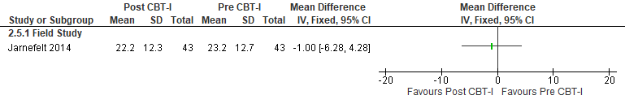
*Jarnefelt 2014: Total data analyzed, measurements from T1 (prior to CBT-I) and T2 (after CBT-I).

Figure S265. CBT-I vs pre-CBT-I (Sleep Efficiency, PSQI: sleep efficiency) [CMT = Not Established] Non-randomized study (SWD)
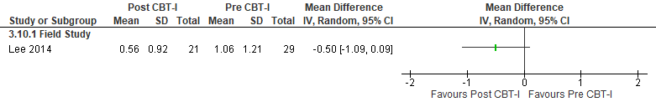*Lee 2014: Data used from timepoints T2 (post control) compared to T3 (post intervention).

Figure S266. CBT-I vs pre-CBT-I (Sleep Efficiency, Sleep Diary) [CMT = 10%] Non-randomized study (SWD)
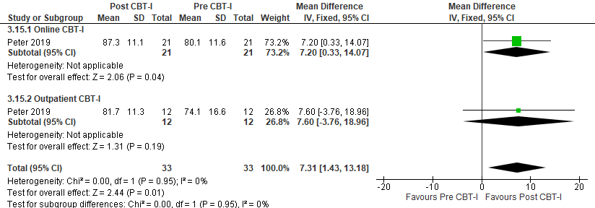

Figure S267. CBT-I vs No CBT-I (Sleep Efficiency, Sleep Diary) [CMT = 10%] RCT (SWD)
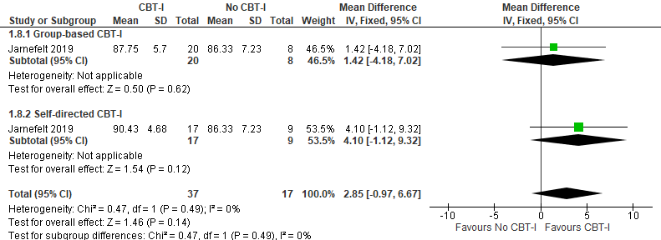*Jarnefelt 2019: Measurements taken from T2 (timepoint following the intervention). 3-arm study, control participants split (total n=17) to not double count. Median and range data converted into Mean and SD using the formula in Hozo et al 2005 paper.
Figure S268. CBT-I vs No CBT-I (Sleep Efficiency, Actigraphy) [CMT = 10%] RCT (SWD)
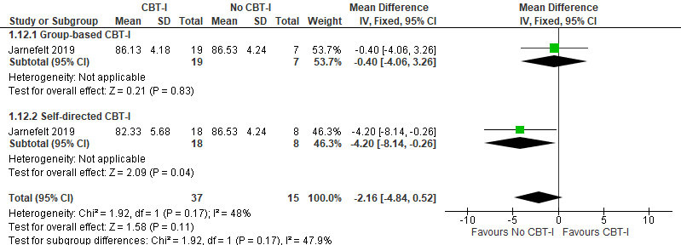*Jarnefelt 2019: Measurements taken from T2 (timepoint following the intervention). 3-arm study, control participants split (total n=15) to not double count. Median and range data converted into Mean and SD using the formula in Hozo et al 2005 paper.

Figure S269. CBT-I vs pre-CBT-I (Sleep Efficiency, Sleep Diary) [CMT = 10%] Non-randomized study (Shift workers without a SWD diagnosis)
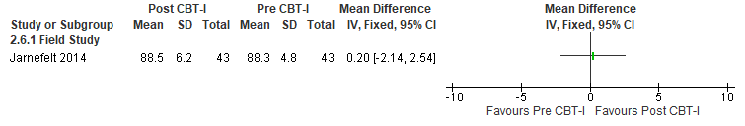*Jarnefelt 2014: Total data analyzed, measurements from T1 (prior to CBT-I) and T2 (after CBT-I).

Figure S270. CBT-I vs pre-CBT-I (Disease Severity, ISI) [CMT = 8] Non-randomized study (SWD)
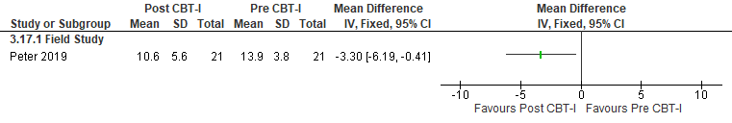 *Peter 2019: Pre/post online CBT only, lower score is better. ISI= insomnia severity index.

Melatonin for daytime sleep

Summary of Findings (GRADE)
Table S23. Melatonin for daytime sleep in adults with shiftwork disorder
References: Aeschbach 2009, Folkard 1993, James 1998, Cavallo 2005, Gilbert 1999, Mishima 1997, Sharkey 2001, Smith 2005, Sharkey 2002, Jockovich 2000
Outcomes [Tool] | Certainty of the evidence  (GRADE) | Absolute Difference  Melatonin for daytime sleep vs Control | No of Participants  (studies)
Excessive sleepiness or alertness  [KSS] | ⨁◯◯◯  VERY LOW^{a,b,c,d} | The mean difference in the melatonin group was 0.56 points more (0.45 fewer to 1.56 more) compared to control | 16  (1 RCT)
Excessive sleepiness or alertness  [VAS-alertness] | ⨁◯◯◯  VERY LOW^{c,e} | The mean difference in the melatonin group was 11.9 higher (0.58 lower to 24.38 higher) compared to control | 14  (1 RCT)
Excessive sleepiness or alertness  [Subjective reporting] | ⨁◯◯◯  VERY LOW^{c,d} | The risk ratio in the melatonin group was 0.81 (0.02 to 1.44) with an absolute risk of 3.7 fewer per 1,000 (19 fewer to 8.5 more) compared to control | 59  (1 RCT)
Excessive sleepiness or alertness  [MSLT] | ⨁◯◯◯  VERY LOW^{a,c,e} | The mean difference in the melatonin group was 0.53 minutes higher (-2.16 fewer to 3.22 more) compared to control | 42  (1 RCT)
Excessive sleepiness or alertness  [VAS-Alertness] | ⨁◯◯◯  VERY LOW^{c,d} | The mean difference in the melatonin group was 0.5 cm lower (1.38 lower to 0.38 higher) compared to control | 44  (1 RCT)
Excessive sleepiness or alertness  [SSS] | ⨁◯◯◯  VERY LOW^{a,c,e} | The mean difference in the melatonin group was 0.19 points fewer (1.05 fewer to 0.67 more) compared to control | 14  (1 RCT)
Cognitive performance  [PVT lapses] | ⨁◯◯◯  VERY LOW^{a,c} | The mean difference in the melatonin group was 0.4 lapses fewer (0.04 fewer to 0.72 more) compared to control | 58  (2 RCTs)
Cognitive performance  [Conner’s Continuous Performance Test] | ⨁◯◯◯  VERY LOW^{c,d,f} | The evidence (1 RCT) is very uncertain about the effect of naps and caffeine on cognitive performance (measured by multiple domains of the Connor’s Continuous Performance Test). | 90  (1 RCT)
Adverse Event  [Headache] | ⨁◯◯◯  VERY LOW^{c,d,f} | The risk ratio in the melatonin group was 0.82 (0.51 to 1.30) with an absolute risk of 11 fewer per 1,000 (30 fewer to 18.4 more) compared to control | 58  (1 RCT)
Adverse Event  [Abdominal pain] | ⨁◯◯◯  VERY LOW^{c,d,f} | The risk ratio in the melatonin group was 1.85 (0.48 to 7.03) with an absolute risk of 8.2 more per 1,000 (5 fewer to 58.4 more) compared to control | 58  (1 RCT)
Adverse Event  [Nausea] | ⨁◯◯◯  VERY LOW^{c,d,f} | The risk ratio in the melatonin group was 2.21 (0.75 to 6.56) with an absolute risk of 15.6 more per 1,000 (3.2 fewer to 71.7 more) compared to control | 58  (1 RCT)
Adverse Event  [Vomiting] | ⨁◯◯◯  VERY LOW^{c,d,f} | The risk ratio in the melatonin group was 9.93 (0.56 to 176.60) with an absolute risk of 0.0 fewer per 1,000 (0 fewer to 0 fewer) compared to control | 58  (1 RCT)
Adverse Event  [Dizziness] | ⨁◯◯◯  VERY LOW^{c,d,f} | The risk ratio in the melatonin group was 1.11 (0.07 to 16.88) with an absolute risk of 0.4 fewer per 1,000 (3 fewer to 51.2 more) compared to control | 58  (1 RCT)
Sleep quality  [VAS-sleep quality] | ⨁◯◯◯  VERY LOW^{c,g} | The mean difference in the melatonin group was 10.6 cm higher (2.51 higher to 18.69 higher) compared to control | 14  (1 RCT)
- Indirectness is due to the fact that participants included in the studies are healthy individuals. The effect in adults with SWD may be different
- Timepoints not within 2300- end of shift.
- Imprecision due to small sample size (<200 participants)
- Confidence interval crosses the line of no effect
- Confidence interval crosses the clinical significance threshold
- Bias in reported data, pooled between subject and within subject data
- Incomplete outcome data

Study Characteristics
Table S24. Melatonin for daytime sleep in adults with shiftwork disorder
Study Citation | Study Design | Number of Participants (% Female) | Age (years) | Population | Intervention (dose) |  | Comparator | Time of Intervention Delivery | Duration of Follow-up
Aeschbach 2009 | RCT, crossover | 8 (50) | 27.8 ± 3.6 | Healthy participants | melatonin (2.1 mg patch) |  | Placebo patch | 1 hour before daytime sleep opportunity | 1 day
Cavallo 2005 | RCT, crossover | 45 (64) | 28.6 ± 1.9 | Shift workers without SWD diagnosis |  | melatonin (3 mg) | Placebo | before bedtime in the morning after night shift | 1 night
Folkard 1993 | RCT, crossover | 17 (12) | 29 ± 7 | Shift workers without SWD diagnosis | Melatonin (5 mg) |  | Placebo | before day sleeps between the night shifts at 06:42 h ± 7.6 min | 28 days
Gilbert 1999 | RCT, crossover | 20 (35) | 23.5 ± 0.4 | Healthy participants | Melatonin (5 mg) |  | Placebo | 14:00 | 1 night
James 1998 | RCT, crossover | 22 (23) | 29 ± 8 | Shift workers without SWD diagnosis | Melatonin (6 mg) |  | Placebo | 30 minutes before each consecutive day sleep | 4 nights
Jockovich 2000 | RCT, crossover | 19 (21) | 28.4 | Shift workers without SWD diagnosis | Melatonin (1 mg) |  | Placebo | 30-60 minutes before daytime sleep session | 3 days
Mishima 1997 | RCT, crossover | 6 (0) | 22.5 ± 1.9 | Healthy participants | Melatonin (3 or 9 mg) |  | Placebo | 9:30 | 1 day
Sharkey 2001 | RCT, crossover | 21 (43) | 27.0 ± 5.0 | Healthy participants | Melatonin  (1.8 mg sustained release) |  | Placebo | 30 min before bedtime | 6 days
Sharkey 2002 | RCT | 32 (41) | 24.2 ± 4.8 | Healthy participants | Melatonin (0.5 or 3 mg) |  | Placebo | 30 min before bedtime | 8 days
Smith 2005 | RCT | 67 (52) | 23.9 ± 6.2 | Healthy participants | melatonin (1.8 mg sustained release) |  | placebo | bright light during the night shifts | 5 nights

Critical Outcomes
Figure S271. Melatonin vs Control (Excessive Sleepiness, KSS) [CMT=1 point] RCT (Healthy participants)
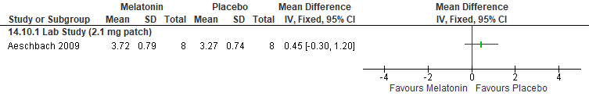
*Aeschbach 2009: KSS data extracted from graph; SEM converted to SD.

Figure S272. Melatonin vs placebo (Excessive Sleepiness, VAS-Alertness) [CMT = Not Established] RCT (Shift workers without SWD diagnosis)
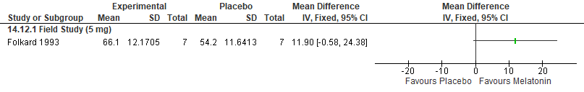
*Folkard 1993: data extracted from the figure, pooled from 22:00-6:00, SEM converted to SD

Figure S273. Melatonin vs placebo (Excessive Sleepiness, VAS-Alertness) [CMT = Not Established] RCT (Shift workers without SWD diagnosis)
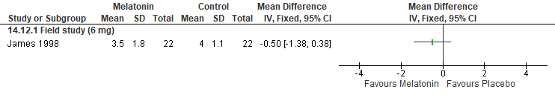 *James 1998: mean and SD calculated from median and IQR
Figure S274. Melatonin vs placebo (Excessive Sleepiness, Subjective Report of Adverse Events) [CMT = Not Established] RCT (Shift workers without SWD diagnosis)
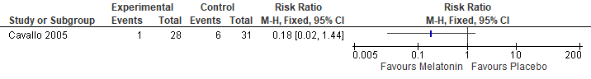

Figure S275. Melatonin vs placebo (Excessive Sleepiness, MSLT) [CMT = 1 min] RCT (Healthy participants)
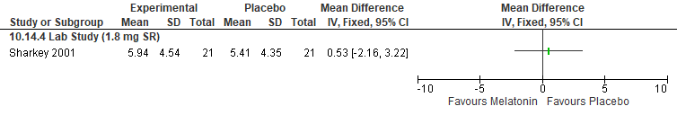

Figure S276. Melatonin vs placebo (Excessive Sleepiness, SSS) [CMT = 1 pt] RCT (Healthy participants)
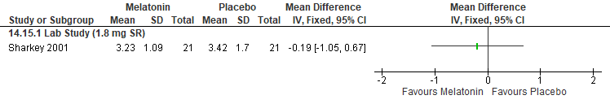

Figure S277. Melatonin vs placebo (Sleep Quality, Movement Minutes) [CMT = Not Established] RCT (Healthy participants)
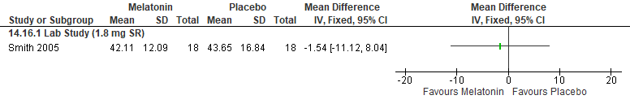

Figure S278. Melatonin vs placebo (Sleep Quality, VAS-sleep quality) [CMT = Not Established] RCT (Shift workers without a diagnosis of SWD)
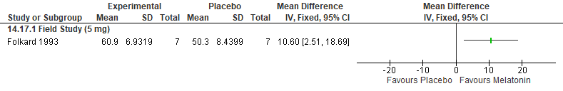
*Folkard 1993: SEM converted to SD, 5 mg taken prior to each of the 6 successive day sleeps taken between the night shifts at 06:42 h ± 7.6 min

Figure S279. Melatonin vs Control (Cognitive Performance, PVT lapses) [CMT= 1 lapse] RCT (Healthy participants)
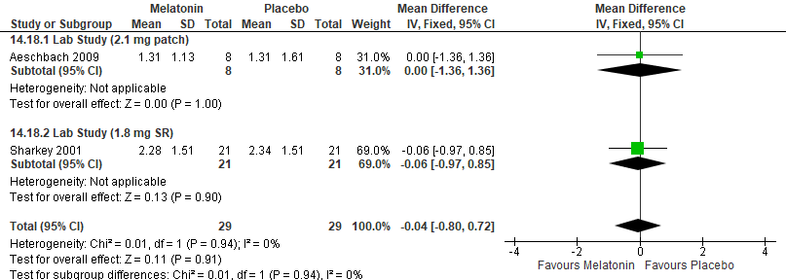
*Aeschbach 2009: 2.1 mg melatonin patch was placed on participants at 0800 (an hour prior to their daytime sleep). Crossover-study, acceptable washout period. 2100 timepoint used, data extracted from graph; SEM converted to SD.

Figure S280. Melatonin vs Control (Cognitive Performance, Conner’s Continuous Performance Test (reaction time)) [CMT = Not Established] RCT (Shift workers without a diagnosis of SWD)
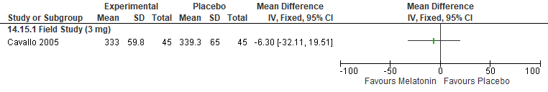
*Cavallo 2005: 3 mg melatonin or placebo were given in the morning of the days of night work

Figure S281. Melatonin vs Control (Cognitive Performance, Conner’s Continuous Performance Test (Hit reaction time block change)) [CMT = Not Established] RCT (Shift workers without a diagnosis of SWD)
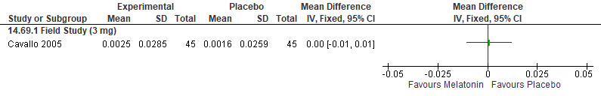*Cavallo 2005: 3 mg melatonin or placebo were given in the morning of the days of night work

Figure S282. Melatonin vs Control (Cognitive Performance, Conner’s Continuous Performance Test (Attentiveness)) [CMT = Not Established] RCT (Shift workers without a diagnosis of SWD)
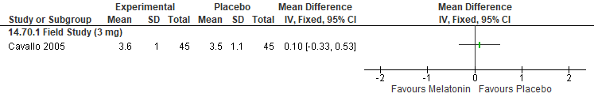*Cavallo 2005: 3 mg melatonin or placebo were given in the morning of the days of night work

Figure S283. Melatonin vs Control (Cognitive Performance, Conner’s Continuous Performance Test (Risk Taking)) [CMT = Not Established] RCT (Shift workers without a diagnosis of SWD)
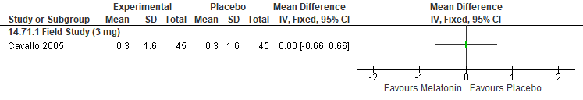*Cavallo 2005: 3 mg melatonin or placebo were given in the morning of the days of night work

Figure S284. Melatonin vs Control (Cognitive Performance, Conner’s Continuous Performance Test (No. of commission errors)) [CMT = Not Established] RCT (Shift workers without a diagnosis of SWD)
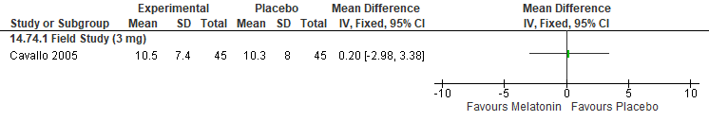

Important Outcomes
Figure S285. Melatonin vs placebo (Total Sleep Time, PSG) [CMT = 15 min] RCT (Healthy participants)
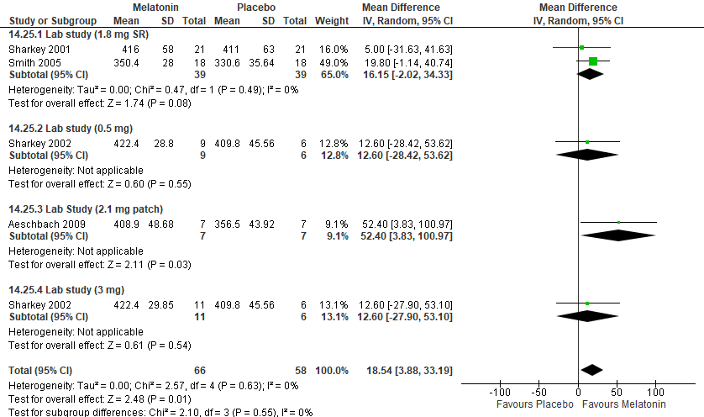*Aeschbach 2009: 2.1 mg melatonin patch was placed on participants at 0800 (an hour prior to their daytime sleep, 0900-1700, following lab shiftwork). Crossover-study, acceptable washout period. SEM converted to SD.
Satomura 2001: medication administered at 13:30 h

Figure S286. Melatonin vs placebo (Total Sleep Time, Sleep Diary or questionnaire) [CMT = 15 min] RCT (Healthy participants)
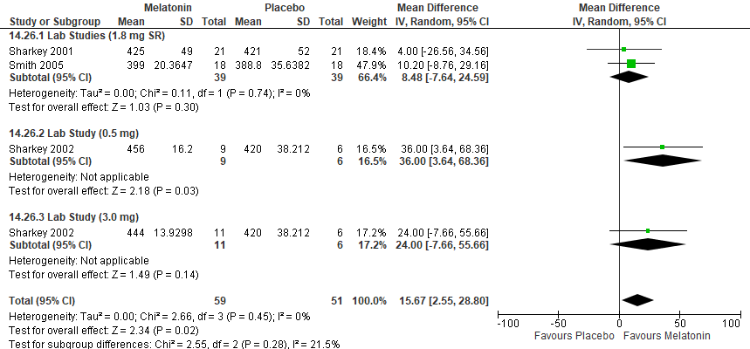

Figure S287. Melatonin vs placebo (Total Sleep Time, Sleep Diary or questionnaire) [CMT = 15 min] RCT (Shift workers without a diagnosis of SWD)
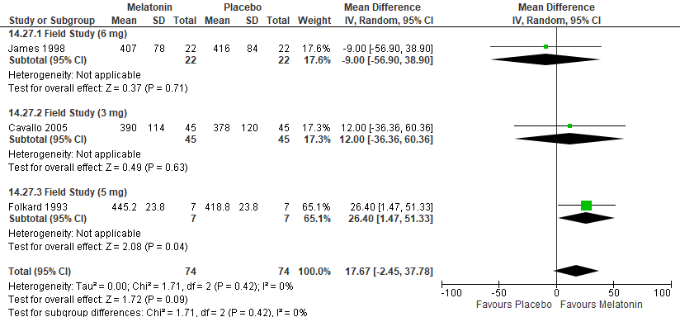*Folkard 1993: hours converted into minutes; SEM converted to SD; 5 mg taken prior to each of the 6 successive day sleeps taken between the night shifts at 06:42 h ± 7.6 min
Cavallo 2005: hours converted to minutes, data from morning treatment days was used, 3 mg melatonin or placebo were given in the morning of the days of night work

Figure S288. Melatonin vs Placebo (Mental Health, POMS (tension/anxiety)) [CMT = Not Established] RCT (Shift workers without a diagnosis of SWD)
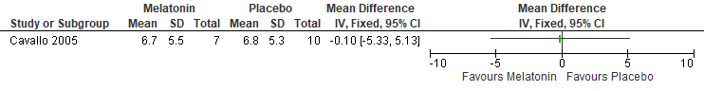

Figure S289. Melatonin vs Placebo (Mental Health, POMS (depression)) [CMT = Not Established] RCT (Shift workers without a diagnosis of SWD)
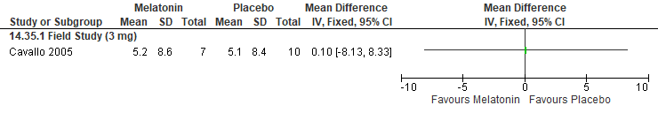

Figure S290. Melatonin vs Placebo (Mental Health, POMS (anger)) [CMT = Not Established] RCT (Shift workers without a diagnosis of SWD)
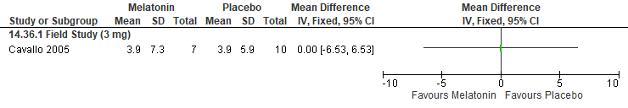

Figure S291. Melatonin vs Placebo (WASO (min), PSG) [CMT= 20 min] RCT (Healthy participants)
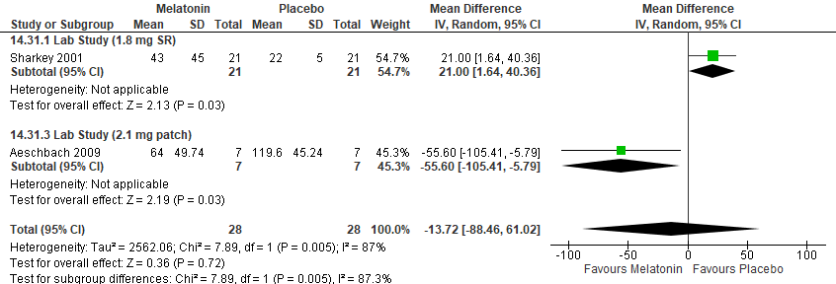
*Aeschbach 2009: 2.1 mg melatonin patch was placed on participants at 0800 (an hour prior to their daytime sleep, 0900-1700, following lab shiftwork). Crossover-study, acceptable washout period. SEM converted to SD.

Figure S292. Melatonin vs Placebo (Sleep Latency (min), PSG) [CMT= 20 min] RCT (Shift workers without a diagnosis of SWD)
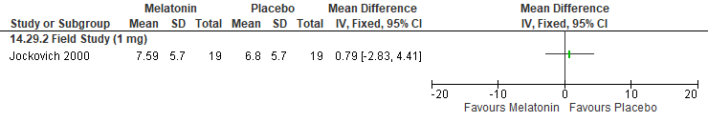
*Jockovich 2000: SD calculated from p value, administered 30 to 60 minutes prior to their anticipated daytime sleep session

Figure S293. Melatonin vs Placebo (Sleep Latency (min), PSG) [CMT= 20 min] RCT (Healthy participants)
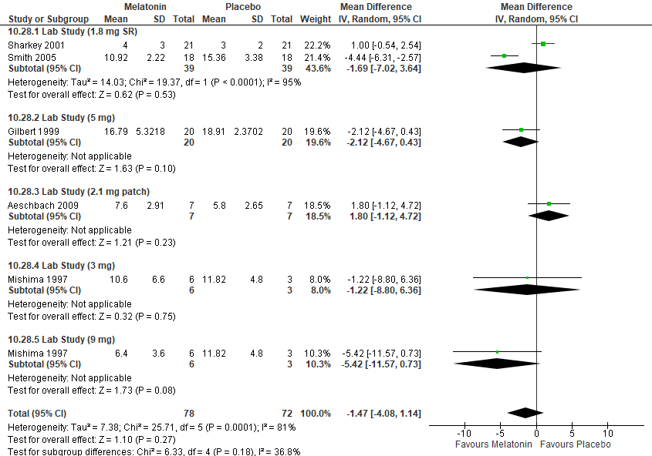

Figure S294. Melatonin vs Placebo (Sleep Latency (min), Sleep diary) [CMT= 20 min] RCT (Shift workers without a diagnosis of SWD)
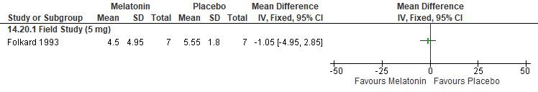
*Folkard 1993: SEM converted to SD; 5 mg taken prior to each of the 6 successive day sleeps taken between the night shifts at 06:42h ± 7.6 min

Figure S295. Melatonin vs Placebo (Sleep Efficiency (%), PSG) [CMT= 10%] RCT (Shift workers without a diagnosis of SWD)
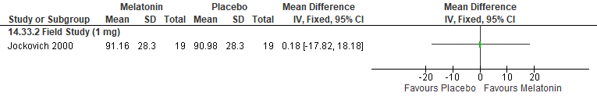 *Jockovich 2000: SD calculated from p value, 5 mg taken prior to each of the 6 successive day sleeps taken between the night shifts at 06:42 h ± 7.6 min

Figure S296. Melatonin vs Placebo (Sleep Efficiency (%), PSG) [CMT= 10%] RCT (Healthy participants)
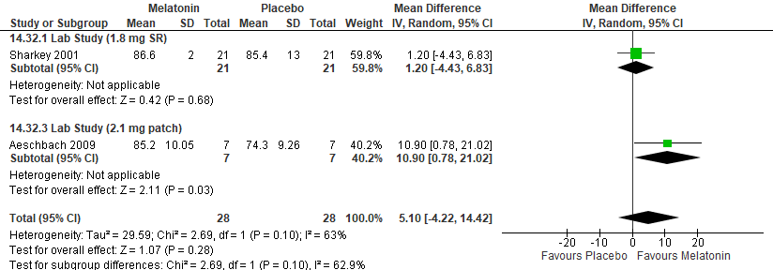
*Aeschbach 2009: 2.1 mg melatonin patch was placed on participants at 0800 (an hour prior to their daytime sleep, 0900-1700, following lab shiftwork). Crossover-study, acceptable washout period. SEM converted to SD.

Figure S297. Melatonin vs Control (Adverse Events, headache) [CMT = Not Established] RCT (Shift workers without a diagnosis of SWD)
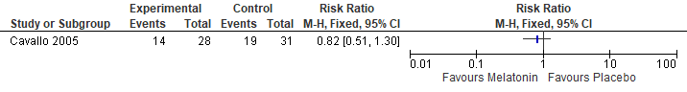

Figure S298. Melatonin vs Control (Adverse Events, Abdominal Pain) [CMT = Not Established] RCT (Shift workers without a diagnosis of SWD)
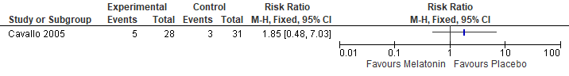

Figure S299. Melatonin vs Control (Adverse Events, Vomiting) [CMT = Not Established] RCT (Shift workers without a diagnosis of SWD)
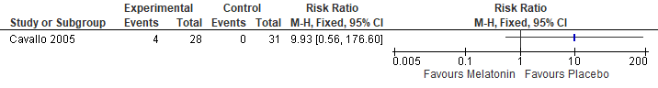

Figure S300. Melatonin vs Control (Adverse Events, Nausea) [CMT = Not Established] RCT (Shift workers without a diagnosis of SWD)
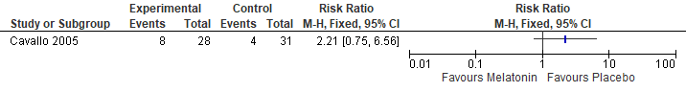

Figure S301. Melatonin vs Control (Adverse Events, Dizziness) [CMT = Not Established] RCT (Shift workers without a diagnosis of SWD)
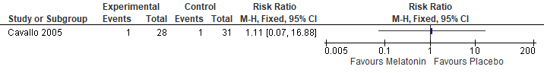

Melatonin for transition from daytime to nighttime sleep following the night shift

Summary of Findings (GRADE)
Table S25. Melatonin for transitioning from day to night sleeping in adults with shiftwork disorder
References: Sadeghniiat- Haghighi 2008, Sadeghniiat-Haghighi 2016, Farahmand 2018
Outcomes [Tool] | Certainty of the evidence  (GRADE) | Absolute Difference  Melatonin for recovery from night shift vs Control | No of Participants  (studies)
Sleep quality  [Questionnaire] | ⨁⨁◯◯  LOW^{a,b} | The mean difference in the melatonin group was 0.11 lower (0.32 lower to 0.1 higher) compared to control | 172  (1 RCT)
Total sleep time  [Sleep diary] | ⨁⨁◯◯  LOW^{a,c} | The mean difference in the melatonin group was 20.1 minutes more (4.88 more to 35.32 more) compared to control | 172  (1 RCT)
Total sleep time  [Actigraphy] | ⨁⨁◯◯  LOW^{a,c} | The mean difference in the melatonin group was 18 minutes more (12.49 fewer to 48.49 more) compared to control | 56  (1 RCT)
Mental health  [POMS] | ⨁⨁◯◯  LOW^{a,b} | The mean difference in the melatonin group was 1.25 higher (24.15 lower to 26.65 higher) compared to control | 48  (1 RCT)
WASO  [Actigraphy] | ⨁⨁◯◯  LOW^{a,b} | The mean difference in the melatonin group was 5.4 minutes fewer (19.85 fewer to 9.05 more) compared to control | 56  (1 RCT)
Sleep latency  [Sleep diary] | ⨁⨁⨁◯  MODERATEª | The mean difference in the melatonin group was 28.2 minutes fewer (35.62 fewer to 20.78 fewer) compared to control | 172  (1 RCT)
Sleep latency  [Actigraphy] | ⨁⨁◯◯  LOW^{a,b} | The mean difference in the melatonin group was 6.6 minutes fewer (11.47 fewer to 1.73 fewer) compared to control | 56  (1 RCT)
Sleep efficiency  [actigraphy] | ⨁⨁◯◯  LOW^{a,b} | The mean difference in the melatonin group was 2.96 percent higher (0.84 lower to 6.76 higher) compared to control | 56  (1 RCT)
- Imprecision due to small sample size (<200 participants)
- Confidence interval crosses the line of no effect
- Confidence interval crosses the CMT

Study Characteristics
Table S26. Melatonin for transitioning from day to night sleeping in adults with shiftwork disorder
Study Citation | Study Design | Number of Participants (% Female) | Age (years) | Population | Intervention (dose) | Comparator | Time of Intervention Delivery | Duration of Follow-up
Farahmand 2018 | RCT. Crossover | 24 (42) | 31.21±5.23 | Shift workers without SWD diagnosis | melatonin (3 mg) | Placebo | about 1 hour before habitual nighttime sleep | 4 nights
Sadeghniiat-Haghighi 2008 | RCT, crossover | 86 (80) | 30.5 ± 5.2 | Shift workers without SWD diagnosis | Melatonin (5 mg) | Placebo | 30 min before night time sleep following shift work | 1 night
Sadeghniiat-Haghighi 2016 | RCT, crossover | 50 (0) | 32.9 ± 8 | Shift workers without SWD diagnosis | Melatonin (3 mg) | Placebo | 30 min before night time sleep following shift work | 3 days

Critical Outcomes
Figure S306. Sleep Promoting Medication (Melatonin) vs Control (Sleep quality, questionnaire) [CMT = Not Established] RCT (Shift workers without SWD diagnosis)
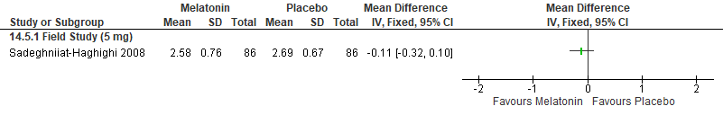
*Sadeghniiat- Haghighi 2008: 5 mg Melatonin tablet, 30 min prior to bedtime (on the first night after shift work) (crossover-study, acceptable washout period). Sleep quality questionnaire (1= very satisfied, 5= very unsatisfied)

Important Outcomes
Figure S307. Melatonin vs placebo (Total Sleep Time, Sleep Diary or questionnaire) [CMT = 15 min] RCT (Shift workers without SWD diagnosis)
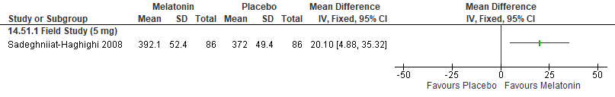*Sadeghniiat- Haghighi 2008: 5 mg Melatonin tablet, 30 min prior to bedtime (on the first night after shift work); questionnaire. Crossover-study, acceptable washout period.

Figure S308. Melatonin vs placebo (Total Sleep Time, Actigraphy) [CMT = 15 min] RCT (Shift workers without SWD diagnosis)
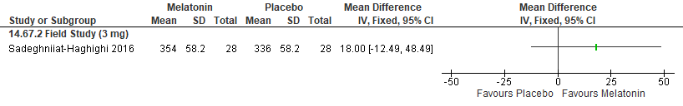 *Sadeghniiat-Haghighi 2016: hours converted to minutes, used average of the three days, 3 mg of melatonin or placebo was administered 30 minutes before usual sleep time

Figure S309. Melatonin vs Placebo (Mental Health, POMS) [CMT = Not Established] RCT (Shift workers without SWD diagnosis)
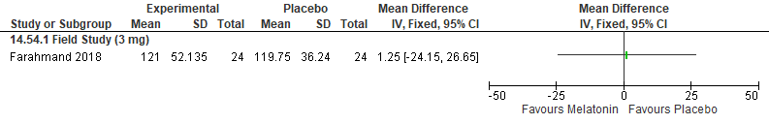
*Farahmand 2018: POMS pooled for night 1 and 2, 3 mg tablets taken one hour before their night-time sleep at their first and second nights off
Figure S310. Melatonin vs Placebo (WASO (min), Actigraphy) [CMT= 20 min] RCT (Shift workers without SWD diagnosis)
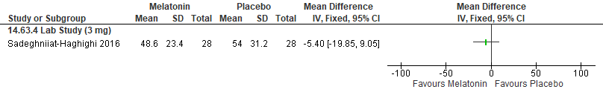 *Sadeghniiat-Haghighi 2016: hours converted to minutes, 3 mg of melatonin or placebo was administered 30 minutes before usual sleep time
Figure S311. Melatonin vs Placebo (Sleep Latency (min), Questionnaire) [CMT= 20 min] RCT (Shift workers without SWD diagnosis)
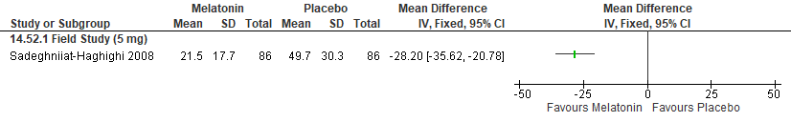
*Sadeghniiat- Haghighi 2008: 5 mg Melatonin tablet, 30 min prior to bedtime (on the first night after shift work). All participants used in both arms (crossover-study, acceptable washout period). Measured by sleep onset latency.

Figure S312. Melatonin vs Placebo (Sleep Latency (min), Actigraphy) [CMT= 20 min] RCT (Shift workers without SWD diagnosis)
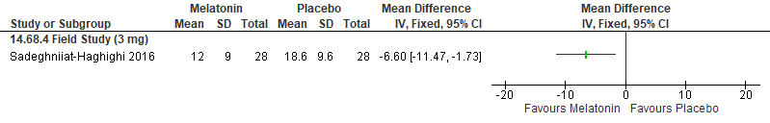
*Sadeghniiat-Haghighi 2016: hours converted to minutes, used average of the three days, 3 mg of melatonin or placebo was administered 30 minutes before usual sleep time

Figure S313. Melatonin vs Placebo (Sleep Efficiency (%), PSG) [CMT= 10%] RCT (Shift workers without SWD diagnosis)
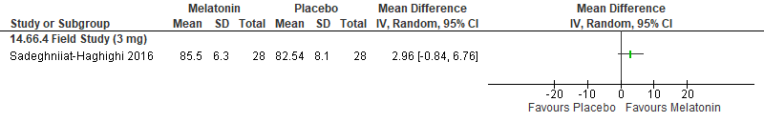

Melatonin for naps prior to the first night shift

Summary of Findings (GRADE)
Table S27. Melatonin for daytime sleep prior to the first night shift in adults with shiftwork disorder
References: Hughes 1997, Satomura 2001, Dijk 1995, Dollins 1994
Outcomes [Tool] | Certainty of the evidence  (GRADE) | Absolute Difference  Melatonin vs Control | No of Participants  (studies)
Total sleep time  [PSG] | ⨁◯◯◯  VERY LOW^{a,b,c} | The mean difference in the melatonin group was 15.7 minutes more (6.06 more to 25.34 more) compared to control | 76  (3 RCTs)
WASO  [PSG] | ⨁◯◯◯  VERY LOW^{a,b,c} | The mean difference in the melatonin group was 20.04 minutes fewer (29.69 fewer to 10.43 fewer) compared to control | 60  (2 RCTs)
Sleep latency  [PSG] | ⨁⨁◯◯  LOW^{a,b} | The mean difference in the melatonin group was 1.97 minutes fewer (2.55 fewer to 1.39 fewer) compared to control | 56  (3 RCTs)
Sleep latency  [Sleep test] | ⨁⨁◯◯  LOW^{a,b} | The mean difference in the melatonin group was 9.52 minutes lower (12.36 lower to 6.68 lower) compared to control | 100  (1 RCT)
Sleep latency  [Sleep diary] | ⨁⨁◯◯  LOW^{a,b} | The mean difference in the melatonin group was 10.76 minutes fewer (13.55 fewer to 7.96 fewer) compared to control | 100  (1 RCT)
Sleep efficiency  [PSG] | ⨁◯◯◯  VERY LOW^{a,b,c,d} | The mean difference in the melatonin group was 7.22 percent higher (1.68 lower to 16.12 higher) compared to control | 44  (2 RCTs)
- Indirectness is due to the fact that participants included in the studies are healthy individuals. The effect in adults with SWD may be different.
- Imprecision due to small sample size (<200 participants)
- Imprecision due to the 95% CI crossing the CMT
- Imprecision due to the 95% CI crossing the null

Study Characteristics
Table S28. Melatonin for daytime sleep prior to the first night shift in adults with shiftwork disorder
Study Citation | Study Design | Number of Participants (% Female) | Age in years | Population | Intervention (dose) | Comparator | Time of Intervention Delivery | Duration of Follow-up
Dijk 1995 | RCT, crossover | 8 (0) | 22.4 | Healthy participants | Melatonin (5 mg) | Placebo | 12:30 (30 min before nap from 13:00-17:00) | 1 night
Dollins 1994 | RCT, crossover | 20 (0) | 23.05 ± 4.22 | Healthy participants | Melatonin (0.1, 0.3, 1, or 10 mg) | Placebo | 11:45 (1h 45 min before a sleep onset test at 13:30) | 5 nights
Hughes 1997 | RCT, crossover | 8 (0) | 18-30 | Healthy participants | Melatonin (1, 10, or 40 mg) | placebo | 10:00 (2h before nap from 12:00-16:00) | 1 day
Satomura 2001 | RCT, crossover | 7 (0) | 23.7 ± 1.7 | Healthy participants | Melatonin (1, 3, or 6 mg) | Placebo | 13:30 (30 min before nap from 14:00 h to 17:00) | 1 day

Critical Outcomes
None

Important Outcomes
Figure S310. Melatonin vs placebo (Total Sleep Time, PSG) [CMT = 15 min] RCT (Healthy participants)
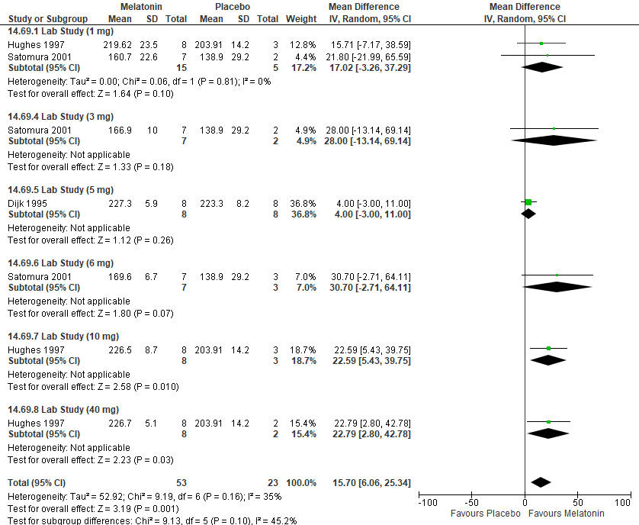
*Hughes 1997: SEM converted to SD

Figure S311. Melatonin vs Placebo (WASO (min), PSG) [CMT= 20 min] RCT (Healthy participants)
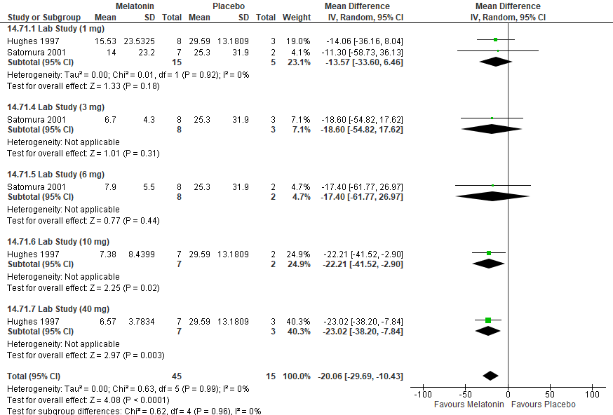 *Hughes 1997: SEM converted to SD

Figure S312. Melatonin vs Placebo (Sleep Latency (min), PSG) [CMT= 20 min] RCT (Healthy participants)
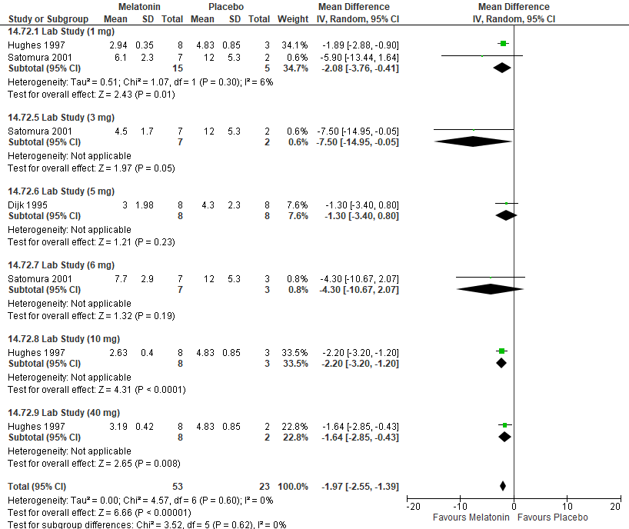
*Hughes 1997: SEM converted to SD

Figure S313. Melatonin vs Placebo (Sleep Latency (min), sleep test) [CMT= 20 min] RCT (Healthy participants)
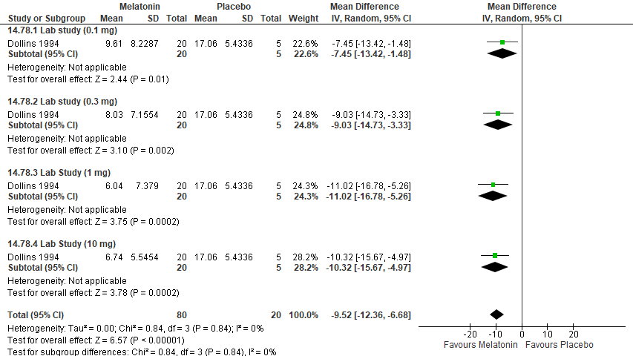
*Dollins 1994: SEM converted to SD

Figure S314. Melatonin vs Placebo (Sleep Latency (min), self-report) [CMT= 20 min] RCT (Healthy participants)
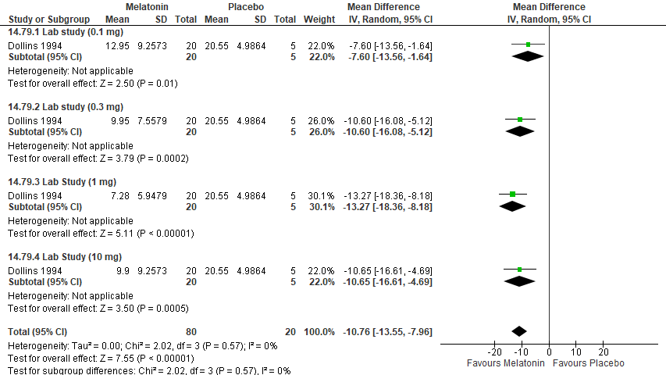
*Dollins 1994: SEM converted to SD

Figure S315. Melatonin vs Placebo (Sleep Efficiency (%), PSG) [CMT= 10%] RCT (Healthy participants)
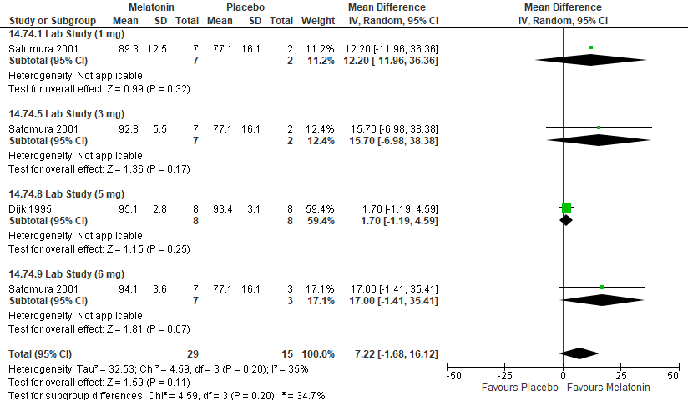

Ramelteon

Summary of Findings (GRADE)
Table S29. Ramelteon in adults with shiftwork disorder
References: Markwald 2010
Outcomes [Tool] | Certainty of the evidence  (GRADE) | Absolute Difference  Ramelteon vs Control | No of Participants  (studies)
Excessive sleepiness or alertness  [Percent wakefulness] | ⨁⨁◯◯  LOW^{a,b,c} | The mean difference in the ramelteon group was 16.2 percent lower (31.95 lower to 0.45 lower) compared to control | 28  (1 RCT)
Total sleep time  [EEG] | ⨁⨁◯◯  LOW^{a,b,d} | The mean difference in the ramelteon group was 43.2 minutes higher (5.05 higher to 81.35 higher) compared to control | 28  (1 RCT)
Total sleep time  [Sleep log] | ⨁⨁◯◯  LOW^{a,b} | The mean difference in the ramelteon group was 76 minutes higher (25.75 higher to 126.25 higher) compared to control | 28  (1 RCT)
WASO  [EEG] | ⨁⨁◯◯  LOW^{a,b,d} | The mean difference in the melatonin group was 36.50 minutes lower (72.54 lower to 0.46 lower) compared to control | 28  (1 RCT)
Sleep latency  [EEG] | ⨁⨁◯◯  LOW^{a,b,d} | The mean difference in the melatonin group was 1.6 minutes lower (4.66 lower to 1.46 higher) compared to control | 28  (1 RCT)
- Indirectness is due to the fact that participants included in the studies are healthy individuals. The effect in adults with SWD may be different
- Imprecision due to small sample size (<200 participants)
- Wide confidence intervals
- Confidence interval crosses the CMT

Study Characteristics
Table S30. Ramelteon in adults with shiftwork disorder
Study Citation | Study Design | Number of Participants (% Female) | Age in years | Population | Intervention (dose) | Comparator | Time of Intervention Delivery | Duration of Follow-up
Markwald 2010 | RCT, crossover | 14 (36) | 23.2 ± 4.2 | Healthy participants | Ramelteon (8 mg) | Placebo | 2 h prior to a 4-h daytime sleep opportunity. | 1 day

Critical Outcomes
None

Important Outcomes
Figure S316. Sleep Promoting medication (Ramelteon) vs Placebo (Total Sleep Time, EEG) [CMT= 15 min] RCT (Healthy participants)
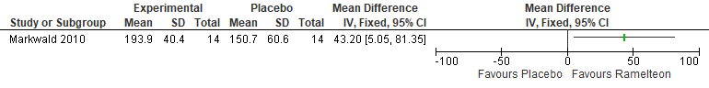* Markwald 2010: SEM converted to SD

Figure S317. Sleep Promoting medication (Ramelteon) vs Placebo (Total Sleep Time, Subjective Sleep Log) [CMT= 15 min] RCT (Healthy participants)
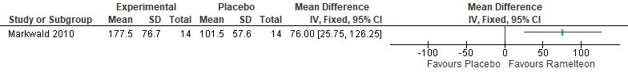
* Markwald 2010: SEM converted to SD

Figure S318. Sleep Promoting medication (Ramelteon) vs Placebo (WASO, EEG) [CMT=20 min] RCT (Healthy participants)
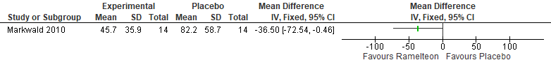
* Markwald 2010: SEM converted to SD

Figure S319. Sleep Promoting Medication (Ramelteon) vs Control (Wakefulness during sleep opportunity, Percent Wakefulness) [CMT=10%] RCT (Healthy participants)
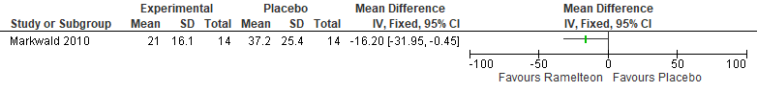
*Markwald 2010: SEM converted to SD, % wakefulness is expressed relative to the 240-minute sleep opportunity recording time (RT)

Figure S320. Sleep Promoting medication (Ramelteon) vs Placebo (Sleep Latency, PSG) [CMT= 20 min] RCT (Healthy participants)
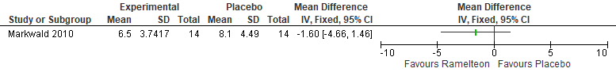* Markwald 2010: SEM converted to SD

Suvorexant

Summary of Findings (GRADE)
Table S31. Suvorexant in adults with shiftwork disorder
References: Zeitzer 2020
Outcomes [Tool] | Certainty of the evidence  (GRADE) | Absolute Difference  Suvorexant vs Control | No of Participants  (studies)
Sleep Quality  [Subjective sleep quality score] | ⨁⨁⨁◯ MODERATEª | The mean difference in the suvorexant group was 0.97 points higher (0.27 higher to 1.67 higher) compared to control | 22  (1 RCT)
Total Sleep Time  [Actigraphy] | ⨁⨁⨁◯ MODERATEª | The mean difference in the suvorexant group was 201.6 minutes higher (139.96 higher to 263.24 higher) compared to control | 22  (1 RCT)
Total Sleep Time  [Subjective Report] | ⨁⨁⨁◯ MODERATEª | The mean difference in the suvorexant group was 172.8 minutes higher (108.36 higher to 237.24 higher) compared to control | 22  (1 RCT)
Sleep Latency  [Subjective Report] | ⨁⨁◯◯  LOW^{a,b} | The mean difference in the suvorexant group was 22.96 minutes fewer (34.21 fewer to 11.71 fewer) compared to control | 22  (1 RCT)
Disease Severity  [CGI-S] | ⨁⨁◯◯  LOW^{a,b} | The mean difference in the suvorexant group was 1.9 points lower (3.4 lower to 0.4 lower) compared to control | 22  (1 RCT)
- Imprecision due to small sample size (<200 participants)
- Confidence intervals cross the critical significance threshold

Study characteristics
Table S32. Suvorexant in adults with shiftwork disorder
Study Citation | Study Design | Number of Participants (% Female) | Age in years | Population | Intervention (dose) | Comparator | Time of Intervention Delivery | Duration of Follow-up
Zeitzer 2020 | RCT | 13 (42) | 37.7 (11.1) | Shift workers without SWD diagnosis | Suvorexant 10 or 20 mg) | Placebo | before each daytime sleep episode | 3 weeks

Critical Outcomes
Figure S321. Sleep Promoting Medication (Suvorexant) vs Control (Sleep Quality, Subjective Sleep Quality Score) [CMT = Not Established] RCT (Shift workers without SWD diagnosis)
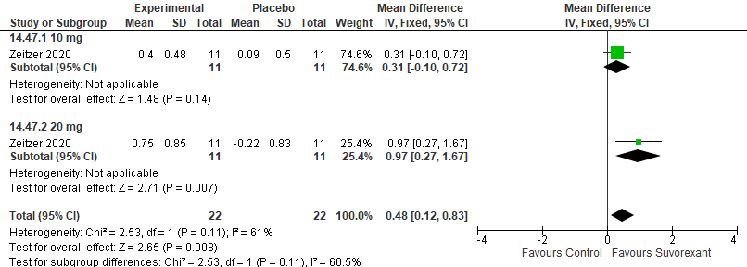
* Zeitzer 2020, Subjective sleep quality score: 5-point Likert-like scale (with 1 indicating very poor and 5, very good), change from baseline data presented, data extracted from graph

Important Outcomes
Figure S322. Sleep Promoting medication (Suvorexant) vs Placebo (Total Sleep Time, Actigraphy) [CMT= 15 min] RCT (Shift workers without SWD diagnosis)
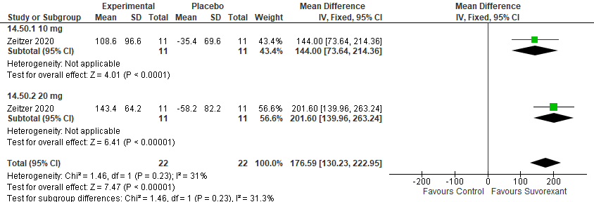*Zeitzer 2020, One participant in the suvorexant and 1 participant in the placebo treatment groups were excluded from actigraphy-based sleep analyses owing to data loss, data converted from hours to minutes, change from baseline data presented, data extracted from graph

Figure S323. Sleep Promoting medication (Suvorexant) vs Placebo (Total Sleep Time, Sleep Log) [CMT= 15 min] RCT (Shift workers without SWD diagnosis)
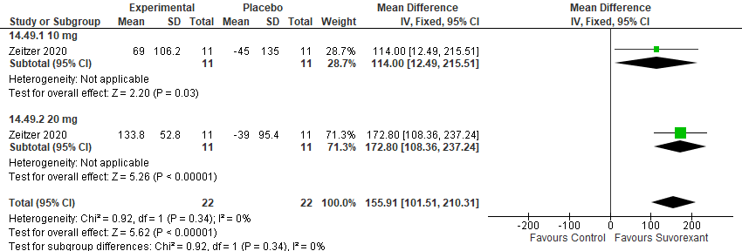
*Zeitzer 2010, data converted from hours to minutes, change from baseline data presented, data extracted from graph

Figure S324. Sleep Promoting medication (Suvorexant) vs Placebo (Disease Severity, CGI-S) [CMT= 1 point] RCT (Shift workers without SWD diagnosis)
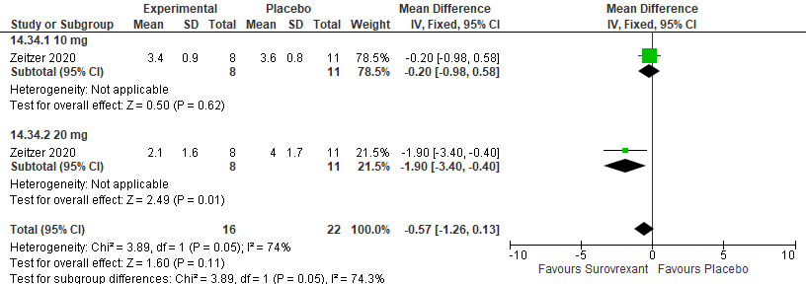
*Zeitzer 2020, SD calculated from median and IQR

Figure S325. Sleep Promoting medication (Suvorexant) vs Placebo (Mental Health, CES-D) [CMT = Not Established] RCT (Shift workers without SWD diagnosis)
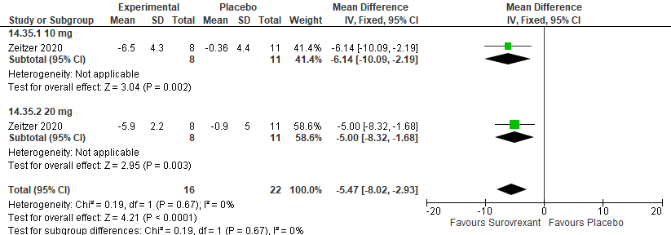
*Zeitzer 2020, data reported as change score

Figure S326. Sleep Promoting medication (Suvorexant) vs Placebo (Sleep Latency, Patient reported sleep logs) [CMT= 20 min] RCT (Shift workers without SWD diagnosis)
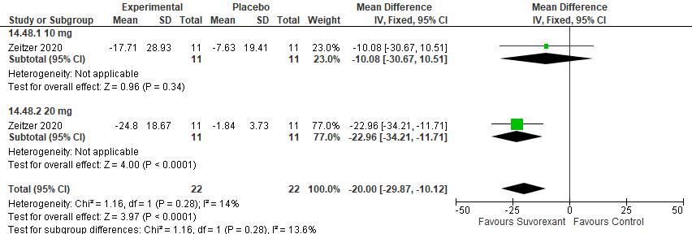
*Zeitzer 2010, data converted from hours to minutes, change from baseline data presented, data extracted from graph

Triazolam

Summary of Findings (GRADE)
Table S33. Triazolam in adults with shiftwork disorder
References: Seidel 1986, Stomura 2001, Walsh 1991, Walsh 1998
Outcomes [Tool] | Certainty of the evidence  (GRADE) | Absolute Difference  Ramelteon vs Control | No of Participants  (studies)
Excessive Sleepiness  [MSLT] | ⨁⨁⨁◯ MODERATEª | The mean difference in the triazolam group was 1.01 minutes more (0.44 more to 1.58 more) compared to control | 240  (4 RCTs)
Excessive Sleepiness  [RTSW] | ⨁◯◯◯  VERY LOW^{a,b,c} | The mean difference in the triazolam group was 1.19 minutes more (4.82 fewer to 7.21 more) compared to control | 12  (1 RCT)
Sleep Quality  [Subjective Questionnaire] | ⨁◯◯◯  VERY LOW^{a,b,c,d} | The mean difference in the triazolam group was 0.8 points more (0.24 fewer to 1.84 more) compared to control | 12  (1 RCT)
- Indirectness is due to the fact that participants included in the studies are healthy individuals. The effect in adults with SWD may be different
- Imprecision due to small sample size (<200 participants)
- Confidence intervals cross the line of no effect
- Lack of blinding of participants and personnel

Study Characteristics
Table S34. Triazolam in adults with shiftwork disorder
Study Citation | Study Design | Number of Participants (% Female) | Age in years | Population | Intervention (dose/) | Comparator | Time of Intervention Delivery | Duration of Follow-up
Satomura 2001 | RCT, crossover | 7 (0) | 23.7 ± 1.7 | Healthy participants | Triazolam (0.125 mg) | Placebo | 13:30 | 1 day
Seidel 1986 | RCT, crossover | 48 | 24.3 ± 3.4 to 26.6 ± 4.6 | Healthy participants | Triazolam (0.25 or 0.5 mg) | Placebo | 30 minutes before bedtime | 2 days
Walsh 1988 | RCT, crossover | 18 (56) | 23.2 | Healthy participants | Triazolam (0.25 -0.5 mg) | Placebo | 30 min prior to sleep periods 1 through 4 during one tour | 6 nights
Walsh 1991 | RCT, crossover | 15 (73) | 41.1 | Healthy participants | Triazolam (0.25 mg) | Placebo | before the first sleep period of both tours | 2 weeks

Critical Outcomes
Figure S327. Sleep Promoting Medication (Triazolam) vs Control (Excessive Sleepiness, MLST) [CMT= 1 minute] RCT (Healthy participants)
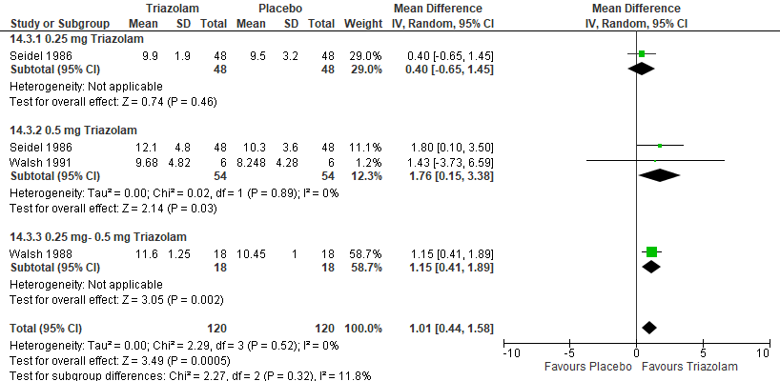
*Walsh 1988-averaged across Sleep periods 1-4, 0.5 mg Triazolam (listed in the Walsh 1991 paper); Walsh 1991- MSLT averaged across the nights, participants received 0.25 mg on night one, dose was increased for subsequent nights if TST was <7 hours

Figure S328. Sleep Promoting Medication (Triazolam) vs Control (Excessive Sleepiness, RTSW) [CMT= 2 minutes] RCT (Healthy participants)
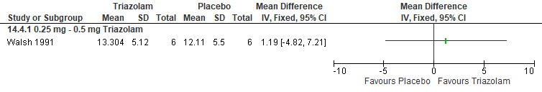 * Walsh 1991- RTSW averaged across the nights, participants received 0.25 mg on night one, dose was increased for subsequent nights if TST was <7 hours

Figure S329. Sleep Promoting Medication (Triazolam) vs Control (Sleep Quality, Subjective Questionnaire) [CMT = Not Established] RCT (Healthy participants)
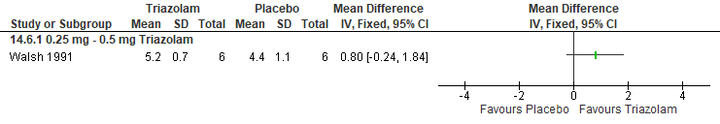
*Walsh 1991, 2 = extremely bad; 7 = extremely good, participants received 0.25 mg on night one, dose was increased for subsequent nights if TST was <7 hours

Important Outcomes
Figure S330. Sleep Promoting medication (Triazolam) vs Placebo (Total Sleep Time, Subjective Report) [CMT= 15 min] RCT (Healthy participants)
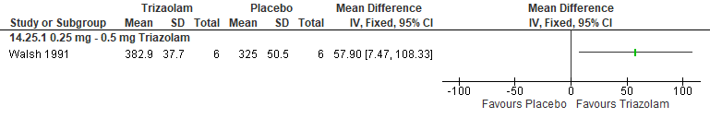
*Walsh 1991, participants received 0.25 mg on night one, dose was increased for subsequent nights if TST was <7 hours

Figure S331. Sleep Promoting medication (Triazolam) vs Placebo (Total Sleep Time, PSG) [CMT=15 min] RCT (Healthy participants)
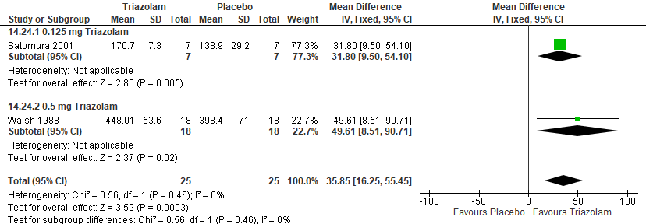
*Walsh 1988-averaged across Sleep periods 1-4, participants received 0.5 mg Triazolam; Satomura 2001, 0.125 mg Triazolam

Figure S332. Sleep Promoting medication (Triazolam) vs Placebo (WASO, PSG) [CMT= 20 min] RCT (Healthy participants)
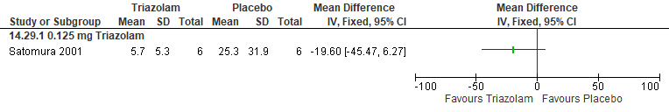

Figure S333. Sleep Promoting medication (Triazolam) vs Placebo (Sleep Latency, PSG) [CMT= 20 min] RCT (Healthy participants)
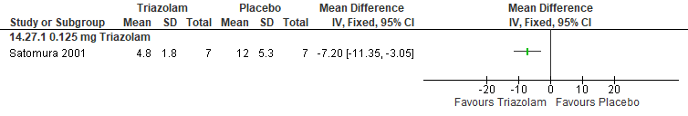
*Satomura 2001, 0.125 mg Triazolam

Figure S334. Sleep Promoting medication (Triazolam) vs Placebo (Sleep Latency, Subjective Report) [CMT= 20 min] RCT (Healthy participants)
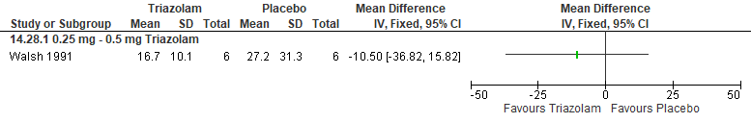
*Walsh 1991, participants received 0.25 mg on night one, dose was increased for subsequent nights if TST was <7 hours
Figure S335. Sleep Promoting medication (Triazolam) vs Placebo (Sleep Efficiency, PSG) [CMT= 10%] RCT (Healthy participants)
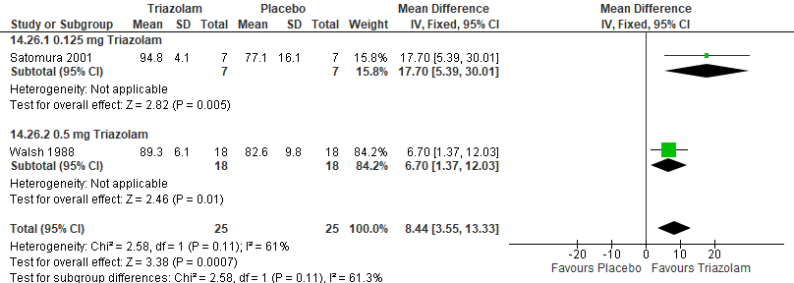
*Walsh 1988: averaged across Sleep periods 1-4, participants received 0.5 mg Triazolam; Satomura 2001, 0.125 mg Triazolam

Circadian Adaptation

Bright light during the night shift

Summary of Findings (GRADE)
Table S35. Phase shift bright light in adults with shiftwork disorder
References: Bjorvatn 2007, Bjorvatn 1999, Horowitz 2001, Campbell 1995, Costa 1995, Crowley 2003, Rizza 2022, Smith 2008, Dawson 1991, Dawson 1995, Dumont 2009
Outcomes [Tool] | Certainty of the evidence  (GRADE) | Absolute Difference  Bright light vs Control | No of Participants  (studies)
Excessive Sleepiness  [KSS] | ⨁◯◯◯  VERY LOW^{a,b,c} | The mean difference in the bright light group was 0.32 points fewer (1 fewer to 0.35 more) compared to control | 34  (1 RCT)
Excessive Sleepiness  [KSS] | ⨁◯◯◯  VERY LOW^{a,b,c} | The mean difference in the bright light group was 0.62 points fewer (1.71 fewer to 0.46 more) compared to control | 14  (1 non-randomized study)
Excessive Sleepiness  [VAS, Alertness] | ⨁◯◯◯  VERY LOW^{a,b,c,d} | The mean difference in the bright light group was 5.51 higher (7.33 lower to 18.35 higher) compared to control | 27  (1 RCT)
Excessive Sleepiness  [RTSW] | ⨁◯◯◯  VERY LOW^{b,c,d} | The mean difference in the bright light group was 2.25 minutes more (0.28 fewer to 4.79 more) compared to control | 51  (2 RCTs)
Excessive Sleepiness  [Fatigue Ratings] | ⨁◯◯◯  VERY LOW^{b,c} | The mean difference in the bright light group was 0.9 higher (3.14 lower to 4.94 higher) compared to control | 30  (1 non-randomised study)
Sleep Quality  [VAS-sleep quality] | ⨁◯◯◯  VERY LOW^{a,b,c} | The mean difference in the bright light group was 0 (0.49 lower to 0.49 higher) compared to control | 34  (1 RCT)
Sleep Quality  [VAS-sleep quality] | ⨁◯◯◯  VERY LOW^{a,b,c} | The mean difference in the bright light group was 0 (0.31 lower to 0.31 higher) compared to control | 14  (1 non-randomised study)
Sleep Quality  [PSQI (number of participants with score 1-4)] | ⨁◯◯◯  VERY LOW^{a,b,c} | The risk ratio in the bright light group was 1.04 (0.22 to 5.01) with an absolute risk of 9 more per 1,000 (173 fewer to 891 more) compared to control | 22  (1 RCT)
Sleep Quality  [PSQI (number of participants with score 5-21)] | ⨁◯◯◯  VERY LOW^{a,b,c} | The risk ratio in the bright light group was 1.15 (0.67 to 2.00) with an absolute risk of 100 more per 1,000 (220 fewer to 667 more) compared to control | 22  (1 RCT)
Cognitive Performance  [SALT (% Correct)] | ⨁◯◯◯  VERY LOW^{b,c,d} | The mean difference in the bright light group was 0.81 percent lower (7.41 lower to 5.79 higher) compared to control | 26  (1 RCT)
Cognitive Performance  [SALT (Time to respond)] | ⨁◯◯◯  VERY LOW^{b,c,d} | The mean difference in the bright light group was 0.52 lower (2.03 lower to 0.99 higher) compared to control | 26  (1 RCT)
Cognitive Performance  [ANAM (Reaction time)] | ⨁◯◯◯  VERY LOW^{a,b,c,d} | The mean difference in the bright light group was 21.21 lower (48.83 lower to 6.41 higher) compared to control | 24  (1 RCT)
Cognitive Performance [Karolinska sleep diary] | ⨁⨁◯◯  LOW^{b} | The mean difference in the bright light group was 10.4 lower (18.12 lower to 2.68 lower) compared to control | 34  (1 RCT)
- Risk of bias concerns due to lack of blinding
- Imprecision due to small sample size (<200 participants)
- Certainty in evidence lowered because of a small number of events leading to wide confidence intervals.
- Indirectness is due to the fact that participants included in the studies are healthy individuals. The effect in adults with SWD may be different.

Study Characteristics
Table S36. Phase shift bright light in adults with shiftwork disorder
Study Citation | Study Design | Number of Participants (% Female) | Age (years) | Population | Intervention (intensity) | Comparator | Time of Intervention Delivery | Duration of Follow-up
Bjorvatn 1999 | non-RCT | 7 (0) | 38.9 (range 29–47) | Shift workers without SWD diagnosis | Bright light (10,000 lux) | Normal light (20-700 lux) | 30 min between 14:00 -15:30 during the first day at home | 1 day
Bjorvatn 2007 | RCT, crossover | 17 (6) | 29–55 | Shift workers without SWD diagnosis | Bright light (10,000 lux)  Melatonin (3 mg) | Ambient Light (200-300 lux)  Placebo | 30 minutes of bright light between 00:00-05:00;  Melatonin or placebo given 1 hour before bedtime | 1 week
Campbell 1995 | RCT | 26 (27) | 49.1 ± 6.4 | Healthy participants | Bright light (>4,000 lux)  Bright light (1,000 lux) | dim light (<100 lux) | 4-hour pulse of bright light from 24:00 to 04:00 on night shift one  Exposure lasted for duration of the night shift on night shifts two and three | 3 nights
Costa 1995 | non-RCT, crossover | 15 (100) | 23.4 (range 21-29) | Shift workers without SWD diagnosis | Bright Light (2350 lux) | normal light (100 lux) | 4 x 20min during the night shift (before work and every 2hrs while working) | 2 nights
Crowley 2003 | RCT | 67 (52) | 23.9 ± 6.2 | Healthy participants | Bright light (~5000 lux) | room light (~150 lux) | bright light during the night shifts | 5 nights
Dawson 1991 | RCT | 13 (46) | 21.2 ± 3.1 | Healthy participants | bright light (6,000 lux) | normal ambient room illumination (150-200 lux) | 24:00-04:00 on the first night shift | 1 night
Dawson 1995 | RCT | 36 | 23.6 ± 3.9 | Healthy participants | Bright light (4,000-7,000 lux) | dim red light (50 lux) | 24:00 -04:00 | 3 nights
Dumont 2009 | RCT | 38 (61) | 20 to 35 | Healthy participants | Bright light (1800 lux) | dim indoor light (20 lux) | 08:00 to 09:00 | 7 days
Horowitz 2001 | RCT | 27 (74) | 26.99 ± 6.22 | Healthy participants | Bright light (2,500 lux) | room light (150 lux) | 23:00-05:00 | 3 nights
Rizza 2022 | RCT | 22 (59) | 40.4 ± 6.9 | Shift workers without SWD diagnosis | Bright light (10,000 lux) | control | 30 min per day between 06:00 and 09:00 h | 12 weeks
Smith 2008 | non-RCT | 24 (58) | 28.9 ± 5.8 (bright light)  23.7 ± 3.6 (control) | Healthy participants | ~ 4100 lux | normal room light (< 50 lux) | five 15-min intermittent bright light pulses each night shift beginning at 00:45 and ending at 05:00

Critical Outcomes
Figure S336. Bright Light vs Control (Excessive Sleepiness, KSS) [CMT = 1 point] RCT (Shift workers without a SWD diagnosis)
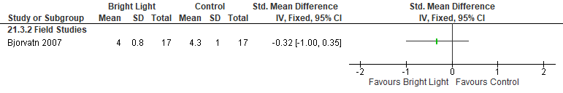
Bjorvatn 2007: Bright Light (10,000 lux for 30min/day between 24:00-0500) across a week. Ambient Light (200-300 lux). Crossover, acceptable washout period. KSS data across the week.

Figure S337. Bright Light vs Control (Excessive Sleepiness, KSS) [CMT = 1 point] non-RCT (Shift workers
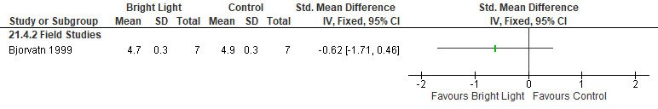
Bjorvatn 1999: SEM converted to SD, used on the platform data

Figure S338. Bright Light vs Control (Excessive Sleepiness, VAS- Alertness) [CMT = Not Established] RCT (Healthy participants)
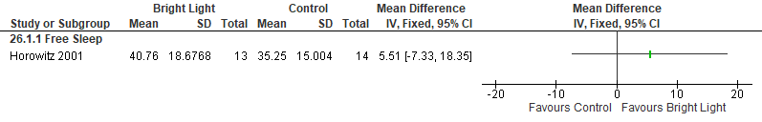
*Horowitz 2001: BL (~2500 lux from 2300-0500hrs, ~150 lux from 0500-0700hrs). Room Light ~105 lux for the full 8hrs. Participants were then moved to <8 lux of constant routine, in a semi-recumbent posture; VAS (for phase shifting) was measured during the first 24 hours of constant routine (higher= more alert). Data extracted from graph; SEM converted to SD.

Figure S339. Bright Light vs Control (Excessive Sleepiness, RTSW) [CMT = 2.0 min] RCT (Healthy participants)
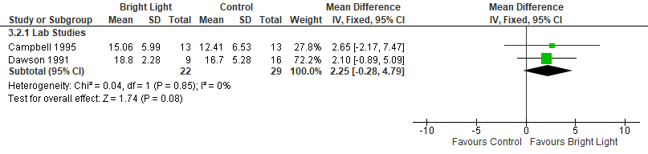
*Campbell 1995: SEM converted to SD, extracted from graphs.
Dawson 1991: data extracted from Figure 4, SEM converted to SD

Figure S340. Bright Light vs Control (Excessive Sleepiness, Fatigue Ratings) [CMT = Not Established] non-randomized study (Shift workers without SWD diagnosis)
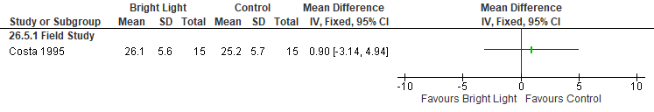*Costa 1995- 4 x 20min of Bright Light (2350 lux) in the break room (versus 100 lux) during Night Shift (before work and every 2hrs while working). Crossover, acceptable washout period. First night of bright light, overall fatigue (5 min to 35 max).

Figure S341. Bright Light vs Control (Sleep Quality, Sleep Diary) [CMT = Not Established] RCT (Shift workers without SWD diagnosis)
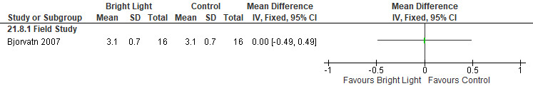
*Bjorvatn 2007: Bright Light (10,000 lux for 30min/day between 24:00-0500). Ambient Light (200-300 lux) across a week. Crossover, acceptable washout period. Higher value indicates better sleep. Sleep diary data across the week.

Figure S342. Bright Light vs Control (Sleep Quality, Sleep Diary) [CMT = Not Established] non-RCT (Shift workers without SWD diagnosis)
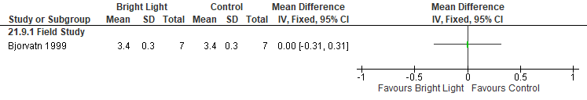
*Bjorvatn 1999: SEM converted to SD, at the platform data was used.

Figure S343. Bright Light vs Control (Sleep Quality, PSQI (number of participants with score 1-4)) [CMT = Not Established] RCT (Shift workers without SWD diagnosis)
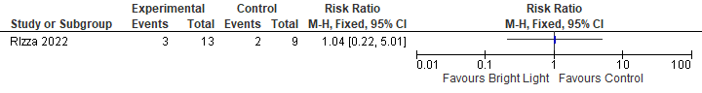

Figure S344. Bright Light vs Control (Sleep Quality, PSQI (number of participants with score 5-21)) [CMT = Not Established] RCT (Shift workers without SWD diagnosis)
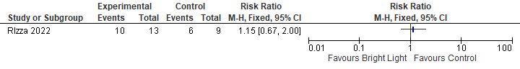

Figure S345. Bright Light vs Control (Cognitive Performance, Night 3 % Correct SALT) [CMT = Not Established] RCT (Healthy participants)
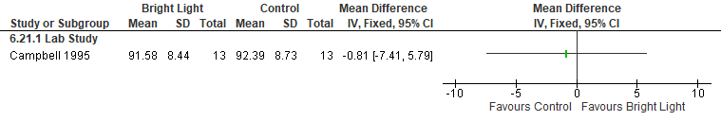
*Campbell 1995: BL 1000 lux, dim light <100 lux; Night 3 data was the average of timepoint during 2300- 0700 (phase shift) SEM converted to SD, extracted from graphs.

Figure S346. Bright Light vs Control (Cognitive Performance, Night 3 Time to respond SALT) [CMT = Not Established] RCT (Healthy participants)
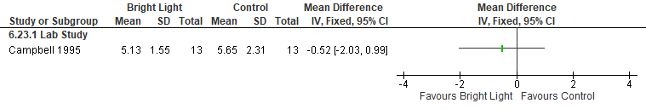
*Campbell 1995: BL 1000 lux, dim light- <100 lux; Night 3 data was the average of timepoint during 2300- 0700 (phase shift) SEM converted to SD, extracted from graphs.

Figure S347. Bright Light vs Control (Cognitive Performance, ANAM mean reaction time) [CMT = Not Established] non-RCT (Healthy participants)
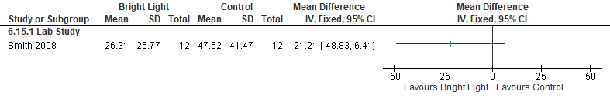
*Smith 2008: BL ~4100 lux, dim light<50 lux, only used NS7. SEM converted SD for study, extracted from graphs. ANAM= Automated Neurophysiological Assessment Metrics.

Figure S348. Bright Light vs Control (Cognitive Performance, Karolinska sleep diary: reduced performance) [CMT = Not Established] Non-RCT (Shift workers without SWD diagnosis)
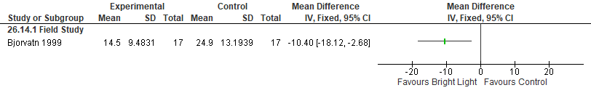

Important Outcomes
Figure S349. Bright Light vs Control (Total Sleep Time, EEG) [CMT = 15 min] RCT (Healthy participants)
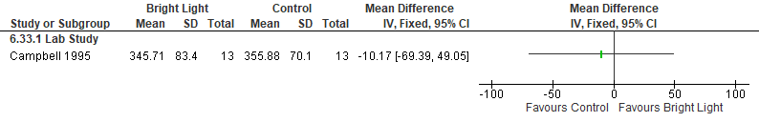
*Campbell 1995: BL 1000 lux, dim light <100 lux; Night 3 data was the average of timepoint during 2300- 0700 (phase shift).

Figure S350. Bright Light vs Control (Total Sleep Time, Actigraphy) [CMT = 15 min] RCT (Shift workers without SWD diagnosis)
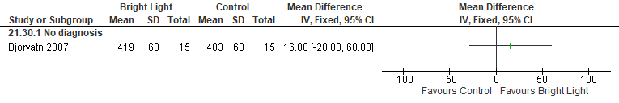
*Bjorvatn 2007: Bright Light (10,000 lux for 30min/day between 24:00-0500). Ambient Light (200-300 lux). Crossover, acceptable washout period. Actigraphy data across the week

Figure S351. Bright Light vs Control (Total Sleep Time, Sleep Diary) [CMT = 15 min], RCT (Shift workers without SWD diagnosis)
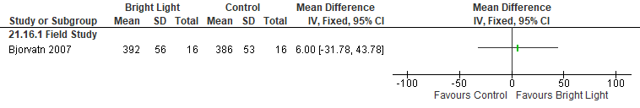
*Bjorvatn 2007: Bright Light (10,000 lux for 30min/day between 24:00-0500). Ambient Light (200-300 lux). Crossover, acceptable washout period. Sleep diary data across the week

Figure S352. Bright Light vs Control (Total Sleep Time, Sleep Diary) [CMT = 15 min], non-RCTs (Shift workers without SWD diagnosis)
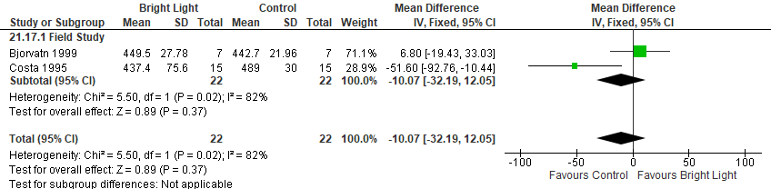
*Bjorvatn 1999: SEM converted to SD, at the platform data was used.

Figure S353. Bright Light vs Control (Total Sleep Time, PSG/EEG) [CMT=15 min], non-RCTs (healthy participants)
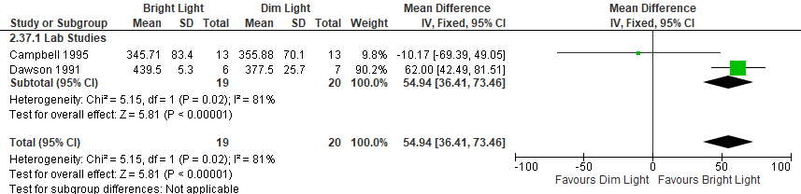

Figure S354. Bright Light vs Control (Mental Health, HADS-anxiety) [CMT = Not Established] RCT (Shift workers without SWD diagnosis)
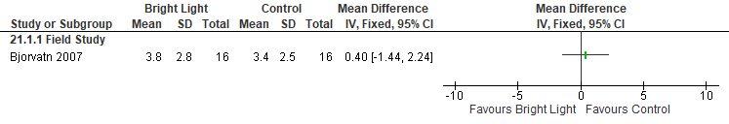
*Bjorvatn 2007: Bright Light (10,000 lux for 30min/day between 24:00-0500). Ambient Light (200-300 lux). Crossover, acceptable washout period. Overall questionnaire; higher scores on HADS indicate more severe impairment.

Figure S355. Bright Light vs Control (Mental Health, HADS-depression) [CMT = Not Established] RCT (Shift workers without SWD diagnosis)
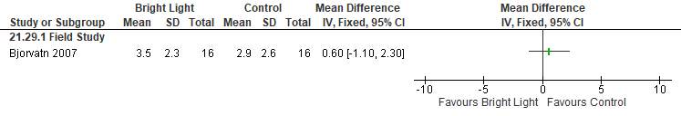
*Bjorvatn 2007: Bright Light (10,000 lux for 30min/day between 24:00-0500). Ambient Light (200-300 lux). Crossover, acceptable washout period. Overall questionnaire; higher scores on HADS indicate more severe impairment.

Figure S356. Bright Light vs Control (Circadian Adaptation, DLMO) [CMT = Not Established] RCT (Healthy participants)
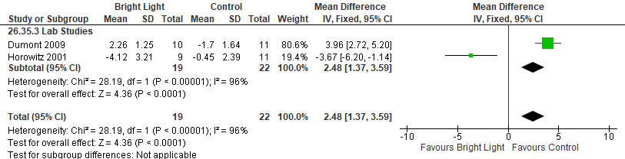
*Horowitz 2001: BL (~2500 lux from 2300-0500hrs, ~150 lux from 0500-0700hrs). Room Light ~105 lux for the full 8hrs. Participants were then moved to <8 lux of constant routine, in a semi-recumbent posture; Phase shift of the DLMO was defined as constant routine phase minus DLMO (measured from 1700-2300) prior to the start of night shift. Data extracted from graph; SEM converted to SD.
Dumont 2009: DLMO phase shift (h), advance group vs stable group

Figure S357. Bright Light vs Control (Circadian Adaptation, Midpoint Melatonin Secretion) [CMT = Not Established] RCT (Healthy participants)
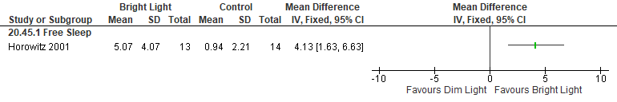
*Horowitz 2001: BL (~2500 lux from 2300-0500hrs, ~150 lux from 0500-0700hrs). Room Light ~105 lux for the full 8hrs. Participants were then moved to <8 lux of constant routine, in a semi-recumbent posture; Midpoint melatonin secretion episode was calculated for the first 24hrs of constant routine. Data (in clock hours) extracted from graph; SEM converted to SD

Figure S358. Bright Light vs Control (Circadian Adaptation, Phase shift MEL25%up (hours)) [CMT = Not Established], RCT (Healthy participants)
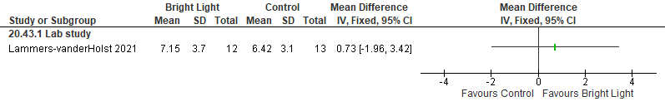

Figure S359. Bright Light vs Control (Circadian Adaptation, Phase shift MEL25%down (hours)) [CMT = Not Established], RCT (Healthy participants)
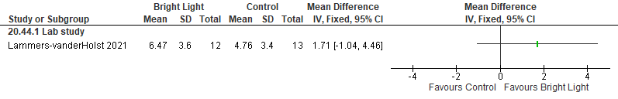

Figure S360. Bright Light vs Control (Circadian Alignment, Overlap melatonin-sleep (hours)) [CMT = Not Established], RCTs (Healthy participants)
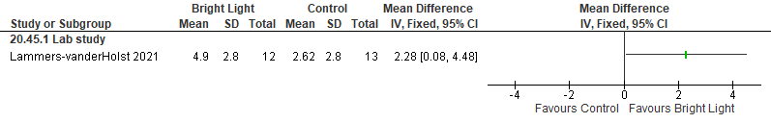

Figure S361. Bright Light vs Control (Circadian Adaptation, Core Body Temperature Phase) [CMT = Not Established] RCT (Healthy participants)
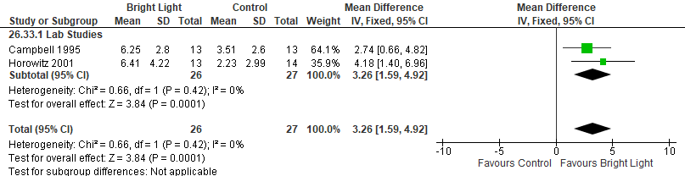
*Horowitz 2001: BL (~2500 lux from 2300-0500hrs, ~150 lux from 0500-0700hrs). Room Light ~105 lux for the full 8hrs. Participants were then moved to <8 lux of constant routine, in a semi-recumbent posture. Core Body Temp phase was defined as the average nadir of the fundamental and the composite from a 2-harmonic cosine fit, by group. Data extracted from graph; SEM converted to SD.
*Campbell 1995: BL-1000 lux, dim light- <100 lux; Net shift relative to baseline (phase shift).

Figure S362. Bright Light vs Control (Quality of Life, Karolinska Sleep Diary) [CMT = Not Established] RCT (Shift workers without SWD diagnosis)
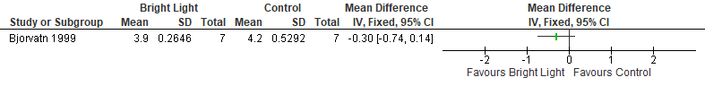
*Bjorvatn 1999: SEM converted to SD, at the platform data was used
Figure S363. Bright Light vs Control (Wake After Sleep Onset (WASO), EEG) [CMT= 20 min] RCT (Healthy participants)
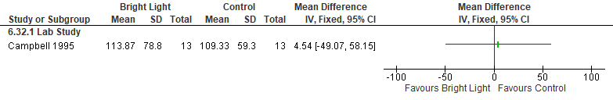
*Campbell 1995: BL-1000 lux, dim light- <100 lux; Night 3 data was the average of timepoint during 2300- 0700 (phase shift).

Figure S364. Bright Light vs Control (Wake After Sleep Onset (WASO), Karolinska Sleep Diary) [CMT= 20 min] non-RCT (Shift workers without SWD diagnosis)
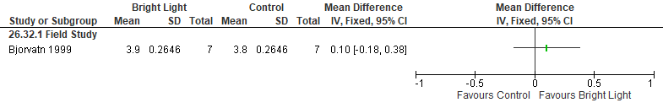
Bjorvatn 1999: SEM converted to SD, at the platform data was used.

Figure S365. Bright Light vs Control (Sleep Latency, EEG) [CMT= 20 min] RCT (Healthy participants)
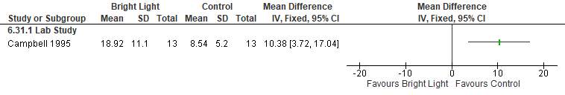
*Campbell 1995: BL-1000 lux, dim light- <100 lux; Night 3 data was the average of timepoint during 2300- 0700 (phase shift).
Figure S366. Bright Light vs Control (Sleep Latency, Sleep Diary) [CMT= 20 min] RCT (Shift workers without SWD diagnosis)
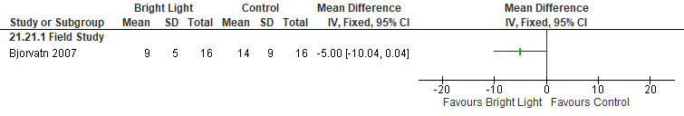
*Bjorvatn 2007: Bright Light (10,000 lux for 30min/day between 24:00-0500). Ambient Light (200-300 lux). Crossover, acceptable washout period. Sleep diary data across the week.

Figure S367. Bright Light vs Control (Sleep Latency, Sleep Diary) [CMT= 20 min] non-RCT (Shift workers without SWD diagnosis)
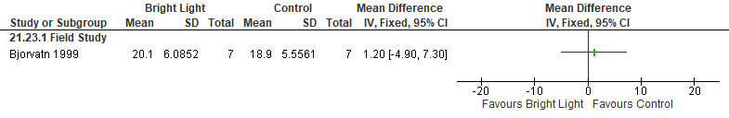
*Bjorvatn 1999: SEM converted to SD, at the platform data was used.

Figure S368. Bright Light vs Control (Sleep Efficiency, EEG) [CMT = 10%] non-RCT (Healthy participants)
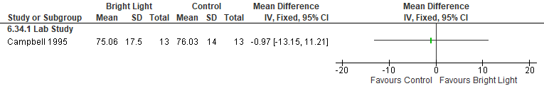
*Campbell 1995: BL-1000 lux, dim light- <100 lux; Night 3 data was the average of timepoint during 2300- 0700 (phase shift).
Figure S369. Bright Light vs Control (Sleep Efficiency, Sleep Diary) [CMT = 10%] RCT (Shift workers without SWD diagnosis)
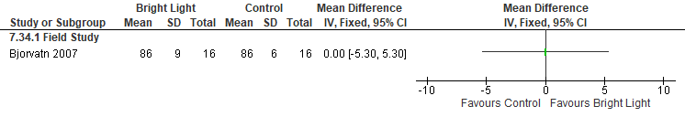
*Bjorvatn 2007: Bright Light (10,000 lux for 30min/day between 24:00-0500). Ambient Light (200-300 lux). Crossover, acceptable washout period. Sleep diary data across the week.
Figure S370. Bright Light vs Control (Sleep Efficiency, Actigraphy) [CMT = 10%] RCT (Shift workers without SWD diagnosis)
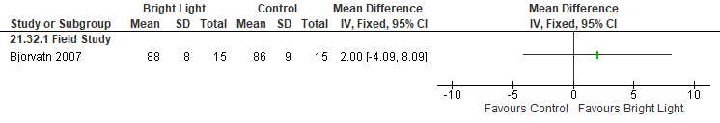
*Bjorvatn 2007: Bright Light (10,000 lux for 30min/day between 24:00-0500). Ambient Light (200-300 lux). Crossover, acceptable washout period. Actigraphy data across the week.

Bright Light and fixed sleep timing

Summary of Findings (GRADE)
Table S37. Bright light and fixed sleep timing in adults with shiftwork disorder
References: Horowitz 2001
Outcomes [Tool] | Certainty of the evidence  (GRADE) | Absolute Difference  Bright light and fixed sleep timing vs Control | No of Participants  (studies)
Excessive sleepiness or alertness  [VAS-alertness] | ⨁◯◯◯  VERY LOW^{a,b,c} | The mean difference in the bright light and fixed sleep group was 19.8 higher (5.49 lower to 34.11 higher) compared to control | 27  (1 RCT)
Circadian adaptation  [DLMO] | ⨁⨁◯◯  LOW^{a,b,c} | The mean difference in the bright light and fixed sleep group was 5.52 hours lower (7.04 lower to 4 lower) compared to control | 22  (1 RCT)
Circadian adaptation  [Midpoint melatonin secretion] | ⨁⨁◯◯  LOW^{a,b,c} | The mean difference in the bright light and fixed sleep group was 7.31 hours higher (5.97 higher to 8.65 higher) compared to control | 22  (1 RCT)
Circadian adaptation  [Core body temperature phase] | ⨁⨁◯◯  LOW^{a,b,c} | The mean difference in the bright light and fixed sleep group was 7.19 hours higher (5.26 higher to 9.12 lower) compared to control | 22  (1 RCT)
- Risk of bias concerns due to the lack of blinding
- Indirectness is due to the fact that participants included in the studies are healthy individuals. The effect in adults with SWD may be different.
- Imprecision due to small sample size (<200 participants)

Study Characteristics
Table S38. Bright light and fixed sleep timing in adults with shiftwork disorder
Study Citation | Study Design | Number of Participants (% Female) | Age (years) | Population | Intervention (intensity) | Comparator | Time of Intervention Delivery | Duration of Follow-up
Horowitz 2001 | RCT | 27 (74) | 26.99 ± 6.22 | Healthy participants | Bright light (2,500 lux) | room light (150 lux) | 23:00-05:00 | 3 nights

Critical Outcomes
Figure S371. Bright Light + Fixed Sleep vs Dim Light + Free Sleep (Excessive Sleepiness, VAS- Alertness) [CMT = Not Established] RCT (Healthy participants)
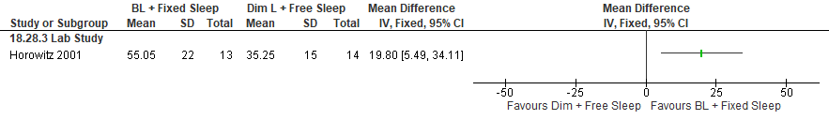
*Horowitz 2001: BL (~2500 lux from 2300-0500hrs, ~150 lux from 0500-0700hrs). Room Light ~105 lux for the full 8hrs. Participants were then moved to <8 lux of constant routine, in a semi-recumbent posture; VAS (for phase shifting) was measured during the first 24 hours of constant routine (higher= more alert). Data extracted from graph; SEM converted to SD.

Important Outcomes
Figure S372. Bright Light + Fixed Sleep vs Dim Light + Free Sleep (Circadian Alignment, DLMO) [CMT = Not Established] RCT (Healthy participants)
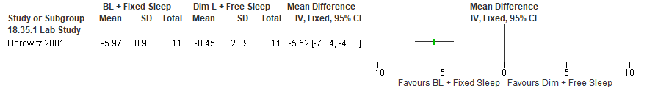
*Horowitz 2001: BL (~2500 lux from 2300-0500hrs, ~150 lux from 0500-0700hrs). Room Light ~105 lux for the full 8hrs. Participants were then moved to <8 lux of constant routine, in a semi-recumbent posture; Phase shift of the DLMO was defined as constant routine phase minus DLMO (measured from 1700-2300) prior to the start of night shift. Data extracted from graph; SEM converted to SD.

Figure S373. Bright Light + Fixed Sleep vs Dim Light + Free Sleep (Circadian Alignment, Midpoint Melatonin Secretion) [CMT = Not Established] RCT (Healthy participants)
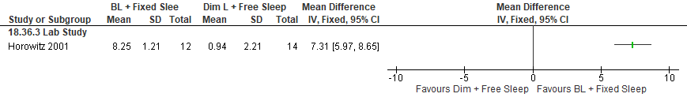
*Horowitz 2001: BL (~2500 lux from 2300-0500hrs, ~150 lux from 0500-0700hrs). Room Light ~105 lux for the full 8hrs. Participants were then moved to <8 lux of constant routine, in a semi-recumbent posture; Midpoint melatonin secretion episode was calculated for the first 24hrs of constant routine. Data (in clock hours) extracted from graph; SEM converted to SD.

Figure S374. Bright Light + Fixed Sleep vs Dim Light + Free Sleep (Circadian Alignment, Core Body Temperature Phase) [CMT = Not Established] RCT (Healthy participants)
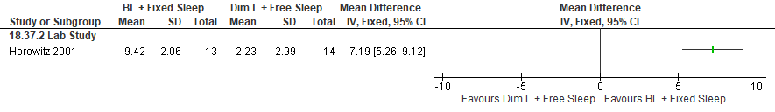
*Horowitz 2001: BL (~2500 lux from 2300-0500hrs, ~150 lux from 0500-0700hrs). Room Light ~105 lux for the full 8hrs. Participants were then moved to <8 lux of constant routine, in a semi-recumbent posture. Core Body Temp phase was defined as the average nadir of the fundamental and the composite from a 2-harmonic cosine fit, by group. Data extracted from graph; SEM converted to SD.

Bright Light, fixed sleep timing, and reduced light-transmittance glasses

Summary of Findings (GRADE)
Table S39. Bright light, fixed sleep timing, and reduced light-transmittance glasses in adults with shiftwork disorder
References: Olson 2020, Boivin 2012, Boivin 2012, Lee 2006, Crowley 2003
Outcomes [Tool] | Certainty of the evidence  (GRADE) | Absolute Difference  Bright light, fixed sleep timing, an vs Control | No of Participants  (studies)
Excessive sleepiness or alertness  [KSS] | ⨁◯◯◯  VERY LOW^{a,b,c} | The mean difference in the bright light, fixed sleep, and glasses group was 0.39 points fewer (1.47 fewer to 0.69 more) compared to control | 66  (1 non-randomized study)
Accident risk  [Number of errors] | ⨁◯◯◯  VERY LOW^{b,c} | The risk ratio in the bright light, fixed sleep, and glasses group was 0.38 (0.15 to 0.96) with an absolute risk of 244 fewer per 1,000 (335 fewer to 16 fewer) compared to control | 66  (1 non-randomized study)
Sleep quality  [Sleep quality scale] | ⨁◯◯◯  VERY LOW^{b,c} | The mean difference in the bright light, fixed sleep, and glasses group was 0.41 points higher (0.27 lower to 1.09 higher) compared to control | 66  (1 non-randomized study)
Cognitive performance  [PVT reaction time] | ⨁⨁◯◯  LOW^{b,c} | The mean difference in the bright light, fixed sleep, and glasses group was 16.2 ms fewer (44.75 fewer to 12.35 more) compared to control | 17  (1 RCT)
Cognitive performance  [PVT reaction speed] | ⨁⨁◯◯  LOW^{b,c} | The mean difference in the bright light, fixed sleep, and glasses group was 0.24 1/s more (0.22 fewer to 0.7 more) compared to control | 17  (1 RCT)
Total sleep time  [PSG] | ⨁⨁◯◯  LOW^{b,d} | The mean difference in the bright light, fixed sleep, and glasses group was 30 minutes higher (3.34 higher to 56.66 higher) compared to control | 17  (1 RCT)
Total sleep time  [Self-report] | ⨁◯◯◯  VERY LOW^{a,b,d} | The mean difference in the bright light, fixed sleep, and glasses group was 15 minutes higher (74.36 lower to 104.36 higher) compared to control | 66  (1 non-randomized study)
Total sleep time  [Sleep log] | ⨁◯◯◯  VERY LOW^{a,b,e} | The mean difference in the bright light, fixed sleep, and glasses group was 117 minutes higher (54.49 higher to 179.51 higher) compared to control | 23  (1 RCT)
Circadian adaptation  [DLMO] | ⨁◯◯◯  VERY LOW^{a,b,e,f} | The mean difference in the bright light, fixed sleep, and glasses group was 2.82 hours higher (1.97 higher to 3.98 lower) compared to control | 45  (2 RCTs)
- Risk of bias concerns due to a lack of blinding
- Imprecision due to small sample size (<200 participants)
- Imprecision due to the 95% CI crossing the null
- Imprecision due to the 95% CI crossing the CMT
- Indirectness is due to the fact that participants included in the studies are healthy individuals. The effect in adults with SWD may be different.
- Crowley 2003 used only a subset of participants for the DLMO.

Study Characteristics
Table S40. Bright light, fixed sleep timing, and reduced light-transmittance glasses in adults with shiftwork disorder
Study Citation | Study Design | Number of Participants (% Female) | Age (years) | Population | Intervention (intensity) | Comparator | Time of Intervention Delivery | Duration of Follow-up
Boivin 2012 (police) | RCT | 17 (47) | 30.1 ± 5.2 | Shift workers without SWD diagnosis | Bright light (5,000 lux)  orange-tinted goggles | no bright light or goggles | bright light used intermittently during the first 6 hours of the night shift, and goggles used from sunrise until daytime sleep | 2 nights
Boivin 2012 (nurses) | non-RCT | 15 (60) | 41.6 ± 8.6 | Shift workers without SWD diagnosis | Bright light (3243 ± 2274 lux)  shaded goggles on the commute home | normal lighting (111 ± 97 lux)  clear, ultraviolet (UV)-excluding goggles on the commute home | Bright light during the first 6 hr of each night shift and glasses worn during the commute home | 1 night
Crowley 2003 | RCT | 67 (52) | 23.9 ± 6.2 | Healthy participants | Bright light (~5000 lux)  fixed daytime dark/sleep  dark sunglasses  melatonin (1.8 mg sustained release) | room light (~150 lux)  normal sunglasses  placebo | fixed daytime dark/sleep schedule  sunglasses whenever they were outside during the day  bright light during the night shifts  melatonin before daytime sleep at 08:30 | 5 nights
Lee 2006 | RCT | 23 (52) | 27.3 ± 6.2 | Healthy participants | Bright light (3500 lux) and blue-blocker glasses |  | 5x 15 min light pulses ending at 01:00, 02:00, 03:00, 04:00, and 05:00  glasses worn after nightshift & while driving home | 25 days
Olson 2020 | non-RCT, crossover | 33 (76) | 32.7 ± 8.6 | Shift workers without SWD diagnosis | Bright light (~5,500 lux), sunglasses, and fixed sleep schedule | control | 40 min of bright light before night shift, sunglasses worn after night shift until bedtime | 3-6 days

Critical Outcomes
Figure S375. Bright Light + Glasses vs Dim-light + No glasses (Excessive Sleepiness, KSS) [CMT = 1pt] non-randomized study (Shift workers without SWD diagnosis)
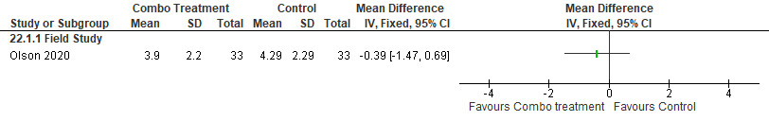

Figure S376. Bright Light + Glasses vs Dim-light + No glasses (Accident Risk, number of errors) [CMT = any decrease] non-randomized study (Shift workers without SWD diagnosis)
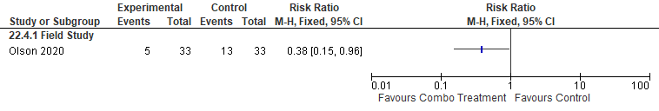

Figure S377. Bright Light + Glasses vs Dim-light + No glasses (Sleep Quality, Sleep Quality Scale) [CMT = Not Established] non-randomized study (Shift workers without SWD diagnosis)
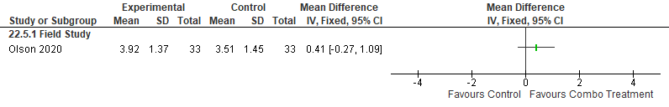

Figure S378. Bright Light + Glasses vs Dim-light + No glasses (Cognitive Performance, PVT mean reaction time) [CMT = Not Established] RCT (Shift workers without SWD diagnosis)
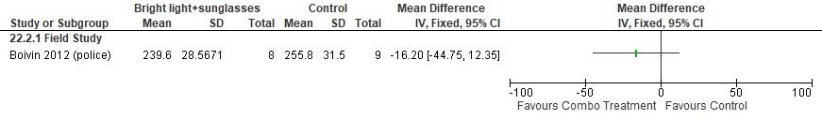 *Boivin 2012: night shift 7 data used, SEM converted to SD

Figure S379. Combination Treatment (Bright light + Glasses) vs Control (Dim-light + No glasses) (Cognitive Performance, PVT reaction speed) [CMT = Not Established] RCT (Shift workers without SWD diagnosis)
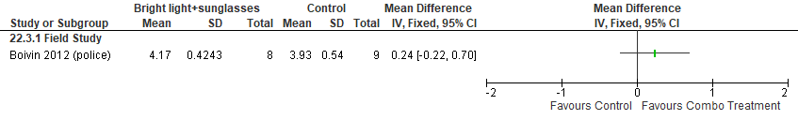*Boivin 2012: night shift 7 data used, SEM converted to SD

Important Outcomes
Figure S380. Combination Treatment (Bright light + Glasses) vs Dim-light + No Glasses (Total Sleep Time, PSG) [CMT = 15 min] RCT (Shift workers without SWD diagnosis)
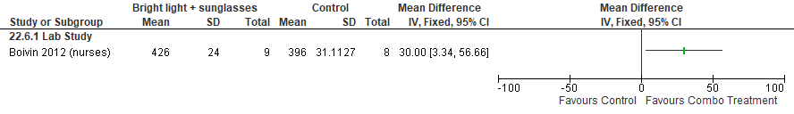 *Boivin 2012 (nurses): SEM converted to SD

Figure S381. Combination Treatment (Bright light + Glasses) vs Dim-light + No Glasses (Total Sleep Time, self-reported) [CMT = 15 min] non-randomized study (Shift workers without SWD diagnosis)
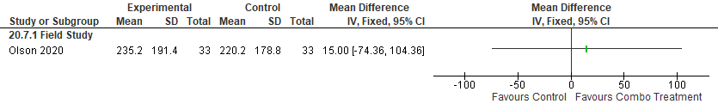

Figure S382. Combination Treatment (Bright light + Glasses) vs Dim-light + No Glasses (Total Sleep Time, self-reported) [CMT = 15 min] RCT (Healthy participants)
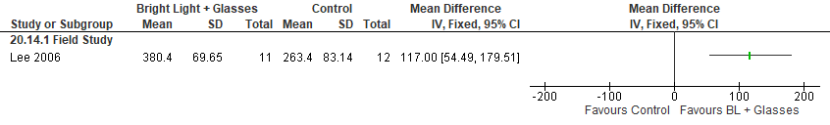
*Lee 2006: Combo (bright light and blue-blocker glasses). Night shift (2300-0700). Experimental received 5x 15min BL pulses (3500 lux) 1/hr on night shift. Wore blue-blocker glasses after nightshift & while driving home. Data extracted from graph (Day sleep after 2nd night shift); SEM converted to SD
Figure S383. Combination Treatment (Bright light + Glasses) vs Dim-light + No Glasses (Mental Health, I-PANAS-SF positive mood) [CMT = Not Established] non-randomized study (Shift workers without SWD diagnosis)
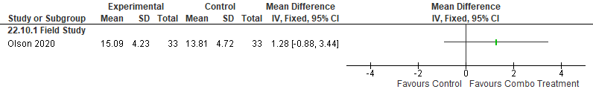
Figure S384. Combination Treatment (Bright light + Glasses) vs Dim-light + No Glasses (Mental Health, I-PANAS-SF negative mood) [CMT = Not Established] non-randomized study (Shift workers without SWD diagnosis)
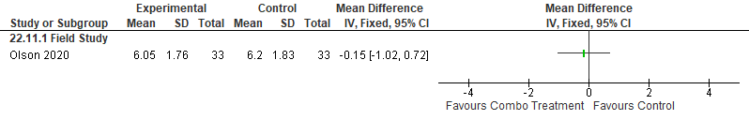
Figure S385. Bright Light + Fixed Sleep + Glasses vs Control (Circadian Alignment, DLMO in hours) [CMT= Not Established] RCT (Healthy participants)
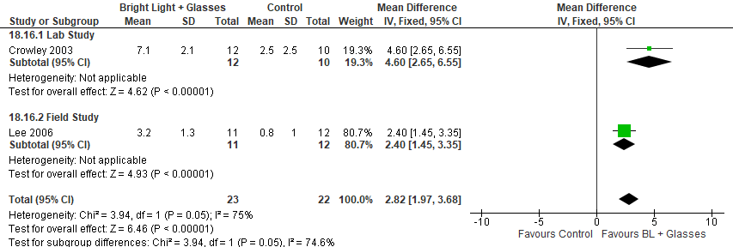
*Crowley 2003: Combo (dark sunglasses and bright light with or without melatonin). Bright light (~5000 lux, 20 min on, 40 min off, 4-5 light pulses/night), phase delay shift in hours.
Lee 2006: Combo (bright light and blue-blocker glasses). Night shift (2300-0700). Experimental received 5x 15min BL pulses (3500 lux) 1/hr on night shift. Wore blue-blocker glasses after nightshift & while driving home. Data extracted from graph (Day sleep after 2nd night shift); SEM converted to SD.

Figure S386. Bright Light vs Control (Circadian Adaptation, Plasma Melatonin (tmidpoint)) [CMT = Not Established] RCT (Shift workers without SWD diagnosis)
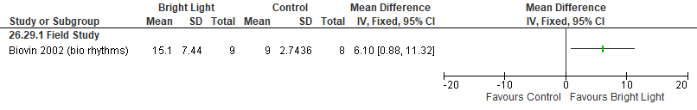
*Boivin 2002: SEM converted to SD, data following the night shifts

Figure S387. Bright Light vs Control (Circadian Adaptation, Plasma Melatonin (phase angle)) [CMT = Not Established] RCT (Shift workers without SWD diagnosis)
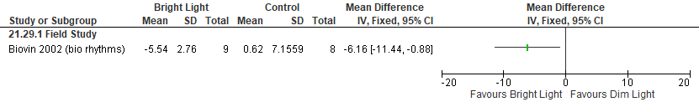*Boivin 2002: SEM converted to SD, data following the night shifts

Figure S388. Bright Light vs Control (Circadian Adaptation, Core body temperature (t_{mint})) [CMT = Not Established] RCT (Shift workers without SWD diagnosis)
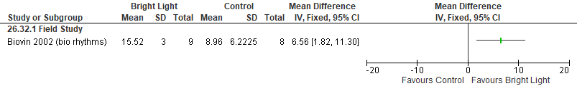*Boivin 2002: SEM converted to SD, data following the night shifts

Figure S389. Bright Light vs Control (Circadian Adaptation, Core body temperature (phase angle)) [CMT = Not Established] RCT (Shift workers without SWD diagnosis)
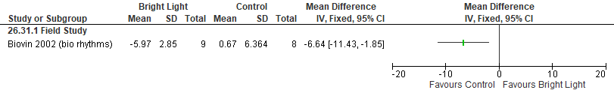*Boivin 2002: SEM converted to SD, data following the night shifts

Figure S390. Combination Treatment (Bright light + Glasses) vs Dim-light + No Glasses (Sleep Latency, PSG) [CMT = 15 min] RCT (Shift workers without SWD diagnosis)
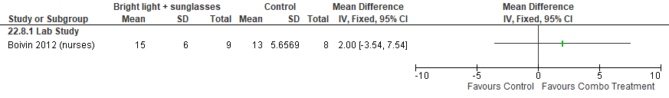

Figure S391. Combination Treatment (Bright light + Glasses) vs Dim-light + No Glasses (Sleep Latency, Self-reported) [CMT = 15 min] non-randomized study (Shift workers without SWD diagnosis)
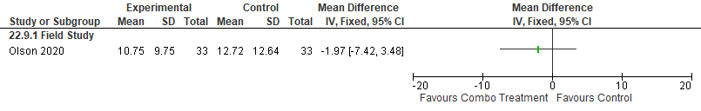

Figure S392. Combination Treatment (Bright light + Glasses) vs Dim-light + No Glasses (Sleep Efficiency, PSG) [CMT = 10%] RCT (Shift workers without SWD diagnosis)
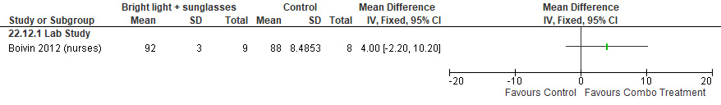

Other Considerations for Adults with SWD

8-hour or 12-hour work shift

Summary of Findings (GRADE)
Table S41. 8-hour or 12-hour work shift in adults with shiftwork disorder
References: Axelsson 1998, Rosa 1989, Jaffe 1996, Tucker 1996, Williamson 1994
Outcomes [Tool] | Certainty of the evidence  (GRADE) | Absolute Difference  8-hour work shift vs 12-hour work shift | No of Participants  (studies)
Excessive sleepiness or alertness  [Modified SSI] | ⨁◯◯◯  VERY LOW^{a,b} | The mean difference in the 8-hour work shift group was 0.2 higher (0.3 lower to 0.7 higher) compared to the 12-hour work shift | 162  (1 non-RCT)
Excessive sleepiness or alertness  [KSS] | ⨁◯◯◯  VERY LOW^{a,b} | The mean difference in the 8-hour work shift group was 0.6 points lower (0.88 lower to 0.32 lower) compared to the 12-hour work shift group | 62  (1 non-RCT)
Sleep quality  [Questionnaire] | ⨁◯◯◯  VERY LOW^{a,b} | The mean difference in the 8-hour work shift group was 0.1 points higher (0.18 lower to 0.38 higher) compared to the 12-hour work shift group | 62  (1 non-RCT)
Sleep quality  [Questionnaire] | ⨁◯◯◯  VERY LOW^{a,b} | The mean difference in the 8-hour work shift group was 0.15 points lower (0.69 lower to 0.39 higher) compared to the 12-hour work shift group | 120  (1 non-RCT)
Sleep quality  [Shift work survey questionnaire] | ⨁◯◯◯  VERY LOWª | The mean difference in the melatonin group was 0.7 higher (0.83 lower to 2.23 higher) compared to control | 214  (1 non-RCT)
Cognitive performance  [Serial Simple Reaction Time Test] | ⨁◯◯◯  VERY LOW^{a,b} | The mean difference in the melatonin group was 15 msec lower (59.05 lower to 29.05 higher) compared to control | 26  (1 non-RCT)
- Imprecision due to the 95% CI crossing the line of no effect.
- Imprecision due to small sample size (<200 participants)

Study Characteristics
Table S42. 8-hour or 12-hour work shift in adults with shiftwork disorder
Study Citation | Study Design | Number of Participants (% Female) | Age (years) | Population | Intervention | Comparator | Duration of Follow-up
Axelsson 1998 | non-RCT, crossover | 31 (13) | M: 38 ± 2 (SE)  F: 29 ± 2 (SE) | Shift workers without SWD diagnosis | 8-hour night shift | 12-hour night shift | 3 days
Jaffe 1996 | non-RCT | 214 (5) | 38.3 | Shift workers without SWD diagnosis | 8-hour night shift | 12-hour night shift | 12 days
Rosa 1989 | non-RCT | 120 | 25-35 (data only available for 49 participants) | Shift workers without SWD diagnosis | 8-hour night shift | 12-hour night shift | 5 weeks
Tucker 1996 | non-RCT | 162 (0) | 42.1 | Shift workers without SWD diagnosis | 8-hour shift schedule | 12-hour shift schedule | 28 days
Williamson 1994 | non-RCT, crossover | 18 (NR) | 24.4 (4.35) | Shift workers without SWD diagnosis | 8-hour shift schedule | 12-hour shift schedule | 8 weeks

Critical Outcomes
Figure S393. 8-hour Work Shift vs 12-hour Work Shift (Excessive Sleepiness, modified SSI: alertness rating) [CMT = Not Established] Non-randomized study (Shift workers without SWD diagnosis)
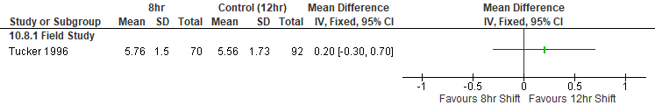*Tucker 1996: Data extracted from graph and averaged from 2400-0600 timepoints, SEM converted to SD. Higher score is associated with less alertness.

Figure S394. 8-hour Work Shift vs 12-hour Work Shift (Excessive Sleepiness, KSS) [CMT = 1 pt] Non-randomized study (Shift workers without SWD diagnosis)
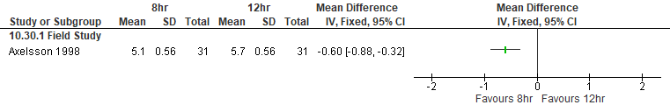*Axelsson 1998: SEM converted to SD.

Figure S395. 8-hour Work Shift vs 12-hour Work Shift (Sleep Quality, Questionnaire) [CMT = Not Established] Non-randomized study (Shift workers without SWD diagnosis)
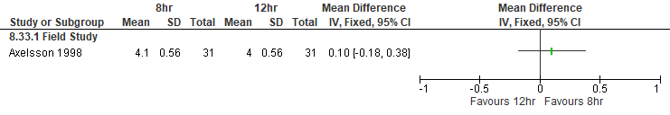*Axelsson 1998: SEM converted to SD. Sleep Quality Index (1-poor to 5-good).

Figure S396. 8-hour Work Shift vs 12-hour Work Shift (Sleep Quality, Questionnaire) [CMT = Not Established] Non-randomized study (Shift workers without SWD diagnosis)
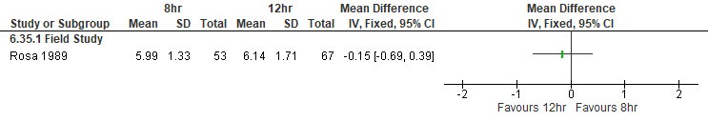*Rosa 1989: Sleep quality (1-poor to 9-good).

Figure S397. 8-hour Work Shift vs 12-hour Work Shift (Sleep Quality, Shift work survey questionnaire) [CMT = Not Established] Non-randomized study (Shift workers without SWD diagnosis)
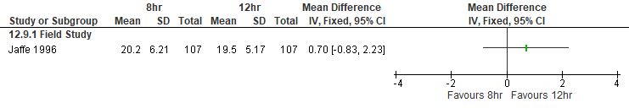*Jaffe 1996: 8hr night shift (backward rotation) vs 12hr night shift. Higher mean score= poorer sleep quality.

Figure S398. 8-hour Work Shift vs 12-hour Work Shift (Cognitive Performance, Serial Simple Reaction Time) [CMT = Not Established] Non-randomized study (Shift workers without SWD diagnosis)
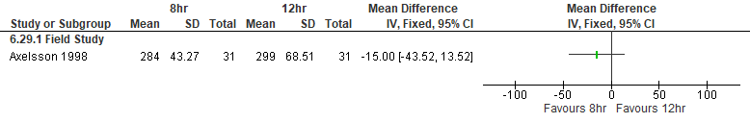*Axelsson 1998: Participants worked both shift types (crossover, assumed acceptable washout period). Used end of shift; reaction time in msec; SEM converted to SD.

Important Outcomes
Figure S399. 8-hour Work Shift vs 12-hour Work Shift (Total Sleep Time, Karolinska Sleep Diary or Questionnaire) [CMT= 15 min] Non-randomized study (Shift workers without SWD diagnosis)
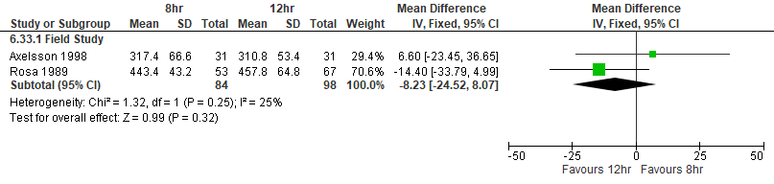*Axelsson 1998: Participants worked both shift types (crossover, assumed acceptable washout period). TST in hours converted to minutes; SEM converted to SD.
Rosa 1989: 8hr and 12hr shifts both had a rotation. TST in hours converted to minutes.

Figure S400. 8-hour Work Shift vs 12-hour Work Shift (Mental Health, General health questionnaire) [CMT = Not Established] Non-randomized study (Shift workers without SWD diagnosis)
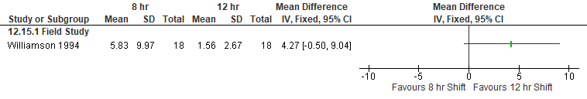*Williamson 1994: Participants were originally on a rotating 8hr shift (day, afternoon, night) and were changed to rotating 12hr shifts (day, night). GHQ score, low score = high well-being. SD calculated from a matched t-test (of operators who participated in both 8hr and change to 12 hr shifts).

Figure S401. 8-hour Work Shift vs 12-hour Work Shift (Sleep Latency, Karolinska Sleep Diary or Questionnaire) [CMT= 20 min] Non-randomized study (Shift workers without SWD diagnosis)
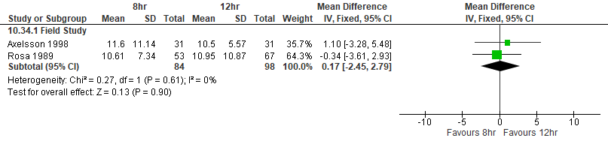*Axelsson 1998: Participants worked both shift types (crossover, assumed acceptable washout period). Latency (min); SEM converted to SD.
Rosa 1989: 8hr and 12hr shifts both had a rotation.

