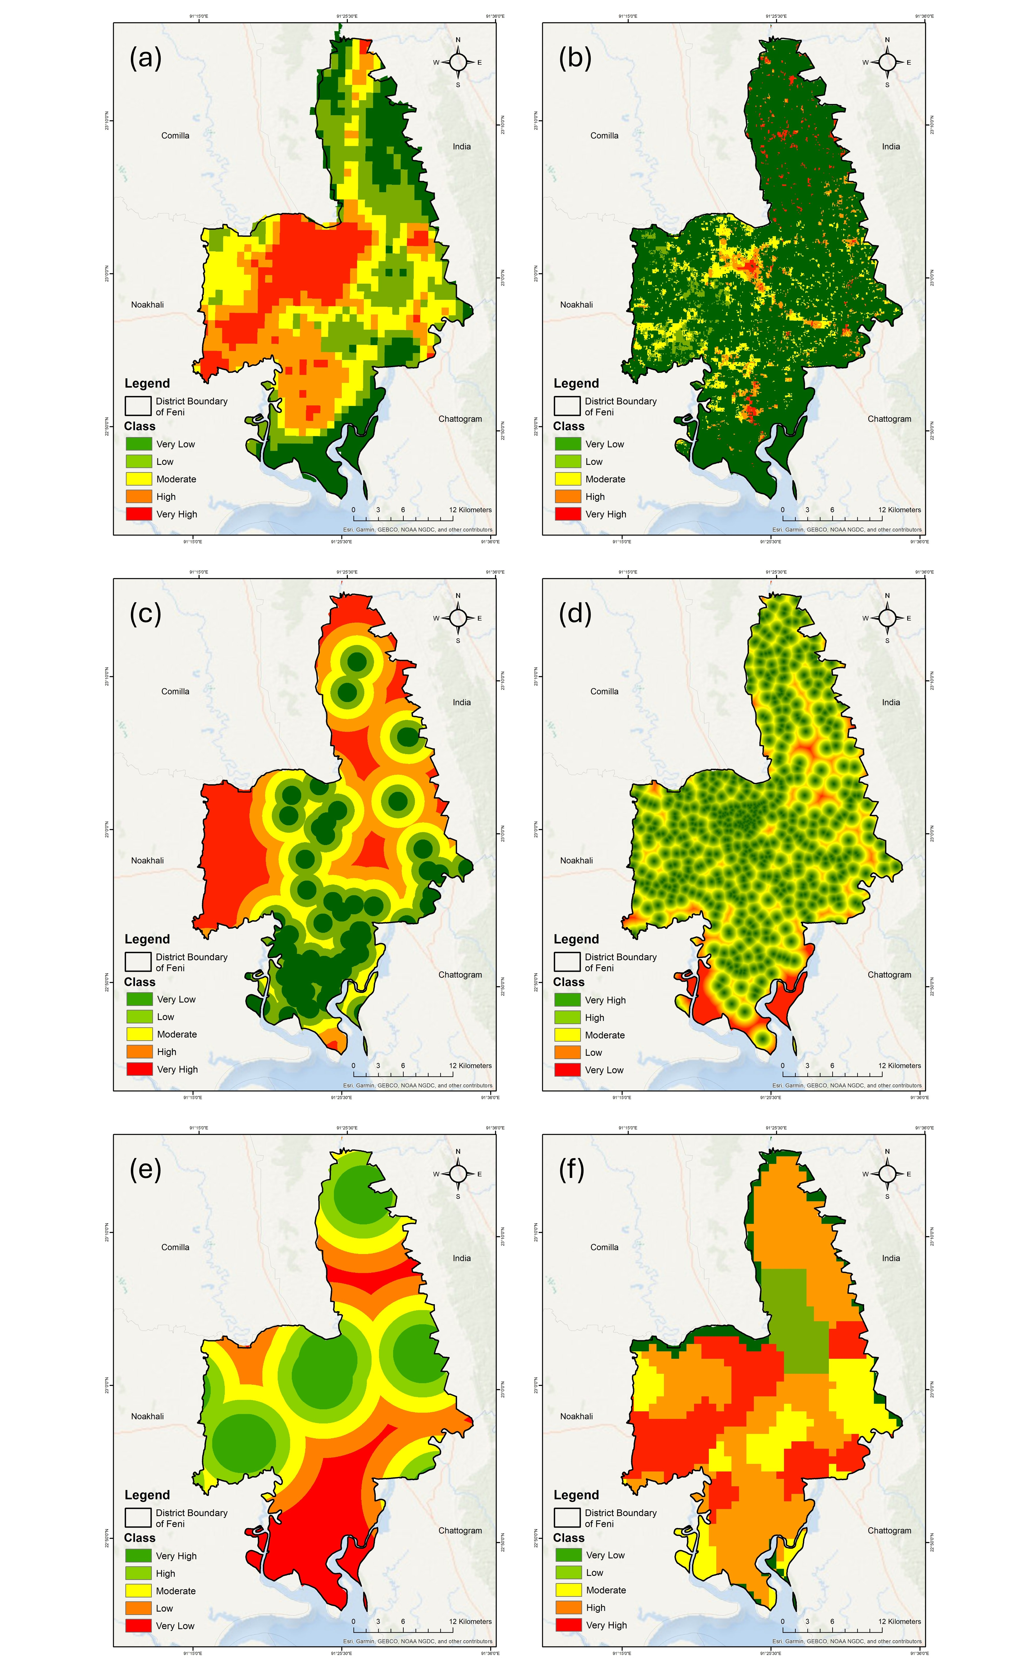
Figure S1. Variables under exposure: (a) Density of population; (b) Density of vulnerable age group; Resilience: (c) Distance from shelter; Susceptibility: (d) Literacy rate; (e) Distance from healthcare facilities; (f) Rate of poverty.
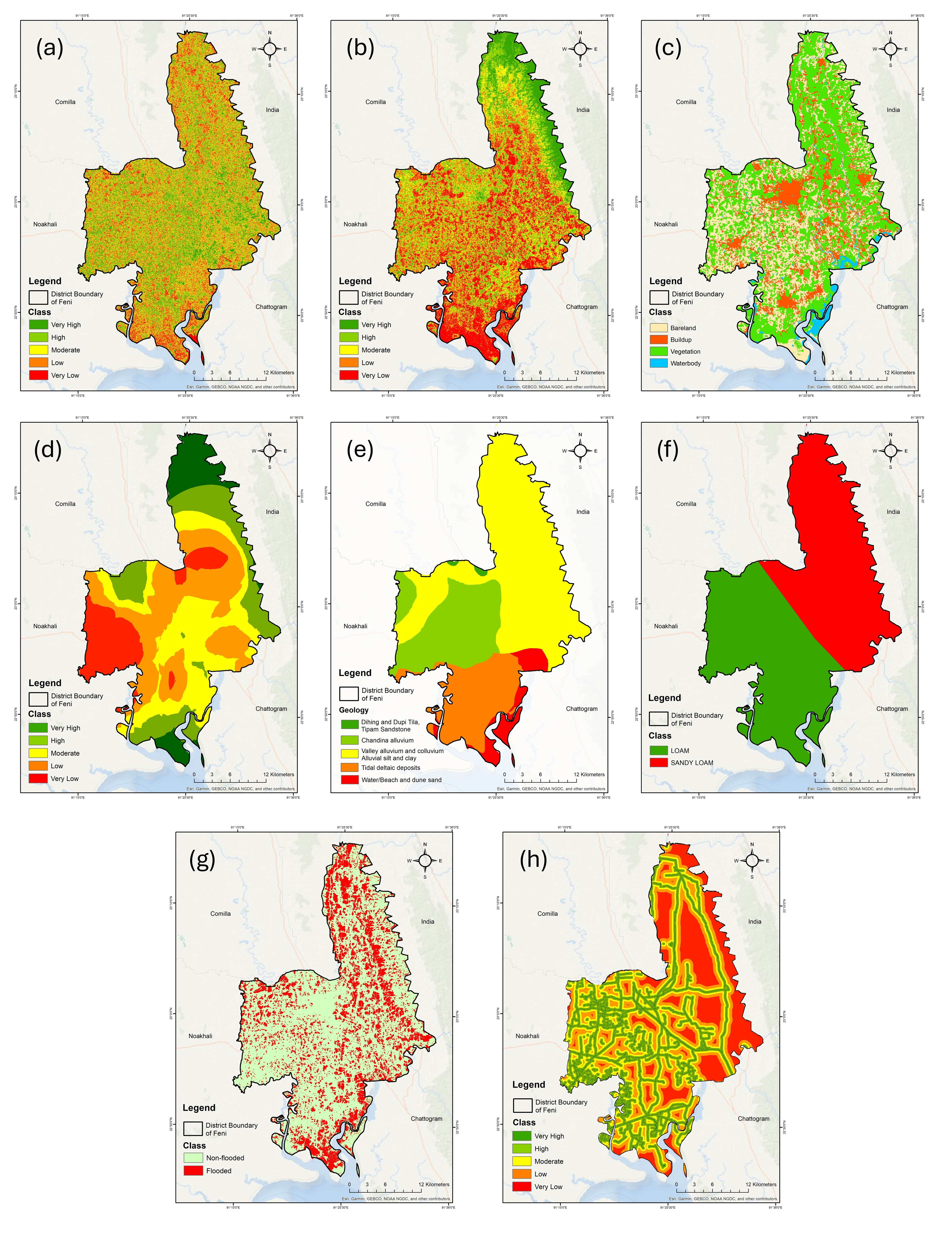
Figure S2. Variables under exposure: (a) Slope; (b) Elevation; (c) LULC; (d) Drainage density; (e) Geology; (f) Soil type; Susceptibility: (g) Previous flood extent; Resilience: (h) Access to road.
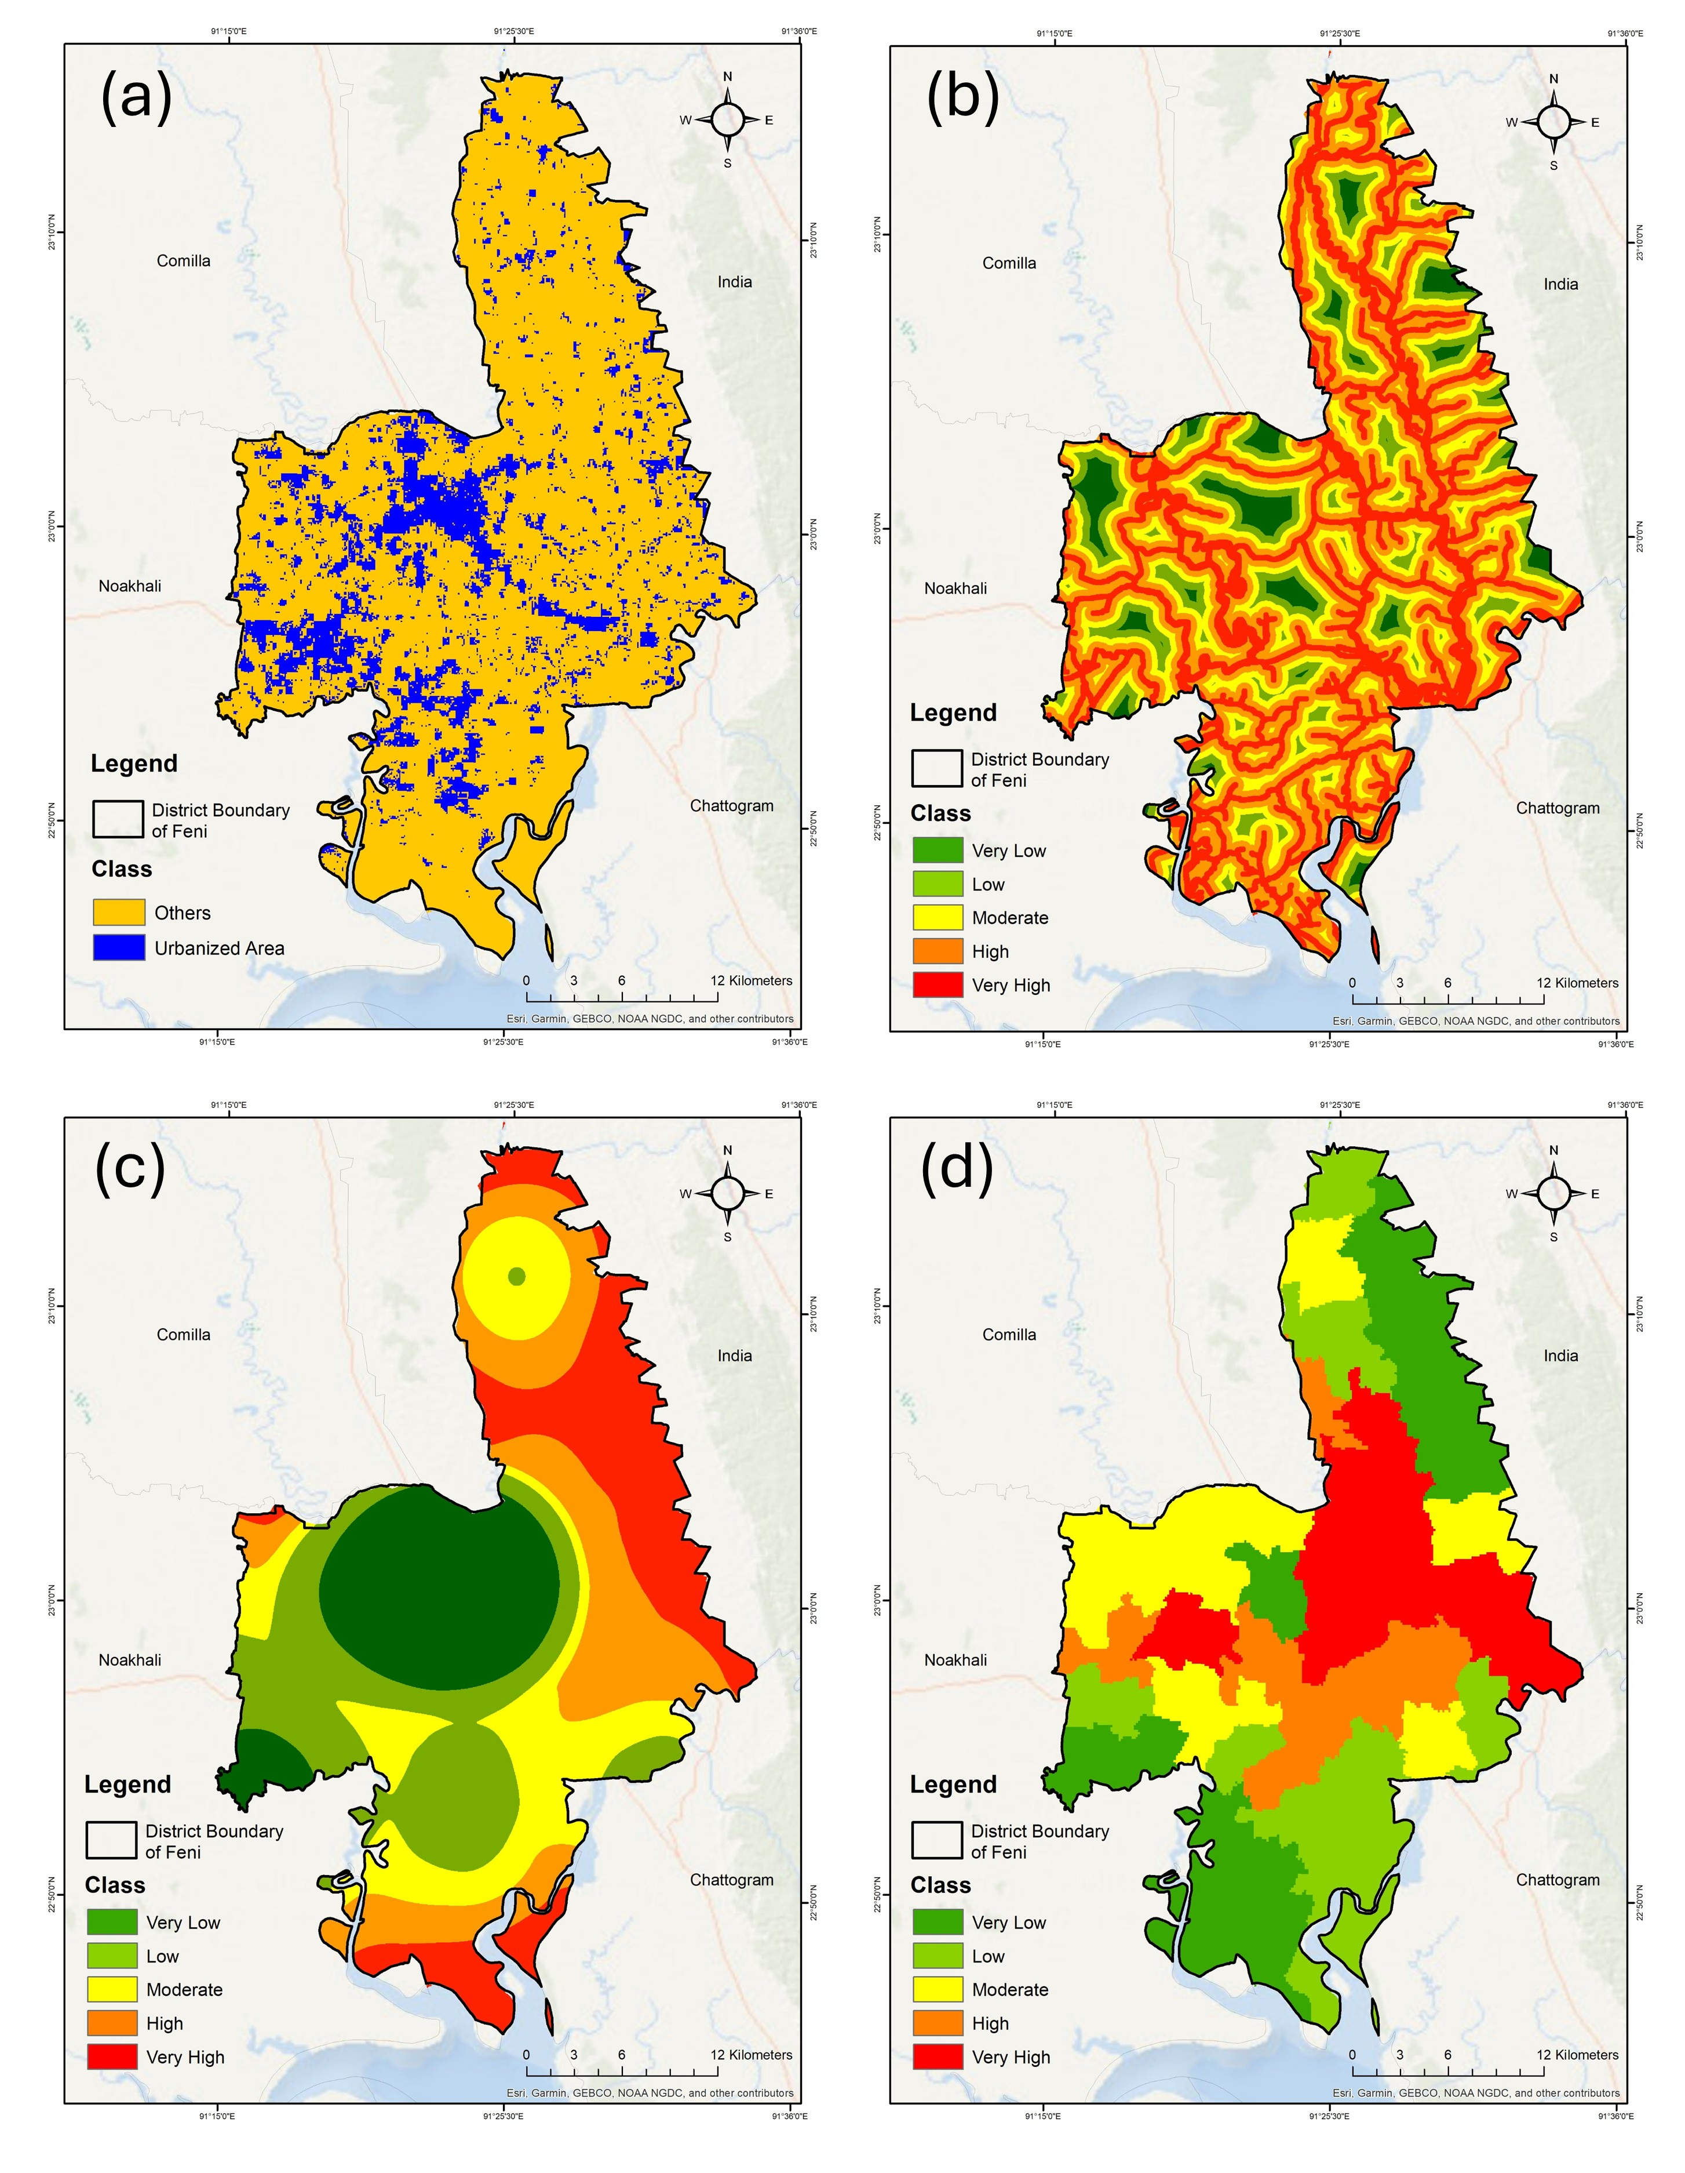
Figure S3. Variables under exposure: (a) Urbanized area; (b) Contact with river; Susceptibility: (c) Unemployment; Resilience: (d) Recovery time to flood.
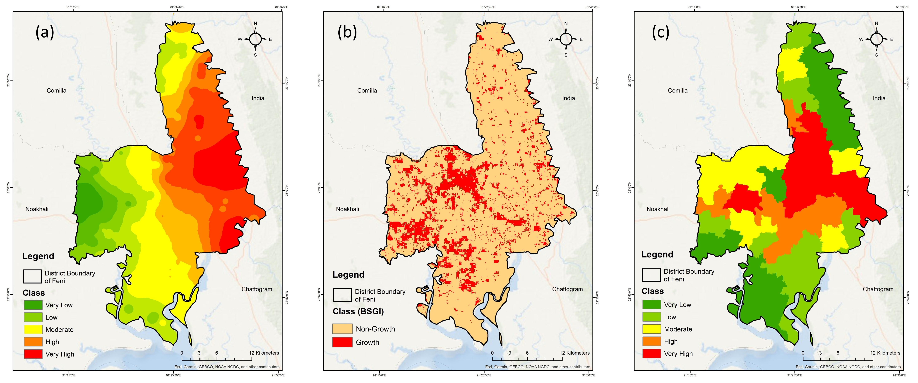
Figure S4. Variables under exposure: (a) Rainfall intensity; Susceptibility: (b) Urban Growth (Build Settlement Growth Index); Resilience: (c) Recovery time after flood.
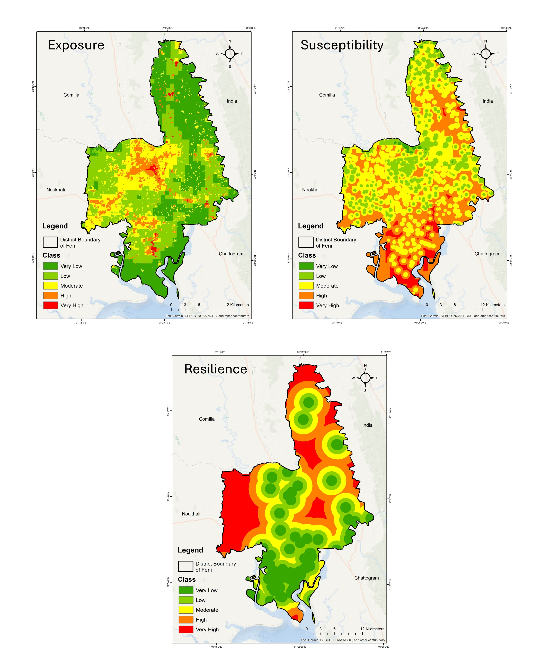
Figure S5. Factors of Social Vulnerability: Exposure, Susceptibility and Resilience (from left to right)
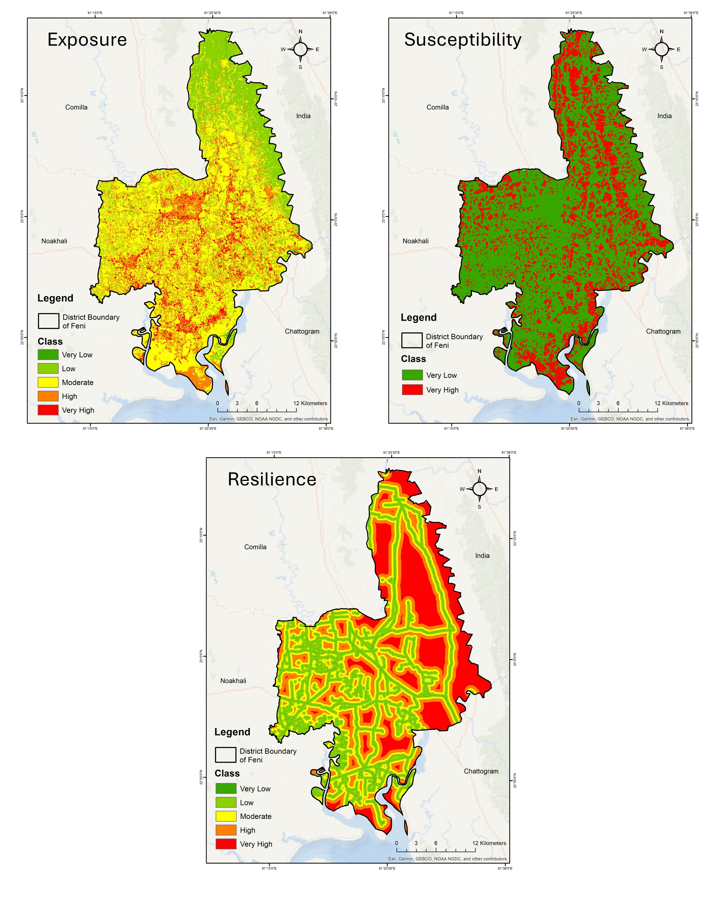
Figure S6. Factors of Physical Vulnerability: Exposure, Susceptibility and Resilience (from left to right)
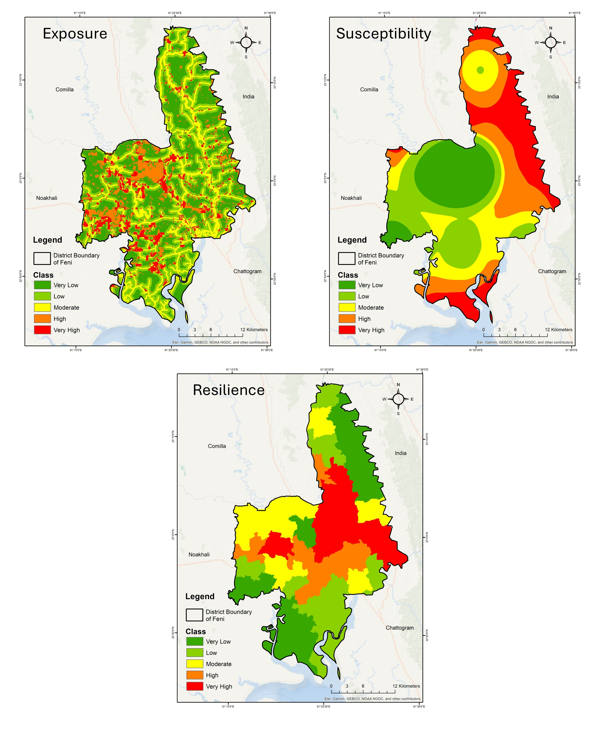
Figure S7. Factors of Economic Vulnerability: Exposure, Susceptibility and Resilience (from left to right)
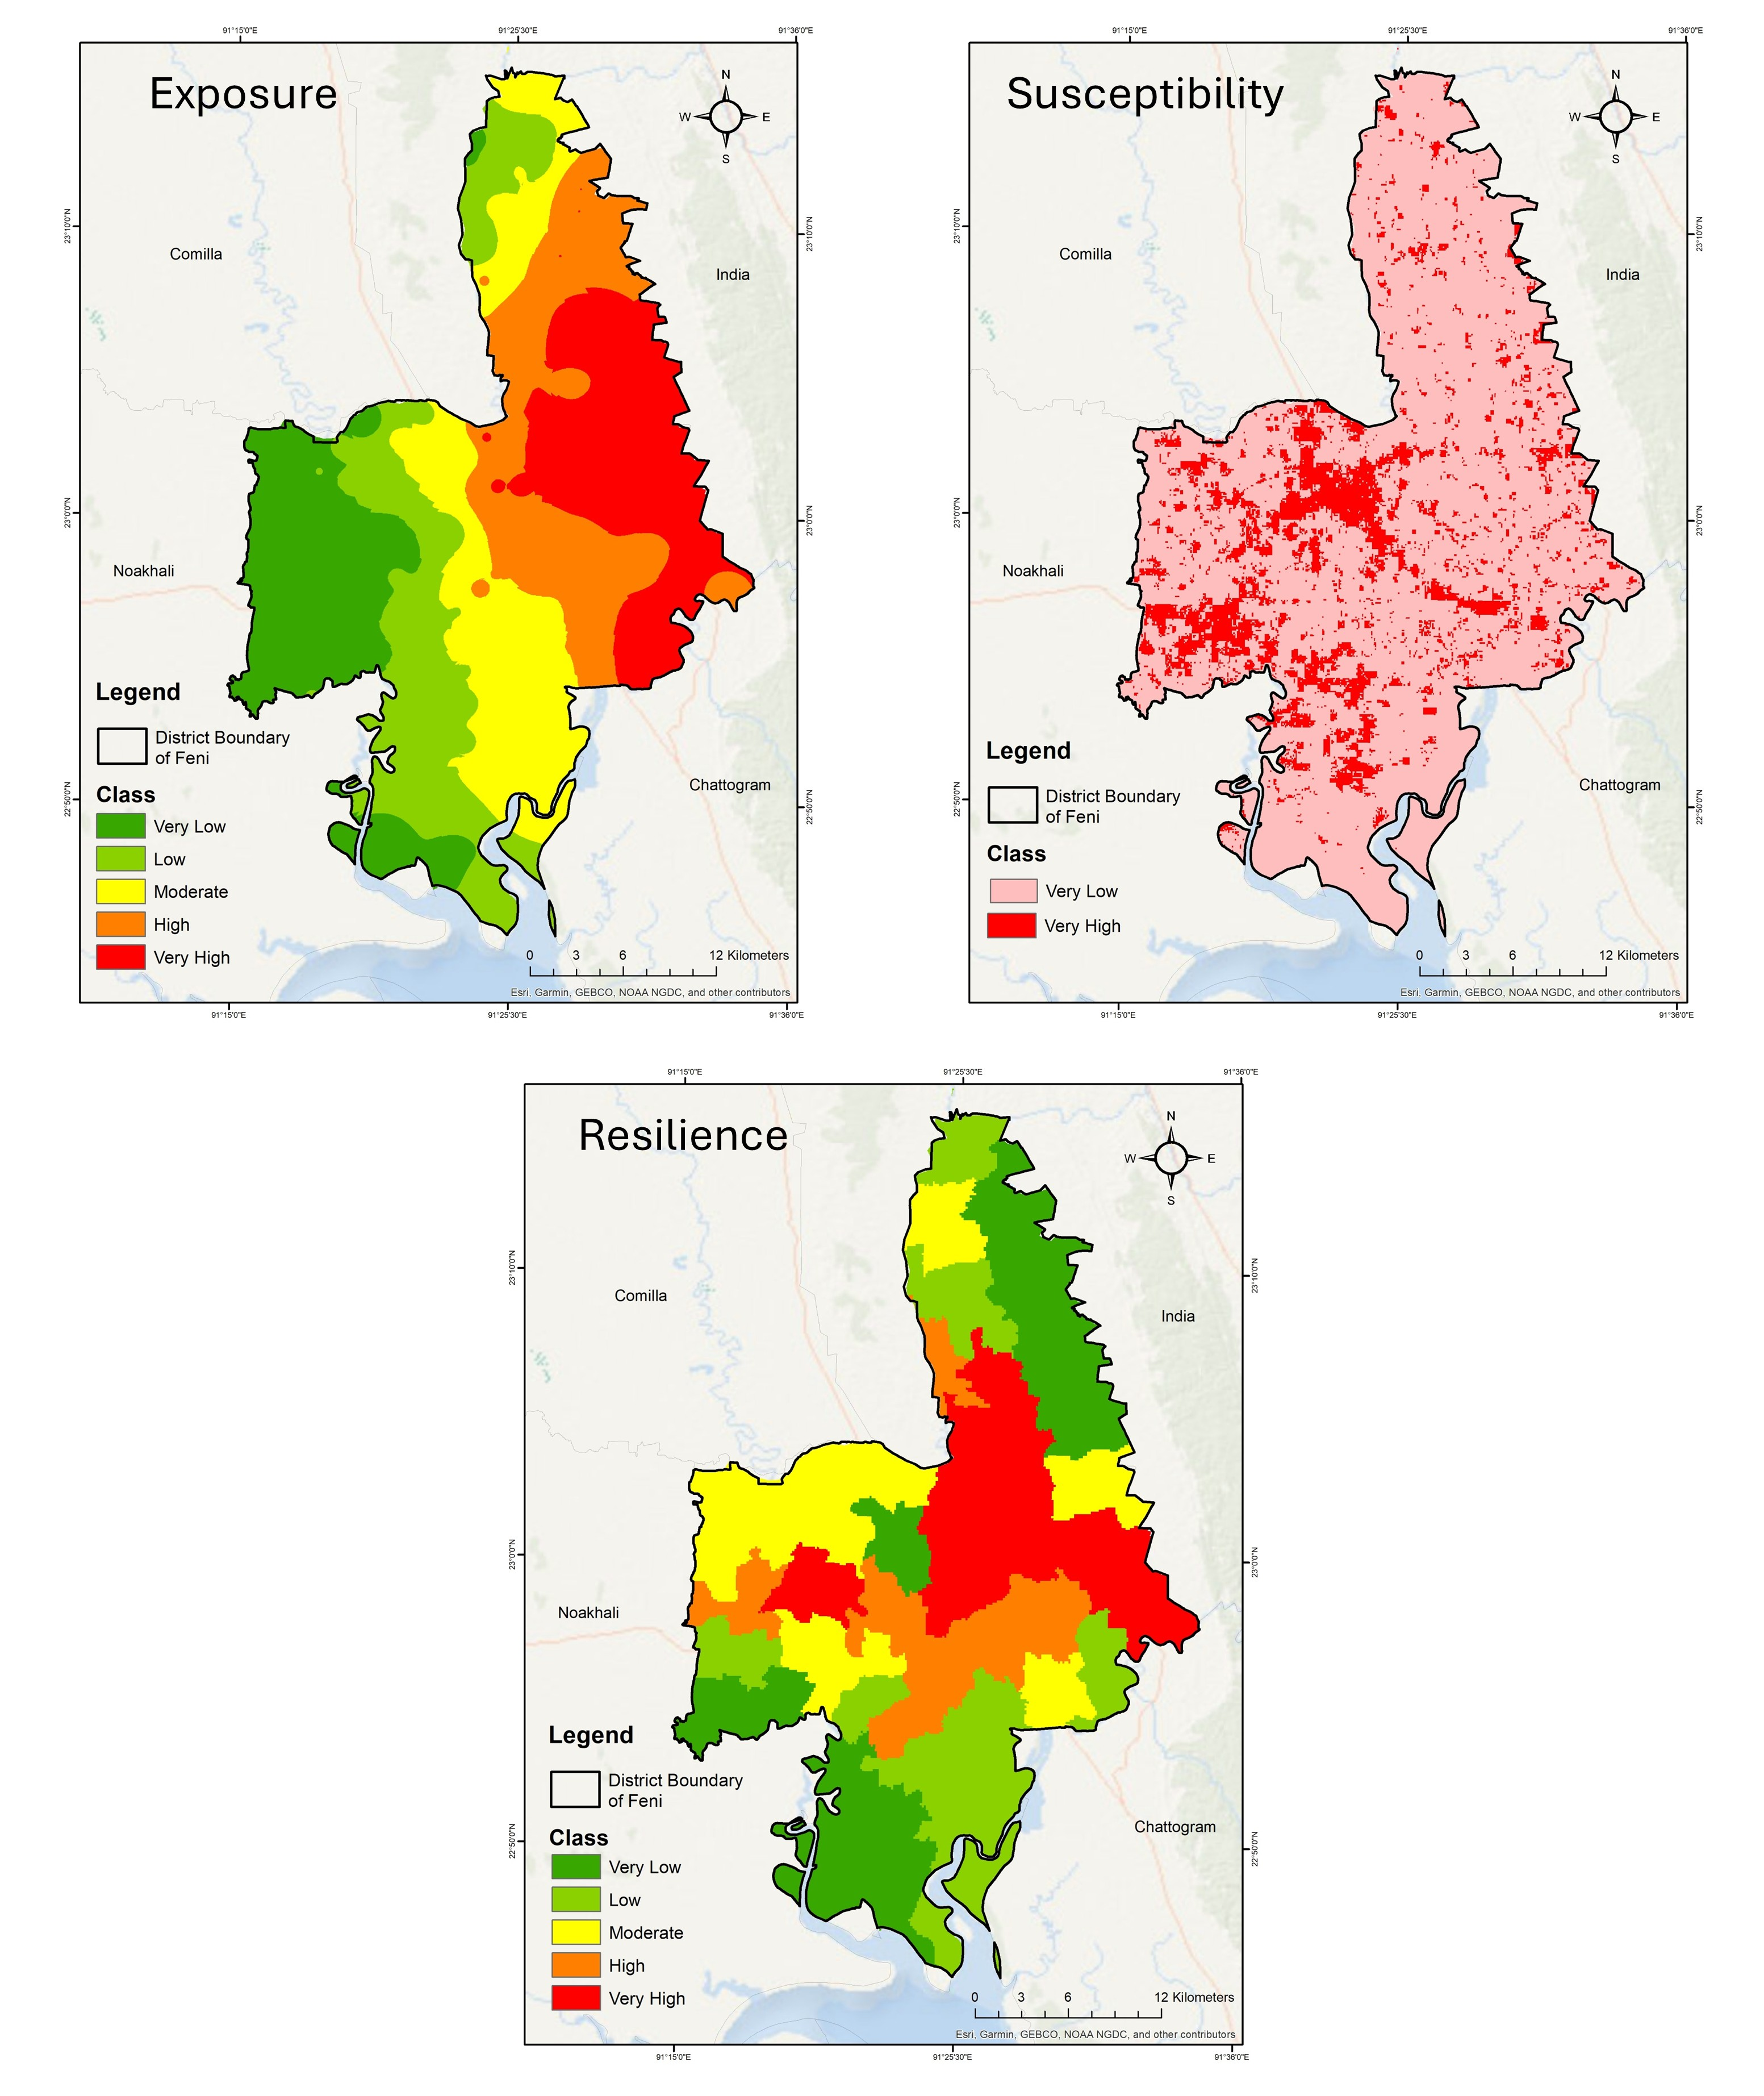
Figure S8: Factors of Environmental Vulnerability: Exposure, Susceptibility and Resilience (from left to right)
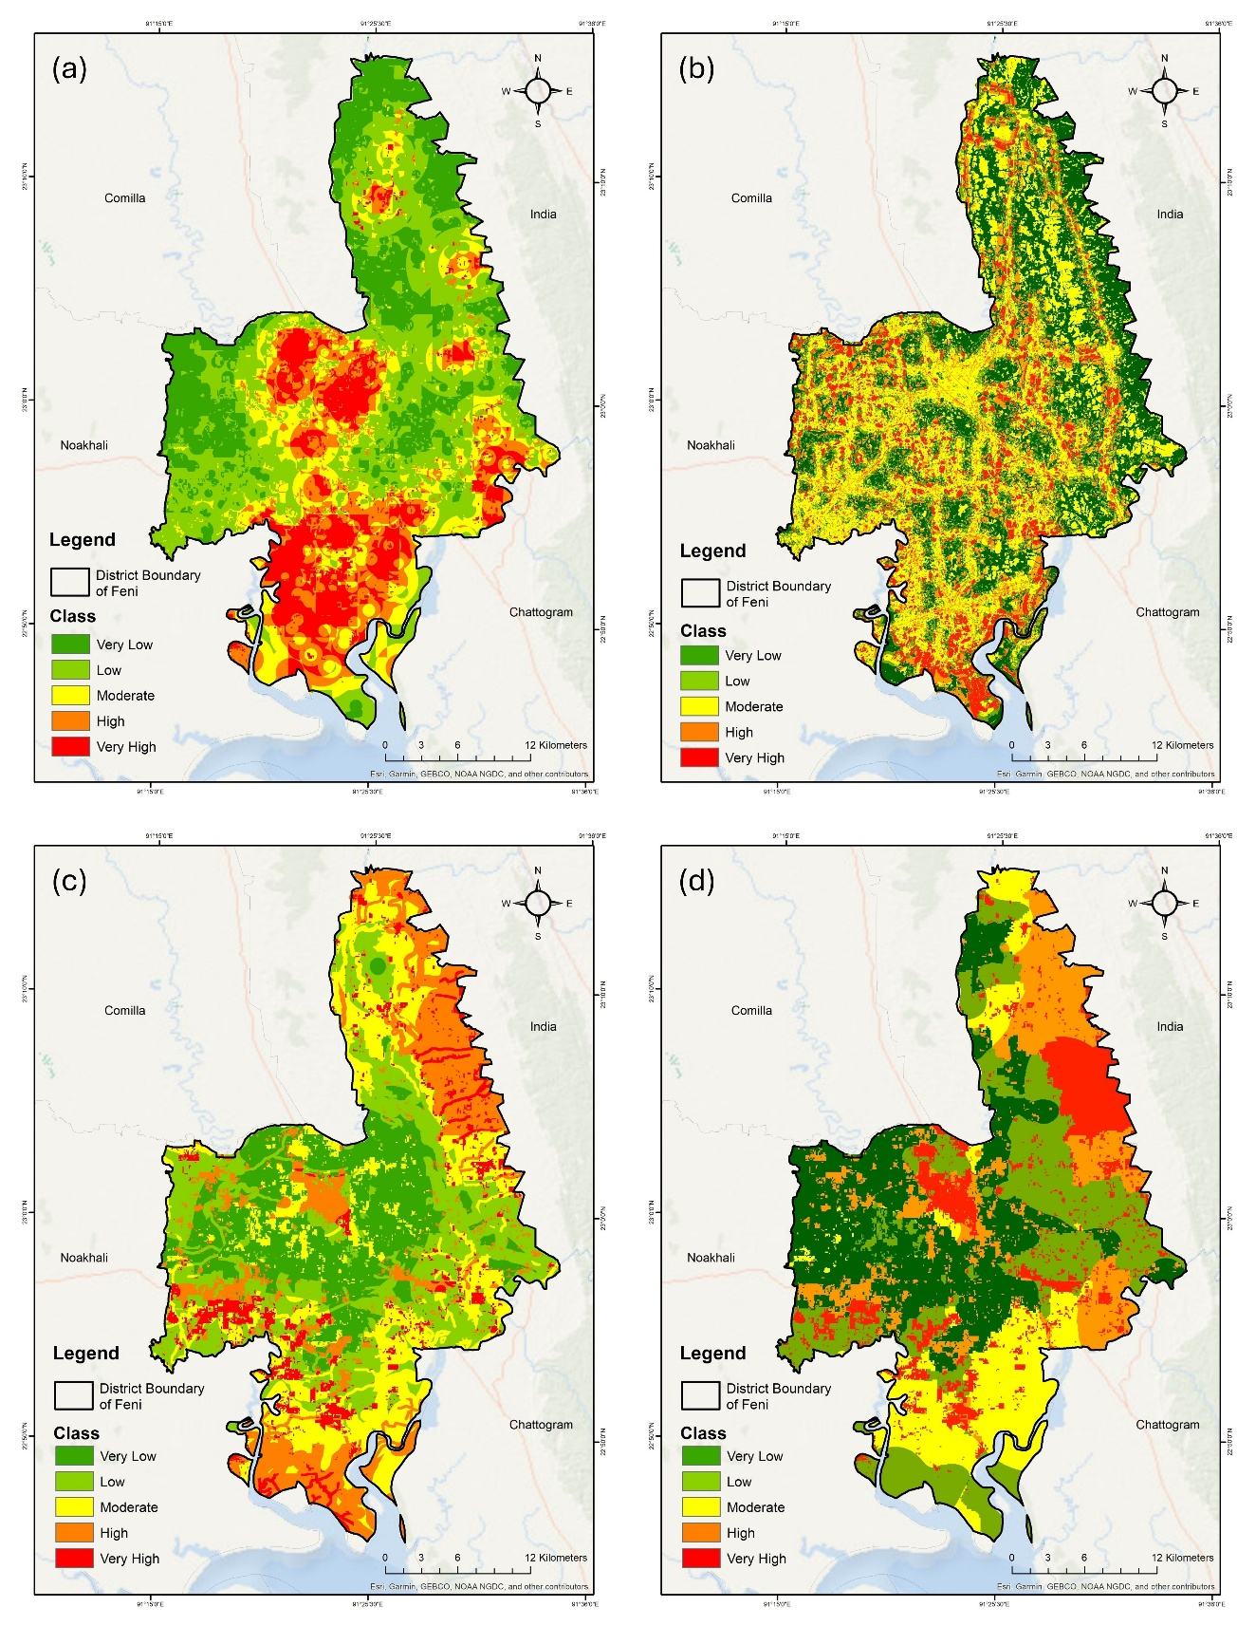
Figure S9. Spatial Analysis of Vulnerability in Feni District, Bangladesh: (a) Social Vulnerability, (b) Physical Vulnerability, (c) Economic Vulnerability, (d) Environmental Vulnerability.

Table S1. Sentinel-1 SAR Image Specifications and Acquisition Parameters
Parameter | Pre-Flood Baseline | Flood Event
Acquisition Date | August 10, 2024 | August 23, 2024
Sensor | Sentinel-1A/B | Sentinel-1A/B
Product Type | Ground Range Detected (GRD) | Ground Range Detected (GRD)
Mode | Interferometric Wide (IW) | Interferometric Wide (IW)
Polarization | VH (Vertical-Horizontal) | VH (Vertical-Horizontal)
Spatial Resolution | 10 m × 10 m | 10 m × 10 m
Pass Direction | Descending | Descending
Incidence Angle | 30°–45° | 30°–45°
Orbit Number | 49872 | 50047
Scene Coverage | Feni District, Bangladesh (22.5°N–23.2°N, 91.2°E–91.8°E) | Same
Data Source | ESA Copernicus Open Access Hub | ESA Copernicus Open Access Hub
Processing Level | Level-1 GRD | Level-1 GRD
Purpose | Baseline backscatter reference | Flood event detection

Table S2. Sentinel-1 SAR Image Preprocessing Workflow Using SNAP 9.0
Processing Step | Method/Algorithm | Parameters/Settings | Purpose | Output
1. Orbit Correction | Apply Precise Orbit Files | Orbit type: Sentinel Precise  Polynomial degree: 3 | Corrects satellite position and velocity errors; improves geolocation accuracy | Orbit-corrected SAR image
2. Thermal Noise Removal | Thermal Noise Removal operator | Remove thermal noise: Yes  Re-introduce thermal noise: No | Eliminates sensor-generated noise from low-backscatter areas | Noise-reduced image
3. Radiometric Calibration | Radiometric Calibration operator | Output: Sigma Naught (σ⁰)  Auxiliary file: Latest | Converts digital numbers to physically meaningful backscatter coefficients | Calibrated backscatter (σ⁰)
4. Speckle Filtering | Lee Sigma Filter | Filter: Lee Sigma  Window size: 7 × 7  Sigma: 0.9  Target window size: 3 × 3 | Reduces speckle noise while preserving edges and features; balances smoothing with detail retention | Speckle-filtered image
5. Terrain Correction | Range-Doppler Terrain Correction | DEM: SRTM 1-Arc Second (30 m)  Map projection: WGS84/UTM Zone 46N  Pixel spacing: 10 m  Resampling: Bilinear interpolation | Corrects geometric distortions (foreshortening, layover, shadow) caused by topography | Geocoded, terrain-corrected image
6. Conversion to Decibel Scale | Linear to dB conversion | Formula: σ⁰(dB) = 10 × log₁₀(σ⁰)  Applied to both images | Compresses dynamic range; facilitates visual interpretation and threshold determination | Backscatter in dB scale
7. Co-registration | Create Stack operator | Master: Pre-flood image  Slave: Flood image  Resampling: Bilinear | Aligns pre-flood and flood images to same geometry for change detection | Co-registered image stack
Software: Sentinel Application Platform (SNAP) version 9.0, ESA
Processing Time: ~45 minutes per scene (Intel Core i7, 32 GB RAM)

Table S3. Flood Extent Extraction and Classification Parameters
Parameter/Method | Specification | Justification/Reference
Change Detection Method | Backscatter Difference | Standard approach for SAR flood mapping (Auradkar et al., 2022; Zhou et al., 2025)
Calculation Formula | Δσ⁰(dB) = σ⁰_flood(dB) − σ⁰_baseline(dB) | Negative values indicate backscatter decrease (water accumulation)
Classification Threshold | Δσ⁰ < −3 dB | Water pixels exhibit >3 dB backscatter decrease; threshold optimized through iterative comparison with ground truth (Krok & Lisowska, 2025)
Minimum Mapping Unit | 0.01 hectares (1 pixel) | 10 m resolution allows detection of small flooded patches
Post-classification Filter | Majority filter (3×3 kernel) | Removes isolated misclassified pixels; improves spatial coherence
Flooded Area Calculation | Pixel count × pixel area (100 m²) | Total classified flood extent: 26,520 hectares
Output Format | GeoTIFF, Shapefile (vector polygon) | Compatible with GIS platforms for further analysis

Table S4. Flood Classification Validation Sources and Methods
Validation Source | Type | Sample Size/Coverage | Method | Agreement Metric
GPS Field Observations | Ground truth points | n = 28 flood boundary points | Field team visited flood-affected areas (Aug 24-26, 2024) and recorded GPS coordinates of visible flood extent boundaries using handheld GPS (±5 m accuracy) | Point-to-classification comparison;  Kappa coefficient = 0.87  (Strong agreement)
High-Resolution Optical Imagery | Satellite imagery | Post-flood Google Earth imagery (Aug 25-28, 2024)  Spatial resolution: 0.5–2 m | Visual interpretation by two independent analysts; flooded areas identified by water color, inundated infrastructure, vegetation stress | Qualitative validation;  Analyst agreement: 94%
Local Authority Reports | Official flood reports | District Disaster Management Committee reports  Union-level flood damage assessments | Cross-referenced reported flooded villages and unions with classified extent; confirmed spatial patterns | Spatial correspondence: 88% of reported flooded unions matched classification
Pre-flood Baseline Comparison | Historical imagery | Pre-flood Sentinel-2 optical (Aug 5, 2024) | Compared water body extent in normal conditions vs. flood conditions; ensured baseline captured non-flood state | Confirmed <5% water coverage in baseline period

Table S5. Accuracy Assessment Results and Error Matrix
A. Confusion Matrix (Stratified Random Sample, n = 300)
 | Reference Data (High-Resolution Imagery) |  |  | Total | User's Accuracy (%)
Classified | Flooded | Non-Flooded | Edge
Flooded | 89 | 6 | 4 | 99 | 89.90%
Non-Flooded | 4 | 93 | 3 | 100 | 93.00%
Edge | 7 | 7 | 87 | 101 | 86.10%
Total | 100 | 106 | 94 | 300 | -
Producer's Accuracy (%) | 89.00% | 87.70% | 92.60% | - | -
Overall Accuracy: 269/300 = 89.7%
Kappa Coefficient: κ = 0.84 (Strong agreement; Landis & Koch, 1977)
B. Class-Specific Accuracy Metrics
Class | User's Accuracy (%) | Producer's Accuracy (%) | F1-Score | Commission Error (%) | Omission Error (%)
Flooded | 89.9 | 89 | 0.894 | 10.1 | 11
Non-Flooded | 93 | 87.7 | 0.903 | 7 | 12.3
Edge Pixels | 86.1 | 92.6 | 0.892 | 13.9 | 7.4
Weighted Average | 89.7 | 89.7 | 0.896 | 10.3 | 10.3

Table S6. Classification Error Sources and Spatial Distribution

Error Type | Description | Frequency (%) | Spatial Location | Contributing Factors | Mitigation Strategy
False Positives (Commission) | Non-flooded areas misclassified as flooded | 10.30% | Dense vegetation canopies; agricultural fields with standing crops; urban areas with smooth surfaces | Volume scattering from vegetation; specular reflection from smooth surfaces mimicking water backscatter | Applied vegetation mask using NDVI threshold (>0.4); urban mask from land use data; increased threshold in vegetated areas to −4 dB
False Negatives (Omission) | Flooded areas misclassified as non-flooded | 10.30% | Shallow flooding (<10 cm depth); areas with emergent vegetation; wind-roughened water surfaces | Backscatter increase from vegetation protruding through water; surface roughness increasing backscatter above threshold | Lowered threshold to −2.5 dB in known flood-prone low-lying areas; integrated auxiliary data (elevation <5 m)
Edge Uncertainty | Misclassification at flood boundaries | 13.90% | Transition zones between flooded/non-flooded; gradually sloping terrain | Mixed pixels containing both water and land; gradual soil moisture gradients | Applied majority filter; acknowledged edge uncertainty (±1 pixel = ±10 m) in metadata
Overall Classification Uncertainty: Flood extent estimate = 26,520 hectares ± 2,250 hectares (±8.5% at 95% confidence level)

Table S7. Descriptive Statistics of Vulnerability Dimension Scores
Vulnerability Dimension | N | Mean | Median | Std. Deviation | Variance | Min | Max | Q1 (25th) | Q3 (75th) | IQR | Skewness | Kurtosis
Economic Vulnerability | 384 | 4.08 | 4.14 | 0.42 | 0.176 | 3.29 | 5 | 3.79 | 4.43 | 0.64 | -0.18 | -0.35
Social Vulnerability | 384 | 3.98 | 4 | 0.41 | 0.168 | 3.11 | 5 | 3.67 | 4.33 | 0.66 | -0.12 | -0.28
Environmental Vulnerability | 384 | 4 | 4 | 0.39 | 0.152 | 3.29 | 5 | 3.71 | 4.29 | 0.58 | -0.09 | -0.42
Physical Vulnerability | 384 | 3.96 | 3.86 | 0.44 | 0.194 | 3.14 | 5 | 3.71 | 4.29 | 0.58 | 0.22 | -0.31
Overall Vulnerability | 384 | 4.01 | 4 | 0.38 | 0.144 | 3.21 | 5 | 3.75 | 4.29 | 0.54 | -0.05 | -0.36
Notes:
- All scores on 5-point Likert scale (1 = Strongly Disagree to 5 = Strongly Agree)
- N = Total number of respondents
- Q1 = First Quartile (25th percentile); Q3 = Third Quartile (75th percentile)
- IQR = Interquartile Range (Q3 - Q1)
- Skewness: Negative values indicate left-skewed distribution (concentration at higher scores)
- Kurtosis: Negative values indicate platykurtic distribution (flatter than normal)

Table S8. Outlier Analysis for Vulnerability Dimensions
Vulnerability Dimension | Lower Fence | Upper Fence | Mild Outliers (Count) | Extreme Outliers (Count) | Outlier IDs | Outlier Values
Economic Vulnerability | 2.83 | 5.39 | 3 | 0 | R047, R152, R289 | 3.14, 3.21, 3.29
Social Vulnerability | 2.68 | 5.32 | 2 | 0 | R089, R234 | 3.11, 3.22
Environmental Vulnerability | 2.84 | 5.16 | 0 | 0 | - | -
Physical Vulnerability | 2.84 | 5.16 | 3 | 0 | R076, R198, R321 | 3.14, 3.14, 3.14

Table S9. Frequency Distribution of Vulnerability Scores

Score Range | Economic Vulnerability | Social Vulnerability | Environmental Vulnerability | Physical Vulnerability | Total Frequency | Percentage (%)
3.00–3.25 | 2 | 3 | 0 | 5 | 10 | 2.60%
3.26–3.50 | 8 | 12 | 6 | 18 | 44 | 11.50%
3.51–3.75 | 42 | 58 | 52 | 68 | 220 | 57.30%
3.76–4.00 | 78 | 89 | 96 | 82 | 345 | 89.80%
4.01–4.25 | 98 | 76 | 84 | 72 | 330 | 85.90%
4.26–4.50 | 88 | 68 | 74 | 58 | 288 | 75.00%
4.51–4.75 | 48 | 42 | 38 | 32 | 160 | 41.70%
4.76–5.00 | 20 | 36 | 34 | 49 | 139 | 36.20%

Table S10. Average Scores of Vulnerability Drivers.
(a) Economic Vulnerability Drivers
Drivers of Economic Vulnerability | Avg. Response
Lack of employment opportunities | 4.05
Absence of social safety net services | 4.04
Unable to build up adequate savings | 4.01
Excluded from microcredit opportunities | 3.98
Lack access to affordable insurance coverage | 3.96
High cost of flood mitigation measures | 3.94
Wage theft | 3.93
Lack of government financial assistance programs | 3.92

(b) Social Vulnerability Drivers
Drivers of Social Vulnerability | Avg. Response
Access to essential flood relief services | 4.01
High cost of healthcare facilities | 4.01
Corruption | 4.00
Instances of bribery | 4.00
Absence of accessible healthcare centers | 4.00
Inadequate sanitation facilities | 3.98
Lack of social cohesion and community networks | 3.97
Language or cultural barriers | 3.91

(c) Environmental Vulnerability Drivers
Drivers of Environmental Vulnerability | Avg. Response
Located in a floodplain or other high-risk area | 4.02
Lack of early warning systems | 4.01
Low-lying location | 4.01
Degradation of natural flood buffers | 4.01
Other adverse environmental effects, like deforestation or pollution | 4.00
Riverbank erosion | 3.93

(d) Physical Vulnerability Drivers
Drivers of Physical Vulnerability | Avg. Response
Critical infrastructure issues, like damaged roads or electricity outages | 4.06
Risk of eviction due to floods | 4.04
Water scarcity during floods | 4.00
Food supply chain disruption | 4.00
Poor structural integrity | 3.99
Lack of proper transport infrastructure | 3.99
Accessibility challenges for the elderly or disabled | 3.97
Lack of secure land tenure | 3.91

REFERENCES
Arsiso, B. K. (2025). Flood hazard mapping using satellite remote sensing and GIS techniques: A case study of Awash River basin, Ethiopia. Natural Hazards Research. https://doi.org/10.1016/j.nhres.2024.09.008
Auradkar, S., Patil, S., & Agarwal, V. (2022). Flood inundation mapping using Sentinel-1 SAR data: A case study of Kerala floods. Journal of the Indian Society of Remote Sensing, 50(2), 301-315.
Baraha, S., Hinge, G., Sharma, A., & Pandey, A. C. (2025). A multi-temporal flood mapping approach using Sentinel-1 and Sentinel-2 data. Environmental Monitoring and Assessment, 197(1), 45.
Bo, S., Liu, W., & Zhang, Y. (2026). Synergistic use of optical and SAR imagery for improved flood detection. Remote Sensing of Environment, 298, 113845.
Krok, G., & Lisowska, A. (2025). Sentinel-1 SAR for operational flood mapping: Threshold optimization and accuracy assessment. IEEE Journal of Selected Topics in Applied Earth Observations and Remote Sensing, 18(2), 1245-1260.
Landis, J. R., & Koch, G. G. (1977). The measurement of observer agreement for categorical data. Biometrics, 33(1), 159-174.
Yoo, C., Kim, D., & Lee, M. (2025). Comparative assessment of optical and radar remote sensing for flood extent mapping. International Journal of Remote Sensing, 46(3), 890-915.
Zhou, L., Pan, S., & Chen, X. (2025). Automated flood mapping using deep learning and Sentinel-1 time series. ISPRS Journal of Photogrammetry and Remote Sensing, 209, 145-162.

    - : Questionnaire of the survey
Questionnaire Survey on
Drivers of Flash Flood Vulnerability Assessment Questionnaire
MURP Thesis: Department of Urban and Regional Planning, CUET, Chattogram
(Used only for Academic Purposes)

Survey Location: | Union: | Questionnaire No:

Please rate your level of agreement with the following statements on a scale from 1 to 5, where 1 indicates "Strongly Disagree" and 5 indicates "Strongly Agree"

A. Economic Vulnerability
- Does the lack of employment opportunities in your community affect your vulnerability to floods?
o (Strongly Disagree) o (Disagree) o (Neutral) o (Agree) o (Strongly Agree)
- Do instances of wage theft impact your economic stability, making you more vulnerable during flood situations?
o (Strongly Disagree) o (Disagree) o (Neutral) o (Agree) o (Strongly Agree)
- Does the absence of social safety net services leave your community more exposed to economic hardships during and after floods?
o (Strongly Disagree) o (Disagree) o (Neutral) o (Agree) o (Strongly Agree)
- Are you excluded from microcredit opportunities, affecting your ability to recover economically after flood events?
o (Strongly Disagree) o (Disagree) o (Neutral) o (Agree) o (Strongly Agree)
- Do you have lack access to affordable insurance coverage to protect against flood-related losses?
o (Strongly Disagree) o (Disagree) o (Neutral) o (Agree) o (Strongly Agree)
- Does the high cost of flood mitigation measures, like home fortification, put you out of reach for your household?
o (Strongly Disagree) o (Disagree) o (Neutral) o (Agree) o (Strongly Agree)
- Does the lack of government financial assistance programs leave your community to shoulder the full economic burden of floods?
o (Strongly Disagree) o (Disagree) o (Neutral) o (Agree) o (Strongly Agree)
- Are you unable to build up adequate savings to withstand the financial impacts of repeated flood events?
o (Strongly Disagree) o (Disagree) o (Neutral) o (Agree) o (Strongly Agree)

B. Social Vulnerability
- Does corruption in local institutions impact your community's ability to receive timely assistance during floods?
o (Strongly Disagree) o (Disagree) o (Neutral) o (Agree) o (Strongly Agree)
- Do instances of bribery hinder the proper allocation of resources needed during flood emergencies?
o (Strongly Disagree) o (Disagree) o (Neutral) o (Agree) o (Strongly Agree)
- Does the existence of a patronage system affect your community's access to essential flood relief services?
o (Strongly Disagree) o (Disagree) o (Neutral) o (Agree) o (Strongly Agree)
- Does the high cost of healthcare affect your community's overall health and well-being during flood events?
o (Strongly Disagree) o (Disagree) o (Neutral) o (Agree) o (Strongly Agree)
- Is the absence of accessible healthcare centers a barrier to your community's health services availability during floods?
o (Strongly Disagree) o (Disagree) o (Neutral) o (Agree) o (Strongly Agree)
- Do inadequate sanitation facilities impact your community's health and well-being, particularly in flood-prone conditions?
o (Strongly Disagree) o (Disagree) o (Neutral) o (Agree) o (Strongly Agree)
- Are there language or cultural barriers that prevent your community from accessing important flood preparedness information?
o (Strongly Disagree) o (Disagree) o (Neutral) o (Agree) o (Strongly Agree)
- Does a lack of social cohesion and community networks limit your ability to collectively respond to and recover from floods?
o (Strongly Disagree) o (Disagree) o (Neutral) o (Agree) o (Strongly Agree)

C. Environmental Vulnerability
- Does your community's low-lying location increase the risk of flooding?
o (Strongly Disagree) o (Disagree) o (Neutral) o (Agree) o (Strongly Agree)
- Does the frequent riverbank erosion affect your community's safety and housing stability during floods?
o (Strongly Disagree) o (Disagree) o (Neutral) o (Agree) o (Strongly Agree)
- Do other adverse environmental effects, like deforestation or pollution, impact your community negatively during and after floods?
o (Strongly Disagree) o (Disagree) o (Neutral) o (Agree) o (Strongly Agree)
- Is your community located in a floodplain or other high-risk area prone to recurring flood events?
o (Strongly Disagree) o (Disagree) o (Neutral) o (Agree) o (Strongly Agree)
- Do you think, there is lack of early warning systems to prepare for impending floods?
o (Strongly Disagree) o (Disagree) o (Neutral) o (Agree) o (Strongly Agree)
- Does the degradation of natural flood buffers, like wetlands, increase your community's exposure to flood impacts?
o (Strongly Disagree) o (Disagree) o (Neutral) o (Agree) o (Strongly Agree)

D. Physical Vulnerability
- Does the risk of eviction due to floods affect your community's housing stability and overall security?
o (Strongly Disagree) o (Disagree) o (Neutral) o (Agree) o (Strongly Agree)
- Does household water scarcity during floods affect your community's daily activities and health?
o (Strongly Disagree) o (Disagree) o (Neutral) o (Agree) o (Strongly Agree)
- Does the lack of proper transport infrastructure affect your community's ability to evacuate and access essential services during floods?
o (Strongly Disagree) o (Disagree) o (Neutral) o (Agree) o (Strongly Agree)
- Are critical infrastructure issues, like damaged roads or electricity outages, a concern for your community during and after floods?
o (Strongly Disagree) o (Disagree) o (Neutral) o (Agree) o (Strongly Agree)
- Does the poor structural integrity of your home make it more vulnerable to flood damage?
o (Strongly Disagree) o (Disagree) o (Neutral) o (Agree) o (Strongly Agree)
- Are there accessibility challenges for the elderly or disabled in your community to safely shelter in place or evacuate during floods?
o (Strongly Disagree) o (Disagree) o (Neutral) o (Agree) o (Strongly Agree)
- Does the lack of secure land tenure make your household more vulnerable to displacement from flood events?
o (Strongly Disagree) o (Disagree) o (Neutral) o (Agree) o (Strongly Agree)
- Is your community's food supply chain disrupted during and after flood episodes, affecting food security?
o (Strongly Disagree) o (Disagree) o (Neutral) o (Agree) o (Strongly Agree)

Table S11: Priority Ranking of the Drivers for Providing Recommendation Measures
Unions | Dimensions | Priority |  |  | Unions | Dimensions | Priority
Unions | Dimensions | 1 | 2 | 3 | Unions | Dimensions | 1 | 2 | 3
Amirabad | Economic | Q4 | Q7 | Q3 | Matabi | Economic | Q4 | Q1 | Q7
Amirabad | Social | Q11 | Q12 | Q10 | Matabi | Social | Q11 | Q12 | Q10
Amirabad | Environmental | Q21 | Q18 | Q17 | Matabi | Environmental | Q20 | Q17 | Q18
Amirabad | Physical | Q27 | Q28 | Q29 | Matabi | Physical | Q29 | Q27 | Q28
Amjadhat | Economic | Q8 | Q7 | Q3 | Mathu Bhuiyan | Economic | Q1 | Q2 | Q3
Amjadhat | Social | Q12 | Q10 | Q11 | Mathu Bhuiyan | Social | Q11 | Q12 | Q10
Amjadhat | Environmental | Q19 | Q20 | Q17 | Mathu Bhuiyan | Environmental | Q20 | Q17 | Q18
Amjadhat | Physical | Q27 | Q23 | Q28 | Mathu Bhuiyan | Physical | Q29 | Q27 | Q28
Anandapur | Economic | Q1 | Q3 | Q4 | Matiganj | Economic | Q1 | Q3 | Q6
Anandapur | Social | Q10 | Q12 | Q15 | Matiganj | Social | Q11 | Q12 | Q10
Anandapur | Environmental | Q17 | Q20 | Q18 | Matiganj | Environmental | Q20 | Q17 | Q18
Anandapur | Physical | Q27 | Q29 | Q26 | Matiganj | Physical | Q29 | Q27 | Q28
Bagadana | Economic | Q3 | Q5 | Q8 | Mirzanagar | Economic | Q1 | Q3 | Q4
Bagadana | Social | Q11 | Q12 | Q10 | Mirzanagar | Social | Q11 | Q12 | Q10
Bagadana | Environmental | Q20 | Q17 | Q18 | Mirzanagar | Environmental | Q18 | Q17 | Q19
Bagadana | Physical | Q26 | Q27 | Q28 | Mirzanagar | Physical | Q29 | Q27 | Q28
Baksh Mohammad | Economic | Q2 | Q4 | Q7 | Mohamaya | Economic | Q4 | Q3 | Q5
Baksh Mohammad | Social | Q11 | Q15 | Q16 | Mohamaya | Social | Q11 | Q12 | Q10
Baksh Mohammad | Environmental | Q18 | Q17 | Q19 | Mohamaya | Environmental | Q19 | Q17 | Q18
Baksh Mohammad | Physical | Q29 | Q26 | Q27 | Mohamaya | Physical | Q26 | Q27 | Q28
Baligaon | Economic | Q1 | Q3 | Q8 | Munshirhat | Economic | Q5 | Q1 | Q3
Baligaon | Social | Q12 | Q16 | Q10 | Munshirhat | Social | Q11 | Q12 | Q10
Baligaon | Environmental | Q17 | Q20 | Q18 | Munshirhat | Environmental | Q20 | Q17 | Q18
Baligaon | Physical | Q23 | Q27 | Q29 | Munshirhat | Physical | Q29 | Q27 | Q28
Char Chandia | Economic | Q3 | Q6 | Q4 | Nawabpur | Economic | Q13 | Q7 | Q3
Char Chandia | Social | Q9 | Q14 | Q10 | Nawabpur | Social | Q11 | Q12 | Q10
Char Chandia | Environmental | Q19 | Q20 | Q17 | Nawabpur | Environmental | Q20 | Q17 | Q18
Char Chandia | Physical | Q27 | Q29 | Q28 | Nawabpur | Physical | Q27 | Q23 | Q28
Char Darbesh | Economic | Q5 | Q6 | Q8 | Panchgachhiya | Economic | Q1 | Q3 | Q5
Char Darbesh | Social | Q12 | Q10 | Q11 | Panchgachhiya | Social | Q11 | Q12 | Q10
Char Darbesh | Environmental | Q20 | Q17 | Q18 | Panchgachhiya | Environmental | Q20 | Q17 | Q18
Char Darbesh | Physical | Q27 | Q23 | Q28 | Panchgachhiya | Physical | Q29 | Q27 | Q28
Char Majlishpur | Economic | Q1 | Q5 | Q3 | Parshuram Paurashava | Economic | Q2 | Q8 | Q7
Char Majlishpur | Social | Q11 | Q15 | Q16 | Parshuram Paurashava | Social | Q11 | Q12 | Q10
Char Majlishpur | Environmental | Q19 | Q20 | Q18 | Parshuram Paurashava | Environmental | Q20 | Q17 | Q18
Char Majlishpur | Physical | Q29 | Q27 | Q28 | Parshuram Paurashava | Physical | Q29 | Q27 | Q28
Chhagalnaiya Paurashava | Economic | Q8 | Q9 | Q10 | Pathannagar | Economic | Q1 | Q8 | Q2
Chhagalnaiya Paurashava | Social | Q12 | Q10 | Q11 | Pathannagar | Social | Q11 | Q12 | Q10
Chhagalnaiya Paurashava | Environmental | Q19 | Q17 | Q18 | Pathannagar | Environmental | Q20 | Q17 | Q18
Chhagalnaiya Paurashava | Physical | Q23 | Q27 | Q28 | Pathannagar | Physical | Q29 | Q27 | Q28
Chithalia | Economic | Q1 | Q3 | Q6 | Purba Chandrapur | Economic | Q1 | Q6 | Q8
Chithalia | Social | Q10 | Q15 | Q12 | Purba Chandrapur | Social | Q11 | Q12 | Q10
Chithalia | Environmental | Q20 | Q17 | Q18 | Purba Chandrapur | Environmental | Q20 | Q17 | Q18
Chithalia | Physical | Q29 | Q26 | Q27 | Purba Chandrapur | Physical | Q29 | Q27 | Q28
Daganbhuiyan Paurashava | Economic | Q1 | Q2 | Q8 | Radhanagar | Economic | Q1 | Q2 | Q3
Daganbhuiyan Paurashava | Social | Q9 | Q12 | Q10 | Radhanagar | Social | Q11 | Q12 | Q10
Daganbhuiyan Paurashava | Environmental | Q18 | Q17 | Q19 | Radhanagar | Environmental | Q20 | Q17 | Q18
Daganbhuiyan Paurashava | Physical | Q26 | Q27 | Q28 | Radhanagar | Physical | Q29 | Q27 | Q28
Darbarpur | Economic | Q2 | Q4 | Q1 | Rajapur | Economic | Q8 | Q3 | Q4
Darbarpur | Social | Q11 | Q12 | Q15 | Rajapur | Social | Q11 | Q12 | Q10
Darbarpur | Environmental | Q20 | Q17 | Q18 | Rajapur | Environmental | Q20 | Q17 | Q18
Darbarpur | Physical | Q29 | Q27 | Q28 | Rajapur | Physical | Q29 | Q27 | Q28
Dhalia | Economic | Q2 | Q8 | Q1 | Ramnagar | Economic | Q2 | Q8 | Q7
Dhalia | Social | Q11 | Q12 | Q16 | Ramnagar | Social | Q11 | Q12 | Q10
Dhalia | Environmental | Q20 | Q17 | Q18 | Ramnagar | Environmental | Q20 | Q17 | Q18
Dhalia | Physical | Q27 | Q28 | Q29 | Ramnagar | Physical | Q29 | Q27 | Q28
Dharmapur | Economic | Q6 | Q3 | Q4 | Sanua | Economic | Q3 | Q5 | Q7
Dharmapur | Social | Q11 | Q15 | Q12 | Sanua | Social | Q11 | Q12 | Q10
Dharmapur | Environmental | Q20 | Q17 | Q18 | Sanua | Environmental | Q20 | Q17 | Q18
Dharmapur | Physical | Q29 | Q27 | Q28 | Sanua | Physical | Q29 | Q27 | Q28
Farhadnagar | Economic | Q2 | Q3 | Q8 | Sarishadi | Economic | Q3 | Q7 | Q1
Farhadnagar | Social | Q9 | Q12 | Q10 | Sarishadi | Social | Q11 | Q12 | Q10
Farhadnagar | Environmental | Q20 | Q17 | Q18 | Sarishadi | Environmental | Q20 | Q17 | Q18
Farhadnagar | Physical | Q27 | Q28 | Q29 | Sarishadi | Physical | Q29 | Q27 | Q28
Fazilpur | Economic | Q7 | Q8 | Q3 | Sindurpur | Economic | Q4 | Q5 | Q3
Fazilpur | Social | Q11 | Q12 | Q10 | Sindurpur | Social | Q11 | Q12 | Q10
Fazilpur | Environmental | Q20 | Q17 | Q18 | Sindurpur | Environmental | Q20 | Q17 | Q18
Fazilpur | Physical | Q29 | Q27 | Q28 | Sindurpur | Physical | Q29 | Q27 | Q28
Feni Paurashava | Economic | Q3 | Q4 | Q8 | Sonagazi | Economic | Q1 | Q4 | Q7
Feni Paurashava | Social | Q11 | Q12 | Q10 | Sonagazi | Social | Q11 | Q12 | Q10
Feni Paurashava | Environmental | Q19 | Q17 | Q18 | Sonagazi | Environmental | Q18 | Q17 | Q19
Feni Paurashava | Physical | Q23 | Q27 | Q28 | Sonagazi | Physical | Q29 | Q27 | Q28
Fulgazi | Economic | Q3 | Q5 | Q6 | Sonagazi Paurashava | Economic | Q1 | Q4 | Q7
Fulgazi | Social | Q11 | Q12 | Q10 | Sonagazi Paurashava | Social | Q11 | Q12 | Q10
Fulgazi | Environmental | Q20 | Q17 | Q18 | Sonagazi Paurashava | Environmental | Q20 | Q17 | Q18
Fulgazi | Physical | Q29 | Q27 | Q28 | Sonagazi Paurashava | Physical | Q23 | Q27 | Q28
G.M.Hat | Economic | Q1 | Q5 | Q2 | Subhapur | Economic | Q1 | Q3 | Q5
G.M.Hat | Social | Q11 | Q12 | Q10 | Subhapur | Social | Q11 | Q12 | Q10
G.M.Hat | Environmental | Q17 | Q19 | Q18 | Subhapur | Environmental | Q20 | Q17 | Q18
G.M.Hat | Physical | Q29 | Q27 | Q28 | Subhapur | Physical | Q29 | Q27 | Q28
Gopal | Economic | Q9 | Q8 | Q5 | Kazirbag | Economic | Q3 | Q4 | Q5
Gopal | Social | Q11 | Q12 | Q10 | Kazirbag | Social | Q11 | Q12 | Q10
Gopal | Environmental | Q20 | Q17 | Q18 | Kazirbag | Environmental | Q20 | Q17 | Q18
Gopal | Physical | Q23 | Q27 | Q28 | Kazirbag | Physical | Q29 | Q27 | Q28
Jailashkara | Economic | Q1 | Q3 | Q6 | Lemua | Economic | Q1 | Q4 | Q5
Jailashkara | Social | Q11 | Q12 | Q15 | Lemua | Social | Q11 | Q12 | Q10
Jailashkara | Environmental | Q20 | Q17 | Q18 | Lemua | Environmental | Q18 | Q17 | Q19
Jailashkara | Physical | Q23 | Q27 | Q28 | Lemua | Physical | Q29 | Q27 | Q28
Kalidah | Economic | Q5 | Q1 | Q3 | Mangalkandi | Economic | Q1 | Q5 | Q7
Kalidah | Social | Q11 | Q12 | Q10 | Mangalkandi | Social | Q11 | Q12 | Q10
Kalidah | Environmental | Q20 | Q17 | Q18 | Mangalkandi | Environmental | Q20 | Q17 | Q18
Kalidah | Physical | Q29 | Q27 | Q28 | Mangalkandi | Physical | Q29 | Q27 | Q28

Table S12: Union-Wise Breakdown of Vulnerability in Feni District
No | Union | % Of Area
No | Union | Overall Vulnerability |  |  |  |  | Economic Vulnerability |  |  |  |  | Environmental Vulnerability |  |  |  |  | Physical Vulnerability |  |  |  |  | Social Vulnerability
No | Union | Very Low | Low | Moderate | High | Very High | Very Low | Low | Moderate | High | Very High | Very Low | Low | Moderate | High | Very High | Very Low | Low | Moderate | High | Very High | Very Low | Low | Moderate | High | Very High
1 | Amirabad | 0.17 | 15.07 | 38.62 | 34.78 | 11.36 | 0.12 | 33.17 | 58.76 | 3.21 | 4.74 | 0.27 | 0.00 | 93.08 | 0.32 | 6.32 | 33.21 | 10.75 | 29.02 | 22.49 | 4.54 | 0.00 | 8.36 | 21.28 | 37.16 | 33.19
2 | Amjadhat | 0.15 | 6.87 | 29.23 | 44.40 | 19.36 | 0.00 | 0.18 | 0.10 | 80.61 | 19.10 | 0.00 | 0.28 | 0.00 | 20.69 | 79.02 | 54.86 | 6.48 | 33.15 | 5.34 | 0.17 | 16.30 | 54.70 | 20.19 | 6.44 | 2.37
3 | Anandapur | 81.29 | 15.28 | 1.98 | 1.17 | 0.28 | 54.97 | 40.86 | 3.02 | 1.14 | 0.01 | 62.60 | 33.59 | 0.01 | 3.12 | 0.69 | 21.63 | 13.84 | 31.80 | 25.90 | 6.83 | 64.83 | 31.63 | 2.59 | 0.93 | 0.01
4 | Bagadana | 7.06 | 19.26 | 25.42 | 18.11 | 30.14 | 0.27 | 29.65 | 33.02 | 10.19 | 26.87 | 0.86 | 55.40 | 6.51 | 0.42 | 36.80 | 30.53 | 20.97 | 28.89 | 15.55 | 4.06 | 0.01 | 14.58 | 23.73 | 32.58 | 29.10
5 | Baksh Mohammad | 0.04 | 36.04 | 35.79 | 26.07 | 2.06 | 0.00 | 0.11 | 28.49 | 62.54 | 8.86 | 0.00 | 0.11 | 0.09 | 93.61 | 6.19 | 49.79 | 11.98 | 25.63 | 12.31 | 0.29 | 50.80 | 43.67 | 4.02 | 0.78 | 0.72
6 | Baligaon | 45.05 | 33.21 | 9.66 | 6.73 | 5.34 | 78.65 | 5.12 | 14.90 | 1.32 | 0.00 | 83.13 | 0.34 | 0.62 | 15.82 | 0.09 | 19.19 | 20.61 | 37.82 | 14.08 | 8.29 | 0.00 | 17.61 | 29.60 | 36.02 | 16.77
7 | Char Chandia | 0.01 | 6.11 | 16.63 | 52.47 | 24.78 | 0.00 | 0.00 | 0.04 | 66.85 | 33.10 | 0.00 | 70.97 | 27.36 | 0.00 | 1.67 | 14.13 | 4.54 | 13.82 | 51.92 | 15.59 | 6.37 | 18.69 | 22.12 | 36.84 | 15.98
8 | Char Darbesh | 0.26 | 8.75 | 31.40 | 36.04 | 23.55 | 0.09 | 10.40 | 31.59 | 40.99 | 16.94 | 0.09 | 42.30 | 45.15 | 0.00 | 12.46 | 18.39 | 15.53 | 37.41 | 16.54 | 12.14 | 0.00 | 5.62 | 28.84 | 28.85 | 36.69
9 | Char Majlishpur | 25.64 | 37.55 | 16.51 | 6.33 | 13.97 | 5.64 | 36.41 | 6.86 | 4.80 | 6.38 | 74.97 | 6.17 | 0.07 | 17.91 | 0.89 | 6.83 | 18.83 | 46.01 | 18.53 | 9.81 | 1.69 | 26.27 | 31.23 | 24.86 | 15.94
10 | Chhagalnaiya Paurashava | 0.40 | 29.37 | 27.52 | 22.02 | 20.69 | 0.01 | 3.03 | 67.21 | 11.31 | 18.44 | 0.02 | 0.76 | 0.02 | 80.21 | 18.99 | 46.89 | 9.56 | 29.13 | 12.43 | 1.98 | 18.22 | 40.69 | 18.43 | 12.84 | 9.81
11 | Chithalia | 65.81 | 28.09 | 3.35 | 2.24 | 0.51 | 7.22 | 61.20 | 27.37 | 1.52 | 2.69 | 63.81 | 31.49 | 0.41 | 2.88 | 1.42 | 31.76 | 11.51 | 32.17 | 23.50 | 1.06 | 49.57 | 40.11 | 9.46 | 0.57 | 0.28
12 | Daganbhuiyan | 10.51 | 33.09 | 12.37 | 16.63 | 27.40 | 0.02 | 32.02 | 24.31 | 2.34 | 41.31 | 0.43 | 54.79 | 1.13 | 1.00 | 42.65 | 13.22 | 17.83 | 48.83 | 15.90 | 4.22 | 7.75 | 64.97 | 22.28 | 4.98 | 0.02
13 | Daganbhuiyan Paurashava | 36.83 | 8.20 | 9.99 | 40.49 | 4.49 | 0.21 | 9.16 | 0.48 | 8.26 | 3.80 | 44.85 | 0.10 | 0.02 | 54.32 | 0.71 | 5.72 | 18.68 | 57.37 | 14.64 | 3.59 | 21.31 | 76.15 | 2.51 | 0.01 | 0.01
14 | Darbarpur | 81.73 | 13.31 | 2.99 | 1.93 | 0.05 | 7.78 | 70.82 | 16.98 | 3.50 | 0.91 | 56.42 | 38.11 | 0.00 | 4.70 | 0.77 | 44.33 | 11.09 | 32.68 | 8.44 | 3.46 | 70.15 | 29.28 | 0.54 | 0.02 | 0.01
15 | Dhalia | 57.93 | 27.69 | 7.74 | 4.38 | 2.26 | 66.04 | 24.74 | 5.06 | 4.09 | 0.07 | 86.86 | 3.78 | 0.47 | 8.47 | 0.41 | 16.84 | 21.74 | 37.35 | 16.91 | 7.16 | 0.99 | 40.37 | 30.03 | 23.65 | 4.96
16 | Dharmapur | 32.62 | 25.54 | 16.46 | 15.05 | 10.32 | 63.43 | 6.51 | 23.85 | 6.03 | 0.18 | 4.56 | 51.73 | 11.65 | 5.65 | 26.41 | 47.38 | 18.27 | 23.61 | 9.80 | 0.94 | 0.53 | 16.46 | 21.57 | 37.21 | 24.23
17 | Farhadnagar | 10.78 | 45.63 | 30.55 | 9.01 | 4.03 | 0.15 | 64.89 | 26.45 | 2.94 | 5.57 | 0.00 | 0.59 | 54.87 | 36.03 | 8.50 | 48.78 | 11.23 | 30.53 | 7.66 | 1.81 | 6.52 | 48.57 | 36.82 | 6.08 | 2.01
18 | Fazilpur | 27.20 | 39.54 | 12.56 | 4.24 | 16.47 | 1.38 | 57.06 | 20.83 | 7.75 | 12.98 | 0.72 | 72.89 | 5.40 | 0.49 | 20.50 | 18.66 | 19.51 | 34.48 | 21.19 | 6.16 | 11.92 | 60.68 | 20.19 | 6.82 | 0.40
19 | Feni Paurashava | 1.19 | 10.37 | 11.17 | 9.15 | 68.13 | 1.10 | 26.59 | 3.84 | 60.15 | 8.33 | 0.77 | 0.48 | 13.77 | 16.05 | 68.92 | 15.74 | 11.94 | 57.21 | 13.77 | 1.33 | 0.00 | 4.62 | 16.94 | 33.98 | 44.45
20 | Fulgazi | 7.48 | 34.44 | 37.41 | 14.17 | 6.49 | 0.06 | 10.38 | 63.31 | 18.73 | 7.52 | 0.93 | 20.78 | 37.45 | 33.35 | 7.49 | 43.96 | 9.04 | 32.14 | 13.79 | 1.07 | 16.06 | 50.71 | 16.06 | 10.15 | 7.01
21 | G.M.Hat | 79.94 | 15.51 | 1.38 | 2.55 | 0.62 | 17.47 | 59.59 | 17.97 | 2.86 | 2.11 | 47.93 | 47.06 | 0.04 | 2.60 | 2.37 | 47.72 | 7.58 | 34.31 | 9.42 | 0.97 | 57.22 | 41.03 | 1.19 | 0.54 | 0.02
22 | Gopal | 0.19 | 6.25 | 30.40 | 36.28 | 26.88 | 0.13 | 21.32 | 58.55 | 6.43 | 13.57 | 0.24 | 0.34 | 0.05 | 84.98 | 14.39 | 35.30 | 15.55 | 30.88 | 15.85 | 2.42 | 0.01 | 11.58 | 24.95 | 33.13 | 30.33
23 | Jailashkara | 57.94 | 27.45 | 12.60 | 1.72 | 0.28 | 68.92 | 4.95 | 25.86 | 0.26 | 0.00 | 69.41 | 29.39 | 0.87 | 0.32 | 0.00 | 12.35 | 19.17 | 45.04 | 13.52 | 9.92 | 18.01 | 33.80 | 38.42 | 7.70 | 2.07
24 | Kalidah | 53.62 | 14.48 | 13.24 | 11.37 | 7.29 | 72.04 | 8.77 | 18.76 | 0.09 | 0.34 | 71.46 | 0.74 | 0.00 | 27.35 | 0.45 | 23.24 | 18.88 | 31.85 | 21.55 | 4.48 | 8.34 | 39.43 | 15.57 | 14.33 | 22.34
25 | Kazirbag | 41.03 | 27.38 | 8.84 | 16.28 | 6.47 | 74.82 | 10.02 | 14.95 | 0.20 | 0.00 | 45.89 | 28.45 | 0.56 | 22.11 | 3.00 | 27.95 | 15.59 | 33.63 | 19.55 | 3.27 | 0.57 | 20.26 | 18.78 | 30.79 | 29.60
26 | Lemua | 56.93 | 24.18 | 6.59 | 8.30 | 4.00 | 39.22 | 46.76 | 0.76 | 12.79 | 0.47 | 62.39 | 23.75 | 0.32 | 4.73 | 8.81 | 14.11 | 17.37 | 36.51 | 24.41 | 7.60 | 18.07 | 61.70 | 13.00 | 5.98 | 1.24
27 | Mangalkandi | 29.57 | 27.33 | 11.35 | 9.27 | 22.48 | 59.58 | 8.02 | 8.94 | 23.23 | 0.24 | 66.43 | 0.65 | 0.88 | 31.80 | 0.25 | 26.68 | 20.32 | 32.42 | 16.95 | 3.63 | 0.00 | 0.39 | 9.78 | 35.36 | 54.47
28 | Matabi | 77.18 | 13.53 | 6.70 | 2.43 | 0.16 | 66.87 | 23.18 | 7.18 | 2.73 | 0.03 | 46.41 | 43.13 | 0.08 | 7.82 | 2.56 | 29.82 | 14.14 | 34.07 | 15.69 | 6.28 | 49.10 | 48.20 | 2.59 | 0.10 | 0.01
29 | Mathu Bhuiyan | 61.49 | 5.88 | 17.66 | 13.81 | 1.15 | 30.05 | 35.18 | 2.30 | 28.98 | 3.50 | 66.19 | 0.35 | 0.01 | 33.26 | 0.20 | 32.43 | 28.08 | 23.07 | 13.31 | 3.10 | 21.14 | 74.11 | 4.69 | 0.04 | 0.02
30 | Matiganj | 3.89 | 26.34 | 28.90 | 12.73 | 28.15 | 0.52 | 58.85 | 11.69 | 14.50 | 14.45 | 0.52 | 36.16 | 34.37 | 0.28 | 28.67 | 32.17 | 17.34 | 33.78 | 15.30 | 1.41 | 0.00 | 2.50 | 26.64 | 28.24 | 42.62
31 | Mirzanagar | 24.89 | 46.27 | 23.27 | 3.20 | 2.37 | 0.00 | 0.21 | 43.13 | 49.10 | 7.55 | 4.17 | 38.38 | 49.73 | 0.35 | 7.37 | 44.27 | 8.06 | 32.38 | 14.98 | 0.31 | 87.54 | 11.74 | 0.63 | 0.08 | 0.00
32 | Mohamaya | 0.18 | 0.36 | 34.51 | 45.80 | 19.16 | 0.00 | 0.29 | 0.25 | 76.20 | 23.26 | 0.01 | 0.41 | 0.00 | 0.27 | 99.31 | 55.22 | 8.01 | 30.28 | 6.24 | 0.25 | 21.45 | 53.98 | 12.39 | 9.07 | 3.12
33 | Munshirhat | 56.96 | 36.60 | 3.18 | 2.17 | 1.08 | 0.49 | 50.75 | 44.01 | 1.25 | 3.49 | 26.51 | 67.94 | 0.53 | 3.42 | 1.60 | 39.71 | 7.38 | 31.13 | 19.27 | 2.51 | 67.71 | 28.13 | 1.62 | 0.36 | 2.19
34 | Nawabpur | 0.38 | 1.37 | 20.91 | 45.02 | 32.32 | 0.06 | 11.16 | 72.27 | 0.32 | 16.18 | 0.88 | 0.19 | 76.78 | 5.98 | 16.18 | 6.18 | 12.71 | 46.12 | 23.31 | 11.68 | 0.01 | 3.43 | 12.29 | 41.66 | 42.60
35 | Panchgachhiya | 38.52 | 22.39 | 5.72 | 15.11 | 18.27 | 53.36 | 11.60 | 24.63 | 10.41 | 0.00 | 63.50 | 1.37 | 0.21 | 30.02 | 4.90 | 12.56 | 20.89 | 40.75 | 20.88 | 4.91 | 1.36 | 27.80 | 15.71 | 28.54 | 26.59
36 | Parshuram Paurashava | 0.63 | 37.32 | 42.14 | 14.80 | 5.11 | 0.00 | 0.59 | 39.08 | 52.34 | 7.99 | 0.47 | 0.48 | 20.96 | 71.79 | 6.29 | 42.72 | 15.24 | 30.93 | 10.92 | 0.19 | 49.28 | 36.69 | 9.51 | 3.55 | 0.96
37 | Pathannagar | 57.23 | 31.23 | 5.41 | 4.21 | 1.92 | 60.71 | 30.55 | 6.21 | 2.16 | 0.37 | 1.17 | 90.93 | 0.00 | 0.35 | 7.55 | 25.01 | 11.95 | 33.33 | 25.09 | 4.62 | 21.03 | 64.45 | 10.69 | 3.22 | 0.62
38 | Purba Chandrapur | 84.23 | 9.43 | 5.74 | 0.59 | 0.01 | 67.13 | 19.16 | 5.73 | 7.88 | 0.10 | 86.46 | 0.02 | 13.18 | 0.34 | 0.01 | 19.60 | 24.81 | 32.02 | 16.02 | 7.55 | 72.90 | 26.37 | 0.72 | 0.00 | 0.01
39 | Radhanagar | 52.63 | 26.20 | 13.14 | 5.11 | 2.92 | 7.22 | 73.11 | 9.06 | 6.32 | 4.30 | 5.64 | 83.20 | 0.04 | 1.52 | 9.60 | 47.22 | 9.86 | 27.79 | 12.62 | 2.51 | 20.30 | 54.25 | 18.95 | 4.99 | 1.51
40 | Rajapur | 74.81 | 10.51 | 6.70 | 6.46 | 1.53 | 28.30 | 52.50 | 5.05 | 14.05 | 0.10 | 84.64 | 0.04 | 0.02 | 15.30 | 0.01 | 16.31 | 17.50 | 35.53 | 20.98 | 9.69 | 71.07 | 24.23 | 3.27 | 1.40 | 0.03
41 | Ramnagar | 49.21 | 12.15 | 11.66 | 24.74 | 2.24 | 0.47 | 48.50 | 12.31 | 25.04 | 13.69 | 60.73 | 0.52 | 0.11 | 38.53 | 0.12 | 20.37 | 21.43 | 37.73 | 16.98 | 3.48 | 34.14 | 64.49 | 0.87 | 0.48 | 0.02
42 | Sanua | 60.78 | 18.84 | 6.06 | 7.43 | 6.88 | 33.56 | 43.53 | 6.16 | 14.62 | 2.12 | 0.82 | 80.34 | 0.00 | 0.17 | 18.67 | 26.65 | 18.50 | 31.44 | 17.23 | 6.17 | 60.46 | 34.30 | 4.74 | 0.48 | 0.02
43 | Sarishadi | 53.38 | 18.90 | 9.40 | 9.29 | 9.03 | 62.51 | 15.15 | 10.46 | 11.82 | 0.04 | 64.89 | 12.74 | 0.00 | 12.98 | 9.38 | 23.54 | 19.80 | 29.94 | 21.11 | 5.61 | 17.10 | 33.68 | 17.34 | 10.22 | 21.65
44 | Sindurpur | 66.77 | 15.54 | 6.95 | 9.97 | 0.77 | 9.62 | 60.98 | 10.25 | 13.88 | 5.26 | 81.55 | 0.00 | 0.00 | 18.44 | 0.00 | 14.37 | 17.98 | 33.48 | 23.98 | 10.19 | 73.23 | 26.69 | 0.02 | 0.03 | 0.02
45 | Sonagazi | 0.72 | 22.79 | 34.83 | 32.59 | 9.06 | 0.00 | 7.60 | 49.73 | 39.83 | 2.84 | 0.02 | 36.24 | 60.57 | 0.31 | 2.85 | 21.97 | 19.19 | 22.19 | 24.76 | 11.89 | 2.62 | 26.64 | 35.38 | 24.37 | 10.98
46 | Sonagazi Paurashava | 0.00 | 0.79 | 13.80 | 45.45 | 39.96 | 0.00 | 4.64 | 47.30 | 31.23 | 16.82 | 0.05 | 8.18 | 71.74 | 4.03 | 16.00 | 7.66 | 15.41 | 43.49 | 22.76 | 10.68 | 0.00 | 0.40 | 12.12 | 33.42 | 54.05
47 | Subhapur | 38.21 | 38.57 | 15.42 | 5.05 | 2.74 | 19.31 | 67.06 | 4.04 | 8.80 | 0.80 | 28.42 | 61.64 | 0.00 | 3.69 | 6.24 | 48.92 | 8.35 | 36.29 | 5.18 | 1.26 | 5.07 | 22.76 | 29.29 | 31.53 | 11.34
48 | Yakubpur | 26.99 | 48.79 | 5.89 | 6.63 | 11.70 | 0.00 | 56.70 | 24.53 | 3.90 | 14.87 | 0.29 | 80.74 | 0.16 | 0.02 | 18.79 | 6.36 | 24.51 | 58.64 | 5.91 | 4.58 | 14.18 | 81.87 | 3.71 | 0.22 | 0.02

