SUPPLEMENTARY MATERIAL

Compositional Design of CrMnFeCoNi Multicomponent Alloys Based on Solid-Solution Strengthening Predictions

M.H.T. Lopes, A.V. Rodrigues, P.M. Souza, G.C. Stumpf, R.B. Figueiredo, F.G. Coury, E.M. Mazzer, P.H.R. Pereira, W. Wolf

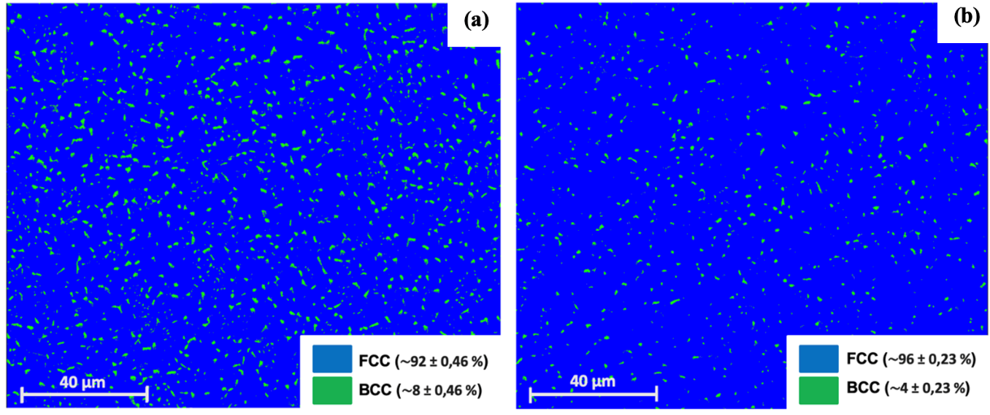
Figure S.1. Area fractions of the FCC matrix and BCC second phase in the alloys: (a) B - Cr₄₂Mn₆Fe₆Co₆Ni₄₀ and (b) C - Cr₄₂Mn₅Fe₅Co₉Ni₃₉.

