SUPPLEMENTARY INFORMATION 1:

Zatsarnaja, J., Hetterich, J., Mohnen, A. & Reiter, K. Behavioral Interventions Steering CO₂-Optimal Electric Vehicle Charging: Evidence from a BMW Field Experiment in the Netherlands. Journal of Industrial Ecology.
This supplementary information provides figures displaying the screens of the 360° Mobility App that were shown to the respective intervention groups: the forecast group (Supplementary Figure 1), the statistics group (Supplementary Figure 2), and the gamification group (Supplementary Figure 3). Additionally, Supplementary Table 1 provides a robustness check that accounts for the different gender composition of the control group relative to the three intervention groups by estimating a fully interacted Difference‑in‑Differences model.

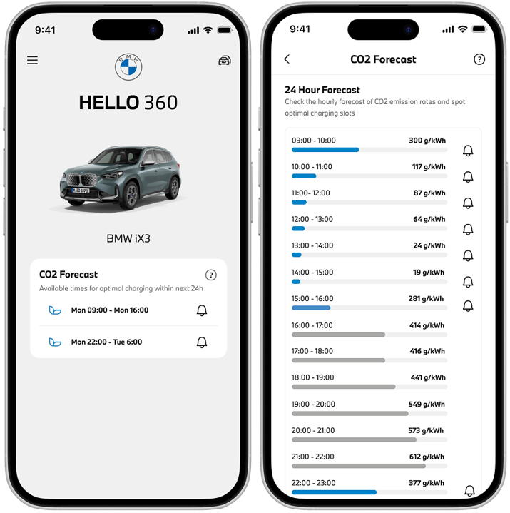
Supplementary Figure 1. CO₂-forecast on the home screen and in detailed view (Source: 360° Mobility App)

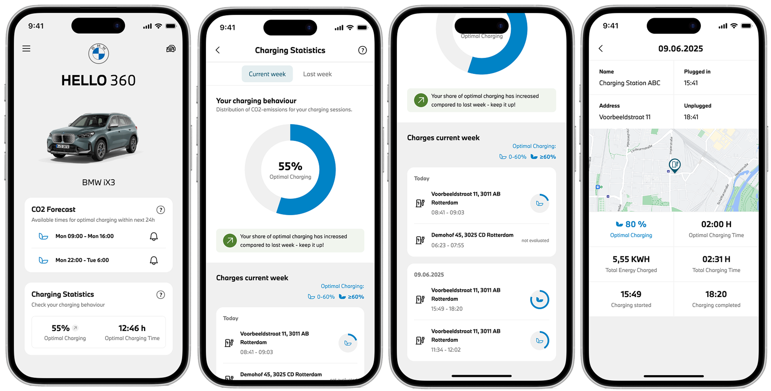
Supplementary Figure 2. Charging statistics on the home screen and in detailed view (Source: 360° Mobility App)

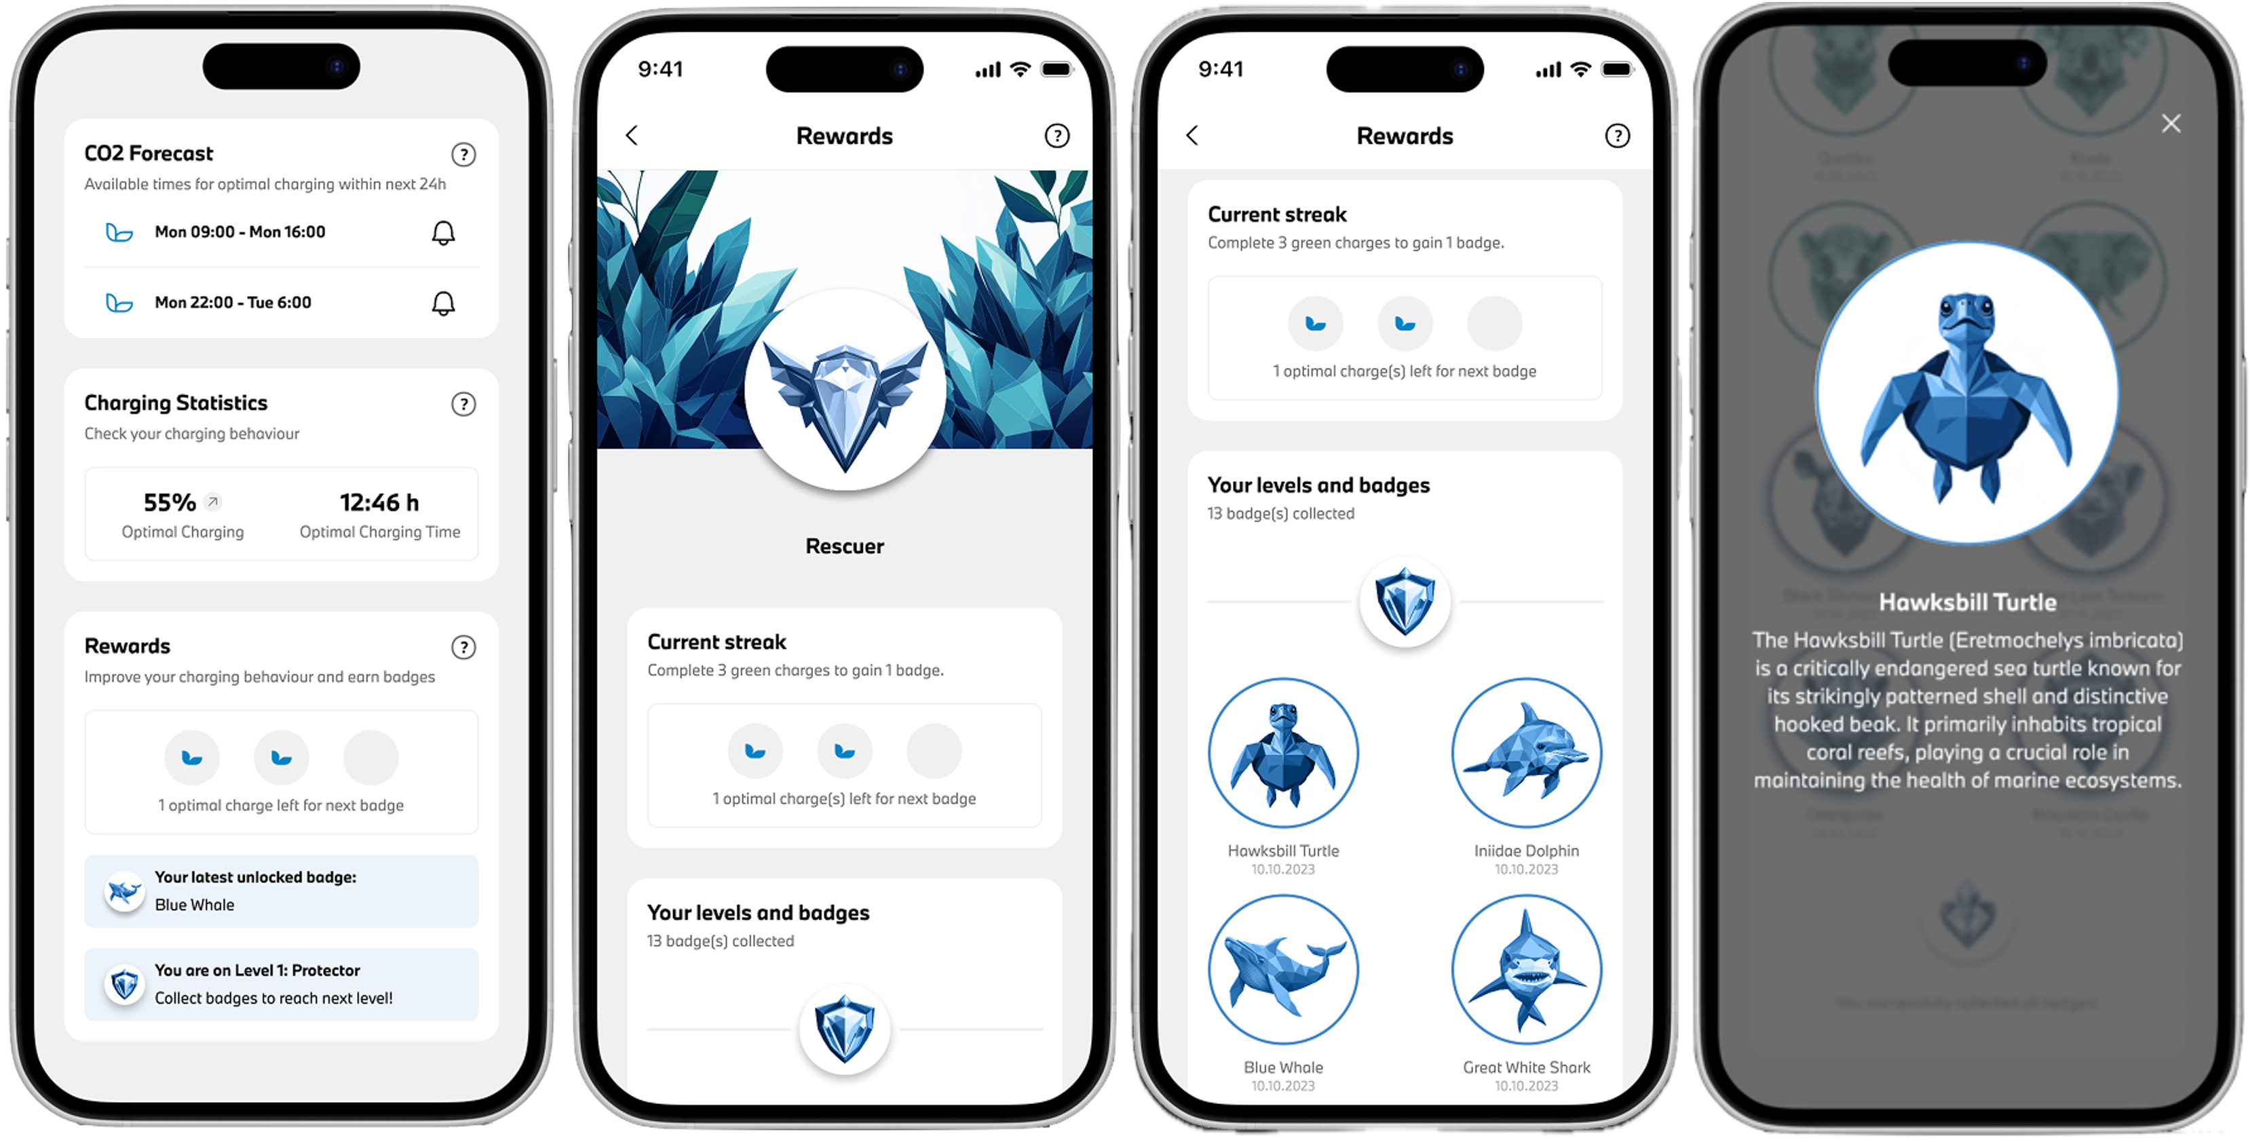
Supplementary Figure 3. Rewards on the home screen and in detailed view (Source: 360° Mobility App)

Supplementary Table 1
Robustness check for gender-heterogeneous treatment effects
 | Coefficient | SE | p | 95% CI
Forecast
Female DiD effect | .210 | .04 | .001 | [.13; .29]
Male DiD effect | .032 | .03 | .302 | [-.03; .09]
Male-female difference | -.179 | .05 | .001 | [-.28; -.08]
Statistics
Female DiD effect | -.057 | .18 | .756 | [-.42; .30]
Male DiD effect | .021 | .03 | .506 | [-.04; .08]
Male-female difference | .078 | .19 | .676 | [-.29; .44]
Gamification
Female DiD effect | .027 | .07 | .698 | [-.11; .16]
Male DiD effect | .050 | .03 | .069 | [-.00; .10]
Male-female difference | .024 | .07 | .751 | [-.12; .17]
Note: Reference base: control group and baseline phase; SE = standard error, CI = confidence interval; N = 13,153 total charging sessions.

