SUPPORTING INFORMATION FOR:

Maeno, K., Islam, K. & Motoshita, M. Assessing positive and negative effects of global supply chains through water footprinting: The balance between economic benefits and environmental pressure from the global and regional scale perspectives. Journal of Industrial Ecology.
This supporting information provides the demonstration of the detailed results for WOC of all countries’ GSCs and the relationship between WOC and VA of each sector within the top 20 country’s GSCs with the largest WOC focused in this study.

Supplementary Information 2

Assessing positive and negative effects of global supply chains through water footprinting: The balance between economic benefits and environmental pressure from the global and regional scale perspectives

Keitaro Maeno^{a,b}*, Kamrul Islam^{a,b}, Masaharu Motoshita^{a,b}
ª Integrated Research Center for Nature Positive Technology, National Institute of Advanced Industrial Science and Technology, AIST Tsukuba West, 16-1 Onogawa, Tsukuba, Ibaraki 305-8569, Japan
^{b} Research Institute of Science for Safety and Sustainability, National Institute of Advanced Industrial Science and Technology, AIST Tsukuba West, 16-1 Onogawa, Tsukuba, Ibaraki 305-8569, Japan

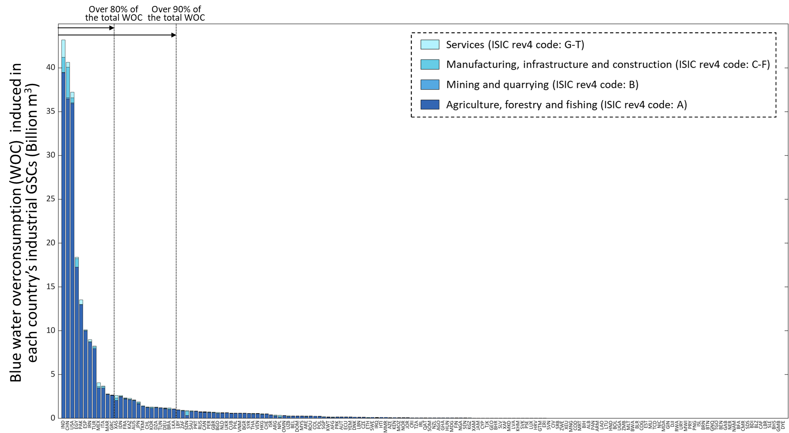
S1. Blue water overconsumption induced in global supply chains (GSCs) of industries in all countries covered by the GLORIA database

Figure S1. Bluewater overconsumption (WOC) within global supply chains (GSCs) which are induced to satisfy global final demands for final products produced in each country (i.e., the GSCs of each country’s industries). Countries are shown in the acronyms as listed in Table S3.
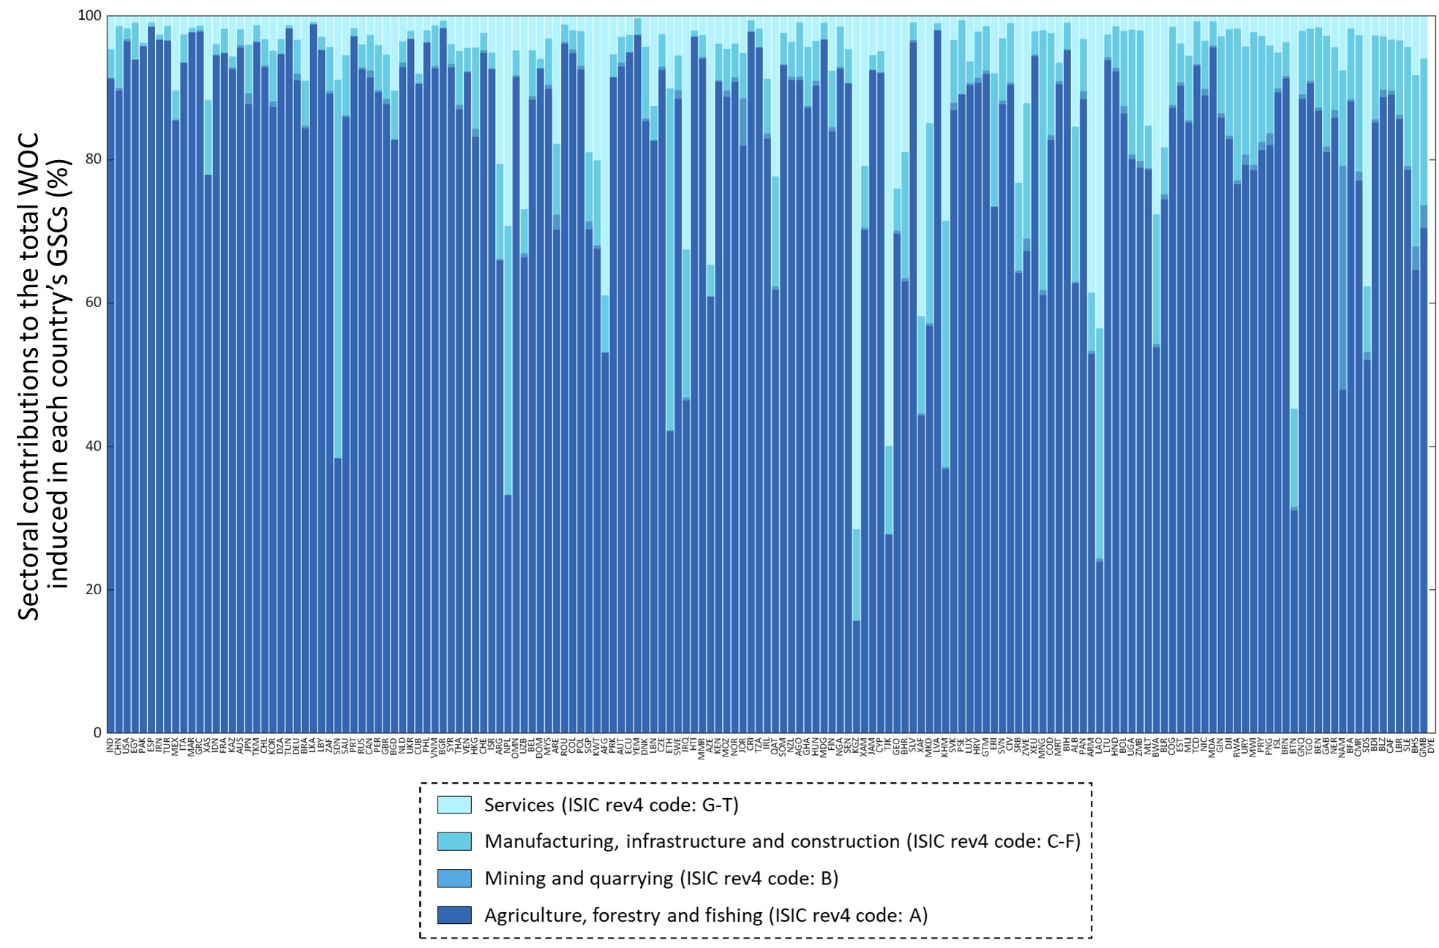
Figure S2. Constitution of the sectoral contributions to the total WOC induced in each country’s GSCs. Countries are shown in the acronyms as listed in Table S3.

Figure S1 shows the blue water overconsumption induced in GSCs of industries in each country covered by the GLORIA database (i.e., 164 countries and regions). From Fig.S1, we observed that the global WOC was concentrated in the specific countries GSCs such as the Indian, Chinese and USA’s GSCs. Specifically, more than 80% and 90% of the global total WOC was induced in GSCs of industries in 12 and 26 countries, respectively.

Figure S2 represents the constitution of the sectoral contributions to the total WOC induced in each country’s GSCs. Based on Fig.S2, we found that more than half of the WOC is generated in the agriculture sector for almost all cases (153 out of 164 cases) other than several specific cases such as the Sudanese, Nepalese and Ethiopian GSCs. This result highlights the dominant role of the agriculture sector in terms of WOC within the GSCs, the universal relevance of the macro scope analysis in this study and the comparability of the results targeting this sector among almost all cases of the GSCs. These findings support our focus on WOC in the agriculture sector within the top 20 GSCs with the largest WOC in the main text.

S2. Relationship between CW-WOC and CW-VA of the other sectors than the agriculture sector in the top 20 GSCs with the largest WOC focused in this study

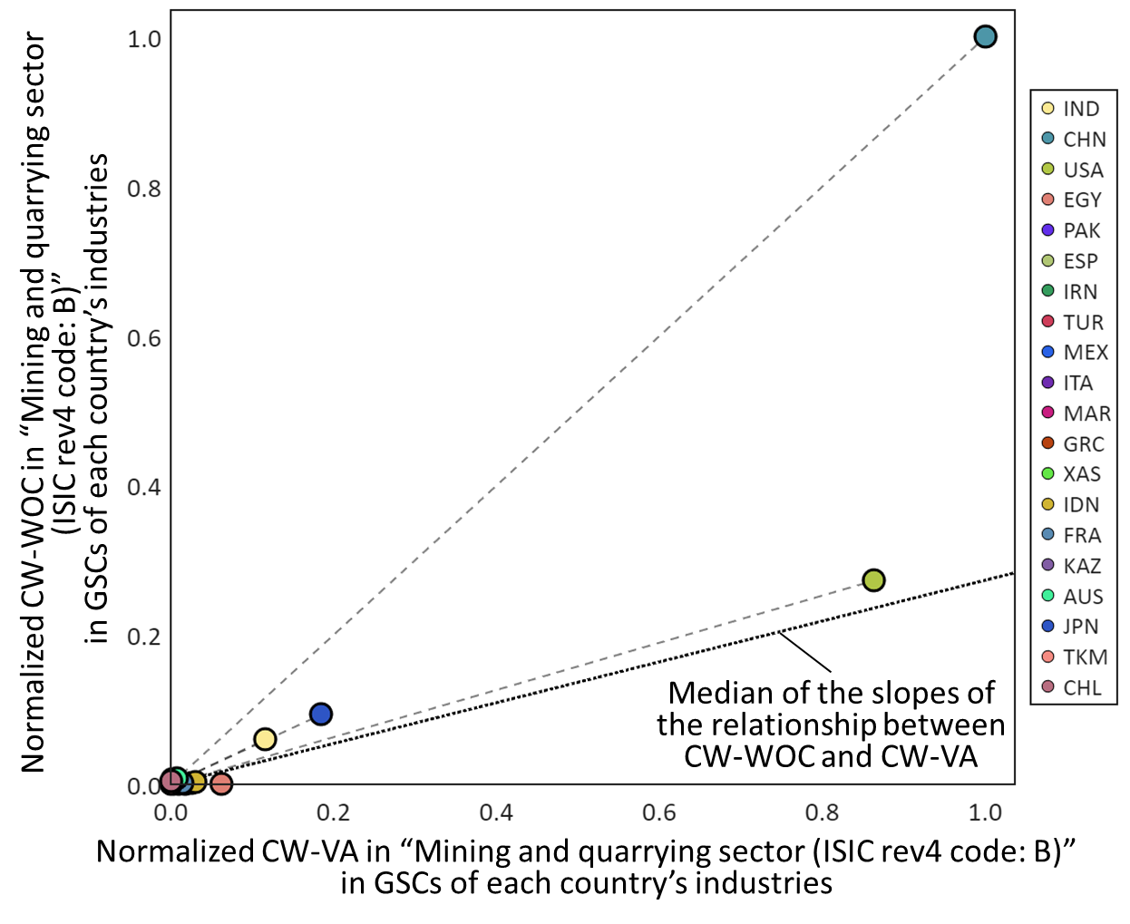
Figure S3. Normalized contribution-weighted blue water overconsumption (CW-WOC) and contribution-weighted value-added (CW-VA) of the “Mining and quarrying sector (ISIC rev4 code: B)” in the top 20 GSCs with the largest WOC focused in this study and the relationship between CW-WOC and CW-VA of each of the relevant GSCs. Countries are shown in the acronyms as listed in Table S3.

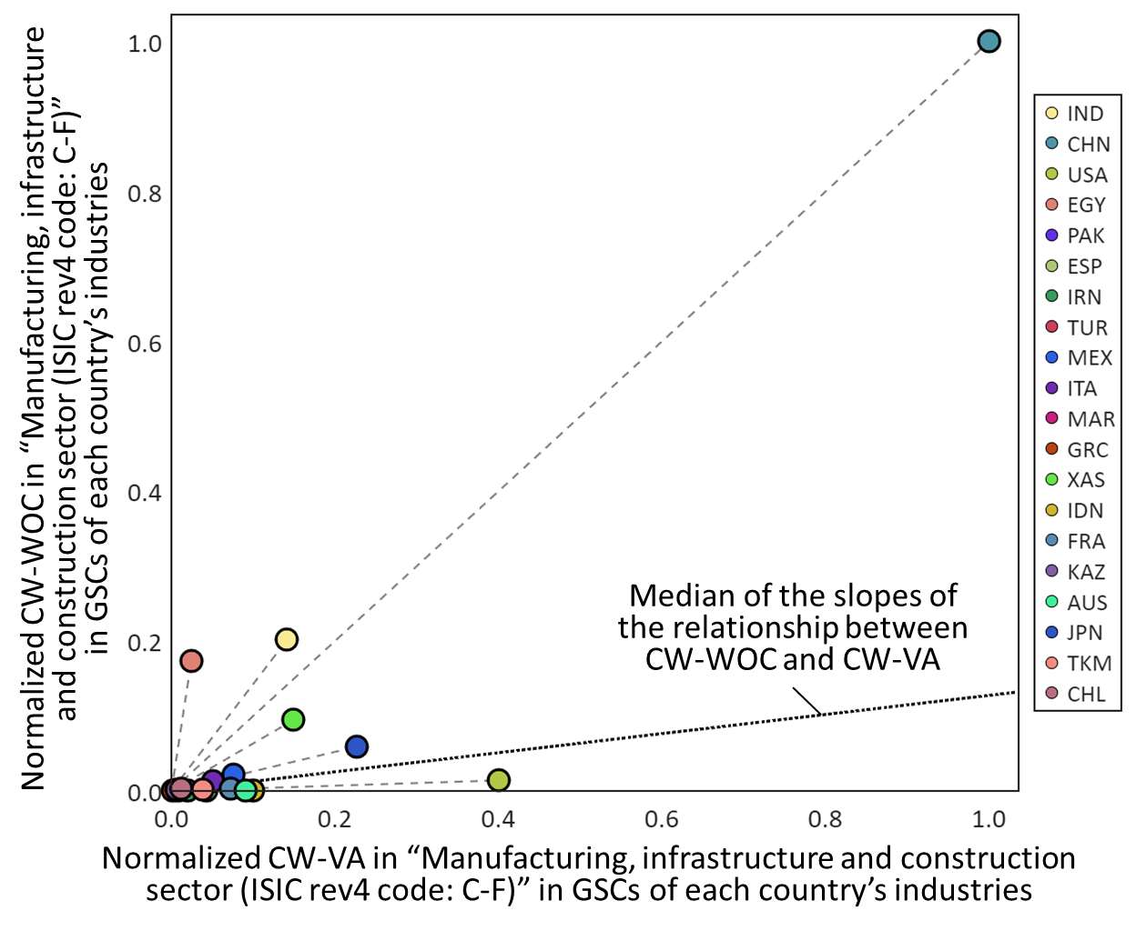
Figure S4. Normalized contribution-weighted blue water overconsumption (CW-WOC) and contribution-weighted value-added (CW-VA) of the “Manufacturing, infrastructure and construction sector (ISIC rev4 code: C-F)” in the top 20 GSCs with the largest WOC focused in this study and the relationship between CW-WOC and CW-VA of each of the relevant GSCs. Countries are shown in the acronyms as listed in Table S3.

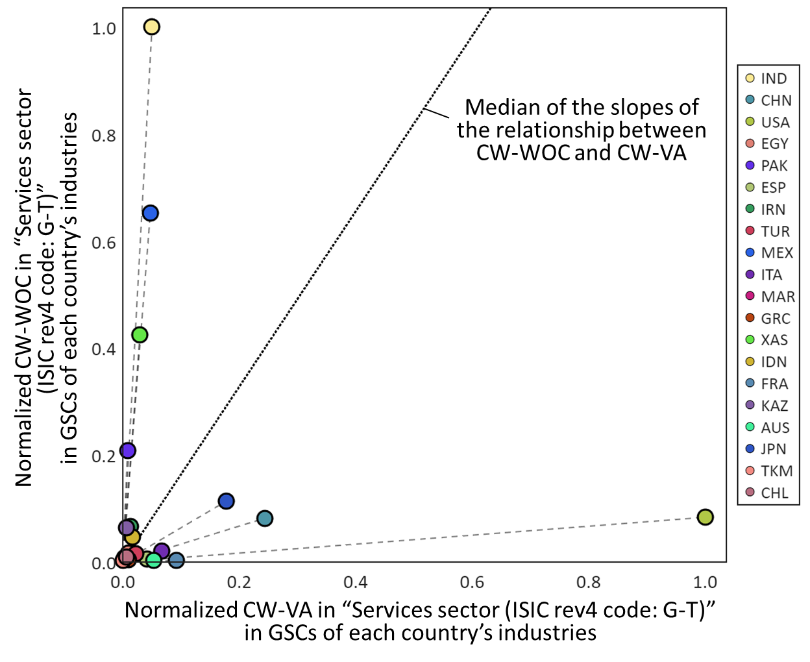
Figure S5. Normalized contribution-weighted blue water overconsumption (CW-WOC) and contribution-weighted value-added (CW-VA) of the “Services sector (ISIC rev4 code: G-T)” in the top 20 GSCs with the largest WOC focused in this study and the relationship between CW-WOC and CW-VA of each of the relevant GSCs. Countries are shown in the acronyms as listed in Table S3.

Figures S3-S5 show the relationship between CW-WOC and CW-VA in sectors other than the agriculture sector involved in the top 20 GSCs with the largest WOC highlighted in this study. These GSCs covered 78.4%, 79.6% and 75.3% of the global total WOC generated by each sector in 2015, respectively. From the figures, we can observe different situations from the analysis focusing on the agriculture sector described in the main text.

For example, the Chinese GSCs showed the highest CW-WOC and CW-VA values in “Mining and quarrying sector” and “Manufacturing, infrastructure and construction sector” involved within the GSCs (Fig.S3-S4), reflecting China’s global dominance in production activities in these sectors. Looking at the slope of the relationships between both indicators (i.e., the VA-based efficiency of WOC in this study) of the relevant GSCs (Fig.S3-S4), we found that the Chinese GSCs were relatively inefficient in terms of the balance between CW-WOC and CW-VA in these sectors within the relevant GSCs, indicating different situations from the result of their agriculture sector. On the other hand, from Fig.S4-S5, the USA’s GSCs showed a relatively efficient balance between CW-WOC and CW-VA in “Manufacturing, infrastructure and construction sector” and “Services sector” within the relevant GSCs, again unlike the result for the agriculture sector. This result highlighted the relevance of our focus on the agriculture sector in this case. For further detailed information, we provided CW-WOC and CW-VA in all countries’ GSCs covered by GLORIA in Tables S4-S7 in Supplementary Information SI1.

