SUPPORTING INFORMATION FOR:

Busch, P., Chen, Y. & Kendall, A. Life cycle performance and carbon handprint of lithium-ion batteries in electric vehicles. Journal of Industrial Ecology.
Supplementary Information S1 provides additional information on the data sources used on the life cycle assessment model, including their temporal and spatial resolution. This supporting information also includes descriptive figures of the main inputs of the model and additional results to support the analysis on the main text.

Characteristics and details of the main data sources used in the life cycle assessment model.
Supplementary tables: Table S1 to Table S3
Table SI1. Model data sources detail, with temporal and spatial resolution. AFDC: Alternative Fuels Data Center; DOE: Department of Energy; ICCT: International Council on Clean Transportation; EIA: Energy Information Administration; LCI: Life Cycle Inventory; EV: Electric Vehicle; ZEV: Zero-Emission Vehicle; GREET: Greenhouse gases, Regulated Emissions, and Energy use in Technologies; LFP: Lithium Iron Phosphate; NCA: Nickel Cobalt Aluminum Oxide; NMC: Nickel Manganese Cobalt Oxide; EURO: European Emission Standard; US: United States; LCV: Light Commercial Vehicle.
Module | Data | Source | Time | Spatial | Details
Fleet Stock | Vehicle sales forecast | ICCT Roadmap v2.6 (ICCT, 2024) | 2025-2050 | US | "Ambitious" Scenario. 100% ZEV sales by 2040.
Fleet Stock | Historical EV sales | AFDC & EVVolumes (DOE, 2024; J.D. Power, 2025) | 2016-2024 | State | EVVolumes has data on total US sales, AFDC provides EV registrations by state.
Fleet Stock | Vehicle sales shares by type | EIA Annual Energy Outlook 2025. Table 38 (EIA, 2025b) | 2025-2050 | EIA Transport Region | Light-duty vehicle types: cars and light trucks.
Manufac-turing | Vehicle manufacturing LCI | ecoinvent 3.11 (Ecoinvent Association, 2022) | 2000-2024 | Global | passenger car production, petrol/natural gas; passenger car production, electric, without battery.
Manufac-turing | Vehicle curb weight | GREET (Wang et al., 2025) | 2024 | US | Not including battery.
Manufac-turing | Battery manufacturing LCI | ecoinvent 3.11 (Ecoinvent Association, 2022) | 2017-2025 | China | battery production, Li-ion, rechargeable for LFP, NCA, NMC111, NMC532, NMC622, NMC811.
Manufac-turing | Battery capacity | EV Volumes (J.D. Power, 2025) | 2024 | US | By vehicle type.
Vehicle Driving | Vehicle energy consumption | EIA Annual Energy Outlook 2025. Table 40. (EIA, 2025b) | 2025-2050 | US | Reference case.
Vehicle Driving | Temperature adjustment factors | Woody et al, 2022 (10.1088/1748-9326/ac5142) (SI Figure S3) (Woody et al., 2022) | 2016-2020 | County | Changes in vehicle energy consumption due to monthly temperature variation.
Vehicle Driving | Annual vehicle miles traveled | Transportation Energy Data Book (Davis & Boundy, 2022) | 2022 | US | By vehicle age and vehicle type.
Vehicle Driving | Electricity upstream LCI | ecoinvent 3.11 (Ecoinvent Association, 2022) | 1980-2024 | Electricity Market Module regions | By energy source type (see Table S2 for further detail).
Vehicle Driving | Electricity grid generation share | EIA Annual Energy Outlook 2025. Table 54 and Table 56. eGrid 2025 (Alaska and Hawaii) (EIA, 2025b, 2025c, 2025a) | 2025-2050 | Electricity Market Module regions | By energy source type (see Table S2 for further detail).
Vehicle Driving | Gasoline upstream LCI | ecoinvent 3.11 (Ecoinvent Association, 2022) | 2005-2024 | Europe (without Switzerland) | petrol production, low-sulfur.
Vehicle Driving | Gasoline combustion emissions | ecoinvent 3.11 (Ecoinvent Association, 2022) | 2012-2024 | Europe | Unitary process for combustion emissions: transport, passenger, car, petrol, large size, EURO 5 (u-so).
Vehicle Driving | Vehicle maintenance LCI | ecoinvent 3.11(Ecoinvent Association, 2022) | 2000-2024 | Global | maintenance, passenger car and electric (without battery).
Recycling | Battery recycling LCI | ecoinvent 3.11 (Ecoinvent Association, 2022) | 2005-2024 | Global | treatment of used Li-ion battery, hydrometallurgical treatment.
Recycling | Vehicle recycling LCI | ecoinvent 3.11 (Ecoinvent Association, 2022) | 1990-2024 | Global | treatment of used light commercial vehicle.
Recycling | Lithium production LCI | ecoinvent 3.11 (Ecoinvent Association, 2022) | 2009-2024 | Global | lithium carbonate production, from spodumene (50%) and concentrated brine (50%).
Table SI2. Materials included in the material inventory, along with their category classification. Critical minerals definition provided by the United States Geological Survey (USGS) (Nassar et al., 2025)
Category | List of materials included
Fossil Fuel | Coal, Crude oil, Natural gas, Uranium, Sulphur, Peat
Metal | Cadmium, Hafnium, Indium, Mercury, Molybdenum, Niobium, Palladium, Platinum, Rhenium, Rhodium, Scandium, Silver, Strontium, Tantalum, Tin, Titanium, Vanadium, Yttrium, Zirconium
Metal & Critical Mineral | Aluminum, Barium, Calcium, Chromium, Cobalt, Copper, Gold, Iron, Lead, Lithium, Magnesium, Manganese, Nickel, Zinc
Non-Metal | Antimony, Argon, Arsenic, Boron, Bromine, Cerium, Dysprosium, Erbium, Europium, Fluorine, Gadolinium, Gallium, Holmium, Iodine, Krypton, Lanthanum, Lutetium, Neodymium, Phosphorus, Potassium, Praseodymium, Samarium, Selenium, Silicon, Sodium, Sulphur, Tellurium, Terbium, Thulium, Xenon, Ytterbium
Table SI3. Primary energy source EIA match with LCI ecoinvent 3.11 process, along with electricity balancing regions. US: United States; ASCC: Alaska Systems Coordinating Council; HICC: Hawaii Coordinating Council; MRO: Midwest Reliability Organization; NPCC: Northeast Power Coordinating Council; RFC: Reliability First Corporation; SERC: SERC Reliability Corporation; TRE: Texas Reliability Entity; WECC: Western Electricity Coordinating Council; GB: Great Britain; CA-ON: Canada – Ontario.
EIA Energy Source | ecoinvent 3.11 process | Region available
Distributed Generation | electricity production, photovoltaic, 3kWp slanted-roof installation, multi-Si, panel, mounted | US-HICC, US-NPCC, US-RFC, US-SERC, US-TRE, US-WECC
Nuclear | electricity production, nuclear, pressure water reactor | US-MRO, US-NPCC, US-RFC, US-SERC, US-TRE, US-WECC
Pumped Storage/Other | electricity production, hydro, pumped storage | US-ASCC, US-HICC, US-MRO, US-NPCC, US-RFC, US-SERC, US-TRE, US-WECC
Petroleum | electricity production, oil | US-ASCC, US-HICC, US-MRO, US-NPCC, US-RFC, US-SERC, US-TRE, US-WECC
Coal | electricity production, lignite | US-ASCC, US-HICC, US-MRO, US-NPCC, US-RFC, US-SERC, US-TRE, US-WECC
Natural Gas Combined Cycle | electricity production, natural gas, combined cycle power plant | US-ASCC, US-MRO, US-NPCC, US-RFC, US-SERC, US-TRE, US-WECC
Natural Gas Conventional | electricity production, natural gas, conventional power plant | US-ASCC, US-MRO, US-NPCC, US-RFC, US-SERC, US-TRE, US-WECC
Wind | electricity production, wind, >3MW turbine, onshore | US-ASCC, US-HICC, US-MRO, US-NPCC, US-RFC, US-SERC, US-TRE, US-WECC
Offshore Wind | electricity production, wind, 1-3MW turbine, offshore | GB
Solar Photovoltaic | electricity production, photovoltaic, 570kWp open ground installation, multi-Si | US-HICC, US-NPCC, US-RFC, US-SERC, US-WECC
Hydropower | electricity production, hydro, reservoir, non-alpine region | US-HICC, US-SERC, US-TRE
Solar Thermal | electricity production, solar thermal parabolic trough, 50 MW | US-SERC, US-WECC
Geothermal | electricity production, deep geothermal | US-HICC, US-SERC, US-WECC
Wood and Other Biomass | electricity production, natural gas, conventional power plant | US-ASCC, US-MRO, US-NPCC, US-RFC, US-SERC, US-TRE, US-WECC
Biogenic Municipal Waste | electricity, from municipal waste incineration to generic market for electricity, medium voltage | CA-ON

Descriptive figures of data inputs.
Supplementary figures: Figure SI1 to Figure SI13
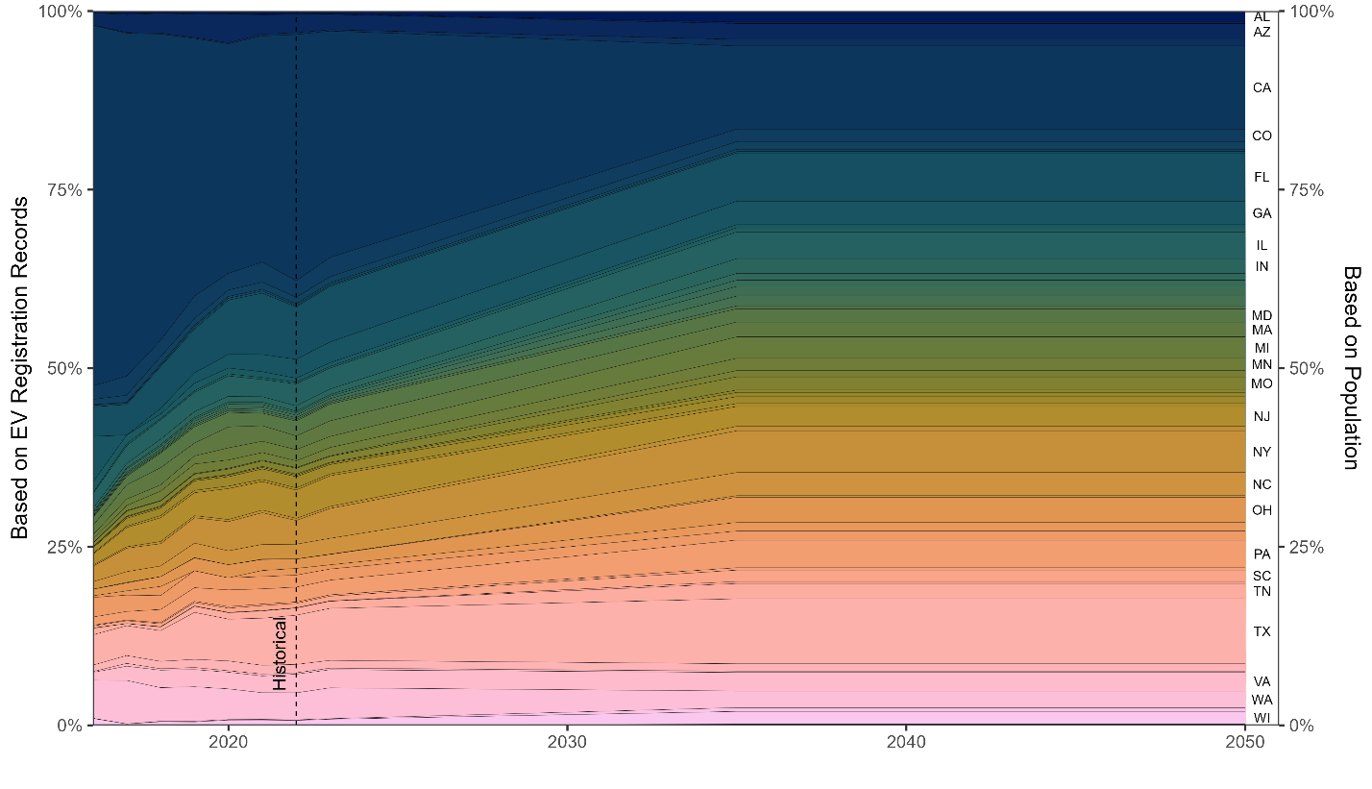
Figure SI1. Vehicle sales disaggregation by state based on historical data of electric vehicle registrations (difference year-to-year) (DOE, 2024) and based on population shares by state (U.S. Census Bureau, 2025). From 2022 to 2035 a linear interpolation between 2022 EV registration shares and population shares was assumed.

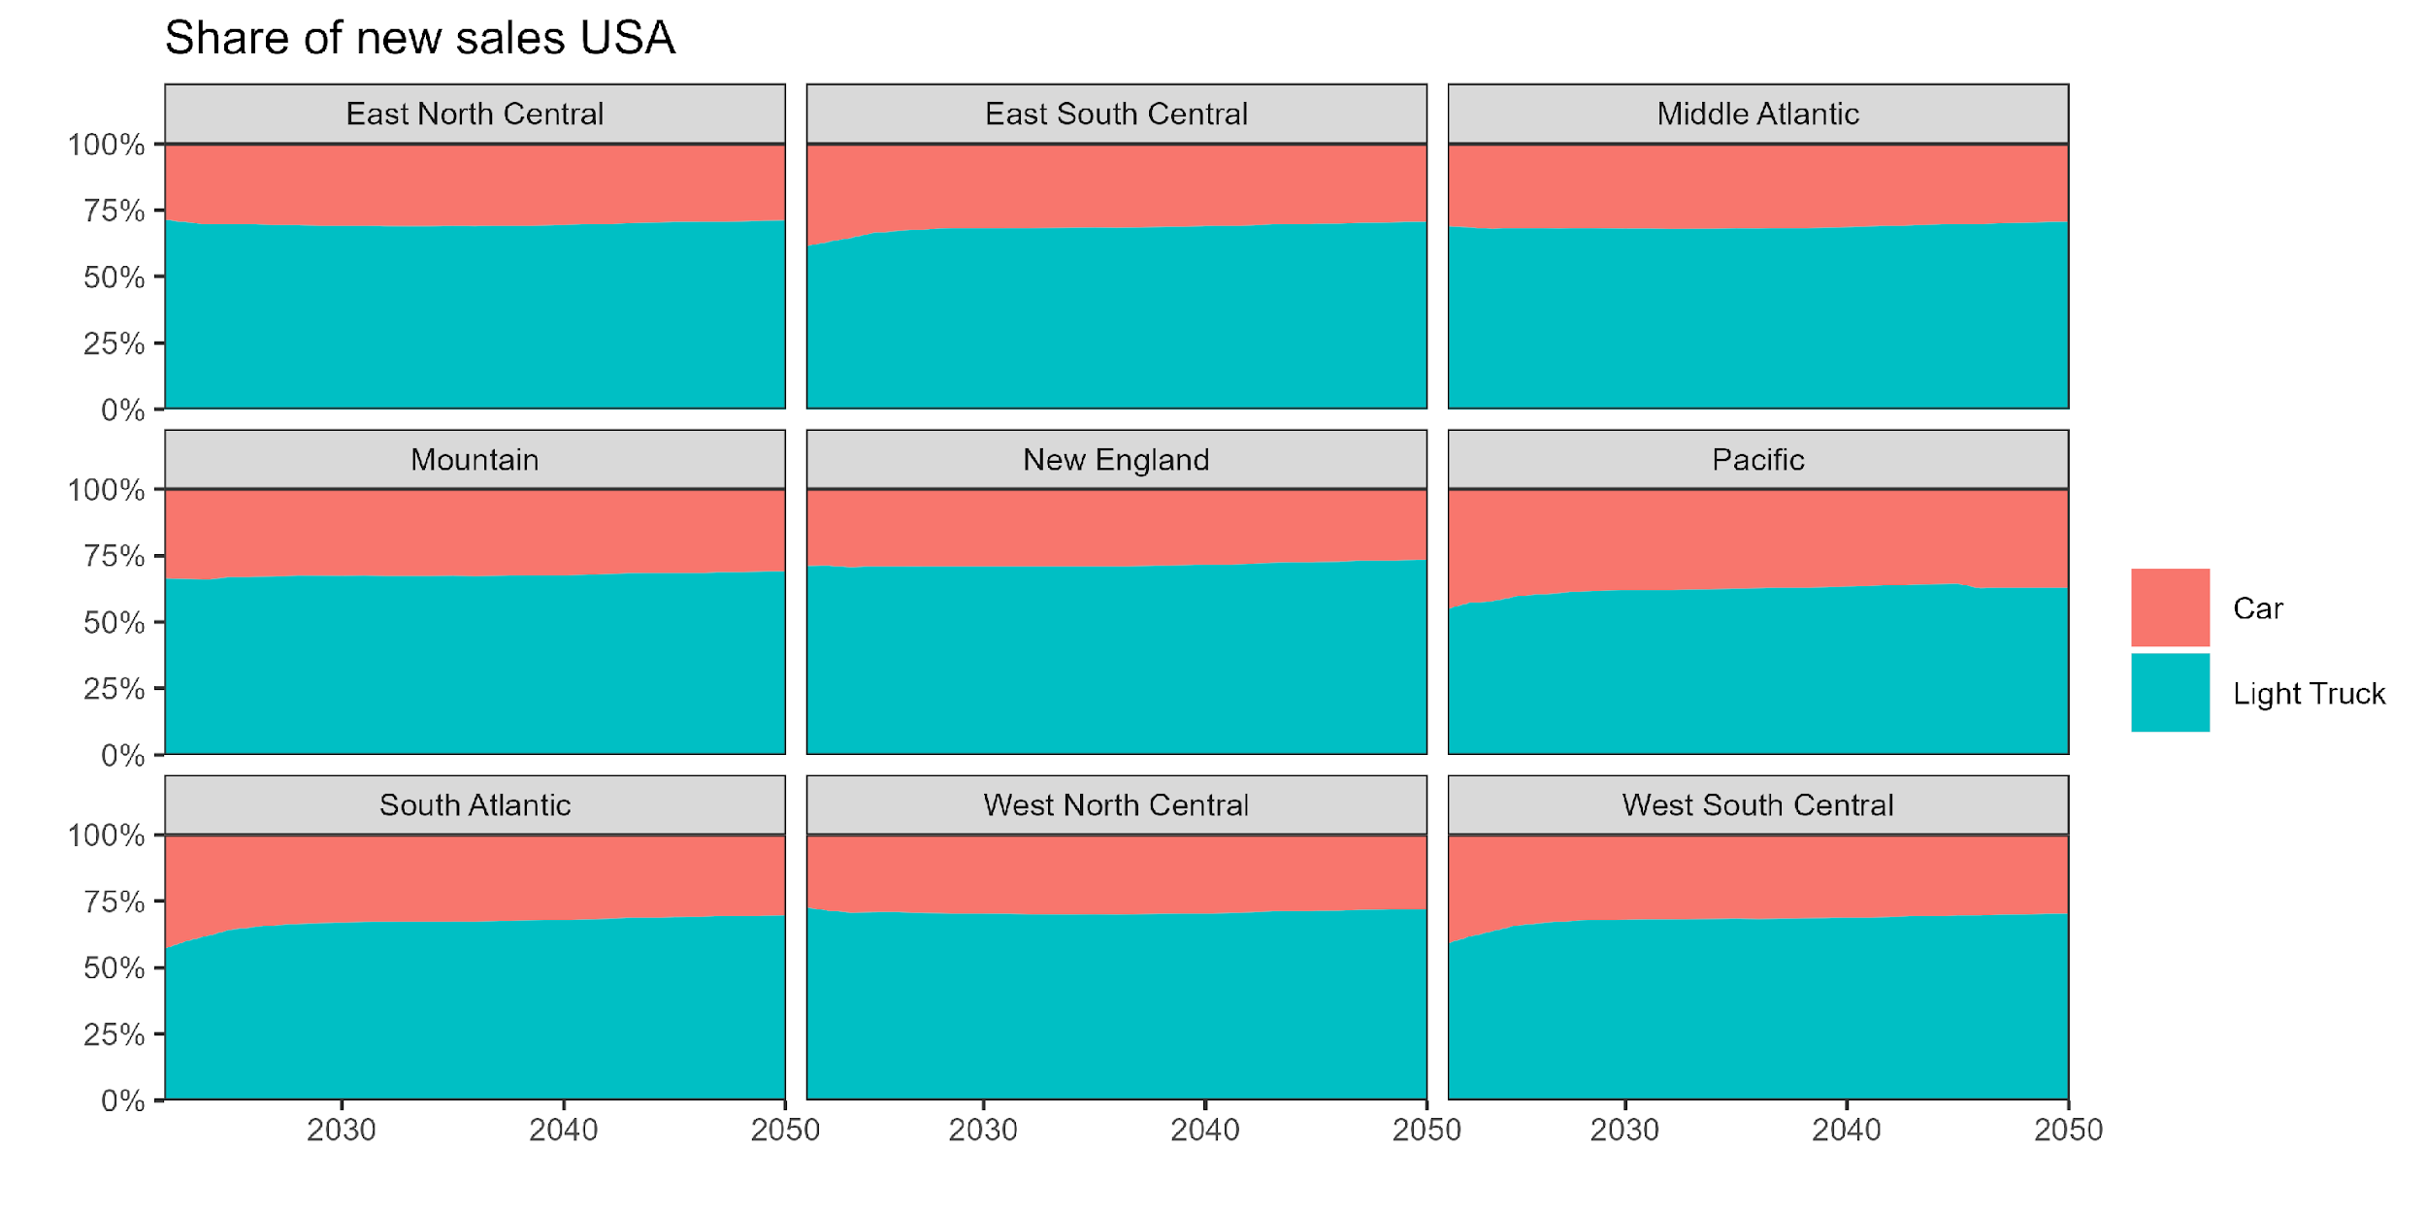
Figure SI2. Share of new vehicle sales by vehicle type (car or light truck) and transport region. Source: (EIA, 2025b) Table 38. Light-Duty Vehicle Sales by Technology Type.

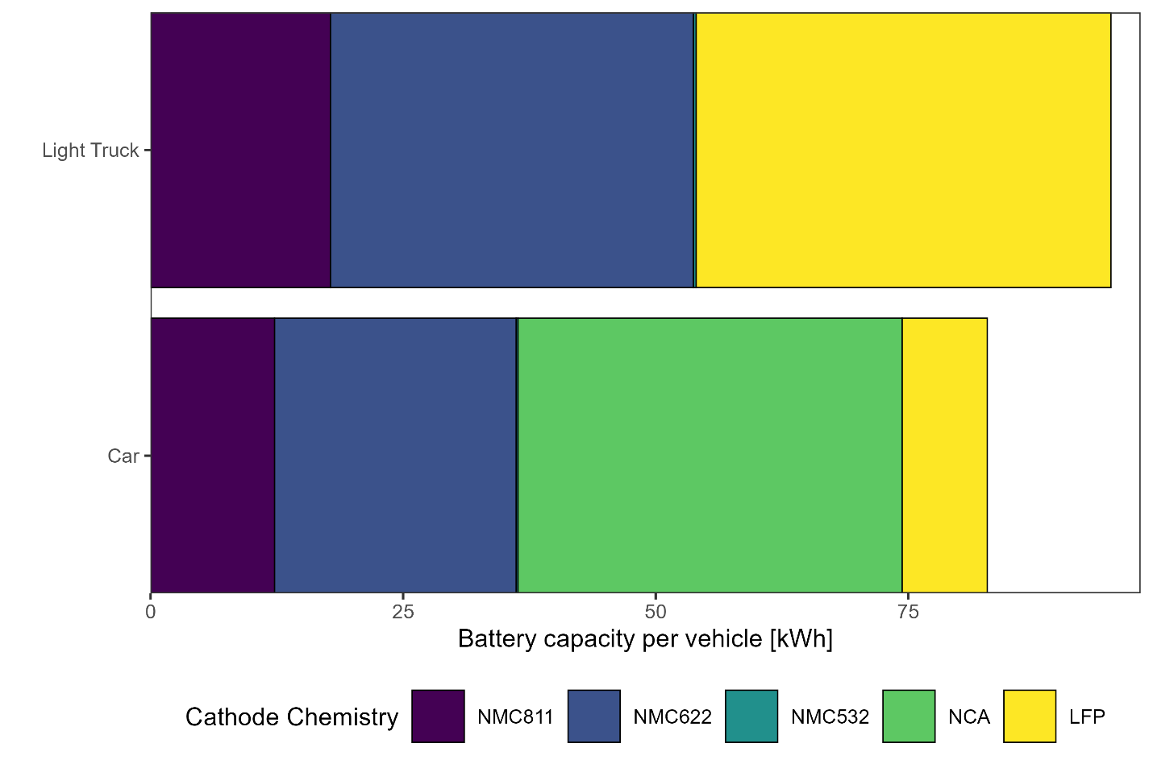
Figure SI3. Average battery capacity by cathode chemistry and vehicle type. Source: EV Volumes (J.D. Power, 2025).
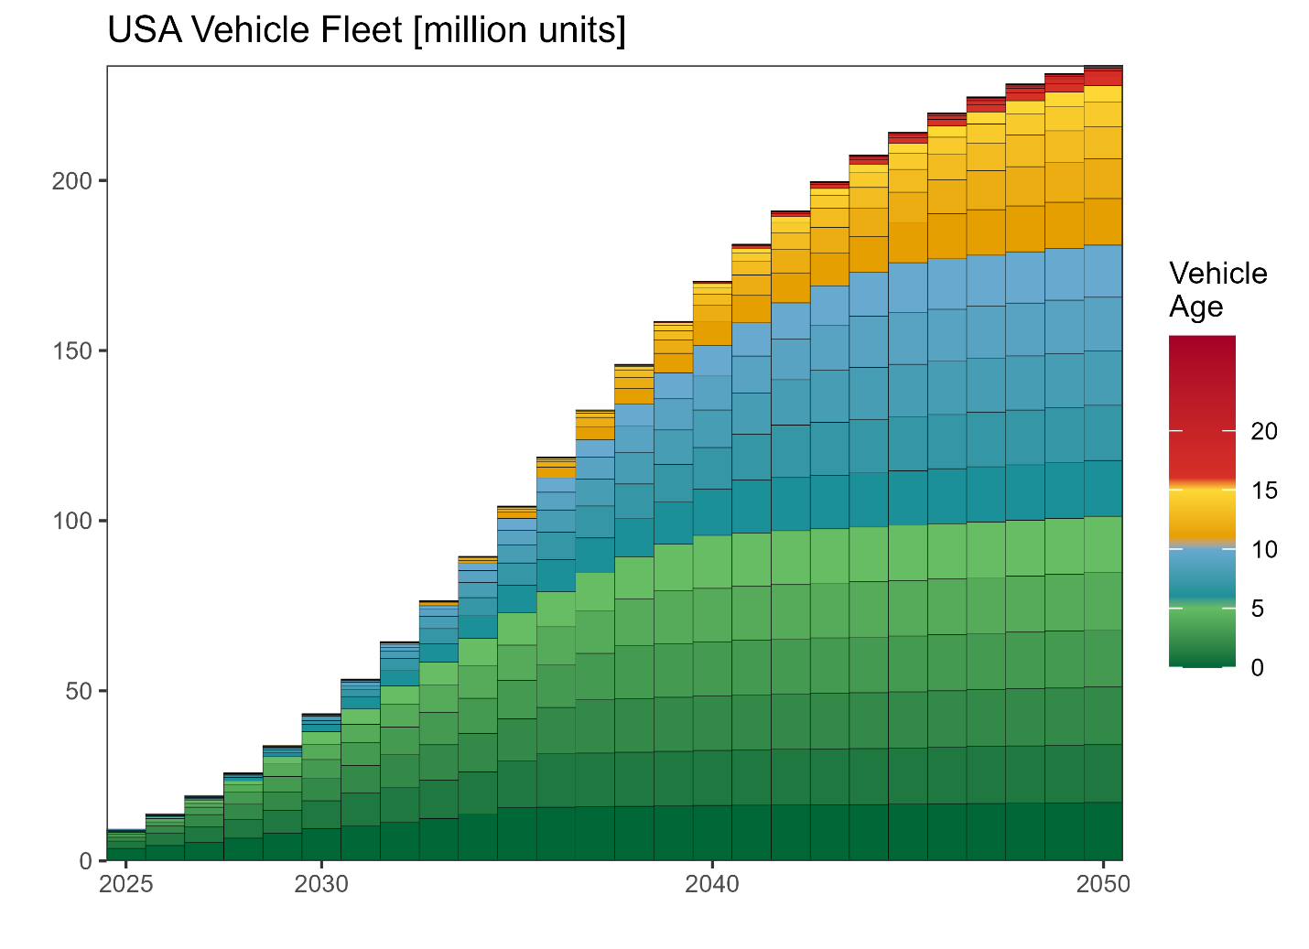
Figure SI4. Vehicle fleet in the US, both for electric vehicles (EV) and internal combustion engine vehicles (ICEV) counterfactual. The model scope ignores current ICEV fleet or projected ICEV sales, it only considers a counterfactual scenario where each future EV sold becomes an ICEV.
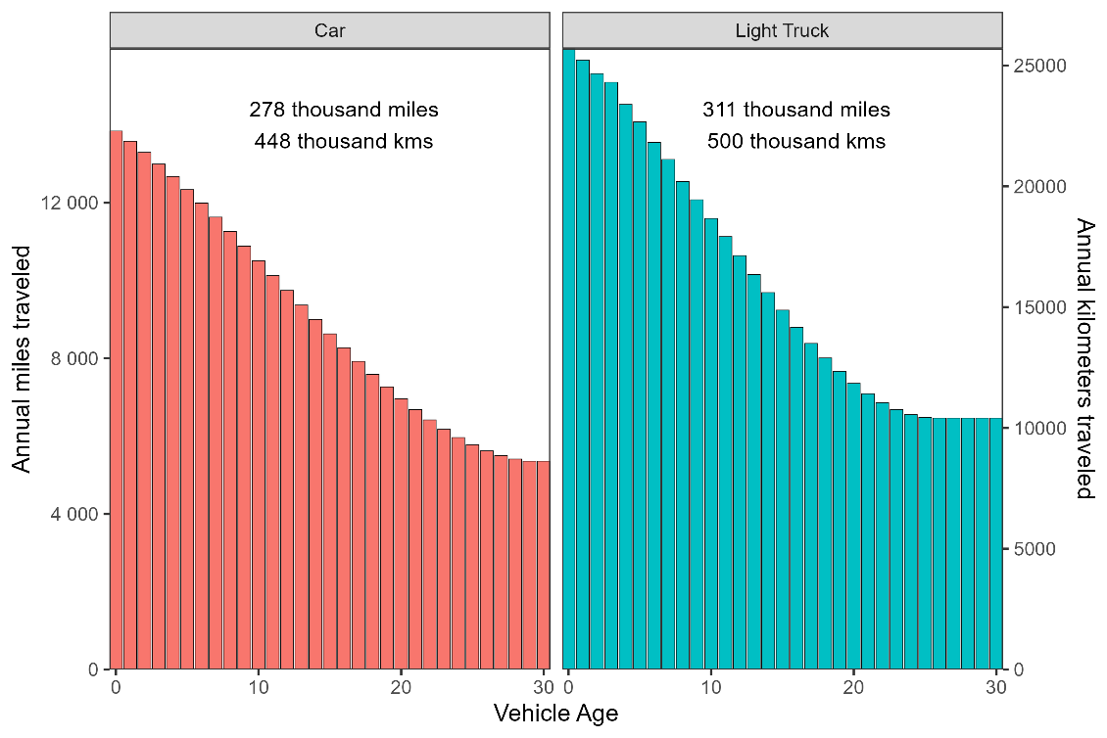
Figure SI5. Annual miles traveled by vehicle age and type. Source: (Davis & Boundy, 2022).
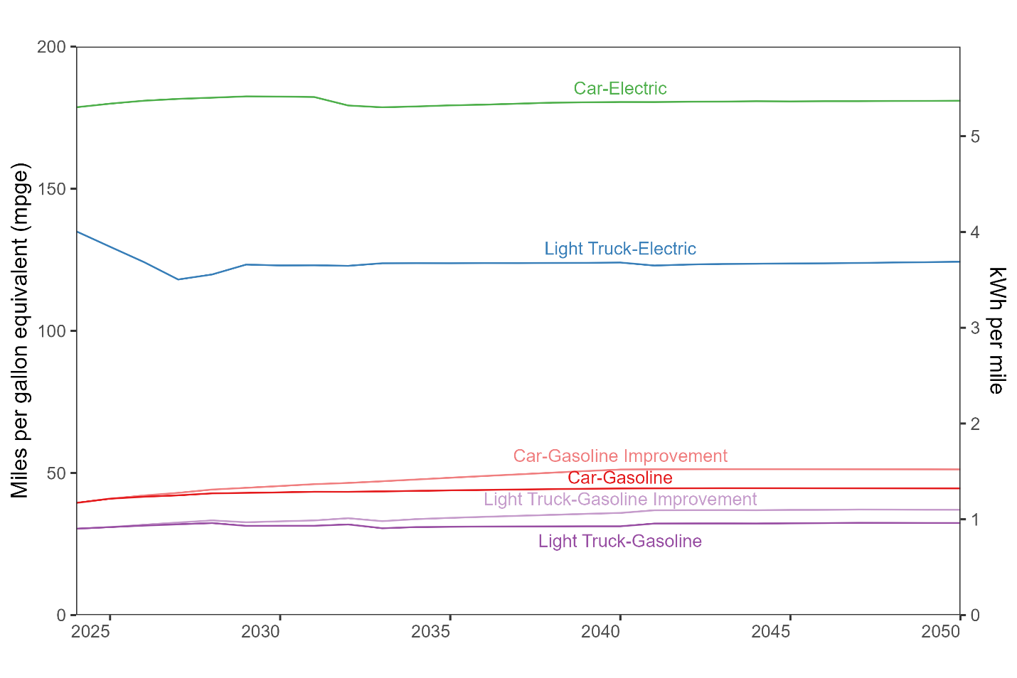
Figure SI6. Energy consumption in miles per gallon equivalent (using environmental protection agency (EPA) conversion factor of 33.7 kWh per gallon of gasoline). Internal combustion vehicles have a scenario with a further 15% improvement in their efficiency. Source: EIA Annual Energy Outlook 2025. Table 40 (EIA, 2025b).

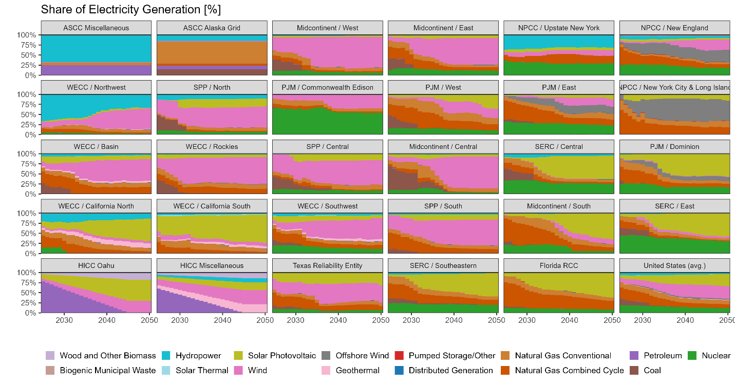
Figure SI7. Electricity generation forecast by Energy Information Agency (EIA) electricity market module region. Natural gas was disaggregated into conventional and combined cycle based on installed capacity. Source: EIA Annual Energy Outlook 2025 Electricity and renewable fuel tables (tables 54–56) (EIA, 2025b). mix forecast for Alaska and Hawaii systems, based on 2023 mix provided by EPA Egrid (EPA, 2025). For Alaska a constant value from 2023 was assumed, and for Hawaii the 2045 policy mandate of 100% renewable energy was assumed, with a linear interpolation (EIA, 2025c, 2025a).

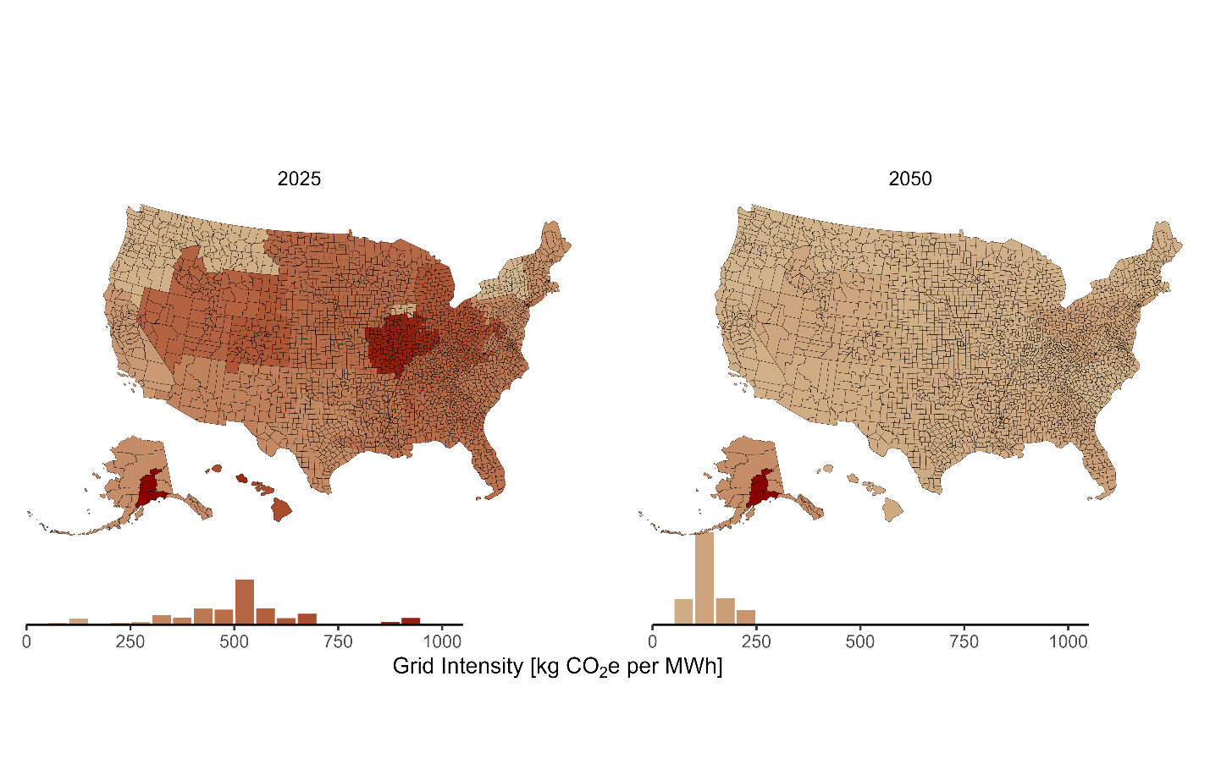
Figure SI8. Carbon intensity of electricity by county, in kg CO₂e per MWh of electricity generated. Transmission and distribution losses are assumed to be 5%. Electricity emissions are estimated based on the forecast of electricity generation (EIA, 2025b; EPA, 2025), ecoinvent 3.9 life cycle inventory emissions (Ecoinvent Association, 2022) using the sixth assessment report (AR6) impact factors excluding biogenic (IPCC, 2023).
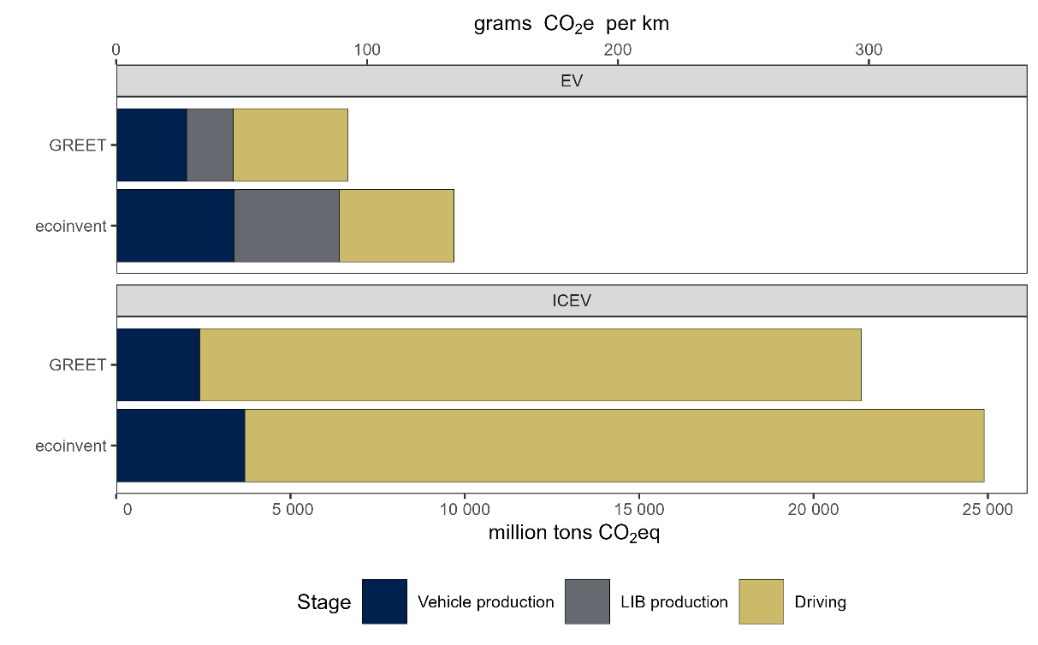
Figure SI9. Cumulated greenhouse gas (GHG) emissions (2025-2050) comparison between an EV fleet versus a counterfactual ICEV fleet using either ecoinvent 3.11 or GREET 2024 for upstream emissions associated with vehicle manufacturing and LIB production (Wang et al., 2025; Ecoinvent Association, 2022). GREET model (Greenhouse gases, Regulated Emissions, and Energy use in Technologies) has lower unitary GHG emissions for vehicle and lithium-ion battery (LIB) manufacturing, increasing the difference between EVs and ICEVs.

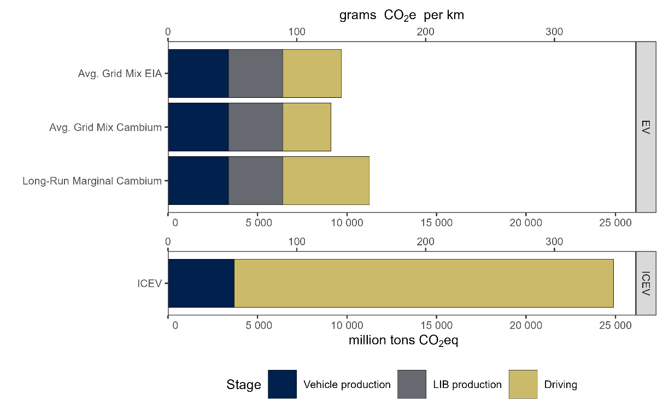
Figure SI10. Cumulated GHG emissions (2025-2050) comparison between an EV fleet versus a counterfactual ICEV fleet using different electricity grid GHG emission factors. Both average grid mix EIA and Cambium uses average share of primary energy used for electricity generation combined with ecoinvent upstream impacts. Long-run marginal refers to estimated emissions factors by National Renewable Energy Laboratory (NREL) Cambium model that take into account induces changes in the electricity grid (NREL, 2025).

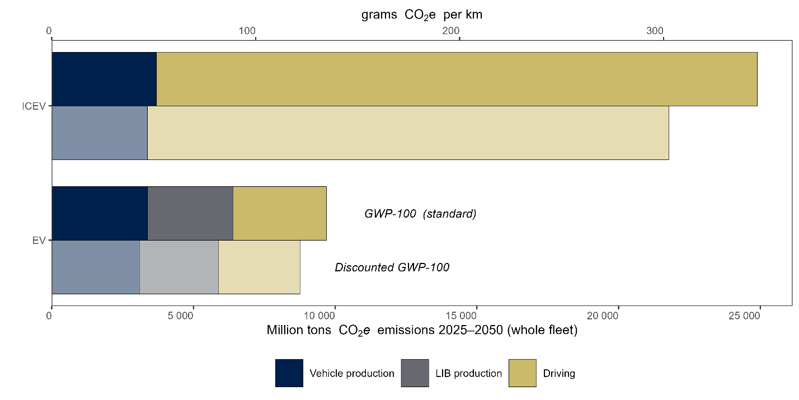
Figure SI11. Cumulated GHG emissions (2025-2050) comparison between an EV fleet versus a counterfactual ICEV using standard GWP-100 factors or using time-adjusted global warming potentials (Kendall, 2012). The discounted represents emissions of CO₂ equivalent to present (2025) emissions, taking into account the radiate forcing profile of each climate pollutant and warming horizon of 100 years (2025 to 2125).

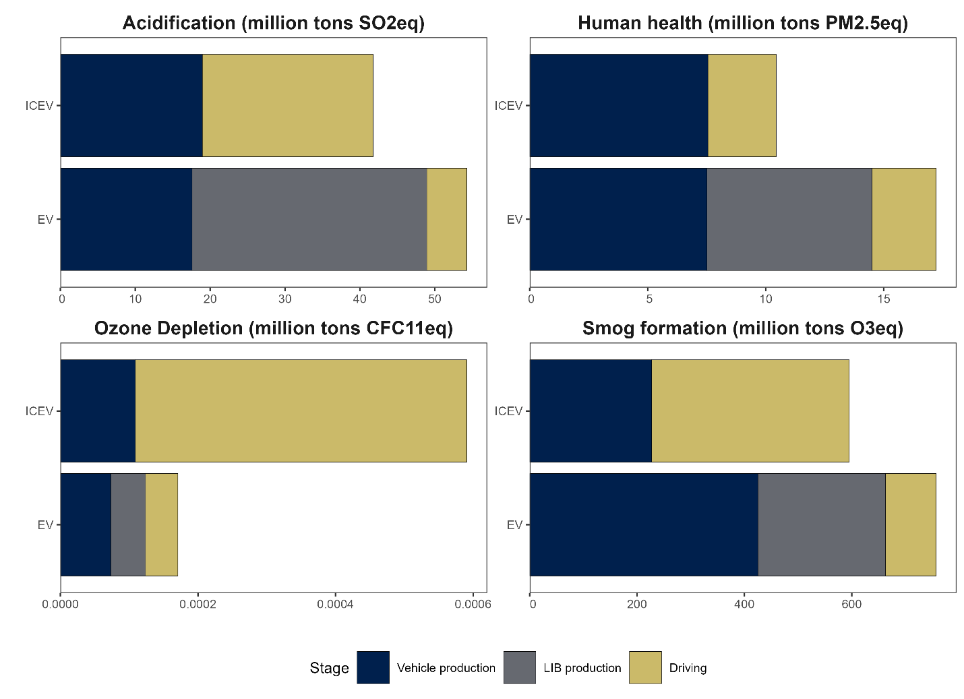
Figure SI12. Fleet level impact for an EV fleet and a counterfactual ICEV fleet (2025-2050). All impacts equivalencies were calculated using TRACI 2.2 (Tool for Reduction and Assessment of Chemicals and Other Environmental Impacts) methodology (EPA, 2021).

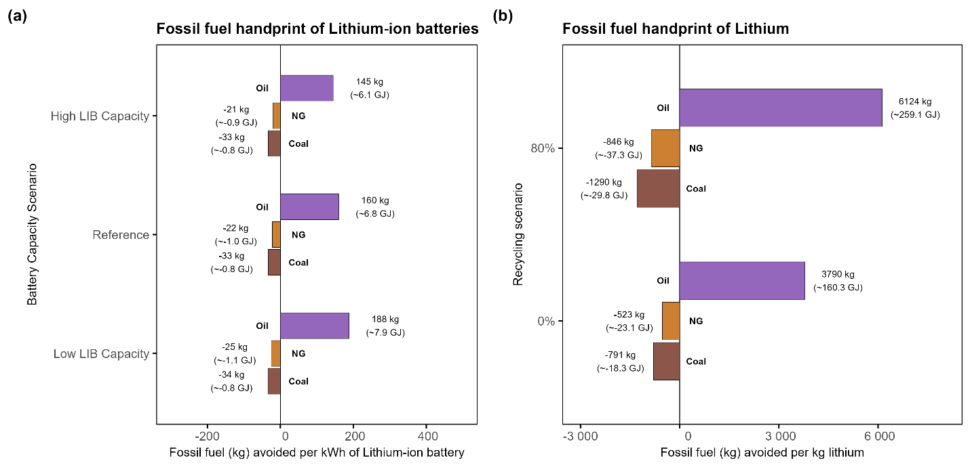
Figure SI13. Fossil fuel handprint (avoided) for (a) lithium-ion batteries and (b) lithium. Negative handprint means increase consumption of fossil fuel, derived from the system change (higher EV adoption) by enabled by LIBs and lithium.

References
Davis, S., & Boundy, R. (2022). Transportation Energy Data Book (Edition 40). https://doi.org/10.2172/1878695
DOE. (2024). TransAtlas - Electric Vehicles Registration. U.S. Department of Energy. https://afdc.energy.gov/transatlas#/
Ecoinvent Association. (2022). ecoinvent 3.9. ecoinvent Association. https://support.ecoinvent.org/ecoinvent-version-3.9
EIA. (2025a). Alaska State Energy Profile. U.S. Energy Information Administration. https://www.eia.gov/state/print.php?sid=AK
EIA. (2025b). Annual Energy Outlook 2025. U.S. Energy Information Administration. https://www.eia.gov/outlooks/aeo/tables_ref.php
EIA. (2025c). Hawaii State Energy Profile. U.S. Energy Information Administration. https://www.eia.gov/state/print.php?sid=HI
EPA. (2021). Tool for Reduction and Assessment of Chemicals and Other Environmental Impacts (TRACI) US EPA. https://www.epa.gov/chemical-research/tool-reduction-and-assessment-chemicals-and-other-environmental-impacts-traci
EPA. (2025). eGrid 2023 Data. U.S. Environmental Protection Agency. https://www.epa.gov/egrid/detailed-data
ICCT. (2024). Roadmap v2.6 Documentation. https://theicct.github.io/roadmap-doc/versions/v2.6/
IPCC. (2023). AR6 Synthesis Report: Climate Change 2023. https://www.ipcc.ch/report/ar6/syr/
J.D. Power. (2025). EV Volumes - 2025 EV Statistics, Sales & Market Forecasts. https://ev-volumes.com/
Kendall, A. (2012). Time-adjusted global warming potentials for LCA and carbon footprints. The International Journal of Life Cycle Assessment 2012 17:8, 17(8), 1042–1049. https://doi.org/10.1007/S11367-012-0436-5
Nassar, N. T., Pineault, D., Allen, S. M., McCaffrey, D. M., Padilla, A. J., Brainard, J. L., Bayani, M., Shojaeddini, E., Ryter, J. W., Lincoln, S., & Alonso, E. (2025). Methodology and Technical Input for the 2025 U.S. List of Critical Minerals—Assessing the Potential Effects of Mineral Commodity Trade Disruptions on the U.S. Economy.
NREL. (2025). Cambium 2024 Scenario Descriptions and Documentation. https://www.nrel.gov/analysis/cambium
U.S. Census Bureau. (2025). County Population Totals and Components of Change: 2020-2024. https://www.census.gov/data/tables/time-series/demo/popest/2020s-counties-total.html
Wang, M., Cai, H., Ou, L., Elgowainy, A., Alam, M. R., Benavides, T., Benvenutti, L., Burnham, A., Do, T. N., Farhad, M., et al. (2025). Summary of expansions and updates in R&D GREET® 2024. Argonne National Laboratory. https://doi.org/10.2172/2524045
Woody, M., Vaishnav, P., Keoleian, G. A., De Kleine, R., Kim, H. C., Anderson, J. E., & Wallington, T. J. (2022). The role of pickup truck electrification in the decarbonization of light-duty vehicles. Environmental Research Letters, 17(3), 034031. https://doi.org/10.1088/1748-9326/ac7cfc

