SUPPORTING INFORMATION FOR:

Iliev, B., Arto, I., Bentsen, N.S., Larrea, A., Thomsen, M. Wood-use scenarios in Sweden using an integrated monetary-physical supply-use framework. Journal of Industrial Ecology.
This supporting information (SI) provides details on (1) the mathematical structure underlying the MSUT, PSUT and the input-output model; (2) the scenarios built in this study; and (3) the design and result of the Monte Carlo analysis performed in the study.

Mathematical description of the MSUT and PSUT

This supplementary information provides a detailed description of the mathematical structure underlying the monetary (MSUT) and physical (PSUT) supply-use models, as well as the input-output (IO) model used and built in this study. The MSUT tracks production, intermediate use, final demand, and the associated value added in monetary units and in real prices. The MSUT also provides the extensions employment, and GHG emissions. The PSUT tracks forest-based physical flows in carbon units and includes a balancing procedure to ensure mass conservation under scenario shocks. The IO model is employed to construct the IO system and calculate the effects of the baseline and scenarios for the period 2020 - 2040.

  - Notation

    - Sub-scripts
p = products 1,….,m
i, j = industries 1,….,n
f = final use categories 1,…,o

    - Superscripts
dom = domestic
imp = imported
tot = total (domestic plus imported)
int = intermediate uses
fin = final uses
nom = nominal

  - Components of the MSUT, PSUT, and extensions

The following data are obtained directly from the MSUTs and PSUTs:
$S$ is the supply table, whose element $s_{p,i}$ is the quantity of product p produced by industry i;
$U^{dom}$ is the matrix of intermediate use of domestic products; thus $u_{p,i}^{\text{dom}}$ is the intermediate use of domestic product p by industry i;
$U^{imp}$ is the matrix of intermediate use of imported products and $u_{p,i}^{\text{imp}}$ denotes the intermediate use of imports product p by industry i;
$U=U^{dom}+U^{imp}$ is the matrix of total intermediate uses (domestic plus imported); $u_{p,i}$ is the total intermediate use of product p by industry i;
$Y^{\text{dom}}$ is the matrix of the final use of domestic products; $y_{p,f}^{\text{dom}}$ is the final use of domestic product p by final demand category f;
$Y^{\text{imp}}$is the matrix of the final use of imported products; $y_{p,f}^{\text{imp}}$ is the final use of domestic product p by final demand category f;
$Y=Y^{\text{dom}}+Y^{\text{imp}}$ is the matrix of total final uses; $y_{p,f}$ is the total final use of product p by final demand category f;
$x$ is the vector of output by industry; $x_{i}=\sum_{p}{s_{p,i}}$ is the output of industry i;
$q$ is the vector of output by product; $q_{p}=\sum_{i}{s_{p,i}}$ is the total output of product p;
$v$ is the vector of value added in the case of the monetary model, and a balancing vector in the case of the physical model; $v_{i}$ value added/balancing input of industry i;
$e$ is the vector of employment; $e_{i}$ is employment of industry i;
$g$ is the vector of GHG emissions; $g_{i}$ is GHG emissions of industry i.

  - Parameters of the input-output model

$B$ is the matrix of market shares; $b_{i,p}={s_{p,i}}/{x_{p}}$ represents the share of sector i in the supply of product p;
$C$ is the matrix of input coefficients; $c_{p,i}={u_{p,i}}/{x_{i}}$ is the total use of product p per unit of output of industry i;
$d$ is the vector of employment coefficients; $d_{i}={e_{i}}/{x_{i}}$ is the employment per unit of output in industry i;
$g$ is the vector of emission coefficients; $g_{i}={h_{i}}/{x_{i}}$ are the emissions per unit of output in industry i;
$M^{\text{int}}$ is the matrix of intermediate import shares; $m_{p,i}^{\text{int}}={u_{p,i}^{\text{imp}}}/{u_{p,i}}$ is the share of the total intermediate use of product p by industry i that is imported;
$M^{\text{fin}}$ is the matrix of final import shares; $m_{p,f}^{fin}={y_{p,f}^{\text{imp}}}/{y_{p,f}}$ is the share of the total final use of product p by final demand category f that is imported;
$Ψ$ is a vector of the annual growth rate of total final demand; $ψ_{p,f}$ is the annual growth rate of final use of product p by final demand category f.

The only changing parameters in the simulations are the annual growth rate of final demand ($ψ_{p,f}$), which captures the growth in the economic activity, and the input coefficients $c_{p,i}$, which capture the change in the production recipe of the different industries (e.g., substitution of non-metallic minerals by wood products in construction).

  - Model equations

    - Equations for calculating MSUT and PSUT model results in real terms or unbalanced physical flows

This section describes the input-output (IO) model used to compute the impacts of the scenarios analysed. In particular, it is used to compute how changes in the input structure affect real output, real value added, employment, and GHG emissions.
The model runs annually from the base year (t=2019) until the year 2040. The first block of equations of the model computes a projection of the domestic final demand by industry that will later be connected to an industry-by-industry IO model. This block starts with a projection of the total final demand by product:
- $y_{p,f,t}={\left(1+ψ_{p,f}\right)}^{t-2019}⋅y$

From (1) and the import shares (which are assumed to be constant in the simulations) the total domestic final demand by product is calculated as:
- $y_{p,f,t}^{\text{dom}}=\left(1-m_{p,f,2019}^{fin}\right)⋅y_{p,f,t}$

Domestic final demand by product is transformed into domestic final demand by industry ($y_{i,f,t}^{\text{ind,dom}})$ using the market shares (constant in the simulations):
- $y_{i,f,t}^{\text{ind,dom}}=\sum_{p}{b_{i,p,2019}}⋅y_{p,f,t}^{\text{dom}}$

The second block of the model computes the output, emissions, employment and value added associated with the projected domestic final demand calculated in (3) and considering potential changes in trade structures (fixed in our scenarios) and technology.
Equation (4) defines the scenario-specific total use coefficients $c_{p,i,t}$, which capture changes in the production recipe of industry $i$(e.g., substitution of non-metallic minerals by wood in construction). The total use coefficients are changed once in the first scenario year 2020 and remain constant thereafter in our model simulations:
- $c_{p,i,t}=c_{p,i, 2019}+ ∆c_{p,i}$ , where $c_{p,i,2019}≡c_{p,i}$ as defined in section 1.3.

The domestic technical coefficients $(a_{i,j,t})$ represent the use of inputs produced by industry i per unit of output of industry j, and are calculated as a function of the market shares, the import shares and the projected total use coefficients:
- $a_{i,j,t}=\sum_{p}{b_{i,p,2019}}⋅\left(1-m_{p,j,2019}^{int}\right)⋅c_{p,j,t}$

From (3) and (4), the standard equation of the IO model can be derived as,
- $x_{i,t}=\sum_{j}{a_{i,j,t}⋅x_{j,t}}+\sum_{f}{y_{i,f,t}^{\text{ind,dom}}}$,
and the solution to this system of equations is given by
- $x_{i,t}=\sum_{j}{l_{i,j,t}⋅}\sum_{f}{y_{j,f,t}^{\text{ind,dom}}}$

Equations (6) and (7) compute the output of industry i to satisfy the domestic final demand of products produced by industry j; $l_{i,j,t}$ is the (i,j) element of Leontief’s inverse matrix ($L≡{\left[I-A\right]}^{-1}$), and represents the total (direct and indirect) output of industry i required to satisfy one unit of final demand of products of industry j.
The total, domestic and imported intermediate uses, and the value added are calculated as:
- $u_{p,i,t}=x_{i,t}⋅c_{p,i,t}$

- $u_{p,i,t}^{\text{imp}}=m_{p,i,2019}^{int}⋅u_{p,i,t}$

- $u_{p,i,t}^{dom}=⋅\left(1-m_{p,j,2019}^{int}\right)⋅u_{p,i,t}$

The supply by product and industry, and the value added are updated consistently:
- $s_{p,i,t}=\sum_{j}{b_{i,p,2019}}⋅u_{p,j,t}^{dom}+\sum_{f}{b_{i,p,2019}}⋅y_{p,f,t}^{\text{dom}}$

- $v_{i,t}=x_{i,t}-\sum_{p}{u_{p,i,t}}$

Finally, emissions and employment follow proportional allocation with unchanged coefficients:

- $h_{i,t}={\text{g}}_{i,2019}⋅x_{i,t}$

- $e_{i,t}=d_{i,2019}⋅x_{i,t}$

    - Price module for results in nominal terms and integrating changes in the input structure

Results in nominal terms, both for the monetary and physical models, can be derived using Leontief’s price model. This allows for consistent transformation of results in real prices into results in nominal prices, including the value added, aligned with national accounts principles (European Commission, 2016).
The starting point of the price model is the vector of primary input coefficients defined as:
- $q_{i,t}=\frac{v_{i,t}+\sum_{p}{u_{p,i,t}^{\text{imp}}}}{x_{i,t}}$

And the prices by industry and product
- $p_{i,t}^{\text{ind}}=\sum_{j}{q_{j,t}⋅l_{j,i,t}}$

- $p_{p,t}^{\text{prod}}=\sum_{i}{b_{i,p,2019}}⋅p_{i}^{\text{ind}}$

The components of the MSUTs and PSUTs in nominal terms can be derived as follows:
- $x_{i,t}^{nom}=p_{i,t}^{\text{ind}}x_{i,t}$

- $u_{p,i,t}^{\text{imp,nom}}=u_{p,i,t}^{\text{imp}}$

- $u_{p,i,t}^{dom,nom}=p_{p,t}^{\text{prod}}⋅u_{p,i,t}^{dom}$

- $u_{p,i,t}^{nom}=u_{p,i,t}^{dom,nom}+u_{p,i,t}^{imp,nom}$

- $v_{i,t}^{nom}=x_{i,t}^{nom}-\sum_{p}{u_{p,i,t}^{nom}}$

- $s_{p,i,t}^{nom}=p_{i,t}^{\text{ind}}s_{p,i,t}$

In the case of the MSUT, the tables in nominal terms capture the changes in the production costs in all the products using (directly or indirectly) the products of an industry j, when industry j changes its input structure ($c_{p,j,t})$. The nominal PSUTs capture the change in the physical wood/carbon content of all the products using (directly or indirectly) the wood-based products produced by industry j, when industry j changes its input structure. In other words, nominal PSUTs capture the fact that when industry j increases its wood input per unit of output, all industries using products from j will increase their physical wood content. This ensures that the nominal PSUT preserves mass balance while remaining consistent with industry and product totals under the scenario.

Scenario description

  - Scenario 1 - CLT construction (mass-timber substitution in buildings)

This scenario considers the substitution of conventional concrete and other non-wood materials with engineered wood, primarily CLT, in the construction of new dwellings. The input structure of the construction sector is parameterised using a bill-of-materials (BoM) inventory reported by Peñaloza et al. (2016), who conducted a life cycle assessment of multi-storey residential buildings in Sweden comparing conventional reinforced concrete with timber-frame and CLT alternatives. We use their bill of materials for the CLT option as representative of a typical Swedish dwelling.
To translate the physical inventories into a cost structure, we combine the reported material quantities with unit prices from Swedish industrial production statistics (Statistics Sweden, 2025b). This provides a monetary BoM, from which we calculate relative cost shares of wood, concrete, steel, insulation and other inputs in an average CLT building. These shares are then compared with the baseline cost structure of the Swedish construction industry, represented by the technical coefficients of the base MSUT model ($c_{p,j,t}$ used in equation (4), SI.1.1). Table S1 reports the baseline and scenario cost shares, multipliers, and adjusted input coefficients, while additional details on the bill of materials and the mapping procedure are provided in SI.2.
Within the MSUT, all wood-processing activities excluding sawing and planing are aggregated in the sector/industry code C162 “Manufacture of wood products”. Since the BoM data allows a finer distinction, we first mapped the inventory to the disaggregated subcategories C162A “Wood panels and parquet flooring” and C1623A “Carpentry”. The cost shares were adjusted at this detailed level to reflect the CLT building composition. However, because the analysis is conducted at the more aggregated MSUT level, the adjusted subcategory coefficients were re-aggregated back into C162 using a weighted procedure: subcategories unaffected by the shock (C16231 “Prefabricated wooden buildings”, C1624 “Wooden packaging”, C16291 “Processed wood fuel”, and C1629A “Other wood products”) were carried forward with a multiplier of one, while the impacted subcategories contributed according to their new shares. This ensures that the final multiplier for C162 represents the weighted average of all subcodes and that the total cost of construction output remains unchanged.
The scenario shock is implemented by replacing the conventional material mix with the CLT cost structure for the share of dwellings in total construction activity, with the adoption rate set to 45%, in line with the share of dwellings in gross fixed capital formation reported by Statistics Sweden (2025), while keeping the overall cost of construction output unchanged. In practice, this means that only the distribution of intermediate inputs changes, not the total intermediate share, prices, or incomes. Final demand for construction follows the same growth path as in the baseline; the shock is therefore implemented as a producer-side technology shift.
Although Peñaloza et al. (2016) differentiate between direct on-site CO₂ emissions for different construction types, we do not adjust the emission coefficients. This is because on-site emissions are insignificant relative to total sectoral emissions, and it is not feasible to separate the emission coefficients of the current construction mix from those of the CLT alternative within our framework.
To preserve consistency across frameworks, the same relative changes are applied in the PSUT. Here, technology is represented as tonnes of carbon wood-based input per tonne of carbon of construction output. The baseline wood inflows to construction are reallocated using the same multipliers derived from the monetary analysis, ensuring that the PSUT reflects the same structural shift as the MSUT (Table S1). This guarantees comparability of results: value added, employment and greenhouse gas emissions in the MSUT can be directly contrasted with carbon storage and flow dynamics in the PSUT. No waste reallocation occurs in this scenario; any downstream effects on the energy sector are indirect; non-wood materials are out of scope.

Table S1. MSUT input coefficients adjusted in the construction sector in scenarios 1 and 3. Baseline shares are the share of the construction material of the total input cost structure of the construction industry and are derived from the technical coefficient matrix in the MSUT ($c_{p,j,t}$ used in equation (4), SI.1.1). CLT-building shares are derived from the BoM. Scenario shares reflect the weighted construction input coefficients with an adoption rate of 45% for dwellings after substitution. Scalars are the factors applied to baseline input coefficients and are derived by dividing the scenario shares by the baseline shares. Only modified cost categories are listed.
Input product category | Baseline share | Scenario share | Scalar
Textiles, clothing, leather | 0.009 | 0.005 | 0.605
Sawnwood* | 0.061 | 0.084 | 1.369
Wood products, of which | 0.275 | 0.487 | 1.771
Carpentry* | 0.111 | 0.365 | 3.293
Wood panels and parquet flooring* | 0.035 | 0.030 | 0.875
Rubber & plastics | 0.098 | 0.063 | 0.643
Non-metallic minerals | 0.363 | 0.272 | 0.749
Iron & steel | 0.036 | 0.020 | 0.550
Basic metals | 0.066 | 0.036 | 0.550
Fabricated metals | 0.223 | 0.125 | 0.562
* These apply to both the MSUT and the PSUT

  - Scenario 2 - Waste-to-materials redirection (material recovery in wood products)
This scenario reallocates secondary wood currently directed to heat and power generation (sector code D35) to material use in the wood-products industry “Manufacture of wood products” (sector code C162), substituting recovered wood for virgin inputs. The substitution is confined to C162’s intra-industry wood inputs (self-use), under the assumption that the recovered fractions are of sufficient quality and functional equivalence to replace these materials. Wood inputs from other industries, comprising sawnwood (treated as technically infeasible to substitute on a like-for-like basis) and sawmilling residues (already routed to pellet production, thus outside the substitution scope) are excluded. The composition of the wood waste is not precisely known, though Eurostat classifies it broadly as comprising, for example, construction and demolition wood, wood packaging and separately collected municipal wood (Eurostat, 2024, 2025).
In the monetary model, we set the self-use of virgin wood input in C162 to zero and assume no additional cost or reciprocal payment is needed for using the recovered wood. We also simplify by not modelling changes in the electricity or heat sectors, on the assumption that redirecting this waste has a minor effect on the overall energy mix. Quantitatively, in the PSUT, an average of 450 thousand t C yr⁻¹ is diverted from incineration, about 4 TWh yr⁻¹ using a factor of 9 MWh per t C for wood fuels, which is about 0.8% of Sweden’s recent total energy supply. We treat this foregone energy as being absorbed by Sweden’s evolving fossil-free supply, consistent with the updated National Energy and Climate Plan (high renewable shares by 2030 and a 100% fossil-free electricity system by 2040) and Swedish Power Network’s long-term outlook indicating large additions of wind power and potential new nuclear capacity, implying no material increase in domestic fossil emissions from this redirection (Regeringskansliet, 2024; Svenska kraftnät, 2024). Final demand is unchanged; effects arise through production linkages and lower costs of producing wood products.
In the physical model, a feasible volume of wood waste is redirected from combustion in D35 to material use in C162, thereby reducing the requirement for virgin wood inputs and, by extension, the sector’s intra-industry self-supply of primary wood materials. This maintains mass balance and ensures that redirection cannot exceed the waste volume previously incinerated. For inter-industry flows, input shares are recomputed, consistent with the application of the scenario shock in the monetary model.

  - Scenario 3 - Combined scenario with roundwood compensation (wood cascade)

The third scenario combines the structural substitution of Scenario 1 (CLT construction) with the material redirection of Scenario 2, while introducing a harvest constraint to represent an integrated cascading strategy consistent with the wood utilisation hierarchy proposed by Iliev et al. (2025).
In the monetary model, the construction sector adopts the CLT input structure and the C162 substitution of self-use wood input for recovered wood. To compensate for the additional harvest implied by these changes, final demand for pulp and paper products is proportionally reduced so that the aggregate roundwood harvest requirement remains equal to the baseline level. This ensures that the macro-level harvest constraint is binding while leaving pulp and paper production technology unchanged.
The physical model mirrors the monetary implementation: construction intensities are shifted toward CLT, and secondary wood is redirected from energy use to wood-products manufacturing. The harvest constraint is enforced by lowering the physical final demand for pulp and paper products, thereby keeping the total roundwood requirement on the baseline trajectory despite the increased wood use in construction.

Additional graphical results

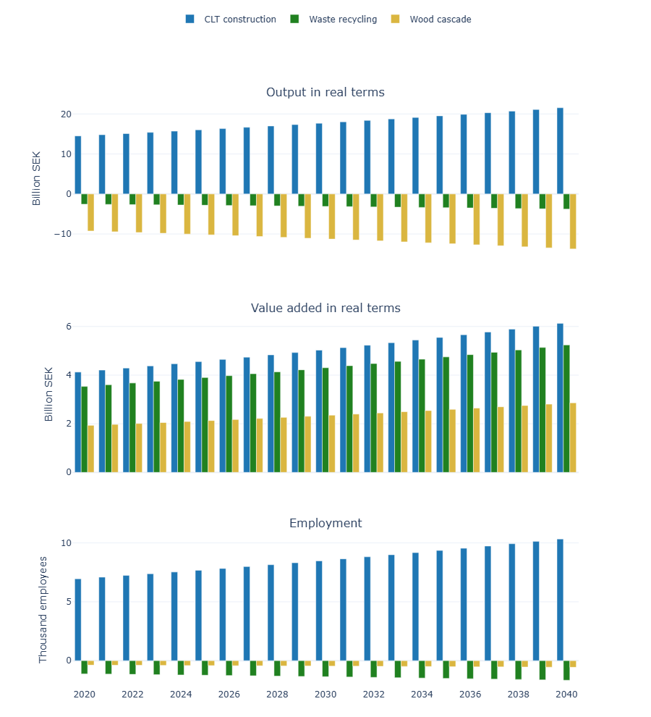
Figure S1. Scenario results in macroeconomic indicators (output, value added, and employment) relative to the baseline, Sweden, 2020–2040. Values show scenario–baseline differences.

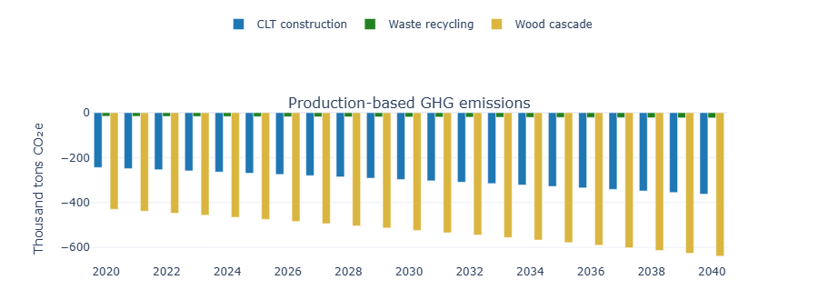
Figure S2. Scenario outcomes relative to the baseline in territorial (production based) GHG emissions, Sweden, 2020–2040. Values show scenario–baseline differences.

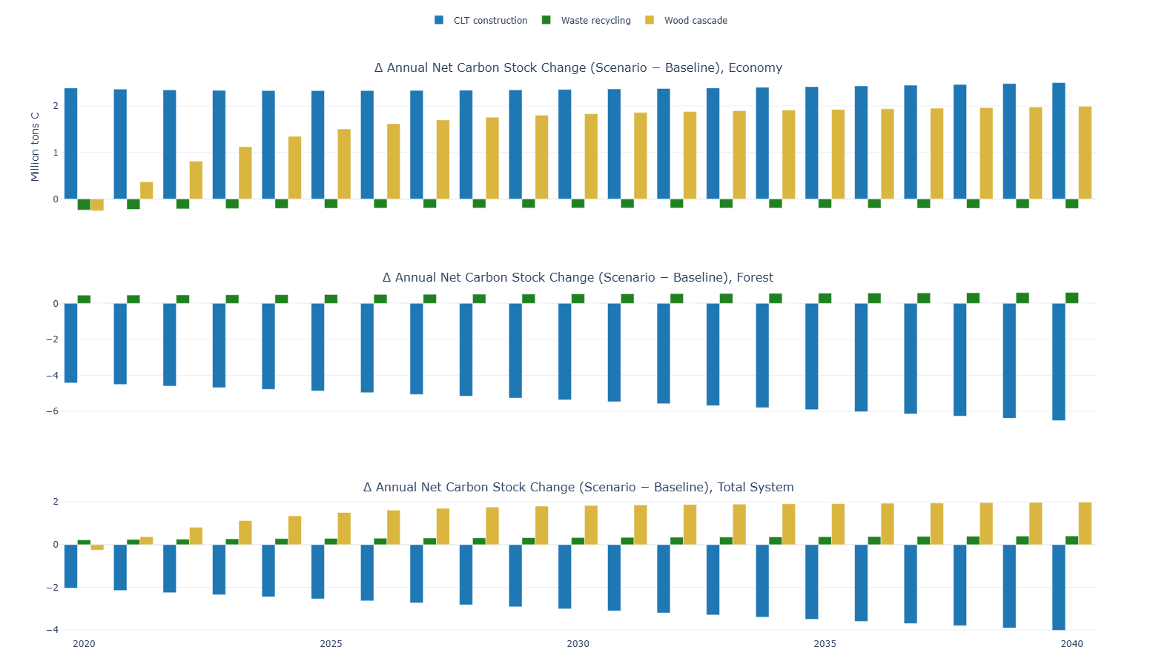
Figure S3. Annual net carbon stock change in Sweden (scenario - baseline), 2020–2040, Mt C.

Monte Carlo design and results

  - Monte Carlo setup, rationale, and toggles
This section specifies the Monte Carlo (MC) experiments used to test how selected assumptions affect the scenario results for 2020–2040. The analysis includes one-at-a-time (OAT) runs, which isolate individual uncertainty sources, and an all-components run, which combines all varied parameter groups. Since empirical parameter distributions were not available, the ranges are treated as exploratory uncertainty bounds rather than formally estimated probability distributions.
The MC design varies four groups of assumptions. First, the construction technical coefficients are varied to test whether the economic, emission, and downstream WBP effects remain robust when the CLT construction substitution shock is stronger or weaker than assumed. Second, the baseline final-demand growth path is varied to test how uncertain macroeconomic growth amplifies or weakens scenario effects. The same yearly growth path is applied to the baseline and all scenarios within a seed, so differences arise because the scenarios modify technical coefficients and therefore map final demand into output differently. Third, WBP half-lives are varied to test how product lifetime uncertainty affects WBP carbon-stock changes. Fourth, initial WBP stocks are varied in the scenarios only, while baseline stocks remain fixed, to test how uncertainty in starting stock size affects scenario carbon pathways.
Tables S2–S4 provide the implementation details. Table S2 reports which parameter groups vary in each run and how the variation is applied. Table S3 shows how the three scenario definitions are implemented across the deterministic, OAT, and all-components runs. Table S4 identifies which outputs are affected by each uncertainty component, distinguishing MSUT-based outputs, output, value added, GHG emissions, and employment, from annual carbon-stock changes in the economy and forest.
The MC design does not cover all potentially important uncertainties. Parameters not varied include waste-redirection shares and yields, demand-specific baseline growth rates, alternative WBP stock-initialisation methods, and forest-dynamics assumptions not represented in the model, such as regrowth, age-structure effects, management responses, and scenario-specific changes in increment. The MC results therefore do not quantify uncertainty from omitted dynamic forest processes. This limitation is important when interpreting the uncertainty intervals in the main manuscript and the additional results below.

Table S2. Randomization details and toggles by run
Run / Scenario | Construction technical coefficients | BAU growth | WBP half-lives | Initial WBP stock | How the variation is applied
deterministic | no | fixed default | no | no | All parameters fixed; serves as reference.
MSUT-A (Construction technical coefficients) | yes  (uniform ±20%) | fixed default | no | no | Random uniform variability with 20% spread around 1.0 on all affected construction coefficients; bundle-only renormalization in MSUT; PSUT receives proportional absolute overrides.
MSUT-B (Per-year BAU growth [1%, 3%]) | no (deterministic) | per-year path, uniform 1-3% (shared by baseline & scenarios) | no | no | One per-year final demand growth path is drawn and applied identically to baseline and scenarios; within a seed, the same path is reused in the “all components” run.
PSUT-A (WBP half-lives ±20%) | no (deterministic) | fixed default | yes (uniform ±20%) | no | Half-life multipliers drawn uniformly ±20% applied to all WBP categories in baseline and scenarios.
PSUT-B (Initial WBP stock ±20%) | no (deterministic) | fixed default | no | yes (uniform ±20%, scenarios only) | Scenario initial WBP stocks multiplied by draws; baseline stocks remain fixed.
All -components (combined effect) | yes (uniform ±20%) | per-year path, uniform 1–3% | yes (uniform ±20%) | yes (uniform ±20%) | All toggles combined in a single run; the per-year growth path is the same one used for MSUT-B with the same seed.

Table S3. Scenario definitions across runs
Run / Scenario | CLT construction | Waste recycling | Wood cascade
deterministic | Deterministic construction coefficients applied to the CLT bundle in MSUT; PSUT receives deterministic absolute overrides. | Scenario application | CLT bundle (deterministic) + C162→C162=0; forest harvest held fixed via PSUT rebalancing.
MSUT-A | Construction coefficients vary ±20% (uniform) in MSUT; PSUT overrides scaled proportionally to the MSUT draw. | No change to deterministic | CLT bundle from the draw + C162→C162=0; forest harvest fixed.
MSUT-B | No change to deterministic | No change to deterministic | No change to deterministic
PSUT-A | Deterministic construction coefficients; only WBP half-lives vary. | No change to deterministic; only WBP half lives vary | Deterministic CLT; forest harvest fixed; half-lives vary.
PSUT-B | Deterministic construction coefficients; only initial WBP stock varies (scenarios) | No change to deterministic; only initial WBP stock varies (scenarios) | Deterministic CLT; forest harvest fixed; initial stock varies (scenarios)
all components | Construction coefficients vary ±20% (uniform) in MSUT; PSUT overrides scaled proportionally. | No change to deterministic; all varied components in runs applied | CLT bundle from the draw + C162→C162=0; forest harvest fixed.

Table S4. Outputs affected by component
Component | Construction technical coefficients | BAU growth | WBP half-lives | Initial WBP stock | MSUT-based outputs (output, VA, GHG, employment) | Annual carbon stock change in economy (via WBP) and forest (via harvest)
deterministic | no | fixed | no | no | no variance | no variance
MSUT-A | yes  (±20%) | fixed | no | no | varies | varies (via PSUT overrides)
MSUT-B | no | yes  (1–3%) | no | no | varies (with growth changes) | varies (via economy–forest coupling)
PSUT-A | no | fixed | yes (±20%) | no | no variance | varies
PSUT-B | no | fixed | no | yes (±20%) | no variance | varies
all components | yes  (±20%) | yes  (1–3%) | yes (±20%) | yes (±20%) | varies | varies

  - Results

    - Relative variance contributions

Table S5. OAT relative variance contributions in percentage. The variance for each run and variable relative to the sum of the collective variance for all runs is used to compute the relative contribution to the overall uncertainty.
CLT construction

Metric | MSUT-A | MSUT-B | PSUT-A | PSUT-B
Output (Δ) | 97.8 | 2.2 | 0.0 | 0.0
VA (Δ) | 99.9 | 0.1 | 0.0 | 0.0
GHG (Δ) | 99.8 | 0.2 | 0.0 | 0.0
Employment (Δ) | 98.3 | 1.7 | 0.0 | 0.0
Economy carbon (Δ) | 52.7 | 0.5 | 0.7 | 46.1
Forest carbon (Δ) | 99.1 | 0.9 | 0.0 | 0.0
System carbon (Δ) | 63.2 | 0.5 | 0.5 | 35.7
Waste recycling
Metric | MSUT-A | MSUT-B | PSUT-A | PSUT-B
Output (Δ) | 0.0 | 100.0 | 0.0 | 0.0
VA (Δ) | 0.0 | 100.0 | 0.0 | 0.0
GHG (Δ) | 0.0 | 100.0 | 0.0 | 0.0
Employment (Δ) | 0.0 | 100.0 | 0.0 | 0.0
Economy carbon (Δ) | 0.0 | 0.0 | 0.0 | 100.0
Forest carbon (Δ) | 0.0 | 100.0 | 0.0 | 0.0
System carbon (Δ) | 0.0 | 0.0 | 0.0 | 100.0
Wood cascade
Metric | MSUT-A | MSUT-B | PSUT-A | PSUT-B
Output (Δ) | 99.7 | 0.3 | 0.0 | 0.0
VA (Δ) | 99.9 | 0.1 | 0.0 | 0.0
GHG (Δ) | 99.5 | 0.5 | 0.0 | 0.0
Employment (Δ) | 100.0 | 0.0 | 0.0 | 0.0
Economy carbon (Δ) | 38.6 | 0.2 | 1.6 | 59.6
Forest carbon (Δ) | 49.3 | 50.7 | 0.0 | 0.0
System carbon (Δ) | 38.6 | 0.2 | 1.6 | 59.6

    - Graphical results
This section provides percentile time-series plots and histograms illustrating the distribution of Monte Carlo outcomes across scenarios. Deterministic trajectories closely follow the Monte Carlo median, with uncertainty bands widening toward 2040, especially for carbon outcomes. This illustrates both the robustness of economic estimates and the greater sensitivity of long-term carbon balances to parameter uncertainty.

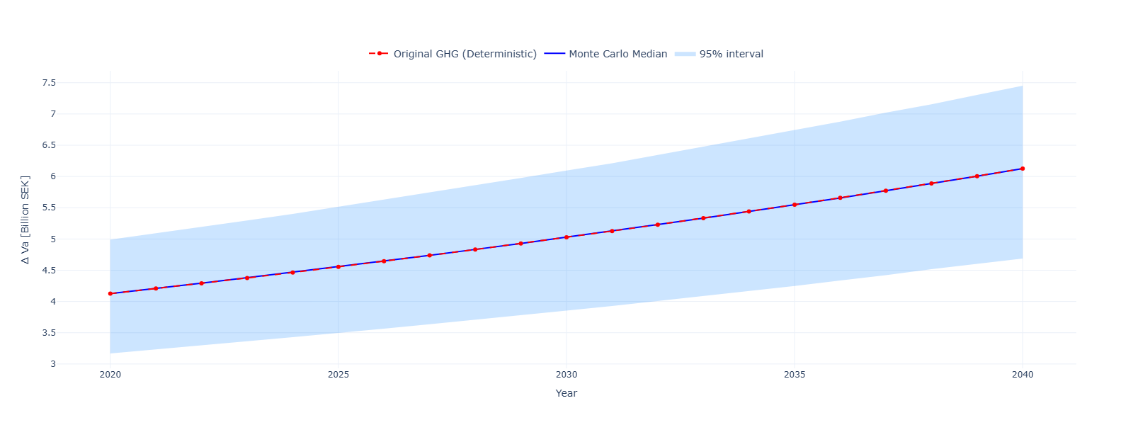
Figure S4. Time-series plot of Monte Carlo results (median and 95% interval) compared with deterministic trajectories for the run = all-components, scenario = CLT construction, and variable = value added.

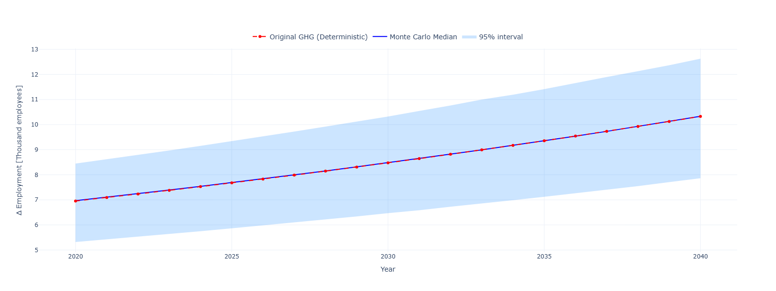
Figure S5. Time-series plot of Monte Carlo results (median and 95% interval) compared with deterministic trajectories for the run = all-components, scenario = CLT construction, and variable = employment.

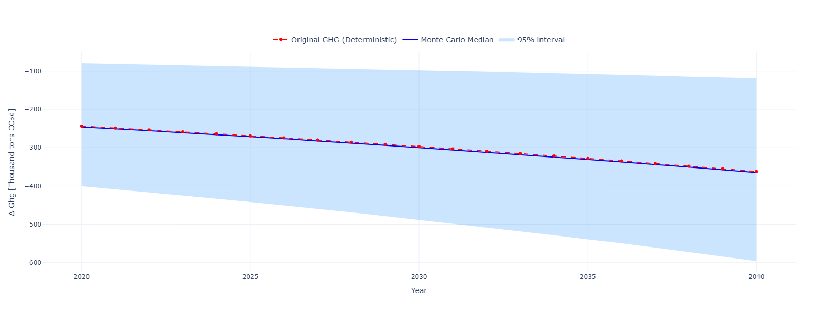
Figure S6. Time-series plot of Monte Carlo results (median and 95% interval) compared with deterministic trajectories for the run = all-components, scenario = CLT construction, and variable = GHG emissions.

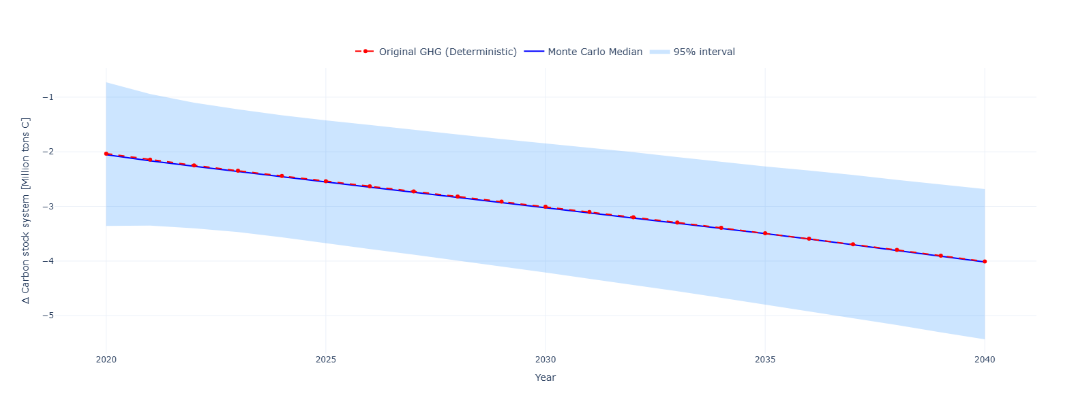
Figure S7. Time-series plot of Monte Carlo results (median and 95% interval) compared with deterministic trajectories for the run = all-components, scenario = CLT construction, and variable = system carbon stock.

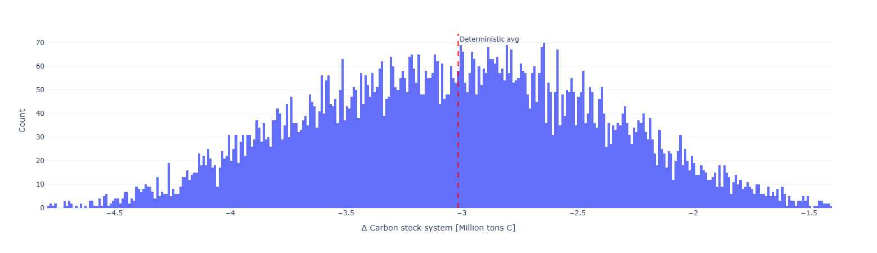
Figure S8. Histogram of Monte Carlo outcomes compared with the deterministic average for the run = all-components, scenario = CLT construction, and variable = system carbon stock change.

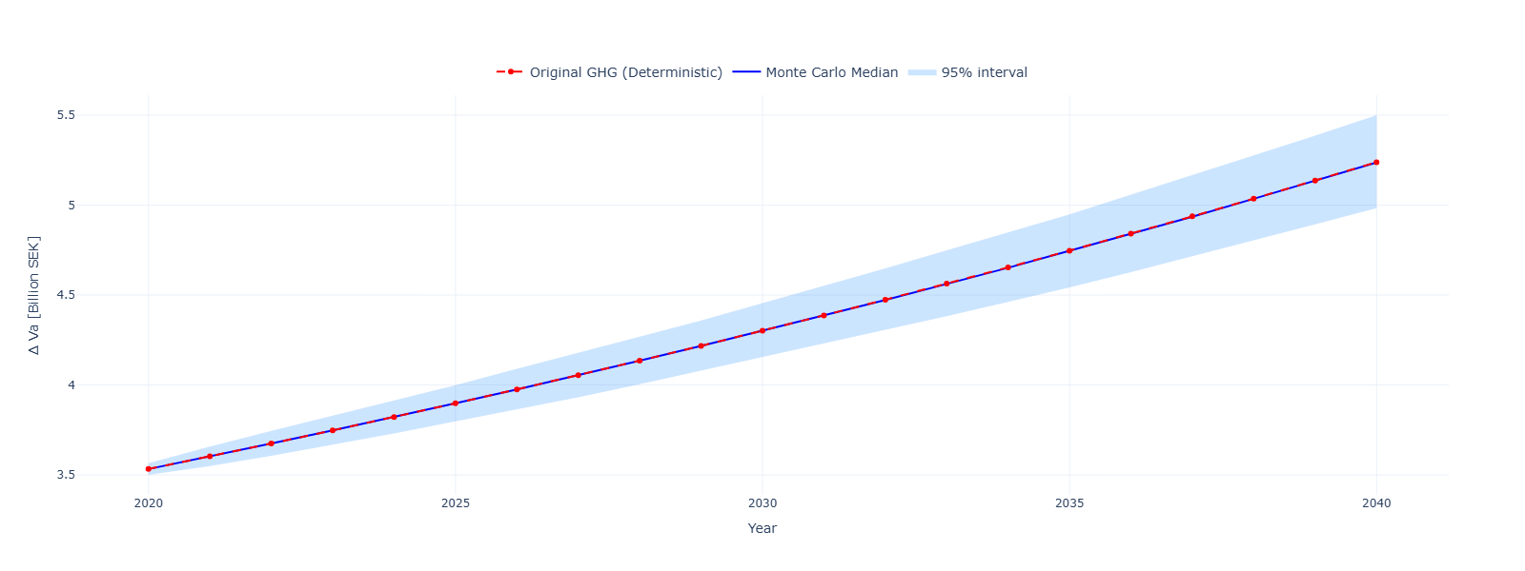
Figure S9. Time-series plot of Monte Carlo results (median and 95% interval) compared with deterministic trajectories for the run = all-components, scenario = Waste recycling, and variable = value added.

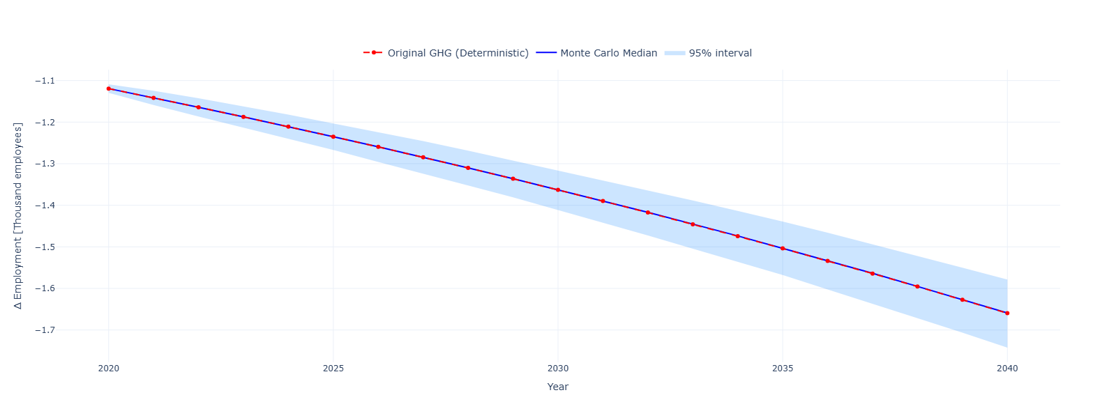
Figure S10. Time-series plot of Monte Carlo results (median and 95% interval) compared with deterministic trajectories for the run = all-components, scenario = Waste recycling, and variable = employment.

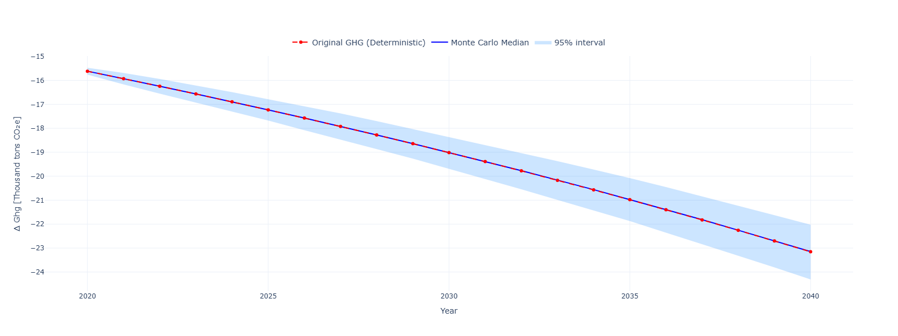
Figure S11. Time-series plot of Monte Carlo results (median and 95% interval) compared with deterministic trajectories for the run = all-components, scenario = Waste recycling, and variable = GHG emissions.

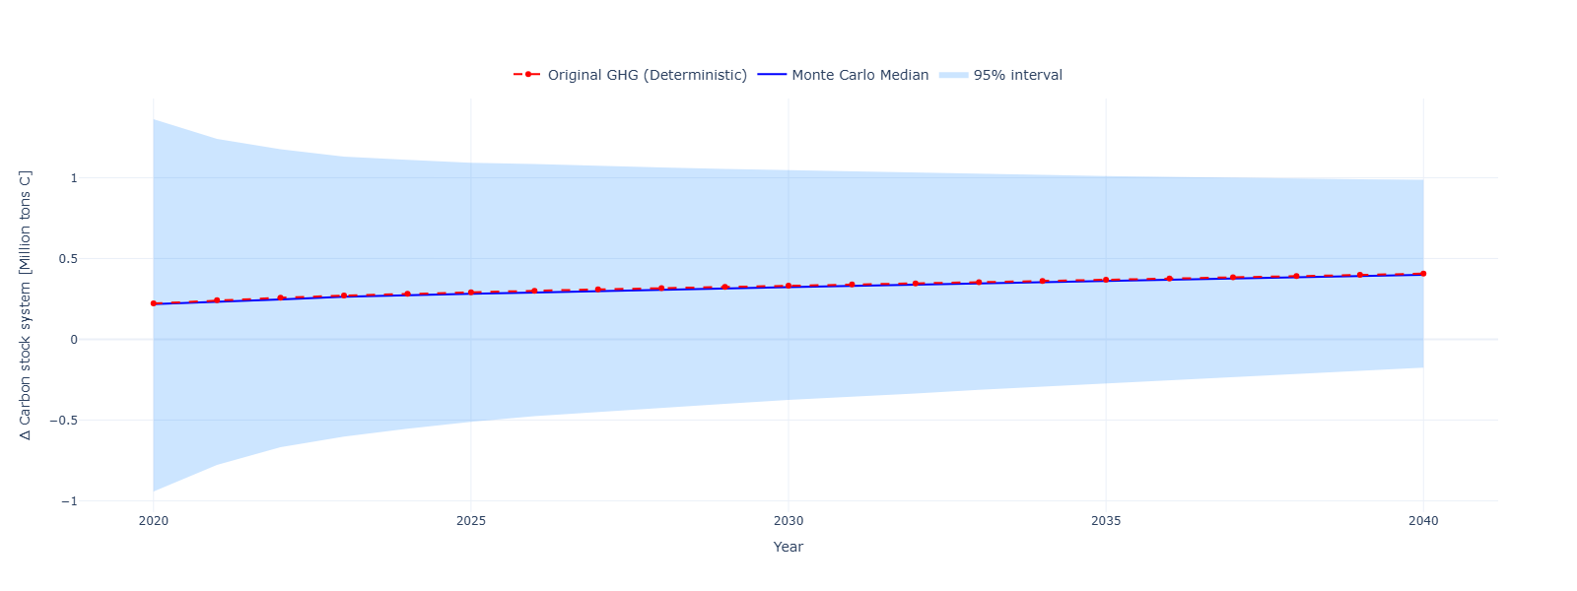
Figure S12. Time-series plot of Monte Carlo results (median and 95% interval) compared with deterministic trajectories for the run = all-components, scenario = Waste recycling, and variable = system carbon stock.

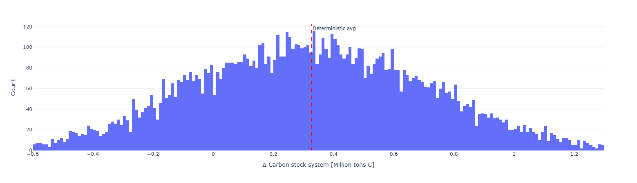
Figure S13. Histogram of Monte Carlo outcomes compared with the deterministic average for the run = all-components, scenario = Waste recycling, and variable = system carbon stock change.

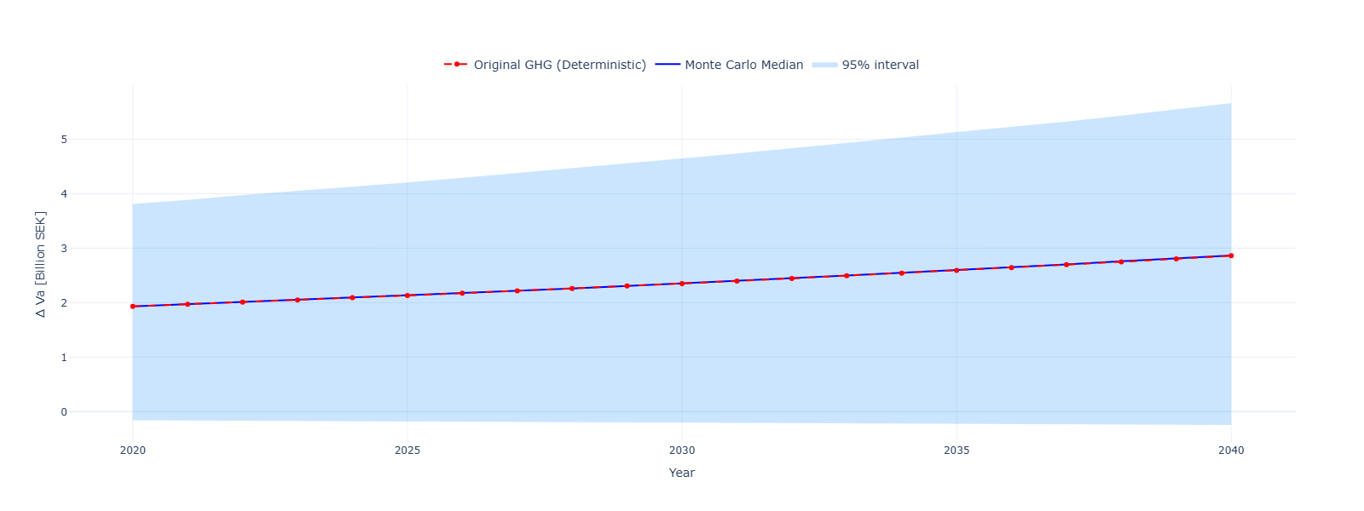
Figure S14. Time-series plot of Monte Carlo results (median and 95% interval) compared with deterministic trajectories for the run = all-components, scenario = Wood cascade, and variable = value added.

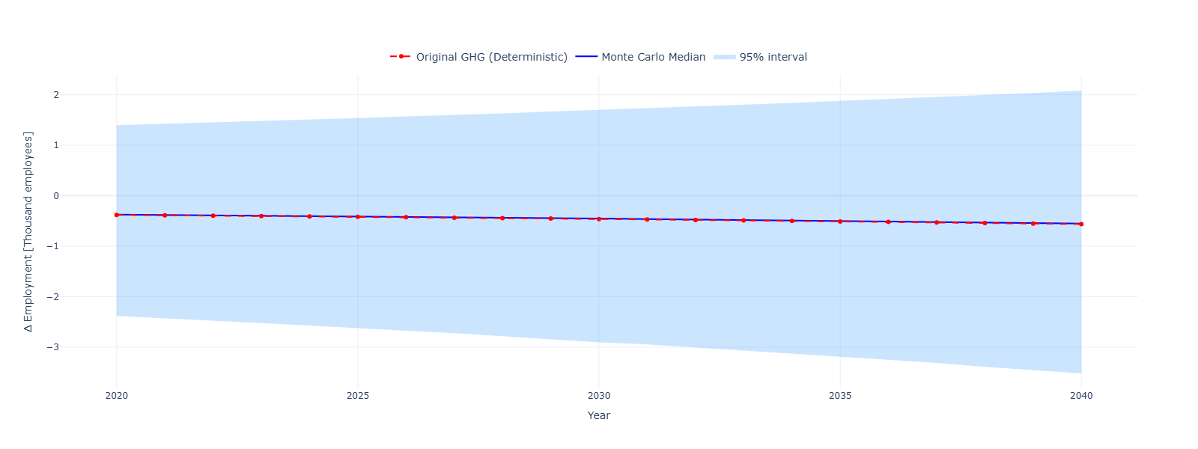
Figure S15. Time-series plot of Monte Carlo results (median and 95% interval) compared with deterministic trajectories for the run = all-components, scenario = Wood cascade, and variable = employment.

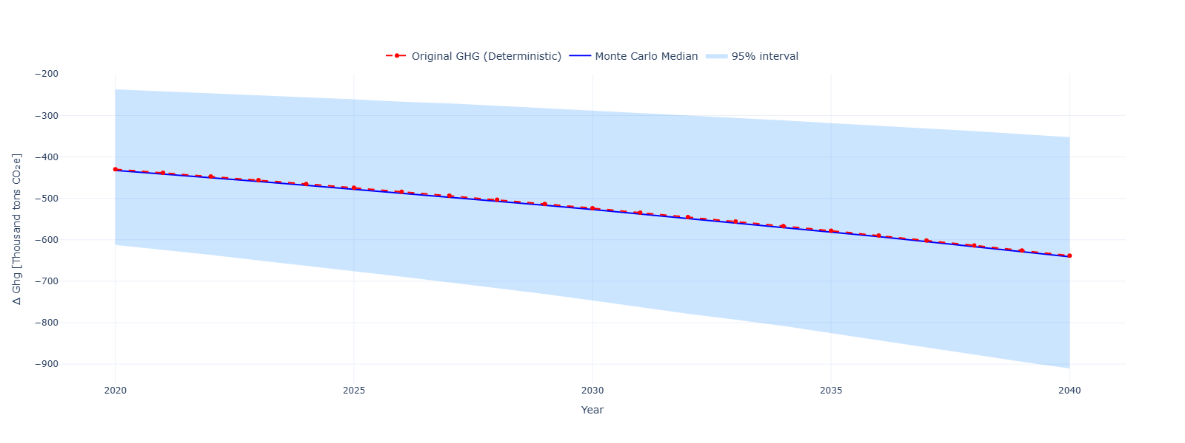
Figure S16. Time-series plot of Monte Carlo results (median and 95% interval) compared with deterministic trajectories for the run = all-components, scenario = Wood cascade, and variable = GHG emissions.

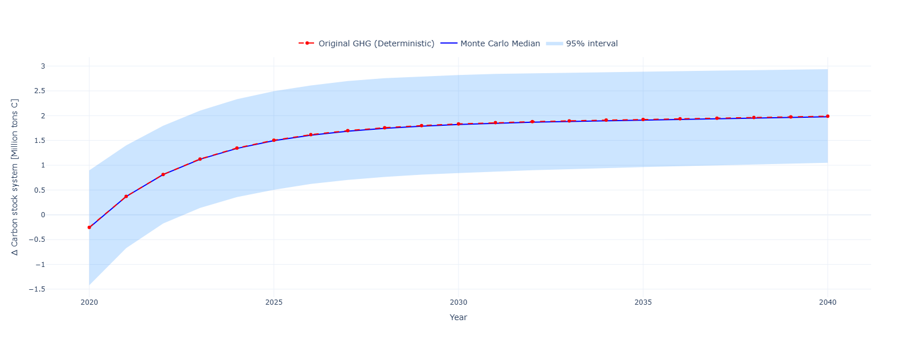
Figure S17. Time-series plot of Monte Carlo results (median and 95% interval) compared with deterministic trajectories for the run = all-components, scenario = Wood cascade, and variable = system carbon stock.

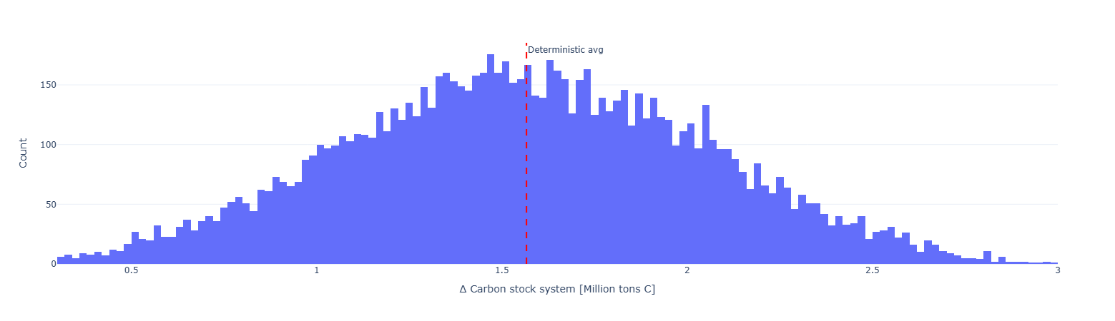
Figure S18. Histogram of Monte Carlo outcomes compared with the deterministic average for the run = all-components, scenario = Wood cascade, and variable = system carbon stock change.

The balancing input represents the difference between the physical output of wood products and the production inputs of wood products in an industry. The balance can be negative (when part of the physical input is dissipated) or positive (when there are additional physical inputs in the production process that are not recorded in the intermediate uses of wood products).
Wood-based products

