SUPPORTING INFORMATION FOR:

Ane N. Johansen, Glen P. Peters, Benjamin Sanderson, Jannick Schmidt
Integrating temperature and CO₂-concentration impact on crops into an input-output framework
Journal of Industrial Ecology.
This supporting information SI1 provides a mapping between the notation used in this paper and the notation used in Weidema et al 2018. It contains a table showing which EXIOBASE files we’ve used for our variables, and eight figures of the same type as Figure2 C)-F), each figure contains data for one RCP scenario and one crop type. The scenarios included are RCP2.6 and RCP6.0, while the croptypes are maize, rice, soy and wheat, several lines of the same color correspond to different forcing models. Further it includes a table listing the 15 sectors that exhibit the highest increase in CO₂ emission due to climate. Last, it includes a figure showing results for the temporal version of the IO calculation, and some reflections around those results.

The formulation developed here is based on Weidema et al 2018, but we have used slightly different notation (building on standard notation in input-output analysis). To avoid confusion, we map the variables in Weidema et al 2018 to the ones used in this paper. We have introduced the equations C₁ and C₂ to link to their Figure 3.
Label (IOA) | This paper | Weidema et al 2018
Technology (flow) matrix | A | I-A
Output | x | S
Stressor per unit output | S | B_{T}
Stressor | s | m
Characterisation matrix | C
Climate Response matrix | R | -D

Based on this, the Weidema et al 2018 equation is written in our notation as
$$\left(\begin{matrix}I-A & 0 & -R \\ S & -I & 0 \\ 0 & C_{1} & C_{2}-I\end{matrix}\right)\left(\begin{matrix}x \\ s \\ c\end{matrix}\right)=\left(\begin{matrix}f \\ 0 \\ 0\end{matrix}\right)$$ | (1)

Rewriting this equation in the form of Equation (9) makes it easier to map between variables, though this equation is only shown for clarity.
$$\left(\begin{matrix}x \\ s \\ c\end{matrix}\right)=\left(\begin{matrix}A & 0 & R \\ S & 0 & 0 \\ 0 & C_{1} & C_{2}\end{matrix}\right)\left(\begin{matrix}x \\ s \\ c\end{matrix}\right)+\left(\begin{matrix}f \\ 0 \\ 0\end{matrix}\right)$$ | (2)

Expanding this to individual equations gives
$$x=Ax+Rc+f$$ | (3)
$$s=Sx$$ | (4)
$$c=C_{1}s + C_{2}c$$ | (5)
Rearranging in the same format as in this paper means the characterisation equation changes to
$$c={(I - C_{2})}^{-1}C_{1}s=Cs$$ | (6)
This equation is now in the form of Equation (8). Other than simple sign changes or redefinition of the flow matrix, the only real difference in the methods is the construction of the characterisation matrix, which they modified in their system to include additional mid-points in the characterisation (hence, the need for C₁ and C₂).

IO variable | EXIOBASE file
Z | MR_HIOT_2011_v3_3_18_by_product_technology
f | MR_HIOT_2011_v3_3_18_FD
F | MR_HIOT_2011_v3_3_18_extensions; Emiss_act, Emis_unreg_w_act, Emiss_FD, Emiss_unreg_w_FD.
Table 1: Overview of where in EXIOBASE HYBRID v3-2011 the IO variables are extracted from. For the total stressor matrix F the sheets with name ending with “_act” is for the activities, while ending “FD” corresponds to final demand. The unreg_w-files contain emission stressors from unregistered waste and has to be included since this is not included in Emiss_act and Emiss_FD.
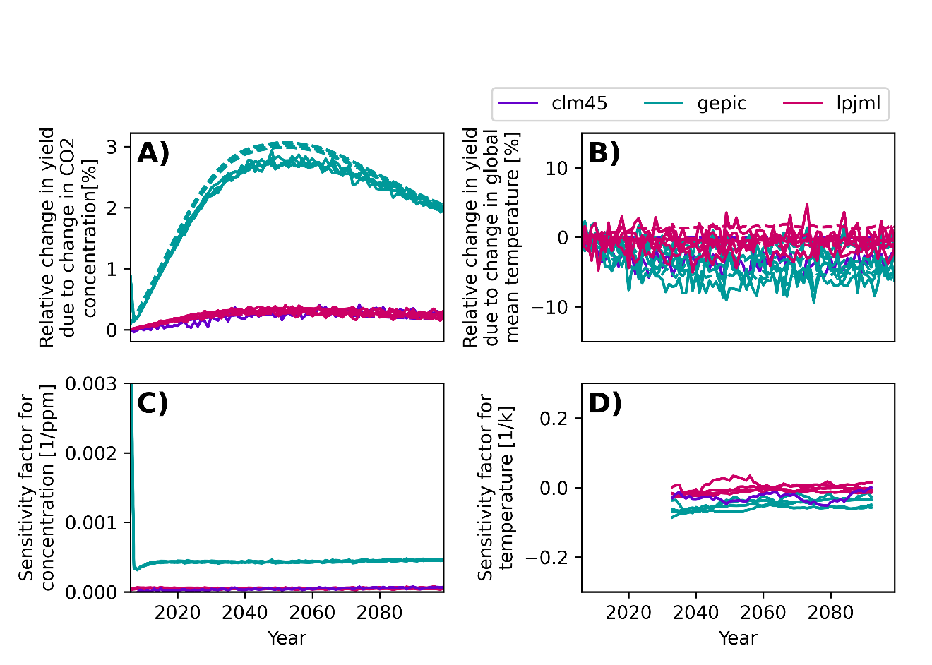
Figure 1: Relative change in yield for the global case due to change in CO₂ concentration (A)) and temperature (B)), and corresponding sensitivity factors (C) and D)) for maize for RCP2.6.
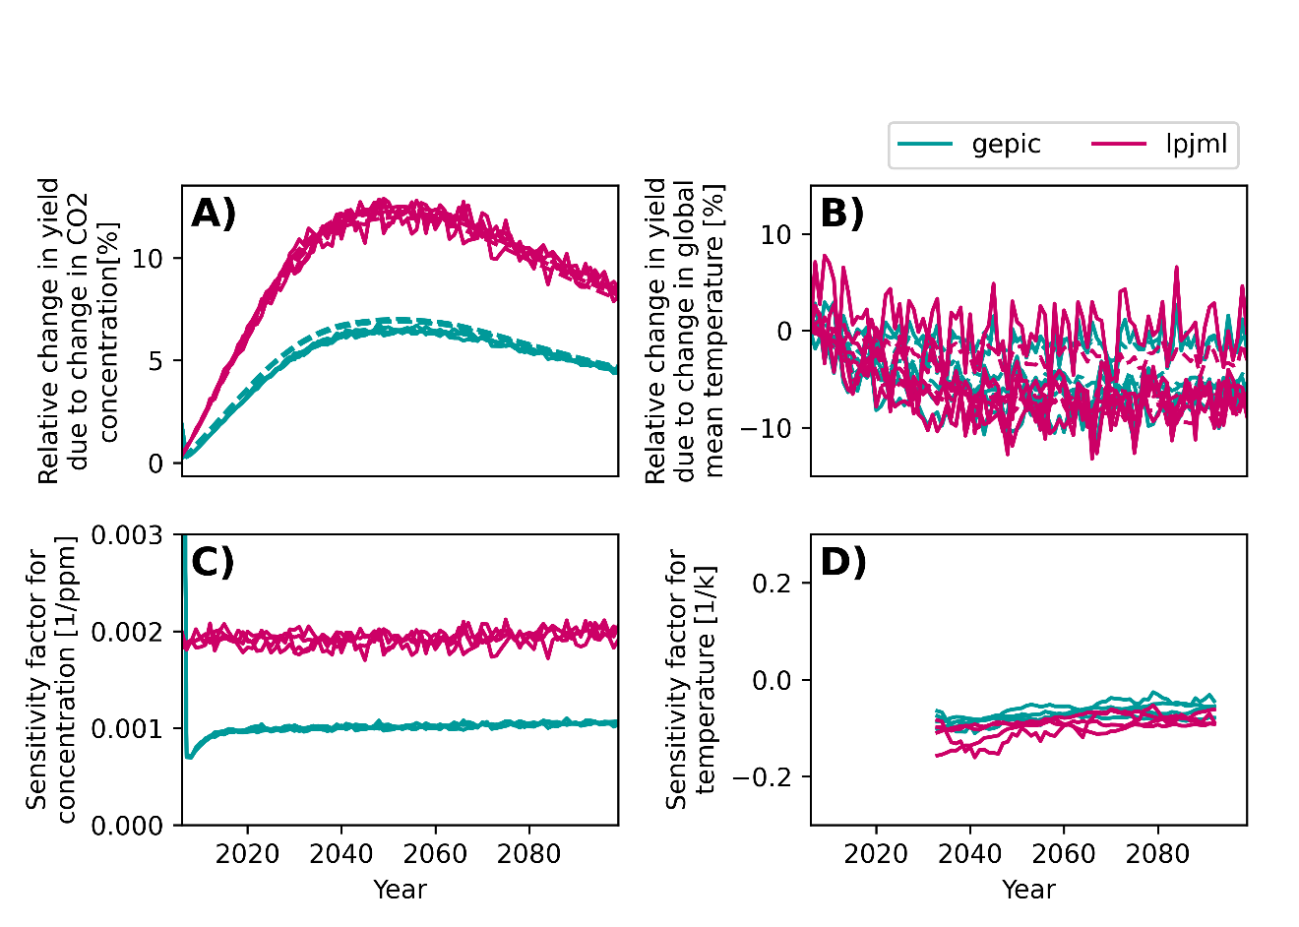
Figure 2: Relative change in yield for the global case due to change in CO₂ concentration (A)) and temperature (B)), and corresponding sensitivity factors (C) and D)) for rice for RCP2.6.
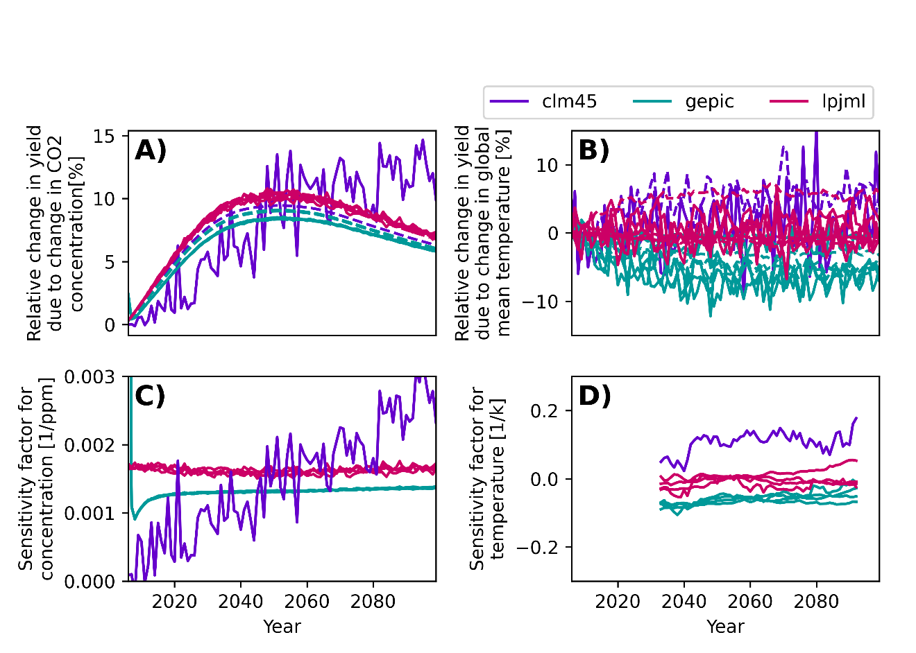
Figure 3: Relative change in yield for the global case due to change in CO₂ concentration (A)) and temperature (B)), and corresponding sensitivity factors (C) and D)) for soy for RCP2.6.
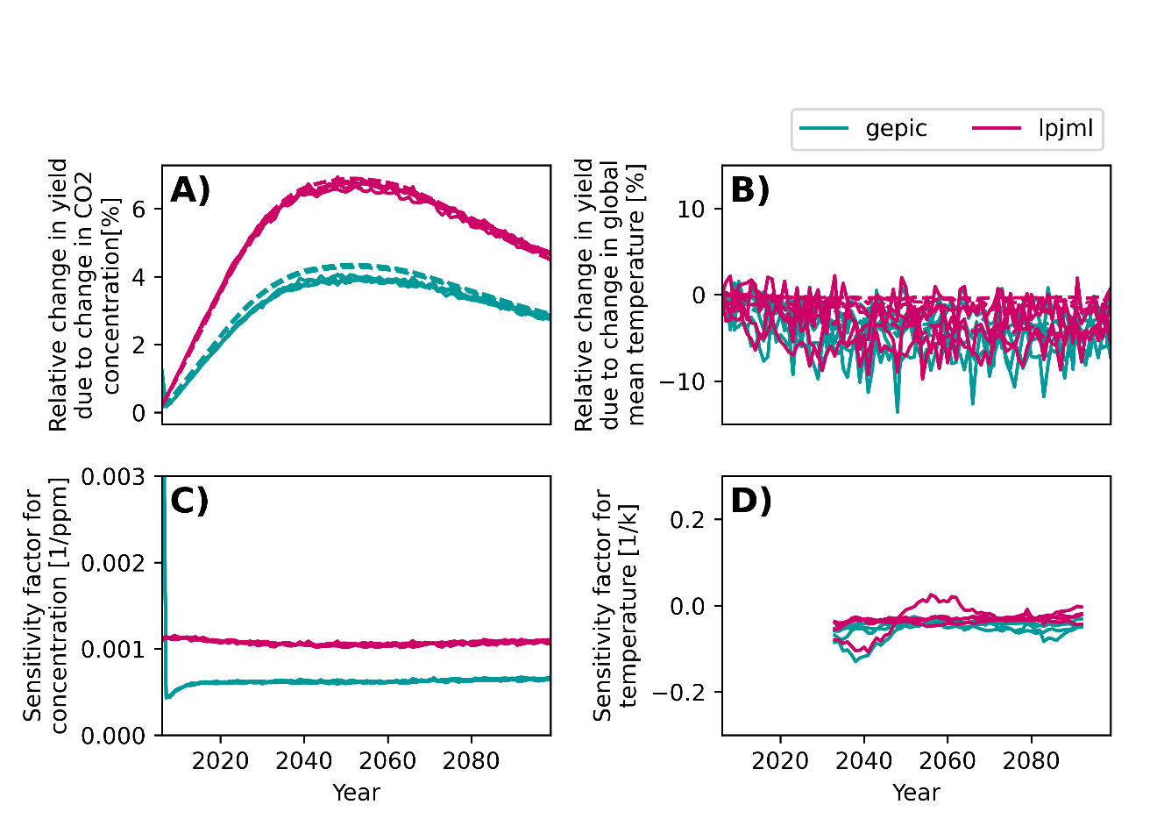
Figure 4: Relative change in yield for the global case due to change in CO₂ concentration (A)) and temperature (B)), and corresponding sensitivity factors (C) and D)) for wheat for RCP2.6.
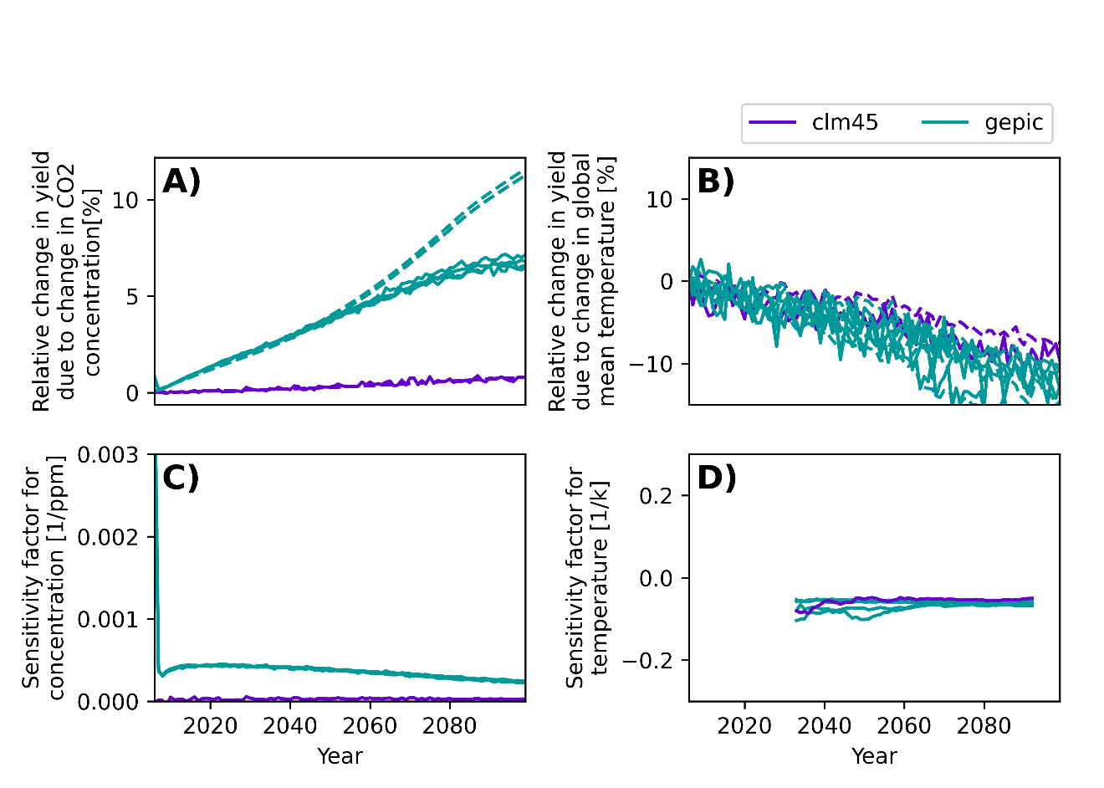
Figure 5: Relative change in yield for the global case due to change in CO₂ concentration (A)) and temperature (B)), and corresponding sensitivity factors (C) and D)) for maize for RCP6.0.
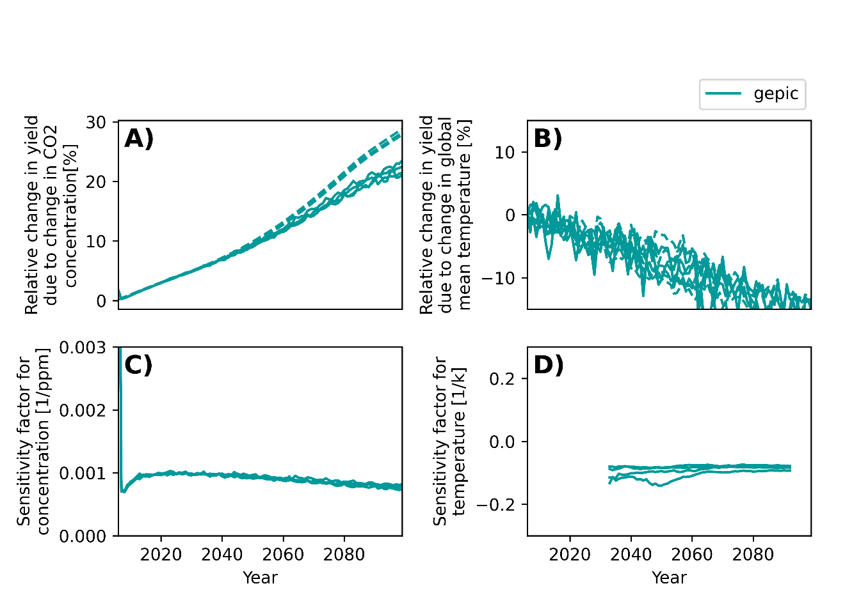
Figure 6: Relative change in yield for the global case due to change in CO₂ concentration (A)) and temperature (B)), and corresponding sensitivity factors (C) and D)) for rice for RCP6.0.
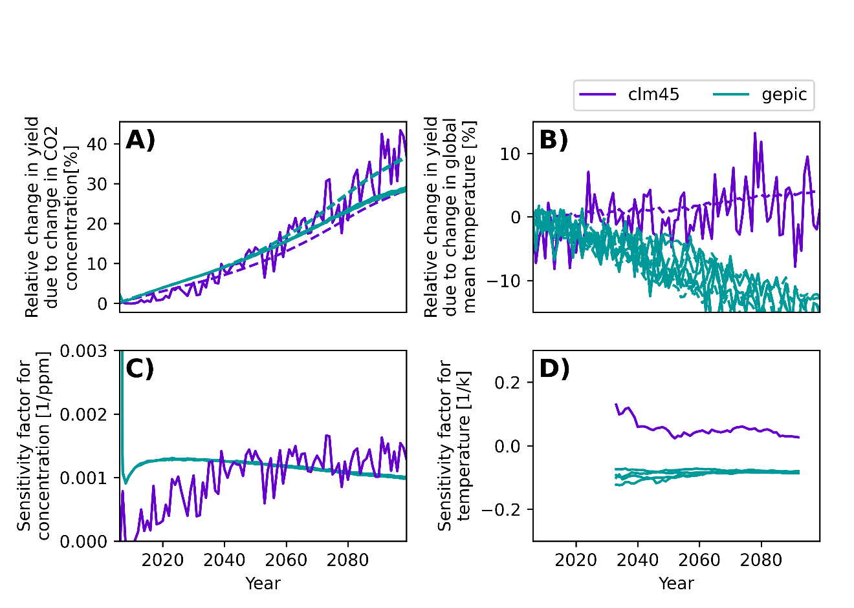
Figure 7: Relative change in yield for the global case due to change in CO₂ concentration (A)) and temperature (B)), and corresponding sensitivity factors (C) and D)) for soy for RCP6.0.
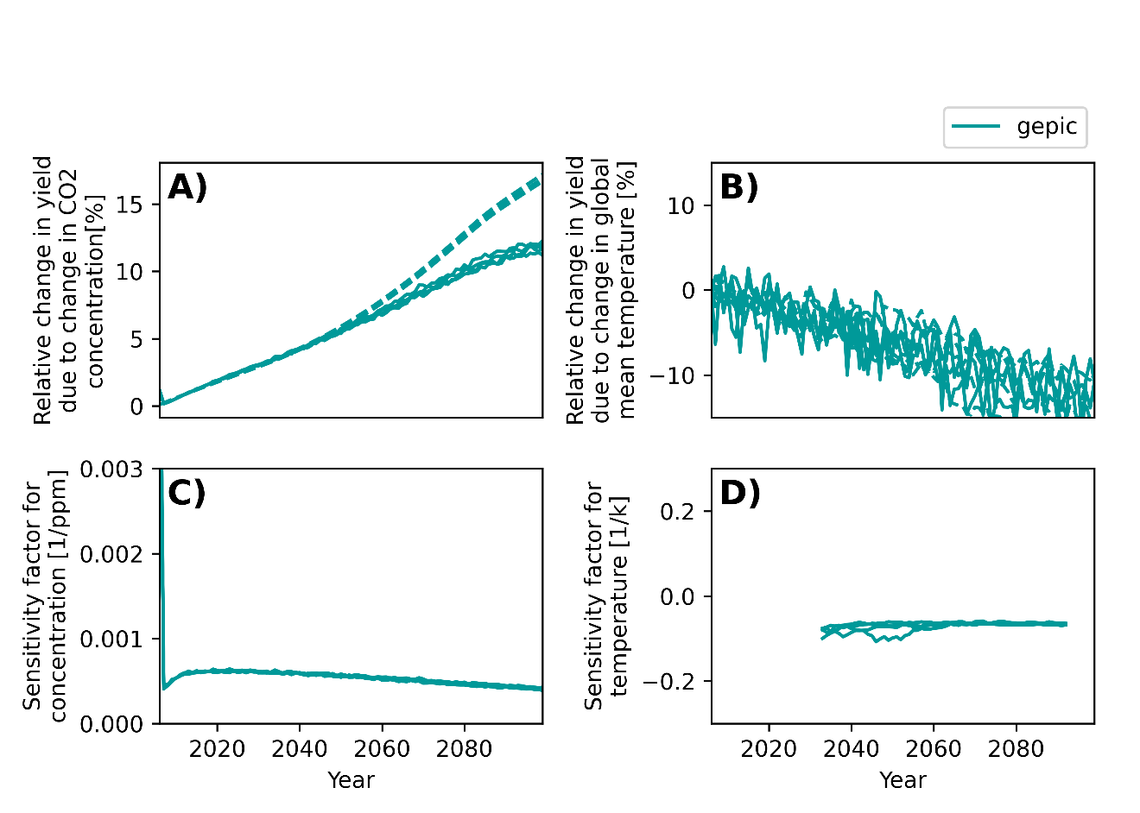
Figure 8: Relative change in yield for the global case due to change in CO₂ concentration (A)) and temperature (B)), and corresponding sensitivity factors (C) and D)) for wheat for RCP6.0.
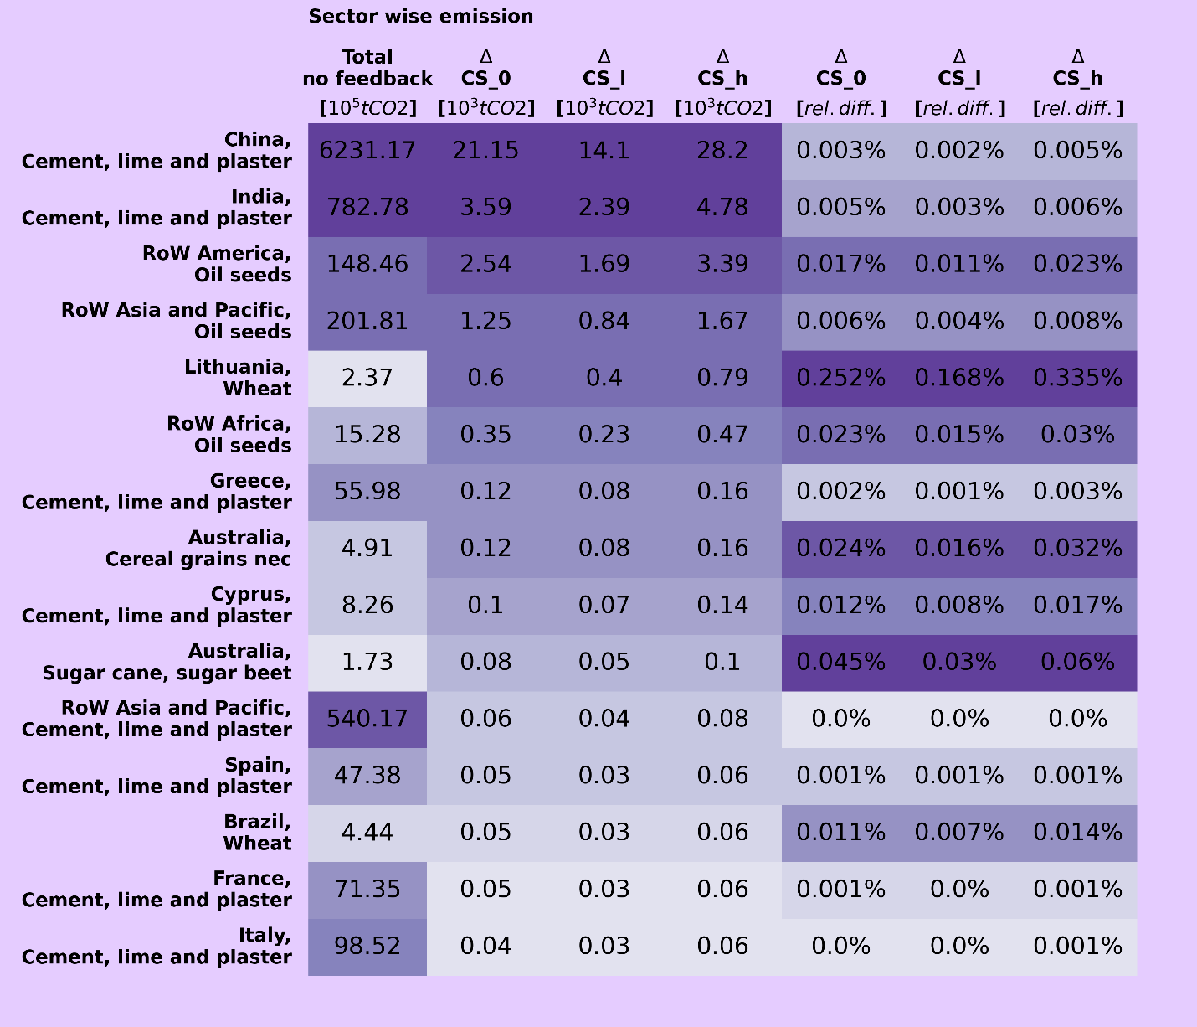
Figure 9. The table lists the 15 sectors with the biggest increase in CO2 emission for the feedback calculation. First column shows the initial total emission from each of the sectors. Second column shows increase in the sectors emission when feedback is added using carbon sensitivity 57*10⁻¹² ppm/tCO2 (CS_0) and the corresponding TCRE 0.45*10⁻¹² °C/tCO_{2,} third and fourth column shows the same but here the carbon sensitivity and hence the TCRE are scaled by 0.30/0.45 (CS_l) and 0.60/0.45 (CS_h). The last three columns give the emission change for each case relative to the initial emission (i.e. first column). The table is sorted after column two, the color shades indicate the size order within each column (only the order, they are not weighted by the values).(Note that column 1 is scaled 10⁵ while columns 2,3 and 4 are scaled 10³).
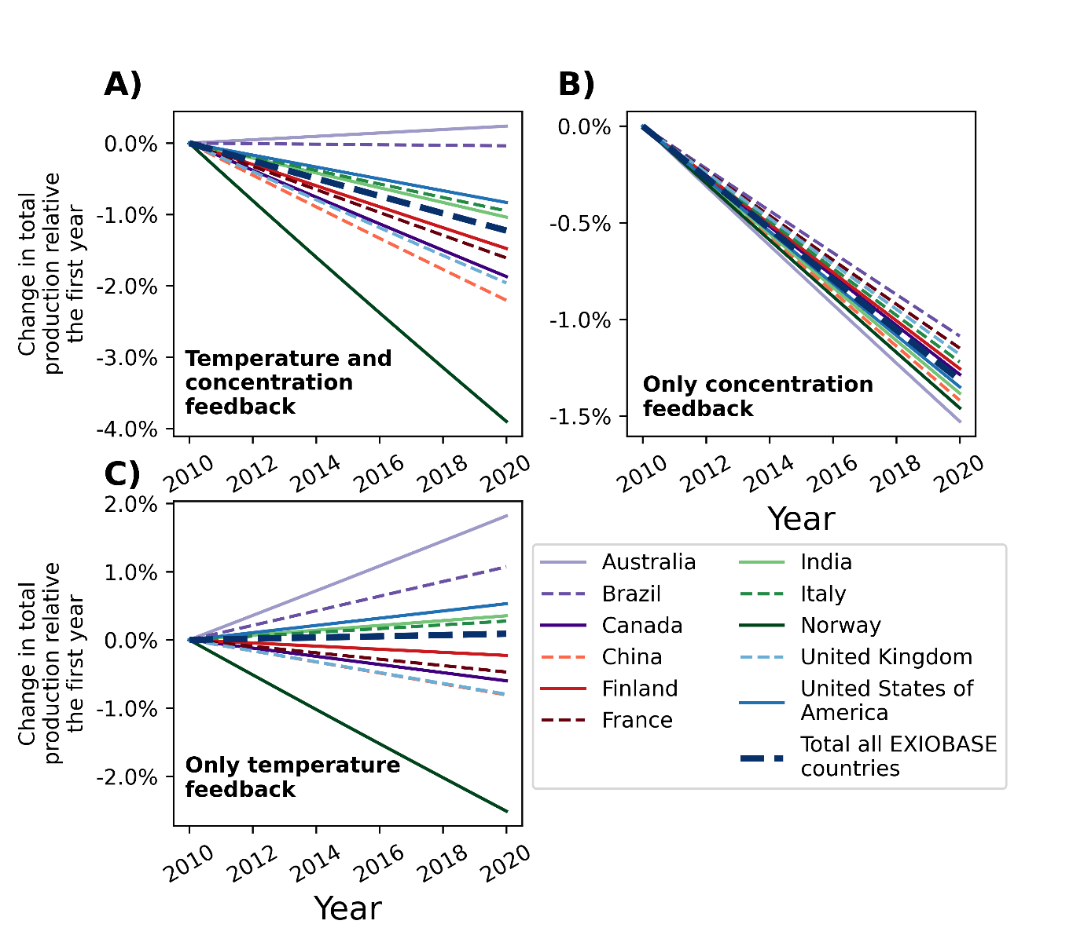
Figure 10 Results for temporal version of the feedback calculation code for the “cereal grains nec” sector, showing change in total production for the sector when including cumulative CO₂ emission back to the first year 2011. Note that this calculation uses data from the same IO-table for all years, not considering that the table is valid only for year 2011. In addition to showing the change for 11 different regions, the total change for all 43 EXIOBASE countries are included. This was chosen instead of showing the global total since feedbacks for the 5 “rest of the world”-regions are zero in the implementation, so adding them together would not give a meaningful trend.
Figure 10 shows change in total production in the cereal grains nec sector for some countries using the temporal method for a 10-year period. The result is linear, since a marginal effect (y+dy) is accumulated over time. The interpretation of this result needs care though, as it masks additional complexities. While the IO coefficients may only have small changes over the time span of a few years (Peters et al., 2007; Yamakawa & Peters, 2011) in comparison to the demand (y) and efficiency (F), the structure of the economy can have more substantial changes over decade periods, particularly if climate impacts (or climate policy) additionally affect the economic structure. Given the rest of the IO model has no dynamic components - these effects cannot be represented, and so we only illustrate the dynamic climate feedback effects assuming the economic structure and demand is fixed.

