Intrinsic Variability of Lithium Metal Foils and Its Impact on Rechargeable Battery Performance
Kun Wang^{1§}, Sravani Duggirala^{1§}, Jinghang Ji¹, Bhargav Bhamwala², Kun Ryu¹, Mingqian Li², Shen Wang², Kathryn Hicks¹, Wurigumula Bao^{1*}, and Ying Shirley Meng^{1,2*}
¹Pritzker School of Molecular Engineering, University of Chicago, Chicago, IL, 60637, USA
²Department of NanoEngineering, University of California San Diego, La Jolla, CA, 92093, USA
§These authors contributed equally.
Co-corresponding author: wubao@uchicago.edu, shirleymeng@uchicago.edu

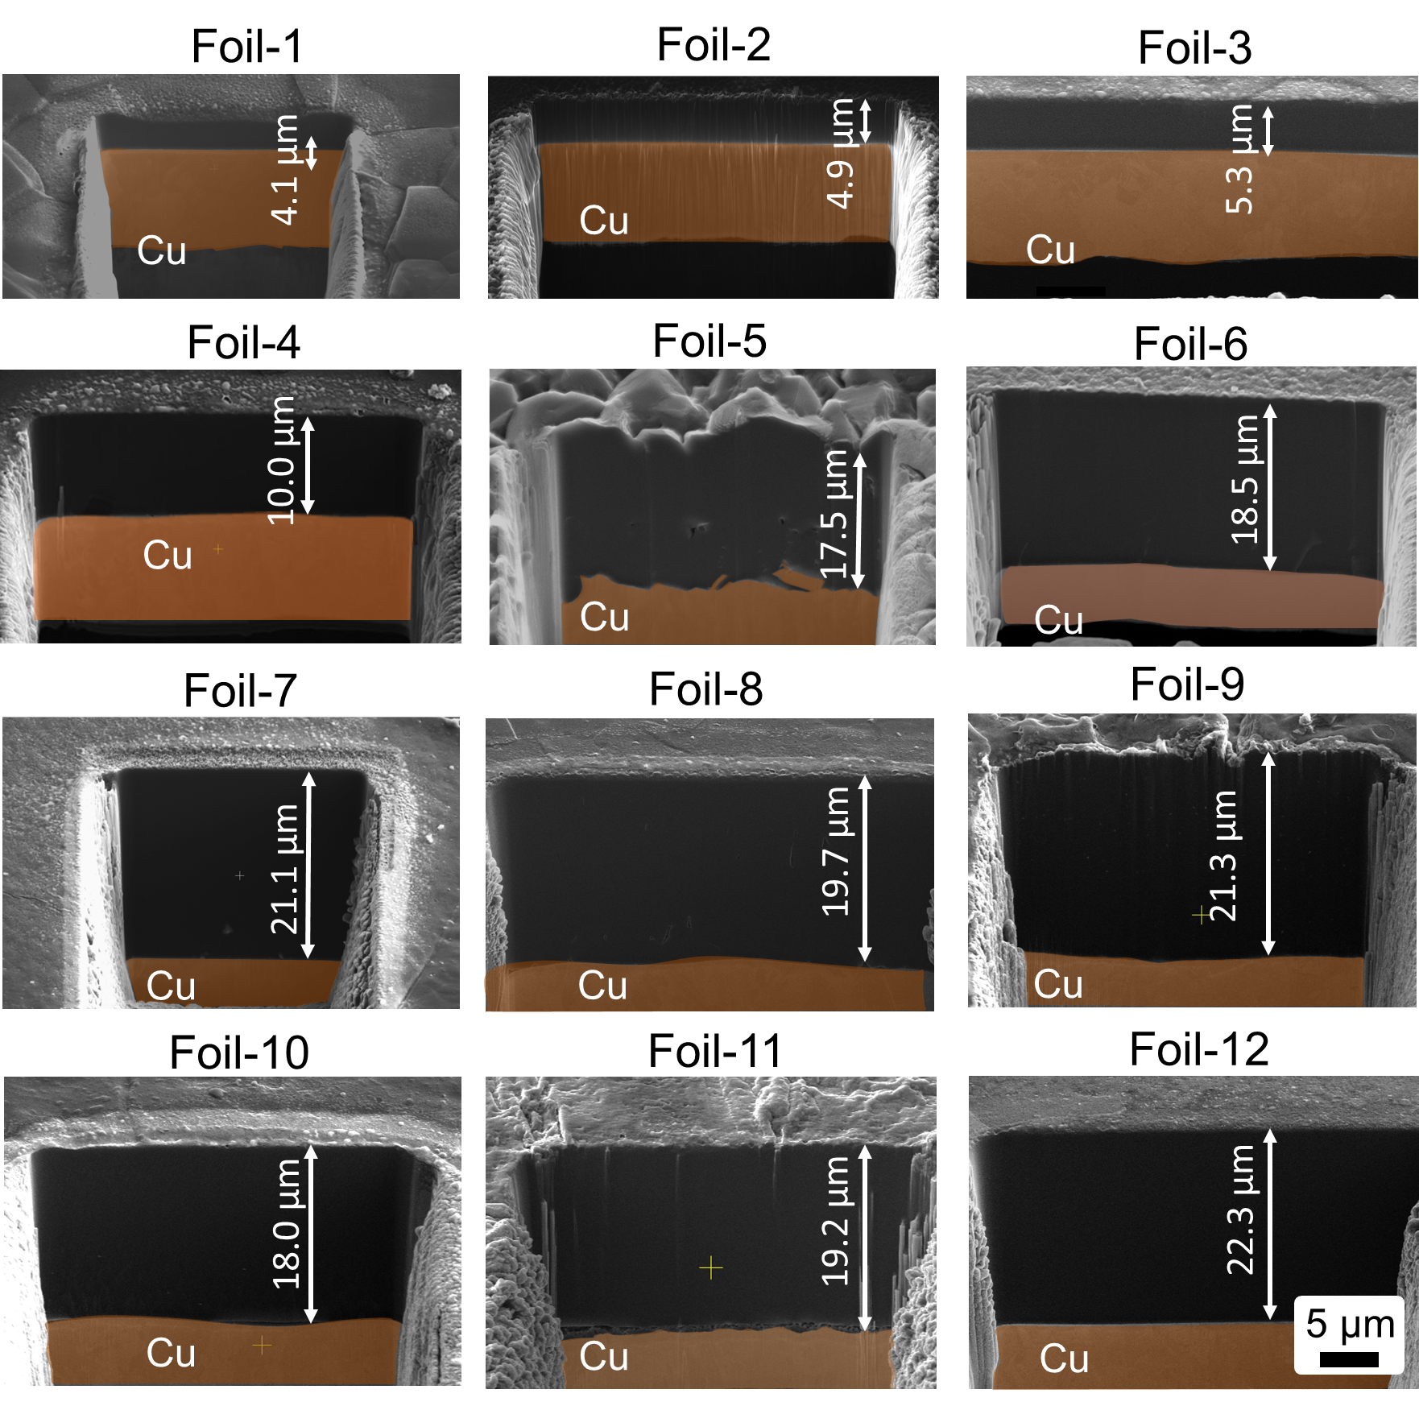
Figure S1. PFIB-SEM cross section morphology of ultrathin lithium metal foils.
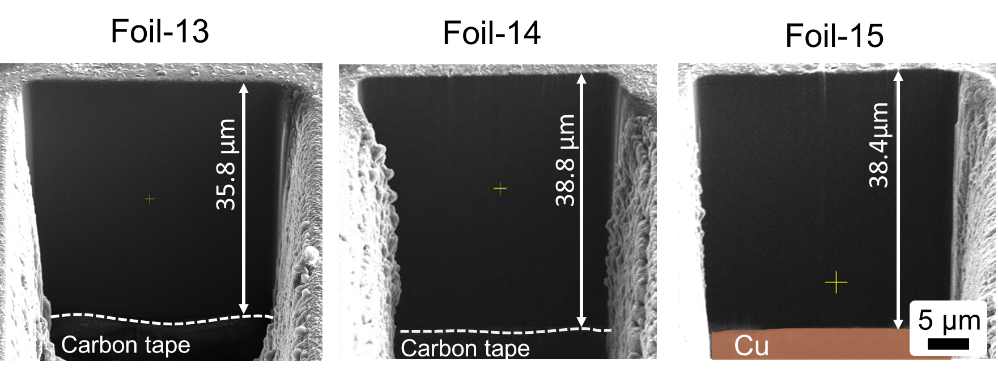
Figure S2. PFIB-SEM cross section morphology of thin lithium metal foils.
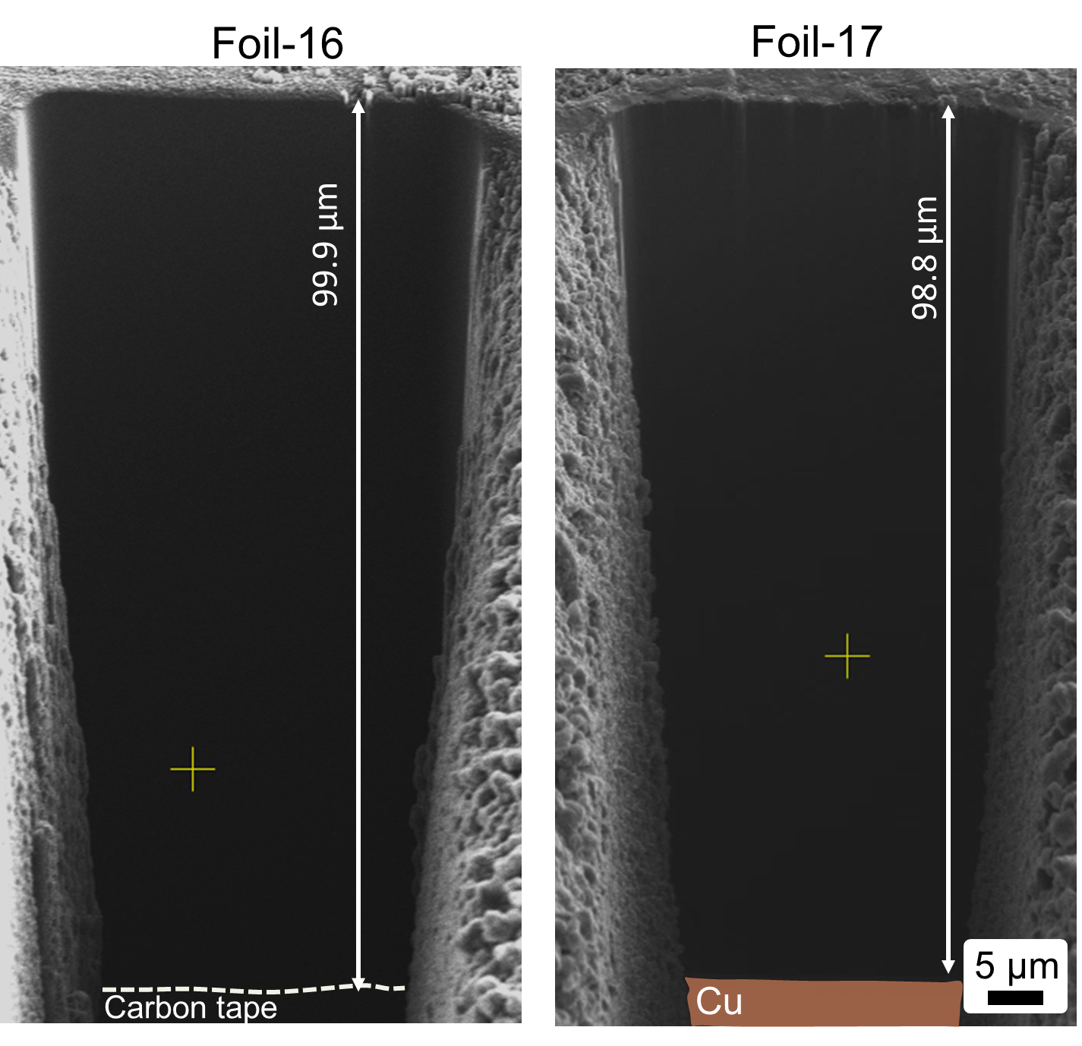
Figure S3. PFIB-SEM cross section morphology of thick lithium metal foils.
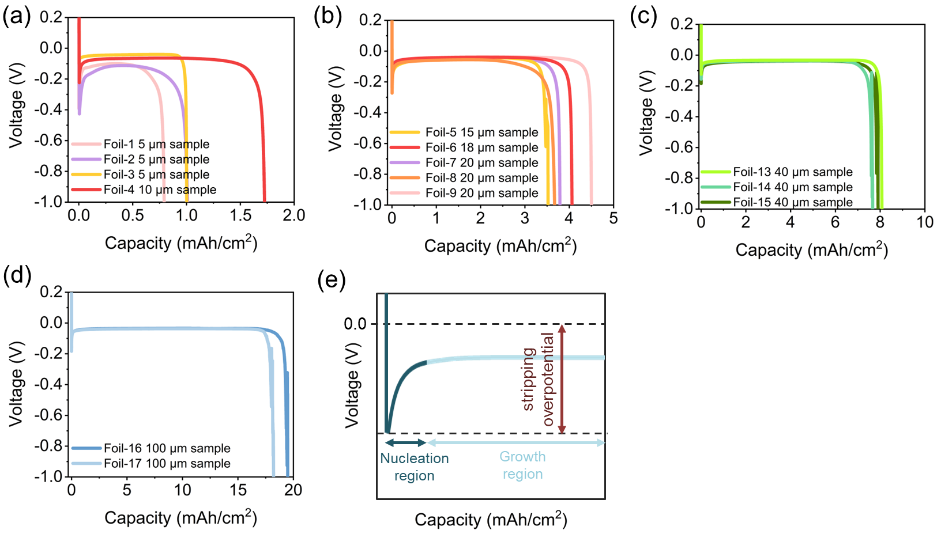
Figure S4. Li stripping in Li||Cu asymmetric cells using a) ultrathin lithium foils (≤10 µm) b) ultrathin lithium foils (10-20 µm), c) thin lithium foils, and d) thick lithium foils. e) Schematic plot of the voltage profiles of galvanostatic Li stripping in Li||Cu asymmetric cells.

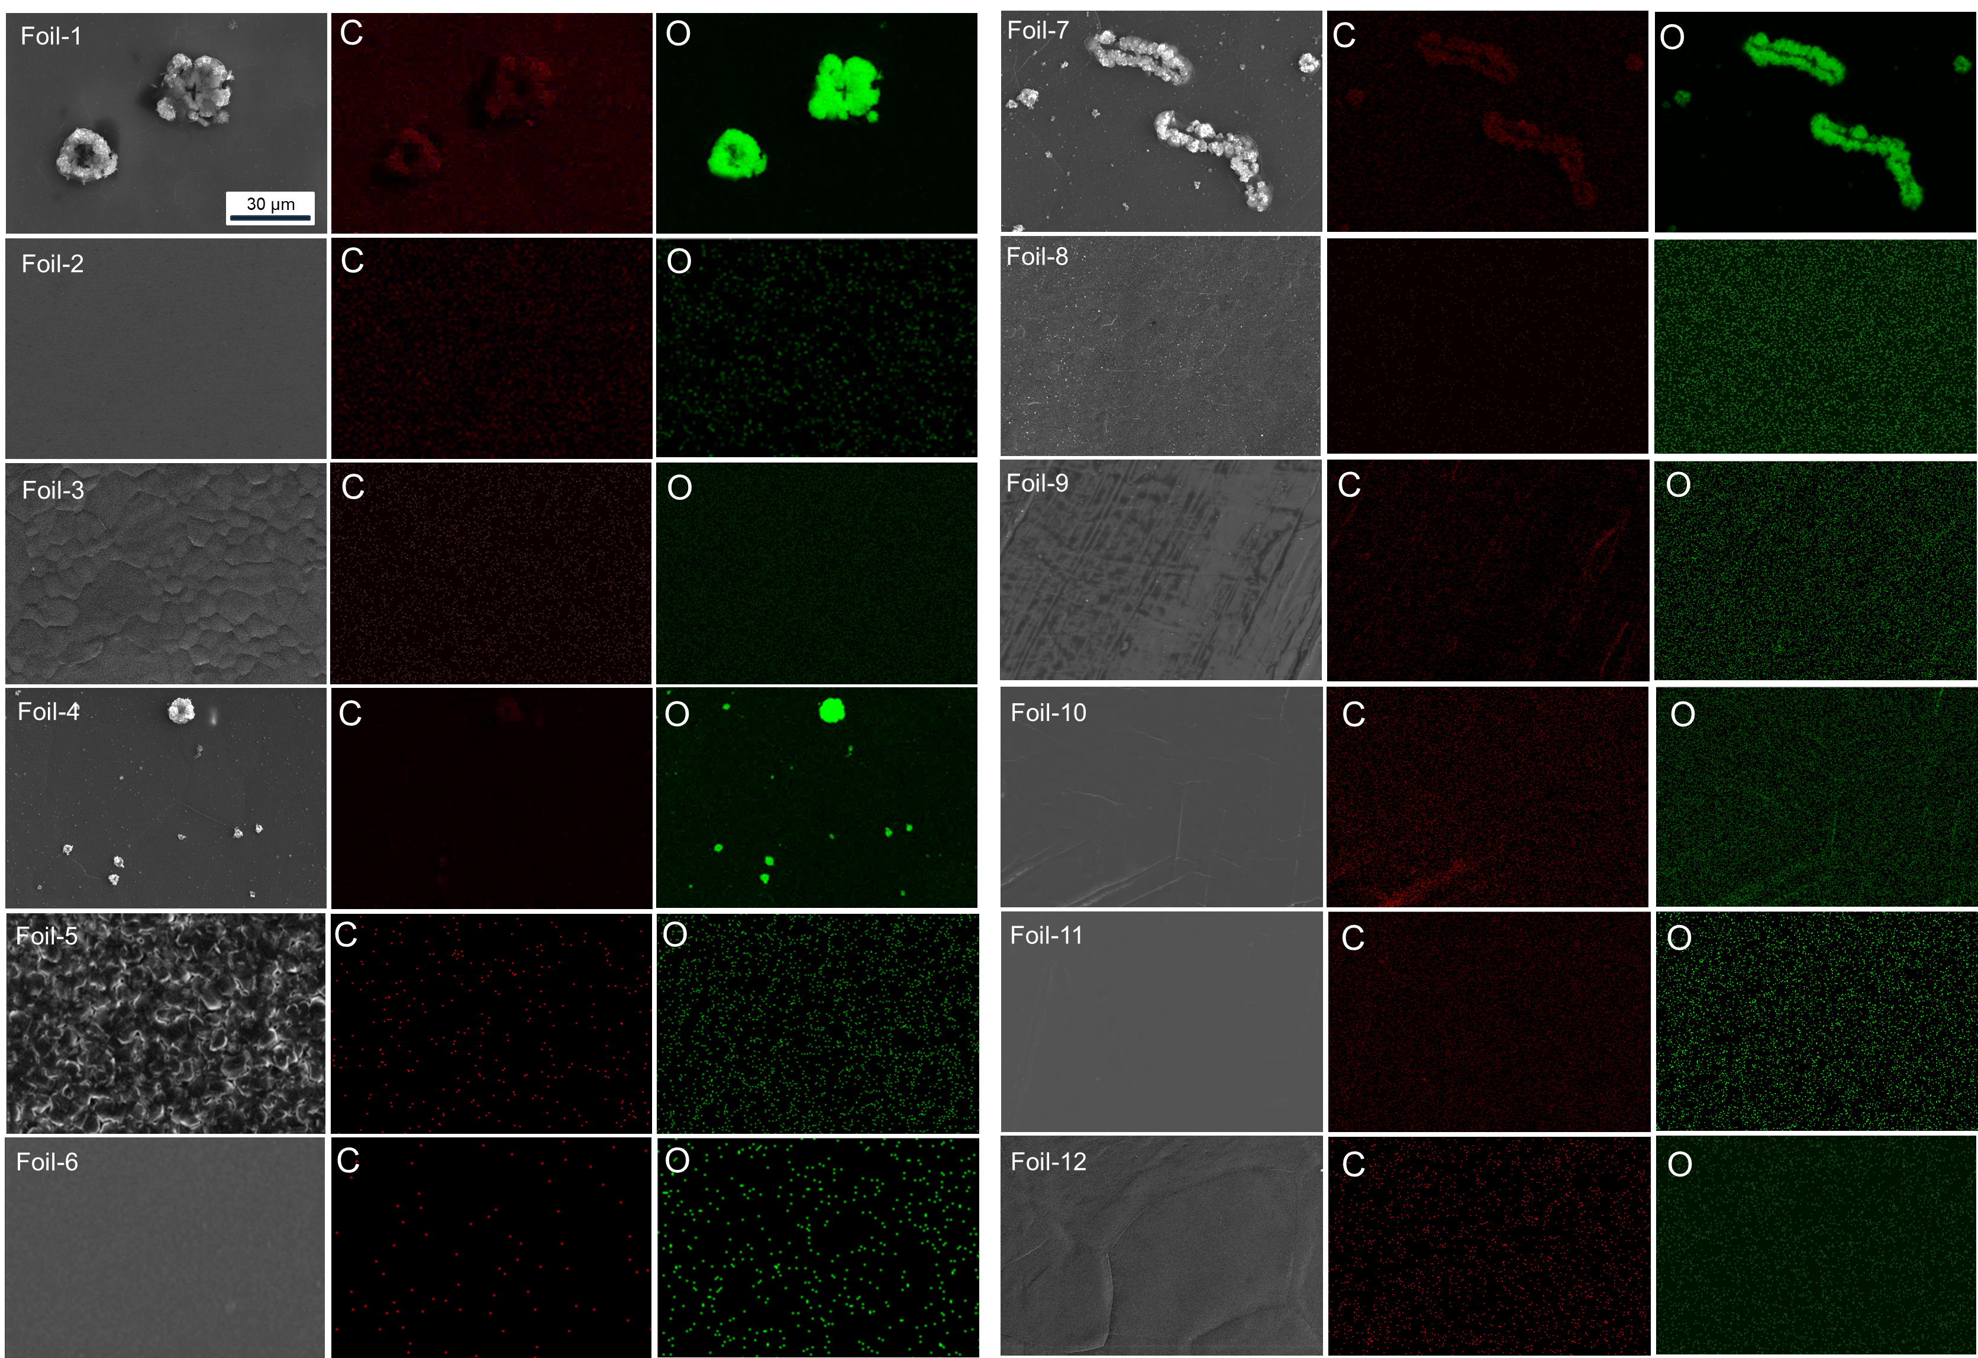
Figure S5. Surface SEM image and EDX mapping of ultrathin (<20 µm)lithium foils.

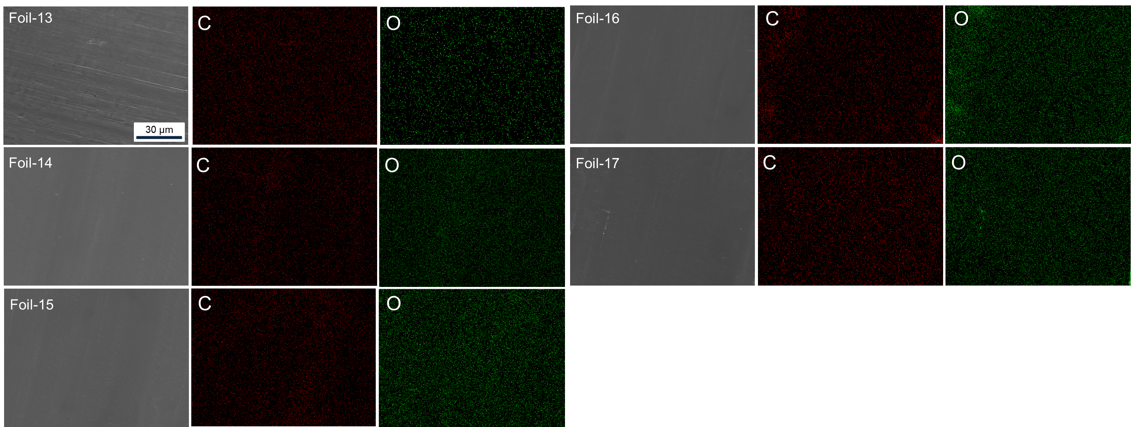
Figure S6. Surface SEM image and EDX mapping of thin (20-50 µm) and thick (>50 µm) lithium foils.

Table S1. Impurity level of Na, Mg, and Fe in lithium foils studied by ICP-MS.
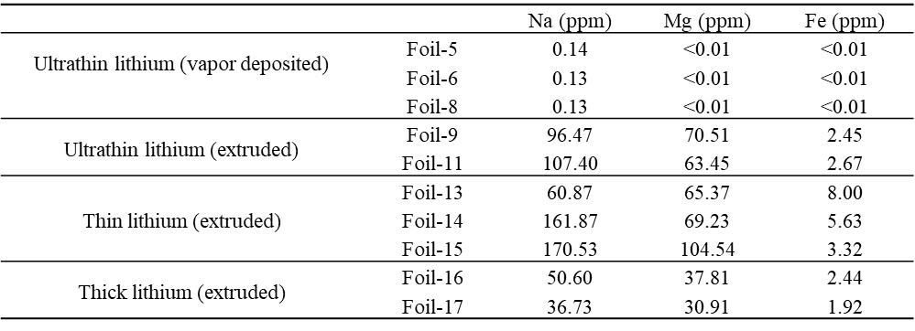

Table S2. Spearman correlation coefficients (ρ) between surface descriptors and stripping overpotential across all 17 commercial lithium foils. Color neutrality is defined as −√(a² + b²). p-values below 0.05 indicate statistically significant correlations.
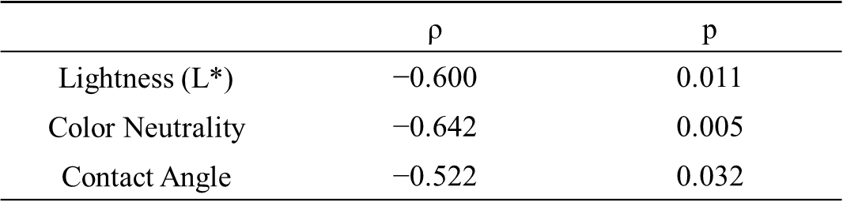
Table S3. Fitting parameters used to identify different compounds on metallic lithium surface in the C 1S XPS spectrum.
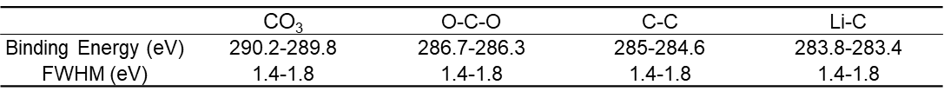

Table S4. Fitting parameters used to identify different compounds on metallic lithium surface in the O 1S XPS spectrum.
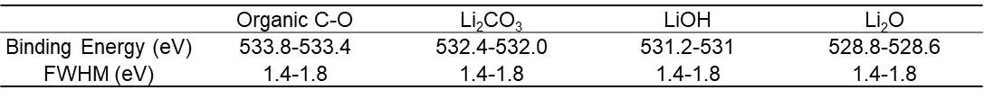

Table S5. Fitting parameters used to identify different compounds on metallic lithium surface in the Li 1S XPS spectrum.
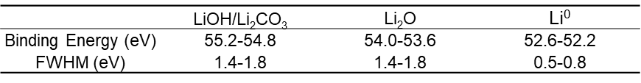

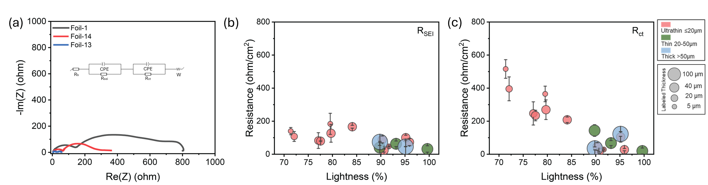
Figure S7. EIS analysis of lithium foils in Li||Li symmetric cells prior to cycling. a) Representative Nyquist plots of Foil-1 (lowest lightness, 71.4%), Foil-14 (intermediate lightness, 89.8%), and Foil-13 (highest lightness, 99.6%), with the inset showing the equivalent circuit used for fitting. b) R_{SEI} and c) R_{ct} as a function of surface lightness across all measured foils, showing that both resistances increase with decreasing lightness, with Rct exhibiting a more pronounced dependence.
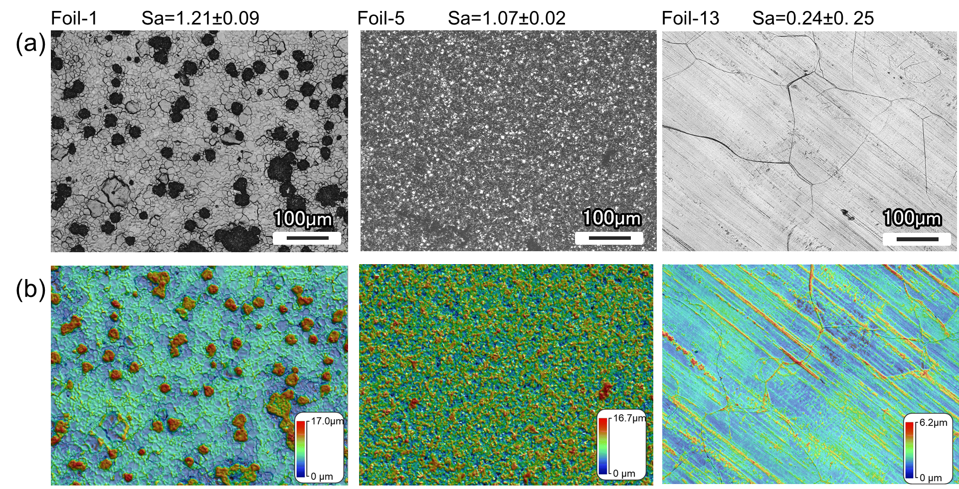
Figure S8. Surface topography and morphology characterization of representative lithium foils with distinct roughness origins. Surface roughness (Sa) across all 17 commercial lithium foils ranges from 0.24 to 1.21 µm, with foil-13 exhibiting the lowest and foil-1 the highest Sa value among the sample set. a) Optical surface images and b) profilometry height maps of foil-1, foil-5, and foil-13. Corresponding profilometry height maps with maximum surface heights of 17.0, 16.7, and 6.2 µm, respectively. Foil-1 exhibits localized oxidation domains and a cracked surface network, with elevated roughness arising from the accumulation of oxidation products. Foil-5 displays a uniformly textured surface with fine granular features characteristic of its manufacturing process. Foil-13 shows a relatively smooth surface dominated by regular parallel rolling marks, consistent with its low Sa value of 0.24 µm.

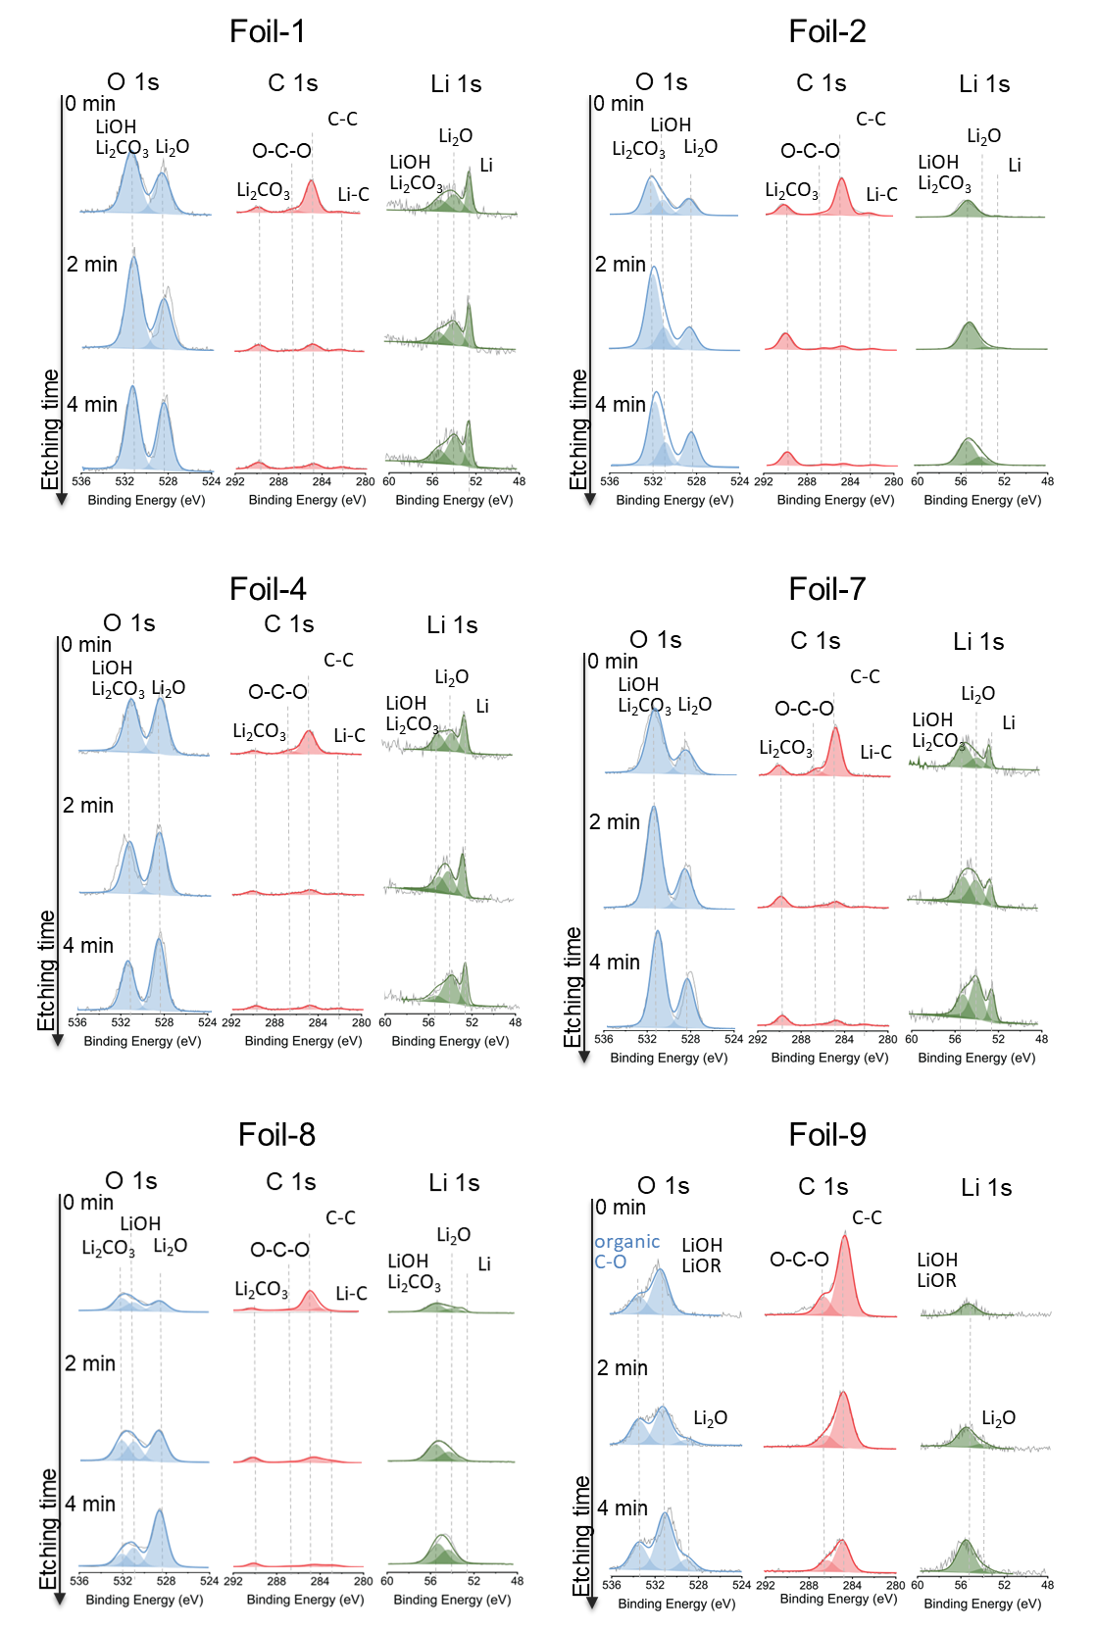
Figure S9. XPS comparison of O 1s, C 1s, and Li 1s spectra for ultrathin (<20 µm)lithium foils.
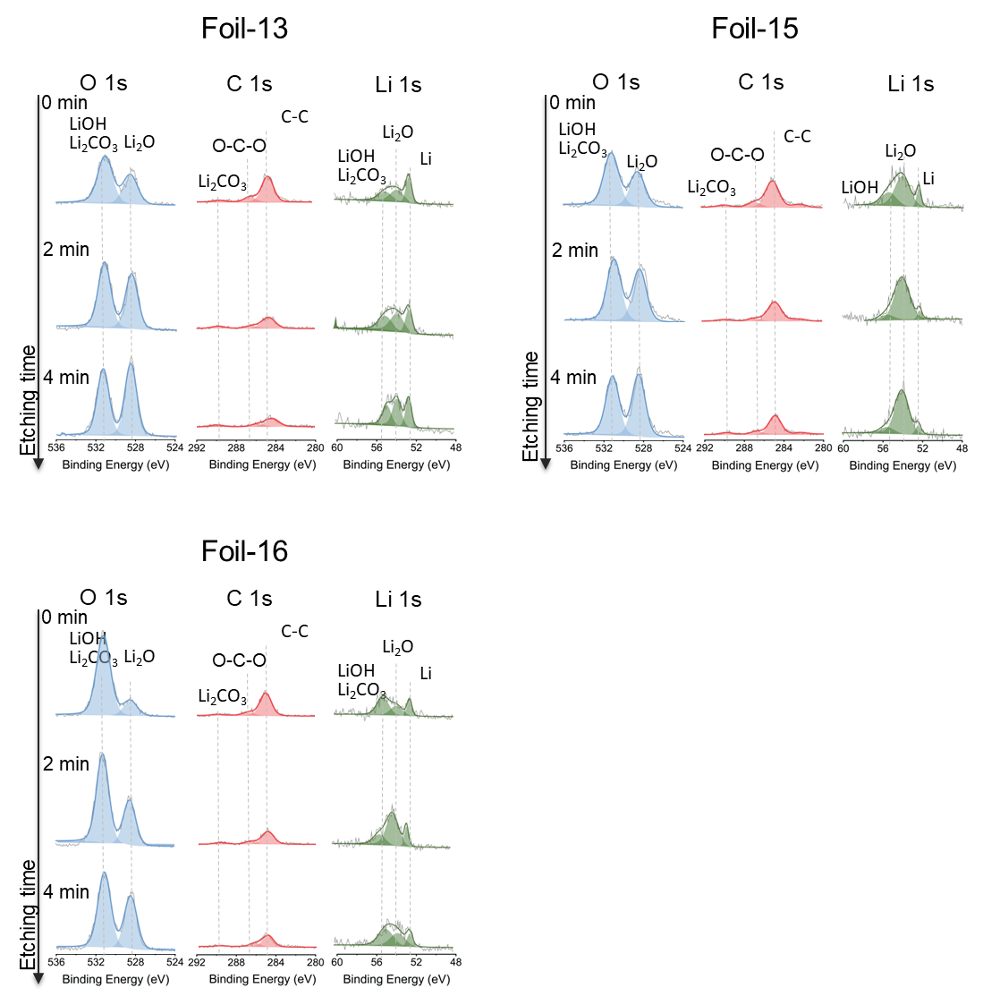
Figure S10. XPS comparison of O 1s, C 1s, and Li 1s spectra for thin (20-50 µm) and thick (>50 µm) lithium foils.
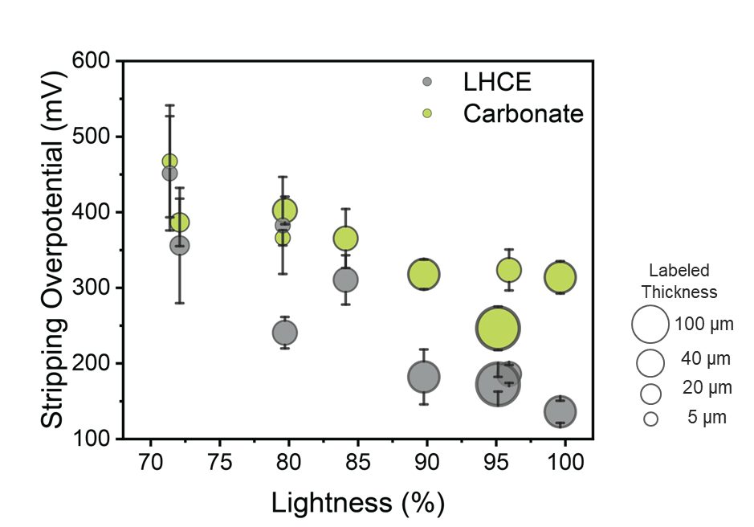
Figure S11. Stripping overpotential as a function of surface lightness (L*) measured in Li||Cu asymmetric cells using LHCE (gray) and carbonate electrolyte (1 M LiPF₆ in EC/DMC = 1:1 v/v, green) for a representative subset of 9 foils spanning a wide range of lightness and thickness values. Bubble size represents the labeled foil thickness.
Note: To assess generalizability, stripping overpotential measurements were performed using a carbonate electrolyte (1 M LiPF₆ in EC/DMC = 1:1 v/v) on a representative subset of 9 foils spanning a wide range of lightness and thickness. for foils with high lightness (L* > 80%), the stripping overpotential in carbonate electrolyte is higher than in LHCE, consistent with previously reported higher interfacial reactivity of carbonate electrolytes toward lithium metal surfaces. In these well-preserved foils, the native passivation layer is thin, allowing the carbonate electrolyte to react more readily with the fresh lithium surface during the 4-hour rest period prior to stripping and during the stripping, forming a more resistive surface. In contrast, for foils with low lightness (L* < 80%), the stripping overpotential remains similarly elevated in both electrolytes. We attribute this to the pre-existing thick and resistive passivation layer on these foils, which already dominates interfacial resistance to such an extent that the additional SEI formed by carbonate electrolyte reactivity contributes only marginally within the resting time to the already high overpotential. Our results therefore suggest that rigorous control of lithium foil quality is a prerequisite for meaningful electrolyte benchmarking.

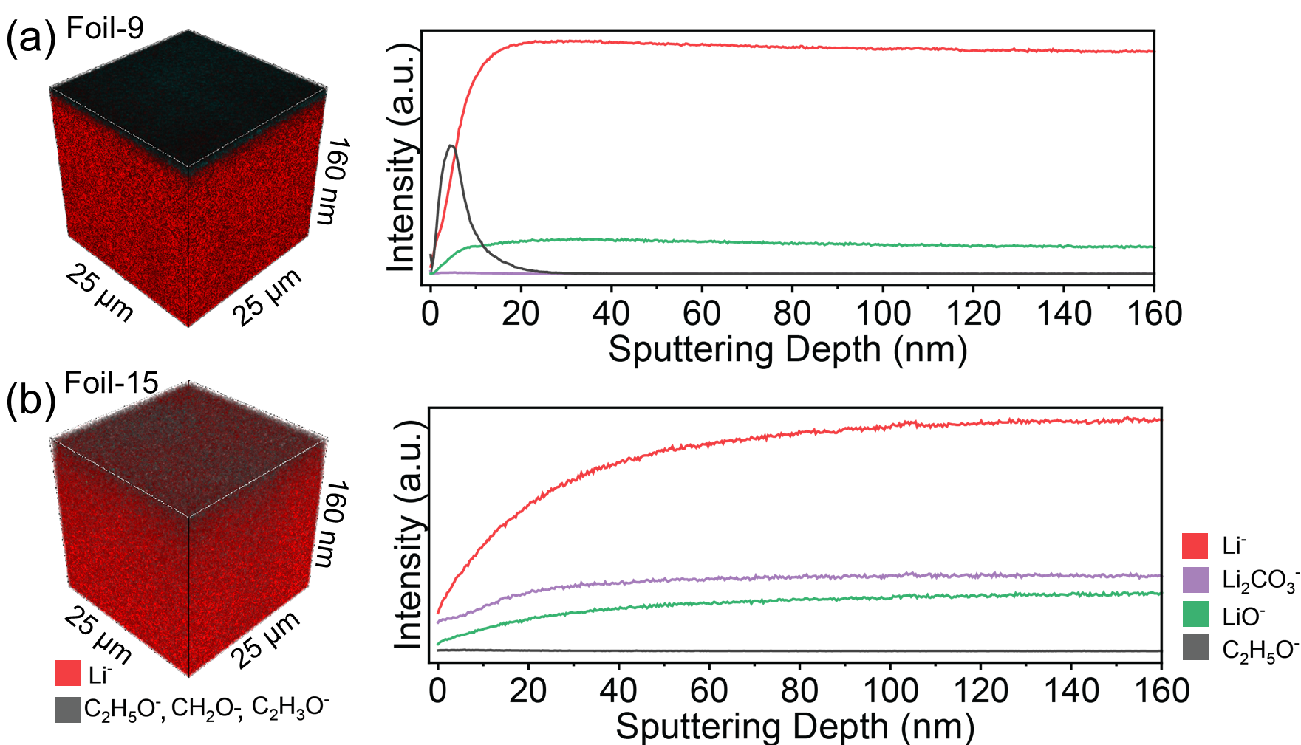
Figure S12. TOF-SIMS depth profiles of representative lithium foils a) foil-9 and b) foil-15. Foil-9 shows a distinct organic-rich surface layer (C₂H₃O⁻) confined to the outermost ~20 nm, followed by a sharp rise in the Li⁻ signal, consistent with an intentional organic coating that effectively suppresses inorganic passivation. The 3D rendering confirms the spatially uniform distribution of the organic layer. b) Foil-15 shows no detectable organic surface species, with Li⁻, Li₂CO₃⁻, and LiO⁻ signals rising gradually without a sharp interface, attributable to lateral averaging over a rough surface (Sa = 1.1 µm) with spatially varying local passivation layer thickness rather than a uniformly thick passivation layer.
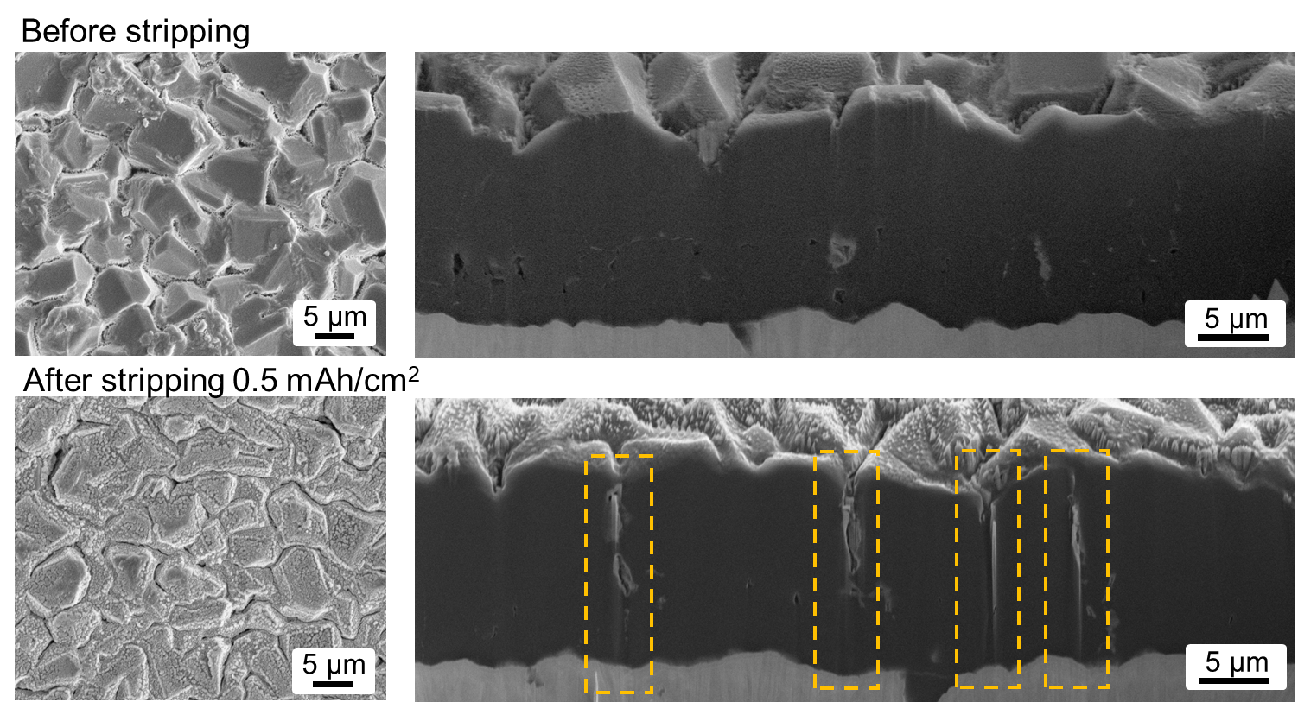
Figure S13. PFIB-SEM cross-section image of foil-5 after stripping 0.5 mAh/cm² under 0.5 mA/cm² current density in a Li||Cu cell.
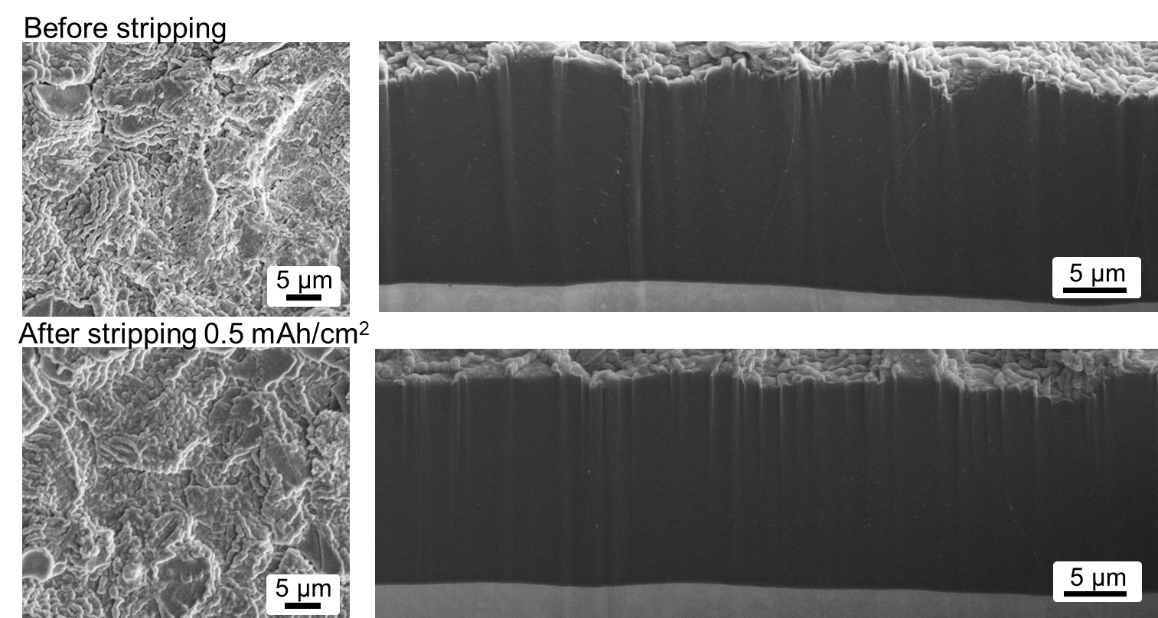
Figure S14. PFIB-SEM cross-section image of foil-6 after stripping 0.5 mAh/cm² under 0.5 mA/cm² current density in a Li||Cu cell.

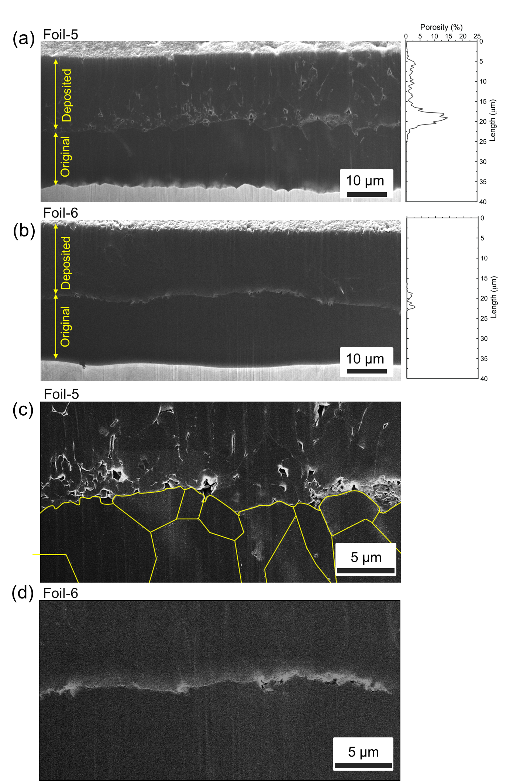
Figure S15. PFIB-SEM cross-section image of a) foil-5 and b) foil-6 after deposition 4 mAh/cm² lithium under 0.5 mA/cm² current density in a Li||Li cell. c) and d) Partially enlarged images.

Supplementary Note- SOP for Full Cell Assembly and Testing

Cathode material:
A single-side coated NMC622 cathode (22.28 mg/cm², 4.01 mAh/cm² based on 180 mAh/g, NMC: Super C65: Solvay 5130 PVDF = 96:2:2, 12 µm Al foil) was used. The cathode discs were dried in a vacuum oven at 120°C overnight and then transferred into an argon-filled glove box (<0.2 ppm O₂, <0.1 ppm H₂O).
Coin cell assembly:
The full cell cycling performance of the lithium foils was evaluated using CR2032 coin cells kit (MTI, USA), including SS316 negative parts, SS316 spacers, and SS316 wave springs. Al-clad positive parts (MTI, USA) were used to prevent corrosion of the can. An additional piece of ¾ inch diameter Al foil (MTI, USA) was placed between the cathode and the positive case. A 20 µm-thick polyethylene (PE) separator (SKSEPR-25-150-200m, SK Korea, Korea) with ¾ inch diameter was employed. Each cell contained 18 g/Ah of electrolyte. For free-standing lithium foils without a copper current collector, an additional Cu foil (MTI, USA) was placed between the Li anode and the SS316 spacer. Cells were crimped at 1000 psi. All material handling and cell assembly were conducted in an argon-filled glovebox (<0.2 ppm O₂, <0.1 ppm H₂O).
Cycling protocols:
Cells were tested in an environmental test chamber (Neware, China) with a constant temperature at 25 °C. The cells were tested in horizontal position to help the distribution of liquid electrolyte. The voltage window was 4.4 V- 2.8 V. Cells were rested for 4 h prior to cycling, followed by two formation cycles at C/10 charge and D/10 discharge rates (1C = 4 mA/cm²). Subsequent cycling was performed at C/5 rate for charge and C/2 rate for discharge until 80% capacity retention was reached.

