Supplementary Information
Hole-Extraction Embedded Ultrathin Donor Realized Highly Homogenized Dense Self-Assembled Monolayers Enabling Organic Photovoltaics Modules With a Certified Efficiency of 16.1%
Xiangyue Kong,¹ Zhi-Xi Liu,^{1,2,}* Liqing Xiao,³ He Liu,^{1,2} Hao Wang,⁴ Zhen Chen,³ Shaoming Sun,^{1,2} Xinxin Xia,⁴ Weifei Fu,¹ Weiming Qiu,^{3,}* Xi Yang,³ Hongzheng Chen^{1,2,}*

¹Zhejiang Provincial Key Laboratory of Optoelectronic Functional Materials and Devices, Zhejiang University-Hangzhou Global Scientific and Technological Innovation Center, Hangzhou 311200, P. R. China.
²State Key Laboratory of Silicon and Advanced Semiconductor Materials, MOE Key Laboratory of Macromolecular Synthesis and Functionalization, Department of Polymer Science and Engineering, Zhejiang University, Hangzhou 310058, P. R. China.
³Guangzhou Chasinglight Technology Co., Ltd., Guangzhou 510535, P. R. China.
⁴National Engineering Research Center for Colloidal Materials, Shandong University, Shandong 250100, P. R. China.
*Correspondence: z-xliu@zju.edu.cn; weimingqiu@chasinglight.cn; hzchen@zju.edu.cn.

Materials and Methods
Material synthesis
Unless otherwise described, all reagents and solvents were purchased from commercial sources and used without further purification. PM6 and L8-BO were purchased from Chasinglight. 1,8-Diiodooctane (DIO) was purchased from Merck. K1, K2, K3 and K4 were synthesized in our group.
Synthesis of K1
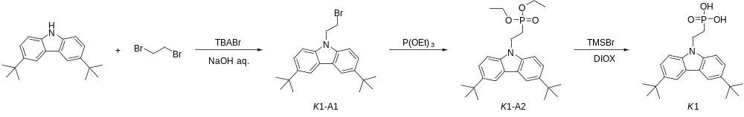
3,6-Di-tert-butylcarbazole (2.79 g, 10 mmol) was dissolved in 1,2-dibromoethane (30 mL), and tetrabutylammonium bromide (0.32 g, 1 mmol) with 50% KOH aqueous solution (20 mL) were added subsequently. Reaction was stirred at 70°C for 3 h. After completion of the reaction, extraction was done with ethyl acetate. The organic layer was dried over anhydrous Na₂SO₄, and the solvent was distilled off under reduced pressure. The crude product was purified by column chromatography using n-hexane as eluent to give 2.9 g K1-A1 (yield 75.1%) as a white crystalline material. Compound K1-A1 (2.9 g, 7.5 mmol) was dissolved in triethyl phosphite (30 mL) and the reaction mixture was heated at reflux for 3h. After reaction completion, the solvent was distilled off under reduced pressure. The crude product was purified by column chromatography using ethyl acetate/n-hexane (1:1 v/v) as eluent to give 2.9 g K1-A2 (yield 87.1%) as clear liquid. Compound K1-A2 (2.9 g, 6.5 mmol) was dissolved in dry 1,4-dioxane (30 mL) under argon. Afterwards, bromotrimethylsilane (2.9 mL) was added dropwise. Reaction was kept for 24 h at 25°C under argon atmosphere. Afterwards, methanol (20 mL) was added to the reaction mixture, the solvent was distilled off under reduced pressure, and distilled water was added dropwise, until precipitate was formed. Product was filtered off and washed with water and dichloromethane to give 1.65 g K1 (yield 65.1%) as a white solid.
Synthesis of K2
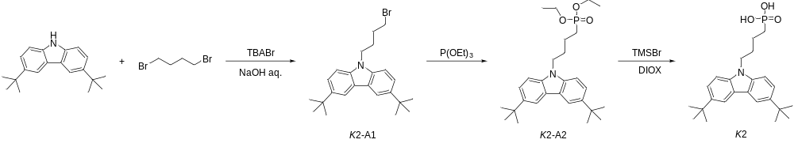3,6-Di-tert-butylcarbazole (2.79 g, 10 mmol) was dissolved in 1,4-dibromobutane (30 mL), and tetrabutylammonium bromide (0.32 g, 1 mmol) with 50% KOH aqueous solution (20 mL) were added subsequently. Reaction was stirred at 70°C for 3 h. After completion of the reaction, extraction was done with ethyl acetate. The organic layer was dried over anhydrous Na₂SO₄, and the solvent was distilled off under reduced pressure. The crude product was purified by column chromatography using n-hexane as eluent to give 3.23 g K2-A1 (yield 77.9%) as a white crystalline material. K2-A1(3.2 g, 7.7 mmol) was dissolved in triethyl phosphite (40 mL) and the reaction mixture was heated at reflux for 3h. After reaction completion, the solvent was distilled off under reduced pressure. The crude product was purified by column chromatography using ethyl acetate/n-hexane (1:1 v/v) as eluent to give 3.0 g K2-A2 (yield 82.4%) as clear liquid. K2-A2 (3.0 g, 6.5 mmol) was dissolved in dry 1,4-dioxane (30 mL) under argon. Afterwards, bromotrimethylsilane (3 mL) was added dropwise. Reaction was kept for 24 h at 25°C under argon atmosphere. Afterwards, methanol (20 mL) was added to the reaction mixture, the solvent was distilled off under reduced pressure, and distilled water was added dropwise, until precipitate was formed. Product was filtered off and washed with water and dichloromethane to give 1.55 g K2 (yield 58.6%) as a white solid.
Synthesis of K3
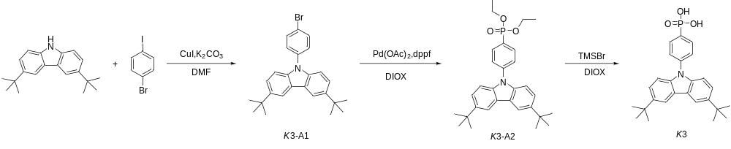3,6-Di-tert-butylcarbazole (2.79 g, 10 mmol) and 1,4-dibromobenzene (5.66 g, 20 mmol) were dissolved in 50 mL N,N-dimethylformamide (DMF), and K₂CO₃ (2.76 g, 20 mmol) and CuI (0.38 g, 2 mmol) were added subsequently. The mixture was stirred at 140°C for 24 h. After cooling to room temperature, the resulting mixture was washed with water and extracted with ethyl acetate. The combined organic layer was dried over anhydrous MgSO₄. After the solvent was evaporated under reduced pressure, the crude product was purified by column chromatography on silica gel (n-hexane:ethyl acetate = 4:1 v/v as the eluent) to give 3 g K3-A1 (yield 69.1%) as a white solid. K3-A1 (3 g, 6.9 mmol) diethyl phosphite (2.33 g, 14 mmol), Pd(OAc)₂ (0.015 g, 0.065 mmol), Dppf (0.072 g, 0.13 mmol) and potassium acetate (0.026 g, 0.26 mmol) were dissolved in 25 mL 1-iodo-4-bromobenzene. The mixture was heated at reflux for 8 h. After cooling to room temperature, the resulting mixture was washed with water and extracted with ethyl acetate. The combined organic layer was dried over anhydrous MgSO₄. After the solvent was evaporated under reduced pressure, the crude product was purified by column chromatography on silica gel (ethyl acetate/n-hexane (1:1 v/v) as the eluent) to give 2.85 g K3-A2 (yield 83.9%) as a white solid. K3-A2 (2.85 g, 5.8 mmol) was dissolved in 30mL CH₂Cl₂. Afterward, bromotrimethyl- silane (2.9 mL, 2.65 mmol) was slowly added dropwise. The mixture was stirred at room temperature for 12 h. The resulting mixture was washed with water and extracted with CH₂Cl_{2.} The combined organic layer was dried over anhydrous MgSO₄. The solution was concentrated under reduced pressure and the product was filtered off and washed with water and dichloromethane to give 1.4 g K3 (yield 55.6%) as a light pink solid. ¹H-NMR (DMSO-d6, ppm): δ 8.30-8.31 (d, 2H), 7.91-7.98 (m, 2H), 7.71-7.75 (m, 2H), 7.47-7.51 (m, 2H), 7.37-7.40 (d, 2H), 2.5 (br, 2H), 1.42 (s, 18H); ¹³C-NMR (101 MHz, CDCl3) δ 142.42, 141.31, 137.37, 134.01, 131.92, 130.20, 126.95, 125.00, 122.75, 115.21, 108.11, 33.61, 30.86. TOF-MS (APCI) m/z: calculated for C₂₆H₃₀NO₃P [+H]⁺ 436.20, found 436.2028.
Synthesis of K4
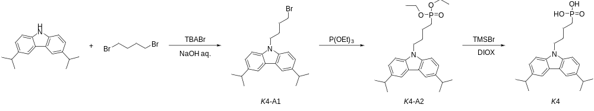
3,6-Diisopropylcarbazole (2.51 g, 10 mmol) was dissolved in 1,4-dibromobutane (25 mL), and tetrabutylammonium bromide (0.32 g, 1 mmol) with 50% KOH aqueous solution (20 mL) were added subsequently. Reaction was stirred at 70°C for 3 h. After completion of the reaction, extraction was done with ethyl acetate. The organic layer was dried over anhydrous Na₂SO₄, and the solvent was distilled off under reduced pressure. The crude product was purified by column chromatography using n-hexane as eluent to give compound 3.1 g K4-A1 (yield 80.2%) as a white crystalline material. Compound K4-A1(3.1 g, 8 mmol) was dissolved in triethyl phosphite (40 mL) and the reaction mixture was heated at reflux for 3 h. After reaction completion, the solvent was distilled off under reduced pressure. The crude product was purified by column chromatography using ethyl acetate/n-hexane (1:1 v/v) as eluent to give compound 2.8 g K4-A2 (yield 78.9%) as clear liquid. Compound K4-A2 (2.8 g, 6.3 mmol) was dissolved in dry 1,4-dioxane (30 mL) under argon. Afterwards, bromo trimethyl silane (2.8 mL) was added dropwise. Reaction was kept for 24 h at 25°C under argon atmosphere. Afterwards, methanol (20 mL) was added to the reaction mixture, the solvent was distilled off under reduced pressure, and distilled water was added dropwise, until precipitate was formed. Product was filtered off and washed with water and dichloromethane to give compound K4 as a white solid. ¹H-NMR (DMSO-d6, ppm): δ 7.98-7.99 (d, 2H), 7.45-7.47 (d, 2H), 7.28-7.31 (br s, 2H), 4.29-4.33 (t, 2H), 3.02-3.07 (sept, 2H), 2.5 (br, 2H), 1.80-1.83 (m, 2H), 1.50-1.53 (m, 4H), 1.23 (d, 12H); ¹³C-NMR (101 MHz, CDCl3) δ 138.34, 138.11, 123.41, 121.84, 116.40, 107.11, 41.56, 33.09, 28.59, 28.45, 24.62, 23.71, 23.16, 18.97. TOF-MS (APCI) m/z: calculated for C₂₂H₃₀NO₃P [+H]⁺ 388.20, found 388.2041.

Device fabrication and characterization
Organic photovoltaics (OPVs) are manufactured on commercially pre-coated ITO-coated glass substrates, specifically with device structures featuring HE-AL and HE-UD, such as ITO/active layer+self-assembled molecules/PDINN/Ag and ITO/PM6+self-assembled molecules/active layer/PDINN/Ag. The patterned ITO-coated glass substrates with a sheet resistance of ~15 Ω sq⁻¹ were purchased from Guangzhou Chasinglight Technology Co., Ltd. Prior to fabrication, the substrate is continuously cleaned with detergent, deionised water, acetone, and isopropyl alcohol for 30 minutes at each step, followed by treatment in an ultraviolet ozone generator for 20 minutes. For HE-AL device, dissolving self-assembled molecules in toluene to form a solution with a concentration of 0.65 mg/mL, the PM6:L8-BO active layer material was dissolved in the above solution (D:A ratio of 1:1.2, concentration of 16.5 mg/mL, 100℃, 2 h, 0.25% DIO). In a nitrogen-filled glove box, spin-coating the corresponding PM6:L8-BO+ self-assembled molecules solution at 2000 rpm for 20 s, followed by annealing at 80℃ for 10 minutes. For HE-UD devices, dissolving self-assembled molecules in toluene to form a solution with a concentration of 0.20 mg/mL (60℃ for 10 minutes), the PM6 material was dissolved in the above solution (purity donor concentration of 1 mg/mL, 60℃ for 1h), and form a PM6+self-assembled molecules solution. First, the PM6+self-assembled molecules solution is spin-coated at a speed of 2500 rpm for 30 s. Subsequently, a toluene solution containing 0.25% DIO at a concentration of 16.5 mg/mL PM6:L8-BO is spin-coated on its surface at the same speed (D:A ratio of 1:1.2). The substrate was then pre-annealed at 80℃ for 10 minutes, followed by spin-coating a 1 mg/mL PDINN methanol solution onto the substrate to form a 5-nm-thick PDINN film as the cathode buffer layer. Finally, a 100 nm Ag electrode was deposited using thermal evaporation, resulting in a device with an effective area of 9 mm² and a testing aperture area of 4.76 mm².
The modules were fabricated with an architecture of ITO/PM6+self-assembled molecules /active layer/PDINN/Ag. The glass substrates were commercially pre-coated with a layer of indium tin oxide (ITO). Prior to fabrication, the substrates were cleaned using detergent, deionized water, acetone and isopropanol consecutively for 15 min in each step, and then treated in an ultraviolet ozone generator for 15 min. The first layer was blade-coated from 0.96mg/ml PM6+self-assembled molecules (0.8:0.16 w/w) toluene solution. Then the wet film was annealed at 80℃ for 10 min. The active layer was blade-coated from 8 mg/ml toluene solution (D:A = 1:1.2 w/w, 0.15%v/v DIO) at room temperature and an air blade was employed to dry the wet film. The distance between the air blade and the solution surface was 10 cm. The angle between the air blade and substrate was kept at 45°. The input N₂ flow pressure was adjusted at 0.3 MPa. Blade coating was performed with an automatic blade coater with a gap height of 100 μm and a coating speed of 10 mm s⁻¹. The coating process was conducted at room temperature. Then, samples were transferred into glove box and annealed at 100℃ for 10 min. After that, PDINN interlayer for modules was blade-coated from a methanol solution (1.0 mg mL⁻¹, filtered through a 0.22 μm filter) using a blade coater with a gap height of 60 μm at 10 mm s⁻¹ and 25 °C, followed by annealing at 80 °C for 5 min. Finally, Ag (100 nm) electrode is deposited under the reduced pressure to complete the device. The series-interconnected module was fabricated using a laser-patterning process. All P1, P2, and P3 patterning steps were performed by laser scribing with precise control of laser power and scanning speed. The effective area of the device is 18.63 cm², then a mask of 18.2 cm² was used to measure the efficiencies. The large-area module was fabricated with a total area of 18.63 cm², consisting of 9 serially interconnected sub-cells. Each sub-cell has a width of 0.46 cm and a length of 4.5 cm. The dead area is mainly composed of the laser scribing regions (P1, P2, P3) and the edge isolation region; the width of dead area is 0.169 cm, corresponding to a GFF of 96.33%.
Contact angle measurements
Prior to sample preparation, the ITO substrate is continuously cleaned with detergent, deionised water, acetone, and isopropyl alcohol for 30 minutes at each step, followed by treatment in an ultraviolet ozone generator for 20 minutes. K-series molecules were dissolved in toluene to form a solution with a concentration of 0.20 mg/mL. K-series solution is spin-coated at a speed of 2500 rpm for 20 s on ITO substrate, which was then pre-annealed at 80℃ for 10 minutes. The contact angle measurements were conducted on a drop shape analysis system, using water and diiodomethane as probe liquids (0.5 µL). Several drops (typically three repetitions) were quickly placed on the surface, the needle was pulled back, and the drop shape was captured immediately with the camera. Images were analyzed with drop shape analysis software to determine the contact angle by the method most suitable for each given drop, usually circle fitting, and the results were averaged. Contact angle measurements were carried out using a drop shape analysis system (Model OCA20, DataPhysics Instruments GmbH, Germany) equipped with high-resolution optical camera and automatic liquid dosing unit.
Structural and optoelectronic characterization
¹H-NMR spectra were measured by Bruker NEO 700 spectrometer. UV-vis absorption spectra were recorded with a Shimadzu UV-1800 spectrophotometer.
Work Function Measurement
Ultraviolet photoelectron spectroscopy (UPS) experiments were performed using a GENESIS 500 system with a He I source (21.22 eV) and an applied negative bias of 10.0 V. Work function is calculated using the standard formula W_{F} = 21.22 eV - E_{cutoff}, where 21.22 eV corresponds to the He I photon energy, and secondary‑electron cutoff (E_{cutoff}) was extracted via linear extrapolation of the steep slope of the secondary‑electron tail. All measurements were calibrated with an Au reference sample prior to data acquisition.
TOF-SIMS measurements
TOF-SIMS characterization was performed with a TOF-SIMS 5 spectrometer (ION-TOF GmbH). A pulsed Bi³⁺ (30 keV, 20 ns) ion beam in a high current mode was applied for depth profiling and a Cs⁺ ion (1 keV) beam was utilized for sputtering. Negative ion mode. Single ion beam: Bi³⁺ 30 keV, 45° incidence, scanning area 50 μm × 50 μm, 128 × 128 pixels. Sputtering ion beam: Cs⁺ 1 kV, 60 nA, 45° incidence, sputtering area 200 μm × 200 μm. Use airtight interface equipment to transfer air-sensitive samples from the argon-filled glove box to the TOF-SIMS instrument to eliminate air contamination during the characterization process. The 3D reconstruction was realized by integrating the sputter-depth-resolved ion intensity data collected during the full depth profile, using the instrument’s built-in software SurfaceLab 7 (ION-TOF GmbH).
Photoelectric characteristics
The J-V measurement was performed using a solar simulator (SS-F5-3A, Enlitech) with AM 1.5G spectra, the intensity of which was calibrated using a certified standard silicon solar cell (SRC-2020, Enlitech) at 100 mW/cm². External quantum efficiency (EQE) data were obtained using the solar cell spectral response measurement system (RE-R, Enlitech).
SCLC mobility measurements
The charge carrier mobilities of the blend films were measured using the space-charge-limited current (SCLC) method. Hole-only devices were fabricated in a structure of indium tin oxide (ITO)/PM6+self-assembled molecules /active layer/MoO₃/Ag. The device characteristics were extracted by modeling the dark current under forward bias using the SCLC expression described by the Mott-Gurney law:
$J=\frac{9}{8}ε_{γ}ε_{0}μ\frac{V^{2}}{L^{3}}$ (1)
Here, ε_{r} ≈ 3 is the average dielectric constant of the blend film, ε₀ is the permittivity of the free space, μ is the carrier mobility, L is the thickness of the film, and V is the applied voltage.
Atomic force microscopy
Topographic images of the films were obtained using a Veeco MultiMode atomic force microscope (AFM) in tapping mode with an etched silicon cantilever at a nominal load of ~2 nN. The scanning rate for an image size of 5 µm × 5 µm was 1.5 Hz.
Kelvin probe force microscopy (KPFM)
Kelvin probe force microscopy (KPFM) measurements were performed under ambient dark atmosphere using an atomic force microscope system (Asylum Research, Cypher ES, Oxford Instrument) equipped with a conductive Pt/Ir-coated silicon tip (SCM-PIT-V2, Bruker). The scanning mode was set to lift-mode KPFM with a lift height of 30 nm to eliminate topographic crosstalk. A scan rate of 1 Hz was adopted for all samples, and the scanning area was fixed at 5 × 5 μm for uniform comparison. Surface potential distribution histograms were derived from the raw potential data of the scanned region.
Grazing incidence wide angle x-ray scattering
The equipment used is the Xeuss 3.0 SAXS/WAXS. The detector model is Eiger2R 1M, with a pixel size of 75 mm; an 8.05 KeV X-ray from a copper target was used, with a wavelength of 1.54189 Å. Test environment: Vacuum (< 1 mbar). Temperature: 24 degrees Celsius Detector-to-sample distance: 100 mm; spot centre coordinates: x 90, z 1034.
Electrochemical impedance spectroscopy
The instrument Model is the CHI604F. Test setup: Electrochemical workstation model, AC perturbation amplitude (0.1 V), Frequency scanning range (3*10⁶ Hz to 0.1 Hz); Fitting procedure: Software used for Nyquist curve deconvolution, fixed equivalent circuit model applied uniformly for all samples.

Supplementary Figures
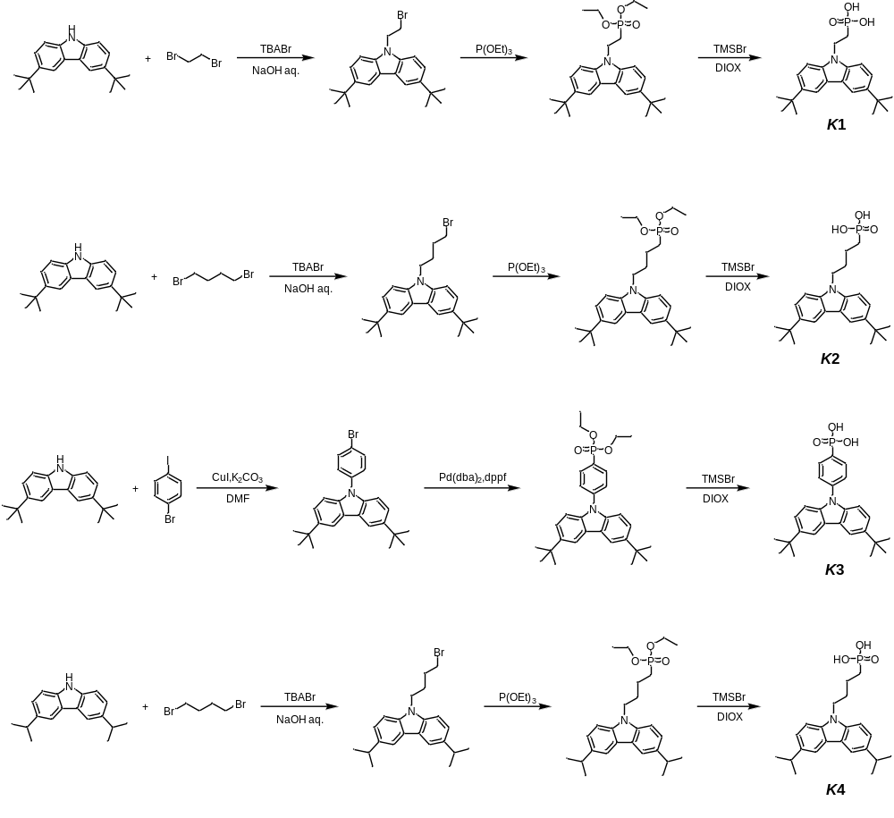Scheme S1 Detailed synthetic routes of self-assembled molecules (K1, K2, K3, K4). Compounds were synthesized according to previous literature.

.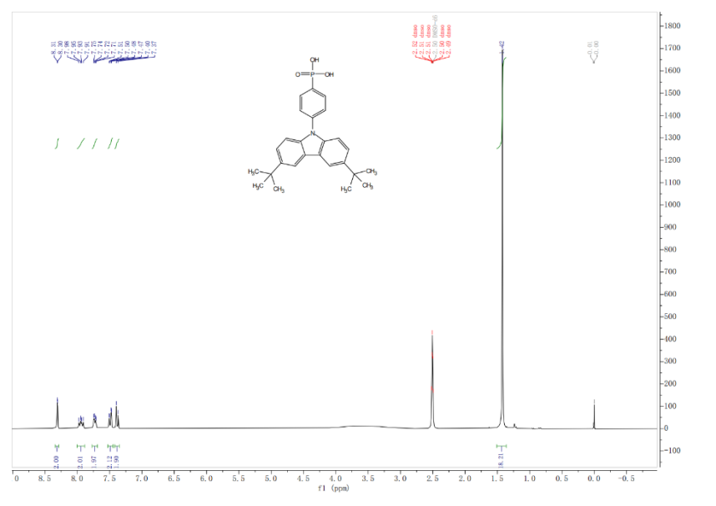
Fig. S1 ¹H NMR spectrum of K3.
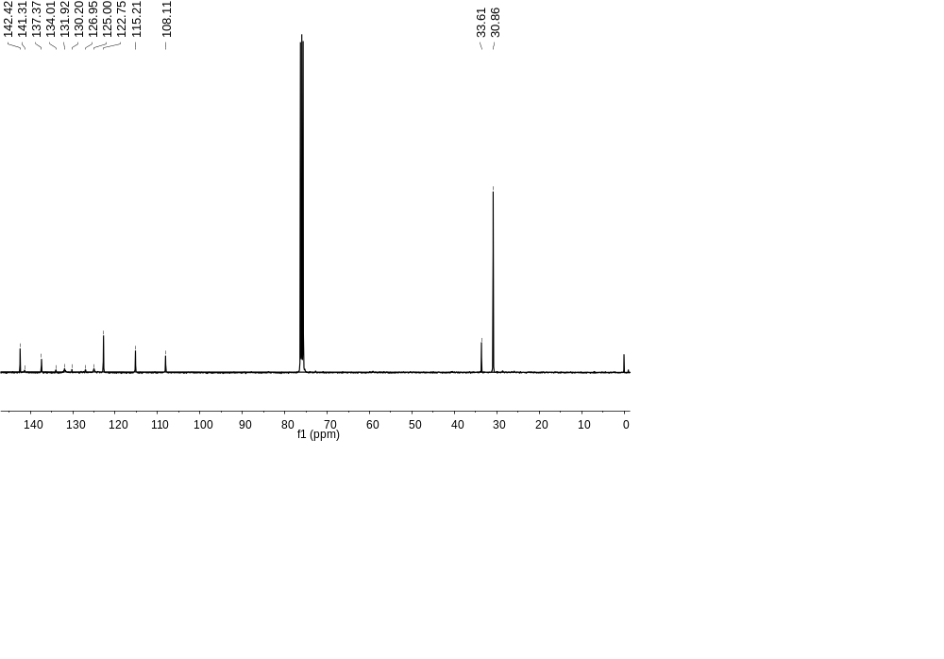
Fig. S2 ¹³C NMR spectrum of K3.
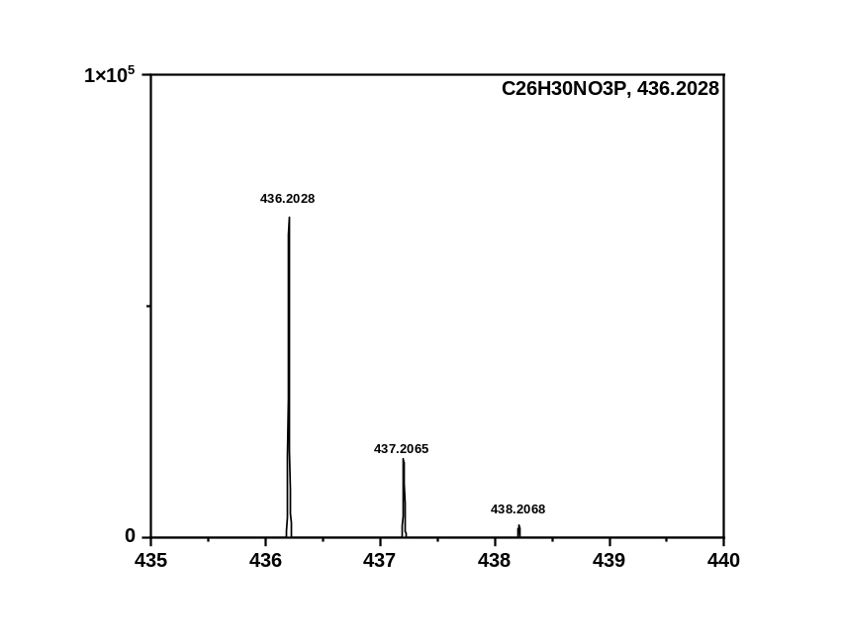
Fig. S3 Mass spectra of K3.
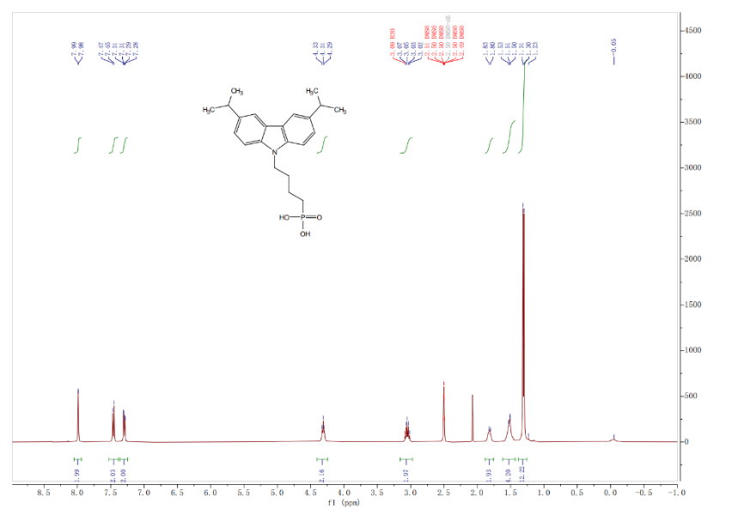
Fig. S4 ¹H NMR spectrum of K4.
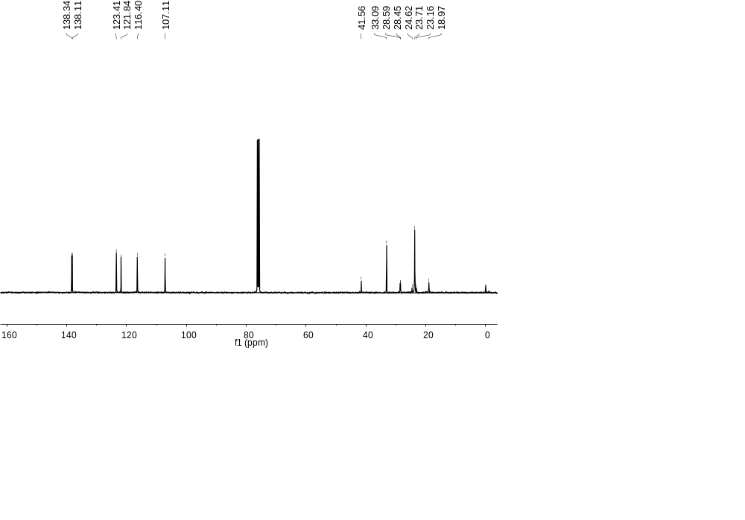
Fig. S5 ¹³C NMR spectrum of K4.
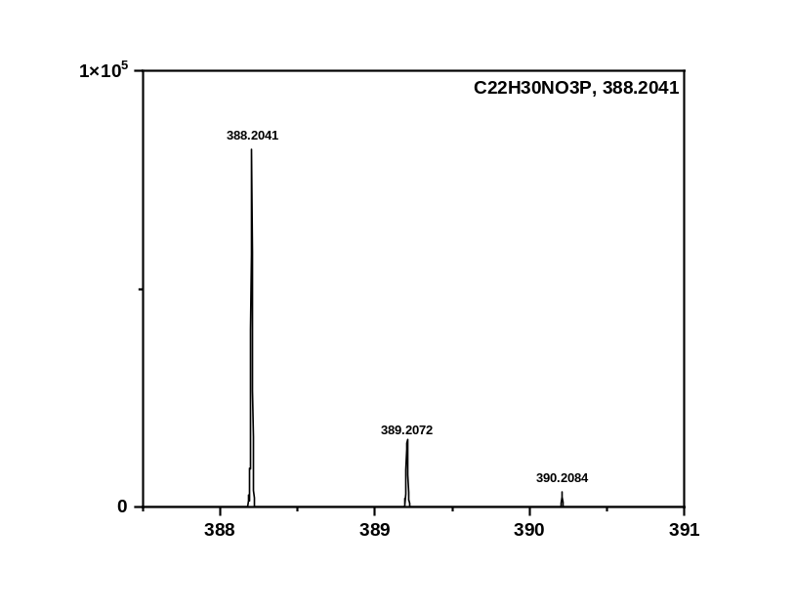
Fig. S6 Mass spectra of K4.
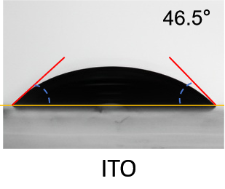
Fig. S7 Water drop contact angles of bare ITO.

Table S1 Summary of dispersion (γ^{d}) and polar (γ^{p}) components of surface tensions, surface tensions (γ), Flory-Huggin’s interaction parameters (χ) for various films.
Film | $$γ^{d}$$  (mN m⁻¹) | $$γ^{p}$$  (mN m⁻¹) | γ  (mN m⁻¹) | $$γ_{PM6-SAM}^{b}$$ | $${}_{PM6-SAM}^{a}$$
2PACz | 13.38 | 47.21 | 60.58 | / | /
K1 | 3.01 | 58.86 | 61.87 | 2.46 | 0.30
K2 | 2.82 | 64.69 | 67.51 | 1.53 | 0.04
K3 | 2.25 | 61.92 | 64.17 | 1.35 | 0.16
K4 | 4.12 | 62.80 | 66.92 | 2.87 | 0.06
PM6 | 0.68 | 70.15 | 70.83 | / | /
L8-BO | 1.99 | 74.07 | 76.06 | / | /
ª The relative interaction parameter between the donor (D) and self-assembled molecule (S) was estimated using the surface-energy-based relation ${}^{D-S}={\left(\sqrt{γ_{D}}-\sqrt{γ_{S}}\right)}^{2}$, where γᴰ and γ^{S} are the surface tensions of the donor and self-assembled molecule films, respectively. No additional empirical constant k was used in this calculation.
^{b} The interfacial tension between A and B can be calculated through the Wu’s Equation of $γ_{A/B}=γ_{A}+γ_{B}-4\left(\frac{{γ_{A}}^{d}{γ_{B}}^{d}}{{γ_{A}}^{d}+{γ_{B}}^{d}}+\frac{{γ_{A}}^{p}{γ_{B}}^{p}}{{γ_{A}}^{p}+{γ_{B}}^{p}}\right)$.

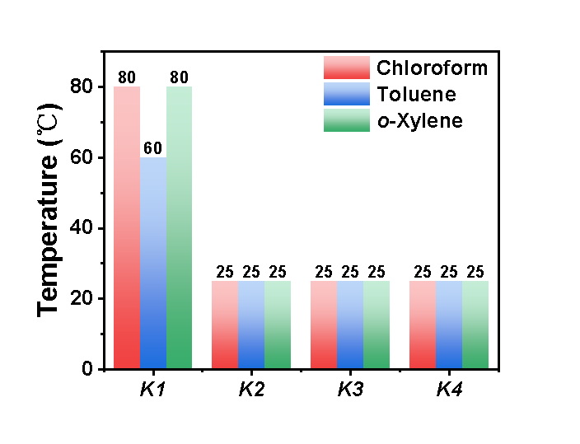
Fig. S8 Testing the dissolution behavior of self-assembled molecules in different solvents (the concentration of all self-assembled molecules was fixed at 0.2 mg/mL, with dissolution monitored via temperature profiling).

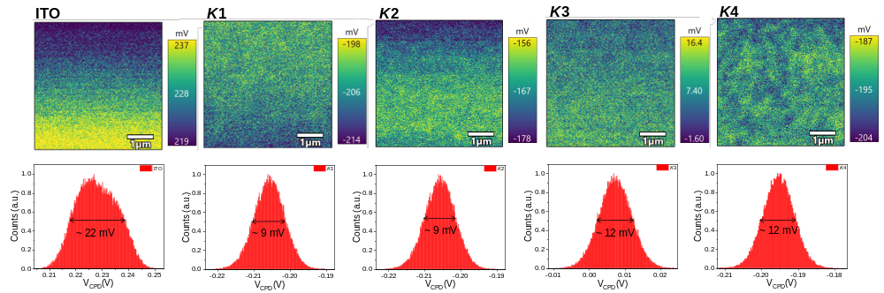
Fig. S9 KPFM surface potential maps and histograms of ITO substrates modified with K-series molecules after toluene washing. The labeled mV values denote the full width at half maximum (FWHM) of each CPD distribution. A rigorous re-examination of raw instrument parameter logs confirms that all measurements were conducted under strictly unified conditions (identical tip, constant scanning duration, and dark ambient environment).
Table S2 Three parallel water contact angle measurements on bare ITO and the K-series interfacial layers after toluene treatment (toluene washing was used to remove the active layer and physiosorbed molecules that did not form chemical bonds with the ITO substrate).
 | θ_{water} (°) | θ_{water} (°) | θ_{water} (°) | Deviation
ITO | 46.5 | 45.9 | 46.1 | 0.31
K1 | 93.8 | 94.5 | 94.8 | 0.51
K2 | 93.2 | 92.4 | 93.4 | 0.53
K3 | 98.0 | 95.9 | 93.8 | 2.10
K4 | 88.3 | 89.5 | 85.7 | 1.94

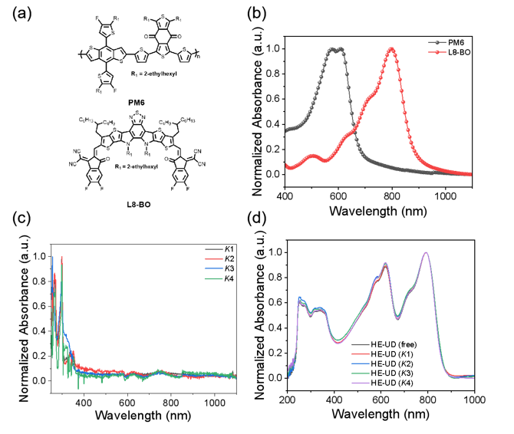
Fig. S10 (a) Chemical structures and (b) normalized UV-vis spectra of PM6 and L8-BO pure films. (c) Normalized UV-vis spectra of self-assembled molecules and (d) HE-UD blends. All spectra were normalized to their respective maximum absorbance intensity without baseline subtraction. The films in panels (c-d) were prepared on glass substrates.
Table S3 The performance parameters of the control devices based on various ITO/self-assembled molecules/AL under AM 1.5G irradiation (100 mW cm⁻²).
 |  | V_{oc} (V) | J_{sc} (mA cm⁻²) | FF (%) | PCE (%)
SD | K1 | 0.864 | 27.0 | 72.7 | 16.9
SD | K2 | 0.865 | 27.3 | 75.8 | 17.9
SD | K3 | 0.843 | 27.4 | 73.6 | 17.0
SD | K4 | 0.801 | 27.9 | 73.6 | 16.5

Table S4 The performance parameters of the HE-AL devices based on K1 molecules concentration under AM 1.5G irradiation (100 mW cm⁻²).
 | Concentration（mg mL⁻¹） | V_{oc} (V) | J_{sc} (mA cm⁻²) | FF (%) | PCE (%)
HE-AL | 0.20 | 0.843 | 25.7 | 63.1 | 13.7
HE-AL | 0.45 | 0.850 | 25.8 | 65.3 | 14.3
HE-AL | 0.65 | 0.860 | 26.0 | 70.9 | 15.8
HE-AL | 0.85 | 0.862 | 26.0 | 64.5 | 14.5

Table S5 The performance parameters of the HE-UD devices based on K1 molecules concentration under AM 1.5G irradiation (100 mW cm⁻²).
 | Concentration（mg mL⁻¹） | V_{oc} (V) | J_{sc} (mA cm⁻²) | FF (%) | PCE (%)
HE-UD | 0.20 | 0.869 | 28.1 | 76.3 | 18.7
HE-UD | 0.45 | 0.868 | 28.0 | 75.7 | 18.4
HE-UD | 0.65 | 0.868 | 27.2 | 76.8 | 18.2

Table S6 The performance parameters of the control devices based on various ITO/self-assembled molecules/PM6/AL under AM 1.5G irradiation (100 mW cm⁻²).
 |  | V_{oc} (V) | J_{sc} (mA cm⁻²) | FF (%) | PCE (%)
self-assembled molecules/PM6/AL | K1 | 0.867 | 26.9 | 73.7 | 17.2
self-assembled molecules/PM6/AL | K2 | 0.861 | 27.7 | 74.4 | 17.7
self-assembled molecules/PM6/AL | K3 | 0.837 | 27.2 | 73.0 | 16.6
self-assembled molecules/PM6/AL | K4 | 0.800 | 27.9 | 73.8 | 16.5

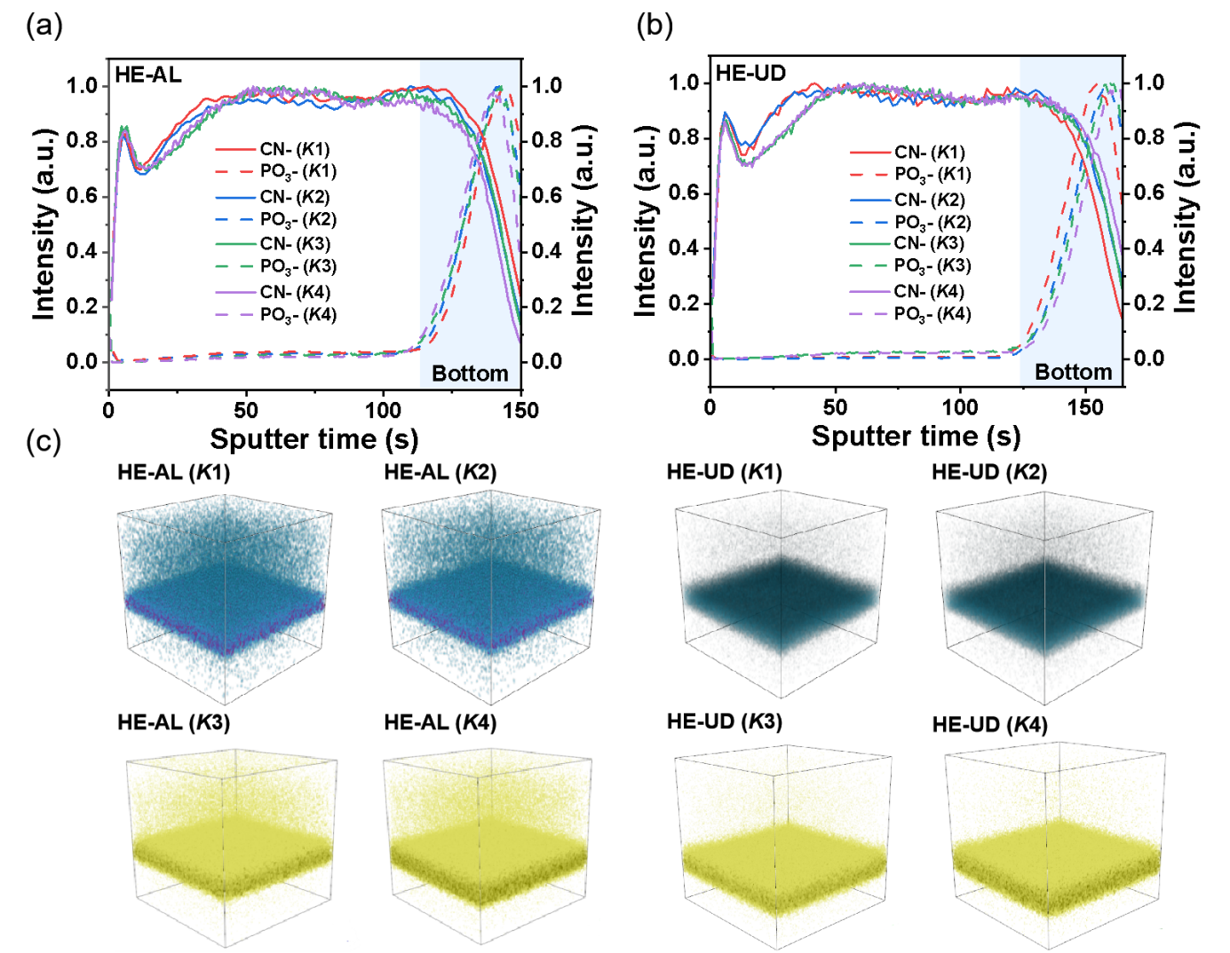
Fig. S11 (a) CN⁻ and PO₃⁻ ion yield of TOF-SIMS at different sputtering times in HE-AL structure of PM6:L8-BO+K1-K4, (b) and HE-UD structure of PM6+K1-K4/PM6:L8-BO. (c) 3D reconstructed images comparing the kinetic trapping in HE-AL versus the thermodynamically driven exclusion in HE-UD.

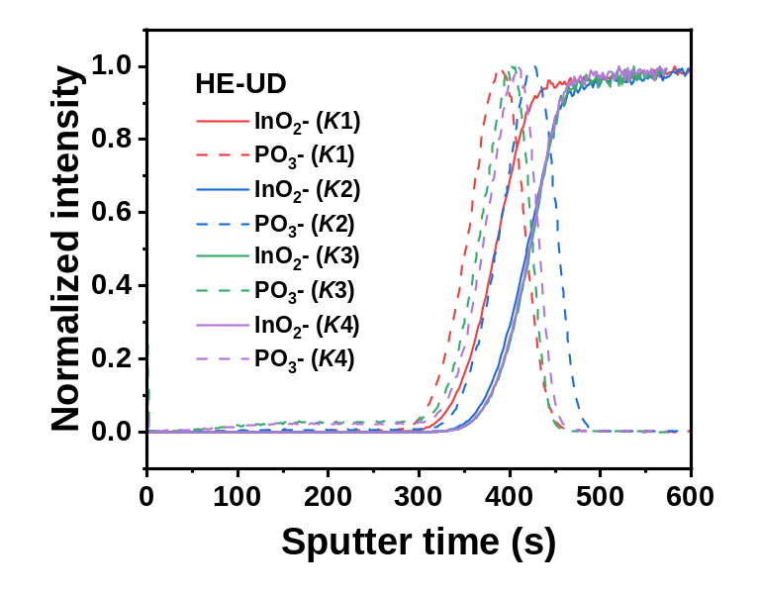
Fig. S12 TOF-SIMS depth profiles of K1-K4-based HE-UD films.

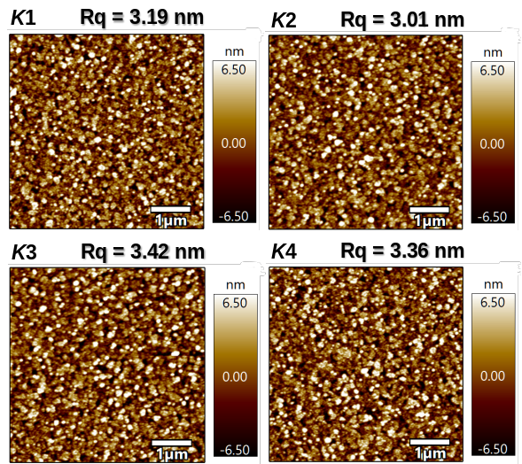
Fig. S13 AFM height images of pure self-assembled molecule films.

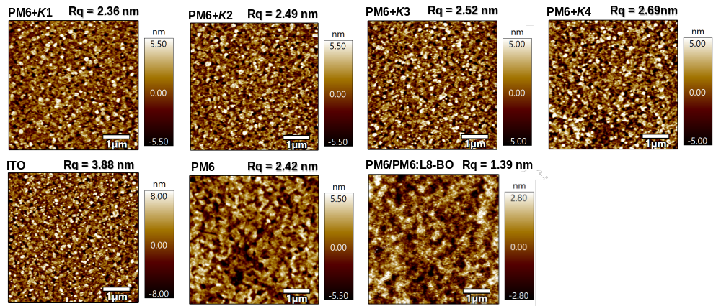
Fig. S14 AFM height images of blend films of PM6+self-assembled molecules, bare ITO, pure donor PM6 film, and PM6/PM6:L8-BO film.

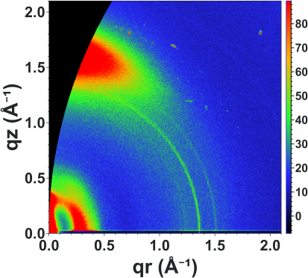
Fig. S15 GIWAXS 2D image of PM6/PM6:L8-BO film.

Table S7 Structure parameters of the various films with different incidence angles obtained from GIWAXS data.
 | q^{r} (Lamellar stacking) |  |  |  | q^{z} (π-π stacking)
 | Location  (Å⁻¹) | d-spacing  (Å) | FWHM  (Å⁻¹) | CCL  (Å) | Location  (Å⁻¹) | d-spacing  (Å) | FWHM  (Å⁻¹) | CCL  (Å)
HE-UD  (free) | 0.296 | 21.23 | 0.135 | 41.89 | 1.798 | 3.49 | 0.305 | 18.54
HE-UD (K1) | 0.332 | 18.93 | 0.138 | 40.98 | 1.819 | 3.47 | 0.225 | 25.13
HE-UD (K2) | 0.327 | 19.21 | 0.134 | 42.20 | 1.808 | 3.48 | 0.246 | 22.99
HE-UD (K3) | 0.313 | 20.05 | 0.131 | 43.17 | 1.735 | 3.62 | 0.202 | 27.99
HE-UD (K4) | 0.331 | 18.98 | 0.148 | 42.45 | 1.826 | 3.44 | 0.256 | 22.09

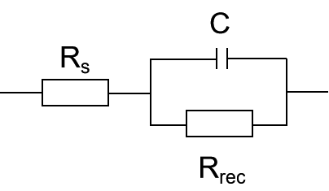
Fig. S16 The equivalent circuit used for EIS fitting.

Table S8 Electrochemical impedance spectroscopy (EIS) fitting parameters for the HE-UD devices based on different self-assembled molecules (R_{s} refers to the series resistance associated with electrodes and Ohmic contacts, R_{rec} denotes the recombination resistance, and C refers to the geometric capacitance related to carrier recombination behavior).
Devices | R_{s}ª (Ω) | R_{rec} (Ω) | C (F)
HE-UD (K1) | 15.2 | 626 | 2.1*10⁻⁹
HE-UD (K2) | 44.9 | 467 | 1.9*10⁻⁹
HE-UD (K3) | 20.5 | 95 | 3.6*10⁻⁹
HE-UD (K4) | 27.4 | 387 | 4.1*10⁻⁹
ª The R_{s} and R_{rec} are extracted from EIS measurements with an equivalent circuit model via ZView software.

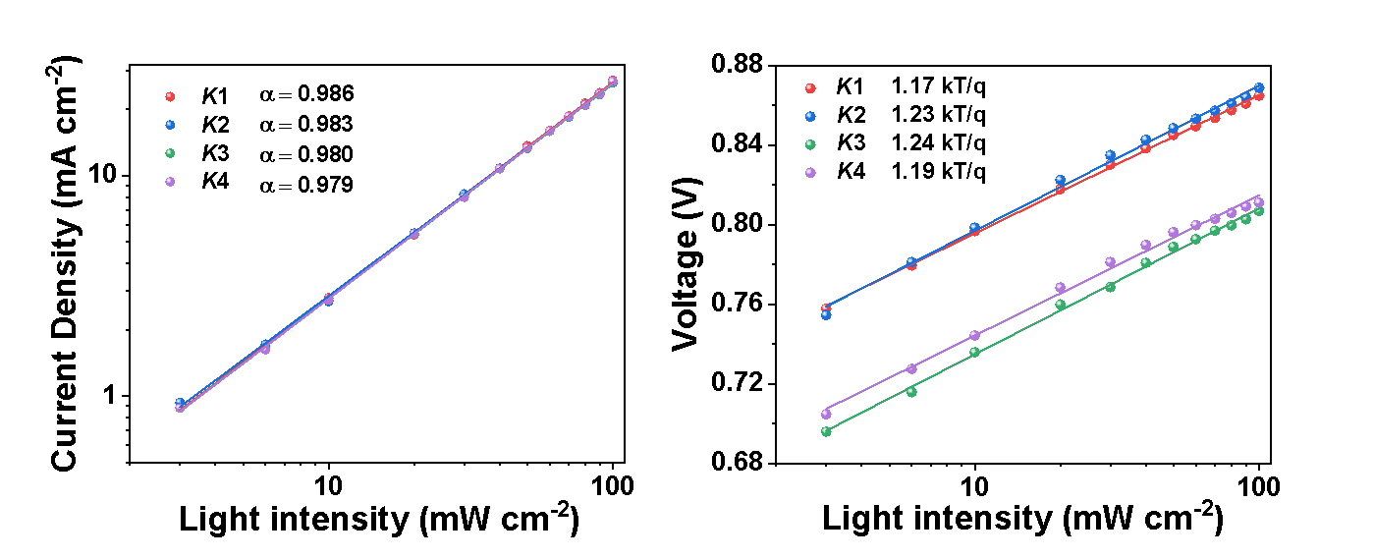
Fig. S17 Dependence of J_{sc} and V_{oc} on light intensity of the HE-UD devices.

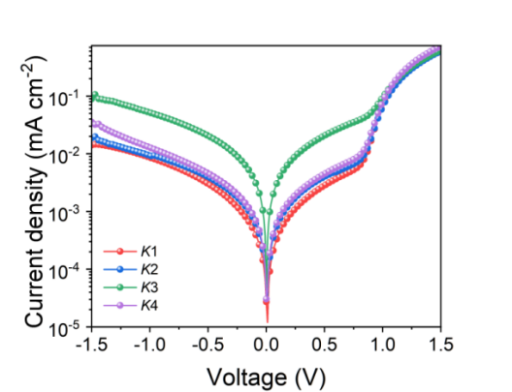
Fig. S18 Dark J-V curves for relevant HE-UD devices.
Table S9 The performance parameters of the devices based on various self-assembled molecules under AM 1.5G irradiation (100 mW cm⁻²). OPVs made based on HE-UD (K1), PEDOT:PSS/AL, HE-AL (K1) and SD (K1) Humidity and temperature were controlled at 50%-60% and 25.0℃±1.0℃ during device fabrication. Under atmospheric conditions, humidity is controlled below 60% to monitor the photovoltaic performance of the devices.
 | Time | V_{oc} (V) | J_{sc} (mA cm⁻²) | FF (%) |  | PCE (%)
HE-UD (K1) | 0 | 0.864 | 27.2 | 77.3 |  | 18.5
HE-UD (K1) | 24 | 0.863 | 27.6 | 76.9 |  | 18.3
HE-UD (K1) | 48 | 0.860 | 27.4 | 76.9 |  | 18.1
HE-UD (K1) | 96 | 0.850 | 27.8 | 75.6 |  | 17.9
PEDOT:PSS | 0 | 0.868 | 26.9 | 78.2 |  | 18.3
PEDOT:PSS | 24 | 0.862 | 26.9 | 76.3 |  | 17.7
PEDOT:PSS | 48 | 0.864 | 26.8 | 75.8 |  | 17.6
PEDOT:PSS | 96 | 0.866 | 25.4 | 68.4 |  | 15.1
HE-AL (K1) | 0 | 0.861 | 26.3 |  | 70.6 | 16.0
HE-AL (K1) | 24 | 0.852 | 26.2 |  | 69.2 | 15.4
HE-AL (K1) | 48 | 0.850 | 25.6 |  | 65.2 | 14.2
HE-AL (K1) | 96 | 0.844 | 25.3 |  | 63.1 | 13.5
SD (K1) | 0 | 0.864 | 26.7 |  | 73.2 | 16.9
SD (K1) | 24 | 0.850 | 26.4 |  | 70.3 | 15.8
SD (K1) | 48 | 0.850 | 25.8 |  | 68.1 | 14.9
SD (K1) | 96 | / | / |  | / | /

Table S10 The performance parameters of the devices based on large-area air-blade modules devices under AM 1.5G irradiation (100 mW cm⁻²).
Active Layer | V_{oc} (V) | J_{sc} (mA cm⁻²) | FF (%) | PCE (%) | R_{s} (Ohm)
HE-UD (K1)  (18.20 cm²) | 7.785 | 2.9 | 71.5 | 16.2 | 16.3
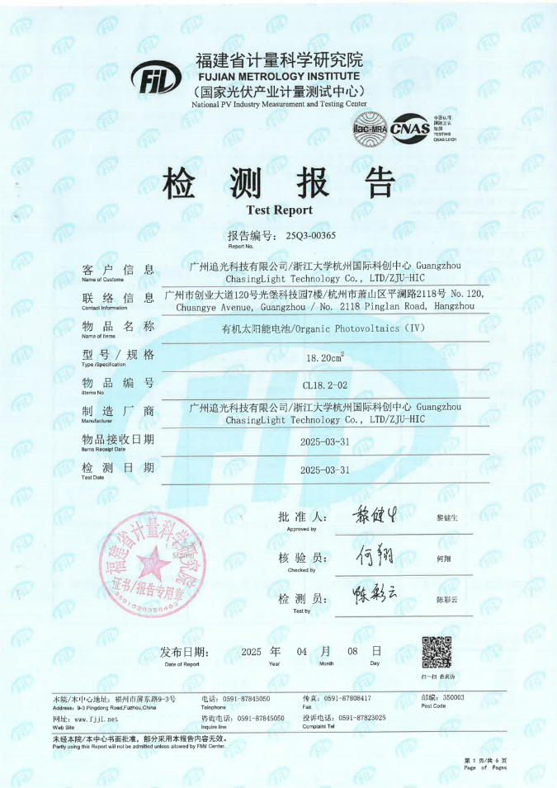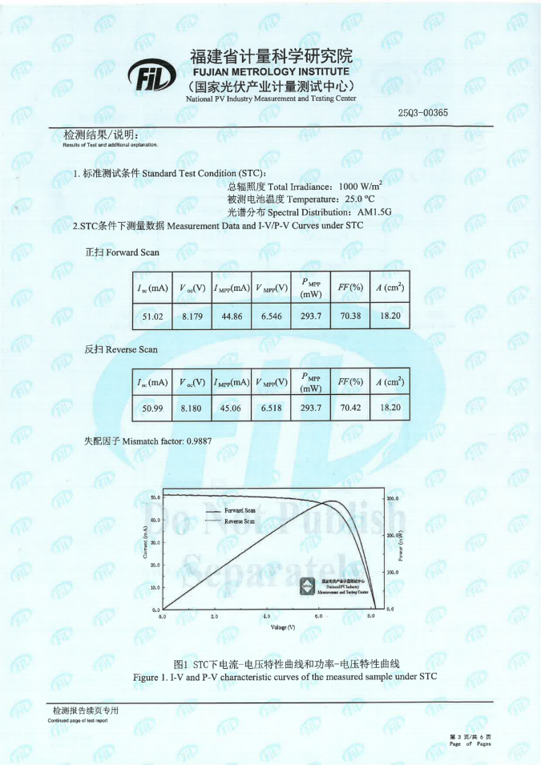
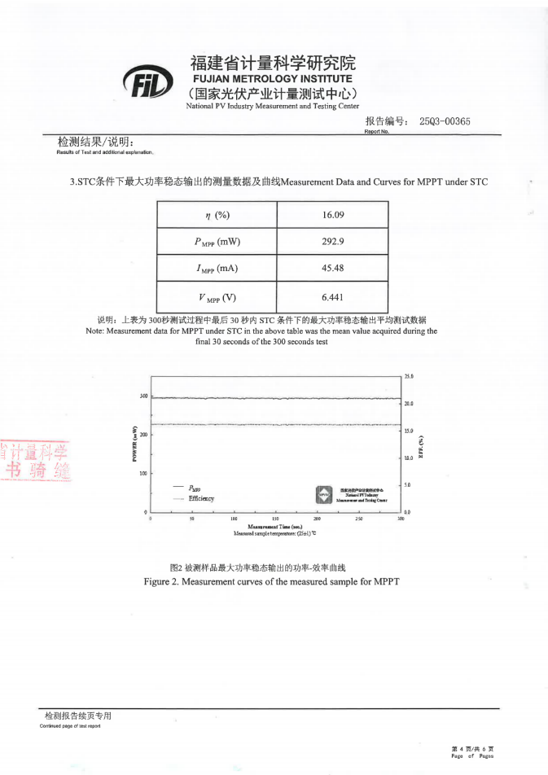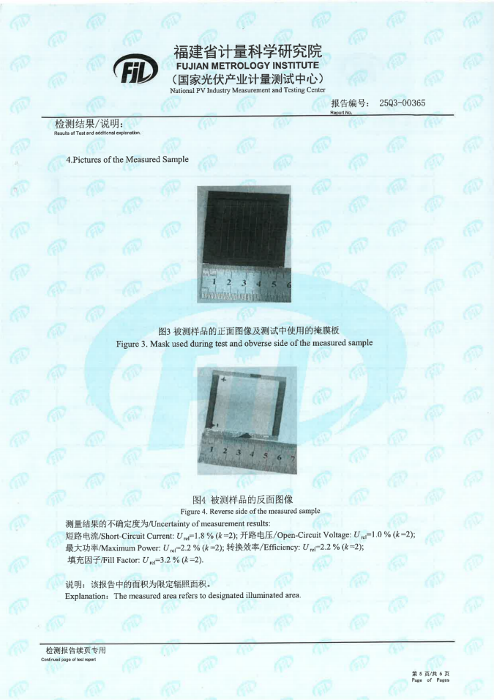
Fig. S19 Efficiency certification report for device based on HE-UD (K1) from the National PV Industry Measurement and Testing Center (NPVIM).
Table S11 The summary of PCEs obtained from recently reported large-area OPV module.
Area  (cm2) | HEL | Active layer | PCE  (%) | Ref.
1 | / | PM6:Y6-BO+2PACz | 15.8 | Nano Energy 93, 106814 (2022)
1 | ph-4PACz | D18:BTP-eC9:L8-BO | 18.6 | Adv. Funct. Mater. e12687 (2025)
1 | 2PACz/Cz | D18:PM6:BTP-eC9 | 18.65 | Small 21, 2500230 (2025)
1 | 3-BPIC-F | PM6:L8-BO:BTP-eC9 | 17.25 | J. Am. Chem. Soc. 146, 14287−14296 (2024)
1.008 | Cbz-2Ph | PM6:BTP-eC9:L8BO-2F | 17.76 | Energy Environ. Sci. 18, 799-806 (2025)
1.05 | 2PACZ-SAI | PBDB-TF:L8-BO:BTP-eC9 | 18.41 | Adv. Mater. 36, 2400342 (2024)
1.05 | BCZ-1 | PM6:BTP-eC9 | 17.9 | Adv. Mater. 37, 2501117(2025)
2 | 2C2BA | PM6:BO-4Cl | 16.7 | J. Mater. Chem. A 13, 11458-11465 (2025)
11.9 | 4BCP | PM6:BTP-eC9 | 15.7 | Sci. China Chem. 68, 5813–5822 (2025)
18.20 | / | PM6+K1/PM6:L8-BO | 16.2 | Our work
19.3 | 4PADCB | D18:L8-BO | 15.44 | Adv. Energy Mater. 14, 2304000 (2024)
19.31 | 2PACz | PM6:BO-4Cl | 15.74 | Energy Environ. Sci. 17, 3908-3916 (2024)

