Supplementary File

Glossary of Acronyms
This glossary provides definitions of acronyms used throughout the manuscript to aid interdisciplinary readers.
Acronym | Full Form
AI | Artificial Intelligence
AWS | Amazon Web Services
CHIME | Copernicus Hyperspectral Imaging Mission for the Environment (ESA)
CLM | Community Land Model
CNN | Convolutional Neural Network
DGVM | Dynamic Global Vegetation Model
DTF | Digital Twin Forestry
ECOSTRESS | ECOsystem Spaceborne Thermal Radiometer Experiment on Space Station (NASA)
ED2 | Ecosystem Demography Model, version 2
EO | Earth Observation
EnMAP | Environmental Mapping and Analysis Program (German hyperspectral mission)
EnKF | Ensemble Kalman Filter
ESA | European Space Agency
FAIR | Findable, Accessible, Interoperable, Reusable
FAPAR | Fraction of Absorbed Photosynthetically Active Radiation
GCMD | Global Change Master Directory
GEDI | Global Ecosystem Dynamics Investigation (NASA LiDAR mission)
GPP | Gross Primary Productivity
HYDRUS | Hydrological model family (e.g., HYDRUS-Plant)
ICESat-2 | Ice, Cloud, and land Elevation Satellite-2 (NASA)
IoT | Internet of Things
ISIMIP | Inter-Sectoral Impact Model Intercomparison Project
JULES | Joint UK Land Environment Simulator
LAI | Leaf Area Index
LANDIS-II | Landscape Disturbance and Succession Model, version II
LiDAR | Light Detection and Ranging
LPJ | Lund-Potsdam-Jena Dynamic Global Vegetation Model
LPJ-GUESS | Lund-Potsdam-Jena General Ecosystem Simulator
ML | Machine Learning
MODIS | Moderate Resolution Imaging Spectroradiometer
NDVI | Normalized Difference Vegetation Index
NISAR | NASA-ISRO Synthetic Aperture Radar mission
ORCHIDEE | Organizing Carbon and Hydrology In Dynamic Ecosystems (DGVM)
OCO-2/3 | Orbiting Carbon Observatory-2/3 (NASA SIF missions)
PEcAn | Predictive Ecosystem Analyzer (Bayesian framework)
PF | Particle Filter
Pg | Petagram (1015 grams)
PRISMA | PRecursore IperSpettrale della Missione Applicativa (Italian hyperspectral mission)
PRISMA 2020 | Preferred Reporting Items for Systematic Reviews and Meta-Analyses (2020 update)
PFT | Plant Functional Type
REDD+ | Reducing Emissions from Deforestation and Forest Degradation (UN program)
RMSE | Root Mean Square Error
ROBIS | Risk Of Bias In Systematic reviews framework
SAR | Synthetic Aperture Radar
SBG | Surface Biology and Geology mission (NASA, planned hyperspectral mission)
SDG | Sustainable Development Goal
SIF | Solar-Induced Fluorescence
SPI | Standardized Precipitation Index
TLS | Terrestrial Laser Scanning
UAV | Unmanned Aerial Vehicle
UN SDG | United Nations Sustainable Development Goal
VOSviewer | Visualization of Similarities viewer (bibliometric software)

Table S1. Categorization of the 57 systematically reviewed studies (2016–2025). Studies are grouped into three categories: operational/prototype digital twins, enabling technology studies, and proposed/future applications. Only articles published between January 2016 and December 2025 were included in the systematic review dataset. Early-online 2026 publications (e.g., Quan et al. 2026; Olawade et al. 2026; Görtz 2026) were excluded from the evidence base but are discussed narratively in the manuscript as forward-looking references. This table complements the PRISMA 2020 flow diagram by showing how the evidence base was structured.

Category | Study (Author, Year) | Title / Focus
Operational / Prototype Digital Twin | Qiu et al. (2023) | Forest digital twin: spatio temporal data, 3D simulation engine, interactive environment
 | Jiang et al. (2022) | Forestry digital twin with machine learning in Landsat 7 data
 | Buonocore et al. (2022) | Proposal for a forest digital twin framework
 | Sasaki & Abe (2025) | Digital twin architecture for forest restoration (AI, IoT, blockchain)
 | De Koning (2025) | Crane radar: operational eco digital twin
 | Khan et al. (2025) | TwinEco: unified framework for ecological digital twins
Enabling Technology Studies | Dubayah et al. (2020) | GEDI: global ecosystem dynamics investigation (LiDAR)
 | Rodríguez Veiga et al. (2019) | Forest biomass retrieval approaches across biomes
 | Reichstein et al. (2019) | Deep learning and process understanding for Earth system science
 | Frieler et al. (2017) | ISIMIP2b simulation protocol for climate impacts
 | Li et al. (2023) | Adaptive digital twin for UAV assisted sensing networks
 | Dokoohaki et al. (2022) | PEcAn regional data assimilation system
 | Fisher et al. (2018) | Vegetation demographics in Earth system models
 | Buxton et al. (2022) | Monitoring resilience of patterned vegetation in the Sahel
 | Doughty et al. (2024) | Satellite derived trait data for tropical forest biomass
 | Ghafariasl et al. (2024) | Neural network surrogate modeling
 | Raissi et al. (2019) | Physics informed neural networks
 | Ling et al. (2019) | Assimilation algorithms for LAI
 | Ma et al. (2024) | Biomass calibration in IBIS
 | Argles et al. (2022) | Demographic process representation in DGVMs
 | Rödig et al. (2017) | Individual based forest model for carbon fluxes
 | Angione et al. (2022) | ML surrogate for agent-based simulations
 | Bach & Ghil (2023) | Multi model ensemble Kalman filter
 | Bannister (2017) | Variational and ensemble variational assimilation
 | Nino Ruiz & Diaz Rodriguez (2024) | 4D EnKF method
 | Carrassi et al. (2018) | Data assimilation in geosciences
 | Dong et al. (2022) | ML based 4D variational assimilation
 | Xu et al. (2023) | Hydraulic trait control in demographic vegetation models
 | Konings et al. (2016) | Vegetation optical depth retrieval
 | Liu et al. (2021) | GEDI and ICESat 2 evaluation
 | Wallace et al. (2016) | UAV laser scanning vs SfM
 | Disney (2019) | Terrestrial LiDAR revolution
 | Yan et al. (2021) | Spectroscopy for photosynthetic capacity
 | Aasen et al. (2019) | Sun induced chlorophyll fluorescence review
 | Wang et al. (2024) | Biomass estimation with Sentinel 1/2 and GEDI
 | Santoro et al. (2022) | Biomass estimation with scatterometer + LiDAR
 | Cartus & Santoro (2019) | Radar backscatter for biomass
 | Dash et al. (2017) | UAV imagery for forest health
 | Aasen et al. (2018) | UAV spectroscopy review
 | Maes & Steppe (2019) | UAVs in precision agriculture
 | Fisher et al. (2020) | ECOSTRESS mission
 | Smigaj et al. (2024) | Thermal infrared sensing of forest stress
 | Mohammed et al. (2019) | Remote sensing of SIF
 | Sun et al. (2018) | OCO 2 SIF overview
 | Zhang et al. (2023) | SIF for GPP estimation
 | Tang et al. (2019) | Global canopy cover with LiDAR
 | Houborg & McCabe (2018) | CubeSat + Landsat + MODIS fusion
 | Miraglio et al. (2023) | Canopy traits mapping with spectroscopy
 | Coops et al. (2023) | Near real time forest inventory
 | Huntington et al. (2017) | Cloud computing for climate/remote sensing
Proposed / Future Applications | Buonocore et al. (2022) | Forest digital twin framework proposal
 | Liu et al. (2023) | Reconstructing forest digital twins from 3D libraries
 | Bolton et al. (2018) | Vegetation greening trends informed by LiDAR
 | Buxton et al. (2022) | Vegetation resilience monitoring
 | Tao et al. (2019) | Digital twin enabling technologies
 | Fuller et al. (2020) | Digital twin enabling technologies
 | Grieves & Vickers (2017) | Digital twin in complex systems

Table S2. Checklist for Extracted Characteristics.
This table defines each column used in Supplementary Table S1, including citation, biome, geographic region, sensor platforms, modeling approaches, assimilation methods, validation metrics, application, and maturity level. It documents the coding protocol applied during data extraction, ensuring transparency, reproducibility, and consistency with PRISMA 2020 guidelines.
Column | Definition | Examples
Citation (Author, Year) | Standard bibliographic citation of the study. | Qiu et al. (2023)
Biome | The ecological zone or forest type studied. | Temperate forest, Tropical moist deciduous, Mangrove, Boreal
Geographic Region | Country or region where the study was conducted. | Brazil, China, Canada, USA, Global
Sensor Platforms | Remote sensing or monitoring technologies used. | UAV LiDAR, Landsat, Sentinel 2, GEDI, Flux towers
Modeling Approaches | Ecosystem or computational models applied. | DGVMs, SIPNET, ML regression, Radiative transfer models
Assimilation Methods | Data assimilation techniques used (if any). | Ensemble Kalman Filter, Variational assimilation, None
Validation Metrics | Quantitative or qualitative measures of accuracy. | RMSE, R², Bias, Case study validation
Application | Intended use or focus of the study. | Biomass estimation, Carbon cycle reanalysis, Forest restoration, Biodiversity monitoring
Maturity Level | Stage of development of the digital twin or enabling study. | Prototype, Operational, Conceptual, Enabling

Together, these tables allow readers to distinguish between systematic review evidence and the authors’ forward-looking synthesis.

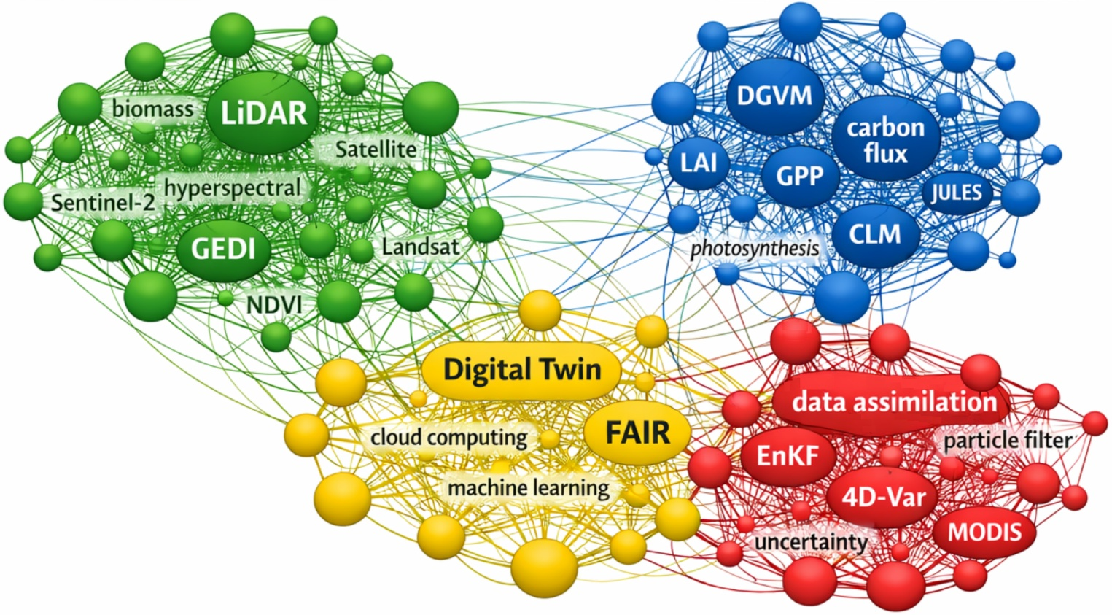
Figure S1. Keyword Co-Occurrence Map.

Network visualization of keyword co-occurrence in digital twin forestry research. Four major clusters are shown: (i) Remote Sensing & Forest Structure (green), (ii) Ecosystem Modeling & Carbon Flux (blue), (iii) Data Assimilation & Uncertainty (red), and (iv) Digital Twin & Informatics (yellow). Node size represents keyword frequency, and link thickness indicates co-occurrence strength. The map illustrates the growing integration of sensing, modeling, and informatics within the emerging digital twin forestry framework.
The bibliometric keyword co-occurrence analysis (Figure S1) reveals four dominant research clusters that define the intellectual landscape of digital twin forestry. The Remote Sensing & Forest Structure cluster (green) highlights the foundational role of LiDAR, GEDI, Sentinel-2, and hyperspectral data in structural and biomass mapping. The Ecosystem Modeling & Carbon Flux cluster (blue) emphasizes process-based modeling approaches such as DGVM, CLM, and JULES, which link EO-derived parameters to carbon and energy fluxes. The Data Assimilation & Uncertainty cluster (red) captures the methodological evolution toward ensemble Kalman filters (EnKF), particle filters, and 4D-Var techniques for dynamic model updating. Finally, the Digital Twin & Informatics cluster (yellow) represents the emerging informatics paradigm integrating FAIR data principles, cloud computing, and machine learning. Together, these clusters demonstrate the convergence of sensing, modeling, and assimilation into a unified informatics architecture that underpins digital twin forestry.

