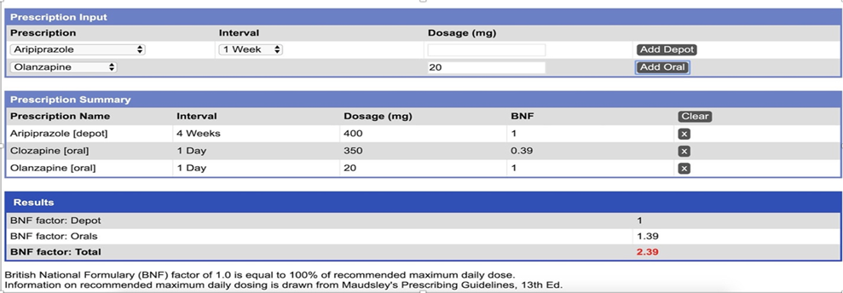

Supplimentary Figure 1: An example of a TDD calculation (a long-acting injectable (LAI, 'depot') medication and two oral medications) (https://kornor.github.io/).

