SUPPLEMENTARY FIGURES AND DESCRIPTION

Universal high work function flexible anode for simplified ITO-Free organic and perovskite light-emitting diodes with ultra-high efficiency
Running title: Simplified organic and perovskite Light-Emitting Diodes
Su-Hun Jeong,^{1†} Seong-Hoon Woo,^{1†} Tae-Hee Han,² Min-Ho Park,¹ Himchan Cho,² Young-Hoon Kim,² Hyunsu Cho,³ Hobeom Kim,¹ Seunghyup Yoo,³ Tae-Woo Lee²*
¹Department of Materials Science and Engineering, Pohang University of Science and Technology (POSTECH), 77 Cheongam-Ro, Nam-Gu, Pohang, Gyungbuk 790-784, Republic of Korea Address here.
²Department of Materials Science and Engineering, Seoul National University, 1 Gwanak-Ro, Gwanak-gu, Seoul 08826, Republic of Korea
³Department of Electrical Engineering, Korea Advanced Institute of Science and Technology (KAIST), 373-1 Guseong-dong, Daejeon 305-701, Republic of Korea
†These authors contributed equally to this work.

*Corresponding author: Tae-Woo Lee
Telephone: +82-2-880-8021
Fax: +82-54-279-2399
E-mail: twlees@snu.ac.kr, taewlees@gmail.com
Difference between AnoHIL and GraHIL

Table S1 summarizes the composition, conductivity, work function, and application of the AnoHIL and GraHlL. The composition of our AnoHIL is different from that of the GraHIL. Both AnoHIL and GraHIL are based on a conducting polymer, poly(3,4-ethylenedioxythiophene):poly(styrene sulfonate) (PEDOT:PSS). However, the types of used PEDOT:PSS are different. The commercially available PEDOT:PSS solutions from Heraeus have several types depending of their uses. Our AnoHIL uses CleviosTM PH 500 (PEDOT:PSS = 1:2.5), which can have high conductivity with an additional dopant. In the case of AnoHIL, dimethyl sulfoxide (DMSO) is additionally added as a dopant to increase its conductivity. However, the GraHIL uses CleviosTM P VP AI4083 (PEDOT:PSS = 1:6). CleviosTM P VP AI4083 has relatively high work function (5.0 – 5.2 eV), compared to that of CleviosTM PH500 (4.8 – 5.0 eV), and it is generally used as a hole injection layer (HIL). Even with an additional dopant, CleviosTM P VP AI4083 cannot be used as anodes due to its inherently very low conductivity. The reported GraHIL only focused on matching the low work function of anodes (4.4 eV for graphene) and the deep highest occupied molecular orbital (HOMO) levels of overlying organic semiconducting layers (> 5.4 eV). Therefore, it only acts as a HIL. However, our AnoHIL has high conductivity, and it can be used as an anode. Also, due to its high work function, it does not require an additional HIL. The AnoHIL acts as both anode and HIL.

Table S1. Summary of composition, conductivity, work function, and application of AnoHIL and GraHIL.
Sample name | Type of PEDOT:PSS | PEDOT/PSS/PFSA  (w/w/w) | Dopant | Conductivity  (S/cm) | Thickness  (nm) | Work function (eV) | Application
AnoHIL | CleviosTM PH500 | 1 : 2.5 : 11.2 | Dimethyl sulfoxide | 50 | 100 | 5.80 | Anode
GraHIL | CleviosTM  P VP AI4083 | 1 : 6 : 25.4 | - | < 10⁻³ | 50 | 5.95 | HIL

Work function and conductivity of AnoHILs

Table S2. The composition of each AnoHILs and its work function and conductivity.
Sample code | PEDOT/PSS/PFSA  (w/w/w) | Work Function  (eV) | Sheet resistance  (ohm sq⁻¹) | Conductivity  (S cm⁻¹)
PEDOT:PSS | 1 : 2.5 : 0 | 4.73 | 333 | 300
AnoHIL161 | 1 : 2.5 : 1.0 | 5.07 | 800 | 125
AnoHIL81 | 1 : 2.5 : 2.3 | 5.23 | 1333 | 75
AnoHIL41 | 1 : 2.5 : 4.9 | 5.64 | 1639 | 61
AnoHIL31 | 1 : 2.5 : 8.4 | 5.71 | 1754 | 57
AnoHIL21 | 1 : 2.5 : 11.2 | 5.80 | 2000 | 50

Molecular depth profile of AnoHILs

X-ray photoelectron spectroscopy was recorded on an AXIS-NOVA (Kratos Inc. U.K.) at Korea Basic Science Institute (KBSI) Daejeon using a monochromatic AL KA X-ray source (1486.6 eV).

Table S3. The ratio of the area of the F 1s core level spectra to the area of the S 2p core level spectra measured by X-ray photoelectron spectroscopy.
Sample code | Peak Area |  | Area Ratio
Sample code | S 2p | F 1s | F_{(PFSA)}/S_{(PEDOT:PSS)}
PEDOT:PSS | 2673.1 | - | -
AnoHIL161 | 2684.5 | 56330.3 | 21.0
AnoHIL81 | 2069.8 | 52738.6 | 25.5
AnoHIL41 | 1784.0 | 57418.9 | 32.2
AnoHIL31 | 1538.9 | 65621.2 | 42.6
AnoHIL21 | 1638.3 | 73142.5 | 44.6

Surface morphologies of AnoHILs

In the atomic force microscope (AFM) images of AnoHILs (Figure S1), the surface roughness of AnoHILs decreased as [PFSA] increased. However, above a certain [PFSA] (AnoHIL21), the surface roughness of AnoHIL increased. In detail, the root mean square (RMS) roughness was 1.42 nm, 1.33 nm, 1.19 nm, and 1.49 nm (In the case of PEDOT:PSS (in which [PFSA] = 0), rms roughness = 1.56 nm). Because the addition of 5 wt % DMSO increases the surface roughness due to PEDOT aggregation, we can emphasize that adding PFSA contributes to formation of a smoother film surface.

Figure S1. Atomic Force Microscope (AFM) images of AnoHIL and PEDOT:PSS anodes.

Device characteristics of green phosphorescent OLEDs employing various anodes

Figure S2. Green phosphorescent OLED device characteristics employing different anode layer. (a) Energy level band diagram, (b) external quantum efficiency, and (c) angle-dependent emission profile of green phosphorescent OLEDs fabricated on conventional ITO and AnoHIL anodes.

Summary of green phosphorescent OLED performance

Table S4. Summary of green phosphorescent OLED performances.
Anode | Maximum  Current Efficiency  (cd A⁻¹) | Current Efficiency  @ 100 cd m⁻²  (cd A⁻¹) | Current Efficiency  @ 1000 cd m⁻²  (cd A⁻¹) | Current Efficiency  @ 10,000 cd m⁻²  (cd A⁻¹)
ITO/PEDOT:PSS | 88 | 85 | 84 | 74
PEDOT:PSS  (High conductivity) | 71 | 62 | 71 | 49
AnoHIL31 | 128 | 127 | 120 | 83
AnoHIL31 with a hemisphere lens | 239 | 238 | 231 | 186
ITO/PEDOT:PSS (Tandem) | 167 | 165 | 159 | 140
AnoHIL31 (Tandem) | 235 | 234 | 225 | 190
AnoHIL31 (Tandem) with a hemisphere lens | 415 | 408 | 409 | 373

Refrative indices of AnoHIL, PEDOT:PSS (High conductivity), and ITO anodes

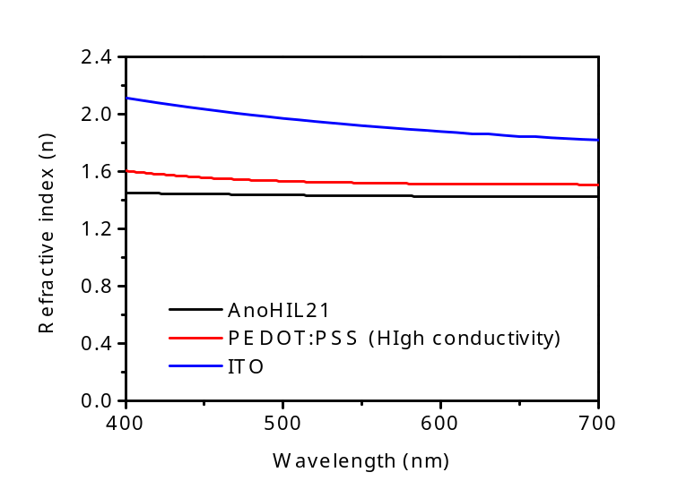
Figure S3. Refractive indices of AnoHIL21, PEDOT:PSS (High conductivity), and ITO anodes.

Device characteristics of green PeLEDs employing various anodes

Figure S4. Green PeLED device characteristics employing different anode layer. (a) Energy level band diagram, (b) electroluminescence spectra, and (c) external quantum efficiency of green PeLEDs fabricated on various anodes.

Table S5. Summary of green PeLED performances.
Anode | AnoHIL21 | AnoHIL31 | AnoHIL41 | AnoHIL81 | AnoHIL161 | PEDOT:PSS  (High conductivity)
Maximum current efficiency  (cd A⁻¹) | 42 | 26 | 26 | 15 | 14 | 9
Maximum EQE  (%) | 8.66 | 5.40 | 5.26 | 3.14 | 2.94 | 1.95

Time-correlated single photon counting (TCSPC) measurement of MAPbBr₃ films

The photoluminescence (PL) lifetime of MAPbBr₃ films on top of various polymeric anodes were measured using a TCSPC measurement. The TCSPC system is comprised of a picosecond pulse laser head (LDH-P-C-405B, PicoQuant), monochromator (SP-2155, Acton) and ultrafast detection (MCP-PMT (R3809U-50, Hamamatsu)). The PL lifetime curves were fitted with a bi-exponential decay model.
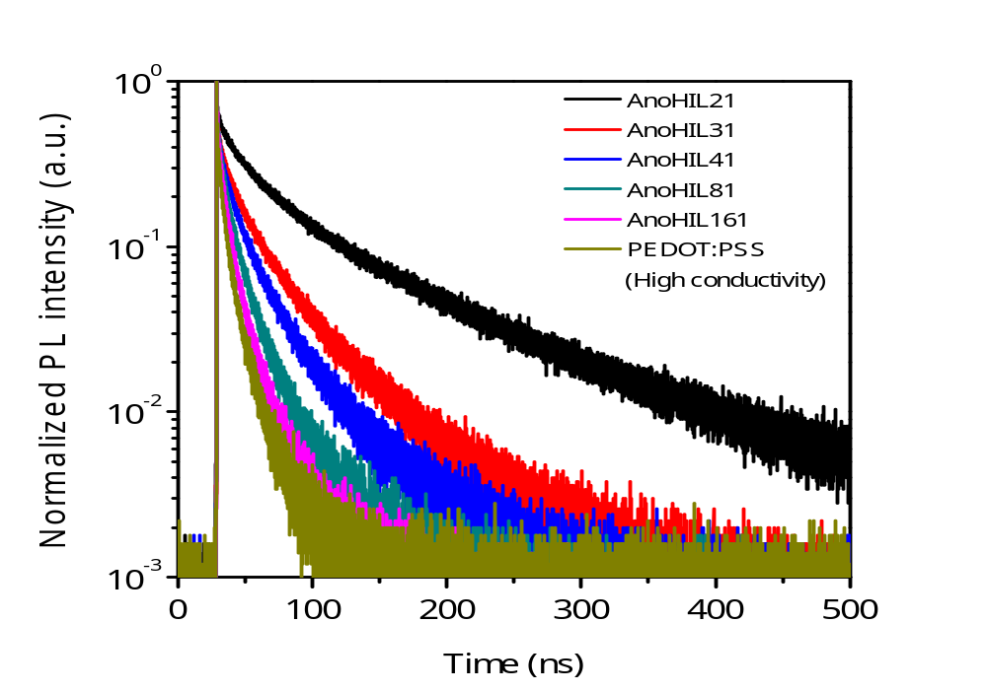
Figure S5. PL lifetime of MAPbBr₃ layers on top of various polymeric anodes.

Table S6. Summary of fast PL lifetime (τ₁), slow PL lifetime (τ₂) and average lifetime (τ_{avg}) of MAPbBr₃ layers on top of various anodes.
Anode | Fitting model  (exponential decay) | τ₁ (ns) | f₁ (%) | τ₂ (ns) | f₂ (%) | τ_{avg} (ns)
AnoHIL21 | Bi- | 35.38 | 36.55 | 142.01 | 63.45 | 103.04
AnoHIL31 | Bi- | 21.25 | 45.05 | 67.93 | 54.95 | 46.90
AnoHIl41 | Bi- | 17.59 | 51.82 | 57.21 | 48.18 | 36.68
AnoHIL81 | Bi- | 10.74 | 63.60 | 39.97 | 36.40 | 21.38
AnoHIL161 | Bi- | 8.35 | 64.47 | 33.21 | 35.53 | 17.18
PEDOT:PSS  (High  conductivity) | Bi- | 7.33 | 60.34 | 26.87 | 39.66 | 15.08
X-ray diffraction (XRD) pattern of MAPbBr3 layers on top of various polymeric anodes

The crystal structures of MAPbBr₃ films were analyzed by using XRD (Rigaku, D/MAX-2500) (Figure S6). The XRD peaks were positioned at 15.02°, 21.3°, 30.28°, 33.92°, 37.24°, 43.28°, and 46.00° which can be assigned to (100), (110), (200), (210), (211), (220) and (300) planes , respectively, by using Bragg’s law. It indicates that the MAPbBr₃ films have a cubic 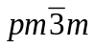 phase. The crystal structure of MAPbBr₃ films was not affected by the underlying anode layers.

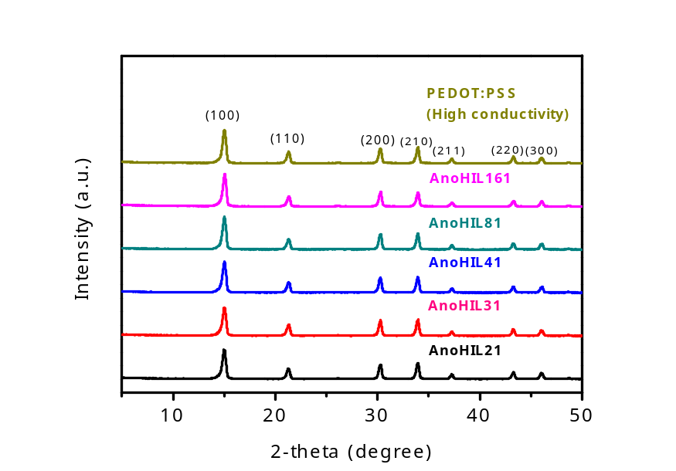
Figure S6. XRD patterns of MAPbBr₃ layers on top of various polymeric anodes.

Simplified green phosphorescent tandem OLEDs by using the AnoHIL anode

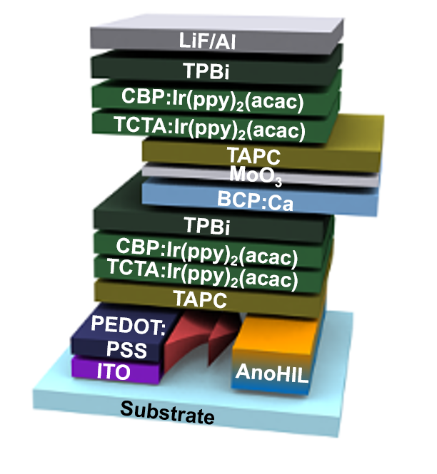
Figure S7. Device structure for the green phosphorescent tandem OLEDs with AnoHIL and ITO/PEDOT:PSS.

Figure S8. Angle-dependent emission profiles of the green phosphorescent tandem OLEDs with AnoHIL and ITO/PEDOT:PSS.
White OLEDs using AnoHIL anodes

Figure S9. (a) The schematic device structure of simplified green phosphorescent WOLEDs. (b) Current efficiency of white phosphorescent OLEDs on top of conventional ITO and AnoHIL. (c) Electroluminescence spectrum of the AnoHIL-based WOLED.

Fabrication of a large areal general lighting using AnoHIL anodes.

In this paper, we demonstrated a flexible white OLED with a large device area of 3 x 3.5 cm² (Figure S10). This device includes two blue-emitting layers, one red-emitting layer, and a 100-nm-thick AnoHIL81 flexible electrode layer. The HTL was N’-diphenyl-N,N’-bis(1-napthly)-1,1’-biphenyl-4,4’-diamine (NPB) and the ETL was bis(10-hydroxyben-zo[h]quinolinato)beryllium (Bebq₂); both HTL and ETL were 20 mnm thick. A 10-nm mixed-host blue-emitting layer consisting of 87.5% 2-tert-butyl-9,10-di-beta-naphthylanthracene (TBADN): 7.5% NPB: 5% 4,4'-bis[2-(4-(N,N-diphenylamino)phenyl)vinyl]biphenyl (DPAVBi), and a second 15-nm blue-emitting layer of 95% TBADN: 5% DPAVBi were used to broaden the spectral emission and efficiently achieve a recombination zone. Before fabricating the blue-emitting layers, a 10-nm mixed-host red-emitting layer of 87.5% TBADN: 7.5% NPB: 5% 5,6,11,12-tetraphenylnaphthacene (Rubrene) was used to improve charge confinement. The top cathode was either BaF₂ (1 nm) or Al (130 nm).

Figure S10. Device structure for the flexible WOLED lighting device with AnoHIL

