Supplementary Appendix

Table S1. International classification of diseases (ICD) codes used to classify cancer site
Cancer site | ICD-7 | ICD-8 | ICD-9 | ICD-10
All cancer | 140-207 | 140-209 | 140-208 | C00-C97
Breast | 170 | 174 | 174 | C50
Prostate | 177 | 185 | 185 | C61
Pulmonary (primary) | 162 | 162 | 162 | C33, C34
Colorectal | 153, 154 | 153, 154.0, 154.1 | 153, 154.0, 154.1 | C18-C20
Gastroesophageal | 150, 151 | 150, 151 | 150, 151 | C15-C16
Hepatobiliary (primary) | 155 | 155, 156 | 155, 156 | C22-C24
Pancreas | 157 | 157 | 157 | C25
Kidney | 180 | 189.0, 189.1 | 189.0, 189.1 | C64, C65
Bladder | 181 | 188 | 188 | C67
Gynecological | 171-176 | 180-184 | 179-184 | C51-C58
Head and neck | 140-148, 160-161 | 140-149, 160-161 | 140-149, 160-161 | C00-C14, C30-32
Melanoma | 190 | 172 | 172 | C43
Central nervous system (CNS) | 193 | 191, 192 | 191, 192 | C70-C72
Thyroid | 194 | 193 | 193 | C73
Haematological | 200-207 | 200-209 | 200-208 | C81-C96

Table S2. Correlation between serum LDH levels measured in different time intervals prior to breast cancer diagnosis
Months before breast cancer diagnosis | Pearson correlation coefficients and P-values
Months before breast cancer diagnosis | 0-6 | 6-12 | 12-18 | 18-24 | 24-30 | 30-36
0-6 | 1 | 0.73 | 0.57 | 0.57 | 0.66 | 0.59
 | P<0.0001 | P<0.0001 | P<0.0001 | P<0.0001 | P<0.0001 | P<0.0001
6-12 | 0.72 | 1 | 0.68 | 0.63 | 0.55 | 0.62
 | P<0.0001 | P<0.0001 | P<0.0001 | P<0.0001 | P<0.0001 | P<0.0001
12-18 | 0.57 | 0.68 | 1 | 0.60 | 0.56 | 0.50
 | P<0.0001 | P<0.0001 | P<0.0001 | P<0.0001 | P<0.0001 | P<0.0001
18-24 | 0.57 | 0.62 | 0.60 | 1 | 0.68 | 0.69
 | P<0.0001 | P<0.0001 | P<0.0001 | P<0.0001 | P<0.0001 | P<0.0001
24-30 | 0.66 | 0.55 | 0.56 | 0.68 | 1 | 0.60
 | P<0.0001 | P<0.0001 | P<0.0001 | P<0.0001 | P<0.0001 | P<0.0001
30-36 | 0.59 | 0.62 | 0.50 | 0.49 | 0.60 | 1
 | P<0.0001 | P<0.0001 | P<0.0001 | P<0.0001 | P<0.0001 | P<0.0001

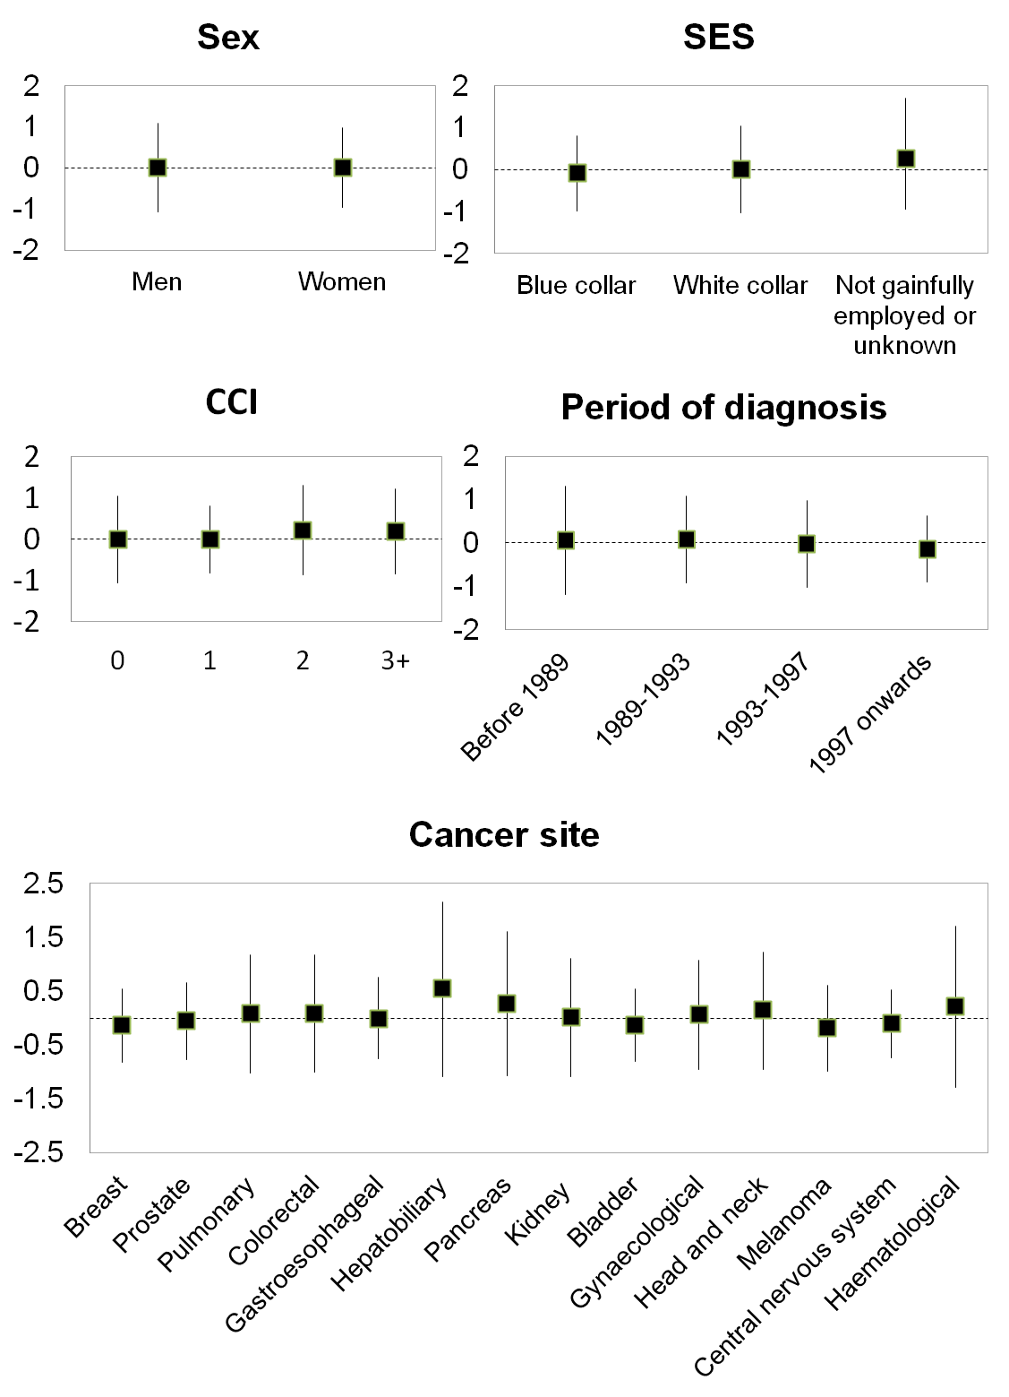
Figure S1. Mean and standard deviation of serum LDH z-score based on baseline characteristics of participants

Figure S2. The average of serum LDH measured within 6-month interval times prior to cancer diagnosis, stratified by cancer site

