Supplementary Figure S1. Quantile-quantile plots of gene-level P-values for the: a) discovery; b) replication; and c) combined data sets.

Supplementary Figure S2. PAX8 knockdown was achieved by lentiviral delivery of short hairpin RNAs (shRNAs). PAX8 expression was measured by real-time quantitative-PCR, normalized relative PAX8 expression is shown as mean ± SD. Differences in PAX8 expression were assessed using two-tailed paired samples Student’s t-tests.

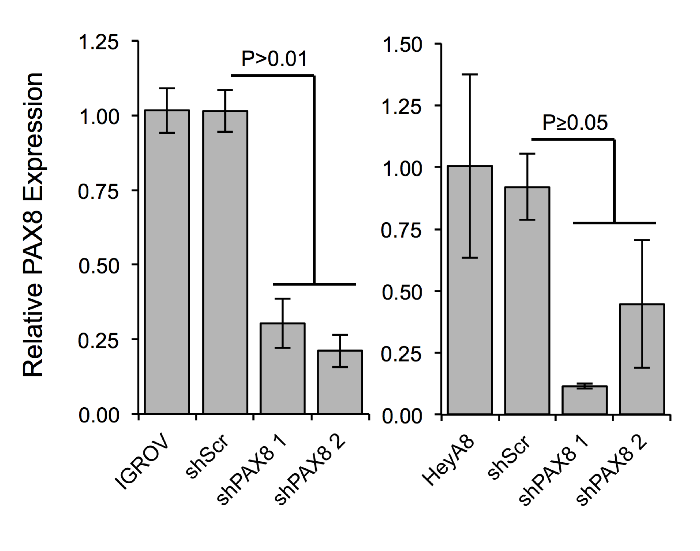

Supplementary Figure S3. Gene set enrichment analysis results for the PAX8 pathway using the list of genes differentially expressed after PAX8 silencing (ranked based on the signal-to-noise ratio) in the a) HeyA8 and b) IGROV1 cell lines (1,000 phenotype-label permutations).

