Supplementary methods:
Qualitative study
Theoretical framework of the Patient Education Program
Examples of educational animations
Statistical analysis
Table S1
References

Qualitative study
In order to follow the Patient Education Program construction methodology guidelines (CPEN Guidelines draft_Oct7 2013.indd - CPENStandardsofPractice.Nov14.pdf), a qualitative survey was performed in 2006 (March to June), with an anthropological approach, in order to identify patients’ educational needs. All patients considered for participation were followed in the Lucien Neuwirth Cancer Institut of Saint Etienne and were screened for CRF during an outpatient visit. Inclusion criteria included age older than 18 years and any type of tumor site, having being treated with first-line chemotherapy and/or having undergone radiotherapy treatment, having rated Fatigue Severity on a Visual Analogical Scale equal to or above 2.Nine Patients were included consecutively in this preliminary study. The first 4 patients participated each to a one hour face-to-face individual interview with a socio-anthropologist to explore representations, knowledge, experience and management strategies related to their Cancer Related Fatigue. A content analysis of all the transcribed interviews was performed in order to identify leading patients’ needs. The following 5 patients were included in a focus group, in order to confront the first results to the group and to confirm or complete patients’ educational needs. Among this population, 5 patients were suffering of breast cancer, the others were suffering of prostate (N=2), colorectal and ovarian cancers. The educational needs identified through this qualitative study were translated into educational objectives, as described in Table 1, and a tailored program was constructed from those elements and following the Health Belief Model to initiate the process of behavioral changes. The program is defined as “tailored” because its objectives are directly elicited from the population of interest, through the qualitative study.
Theoretical framework of the Patient Education Program
This program took the Health Belief Model as a framework because this model relies on perceptions about the disease and the strategies available to decrease its occurrence (Hochbaum, 1958). Those perceptions are responsible of the patient’s health behavior. If a program target and enable the patient to use those perceptions in a virtuous way, the impact could be the development by the patient of a coping behavior. Following this theory, the the program developed in this study was targeted the management by the patient of the CRF. The program was then targeting:
- The identification by the patient of his/her perceived CRF
- The identification by the patient of the impact of the CRF on their everyday life
- The identification or the construction by the patient of the effective strategies he/she has or could set up to manage this CRF
- The identification of the knowledge or the skills that the patient is missing to develop those coping strategies
Examples of educational animations:
- Session one : the silhouette or “the figure” : the educator distributes to each patient a draw of a figure (man or woman), both sides printed
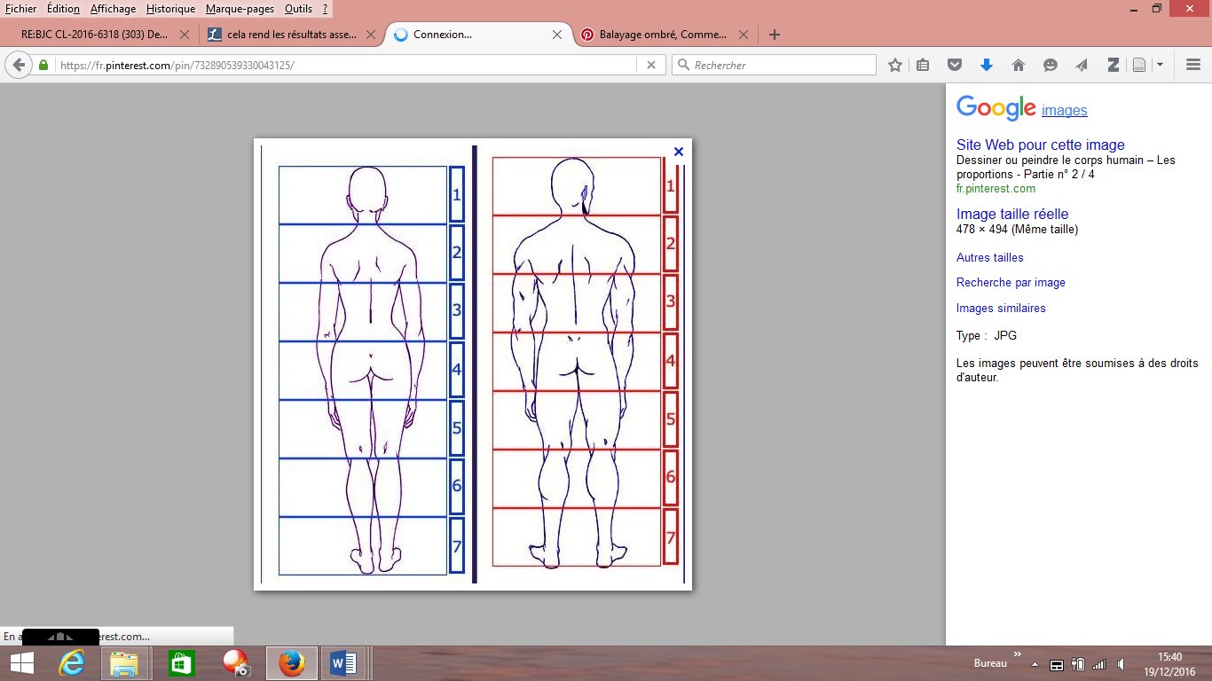 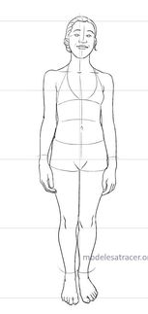 or 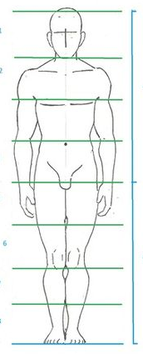
And the patient is asked to color the body parts where their Fatigue express itself. Then hi/she is ask to report it to the group. It helps the patient to express its representations of the Fatigue and his/her personal experience toward it and to express it to the group (communication skill)
- Session 2 : The “Marguerite” tool (daisy) is distributed by the educator to each patient. The patient is asked to write down in each petal, one thing he/she does today to fight against Fatigue. Then all strategies are shared among patients. This tool has the objective to lead patients to the expression of their skills. The Marguerite is distributed again in session 5 and patients can write down new strategies they have developed during the program: the objective is to compare session 2 and Session 5 Marguerites’ content: It highlights the acquisition of skills and the co-development of coping strategies.
Write down one or several things you do today to fight against Fatigue :
today
S Figure 1 : the “Marguerite” or Daisy , as it is distributed to patients

- Regnier Abbacus : A battery of ambiguous sentences are read to patients. For each sentence, they have to take position in favor or not of the sentence and discuss about their personal choice. The debate generated allows to patients to construct and strengthen the knowledges of the group. Example of a sentence read: “ The less physical activity I practice, the less tired I am”.
Statistical analysis
Additional questionnaires
Minimal Clinically Important Differences for each scale were respectively:
Between – 1.4 and +0.9 for a Fatigue VAS assessment (Colangelo et al, 2009) ; 3 points for FACT-F (Cella et al, 2002) ; 5 to 10 points for “ little" change , 10 to 20 points for "moderate" change, and More than 20 for "very much" change regarding QLQ-C30 (Osoba et al, 1998); 1.5 points for the Hospital Anxiety and Depression Scale (Puhan et al, 2008).

Longitudinal analysis of fatigue level: Multivariate Cox regression model
Variables tested in the model were gender (men vs. women), age (≤60 vs. >60 years), educational level (less than high school diploma vs. over high school diploma vs apprenticeship), advanced cancer (yes vs. no), professional status (active vs. retired), performance status (0 vs. 1 vs. 2), underwent surgery (yes vs. no), initial level of fatigue (≤ 5 vs. >5) , centers (6 centers), the delay between diagnosis and date of inclusion (into quintiles) and all scores of both QLQ-C30 and HAD questionnaires as continuous variables. All variables with an univariate p-value <0.20 were eligible for multivariate analysis. At most 1 variable per 10 events was including in the multivariate model (Peduzzi et al, 1996) . Correlations were tested for eligible variables. To prevent collinearity, when two variables were significantly correlated, one variable was retained according to its clinical relevance. Risk proportionality assumption of the Cox model was checked with analysis of Schoenfeld residuals ( Schoenfeld & Richter, 1982). The treatment arm effect was forced in the multivariate model.

TableS1 : univariate analysis on Time to Deterioration For Fatigue Severity

Variables | modality | Hazard ratio (CI 95%) | p-value | N (events)
Dependent children | no | 1
 | yes | 0.51 (0.35-0.75) | 0.0004 | 169 (122)
Educational level | Less than High school diploma | 1
 | Over high school diploma | 1.55 (1.03-2.31) | 0.034 | 159(14)
 | Apprenticeship | 1.12 (0.52-2.41) | 0.78
Marital status | In couples | 1
 | Alone | 0.93 (0.59-1.46) | 0.75 | 165 (119)
current professional situation | still working | 1 |  | 165 (118)
 | retired | 0.67 (0.46-0.99) | 0.0489
 | housewife | 0.86 (0.35-2.15) | 0.748
 | other | 0.20 (0.05-0.83) | 0.026
gender | men | 1 |  | 173 (126)
 | women | 1,18 (0.73-1.91) | 0.50
Advanced Cancer | no | 1
 | yes | 0.63 (0.39-1.02) | 0.058 | 172 (125)
Cancer site | breats | 1
 | other | 0.87 (0.60-1.24) | 0.434 | 173 (126)
Performance Status | 0 | 1
 | 1 | 0.76 (0.51-1.14) | 0.19 | 161 (116)
 | 2 | 0.49 (0.25-0.93) | 0.28
Age* |  | 0.98 (0.96-0.99) | 0.005 | 173 (126)
delay between diagnosis and date of inclusion (into quintiles)
 | < 76 days | 1 | 0.027 | 173 (126)
 | < 103 days | 1.46 (0.83-2.56) | 0.19
 | < 132 days | 1.38 (0.80-2.36) | 0.25
 | < 215 days | 0.75 (0.42-1.37) | 0.36
 | ≥ 215 days | 1.87 (1.05-3.32) | 0.033
Surgery | No | 1
 | yes | 0.97 (0.66-1.43) | 0.883 | 170 (123)
IV chemotherpy | No | 1
 | Yes | 0.98 (0.47-2.01) | 0.953 | 173 (126)
Radiation | No | 1
 | Yes | 0.74 (0.30-1.82) | 0.516 | 171 (124)
Endocrine therapy | No | 1
 | Yes | 1.32 (0.58-3.03) | 0.512 | 171 (124)
Haemoglobin (g/dL) |  | 1.09 (0.93-1.26) | 0.281 | 164 (118)
QLQ-C30 à Day 0 | Global Health Status | 0.999 (0.99-1.01) | 0.734 | 171 (124)
 | Physical functioning | 0.995 (0.99-1.01) | 0.349 | 169 (122)
 | role functioning | 0.99 (0.99-1.00) | 0.0741 | 164 (119)
 | emotional functioning | 1.00 (0.99-1.01) | 0.945 | 171 (124)
 | social functioning | 0.996 (0.99-1.00) | 0.233 | 169 (122)
 | cognitive functioning | 0.998 (0.99-1.01) | 0.589 | 168 (121)
 | fatigue | 1.01 (1.00-1.01) | 0.0646 | 170 (123)
 | pain | 1.00 (0.99-1.01) | 0.724 | 170 (123)
 | nausea and vomiting | 0.999 (0.99-1.01) | 0.977 | 161 (117)
 | dyspnea | 0.997 (0.99-1.00) | 0.291 | 168 (121)
 | insomnia | 1.01 (0.999-1.01) | 0.0843 | 169 (122)
 | appetite loss | 0.998 (0.99-1.01) | 0.624 | 170 (123)
 | constipation | 1.00 (0.997-1.01) | 0.246 | 169 (123)
 | diarrhea | 1.00 (0.997-1.01) | 0.315 | 167 (123)
HAD at Day 0 | anxiety | 1.00 (0.99-1.01) | 0.942 | 172 (125)
 | Depression | 1.01 (0.996-1.02) | 0.243 | 172 (125)

References:
Cella D, Eton DT, Lai J-S, Peterman AH, Merkel DE (2002) Combining anchor and distribution-based methods to derive minimal clinically important differences on the Functional Assessment of Cancer Therapy (FACT) anemia and fatigue scales. J Pain Symptom Manage 24: 547–561.
Colangelo KJ, Pope JE, Peschken C (2009) The minimally important difference for patient reported outcomes in systemic lupus erythematosus including the HAQ-DI, pain, fatigue, and SF-36. J Rheumatol 36: 2231–2237, doi:10.3899/jrheum.090193.
Osoba D, Rodrigues G, Myles J, Zee B, Pater J (1998) Interpreting the significance of changes in health-related quality-of-life scores. J Clin Oncol Off J Am Soc Clin Oncol 16: 139–144.
Peduzzi P, Concato J, Kemper E, Holford TR, Feinstein AR (1996) A simulation study of the number of events per variable in logistic regression analysis. J Clin Epidemiol 49: 1373–1379.
Puhan MA, Frey M, Büchi S, Schünemann HJ (2008) The minimal important difference of the hospital anxiety and depression scale in patients with chronic obstructive pulmonary disease. Health Qual Life Outcomes 6: 46, doi:10.1186/1477-7525-6-46.
Schoenfeld DA, Richter JR (1982) Nomograms for calculating the number of patients needed for a clinical trial with survival as an endpoint. Biometrics 38: 163–170.

