Online-Only Supplemental Material
Treatment with a GLP-1 receptor agonist diminishes the decrease in free plasma leptin during maintenance of weight loss

Supplementary table 1. Glucose tolerance status

Supplementary table 2. Adverse events with an incidence of 5% or more by system organ

Supplementary table 3. Summary of adverse events

Supplementary table 4. Pancreatic amylase and Liver alkaline phosphatase

Figure legends
Supplementary figure 1. Study participant flow. In the liraglutide group two were lost to follow-up and two withdrawn consent; one due to work situation and one due to family situation. In the control group two was lost to follow-up and one was not compliant with study protocol and two withdrawn consent due to work situation. VLCD, very low calorie diet.

Supplementary figure 2. Serum insulin during the meal tests. P_{group}<0.05, P_{time} p<0.05, P_{group*time} =0.5. P-values are given for the overall ANOVA with asterisks indicating significantly different time points.

Supplementary figure 3. Plasma ghrelin during a meal test at week 52 during weight loss maintenance. Mean ± SEM, P_{group} =0.5, P_{time} p=0.6, P_{group*time} =0.6. Filled square, GLP-1 group; open circle, control group.

Supplementary figure 4. Relationship between maintenance of weight loss and differences in leptin and free leptin index
Increase in leptin level during weight maintenance correlated positively to an increase in weight; R² = 0.46, p > 0.0001 (GLP1-RA group: R² = 0.39, p = 0.001; Control group: R² = 0.57, P < 0.0001). Increase in free leptin index correlated positively to an increase in weight; R² = 0. 48, p < 0.0001 (GLP1-RA group: R² = 0.52, p < 0.0001; Control group: R² = 0.46, P = 0.0001).

Supplementary figure 5. Relationship between maintenance of weight loss and change in soluble leptin receptor
Increase in soluble leptin receptor during weight maintenance correlated to a decrease in weight in the control group only (R² = 0.09, p > 0.05; GLP1-RA group: R² =0.06, p = 0.7; Control group R² = 0.18, p < 0.05).

 | Liraglutide N (%) |  |  | Control N (%)
 | At screening | At baseline | At 52 weeks | At screening | At baseline | At 52 weeks
NGT | 25/27 (93) | 25/27 (93) | 23/23 (100) | 24/25 (96) | 23/25 (92) | 18/20 (90)
i-IFG | 1/27 (4) | 0/27 (0) | 0/23 (0) | 0/25 (0) | 0/25 (0) | 0/20 (0)
i-IGT | 0/27 (0) | 2/27 (7) | 0/23 (0) | 0/25 (0) | 2/25 (8) | 2/20 (10)
IFG+IGT | 1/27 (4) | 0/27 (0) | 0/23 (0) | 1/25 (4) | 0/25 (0) | 0/20 (0)
T2D | 0/27 (0) | 0/27 (0) | 0/27 (0) | 0/27 (0) | 0/25 (0) | 0/27 (0)
Supplementary table 1. Glucose tolerance status
Study participants were classified according to the meal test as having normal glucose tolerance (NGT; fasting glucose <6.1 mmol/L and 2-hour glucose <7.8 mmol/L), isolated impaired fasting glycaemic (i-IFG; 6.1 mmol/L ≤ fasting glucose < 7.0 mmol/L) and 2-hour glucose < 7.8 mmol/L), isolated impaired glucose tolerance (i-IGT; fasting glucose < 6.1 mmol/L and 7.8 mmol/L ≤ 2-hour glucose < 11.1 mmol/L), combined IFG&IGT (6.1 mmol/L ≤ fasting glucose < 7.0 mmol/L and 7.8 mmol/L ≤ 2-hour glucose < 11.1 mmol/L) or screen-detected type 2 diabetes, T2D (fasting glucose ≥ 7.0 mmol/L or 2-hour glucose ≥ 11.1 mmol/L)

Supplementary table 2. Adverse events with an incidence of 5% or more by system organ

 | Control  N=25 (%) | Liraglutide (1.2 mg)  N=27 (%)
Any AE | 15 (60) | 22 (81)
GI Disorders | 8(32) | 14(51)
Constipation | 3 (4) | 2(7)
Diarrhea NOS | 1(4) | 3(11)
Dyspepsia |  | 2(7)
Nausea | 1(4) | 11(40)
Abdominal pain | 2(8)
Vomiting | 1(4) | 2(7)
Infections/Infestations | 3(12) | 2(7)
Flu | 3(12) | 1(4)
Common cold | 2(14) | 1(4)
Pneumonia | 1(4)
Cystitis | 1(4)
Musculoskeletal/Connective Tissue Disorder | 2(8)
Back pain | 1(4)
Arthritis | 1(4)
Nervous System Disorders | 2(8) | 6(22)
Dizziness |  | 4(15)
Concussion | 2(8)
Headache NOS |  | 3(11)

Patients who experienced more than one episode of a particular AE were counted only once for that experience. Patients who had more than one AE within a body system category were counted only once in that body system total.
AE=Adverse Experience; GI=Gastrointestinal; NOS=Not Otherwise Specified;
Supplementary table 3. Summary of adverse events
 | Control (N=25) |  |  | Liraglutide 1.2 mg (N=27)
 | N | (%) | N |  | (%)
Adverse events | 15 | 60 | 22 |  | 81
Serious adverse events | 0 | 0 | 0 |  | 0
Total withdrawals | 5 | 15 | 4 |  | 15
None of the events led to withdrawal. In the liraglutide group two were lost to follow-up and two withdrawn consent; one due to work situation and one due to family situation. In the control group two was lost to follow-up and one was not compliant with study protocol and two withdrawn consent due to work situation.

Supplementary table 4. Pancreatic amylase and Liver alkaline phosphatase
 | Control | Liraglutide 1.2 mg
Pancreatic amylase
(normal range 10-65 U/L)
Screening | 26±2 | 21±2
Baseline | 26±2 | 21±1
Week 52 | 26±2 | 22±2
Liver alkaline phosphatase
(normal range 35-105 U/L)
Screening | 63±4 | 65±3
Baseline | 55±3 | 58±3
Week 52 | 59±4 | 59±3

There were no differences between the groups p > 0.5. Data are shown as mean +/- SEM.

Supplementary figure 1
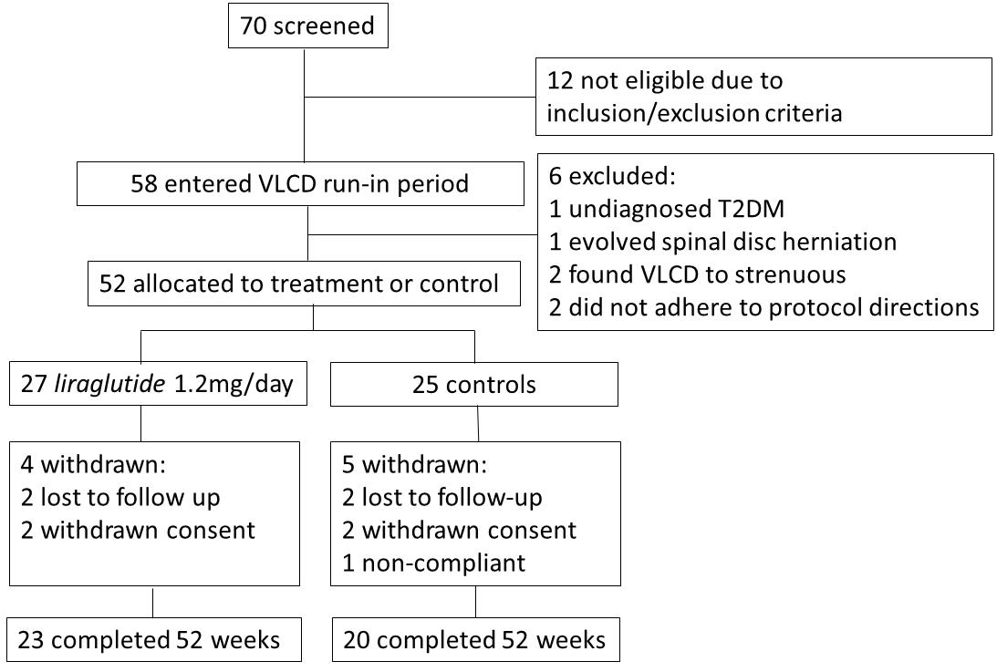
Supplementary figure 2
Supplementary figure 3

Supplementary figure 4
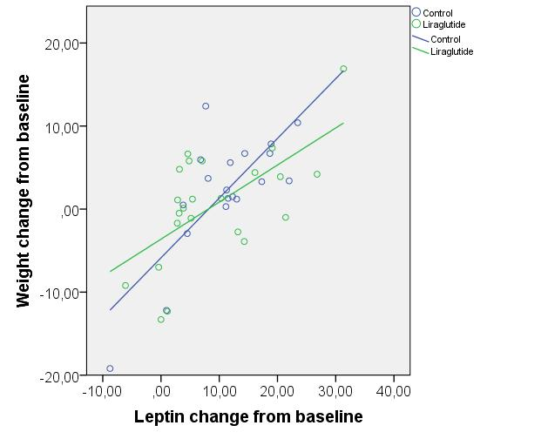
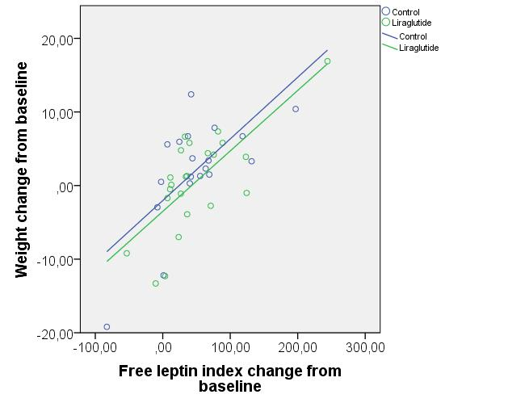

Supplementary figure 5
