Supplemental Material

Supplemental Table 1: Number of reads at each step of sequence data processing for Experiment 1.
Processing Step | Number of Reads
Quality Filtering and Chimera Removal | 10,250,881
OTU Picking | 7,932,440
Sample Filtering | 6,637,351
Rarefaction at 100,000 Reads / Sample | 3,700,000

Supplemental Table 2: Number of reads at each step of sequence data processing for Experiment 2.
Processing Step | Number of Reads
Quality Filtering and Chimera Removal | 6,487,790
OTU Picking | 5,007,234
Sample Filtering | 4,267,285
Rarefaction at 116,000 Reads / Sample | 2,668,000

Supplemental Table 3: Significant differences exist in rhizosphere community structure between day vs. night time points based on Bray-Curtis dissimilarities and adonis tests.
 | df | F Statistic | R² | p-value
Time Point | 1, 15 | 3.433 | 0.186 | 0.001

Supplemental Table 4: Significant differences are observed in rhizosphere community composition between clock genotypes based on Jaccard dissimilarities and adonis tests.
 | df | F Statistic | R² | p-value
Genotype | 2, 20 | 2.769 | 0.191 | 0.001

Supplemental Table 5: Significant differences are observed in rhizosphere community structure between clock genotypes based on Bray-Curtis dissimilarities and adonis tests.
 | df | F Statistic | R² | p-value
Genotype | 2, 20 | 2.772 | 0.217 | 0.001

Supplemental Table 6: Effect of culling OTUs by minimum read numbers on Jaccard and Bray-Curtis dissimilarities. Column 1 indicates the minimum read number or range for OTU culling. Column 2 indicates total reads per sample once OTUs with a given read number or range are selected. P-values are provided for Jaccard and Bray-Curtis dissimilarities. Both common and rare taxa are influenced by plant genotype (df =2, 20).
Read Threshold or Range | Rarefaction | p-value (Jaccard) | p-value (Bray-Curtis)
1 | 116,000 | 0.001 | 0.001
10 | 115,000 | 0.001 | 0.001
50 | 113,000 | 0.001 | 0.001
100 | 111,000 | 0.001 | 0.001
500 | 103,000 | 0.001 | 0.001
1,000 | 98,000 | 0.001 | 0.001
Range 1-500 | 13,000 | 0.001 | 0.001
Supplemental Table 7: Indicator OTUs associated with the toc1-21 rhizosphere, IndVal statistic, and p-value. OTUs often could not be identified to the species level. The lowest phylogenetic level to which we could identify an OTU is indicated by the use of o (for order), f (for family), or g (for genus).
OTU | Phylum (relative abundance) | IndVal Statistic | p-value
Gemmatimonodales;o_;f_;g_ | Gemmatimonadetes | 0.899 | 0.010
Beijerinckia | Proteobacteria | 0.866 | 0.015
Chloracidobacteria;o_;f_;g_ | Acidobacteria | 0.770 | 0.010
Barnesiellacea;g_ | Bacteroidetes | 0.707 | 0.010
Pseudoramibacter | Firmicutes | 0.707 | 0.010
Lachnospira | Firmicutes | 0.707 | 0.035
Polyangiaceae;g_ | Proteobacteria | 0.707 | 0.020
Rickettsia | Proteobacteria | 0.640 | 0.045
Legionellales;f_:g_ | Proteobacteria | 0.572 | 0.050

Supplemental Table 8: Indicator OTUs associated with the ztl-30 rhizosphere, IndVal statistic, and p-value.
OTU | Phylum (relative abundance) | IndVal Statistic | p-value
Dyella | Proteobacteria | 0.935 | 0.005
Mycetocola | Actinobacteria | 0.934 | 0.005
Klebsiella | Proteobacteria | 0.905 | 0.005
Pantoea | Proteobacteria | 0.789 | 0.035
Cytophagales;g_ | Bacteriodetes | 0.655 | 0.045

Supplemental Table 9: Indicator OTU from Lefse analysis for all rhizospheres.
OTU | LDA | Genotype
MIZ46lf;f_;g_ | 2.78 | toc1-21
WD2101;f_;g_ | 2.84 | toc1-21
Novosphingobium | 3.38 | toc1-21
iii1_15;f_;g_ | 2.39 | Ws
Solibacterales;f_;g_ | 2.79 | Ws
Chloroflexi | 2.51 | Ws
Acidobacteria | 3.41 | Ws
Xanthomonadaceae | 2.98 | ztl-30
Micrococcaceae;g_ | 2.70 | ztl-30
Tatlockia | 2.62 | ztl-30
Bacteriovoracaceae;g_ | 3.04 | ztl-30
Erythrobacteraceae;g_ | 3.16 | ztl-30
Nocardioidaceae;g_ | 3.76 | ztl-30
Azospirillum | 2.95 | ztl-30

Supplemental Table 10: There were not significant differences in community size as measured by extracted DNA yield divided by soil mass.
 | df | F Statistic | p-value
Genotype | 2, 19 | 2.49 | 0.11

Supplemental Table 11: Soil pH based on overstory history.
Overstory History | pH
toc1-21 | 5.21
Ws | 5.30
ztl-30 | 5.20

Supplemental Figure 1: Rarefaction based on observed OTUs for Experiments 1 and 2. A) Experiment 1: rarefaction to 100,000 reads. The lines represent 6 A.M. (light blue), 12 P.M. (orange), 6 P.M. (gray), 12 A.M. (blue), and 6 A.M. (black). (B) Experiment 2: rarefaction to 116,000 reads. The lines represent the genotypes Ws (orange), toc1-21 (blue), and ztl-30 (gray).
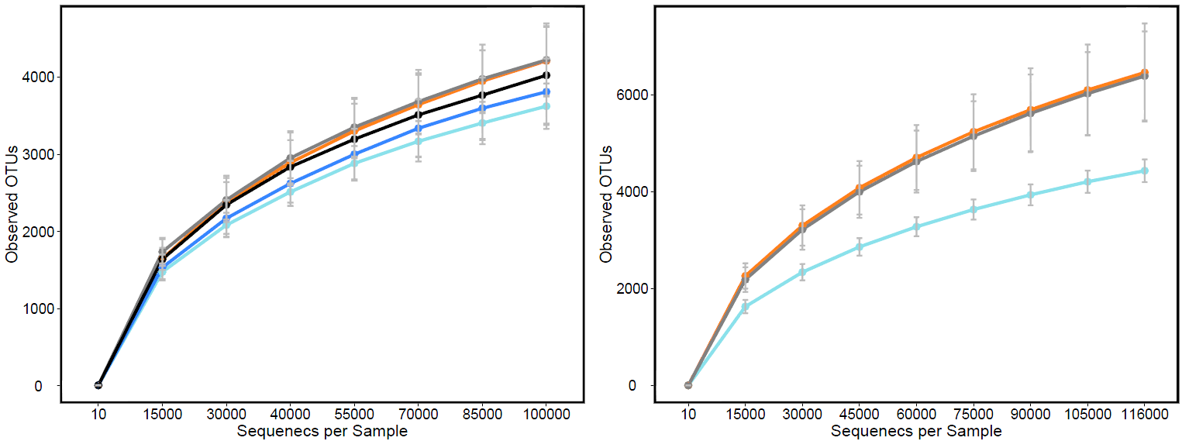

Supplemental Figure 2: Relative abundance of taxa with greater than 1% relative abundance across genotypes.
