Supplementary Information

Genome mining of sordarin biosynthetic gene cluster from Sordaria araneosa Cain ATCC 36386: Characterization of cycloaraneosene synthase and GDP-6-deoxyaltrose transferase

Fumitaka Kudo,¹ Yasunori Matsuura,¹ Takaaki Hayashi,¹ Masayuki Fukushima,² and Tadashi Eguchi²

¹Department of Chemistry, Tokyo Institute of Technology, 2-12-1 O-okayama, Meguro-ku, Tokyo 152-8551, Japan
²Department of Chemistry and Materials Science, Tokyo Institute of Technology, 2-12-1 O-okayama, Meguro-ku, Tokyo 152-8551, Japan

List of SI

Figure S1. Sordarin and related cyclic diterpene natural products
Figure S2. ¹H-NMR analysis of sordarin 1 (400 MHz, CDCl₃)
Figure S3. ¹³C-NMR analysis of sordarin 1 (100 MHz, CDCl₃)
Figure S4. ¹H-NMR analysis of hypoxysordarin 4 (400 MHz, CDCl₃)
Figure S5. ¹³C-NMR analysis of hypoxysordarin 4 (100 MHz, CDCl₃)
Figure S6. ¹H-NMR analysis of cycloalaneosene 2 (SdnA reaction product from GGDP) (500 MHz, CDCl₃)
Figure S7. ¹³C-NMR analysis of cycloalaneosene 2 (SdnA reaction product from GGDP) (125 MHz, CDCl₃)
Figure S8. ¹H-NMR analysis of cycloaraneosene-8-ol 5 (400 MHz, CDCl₃)
Figure S9. ¹³C-NMR analysis of cycloaraneosene-8-ol 5 (100 MHz, CDCl₃)
Figure S10. ¹H-NMR analysis of cycloaraneosene-8,9,13-triol 6 (400 MHz, CDCl₃)
Figure S11. ¹³C-NMR analysis of cycloaraneosene-8,9,13-triol 6
Figure S12. HMQC of cycloaraneosene-8,9,13-triol 6
Figure S13. COSY of cycloaraneosene-8,9,13-triol 6
Figure S14. HMBC of cycloaraneosene-8,9,13-triol 6
Figure S15. NOE analysis of cycloaraneosene-8,9,13-triol 6
Figure S16. SDS-PAGE (12.5%) of SdnA and SdnJ
Figure S17. Synthesis of GDP-6-deoxy-D-altrose 7
Figure S18. LC-ESI-MS analysis of the SdnJ reaction with GDP-D-mannose and GDP-D-glucose
Table S1. NMR data of cycloaraneosene-8,9,13-triol 6
References
Figure S1. Sordarin and related cyclic diterpene natural products

Figure S2. ¹H-NMR analysis of sordarin 1 (400 MHz, CDCl₃)

Figure S3. ¹³C-NMR analysis of sordarin 1 (100 MHz, CDCl₃)
Figure S4. ¹H-NMR analysis of hypoxysordarin 4 (400 MHz, CDCl₃)
DEPT45
DEPT90
DEPT135

Figure S5. ¹³C-NMR analysis of hypoxysordarin 4 (100 MHz, CDCl₃)
DEPT45
DEPT90
DEPT135

Figure S6. ¹H-NMR analysis of cycloalaneosene 2 (SdnA reaction product from GGDP) (500 MHz, CDCl₃)

Figure S7. ¹³C-NMR analysis of cycloalaneosene 2 (SdnA reaction product from GGDP) (125 MHz, CDCl₃)

Figure S8. ¹H-NMR analysis of cycloaraneosene-8-ol 5 (400 MHz, CDCl₃)

Figure S9. ¹³C-NMR analysis of cycloaraneosene-8-ol 5 (100 MHz, CDCl₃)

Figure S10. ¹H-NMR analysis of cycloaraneosene-8,9,13-triol 6 (400 MHz, CDCl₃)

Figure S11. ¹³C-NMR analysis of cycloaraneosene-8,9,13-triol 6
DEPT45
DEPT135
DEPT90

Figure S12. HMQC of cycloaraneosene-8,9,13-triol 6

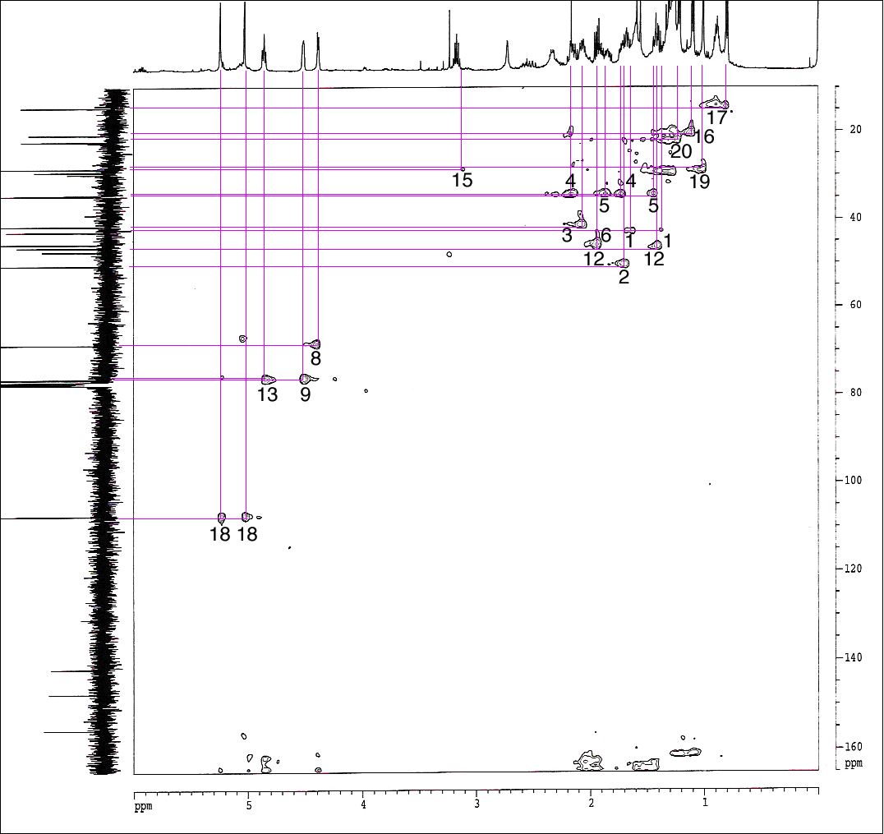

Figure S13. COSY of cycloaraneosene-8,9,13-triol 6

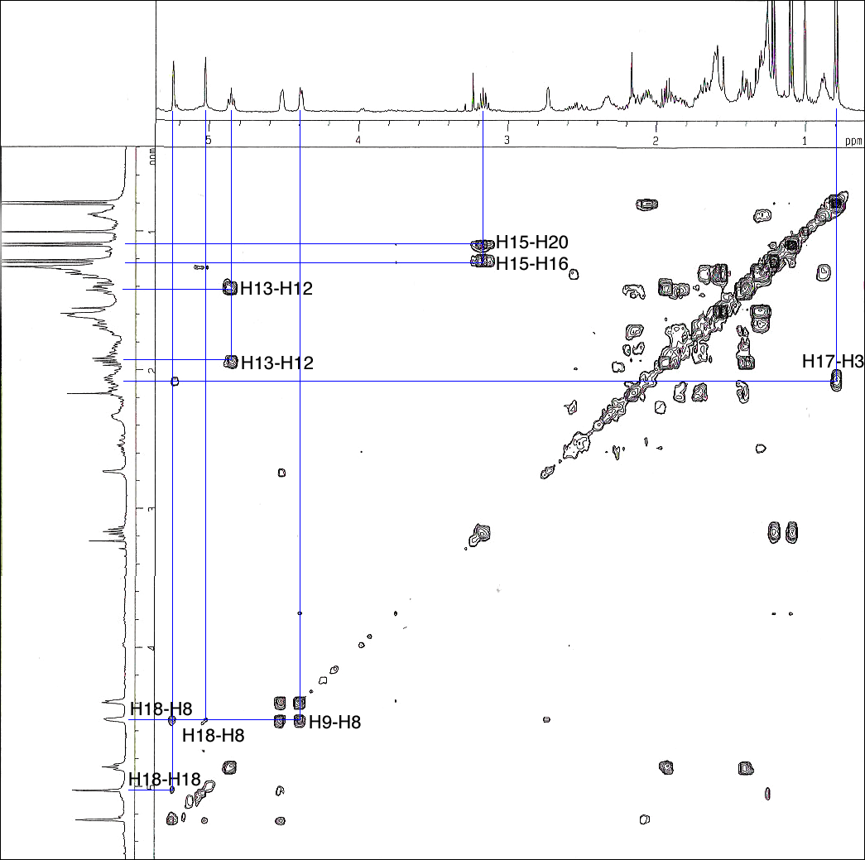

Figure S14. HMBC of cycloaraneosene-8,9,13-triol 6

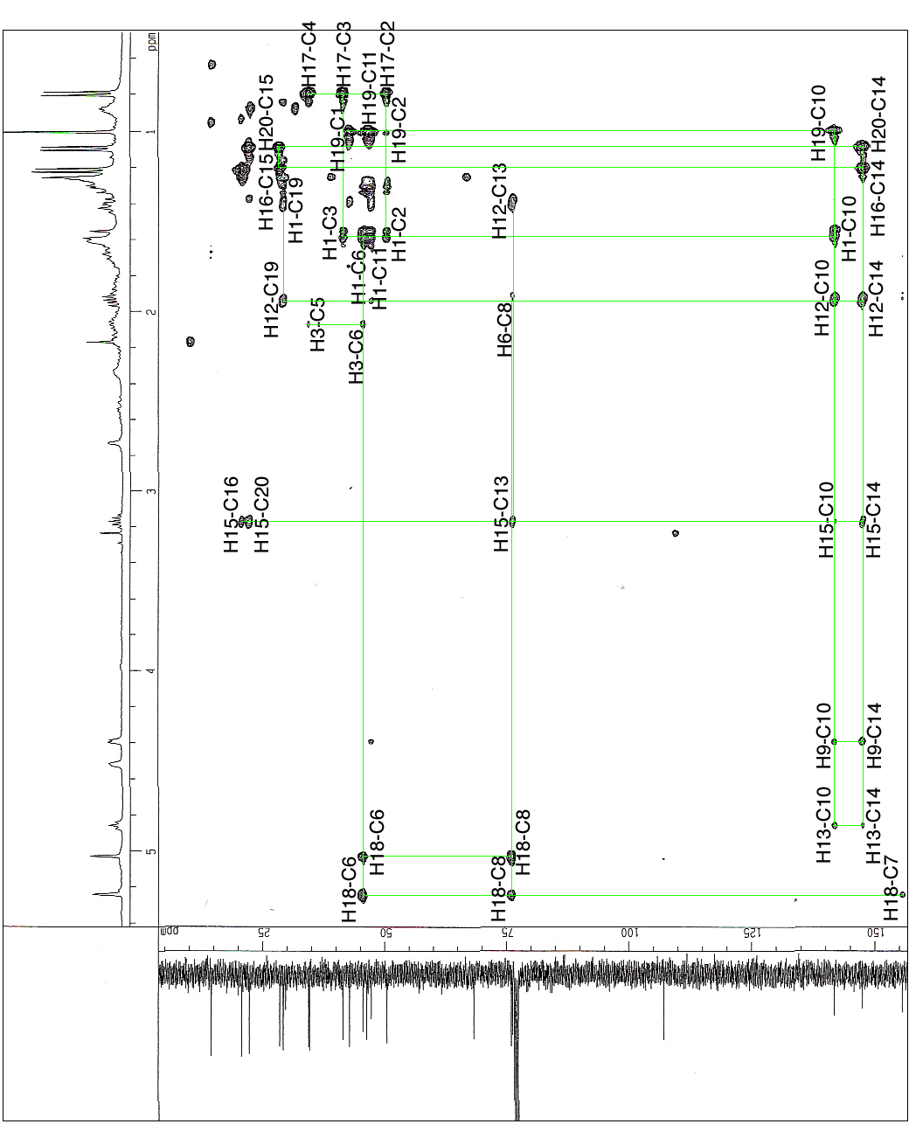
Figure S15. NOE analysis of cycloaraneosene-8,9,13-triol 6
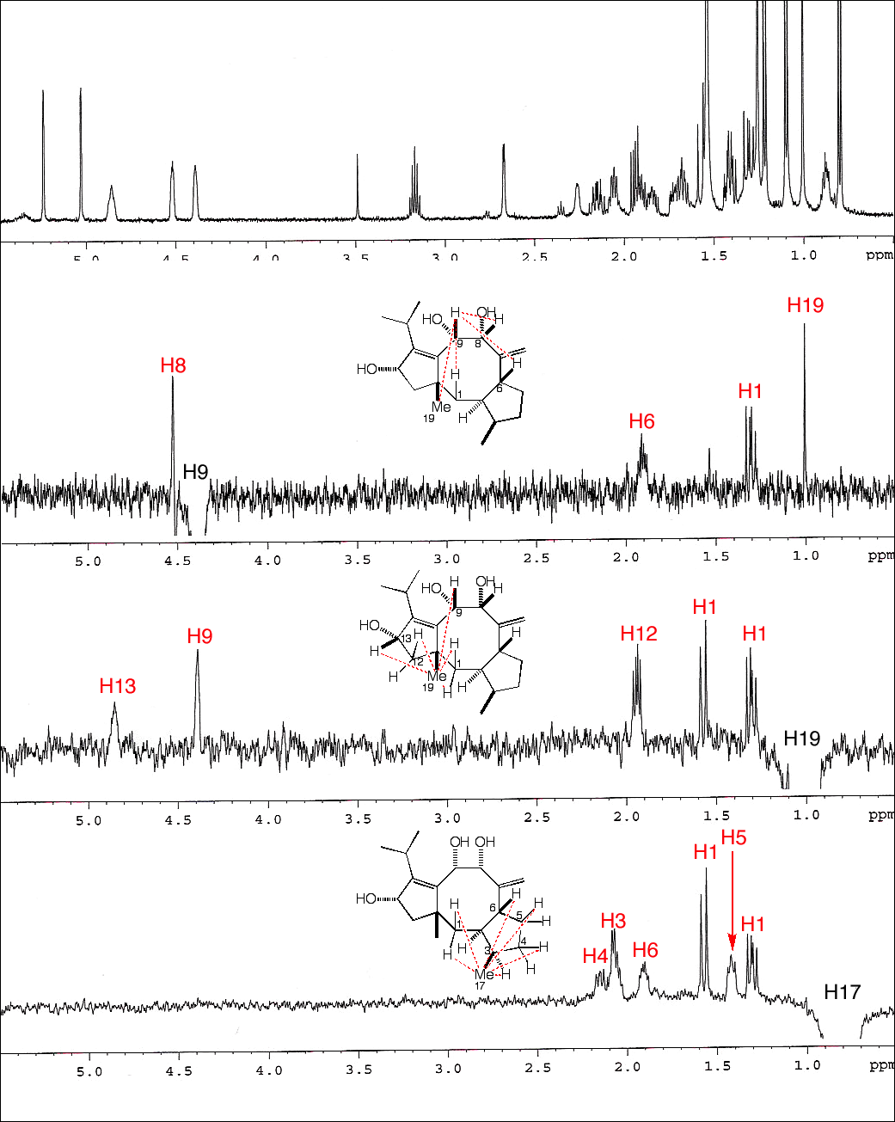

Figure S16. SDS-PAGE (12.5%) of SdnA and SdnJ

Figure S17. Synthesis of GDP-6-deoxy-D-altrose 7
Summary of Synthesis of GDP-6-deoxy-D-altrose (7)
According to the previously reported method, methyl-4,6-O-benzylidene-α-D-altrose 12 was synthesized from commercially available methyl-4,6-O-benzylidene-α-D-glucopyranoside 9 (Sigma-Aldrich).¹ Two hydroxy groups of 12 were acetylated and then treated with N-bromosuccinimide (NBS) to obtain bromide 14, which was then reduced with lithium aluminum hydride (LiAlH₄) to give methyl-α-6-deoxy-D-altrose 15. After acetylation of 15, methyl glycoside 16 was further converted to 6-deoxy-1,2,3,4-O-tetraacetylaltrose 17. 17 was then treated with TiBr₄ to give 1-bromide 18 and further converted to 6-deoxy-2,3,4-O-triacetylaltrose 19.² 19 was reacted with 2-chloro-1,3,2-benzodioxaphosphorin-4-one (salicylchlorophosphite) and followed by oxidation with tert-butylhydroperoxide and catalytic amount of iodine to give 6-deoxy-2,3,4-O-triacetylaltrose-1-phosphate 21.³ Deprotection of acetyl groups under the basic condition afforded 6-deoxyaltrose-1-phosphate 22.⁴ The triethylammonium salt of 22 was mixed with guanosine 5’-monophospho (GMP)-morpholidate 23⁵ and 1H-tetrazole in a pyridine solution and reacted for 3 days at room temperature.⁶ After the reaction, pyridine was removed in vacuo and the coupling product was purified with an anion exchange resin DEAE Sephadex A-25 (OH– form), and further purified by HPLC with ODS column to obtain GDP-6-deoxy-D-altrose 7 (α:β = 4:1). ADP-6-deoxy-D-altrose (α:β = 2:1) and TDP-6-deoxy-D-altrose (α:β = 3:1) were also synthesized to investigate the substrate specificity of SdnJ.

Methyl 4,6-O-benzylidene-2,3-O-diacetyl-α-D-altropyranoside (13)
Compound 12 (6.96 g, 24.7 mmol) was dissolved in 40 mL of pyridine and to the solution were added acetic anhydride (25.8 mL, 234 mmol) and 4-dimethylaminopyridine (5 mg, 41.0 μmol), and the mixture was stirred at room temperature for 2 h. After quenching the reaction with sat. NaHCO₃ solution, the mixture was extracted with ethyl acetate. The organic layer was washed with sat. NH₄Cl solution and brine, and then was dried over anhydrous Na₂SO₄. The organic solution was concentrated on a rotary evaporator to yield 13 (8.98 g, 99%). ¹H-NMR (400 MHz, CDCl₃) δ 7.44-7.46 (2H, m, Ph), 7.35-7.38 (3H, m, Ph), 5.61 (1H, s, acetal), 5.22 (1H, dd, J = 2.8, 3.6 Hz, 3-H), 5.03 (1H, d, J = 2.8 Hz, 2-H), 4.60 (1H, s, 1-H), 4.26-4.36 (2H, m, 5-H, 6-H), 4.00 (1H, dd, J = 3.6, 9.6 Hz, 4-H), 3.79 (1H, dd, J = 10.1, 10.6 Hz, 6-H), 3.40 (3H, s, OMe), 2.12-2.16 (6H, m, Ac). ¹³C-NMR (100 MHz, CDCl₃) δ 170.2, 169.2, 137.3, 129.2, 128.4 (2C), 126.2 (2C), 102.0, 98.8, 74.4, 69.5, 69.3, 67.1, 58.6, 55.7, 21.0 (2C). ESI-MS: m/z 389 ([M+Na]⁺).

Methyl 4-O-benzoyl-6-bromo-2,3-O-diacetyl-6-deoxy-α-D-altropyranoside (14)
Compound 13 (6.28 g, 17.2 mmol) was dissolved in 90 mL of CCl₄ and to the solution were added N-bromosuccinimide (3.95 g, 22.2 mmol) and barium carbonate (2.03 g, 10.3 mmol). The mixture was stirred in argon atmosphere at 65 °C for 3 h. After cooling down to room temperature, the solution was filtered through a Celite pad to remove the precipitate and the resultant solution was concentrated on a rotary evaporated. The residue was chromatographed over silica-gel with hexane-EtOAc (5:1) as the eluent to yield 14 (5.56 g, 73%). ¹H-NMR (400 MHz, CDCl₃) δ 7.97-7.99 (2H, m, Ph), 7.60 (1H, t, J = 7.6 Hz, Ph), 7.44-7.48 (2H, m, Ph), 5.33-5.38 (2H, m, 3-H, 4-H), 5.02 (1H, d, J = 3.2 Hz, 2-H), 4.72 (1H, s, 1-H), 4.49 (1H, ddd, J = 2.8, 9.6, 11.2 Hz, 5-H), 3.62 (1H, dd, J = 2.8, 11.6 Hz, 6-H), 3.49-3.51 (4H, m, 6-H, OMe), 2.04-2.16 (6H, m, Ac). ¹³C-NMR (100 MHz, CDCl₃) δ 169.8, 169.4, 165.2, 133.7, 129.8 (2C), 129.1, 128.7 (2C), 99.0, 69.5, 68.2, 67.5, 66.3, 55.9, 32.2, 21.0, 20.9. ESI-MS: m/z 467, 469 ([M+Na]⁺).

Methyl 6-deoxy-α-D-altropyranoside (15)
Compound 14 (6.14 g, 13.8 mmol) was dissolved in 50 mL of anhydrous THF and to the solution was added LiAlH₄ (5.25 g, 138 mmol). The mixture was stirred in argon atmosphere at 58 °C for 3 h. After cooling down to room temperature, to the solution was added water (5.2 mL), 2 M NaOH (5.2 mL), and water (15 mL), and then stirred at room temperature for 1 h. The solution was filtered through a Celite pad to remove the precipitate and the resultant solution was concentrated on a rotary evaporated. The residue was chromatographed over silica-gel with CHCl₃-CH₃OH (10:1) as the eluent to yield 15 (1.11 g, 45%). ¹H-NMR (400 MHz, CD₃OD) δ 4.43 (1H, s, 1-H), 3.81 (1H, dq, J = 6.4, 9.2 Hz, 5-H), 3.70 (2H, m, 2-H, 3-H), 3.42 (1H, dd, J = 2.8, 9.2 Hz, 4-H), 3.23-3.24 (3H, m, OMe), 1.20 (3H, d, J = 6.4 Hz, 6-H). ¹³C-NMR (100 MHz, CD₃OD) δ 101.4, 71.0, 70.3, 69.8, 64.4, 54.3, 16.6. ESI-MS: m/z 217 ([M+Na]⁺).

Methyl 6-deoxy-2,3,4-O-triacetyl-α-D-altropyranoside (16)
Compound 15 (29 mg, 0.163 mmol) was dissolved in 1 mL of pyridine and to the solution was added acetic anhydride (0.25 mL, 2.27 mmol) and a catalytic amount of 4-dimethylaminopyridine, and the mixture was stirred at room temperature for 2 h. After quenching the reaction with sat. NaHCO₃ solution, the mixture was extracted with ethyl acetate. The organic layer was washed with sat. NH₄Cl solution and brine, and then was dried over anhydrous Na₂SO₄. The organic solution was concentrated on a rotary evaporator to yield 16 (43 mg, 88%). ¹H-NMR (400 MHz, CDCl₃) δ 5.19 (1H, dd, J = 2.0, 3.6 Hz, 3-H), 4.91-4.94 (2H, m, 2-H, 4-H), 4.56 (1H, s, 1-H), 4.18 (1H, dq, J = 6.4, 9.2 Hz, 5-H), 3.38 (3H, s, OMe), 2.02-2.11 (9H, m, Ac), 1.24 (3H, d, J = 6.4 Hz, 6H). ¹³C-NMR (100 MHz, CDCl₃) δ 170.1, 169.9, 169.5, 98.5, 70.1, 69.7, 67.4, 62.7, 55.6, 21.0, 20.9, 20.8, 17.2. ESI-MS: m/z 327 ([M+Na]⁺)

6-Deoxy-1,2,3,4-O-tetraacetyl-α,β-D-altropyranoside (17)
Compound 16 (719 mg, 2.36 mmol) was dissolved in 15 mL of AcOH and 15 mL of acetic anhydride and the mixture was cooled in an ice-water bath. To the solution was added dropwise conc. H₂SO₄ (0.35 mL) and the mixture was stirred at room temperature for 10 h. After quenching the reaction with sat. NaHCO₃ solution, the mixture was extracted with ethyl acetate. The organic layer was washed with sat. NaHCO₃ solution and brine, and then was dried over anhydrous Na₂SO₄. The organic solution was concentrated on a rotary evaporator to yield 17 (773 mg, 98%, α:β = 1.4:1). ¹H-NMR (400 MHz, CDCl₃) α-anomer; δ 5.89 (1H, s, 1-H), 5.22 (1H, dd, J = 2.2, 3.6 Hz, 3-H), 4.92-4.95 (2H, m, 2-H, 4-H), 4.22 (1H, dq, J = 6.9, 9.2 Hz, 5-H), 1.99-2.10 (12H, m, Ac), 1.20 (3H, d, J = 6.4 Hz, 6-H). β-anomer; δ 6.08 (1H, d, J = 1.8 Hz, 1-H), 5.36 (1H, dd, J = 3.2, 5.0 Hz, 3-H), 5.12 (1H, dd, J = 1.8, 5.0 Hz, 2-H), 4.91-4.94 (1H, m, 4-H), 4.06 (1H, dq, J = 6.6, 9.2 Hz, 5-H), 1.99-2.10 (12H, m, Ac), 1.27 (3H, d, J = 6.6 Hz, 6-H). ¹³C-NMR (100 MHz, CDCl₃) α-anomer; δ 169.8, 169.6, 169.2, 168.7, 90.3, 69.6, 68.7, 66.8, 65.0, 20.8 (2C), 17.2. β-anomer; δ 169.8, 169.6, 169.2, 168.7, 90.2, 70.4, 70.3, 66.8, 67.8, 21.0, 18.1. ESI-MS: m/z 355 ([M+Na]⁺).

6-Deoxy-2,3,4-O-triacetyl-α,β-D-altropyranoside (19)
Compound 17 (769 mg, 2.32 mmol) was dissolved in 20 mL of anhydrous CH₂Cl₂. To the solution was added titanium tetrabromide (2.38 g, 6.48 mmol, Strem Chemicals) and the mixture was stirred in argon atmosphere at room temperature for 2 h. After addition of sodium acetate (973 mg, 11.9 mmol), the mixture was stirred at room temperature for 15 min. The solution was filtered through a Celite pad to remove the precipitate. The resultant solution was washed with brine, and then was dried over anhydrous Na₂SO₄. The organic solution was concentrated on a rotary evaporator to yield crude 18. The residue was dissolved in a mixture of 20 mL of acetone and 1 mL of water and to the mixture was silver carbonate (1.3 g, 4.71 mmol), and the mixture was stirred at room temperature for 16 h. The solution was filtered through a Celite pad to remove the precipitate and the solution was concentrated on a rotary evaporator. The residue was chromatographed over silica-gel with hexane-EtOAc (1.5:1) as the eluent to yield 19 (470 mg, 70%, α:β = 1.6:1). ¹H-NMR (400 MHz, CDCl₃) α-anomer; δ 5.35 (1H, d, J = 2.8 Hz, 3-H), 5.16 (1H, s, 1-H), 4.92-4.96 (1H, m, 2-H), 4.82 (1H, dd, J = 2.8, 9.6 Hz, 4-H), 4.00 (1H, dq, J = 6.4, 9.6 Hz, 5-H), 2.01-2.14 (9H, m, Ac), 1.26 (3H, d, J = 6.4 Hz, 6-H). β-anomer; δ 5.28 (1H, d, J = 3.2 Hz, 1-H), 4.92-4.96 (3H, m, 2-H, 3-H, 4-H), 4.30 (1H, dq, J = 6.4, 9.6 Hz, 5-H), 1.99-2.10 (12H, m, Ac), 1.27 (3H, d, J = 6.4 Hz, 6-H). ¹³C-NMR (100 MHz, CDCl₃) α-anomer; δ 170.3, 170.0, 169.3, 91.5, 70.2, 70.1, 68.7, 67.2, 21.1, 21.0, 20.9, 17.8. β-anomer; δ 170.3, 170.0, 169.3, 92.0, 70.2, 70.1, 67.5, 64.0, 21.1, 21.0, 20.9, 17.1. ESI-MS: m/z 313 ([M+Na]⁺).

6-Deoxy-2,3,4-O-triacetyl-α,β-D-altropyranosyl phosphite mono-Et₃N salt (20)
Compound 19 (273 mg, 0.941mmol) was dissolved in a mixture of anhydrous THF (1 mL) and 1,4-dioxane (2 mL) and the mixture was cooled in an ice-water bath. To the mixture were then added Et₃N (0.21 mL, 2.86 mmol) and a solution of 2-chloro-1,3,2-benzodioxaphosphorin-4-one (salicylchlorophosphite, 381 mg, 1.88 mmol) in anhydrous THF (1 mL), and the mixture was stirred under an argon atmosphere at 0 °C for 2 h. After adding 1 mL of water, the solution was concentrated on a rotary evaporator. The residue was suspended with 5 mL of THF and the solution was filtered through a Celite pad to remove the precipitate and the solution was concentrated on a rotary evaporator. The residue was chromatographed through Sephadex LH-20 (1.5 x 90 cm) with CH₃OH-H₂O (9:1) as the eluent to yield crude 18. After concentration, the residue was further chromatographed over silica-gel with CHCl₃ - CH₃OH (10:1) as the eluent to yield 20 (376 mg, 86%, α:β = 2.2:1). ¹H-NMR (400 MHz, CD₃OD) α-anomer; δ 6.03 (1H, s, PH), 5.39 (1H, dd, J = 2.3, 8.0 Hz, 1-H), 5.20 (1H, dd, J = 3.2, 4.0 Hz, 3-H), 4.96 (1H, d, J = 4.0 Hz, 2-H), 4.83 (1H, m, 4-H), 4.40 (1H, dq, J = 6.4, 9.6 Hz, 5-H), 3.15-3.17 (6H, m, (CH₃CH₂)₃N), 2.09-2.11 (9H, m, Ac), 1.27-1.31 (9H, m, (CH₃CH₂)₃N), 1.18 (3H, d, J = 6.4 Hz, 6-H). β-anomer; δ 6.04 (1H, s, PH), 5.60 (1H, dd, J = 2.0, 9.2 Hz, 1-H), 5.34 (1H, dd, J = 3.2, 5.3 Hz, 3-H), 5.05 (1H, dd, J = 2.0, 5.3 Hz, 2-H), 4.83 (1H, m, 4-H), 4.07 (1H, dq, J = 6.4, 9.6 Hz, 5-H), 3.15-3.17 (6H, m, (CH₃CH₂)₃N), 2.09-2.11 (9H, m,Ac), 1.27-1.31 (9H, m, (CH₃CH₂)₃N), 1.18 (3H, d, J = 6.4 Hz, 6-H). ¹³C-NMR (100 MHz, CD₃OD) α-anomer; δ 170.5, 170.3, 169.5, 92.5 (d, J = 3.8 Hz), 70.1, 70.0, 66.9, 63.6, 47.6(3C), 19.4, 19.3, 19.2, 16.0, 7.9 (3C). β-anomer; δ 170.5, 170.3, 169.5, 92.4 (d, J = 3.8 Hz), 70.6, 70.0, 69.2 (d, 6.7 Hz), 66.7, 47.6 (3C), 19.4, 19.3, 19.2, 16.0, 7.9 (3C). ³¹P-NMR (162.0 MHz, CD₃OD) δ 1.25 (s, 1P). ESI-MS: m/z 353 ([M-H]⁻).
6-Deoxy-2,3,4-O-triacetyl-α,β-D-altropyranosyl phosphate mono-Et₃N salt (21)
Compound 20 (750 mg, 1.68 mmol) was dissolved in anhydrous THF (1 mL) and to the mixture was then added Dowex 50WX8 (H⁺ form) until the pH become 3 to 4. After removal of the resin by filtration, the solution was concentrated on a rotary evaporator. The residue was dissolved in 20 mL of anhydrous THF, and iodine (3.0 mg, 11.8 μmol) and tert-butyl hydroperoxide (1.75 mL of 6 M decane solution, 10.5 mmmol) were added to the solution. The mixture was stirred under an argon atmosphere at room temperature for 36 h. After adding 2 mL of Et₃N, the solution was concentrated on a rotary evaporator. The residue was chromatographed over C18 resin (Wakogel 50C18) with water as the eluent to yield 21 (379 mg, 52%, α:β = 2.6:1). ¹H-NMR (400 MHz, CD₃OD) α-anomer; δ 5.36-5.38 (1H, m, 1-H), 5.20 (1H, dd, J = 2.6, 3.6 Hz, 3-H), 5.01 (1H, d, J = 2.6 Hz, 2-H), 4.82 (1H, m, 4-H), 4.08 (1H, dq, J = 6.4, 9.6 Hz, 5-H), 3.16-3.18 (6H, m, (CH₃CH₂)₃N), 2.06-2.12 (9H, m, Ac), 1.28-1.31 (9H, m, (CH₃CH₂)₃N), 1.16 (3H, d, J = 6.4 Hz, 6-H). β-anomer; δ 5.59 (1H, dd, J = 2.0, 9.2 Hz, 1-H), 5.36-5.38 (1H, m, 3-H), 5.06 (1H, dd, J = 2.0, 5.6 Hz, 2-H), 4.82 (1H, m, 4-H), 4.46 (1H, dq, J = 6.4, 9.6 Hz, 5-H), 3.16-3.18 (6H, m, (CH₃CH₂)₃N), 2.06-2.12 (9H, m, Ac), 1.28-1.31 (9H, m, (CH₃CH₂)₃N), 1.16 (3H, d, J = 6.4 Hz, 6-H). ¹³C-NMR (100 MHz, CD₃OD) α-anomer; δ 170.7, 170.3, 169.5, 93.1 (d, 4.6 Hz), 70.2 (2C), 66.9, 63.1, 47.6 (3C), 19.5, 19.4 (2C), 16.1, 7.7 (3C). β-anomer; δ 170.3, 169.9, 169.7, 92.8 (d, J = 4.6 Hz), 70.7, 70.0 (d, J = 9.16 Hz), 66.7, 58.5, 47.6 (3C), 19.5, 19.4 (2C), 16.1, 7.7 (3C). ³¹P-NMR (162.0 MHz, CD₃OD) δ -1.34 (s, 1P). ESI-MS: m/z 369 ([M-H]⁻).

6-Deoxy-α,β-D-altropyranosyl phosphate mono-Et₃N salt (22)
Compound 21 (31 mg, 65.8 μmol) was dissolved in a mixture of water (1 mL), CH₃OH (1 mL) and ammonia solution (0.5 mL of 28% solution), and the mixture was stirred at room temperature for 12 h. After removal of the solvents on a rotary evaporator, the residue was dissolved in a mixture of CH₃OH (4 mL) and Et₃N (0.1 mL). After removal of the solvents, the residue was chromatographed through Sephadex LH-20 (1.5 x 90 cm) with CH₃OH-H₂O (9:1) as the eluent to yield 20 (23 mg, quant, α:β = 2.6:1). ¹H-NMR (400 MHz, CD₃OD) α-anomer; δ 5.12 (1H, dd, J = 2.8, 7.8 Hz, 1-H), 4.05 (1H, dq, J = 6.4, 9.6 Hz, 5-H), 3.75-3.91 (2H, m, 2-H, 3-H), 3.37-3.51 (1H, m, 4-H), 3.03-3.11 (6H, m, (CH₃CH₂)₃N), 1.00-1.19 (12H, m, (CH₃CH₂)₃N, 6-H). β-anomer; δ 5.25 (1H, dd, J = 1.7, 8.7 Hz, 1-H), 3.92 (1H, dd, J = 3.2, 3.6 Hz, 3-H), 3.75-3.91 (2H, m, 2-H, 5-H), 3.37-3.51 (1H, m, 4-H), 3.03-3.11 (6H, m, (CH₃CH₂)₃N), 1.00-1.19 (12H, m, (CH₃CH₂)₃N, 6-H). ¹³C-NMR (100 MHz, CD₃OD) α-anomer; δ 95.3 (d, J = 6.7 Hz), 70.6, 69.9, 69.6, 66.4, 46.7 (3C), 16.5, 8.3 (3C). β-anomer; δ 94.0 (d, J = 3.82 Hz), 70.7, 69.9, 69.5, 66.4, 46.7 (3C), 16.5, 8.3 (3C). ³¹P-NMR (162.0 MHz, CD₃OD) δ -1.42 (s, 1P). ESI-MS: m/z 243 ([M-H]⁻).

Guanosine-5’-phosphomorpholidate (GMP-morpholidate) 23
Guanosine-5’-monophosphate (363 mg, 1.00 mmol) was dissolved in a mixture of H₂O (10 mL) and t-BuOH (10 mL), and to the solution was added morpholine (0.34 ml, 3.90 mmol). The mixture was heated at 90 °C. To the solution, a t-BuOH (15 mL) solution of DCC (900 mg, 4.36 mmol) was added dropwise for 3 h and then further stirred for 3 h at 90 °C. After cooling down to room temperaure, the precipitate was removed by filtration and the solvent was removed by a rotary evaporator. The residue was dissolved in water and washed with diethyl ether for three times. The water layer was concentrated on a rotary evaporator. The resultant residue was dissolved in CH₃OH and crystallized by adding diethyl ether to yield 23 (625 mg, 86%). ¹H-NMR (400 MHz, D₂O) δ 7.91 (1H, s, guanine), 5.76 (1H, d, J = 5.5 Hz, 1’-H), 4.63 (1H, t, J = 5.5 Hz, 2’-H), 4.36 (1H, dd, 3.5, 5.5 Hz, 3’-H), 4.15 (1H, s, 4’-H), 3.95 (2H, m, 5’-H), 3.15-3.63 (8H, m, (CH₂)×4), 1.12-1.75 (10H, m, cyclohexyl×2).

Guanosine-5’-(6-deoxy-α,β-D-altropyranosyl)diphosphate (7, GDP-6-deoxy-D-altrose)
Compound 22 (61 mg, 84.2 μmol) and 1H-tetrazol (5.9 mg, 84.2 μmol) were azeotroped with pyridine for three times and then dried on vacuum pump for 6 h. Compound 23 (22 mg, 63.7 μmol) was also azeotroped with pyridine for three times and then dried on vacuum pump for 6 h. Then, guanosine-5’-phosphomorpholidate was dissolved in a distilled pyridine (5 mL) and was added to the mixture of compound 22 and 1H-tetrazol. The mixture was stirred in argon atmosphere at room temperature for 3 days. After removal of the solvents on a rotary evaporator, the residue was dissolved in water and applied to a DEAE Sephadex A-25 (OH⁻ form) column. The resin was washed with 0.2 M ammonium formate solution and compound 7 was eluted with 0.3 M of the ammonium formate. After removal of the solvents, the residue was purified by HPLC equipped with TSK-Gel ODS100V (TOSOH, 4.6 mm i.d.×250 mm or 10 mm i.d. × 250 mm) with 0.25% NH₄HCO₃ (0.6 mL/min or 3.5 mL/min) as the eluent at rt. The elusion was monitored at 265 nm. The fractions containing the product was lyophilized to yield 7 (5.6 mg, 15%, α:β = 4.1:1). ¹H-NMR (400 MHz, D₂O) α-anomer; δ 8.01 (1H, s, guanine), 5.83 (1H, d, J = 6.4 Hz, 1’-H), 5.24 (1H, dd, J = 2.3, 8.2 Hz, 1”-H), 4.60 (1H, m, 2’-H), 4.43 (1H, dd, J = 3.2, 5.5 Hz, 3’-H), 4.25 (1H, m, 4’-H), 4.09-4.13 (3H, m, 5’-H, 5”-H), 3.84-3.87 (2H, m, 2”-H, 3”-H), 3.51-3.54 (1H, m, 4”-H), 1.18 (3H, m, 6”-H). β-anomer; δ 8.01 (1H, s, guanine), 5.83 (1H, d, J = 6.4 Hz, 1’-H), 5.40 (1H, dd, J = 0.9, 9.2 Hz, 1”-H), 4.60 (1H, m, 2’-H), 4.43 (1H, dd, J = 3.2, 5.5 Hz, 3’-H), 4.25 (1H, m, 4’-H), 4.09-4.13 (2H, m, 5’-H), 3.93 (1H, m, 3”-H), 3.84-3.87 (2H, m, 2”-H, 5”-H), 3.51-3.54 (1H, m, 4”-H), 1.18 (3H, m, 6”-H). ³¹P-NMR (162.0 MHz, D₂O) δ -10.69 (d, 1P, J = 20 Hz), -13.12 (d, 1P, J = 20 Hz). ESI-MS: m/z 588 ([M-H]⁻).

Adenosine-5’-phosphomorpholidate (AMP-morpholidate)
The same procedure for the synthesis of GMP morpholidate was used. ¹H-NMR (400 MHz, D₂O) δ 8.31 (1H, s, adenine), 8.07 (1H, s, adenine), 5.98 (1H, d, J = 5.3 Hz, 1’-H), 4.67 (1H, m, 2’-H), 4.41 (1H, dd, J = 3.5, 5.3 Hz, 3’-H), 4.25 (1H, s, 4’-H), 3.95 (2H, m, 5’-H), 3.15-3.63 (8H, m, (CH₂)×4), 1.12-1.75 (10H, m, cyclohexyl×2).

Adenosine-5’-(6-deoxy-α,β-D-altropyranosyl)diphosphate (ADP-6-deoxy-D-altrose)
According to the same procedure for the synthesis of GDP-6-deoxyaltrose, 4.2 mg (12%, α:β = 2.0:1) of ADP-6-deoxy-D-altrose was obtained. ¹H-NMR (400 MHz, D₂O) α-anomer; δ 8.42 (1H, s, adenine), 8.12 (1H, s, adenine), 6.00 (1H, d, J = 6.4 Hz, 1’-H), 5.20 (1H, dd, J = 2.3, 8.3 Hz, 1”-H), 4.62 (1H, m, 2’-H), 4.41 (1H, dd, J = 3.5, 5.3 Hz, 3’-H), 4.26 (1H, m, 4’-H), 4.04-4.10 (3H, m, 5’-H, 5”-H), 3.75-3.82 (2H, m, 2”-H, 3”-H), 3.47-3.50 (1H, m, 4”-H), 1.10-1.15 (3H, m, 6”-H). β-anomer; δ 8.42 (1H, s, adenine), 8.12 (1H, s, adenine), 6.00 (1H, d, J = 6.4 Hz, 1’-H), 5.34 (1H, dd, J = 0.9, 9.2 Hz, 1”-H), 4.62 (1H, m, 2’-H), 4.41 (1H, dd, J = 3.5, 5.3 Hz, 3’-H), 4.26 (1H, m, 4’-H), 4.04-4.10 (2H, m, 5’-H), 3.88 (1H, m, 3”-H), 3.75-3.3.82 (2H, m, 2”-H, 5”-H), 3.47-3.50 (1H, m, 4”-H), 1.10-1.15 (3H, m, 6”-H). ESI-MS: m/z 572 ([M-H]⁻).

Thymidine-5’-phosphomorpholidate (TMP-morpholidate)
Thymidine-5’-monophosphate disodium salt was dissolved in water, and to the solution was added Dowex 50WX8 (H⁺ form) until pH become 3 ~ 4. After filtration, the solvent was removed by a rotary evaporator to obtain the free form of TMP. The same procedure for the synthesis of GMP-morpholidate was used. ¹H-NMR (400 MHz, D₂O) δ 7.60 (1H, s, thymine), 6.15 (1H, s, 1’-H), 4.40 (1H, m, 3’-H), 3.98 (1 H, s, 4’-H), 3.79-3.81 (2H, m, 5’-H), 3.15-3.63 (8H, m, (CH₂)×4), 2.21 (2H, m, 2’-H), 1.76 (3 H, m, Me), 1.12-1.75 (10H, m, cyclohexyl×2).

Thymidine-5’-(6-deoxy-α,β-D-altropyranosyl)diphosphate (TDP-6-deoxy-D-altrose)
According to the same procedure for the synthesis of GDP-6-deoxyaltrose, 6.0 mg (18%, α:β = 3.0:1) of TDP-6-deoxy-D-altrose was obtained. ¹H-NMR (400 MHz, D₂O) α-anomer; δ 7.60 (1H, s, thymine), 6.20 (1H, dd, J = 6.9, 7.4 Hz, 1’-H), 5.19 (1H, dd, J = 2.3, 8.2 Hz, 1”-H), 4.48 (1H, m, 3’-H), 4.02-4.04 (4H, m, 4’-H. 5’-H, 5”-H), 3.76-3.82 (2H, m, 2”-H, 3”-H), 3.43-3.49 (1H, m, 4”-H), 2.20-2.22 (2H, m, 2’-H), 1.78 (3H, s, Me), 1.10-1.15 (3H, m, 6”-H). β-anomer; δ 7.60 (1H, s, thymine), 6.20 (1H, dd, J = 6.9, 7.4 Hz, 1’-H), 5.33 (1H, dd, J = 0.9, 8.7 Hz, 1”-H), 4.48 (1H, m, 3’-H), 4.02-4.04 (3H, m, 4’-H, 5’-H), 3.89 (1H, dd, J = 4.1, 4.2 Hz, 3”-H), 3.76-3.82 (2H, m, 2”-H, 5”-H), 3.43-3.49 (1H, m, 4”-H), 2.20-2.22 (2H, m, 2’-H), 1.78 (3H, s, Me), 1.10-1.15 (3H, m, 6”-H). ESI-MS: m/z 547 ([M-H]⁻).

Guanosine-5’-α-D-glucopyranosyldiphosphate (GDP-D-glucose)
Glucose 1-phosphate disodium salt (50 mg, 113 μmol) was dissolved in water and passed through a column of Dowex 50WX8 (tri-n-butylamine form) to obtain the tri-n-butylamine salt of glucose 1-phosphate, which was used for the GDP-glucose. According to the same procedure for the synthesis of GDP-6-deoxyaltrose, 7.7 mg (18%) of GDP-D-glucose was obtained. ¹H-NMR (400 MHz, D₂O) δ 7.96 (1H, s), 5.76 (1H, d, J = 6.4 Hz), 5.42 (1H, dd, J = 4.0, 7.6 Hz), 4.61 (1H, t, J = 5.5 Hz), 4.31 (1H, dd, J = 3.7, 5.0), 4.18 (1H, m), 4.03-4.05 (2H, m), 3.55-3.72 (3H, m), 3.25-3.35 (2H, m). ESI-MS: m/z 604 ([M-H]⁻).
Guanosine-5’-α-D-mannopyranosyldiphosphate (GDP-D-mannose) was purchased from Sigma-Aldrich.

Preparation of sordaricin
To a solution of sordarin 1 (101 mg) in acetone (50 mL), conc. HCl (1 mL) was added at 0 °C. The mixture was stirred at room temperature for 3 days. After concentration of the solution, the residue was partitioned with CHCl₃ and water. The CHCl₃ layer was purified by recrystallization with hexane and CH₃OH (100:1) to give sordaricin 3 (60 mg) as colorless crystal. The partially decomposed material containing 3 (10 mg) was further purified by silica-gel chromatography with CHCl₃-CH₃OH (15:1) as the eluent to yield 6.2 mg of pure sample. ¹H-NMR (400 MHz, CD₃OD) δ 9.72 (1H, s, CHO), 6.06 (1H, m), 3.76 (1H, d, J = 11.4 Hz), 3.61 (1H, d, J = 11.4 Hz), 2.58 (1H, m), 2.32 (1H, m), 2.05-2.12 (3H, m), 1.79-1.91 (4H, m), 1.20-1.27 (4H, m), 0.96-1.04 (6H, m), 0.81 (3H, m).

Figure S18. LC-ESI-MS analysis of the SdnJ reaction with GDP-D-mannose and GDP-D-glucose

Table S1. NMR data of cycloaraneosene-8,9,13-triol 6

Position | δ C (ppm) | δ H (multiplicity, J in Hz) | HMBC | NOE
1 | 42.7 | 1.67 (m) | 2, 6, 12, 19
 |  | 1.42 (m)
2 | 50.4 | 1.68 (t, 10.0) | 1
3 | 41.4 | 2.05 (m) | 5, 6
4 | 34.4 | 1.84 (m)
 |  | 2.14 (m)
5 | 34.5 | 1.74 (m)
 |  | 1.41 (m)
6 | 45.5 | 1.88 (ddd, 14.8, 10.0, 4.4) | 8
7 | 155.7
8 | 76.0 | 4.51 (brs) |  | 9
9 | 68.3 | 4.39 (brs) | 10, 11 | 8
10 | 141.8
11 | 47.2
12 | 46.2 | 1.94 (dd, 12.7, 7.5) | 10, 14
 |  | 1.38 (dd, 12.4, 7.6)
13 | 76.2 | 4.86 (t, 6.1) | 10, 14
14 | 147.2
15 | 29.2 | 3.17 (sep, 7.0) | 10, 13, 14, 16, 20
16 | 20.7 | 1.21 (d, 7.0) | 14
17 | 14.5 | 0.79 (d, 7.3) | 2, 3, 4, 5
18 | 107.1 | 5.02 (brs) | 6, 8, 7
 |  | 5.23 (brs)
19 | 28.5 | 1.00 (s) | 1, 10 | 6, 9, 13
20 | 22.2 | 1.09 (d, 6.8) | 14

References
1. Gronwald O., Sakurai K., Luboradzki R., Kimura T., Shinkai S. Further evidence for the gelation ability-structure correlation in sugar-based gelators. Carbohydr. Res. 331, 307-318 (2001).
2. Elhalabi J., Rice K. G. Thiosugar nucleotide analogs: synthesis of 5'-(2,3,4-tri-O-acetyl-6-S-acetyl-6-thio-alpha-D-galactopyranosyl diphosphate). Carbohydr. Res. 337, 1935-1940 (2002).
3. Bosco M., et al. 6-Azido D-galactose transfer to N-acetyl-D-glucosamine derivative using commercially available β-1,4-galactosyltransferase. Tetrahedron Lett. 49, 2294-2297 (2008).
4. Lunau N., Meier C. Synthesis of L-Altrose and Some Derivatives. Eur. J. Org. Chem. 2012, 6260-6270 (2012)
5. Moffatt J. G., Khorana H. G. Nucleoside polyphosphates. X. The synthesis and some reactions of nucleoside 5'-phosphoromorpholidates and related compounds. Improved methods for the preparation of nucleoside 5'-polyphosphates. J. Am. Chem. Soc. 83, 649-658 (1961).
6. Wittmann V., Wong C.-H. 1H-Tetrazole as Catalyst in Phosphoromorpholidate Coupling Reactions: Efficient Synthesis of GDP-Fucose, GDP-Mannose, and UDP-Galactose. J. Org. Chem. 62, 2144-2147 (1997).

