Table of Contents

Supplementary Figure 1A. Page 2
Supplementary Figure 1B. Page 3
Excluded Drugs, Page 4
Table S1, Page 5-6
Study Protocol. Pages 7-44

Figure Caption
Supplementary Figure 1. Folate pathways associated with autism spectrum disorder. (A) Pathways for folate transport into the brain. (B) The Four interconnected critical folate-related metabolic pathways that manifest abnormalities in individuals with autism spectrum disorder: folate, methylation, glutathione and tetrahydrobiopterin pathways.

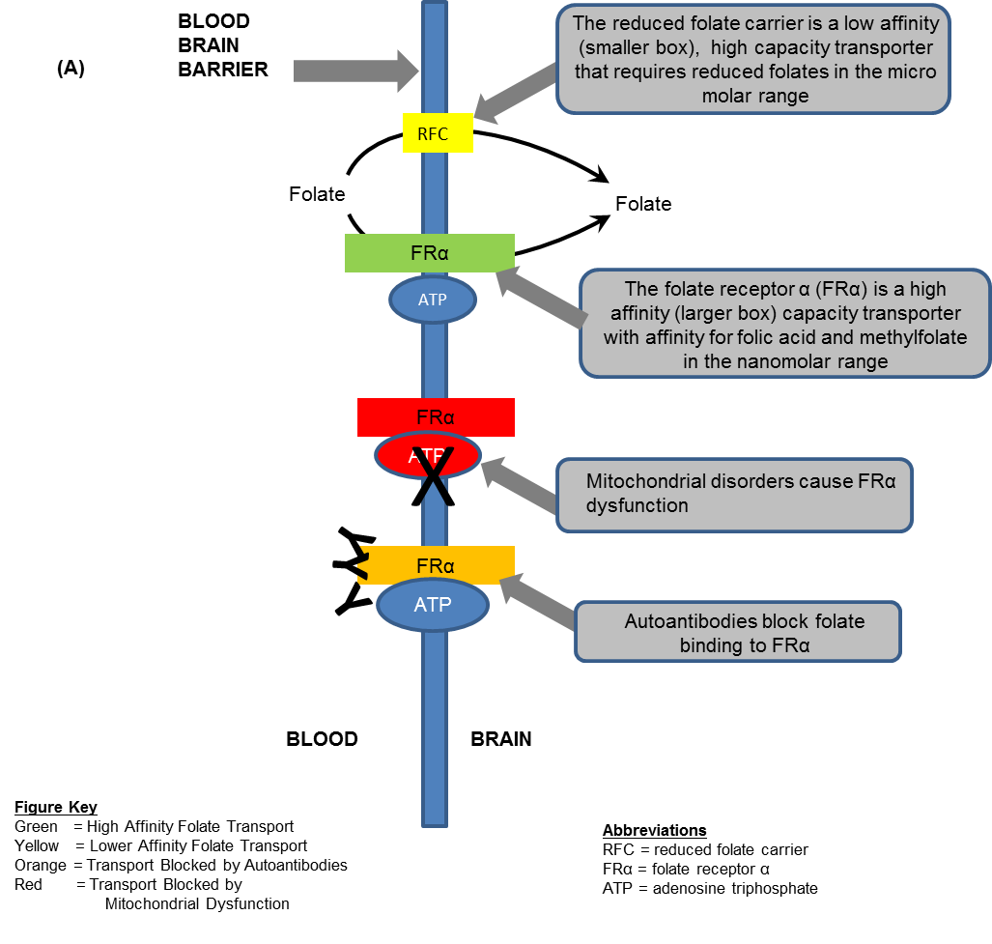

Homocysteine
B6

Cystathionine
Cysteine
GSH GSSG

Methionine

Adenosine
5-CH₃THF
THF
B12
MS
5,10-CH₂THF

Cellular Methylation
Reactions

DNA / RNA

FOLATE CYCLE
METHYLATION
GLUTATHIONE METABOLISM
DHFR
MTHFR
Purines and
Thymidylate
Folic Acid

Folinic Acid

GTP

SAM
SAH
Phenylalanine
Tyrosine
Tryptophan
L-arginine
L-citrulline + NO
5-HTP
L-DOPA
Tyrosine
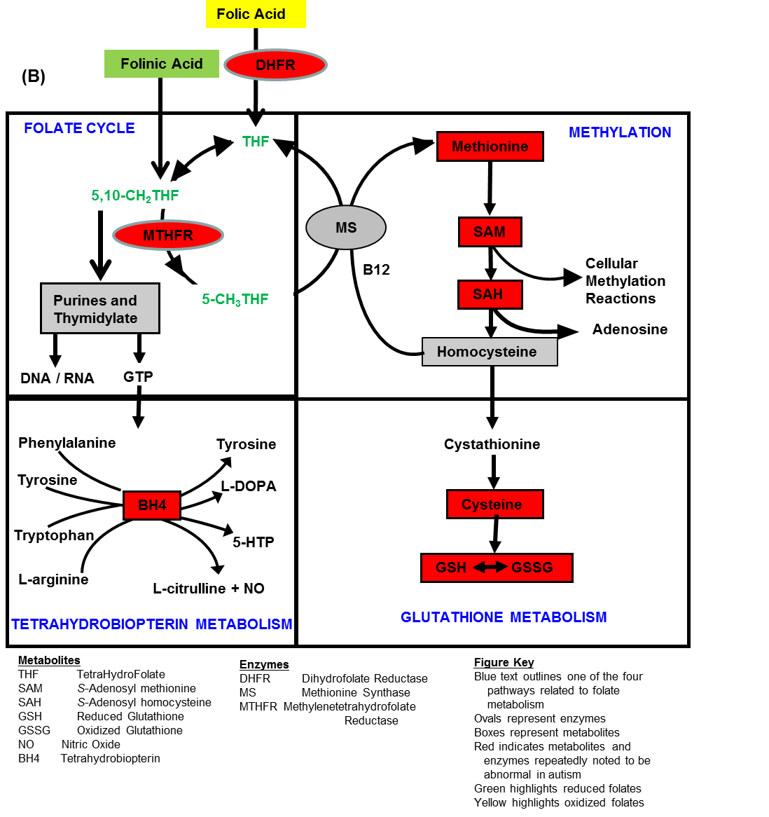

Excluded Drugs

Chemotherapy  Methotrexate (Rheumatrex, Trexall)  Pemetrexed (Alimta)  Raltitrexed (Tomudex)  Aminopterin  Trimetrexate (Neutrexin)  5-fluorouracil  Lometrexol  Thymitaq (Zarix) | Antibiotic  Trimethoprim (Proloprim, Trimpex)  Co-trimoxazole oral (Bactrim)  Trimethoprim/sulfamethoxazole (Septra)  Trimetrexate (Neutrexin)
Immune Suppression Drug
Methotrexate (Rheumatrex, Trexall)
Thymitaq (Zarix)
Antimalarial  Pyrimethamine (Daraprim) | Nutritional Supplement  Folic Acid

Table S1. Demographic and Clinical Characteristics by Treatment Group and Folate Receptor Antibody Status. Mean values with standard deviation in parenthesis and range in brackets.
Variable | Treatment (n=23) |  | Placebo (n=25)
Variable | Folate Receptor Antibody Status¹ |  | Folate Receptor Antibody Status
Variable | Positive  (n=12) | Negative  (n=9) | Positive  (n=18) | Negative  (n=7)
Age, mean (SD), years months | 8y 1m (3y 0m) | 7y 0m (3y 4m) | 7y 5m (2y 11m) | 6y 6m (3y 1m)
Males, N (%) | 10 (83%) | 7 (78%) | 14 (78%) | 6 (86%)
Percent Compliance, mean (SD) | 95.6% (3.9%) | 94.7% (9.7%) | 98.1% (8.5%) | 83.9% (20.7%)
Vineland Adaptive Behavior Composite, mean (SD) | 62.18 (6.10) | 67.89 (8.98) | 66.50 (8.86) | 64.14 (11.22)
Total Therapy, minutes per week, mean (SD) | 454.58 (637.64) | 186.11 (124.14) | 526.39 (441.36) | 435.00 (137.44)
Total Therapy, minutes per week, median [min; max] | 240 [0; 2070] | 150 [60; 415] | 270 [0; 2790] | 405 [120; 930]
Speech Therapy, minutes per week, mean (SD) | 104.58 (79.81) | 92.78 (34.01) | 221.39 (441.36) | 216.43 (137.44)
Behavioral Therapy, minutes per week, mean (SD) | 233.75 (528.88) | 0.00 (0.00) | 266.67 (664.07) | 81.43 (139.34)
Motor Therapy, minutes per week, mean (SD) | 111.25 (158.80) | 93.33 (97.72) | 137.78 (102.37) | 137.14 (84.60)
Folate Receptor Autoantibody
Blocking Titer (pmol/ml) , mean (SD) | 0.13 (0.25) |  | 0.09 (0.17)
Blocking Titer (pmol/ml), median [min; max] | 0.00 [0.00; 0.86] |  | 0.00 [0.00; 0.55]
Binding Titer (pmol/ml), mean (SD) | 0.68 (0.77) |  | 0.84 (0.75)
Binding Titer (pmol/ml), median [min; max] | 0.44 [0.00; 2.64] |  | 0.55 [0.00; 2.46]
Glutathione Redox Ratio, mean (SD) | 9.34 (1.98) | 9.50 (3.23) | 8.13 (1.98) | 8.21 (1.64)
Folate (ng/ml) [Normal 5-21], mean (SD) | 17.72 (2.99) | 17.89 (1.53) | 17.76 (3.56) | 15.74 (2.79)
B12 (pg/ml) [Normal 200-900], mean (SD) | 735.07 (460.11) | 713.55 (238.38) | 871.77 (456.08) | 832.41 (461.65)
Zinc (mg/dL) [Normal 65-120], mean (SD) | 106.31 (18.55) | 99.88 (44.11) | 106.02 (21.27) | 91.97 (18.14)
Copper (µg/dL) [Normal 70-128], mean (SD) | 100.81 (11.45) | 112.14 (2.21) | 106.75 (13.27) | 107.13 (7.01)
Magnesium (µg/g) [Normal 39-59l], mean (SD) | 43.71 (10.05) | 43.18 (11.11) | 46.24 (10.14) | 44.46 (16.46)
Language Testing, N (%)
Preverbal at Start of Study | 6 (50%) | 4 (44%) | 7 (39%) | 3 (43%)
Preschool Language Scales | 0 (0%) | 4 (44%) | 2 (11%) | 2 (29%)
Clinical Evaluation of Language Fundamentals 2 | 8 (67%) | 2 (22%) | 13 (72%) | 3 (43%)
Clinical Evaluation of Language Fundamentals 4 | 4 (33%) | 3 (33%) | 3 (17%) | 2 (29%)
Diagnostic Documentation, N (%)
Autism Diagnostic Observation Schedule | 6 (50%) | 5 (56%) | 13 (72%) | 3 (43%)
3 Practitioner Agreement | 8 (67%) | 8 (89%) | 15 (83%) | 6 (86%)
Single Practitioner with standardized questionnaires² | 2 (17%) | 0 (0%) | 1 (6%) | 0 (0%)
Autism Diagnostic Interview-Revised
Participated in Confirmation Testing, N (%) | 10 (83%) | 8 (89%) | 15 (83%) | 6 (86%)
Social Interaction Score, mean (SD) [range] | 21.50 (5.48) [14-28] | 19.25 (5.63) [10-26] | 24.29 (4.91) [11-30] | 22.67 (4.76) [18-30]
Communication Score: Verbal, mean (SD) [range] | 19.29 (9.73) [14-24] | 14.33 (6.98) [10-17] | 19.38 (10.77) [7-25] | 17.50 (9.17) [15-20]
Communication Score: Non-Verbal, mean (SD) [range] | 14.00 (6.76) [14-14] | 11.00 (5.34) [8-14] | 13.33 (6.85) [13-14] | 13.5 (6.99) [13-14]
Restricted & Repetitive Play Score, mean (SD) [range] | 4.70 (2.36) [2-9] | 4.88 (1.13) [3-7] | 6.21 (2.39) [2-12] | 6.83 (1.17) [5-8]
Summary Score, mean (SD) [range] | 4.30 (0.95) [3-5] | 4.13 (1.25) [2-5] | 4.21 (0.89) [3-5] | 4.33 (1.03) [3-5]
Medications (Concurrent Treatments), N (%)
Stimulant | 3 (25%) | 3 (33%) | 3 (17%) | 3 (43%)
Melatonin | 5 (42%) | 0 (0%) | 3 (17%) | 3 (43%)
Allergy/Asthma Medications | 3 (25%) | 3 (33%) | 3 (17%) | 1 (14%)
Gastrointestinal Medications | 4 (33%) | 1 (11%) | 3 (17%) | 1 (14%)
Alpha-adrenergic agonists | 3 (25%) | 0 (0%) | 4 (22%) | 1 (14%)
Selective Serotonin Reuptake Inhibitors | 0 (0%) | 1 (11%) | 1 (6%) | 2 (29%)
Antiepileptic Medication | 1 (8%) | 0 (0%) | 0 (0%) | 2 (29%)
Antimicrobial Medications | 0 (0%) | 0 (0%) | 1 (6%) | 2 (29%)
Immunomodulatory Medications | 0 (0%) | 0 (0%) | 0 (0%) | 1 (14%)
Supplements (Concurrent Treatments), N (%)
Multivitamin | 5 (42%) | 4 (44%) | 4 (22%) | 0 (0%)
Minerals | 0 (0%) | 2 (22%) | 3 (17%) | 1 (14%)
Vitamin B-12 | 2 (17%) | 2 (22%) | 1 (6%) | 1 (14%)
Other B Vitamins | 1 (8%) | 1 (11%) | 1 (6%) | 1 (14%)
Fatty Acids | 1 (8%) | 2 (22%) | 0 (0%) | 1 (14%)
Other Antioxidants | 0 (0%) | 2 (22%) | 1 (6%) | 0 (0%)
Folate | 2 (17%) | 1 (11%) | 1 (6%) | 0 (0%)
Carnitine | 0 (0%) | 1 (11%) | 1 (6%) | 0 (0%)
CoEnzyme Q10 | 0 (0%) | 0 (0%) | 1 (6%) | 0 (0%)
Amino Acids | 0 (0%) | 0 (0%) | 1 (6%) | 0 (0%)
Other Vitamins | 0 (0%) | 1 (11%) | 0 (0%) | 0 (0%)
Comorbid Medical Conditions, N (%)
Allergic Disorders | 6 (50%) | 3 (33%) | 6 (33%) | 4 (57%)
Gastrointestinal Disorders | 6 (50%) | 3 (33%) | 8 (44%) | 2 (29%)
Neurological Disorders | 4 (33%) | 4 (44%) | 4 (22%) | 2 (29%)
Sleep Disorders | 4 (33%) | 2 (22%) | 4 (22%) | 0 (0%)
Other Psychiatric Disorders | 2 (17%) | 2 (22%) | 6 (33%) | 0 (0%)
Immune Abnormality | 2 (17%) | 2 (22%) | 6 (33%) | 2 (29%)
Mild Congenital Malformations | 1 (8%) | 0 (0%) | 1 (6%) | 0 (0%)
Genetic Disorders³ | 1 (8%) | 0 (0%) | 0 (0%) | 0 (0%)
¹Two participants in the folinic acid treatment groups did not have blood draw and are not included in the data due to unknown antibody status
²Standardized questionnaires included Social Responsiveness Scale, Social Communication Questionnaire and/or Autism Symptoms Questionnaire
³During the study a child was found to have a phosphatase and tensin homolog gene mutation.

11A Folinic acid intervention for ASD: links to folate receptor-α autoimmunity & redox metabolism

Study Sponsor: | University of Arkansas for Medical Sciences  Principal Investigators:  Richard E. Frye, M.D., Ph.D.  Associate Professor of Pediatrics and Director of Autism Research  Arkansas Children’s Hospital Research Institute  13 Children's Way, Slot 512-41B  Little Rock, AR 72202  Office: (501) 364-4662  Fax: (501) 978-6483  Email: REFrye@uams.edu  Daniel Rossignol, M.D., FAAP  Medical Director  Rossignol Medical Center  16251 Laguna Canyon Road Suite 175  Irvine, CA 92618-3623  Phone: (949) 428-8878  Fax: (949) 428-8874  Email: Rossignolmd@gmail.com  William J. Reed, M.D., FAAP  Director Developmental Behavioral Pediatrics/Adolescent Medicine  Driscoll Children’s Hospital  3533 S. Alameda Street, 4th Tower, Sloan Bldg  Corpus Christi, TX 78411  Phone: (361) 694-5657  Fax: (361) 694-4257  Email: William.Reed@dchstx.org  Co-Investigator:  S. Jill James, Ph.D., Director, Autism Metabolic Genomics Laboratory  Stepan Melnyk, M.D., Ph.D., Laboratory Director, Autism Metabolic Genomics Laboratory  Arkansas Children's Hospital Research Institute  13 Children’s Way, Slot 512-41B  Little Rock, AR 72202  Phone: (501) 951-3173  Fax: (501) 364-1648  Email: JamesJill@uams.edu  MelnykStepanB@uams.edu  Sub-Investigator:  Mary Ann Scott, Ph.D., Section Head, Schmieding Developmental Center  Cristina Kehn, LCSW, Schmieding Developmental Center  Centers for Children  519 Latham Drive  Lowell, AR 72745  Phone: (479) 750-0125  Email: ScottMaryAnn@uams.edu  Email: KehnCristina@uams.edu  Thomas Graf, Ph.D., Senior Medical Psychologist  Driscoll Children’s Hospital  3533 S. Alameda Street, 4th Tower, Sloan Bldg  Corpus Christi, TX 78411  Phone: (361) 694-5652  Email: Thomas.Graf@dchstx.org  Angela Sailey, Psychological Examiner  Autism Research Program  13 Children’s Way, Slot 512-41B  Little Rock, AR 72202  Phone: (501) 364-2308  Fax: (501) 978-6483  Email: AMSailey@uams.edu  John Slattery  Program Manager/Study Coordinator  Arkansas Children’s Hospital Research Institute  Autism Research Program  13 Children’s Way, Slot 512-41B  Little Rock, AR 72202  Phone: (501) 364-3556  Fax: (501) 978-6483  Email: JCSlattery@uams.edu  Medial Monitor  Dr. Stephen Kahler, M.D.,  Professor of Pediatrics, UAMS  Division of Genetics and Metabolism  Arkansas Children’s Hospital  1 Children’s Way, Slot 512-22  Little Rock, AR 72202  Direct: (501) 364-2967  Office: (501) 364-2966  Fax: (501) 364-1564  KahlerStephenG@uams.edu  Study Locations:  Arkansas Children's Hospital  11 Children's Way, R4006/R4007  Little Rock, AR 72202  Office: (501) 364-4662  Fax: (501) 364-1648  Rossignol Medical Center  16251 Laguna Canyon Road Suite 175  Irvine, CA 92618-3623  Phone: (949) 428-8878  Fax: (949) 428-8874  Driscoll Children’s Hospital  3533 S. Alameda Street, 4th Tower, Sloan Bldg  Corpus Christi, TX 78411  Phone: (361) 694-5650  Fax: (361) 694-4257
Study Product: | Folinic Acid
Protocol Number: | 136002
IND Number: | IND 115309
Protocol Version | 17
Protocol Date | 8-17-2014

Table of Contents
Study Summary 9
Abbreviation Page 10
1 Introduction 11
1.1 Background 12
1.2 Risk/Benefits 16
2 Study Objectives 17
3 Study Design 17
3.1 General Design 17
3.2 Primary Study Endpoints 18
3.3 Secondary Study Endpoints 19
3.4 Primary Safety Endpoints 19
4 Subject Selection and Withdrawal 19
4.1 Inclusion Criteria 19
4.2 Exclusion Criteria 19
4.3 Subject Recruitment and Screening 20
4.4 Early Withdrawal of Subjects 20
5 Study Drug and Blood Samples 21
5.1 Description 21
5.2 Treatment Regimen 21
5.3 Method for Assigning Subjects to Treatment Groups 21
5.4 Preparation and Administration of Study Drug 22
5.5 Subject Compliance Monitoring 22
5.6 Concomitant Therapy 22
5.7 Packaging 22
5.8 Blinding of Study Drug 22
5.9 Receiving, Storage, Dispensing and Return 22
5.10 Blood Samples 23
6 Study Procedures 24
6.1 Summary of Procedures 24
6.2 Screening Phone Call (See section 4.3 Subject Recruitment and Screening) 24
6.3 Phase 1 Visit 1 25
6.4 Phase 2 Visit 1 25
6.5 Phase 2 Phone Contact 1 25
6.6 Phase 2 Phone Contact 2 25
6.7 Phase 2 Phone Contact 3 25
6.8 Phase 2 Visit 2 (also known as Phase 3 Visit 1) 26
6.9 Phase 3 Phone Contact 1 26
6.10 Phase 3 Phone Contact 2 26
6.11 Phase 3 Phone Contact 3 26
6.12 Phase 3 Visit 2 26
6.13 Phase 3 Follow-Up Visit 27
7 Statistical Plan 27
7.1 Sample Size Determination 27
7.2 Statistical Methods 27
7.3 Subject Population(s) for Analysis 28
7.4 Data Management 28
8 Safety and Adverse Events 28
8.1 Definitions 28
8.2 Recording of Adverse Events 30
8.3 Reporting of Serious Adverse Events 30
8.4 Unblinding Procedures 31
8.5 Medical Monitoring 31
8.6 Protection of Subjects 31
9 Data Handling and Record Keeping 31
9.1 Confidentiality 31
9.2 Source Documents 32
9.3 Case Report Forms 32
9.4 Records Retention 32
10 Study Monitoring, Auditing, and Inspecting 32
10.1 Study Monitoring Plan 32
10.2 Auditing and Inspecting 33
11 Ethical Considerations 33
11.1 Consent Procedures 33
12 Study Finances 33
12.1 Funding Source 33
12.2 Conflict of Interest 33
12.3 Subject Stipends or Payments 34
13 Publication Plan 34
14 References 34
15 Attachments 36

Study Summary
Title | A Folinic Acid Intervention for ASD: Links to Folate Receptor-α Autoimmunity & Redox Metabolism
Short Title | Folinic Acid ASD Study
Protocol Number | 136002
Phase | Phase II
Methodology | Double-blind, placebo-controlled
Study Duration | Approximately 4 years
Study Center(s) | Multi-Center
Objectives | To determine whether Folinic Acid is effective in language improvement in ASD subjects.
Number of Subjects | 217 subjects
Diagnosis and Main Inclusion Criteria | Autism Spectrum Disorder in children aged 3 to 14 years with language impairment as defined by the CELF or PLS
Study Product, Dose, Route, Regimen | For both Phase 2 and Phase 3 the target dose will be 1mg/kg/day in two divided doses (0.5mg/kg/dose; 25mg/day maximum) for two weeks followed by 2 mg/kg/day with a maximum dose of 50mg/day provided the lower dose is well tolerated, administered orally by the subjects.
Duration of administration | Up to 12 weeks for Phase 2 and up to 12 weeks for Phase 3
Reference therapy | Placebo
Statistical Methodology | For all aims, data analysis will begin with a review of descriptive statistics for all major variables and all major sub-groupings of variables in the data set. For the inferential methods, we will use multivariable linear regression models (LMs) and mixed effects analysis of covariance.

Abbreviation Page
ABC Aberrant Behavior Checklist
ACHRI Arkansas Children’s Hospital Research Institute
ADI-R Autism Diagnostic Interview-Revised
ADOS Autism Diagnostic Observation Schedule
AE Adverse event
ASD Autism Spectrum Disorder
CELF Clinical Evaluation of Language Fundamentals
CGI Clinical Global Impression
CLS Core language score
CRF Case report form
C-SSRS Columbia Suicide Severity Rating Scale
DNA Deoxyribonucleic acid
EEG Electroencephalogram
FDA Food and Drug Administration
FRα Folate receptor α
GSH Active reduced form of glutathione
GSH/GSSG Ratio of reduced-to-oxidized glutathione
GSSG Oxidized form of glutathione
HIPAA Health Information Portability and Accountability Act
HPLC High Pressure Liquid Chromatography
IOM Institute of Medicine
IRB Institutional Review Board
ITT Intent-to-Treat
LAR Legally Authorized Representative
LM Linear Regression models
MDOTES Modified Dosage Record and Treatment Emergent Symptom Scale
OACIS Ohio Autism Clinical Impression Scale
PHI Protected health information
PI Principal Investigator
PLS Preschool Language Scales
RBC Red Blood Cell
RBS-R Repetitive Behavior Scale – Revised
RCT Randomized Controlled Trial
RFC Reduced folate carrier
SAH S-adenosylhomocysteine
SAM S-adenosylmethionine
SD Standard deviation
SRS Social responsiveness scale
VABS Vineland Adaptive Behavior Scale
UAMS University of Arkansas for Medical Sciences

1 Introduction
Evidence-based interventions for autism spectrum disorders (ASD) are limited. Currently, there is no FDA approved medical therapy that addresses either core ASD symptoms or pathophysiological processes associated with ASD. For example, the two FDA approved antipsychotic medications for treating ASD are indicated for symptoms associated with ASD, not core ASD symptoms. Based on strong preliminary evidence, this study aims to improve core ASD symptoms with folinic acid. Two biological mechanisms for response to the intervention are proposed and investigated in this study.

Folate is an essential B vitamin required for normal neurodevelopment (1, 2). Folinic acid is a reduced form of folate that has been shown to improve both the metabolic and core symptoms associated with ASD in an open-label study and large case-series. This study will extend this preliminary evidence to demonstrate clinical efficacy of folinic acid in a double-blind placebo-controlled manner while also evaluating the biological mechanisms associated with the clinical response.

Preliminary evidence for the efficacy of folinic acid is two-fold: First, several independent studies have demonstrated that a folinic acid intervention improves ASD core symptoms in ASD patients diagnosed with cerebral folate deficiency – a metabolic disorder in which the primary pathway for the transport of folate across the blood-brain barrier is dysfunctional. The primary transport pathway for folate across the blood-brain barrier uses the folate receptor α (FRα) and energy dependent endocytosis. A secondary pathway, the reduced folate carrier (RFC), can transport reduced forms of folate, such as folinic acid, across the blood-brain barrier. In case-series of children with ASD and cerebral folate deficiency, folinic acid (0.5 to 2 mg/kg/day) improved communication, social interaction, attention, and stereotypical behavior in some (3-6) and completely ameliorated ASD symptoms in others (6, 7).

The major cause of cerebral folate deficiency is an autoantibody that binds to the FRα and interferes with its ability to bind and transport folate. Recently, Frye et al (8) found that (a) autoantibodies to the FRα were present in approximately 75% of children with ASD, and (b) an intervention with folinic acid (2mg/kg/day; max 50mg) in children with ASD and FRα autoantibodies resulted in significant improvements in parental ratings of receptive and expressive language, verbal communication, stereotypic behavior, and attention as compared to parental rating for children that did not undergo any intervention (wait group) over a similar time period. This proposal will extend these preliminary findings by documenting response to a folinic acid intervention in a double-blind placebo-controlled manner and test whether FRα autoantibody titers predict response to a folinic acid intervention. If FRα autoantibody titers are found to predict response to the intervention, such titers could provide a biomarker to identify a subset of children with ASD that may benefit from a folinic acid intervention and may even predict the development of ASD symptoms in high risk siblings during the pre-symptomatic period.

Second, the ratio of reduced-to-oxidized glutathione (GSH/GSSG) is an established measure of systemic redox status and oxidative stress that has been shown in three independent case-control studies to be significantly decreased in many ASD children (9-11). James et al (10) have shown in a 3 month open-label clinical trial that an intervention of folinic acid and methyl-B12 significantly improved GSH/GSSG and Vineland scores for expressive language, receptive language, and socialization in ASD children. Important unanswered questions are (a) whether this preliminary data can be confirmed in a larger double-blind placebo-controlled study, (b) whether redox status before the folinic acid intervention can predict response to intervention and (c) whether improved systemic redox status is associated with improvement in core ASD symptoms.

This study will assess whether a folinic acid intervention can improve both core symptoms of ASD (i.e., communication, socialization, stereotyped movements) and associated comorbid symptoms (i.e., attention) in a double-blind placebo controlled clinical trial. This study will address whether improvements in core ASD symptoms associated with the intervention are related to biomarkers of either (or both) biological mechanisms proposed to be influenced by the intervention (i.e., GSH/GSSG, FRα autoantibody titer). Thus, using these biomarkers, it may be possible that children with ASD who optimally respond to the folinic acid intervention can be readily identified early after diagnosis or even during the pre-symptomatic period.

1.1 Background
Folate is an essential B vitamin required for normal neurodevelopment (1, 2). Defects in folate metabolism can cause secondary physiological abnormalities, some of which have been associated with ASD. Since folate is essential for the production of purines and pyrimidines, the nucleotide precursors of RNA and DNA, low folate levels can result in abnormalities in cell proliferation, transcription, and translation, thus contributing to DNA instability (12) and chromosome breakage (13). Folate depletion can cause DNA methylation alterations in the brain (14) and deficits in folate metabolism have been shown to be associated with methylation deficits and oxidative stress in children with ASD (11, 15, 16).

Deficits in folate metabolism could explain several central nervous system abnormalities documented in ASD. For example, examination of postmortem ASD brains has shown alterations in DNA methylation in the frontal cortex (17) and increased oxidative stress in cortical regions associated with speech, emotion, and social behavior (18). Since chronic oxidative stress can result in mitochondrial dysfunction (19), the increased oxidative stress noted in postmortem ASD brain samples (18) could account for the mitochondrial dysfunction found in similar cortical regions in the postmortem ASD brain (20).

ASD has also been associated with defects in folate metabolism. Polymorphisms in the genes coding for methylenetetrahydrofolate reductase (21) and dihydrofolate reductase (22) enzymes have been reported in children with ASD. Both of these enzymes are involved in the production of 5-methyltetrahydrofolate, a metabolically important reduced form of folate, that can be transported across the blood-brain barrier by the RFC. Moreover, polymorphisms in methylenetetrahydrofolate reductase genes have been associated with more severe ASD behaviors, including unusual body movements, hyperactivity and self-injury (23).

In this study, we aim to study two physiological mechanisms associated with folate abnormalities in children with ASD, FRα autoantibodies that reduce folate transport across the blood-brain barrier and low glutathione redox status. Most importantly, ASD patients with these physiological mechanisms have shown improvement in ASD symptoms with a folinic acid intervention. Here we review the evidence for these physiological mechanisms and the intervention data that support the efficacy of a folinic acid intervention.

High Prevalence of FRα Autoantibody in Children with Autism Spectrum Disorder
Over a 12 month period, Frye (PI) and a colleague obtained FRα autoantibody titers on 93 children with ASD as part of a medical workup (8). From each patient, 1ml of serum was sent to the laboratory of Dr. Edward Quadros, Ph.D. at the State University of New York, Downstate (Brooklyn, NY). Concentrations of both the blocking and binding FRα autoantibodies were measured and categorized as negative, low, medium, or high (6, 24). All children met the Diagnostic and Statistical Manual of Mental Disorders – Fourth Edition – Text Revision criteria for ASD. The sample included 84 male and 9 female children with ASD (mean age= 7y 3m, SD= 3y 1m; range= 2y 11m – 17y 5m). Overall, 60% and 44% were positive for the blocking and binding FRα autoantibody, respectively. For children who were positive for the blocking FRα autoantibody, a low, medium, or high titer was found in 33%, 17%, and 10% of the sample, respectively (Panel A below). For children with the binding FRα autoantibody, a low, medium, and high titer was found in 40%, 4% and 0% of the sample, respectively (Panel B below). Overall, 29% children were positive for both blocking and binding FRα autoantibodies, 46% were positive for only one FRα autoantibody and 75% (70) were positive for at least one FRα autoantibody (Panel C below). Review of the clinical and medical characteristics between children positive for at least one FRα autoantibody as compared to those negative for both FRα autoantibodies demonstrated no significant differences. Although the prevalence of the FRα autoantibody was not studied in typically developing children, previous studies have demonstrated the prevalence of blocking FRα autoantibodies in the United States (unpublished data from Dr. Quadros laboratory), Spain, and Ireland to be 10-15%, 7.2% and 12.6%, respectively. Prevalence of the binding FRα autoantibodies has been reported to be 12% in the United States. These data strongly support the notion that there is a higher prevalence of FRα autoantibodies in children with ASD as compared to the normal populations. Since previous studies have only linked the blocking FRα autoantibody to cerebral folate deficiency in children with ASD, this study will only examine the blocking FRα autoantibody that appears to be present in almost two-thirds of children with ASD.

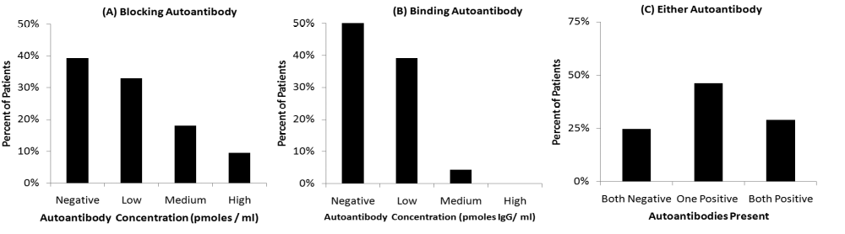

A Folinic Acid Intervention Improves Language in Children Positive for FRα Autoantibodies
Forty-four children (age mean=6y 10m; SD=2y 8m) of the 70 children positive for at least one FRα autoantibody were given an intervention of 2 mg/kg/day of folinic acid in two divided doses (maximum 50 mg daily). The dose was escalated over a two-week period with half of the final dose given during the first two weeks. Intervention response and adverse events were assessed during a phone call or follow-up visit after at least one-month of intervention (mean follow-up time 4.0 months; SD=2.6m). No significant changes were made in other interventions during the follow-up period. Parents were asked to rate intervention response using a modified Clinical Global Impression (CGI) Improvement subscale on cognition and behavior dimensions: verbal communication, receptive language, expressive language, non-verbal communication, stereotypical behavior, hyperactivity, mood, attention, and aggression.

Twenty-six FRα autoantibody positive children were not treated with folinic acid because they were awaiting FRα autoantibody or cerebrospinal fluid results. When the parents were called to give results, only 9 children were found to have not made any changes in interventions since the blood draw for the FRα autoantibodies (age mean=6y 11m, SD=2y 8m); therefore the wait control group was composed of these 9 patients. Parents were asked to rate changes in their child’s behavior since the blood draw on the same scaled described above. The mean time between blood draw and rating was 3.1m (SD=1.3m) for the wait control group, which was not significantly different than the intervention length for the intervention group.

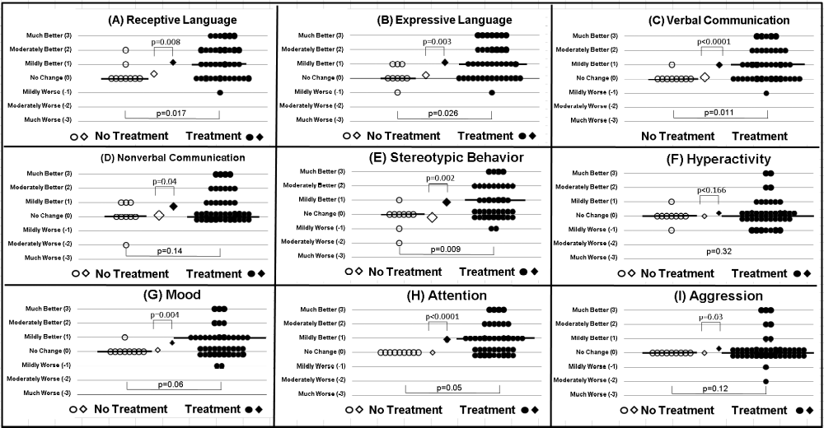

To determine if parental ratings demonstrated greater improvement in the intervention group compared to the control group, one-tailed Mann-Whitney U nonparametric tests were used. The one-tailed test was used since we hypothesized that an improvement, not a decrement, in cognitive-behavioral function would occur with the intervention. Parametric t-tests were also computed for comparison. For comparisons between the intervention and control groups, a power analysis was conducted on the primary outcome variable (i.e., verbal communication) using G*Power 3 (Universität Kiel, Kiel, Germany). The optimal alpha for the one-tailed Mann-Whitney U test was 0.05. This resulted in an 80% power.

The individual ratings for both treated (filled circles) and control (unfilled circles) subjects along with the medians (thick horizontal lines) and means (diamonds) for both groups are provided for each response measure in the figure above. The p-values for the Mann-Whitney U test are at the bottom of each graph while p-values for the t-test are at the top of each graph. Significantly higher improvement ratings were found for treated compared to untreated children on ratings of verbal communication, receptive and expressive language, attention, and stereotypical behavior. These significant differences were confirmed using the Student’s t-test. The Mann-Whitney U did not find significant differences between groups for the ratings of non-verbal communication, mood, hyperactivity, or aggression although the t-test did demonstrate significantly higher improvement ratings for treated compared to untreated children on ratings of non-verbal communication, mood, and aggression. Approximately two-thirds (66%) of the children treated were rated as manifesting improvement in receptive and expressive language, verbal communication, attention, and stereotyped behavior, with one-third (~33%) of children rated as demonstrating moderate or much improvement. Thus, folinic acid appears to result in improvement in core (i.e., communication, stereotyped behavior) and associated (i.e., attention) symptoms of ASD in a significant proportion of children with ASD positive for FRα autoantibodies.

A folinic acid intervention Improves Oxidative Stress Biomarkers and Adaptive Behavior
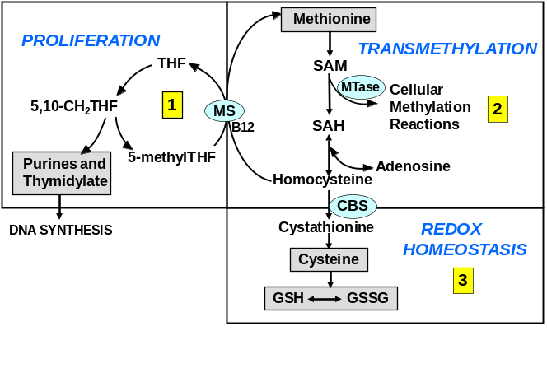
James et al have shown in 3 independent case-control studies that metabolites in folate-dependent one-carbon metabolism diagrammed in the Figure to the right are abnormal in children with ASD relative to age-matched typically developing children (9-11). Briefly, metabolites essential for cellular methylation reactions (methionine and S-adenosylmethionine, SAM) were significantly decreased and the methylation inhibitor (S-adenosylhomocysteine, SAH) was significantly increased resulting in a significant decrease in the SAM/SAH ratio, the accepted indicator of cellular methylation capacity. The methylation metabolites in Pathway 2 of the Figure are functionally connected to Pathway 3 for glutathione synthesis and provide essential precursors for cysteine and glutathione synthesis. Interestingly, both cysteine (the rate limiting amino acid for glutathione synthesis) and the active reduced form of glutathione (GSH) are significantly decreased in many children with ASD while the oxidized form of glutathione (GSSG) is significantly increased. The GSH/GSSG redox ratio is the accepted measure for systemic redox/antioxidant capacity and a measure of relative oxidative stress (25). The low ratio observed in the 3 independent case-control cohorts suggests that many children with ASD are under chronic oxidative stress and have a diminished capacity to resolve a pro-oxidant environmental exposure or an inflammatory response. Folinic acid is well known to normalize folate-dependent one-carbon metabolism (26) and to cross the blood brain barrier with high concentrations. Thus, folinic acid may independently, or additively, normalize both systemic folate-dependent one-carbon metabolism and central nervous system folate levels in the subset of ASD positive for the folate receptor alpha autoantibody. The analysis of the effects of the intervention will determine the independent and interaction effects of autoantibody status and redox status on intervention response. Positive results would provide a mechanistic basis for intervention response.

In an open-label trial, James et al (10) measured biomarkers of oxidative stress (i.e., methylation precursor metabolites and glutathione synthesis) and adaptive behavior (Vineland Adaptive Behavior Scale 1st Edition) before and after three months of a intervention of subcutaneous low-dose folinic acid (800 µg) and methylcobalamin (75 µg/Kg) in 44 children with autistic disorder. Vineland scores before and after intervention were evaluated using the two-sided paired Student’s t test with a 0.05 significance level.

Plasma Metabolite Concentration | Control  Children | Autism  Pre-intervention^{b} | Autism  Post-intervention | p  valueª
Methionine (µmol/L) | 24 ± 3 | 21 ± 4 | 22 ± 3^{c} | ns
S-adenosylmethionine (SAM) (nmol/L) | 78 ± 22 | 66 ± 13 | 69 ± 12^{c} | ns
S-adenosylhomocsyteine (SAH) (nmol/L) | 14.3 ± 4.3 | 15.2 ± 5 | 14.8 ± 4 | ns
SAM/SAH (µmol/L) | 5.6 ± 2.0 | 4.7 ± 1.5 | 5.0 ± 2.0 | ns
Homocysteine (µmol/L) | 5.0 ± 1.2 | 4.8 ± 1.8 | 5.3 ± 1.1 | 0.04
Cysteine (µmol/L) | 210 ± 18 | 191 ± 24 | 215 ± 19 | 0.001
Glutathione (GSH) (µmol/L) | 7.5 ± 1.8 | 5.4 ± 1.3 | 6.2 ± 1.2^{c} | 0.001
Oxidized Glutathione (GSSG) (µmol/L) | 0.18 ± 0.07 | 0.28 ± 0.08 | 0.22 ± 0.06 ^{c} | 0.001
GSH/GSSG redox ratio | 47 ± 18 | 21 ± 6 | 30 ± 9 ^{c} | 0.001
ª Pre- and Post-intervention comparison; ns = not significant (> 0.05); ^{b} All pre-intervention values were significantly different from control (p<0.005) except for Hcy & SAH; ^{c} Post-intervention values significantly different from control (p< 0.01)

Methionine transmethylation metabolites were all significantly different between ASD and control children at baseline (p< 0.005) with the exception of homocysteine and SAH (Table above). The 3 month intervention did not significantly increase methionine, SAM, and SAH concentrations despite the fact that both methylcobalamin and folinic acid provide methyl groups for the methionine cycle. Instead, cysteine (the rate-limiting amino acid for glutathione synthesis) was significantly increased following the intervention and was no longer statistically different from levels in the control children. Although total glutathione concentrations and the GSH/GSSG redox ratio were significantly increased by the intervention, they remained below control levels (p< 0.01). The mean concentration of oxidized GSSG was significantly decreased after intervention (p< 0.001) but remained slightly above the mean concentration in the control children (p<0.01). Despite significant improvement in glutathione redox status with the intervention, redox status did not normalize. It is possible that the folinic acid and/or methyl-B12 doses were not high enough to normalize redox status. The fact that the methylation metabolites were not normalized suggests that these metabolites were still being diverted to cysteine and glutathione synthesis as a metabolic priority. We expect that the folinic acid intervention proposed in this study will normalize methylation and glutathione metabolites.

The impact of the intervention on measures of core behaviors associated with ASD was also assessed. Baseline pre-intervention scores of the individual components of the Vineland Adaptive Behavior Scales were within the range previously reported for ASD children (27). In the Table below we present age equivalent scores for key subscales related to core features of ASD. Age equivalent scores are presented to illustrate the magnitude of the change in these important skills. Over the 3 month intervention period, receptive and expressive language skills increased by 9.9 and 7.0 months, respectively, and social and play skills increased by 6.9 and 13.0 months, respectively. We also analyzed changes in the raw scores for the component scales of the Vineland. Significant increases in the scores for Communication, Socialization and Daily Living Skills were observed (p < 0.001) with intervention. The overall Adaptive Behavior Composite raw scores also significantly increased (p<0.003).

Vineland Scale | Baseline  Age Equivalent  Months (mean ± SE) | Post-Intervention  Age Equivalent  Months (mean ± SE) | Change  In Months  (mean; 95% C I) | p value
Receptive Language | 22.8 ± 1.8 | 32.3 ± 3.4 | 9.9 (4.2, 15.6) | <0.002
Expressive Language | 21.5 ± 1.8 | 28.5 ± 3.0 | 7.0 (3.8,10.2) | <0.0001
Social Skills | 18.7 ± 2.6 | 25.6 ± 4.1 | 6.9 (0.8, 12.9) | <0.03
Play Skills | 22.0 ± 2.3 | 35.2 ± 5.1 | 13.0 (5.4, 20.6) | <0.002

An intervention of folinic acid is associated with a low incidence of adverse effects
Adverse Effects
Aggression | 7%
Insomnia | 5%
Gastroesophageal Reflex | 2%
Headache | 2%
Emotional Liability | 2%
Transient Hyperactivity | 2%
Transient Increase in Tantrums | 2%
Adverse effects of folinic acid were minimal for children positive for the FRα autoantibody who received the intervention for at least one month (Table to left). Four (9%) children of the 44 discontinued the intervention due to adverse effects. Three boys, all taking risperidone, discontinued within 2 weeks, due to worsening aggression. One other subject was taking risperidone but did not demonstrate adverse effects. The fourth boy developed insomnia and gastroesophageal reflux 6 weeks after the intervention started. Thus, overall, there was a very low rate of intervention discontinuation and a low rate of reported adverse effects. For children who underwent the folinic acid and methylcobalamin intervention in the James et al (10) study, four children discontinued the study (9%), two due to the fact that parents were uncomfortable giving methylcobalamin injections and two due to sleep disruption and increased impulsivity and irritability.

The studies presented above outline two physiological mechanisms by which folinic acid could benefit children with ASD. First, children with ASD appear to have a high incidence of the FRα autoantibody which can decrease the transport of folate across the blood-brain barrier and, second, children with ASD appear to have redox abnormalities that deplete key metabolites, including glutathione. Folinic acid has the potential to correct both of these abnormalities. Two studies demonstrate preliminary evidence that children with ASD and these physiological abnormalities respond positively to a folinic acid intervention, with particularly good response in receptive and expressive language. Adverse events were minimal. The current proposal can potentially provide strong evidence for a folinic acid intervention and will provide insight into the subgroups of children with ASD who would benefit from folinic acid. The result of this study will help guide the development of larger clinical trials that can better define intervention parameters for ASD children.

1.2 Risk/Benefits

Potential Risks
An intervention of folinic acid is associated with a low incidence of adverse effects
Adverse Effects
Aggression | 7%
Insomnia | 5%
Gastroesophageal Reflex | 2%
Headache | 2%
Emotional Liability | 2%
Transient Hyperactivity | 2%
Transient Increase in Tantrums | 2%
Adverse effects of folinic acid were minimal for children positive for the FRα autoantibody who received the intervention for at least one month (Table to left). Four (9%) children of the 44 discontinued the intervention due to adverse effects. Three boys, all taking risperidone, discontinued within 2 weeks, due to worsening aggression. One other subject was taking risperidone but did not demonstrate adverse effects. The fourth boy developed insomnia and gastroesophageal reflux 6 weeks after the intervention started. Thus, overall, there was a very low rate of intervention discontinuation and a low rate of reported adverse effects. For children who underwent the folinic acid and methylcobalamin intervention in the James et al (10) study, four children discontinued the study (9%), two due to the fact that parents were uncomfortable giving methylcobalamin injections and two due to sleep disruption and increased impulsivity and irritability. The current study will exclude children concurrently receiving risperidone (or other antipsychotics), will not use injections, and will exclude children with severe aggressiveness in order to make at least one attempt to minimize adverse effects and attrition, when possible.

Potential Benefits
Children that are eligible and enroll in the trial may see improvements in language, communication, stereotyped behaviors, attention, repetitive behaviors, socialization, and other ASD related behaviors. These improvements may, in part, be related to the metabolic biomarkers that are being evaluated in the trial, primarily positive FRα antibody status and/or low glutathione status.

Risk Benefit Ratio
The potential benefits of this study far outweigh the potential risks. ASD is a serious disorder with no effective pharmacotherapy. Patients accepted into the study will receive close medical monitoring as well as intervention with Folinic Acid that has a well-documented safety profile. Patients will be screened prior to admission into the study and those at risk for adverse reactions such as increased aggression due to anti-psychotics will be excluded. The subjects selected for participation will be monitored closely for adverse effects.

2 Study Objectives
Specific Aim 1: To determine whether an intervention of folinic acid over a 12-week period improves core symptoms of autism spectrum disorder. A minimum of approximately 192 subjects will be enrolled in a 12-week double-blind placebo controlled trial. Assessments will occur at 3 time points and will attempt to measure core autism symptoms (communication, social interactions, stereotyped behavior) as well as associated symptoms (attention, aberrant behavior). Subjects will be randomized such that approximately half will receive placebo and approximately half will receive the folinic acid intervention. Hypothesis 1: An intervention of folinic acid will result in improvements in receptive and expressive language (primary outcome) as well as improvements in attention, socialization, stereotyped behavior, and aberrant behavior (secondary outcome) as well as possible other factors.

Specific Aim 2: To determine whether the blocking autoantibody to the folate receptor α predicts the response to the folinic acid intervention. The final analysis will examine whether FRα autoantibody titer at the beginning of the study predicts intervention response for all those that have had FRα autoantibody titers successfully measured at the beginning of the study. Hypothesis 2: Individuals with higher baseline blocking FRα autoantibody titers will demonstrate greater improvement in the primary and secondary outcomes with the folinic acid intervention.

Specific Aim 3: To determine whether baseline redox status predicts the response to the folinic acid intervention. Our preliminary studies indicate that approximately 50% of children with ASD have low GSH/GSSG relative to age-matched controls. As secondary measures, we will make at least one attempt to measure relevant nutrients (such as plasma folate, B12, B6, and zinc; RBC magnesium; whole blood copper) at baseline. Indicators of protein (3-nitrotyrosine, 3-chlorotyrosine) and DNA (8-oxo-deoxyguanosine) oxidative damage may also be measured at baseline as James et al (11) recently published evidence that these biomarkers are abnormal in many children with ASD. The final analysis will make at least one attempt to examine whether baseline redox status predicts behavioral response to the folinic acid intervention and whether pre-existing nutrient deficiencies or oxidative damage possibly mitigate this response. Hypothesis 3: Greater improvements in the primary and secondary outcomes will be associated with lower baseline glutathione redox status, while poor response in the primary and secondary outcomes will be associated with poor baseline nutrient levels. Improvement in the primary and secondary outcomes will be associated with improved glutathione redox status and a reduction in biomarkers of oxidative damage, or possibly other factors as well.

Specific Aim 4: To determine whether a folinic acid intervention in an open-label fashion improves core symptoms of autism spectrum disorder with minimal adverse effects. Individuals who completed the 12-week double-blind placebo RCT will be eligible for Phase 3. Assessments will occur at 3 time points (0, 6, and 12 weeks after starting Phase 3) and will include at least one attempt to measure core autism symptoms (communication, social interactions, stereotyped behavior), as well as associated symptoms (attention, aberrant behavior). The protocol is designed to make at least one attempt to capture complete information on children with early discontinuation. This will allow us to capture changes in children who might need to discontinue the study because the parents wish to implement new medical or behavioral therapies and do not wish to continue a full 6 months (Phase 2 and 3 combined) without any new therapies. Hypothesis 4: The folinic acid intervention will result in improvements in receptive and expressive language (primary outcome) as well as attention, socialization, stereotyped behavior, and aberrant behavior (secondary outcome) with minimal adverse effects.

3 Study Design

3.1 General Design
This double blind, placebo-controlled (DBPC) study will evaluate the efficacy of Folinic Acid for the treatment of language impaired autism spectrum disorder patients aged 3-14 years. The study will consist of a single site trial (with 48 entering the DBPC phase) followed by a multisite trial (with 144 entering the DPBC phase). Subjects will be male or female with current or prospective diagnosis of Autism Spectrum Disorder (ASD). Language Impairments will be defined by the CELF, or PLS when warranted.

Phase 1 will consist of approximately 217 children (57 single site study; 160 multisite study) aged 3-14 with a diagnosis of Autism Spectrum Disorder (as defined by the Autism Diagnostic Observation Schedule or the Autism Diagnostic Interview-Revised), until approximately 192 (48 single site study; 144 multisite study) children with confirmed ASD are enrolled into a randomized control trial (RCT; Phase 2). Enrollment will continue as needed until approximately 173 children (43 single site study; 130 multisite study) complete Phase 2. Approximately 173 children who completed Phase 2 may enter and complete Phase 3.

During the RCT the child will receive either folinic acid or placebo for up to 12 weeks. During the open-label extension (Phase 3), all children can receive up to 12-weeks of folinic acid, if they wish to enter this phase.

The end of Phase 3 will be defined as the 12th week (+/- 7 days) after Phase 3 is started or when a subject is discontinued from the study for any reason. We feel this discontinuation contingency is necessary because a full 6 months (Phase 2 and 3 combined) is a long time to continue without any new therapies. This will allow subjects that have received the placebo in the first 3 months to experience an intervention with folinic acid without being penalized by not being allowed to try new interventions for 6 months.

Parents will be advised that no significant new behavioral or other interventions will be allowed during the study. PI discretion will be exercised to determine what is significant and what is not. Parents will be asked to inform the PI and/or his staff as soon as possible if any interventions are changed or will be changed so the PI can make a determination of whether these changes were significant or not. Subjects who need new behavioral or other interventions will be dropped. The intent-to-treat- model will be employed. Evaluable subjects must have one observation post initiation of study intervention in order to assess primary outcome.

Project Timetable
The project will take less than 4 years. The plan is to randomize approximately 1-2 subjects per week, taking up to 4 years to acquire up to 192 subjects.

3.2 Primary Study Endpoints
Language (measured by the receptive and expressive CELF or PLS language scale) will be the primary outcome for the study. In order to be evaluable, subjects must complete one pre-treatment and one assessment post intervention to be included in analysis. Failure to do so will result in termination from the trial and replacement by another subject. Both preliminary studies have suggested that the folinic acid intervention will be associated with receptive and expressive language improvements. For children that are pre-verbal, we will administer the Preschool Language Scale (PLS-5). The PLS is an instrument that can detect very small levels of vocalization and non-verbal or pre-verbal communication that can’t be captured by the CELF. This test will be used for the lower functioning children, in order to be able to capture some rudimentary language processing that would otherwise go unnoticed on the CELF. The same version of the language test must be used across all assessment time points. See language testing algorithm below for a graphic of how this applies.

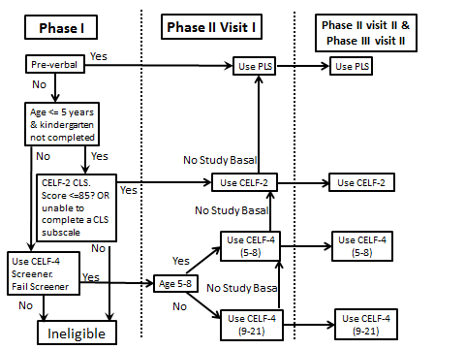

3.3 Secondary Study Endpoints
Stereotyped behavior (as measured by the OACIS, RBS-R and ABC) and social skills (as measured by the VABS, ASQ and SRS) will be the secondary outcomes, as well as other factors that will be measured by other collection instruments, such as mitochondrial function through the mitochondrial symptoms questionnaire.

3.4 Primary Safety Endpoints
The primary safety endpoint will be measurement and collection of any serious adverse event that occurs from initial study treatment through and including the end of Phase 3 of study treatment.

4 Subject Selection and Withdrawal

4.1 Inclusion Criteria
- Autism Spectrum Disorder (as defined by a gold standard measure for ASD diagnosis: the Autism Diagnostic Observation Schedule and/or Autism Diagnostic Interview-Revised). In an event where sufficient diagnostic information is lacking, and the PI believes that the clients meet all other inclusion criteria and a prospective diagnosis of an ASD is clinically warranted, and a formal diagnosis is scheduled to occur within a reasonable time frame from the date of study entry but before dispersing study drug/placebo, then the client may be considered as potentially eligible. Furthermore, a research-reliable rater must complete the diagnosis.
- 3 years to 14 years of age.
- Language Impairment.
- Ability to maintain complementary, traditional, and/or behavioral interventions and to attempt to keep them constant during the study, when possible.
- Unchanged complementary, traditional, and/or behavioral intervention for approximately 8 weeks prior to study entry, when possible.

4.2 Exclusion Criteria
- Currently taking antipsychotic medication.
- Vitamin or Element Supplementation that exceeds the IOM Tolerable Upper Intake Levels (See Attachment 5 in Appendix).
- Any moderate to severe positive response on that Aberrant Behavior Checklist Irritability subscale on questions: Injures self on purpose, is aggressive to other children or adults (verbally or physically), deliberately hurts himself/herself, and/or does physical violence to self.
- Prematurity (<34 weeks gestation) as determined by medical history.
- Current uncontrolled gastroesophageal reflux or ongoing significant kidney or liver disease. The PI will determine whether any ongoing kidney or liver disease is significant.
- Drugs known to affect folate metabolism (e.g., methotrexate) and their derivatives.
- Profound sensory deficits (e.g. hearing and vision deficits) that could interfere with the interpretation of study results.
- Any major genetic defect, or mutation, that is known to be associated with disease or possibly related to disease that affects folate, methylation, and/or glutathione metabolism. Questions regarding eligibility concerning this criterion will be addressed with the lead site PI before enrollment into the trial.
- Documented current or active seizures, as defined by a clinical seizure or abnormal EEG within the past 6 months.
- Children with major single-gene abnormalities, such as Fragile X, Rett’s Syndrome, etc., recognized chromosome syndromes, such as 15q11 microdeletion syndrome, or have been diagnosed with other well recognized syndromes, such as fetal alcohol syndrome. Children with copy number variants that represent known polymorphisms or benign changes will not be excluded. Questions regarding eligibility concerning this criterion should be addressed with the lead site PI before enrollment into the trial.
- Children diagnosed with congenital brain malformations, acquired brain insults, congenital or acquired microcephaly, or infection of the central nervous system.
- Children with major well-defined metabolic disease, such as mitochondrial disease, urea cycle disorders, succinic semialdehyde dehydrogenase deficiency, creatine deficiency syndromes, etc.
- Current therapies that could potentially interfere with interpretation of study results.
- Other conditions which, in the opinion of the study team, will place subjects at unacceptable risk or result in inability to interpret the study data.
- Unwillingness or inability to return for follow-up testing at specified interval.

4.3 Subject Recruitment and Screening
IRB approved flyers and advertisements may be utilized for subject recruitment. All study sites and community physicians will be encouraged to refer potential subjects. Previous autism study subjects, whose parent(s) have given written permission with a HIPAA Authorization to be contacted about future research opportunities, may be contacted for interest in participation.

In order to meet our goal of approximately 173 subjects completing the study, we will enroll approximately 192 subjects assuming an approximate 10% attrition rate. We believe this attrition rate may be an overestimation since the attrition rate in our previous studies was 9% and we have attempted to account for factors that caused attrition previously (i.e., injections, risperidone). To complete target enrollment, we will enroll approximately 1-2 subjects per week.

When a child is identified, the study coordinator or assigned study staff will make at least one attempt to contact the parents and describe the study. If the parents are interested, the coordinator or assigned study staff will make at least one attempt to ask several key questions from the Aberrant Behavior Checklist (ABC) to attempt to ensure that the child does not have severe aggressive behavior. The coordinator or assigned study staff will also screen by asking inclusion/exclusion criteria questions. If the study staff cannot complete the phone screening after at least one attempt, the child will not be considered eligible to participate in the study. If the child qualifies from the telephone interview, the coordinator or assigned study staff will attempt to schedule the baseline visit and (e)mail consent forms for Phases 1 and 2 to the parents for their review.

Screening assessments will be performed to determine subject eligibility criteria, which will be documented on a case report form. The PI will confirm and sign off on the inclusion and exclusion criteria on a case report form (CRF) prior to dispensing study drug/placebo.

4.4 Early Withdrawal of Subjects
Subjects that experience mild or moderate adverse effects will be offered to decrease the dose by approximately half. Further persistence of adverse effects will result in discontinuation of the intervention. The same protocol will be applied to both intervention groups, as the study personnel will not know the group assignment. As an added safety measure, and to ensure the scientific validity of the study, parents will be provided a list of contraindicated medications for them to take to physicians, if and when appointments are warranted throughout the duration of the child’s tenure in the study. Parents will be instructed at least once to take the list to all visits, in order to minimize the event of drug-drug interactions.

Withdrawal criteria
- Serious adverse effects or persistence of adverse effects despite a reduction in dosing.
- At the request of the principal investigators, institutional review board, or parents.
- Consistent non-compliance to study protocol.
- Any acquired illness that impacts cognitive functioning for a prolonged period of time (i.e. > 7 days) that would impact study related testing and/or testing results.
- If subjects are included without a research reliable ADOS or ADI-R verified diagnosis and the subsequent testing does not meet diagnostic criteria for ASD.
- Unwillingness or inability to return for follow-up testing at specified interval.

4.4.1 When and How to Withdraw Subjects
Any subjects experiencing a serious adverse event felt to be related to study drug should be withdrawn from the study. Subjects should be withdrawn if they meet one or more of the withdrawal criteria for Early Withdrawal of Subjects. Subjects will be withdrawn if discontinuation from the study is deemed by the principal investigator to be in their best interest. Any subject withdrawing their consent to participate in the study or their authorization to use their protected health information will be withdrawn from the study.

Subjects discontinued from the clinical trial may be scheduled for a final evaluation and given appropriate treatment referrals, when possible.

It is imperative that all unused medications are returned.

For the final measures, subjects may receive all assessments that were scheduled for the End of Study visit. Subjects withdrawn may be replaced, at the discretion of the principal investigator. Safety data in subjects, as well as preliminary safety data in a small study of ASD subjects show no serious adverse events resulting from abrupt withdrawal from Folinic Acid.

Subjects will be informed at the consent session that treatment may be discontinued due to the withdrawal criteria of the study. (See section 4.4 Early Withdrawal of Subjects). Reasons why subjects are discontinued from the clinical trial will be documented in the study file. Every effort will be made to make at least one attempt to continue to collect data on every randomized subject for the entire study duration regardless of whether or not the subject continues to take study medication, assuming the subject has not withdrawn his/her authorization to obtain such information.

4.4.2 Data Collection and Follow-up for Withdrawn Subjects
Subjects who have study drug discontinued for any reason and are within the stated time windows for follow-up evaluations and are willing to complete study visits and testing may have all study required visit testing administered and collected. For the final measures, subjects may receive all assessments that were scheduled for the End of Study visit.

5 Study Drug and Blood Samples
Folinic acid is a reduced form of folate that has been shown to improve both the metabolic and core symptoms associated with ASD in an open-label study and large case-series.

5.1 Description
Folinic acid and placebo for this study is supplied in dye-free milk-product-free vegetarian capsules. Placebo capsules will be indistinguishable from folinic acid capsules. Capsules will be prepared at specific strength (5mg, 10mg, 25mg) and a certificate of analysis for each capsule strength will be provided. A predetermined quantity of capsules, at each strength, will be shipped to the ACHRI research pharmacy. The ACHRI research pharmacy will request additional capsules as needed.

5.2 Treatment Regimen
Subjects will be randomized to receive Folinic Acid or placebo, to begin after screening, behavioral testing, and at the randomization visit according to the following regimen: Folinic Acid will be given in approximately two equally divided daily doses in dye-free milk-product-free vegetarian capsules. For both Phase 2 and 3, the target dose will be approximately 1mg/kg/day in two divided doses (0.5mg/kg/dose; 25mg/day maximum) for approximately two weeks followed by approximately 2 mg/kg/day with a maximum dose of 50mg/day, provided the lower dose is well tolerated. The subject’s weight will be used to calculate the dose and the dose will be rounded up or down to the nearest 5mg/dose. Parents will be asked to attempt to provide the intervention at approximately the same time each day. Placebo capsules will be indistinguishable from folinic acid capsules.

5.3 Method for Assigning Subjects to Treatment Groups
Approximately 192 subjects will be randomized according to a computer-generated randomization schedule that attempts to assign subjects equally (1:1) to the folinic acid intervention or placebo in Phase 2. The ACHRI Research Pharmacy will have exclusive access to the actual intervention assignment. The status of which intervention the subject receives will be blinded to parents, subjects, PIs, study coordinators, and study and lab personnel.

In the same manner that subjects will be randomized into folinic acid or placebo, subjects will also be randomized into videotaped assessments, or non-videotaped assessments by lead site study staff personnel. Approximately 20% of subjects will be randomized to be videotaped across sites. This will be a measure of fidelity which will be calculated in order to ensure standardization of behavioral testing and interviewing technique, and to measure inter-rater reliability across and within sites. After evaluation of the videotapes, feedback will be given to participating sites. If a subject is randomized into the videotaped arm, all Phase 2 and Phase 3 visits will be videotaped, when possible.

Furthermore, a select few subjects at the lead site will be provided an actigraphy monitor, if available, at baseline in order to monitor sleep and hyperactivity with subsequent retesting during the blinded and open label portion of the trial. Up to 100 subjects may be analyzed with an actigraphy monitor.

5.4 Preparation and Administration of Study Drug
Study drug will be maintained and dispensed by the ACHRI Research Pharmacy. As noted in section 5.7 (Packaging), the Research Pharmacist will package capsules received as bulk study drug per prescription. Capsules will be used as supplied, meaning that other than packaging, there is no further study drug preparation required. Study drug is administered orally.

5.5 Subject Compliance Monitoring
Interventions (Folinic acid or placebo) will be given directly to the parent at the beginning of each phase of the study. Parents will be asked to return the pill bottle with any unused portion at the conclusion of each phase of the trial that meds are dispensed. Proper drug dosing may be reviewed with subjects throughout the trial during monitoring calls with clear instructions to take all study drug as directed and to attempt to document when this does not occur.

The returned, counted bottles will be sent to the ACHRI research pharmacist who will confirm the final count.

5.6 Concomitant Therapy
Concomitant therapy not permitted during the study, (See section 4.2 Exclusion Criteria).
- Antipsychotic Medication.
- Vitamin or Element Supplementation that exceeds the IOM Tolerable Upper Intake Levels (See Attachment 5 in Appendix).
- Drugs known to affect folate metabolism (e.g., methotrexate) and their derivatives.
- Therapies that could potentially interfere with interpretation of study results.

5.7 Packaging
Study drug (active and placebo) will be supplied in bulk shipments by Lee Silsby Compounding Pharmacy (Cleveland Heights, Ohio). The ACHRI research pharmacy will package subject-specific prescriptions based on calculated dosages for each subject in subject-specific kits consisting of the appropriate capsules in a labeled prescription bottle. The ACHRI research pharmacy will ship the drug to participating sites. Study personnel at each site will dispense the drug and instruct subjects on the prescription. Subjects will be provided approximately 12 weeks (+ up to 7 days) of study meds at each dispense.

5.8 Blinding of Study Drug
All subjects, parents, and research staff will be blinded as to whether the subject is in the Folinic acid or placebo treatment group until the end of the study once the decision to break the study blind has been made. Codes linking randomization number for each subject to actual treatment will be secured in the research pharmacy. Research subjects will be given the emergency contact number for the study during the consenting process. (See section 8.4 Unblinding Procedures for a description of the process for unblinding a study subject).

5.9 Receiving, Storage, Dispensing and Return

5.9.1 Receipt of Drug/Placebo
Upon receipt of the study drug/placebo from the Lee Silsby Compounding Pharmacy, an inventory will be performed and a drug receipt log filled out and signed by the research pharmacy. Any damaged or unusable study drug in a given shipment (active drug or placebo) will be documented in the study files and disposed of appropriately. The research pharmacists will notify Lee Silsby Compounding Pharmacy of any damaged or unusable study drug/placebo that was supplied to the investigator’s site and the damaged or unusable drug/placebo will be replaced.

5.9.2 Storage
Stock study drug/placebo and packaged product in subject-specific kits within the ACHRI research pharmacy, and study drug that has been dispensed to the Investigator, will be stored in locked cabinets at room temperature. Access to study drug within the research pharmacy will be controlled by the research pharmacy staff, and access to study drug dispensed to the Investigator will be controlled by the Investigator or research personnel.

5.9.3 Dispensing of Study Drug
All study drug/placebo will be dispensed as subject-specific kits by the ACHRI research pharmacy to the investigator or their designated study staff. The investigator or designated study staff will then dispense the subject-specific kit to the research subject assigned to that kit.

5.9.4 Return or Destruction of Study Drug
At the completion of the study, there will be a final reconciliation of drug dispensed, drug consumed, and drug remaining in inventory. If study medications are not returned for reconciliation, study staff will document non-compliance. This reconciliation will be logged on the drug reconciliation form, signed and dated by study staff. Any discrepancies noted will be investigated, resolved, and documented by ACHRI research pharmacy. After appropriate accounting, unused study drug will be destroyed on site with the date of this action documented in the study files by pharmacy staff and provided to clinical research staff.

5.10 Blood Samples

5.10.1 Blood Specimens
The blood draw for baseline Phase 2 will consist of approximately 20ml each. When subjects are children, there will be occasions when the required blood volume cannot be obtained. In the event the desired volume of blood cannot be obtained, as many of the tests as possible will be completed. EMLA cream, a topical local anesthetic, is available to those parents who wish to utilize it to numb the area before the blood draw. Subjects should consume only water after midnight, the night before the scheduled blood draw. At least one attempt will be made to ensure that the subject has only consumed water after midnight.

5.10.2 Biochemical Measures
Blocking Folate Receptor α Autoantibody: This will be attempted to be performed on the blood samples taken at baseline during Phase 2. The autoantibody titers are measured by the laboratory of Dr. Edward Quadros, Ph.D. at the State University of New York, Downstate (Brooklyn, NY).
Redox Metabolism: This will be attempted to be performed at baseline during Phase 2. Active reduced glutathione (GSH); oxidized disulfide inactive form of glutathione (GSSG); cysteine (rate-limiting amino acid for glutathione synthesis); nitrotyrosine and chlorotyrosine (biomarkers of protein damage due to oxidative stress); 8-oxo-deoxyguanine (biomarker of DNA damage due to oxidative stress); methylation metabolites and precursors for glutathione synthesis (methionine, SAM, SAH, adenosine); These tests are routinely done in Jill James’ Autism Metabolic Genomics Laboratory.

5.10.3 Future Studies
If the family agrees to allow their samples to be stored for future studies, the following will be done: Samples will be stored in a biorepository for future autism research projects looking at biomarkers derived from the blood, when possible. Samples will be given a unique identifier and stored at –80°C in the Autism Research Program Laboratories at Arkansas Children’s Hospital Research Institute. Samples will be stored until they are used up or destroyed. The PI, Dr. Richard Frye, will retain control over the blood sample unless it is requested that the sample be destroyed and then it will not be used for any future studies. If the subject wishes to have the sample removed from storage and destroyed at any time, they may contact a study coordinator or personnel at (501) 364-3556, (501) 405-4490 or (501) 364-4519 Monday through Friday 8:00 a.m. to 4:30 p.m. IRB permission will be obtained prior to sharing samples for future studies. These samples will be de-identified and no PHI will be shared with collaborators. If samples are shared, a log of those who withdraw samples will be documented thoroughly. These samples will be stored for the purpose related to future research on neurodevelopmental disorders. A possible collaborator in which de-identified samples could be shipped includes Dr. Robert Naviaux at University of California – San Diego.

6 Study Procedures

6.1 Summary of Procedures
Table 1: Schedule of Study Procedures and Assessments
Procedure | Screen | P1V1/ P2V1a | P2V1b | P2PC1 | P2PC2 | P2PC3 | P2V2/ P3V1 | P3PC1 | P3PC2 | P3PC3 | P3V2
Timing | -2wk  (±2wk) | -1wk  (± 1wk) | 0wk | 3wk  (±1wk) | 6wk  (±1wk) | 9wk  (±1wk) | 12wk  (± 1wk) | 15wk  (±2wk) | 18wk  (±2wk) | 21wk  (±2wk) | 24wk  (±2wk)
Consent |  | X |  |  |  |  | X
Inclusion/ Exclusion | X
Demographics |  | X | X |  |  |  | X |  |  |  | X
Blood Samples  (See 5.10.2) |  | X
Adverse Events |  | X |  | X | X | X | X | X | X | X
Drug Compliance |  |  |  | X | X | X | X | X | X | X | X
CELF-2 or CELF-4 Screener / Meets Pre-Verbal Criteria |  | X |  |  |  |  |  |  |  |  | X
Randomize |  | X
Dispense Study Drug |  |  | X |  |  |  | X
CELF/PLS |  |  | X |  |  |  | X |  |  |  | X
OACIS |  |  | X |  |  |  | X |  |  |  | X
VINELAND |  |  | X |  |  |  | X |  |  |  | X
Questionnaires**  (See Attachment 2) |  |  | X |  | X |  | X |  | X |  | X
C-SSRS(as needed) |  | X
**Questionnaires are listed in Attachment 2. Please see Attachment 2 for full list of questionnaires and when and to who they will be administered.

6.2 Screening Phone Call (See section 4.3 Subject Recruitment and Screening)
When a child is identified, the study coordinator or study staff member will contact the parents and describe the study. If the parents are interested, the coordinator or study staff member will ask several key questions from the Aberrant Behavior Checklist (ABC) to ensure that the child does not have severe aggressive behavior. The coordinator or study staff member will also make at least one attempt to screen by asking inclusion/exclusion criteria questions. If screening is not possible after one attempt, the child will not be considered eligible for the trial. If the child has not received the diagnosis of ASD from our Autism Treatment Network site, the coordinator or study staff member will confirm that the child has been diagnosed with ASD using a gold standard instrument for diagnosing ASD, as described above, when possible. If the child qualifies from the telephone interview, the coordinator or study staff member will make at least one attempt to schedule the baseline visit and (e)mail consent forms for Phase 1 and 2 of the study to the parents for their review, when possible. The parent will be asked to bring copies of the original diagnostic gold-standard ASD testing which will include such tests as the ADOS and/or ADI-R. If these gold-standard tests have not been done we will allow subjects into the study with a documented ASD diagnosis by three practitioners consisting of a medical doctor, speech pathologist, and psychologist who indicate a diagnosis of ASD, or if PI feels a prospective diagnosis of an ASD is clinically warranted. For subjects without the gold-standard diagnosis, an evaluation with a gold-standard instrument will be scheduled prior to dispensing study drug/placebo.

6.2.1 Visit Scheduling
The signing of the IRB-approved consent for Phase 1 and 2 will be done in person at the baseline visit (Phase 1 Visit 1/Phase 2 Visit 1a). Consents will be (e)mailed to the parents at the time of visit scheduling so that any questions can be addressed before the visit, when possible. Consent for Phase 1 is required in order to give the screening CELF to determine eligibility. If language impairment is documented, parents may sign consent for Phase 2 and proceed with the blood draw and randomization. We anticipate that Phase 2 Visit 1a can be completed in less than approximately 3 hours.

6.3 Phase 1 Visit 1
The parent or LAR will sign the consent for Phase 1 after all of their questions have been addressed. The parents or LAR will be asked to provide the documentation of the original ASD diagnosis based on one of the gold standards, when possible. Based on the child’s age, the screening portion of the CELF-4 or the CELF-2 core language score (CLS) will be used to determine eligibility and for documenting of language impairment. See language algorithm 3.2. If there is no language impairment, the subject will not be eligible. If language impairment is confirmed, the subject will go on to the baseline visit of Phase 2 Visit 1a with a scheduled return for dispensing of study drug and further behavioral testing within approximately 2 weeks of the time of this visit (Phase 2 Visit 1b).

6.4 Phase 2 Visit 1
The affected child’s parent or LAR will be consented for Phase 2 (the RCT) at the completion of the language evaluation for Phase 1 and a qualified staff member will attempt to obtain a blood sample by venipuncture (approximately 20mL) for metabolic and autoantibody testing (refer to 5.10.1 Blood Specimens for specifics of blood sampling). We will refer to this consenting process and blood collection as Phase 2 Visit 1a. After the blood sample has been obtained and essential elements of a prescription are obtained for the study drug, study staff will contact the ACHRI research pharmacist in order to randomize the subject to either Folinic Acid or Placebo (only the ACHRI research pharmacist will know which intervention has the folinic acid). After the blood draw and randomization, the subject and family will be excused to leave and will be invited to return within approximately 2 weeks for further behavioral testing and dispensing of study medication (i.e. Phase 2 Visit 1b). Study staff will make at least one attempt to provide the parent or LAR the behavioral questionnaires (parent and teacher) for them to complete at the Phase 2 Visit 1a visit, so that they can be attempted to be completed and returned at the time of the Phase 2 Visit 1b visit. The study staff will administer language and behavioral assessment (CELF/PLS, OACIS) on the child and the staff member(s) will interview the parent with the Vineland and complete other questionnaires such as the, RBS-R, ASQ, mitochondrial symptoms questionnaire, SRS, and ABC, as possible and if not completed already at the time of this visit. Demographic information including; age, race, gender, and ethnicity will be attempted to be collected if it has not already been completed at P2V1a. Since this study is a FDA approved drug study, the FDA has requested that we use the Columbia Suicide Severity Rating Scale (C-SSRS). This scale will be used at the PI’s discretion to assess suicidality, on an as needed basis via clinical judgment and decision making. Study staff will distribute the drug or placebo to the parent/LAR and instruct the parent/LAR of the proper administration of the intervention. Approximately 91 days of study drug/placebo will be dispensed.

6.5 Phase 2 Phone Contact 1
Adverse effect monitoring phone call will be attempted at approximately 3 weeks (+/- 7 days) from beginning the intervention and will consist of questions regarding adverse effects and study drug compliance. The modified Dosage Record and Treatment Emergent Symptom Scale (MDOTES) will be used to record this information. In preparation for the midpoint (6 week phone interview) the parent will be informed that parent questionnaires such as ABC, ASQ, RBS-R, and SRS (parent only) will be mailed or emailed to the parent to complete and return before the week 6 Phone Contact. Teacher/therapist questionnaires such as ABC, ASQ, and RBS-R will be mailed for completion with a stamped return envelope, or emailed, when possible.

6.6 Phase 2 Phone Contact 2
This phone call will be attempted at approximately 6 weeks (+/- 7 days) from beginning the intervention and will consist of a telephone interview conducted by the study staff with the parents regarding adverse events and study drug/placebo compliance. If the forms sent at the Phase 2 Phone Contact 1 time period have not been returned to the study staff, the study staff will attempt to administer these instruments to the parents and the teachers/therapists by phone. Informed consents for Phase 3 will also be emailed or mailed within 5 business days of this interview for the parent/LAR to review.

6.7 Phase 2 Phone Contact 3
An adverse effects and study drug compliance monitoring phone call will be attempted at approximately 9 weeks (+/- 7 days) from beginning the intervention and will consist of questions regarding the adverse effects and study drug compliance using the MDOTES. Parents and teachers/therapists will also be provided questionnaires to complete for their scheduled Phase 2 Visit 2/Phase 3 Visit 1 study visit. Furthermore, if the parent/LAR is interested in enrolling into Phase 3 of the trial, informed consent will be conducted over the phone, in order to prepare the prescription for Phase 2 Visit 2/Phase 3 Visit 1. The actual consent will need to be signed in person, but phone consent in order to fill the prescription will be necessary in order to attempt to standardize all participating sites and allow adequate time for the research pharmacist to fill the prescription and mail the prescription packs to other investigators for dispense.

6.8 Phase 2 Visit 2 (also known as Phase 3 Visit 1)
The behavioral assessments and questionnaires, as well as the language assessment with the child will be repeated at the end of Phase 2 (at the 12th week after the intervention is started [+/- 7 days]). Compliance will be monitored by pill count in returned bottles by the ACHRI research pharmacist at the end of the study. Children that complete Phase 2 will qualify for Phase 3 of the study and will be asked to enroll. If consent for Phase 3 is signed by parents/LAR with children who qualify for Phase 3, the ACHRI research pharmacist will provide the parent with an appropriate supply of folinic acid to take home based on the expiration of the product (approximately 91 days).

6.8.1 Visit Scheduling
If consent for Phase 3 was not possible at the time of the week 9 phone contact or if it has not occurred by the time of Phase 2 Visit 2 (also known as Phase 3 Visit 1), then if the parent/LAR is interested in going into Phase 3, consent will be obtained and a return visit within approximately 2 weeks will be scheduled, so that medication can be dispensed. Essential elements to fill a prescription will be collected at this time, in order for the research pharmacy to attempt to complete the prescription and have them ready for participating sites within approximately 2 weeks.

6.9 Phase 3 Phone Contact 1
Adverse effect monitoring phone call will be attempted at approximately 3 weeks (+/- 7 days) from beginning of Phase 3 and will consist of questions regarding adverse effects and study drug compliance. The modified Dosage Record and Treatment Emergent Symptom Scale (MDOTES) will be used to record this information. In preparation for the midpoint (6 week phone interview) the parent will be informed that parent questionnaires such as ABC, ASQ, RBS-R, SRS (parent only) will be mailed or emailed to the parent to complete and return before the week 6 Phone Contact. Teacher/therapist questionnaires such as ABC, ASQ, and RBS-R will be mailed for completion with a stamped return envelope, or emailed, when possible.

6.10 Phase 3 Phone Contact 2
This phone call will be attempted at approximately 6 weeks (+/- 7 days) from beginning of Phase 3 and will consist of a telephone interview conducted by the study staff with the parents/LAR regarding adverse events and study drug compliance. If the completed forms sent at the Phase 2 Phone Contact 1 time period have not been received by the study staff, the study staff will attempt to administer these instruments to the parents and the teachers/therapists by phone.

6.11 Phase 3 Phone Contact 3
This phone call will be attempted at approximately 9 weeks (+/- 7 days) from Phase 3 Visit 1 and will consist of a telephone interview conducted by the study staff. The interview will consist of additional questions regarding the adverse effects and compliance using the MDOTES. Parents and teachers/therapists will also be provided questionnaires to complete for their scheduled Phase 3 Visit 2 study visit.

6.12 Phase 3 Visit 2
This visit will be attempted to be scheduled in approximately the 12th week (+/- 7 days) after the folinic acid intervention is started or as soon as possible if the parents wish to discontinue the study. All behavioral and language assessments, as well as questionnaires, from Phase 3 Visit 1 will be attempted to be repeated. Any unused study drugs will be returned at this time and compliance will be monitored by pill count in returned bottles by the ACHRI research pharmacist at the end of the study, when possible. Questions regarding the adverse effects and compliance using the MDOTES will be conducted, when possible.

6.13 Phase 3 Follow-Up Visit
Once the complete results are available for Phase 3, the Principal Investigator will make at least one attempt discuss the results with the family either in person or by phone.

7 Statistical Plan

7.1 Sample Size Determination
The primary hypothesis is that there will be a difference between the interventional group and control group for language ratings at 12 weeks during Phase 2. An intent-to-treat analysis will be performed on all subjects in whom at least one primary outcome post-intervention data point is available. An as-treated analysis will occur on all those that have returned the study medication and demonstrated at least 75% compliance. Sample size was calculated using software PASS 2008 (NCSS LCC Kaysville, Utah). The preliminary data presented above demonstrated large effect sizes. Enrollment will continue until at least 130 subjects in the multisite study have completed one primary outcome post-intervention data point. If study enrollment numbers need to be readjusted to meet this goal, appropriate amendments will be made to enrollment and accrual goals as necessary

The single site trial is designed to confirm previous positive effects rather than determine which aspects of ASD are not affected by the treatment, so a large power was not a priority for the single site study although it was considered in determination of the sample size. For the single-site study, assuming a large effect size (Cohen’s d = 0.80), a two-tailed independent t-test and an alpha of 0.05, a sample size of approximately 48 will achieve a power of 77% while a sample size of 43 (expected based on 10% attrition) would provide a power of approximately 73%. The single-site data will be kept separate from the multi-site data and analyzed separately, except for the biological data which may be analyzed concurrently or combined with multi-site data.

In the multisite study, power was a larger consideration in order to determine the more precise therapeutic aspect of treatment. With a sample size of approximately 144 subjects, and an expected attrition rate of 10% (effective sample size of approximately 130 subjects), a two-tailed independent t-test , an alpha of 0.05 will have 99.5% power to detect a large effect size of 0.80 and an 80% power to detect a moderate effect size of 0.50.

7.2 Statistical Methods
For all aims, data analysis will begin with a review of descriptive statistics for all major variables and all major sub-groupings of variables in the data set. For the inferential methods, we will use multivariable linear regression models (LMs) and mixed effects analysis of covariance. All analyses will be conducted using the package R 2.13.1 (http://www.r-project.org) or SAS 9.3 (SAS Inst, Cary, NC). The “rms” package in R (http://biostat.mc.vanderbilt.edu/wiki/Main/RmS) will be used to impute missing data and to incorporate methods for relaxing linearity assumptions by using restricted cubic splines.

Initial analyses will be undertaken to inspect data for errors, inconsistencies, and incomplete information. This will include examining the data with simple frequency tables and dot plots for univariate data and scatter plots and multi-way dot plots with bivariate and multivariate data. To summarize bivariate relationships among predictors and between predictors and outcomes, Spearman’s rank correlation coefficient will be used. For reporting inferential statistics, regression coefficients along with the 95 percent confidence intervals will be used extensively to quantify degree of clinical importance.

The primary population will be the Intent-to-Treat (ITT) population and is defined as all subjects who have completed at least one post treatment primary outcome measure. A secondary analysis will be performed on the “as treated” population defined as those subjects who had at least 75% compliance of prescribed medications and have not significantly deviated from the protocol.

To determine whether the folinic acid intervention over a 12-week period improves core symptoms of autism spectrum disorder in Phase 2, the procedure Proc Mixed in SAS will be used to fit a mixed model analysis of covariance. For the multisite study, the full model with the response variable language assessment will include predictors such as: intervention, time, autoantibody, intervention by time interaction, autoantibody by intervention interaction, redox status, redox status by time interaction, and baseline covariates. However, for the single site study, the number of variables in the model will be limited due to the smaller sample size and separate models will be performed on subgroups to compare the effects of the treatment in various subgroups. The results from the mixed model will determine if the biomarkers of physiological abnormalities, both autoantibodies and redox status, predict intervention response. Similar analysis will be performed for the secondary outcomes.

7.3 Subject Population(s) for Analysis
The all-randomized population (also known as the intent-to-treat population) will be used for all study analyses. For the purposes of this study, the all-randomized population is defined as any subject randomized into the study, regardless of whether they receive study drug.

7.4 Data Management
A computerized data entry and management system has been developed that will contain all study data. All data will be double entered using data entry Programs created on an IBM/AT compatible system. A closed and password protected data entry system has been designed to ensure that only the responsible data entry person and study supervisors can enter and/or edit data. Data and user stamping will create an audit trail. Range checks, review screens, and various error trapping routines are built into the system as quality control procedures. All possible relevant information on the forms is pre-coded. Whenever possible, the data entry screens will be designed to look like the paper forms. All specific instructions and choices will be provided for all data forms and hard copy data summaries will be provided to the investigators. As a final check on data integrity, the investigator and Research technicians will check these outputs against the raw data in order to resolve any discrepancies.

All subjects will be given a unique identifier. All data (cognitive, behavioral, and biochemical) will be generated with this number. All biomaterials will be stored with this unique identifier. Data generated from sample analysis may consist of: HPLC and Mass Spectrometer results and source data including source chromatograms; Excel file recording of plasma metabolite concentrations for intracellular redox status using oxidized and reduced glutathione and results of nutritional biomarkers; RBC Magnesium, whole blood copper, and plasma zinc results from Doctor’s Data; Blocking Folate Receptor α Autoantibody results from Dr. Edward Quadros’ Laboratory.

8 Safety and Adverse Events

8.1 Definitions

Adverse Event
An adverse event (AE) is any symptom, sign, illness or experience that develops or worsens in severity during the course of the study. Intercurrent illnesses or injuries should be regarded as adverse events. Abnormal results of diagnostic procedures are considered to be adverse events if the abnormality:
- results in study withdrawal
- is associated with a serious adverse event
- is associated with clinical signs or symptoms
- leads to additional treatment or to further diagnostic tests
- is considered by the investigator to be of clinical significance

Reportable Adverse Event
A serious adverse event is any AE that is:
- fatal
- life-threatening
- requires or prolongs hospital stay
- results in persistent or significant disability or incapacity
- a congenital anomaly or birth defect
- an important medical event

Important medical events are those that may not be immediately life threatening, but are clearly of major clinical significance. They may jeopardize the subject, and may require intervention to prevent one of the other serious outcomes noted above. For example, drug overdose or abuse, a seizure that did not result in in-patient hospitalization or intensive treatment of bronchospasm in an emergency department would typically be considered serious. All adverse events that do not meet criteria for serious will be regarded as non-serious adverse events.

Adverse Event Monitoring
Research staff will make at least one attempt to contact families at regular intervals to review the known adverse effects associated with folinic acid and question the family about any additional adverse effects, when possible. A standardized compliance and adverse effects form (MDOTES) will be used to record this information. The site PI will review any serious adverse effects that may occur and such adverse effects will be reported to the IRB and FDA. Parents/LARs will be given the pager number or cell phone number to contact the study personnel for any potential emergent adverse events. Given the excellent safety profile of folinic acid we do not believe a Data Safety Monitoring Board is necessary.

Adverse Event Reporting Period
The study period during which adverse events must be reported is normally defined as the period from the initiation of any study procedures to the end of the study treatment follow-up. For this study, the study treatment follow-up is defined as the last visit of Phase 3.

Preexisting Condition
A preexisting condition is one that is present at the start of the study. A preexisting condition should be recorded as an adverse event if the frequency, intensity, or the character of the condition worsens during the study period.

General Physical Examination Findings
At screening, any clinically significant abnormality should be recorded as a preexisting condition. At the end of the study, any new clinically significant findings/abnormalities that meet the definition of an adverse event must also be recorded and documented as an adverse event.

Post-study Adverse Event
The investigator should follow all unresolved adverse events until the events are resolved, the subject is lost to follow-up, or the adverse event is otherwise explained. At the last scheduled visit, the investigator should instruct each subject to report any subsequent event(s) that the subject, or the subject’s personal physician, believes might reasonably be related to participation in this study. The investigator should notify the study sponsor of any death or adverse event occurring at any time after a subject has discontinued or terminated study participation that may reasonably be related to this study. The Main Site PI should also be notified if the investigator should become aware of the development of cancer or of a congenital anomaly in a subsequently conceived offspring of a subject that has participated in this study.

Hospitalization, Prolonged Hospitalization or Surgery
Any adverse event that results in hospitalization or prolonged hospitalization should be documented and reported as a serious adverse event unless specifically instructed otherwise in this protocol. Any condition responsible for surgery should be documented as an adverse event if the condition meets the criteria for an adverse event.

Neither the condition, hospitalization, prolonged hospitalization, nor surgery are reported as an adverse event in the following circumstances:
- Hospitalization or prolonged hospitalization for diagnostic or elective surgical procedures for a preexisting condition. Surgery should not be reported as an outcome of an adverse event if the purpose of the surgery was elective or diagnostic and the outcome was uneventful.
- Hospitalization or prolonged hospitalization required to allow efficacy measurement for the study.
- Hospitalization or prolonged hospitalization for therapy of the target disease of the study, unless it is a worsening or increase in frequency of hospital admissions as judged by the clinical investigator.

8.2 Recording of Adverse Events
At each contact with the subject, the investigator or his designee must seek information on adverse events by specific questioning and, as appropriate, by examination. Information on all adverse events should be recorded in the source document, and also in the appropriate adverse event module of the case report form (CRF). All clearly related signs, symptoms, and abnormal diagnostic procedures results should recorded in the source document, though should be grouped under one diagnosis.

All adverse events occurring during the study period must be recorded. The clinical course of each event should be followed until resolution, stabilization, or until it has been determined that the study treatment or participation is not the cause. Serious adverse events that are still ongoing at the end of the study period must be followed up to determine the final outcome. Any serious adverse event that occurs after the study period and is considered to be possibly related to the study treatment or study participation should be recorded and reported immediately.

8.3 Reporting of Serious Adverse Events

8.3.1 Study Sponsor Notification by Investigator
A serious adverse event must be reported to the main site PI by telephone within 24 hours of learning about the event. In the event that the lead site PI is not available, the Medical Monitor will be contacted. A Serious Adverse Event (SAE) form must be completed by the investigator and faxed to the study sponsor within 24 hours of learning about the event. The investigator will keep a copy of this SAE form on file at the study site. Report serious adverse events by phone and facsimile to:

Lead Site PI: Richard Frye, MD, phone: (281) 546-8377, fax: (501) 978-6483
Medical Monitor: Dr. Stephen Kahler, MD, phone: (501) 364-2967, fax: (501) 364-1564

At the time of the initial report, the following information should be provided:
- Study identifier | - Whether study treatment was discontinued
- Study Center | - Whether study treatment was discontinued
- Subject number | - The reason why the event is classified as serious
- A description of the event | - The reason why the event is classified as serious
- Date of onset | - Investigator assessment of the association between the event and study treatment
- Current status

As soon as possible, the investigator must provide further information on the serious adverse event in the form of a written narrative. This should include a copy of the completed Serious Adverse Event form, and any other diagnostic information that will assist the understanding of the event. Significant new information on ongoing serious adverse events should be provided promptly to the study main site PI. If the adverse event is serious, related to the study drug and unanticipated, the investigator will complete a MedWatch form.

8.3.2 IRB Notification by Investigator
The IRB performs the required ethical review and approval of the study. If the adverse event is deemed to be serious, increases risk, is related to the study drug and unanticipated, the investigator will be reported to the IRB within 10 working days. All other adverse events will be reported in the continuing review. Copies of each report and documentation of IRB notification and receipt will be kept in the Clinical Investigator’s binder.

8.3.3 FDA Notification by Sponsor
The Sponsor will inform FDA of adverse events according to the requirements listed in 21CFR312.

8.4 Unblinding Procedures
In the event that subjects are prematurely discontinued from the trial, it will be necessary to avoid breaking the blind whenever possible, in order to protect the integrity of the study. If an emergency necessitates that the blind be broken, only the pharmacist will have access to the unblinding codes and will be given the names of the staff with authority to request that the blind be broken (Dr. Frye). If the ACHRI Research Pharmacy is contacted by persons other than Dr. Frye in requesting the study blind be broken for a subject, and Dr. Frye is not reachable, the pharmacist will act according to his/her best judgment in deciding whether or not to break the study blind for that subject. The research pharmacist can be reached 24 hours a day by beeper to rapidly access subject unblinding codes.

The pharmacy emergency beeper number is: (501) 364-4698.

8.5 Medical Monitoring
It is the responsibility of the Principal Investigator or designee to oversee the safety of the study at his/her site. This safety monitoring will include careful assessment and appropriate reporting of adverse events as noted above, as well as the construction and implementation of a site data and safety-monitoring plan (see section 10 Study Monitoring, Auditing, and Inspecting). Medical monitoring will include a regular assessment of the number and type of serious adverse events.
The medical monitor for this study is:
Dr. Stephen Kahler
Direct: (501) 364-2967 | office: (501) 364-2966 | fax: (501) 364-1564
KahlerStephenG@uams.edu

8.6 Protection of Subjects
In addition to the safety measures noted above, additional procedures will be followed to protect the safety of the research subjects. Potential Subjects will be screened for medical illnesses that would preclude the use of Folinic Acid. Specifically, these include known allergies to this agent, current uncontrolled gastroesophageal reflux or current or past history of liver or kidney disease, antipsychotic medication usage, screening for abusive or self-injurious behaviors, any major genetic defect, or mutation, that is known to be associated with disease or possibly related to disease that affects folate, methylation, and/or glutathione metabolism, children with major well-defined metabolic disease, such as mitochondrial disease, urea cycle disorders, succinic semialdehyde dehydrogenase deficiency, creatine deficiency syndromes, etc. as well as children that have uncontrolled epilepsy, seizures, or abnormal EEGs within 6 months prior to study entry.

Subjects selected for the study will be evaluated approximately every 3 weeks while receiving study drug treatments. AEs will be monitored and a study physician will be available to evaluate and treat adverse effects of the medication. Significant AEs will result in exclusion from the study (see section 4.4 Early Withdrawal of Subjects for Clinical Trial Discontinuation Criteria). Venipuncture will be carried out with good aseptic technique by an experienced phlebotomist, nurse or nurse practitioner, or physician. Venipuncture sites will be monitored carefully for signs of infection. The PI will monitor all subjects who are discontinued due to a serious AE until the AE resolves and becomes completely stable, unless a referral to another physician (i.e. specialist) is clinically indicated or requested by the subject.

9 Data Handling and Record Keeping

9.1 Confidentiality
Information about study subjects will be kept confidential and managed according to the requirements of the Health Information Portability and Accountability Act (HIPAA). Those regulations require a signed subject authorization informing the subject of their rights including the following:
- The personal health information (PHI) to be collected from subjects in this study.
- Who will have access to that information and why.
- Who will use or disclose that information.
- To whom the data may be disclosed and the reasons for this disclosure.
- The rights of a research subject to revoke their authorization for use of their PHI.

In the event that a subject revokes authorization to collect or use PHI, the investigator, by regulation, retains the ability to use all information collected prior to the revocation of subject authorization. For subjects that have revoked authorization to collect or use PHI, attempts should be made to obtain permission to collect at least vital status (i.e. that the subject is alive) at the end of their scheduled study period. All data generated from this study will be password controlled and the identity of the samples will be additionally coded as described above (volunteer identification). Access to this link, study specimens, and research records will be restricted to the research team and institutional (e.g. IRB, Research Compliance) and regulatory oversight personnel.

9.2 Source Documents
Source data is all information, original records of clinical findings, observations, or other activities in a clinical trial necessary for the reconstruction and evaluation of the trial. Source data are contained in source documents. Examples of these original documents, and data records include: hospital records, clinical and office charts, laboratory notes, memoranda, subjects’ diaries or evaluation checklists, pharmacy dispensing records, recorded data from automated instruments, copies or transcriptions certified after verification as being accurate and complete, microfiches, photographic negatives, microfilm or magnetic media, x-rays, subject files, and records kept at the pharmacy, at the laboratories, and at medico-technical departments involved in the clinical trial.

9.3 Case Report Forms
Data will be entered into the database directly from source documents and/or a study specific case report form (CRF). All data requested on the CRF must be recorded. All missing data must be explained. If a space on the CRF is left blank because the procedure was not done or the question was not asked, a note describing why will be attempted in the file, when possible. If the item is not applicable to the individual case, write “N/A”. All entries should be printed legibly in ink. If any entry error has been made, to correct such an error, draw a single straight line through the incorrect entry and enter the correct data above it. All such changes must be initialed and dated. Do not erase or white out errors. For clarification of illegible or uncertain entries, print the clarification above the item, then initial and date it.

9.4 Records Retention
Study records will be maintained for the period of time the investigator file is required to be retained by local institutional policy or regulatory requirements, whichever is greater. Biomaterials will be stored with the unique identifier until the end of the study and kept for future studies (if consent for this is provided) until they are either used or destroyed.

Since this is an FDA-regulated study, it is the investigator’s responsibility to retain study essential documents for at least 2 years after the last approval of a marketing application and until there are no pending or contemplated marketing applications or at least 2 years have elapsed since the formal discontinuation of clinical development of the investigational product.

Videotaping to ensure fidelity and inter-rater reliability within and across sites will be used strictly for research purposes related to the study and will be kept for statutory retention period, approximately 2 years after study completion 21CFR312.57. Videotaped records will be secured with limited access to only study personnel. Videos will be kept under lock and key on site, or in encrypted folders with limited access to only study personnel.

10 Study Monitoring, Auditing, and Inspecting

10.1 Study Monitoring Plan
This study will be monitored according to the Sponsor’s monitoring plan:

The Sponsor will be responsible for monitoring all study records in accordance with 21CFR312 and the Monitoring Plan. Results and deviations will be reported to the PI. All results will be kept as a hard copy or electronic copy, and kept secured in a file folder in locked filing cabinet in the offices of study personnel or in a secured shared drive.

The Sponsor will document monitoring activities in formal monitoring reports. The investigator will allocate adequate time for such monitoring activities. The Investigator will also ensure that the monitor or other compliance or quality assurance reviewer is given access to all study-related documents and study related facilities (e.g. pharmacy, diagnostic laboratory, etc.), and has adequate space to conduct the monitoring visit.

10.2 Auditing and Inspecting
The investigator will permit study-related monitoring, audits, and inspections by the IRB, the sponsor, government regulatory bodies, and University of Arkansas for Medical Sciences (UAMS) and ACHRI compliance and quality assurance groups of all study related documents (e.g. source documents, regulatory documents, data collection instruments, study data etc.). The investigator will ensure the capability for inspections of applicable study-related facilities (e.g. pharmacy, diagnostic laboratory, etc.).

Participation as an investigator in this study implies acceptance of potential inspection by the University of Arkansas for Medical Sciences (UAMS), Institutional Review Boards (IRBs), the Office for Human Research Protections (OHRP), other institutional oversight offices, any funding source or sponsor and the Food and Drug Administration (FDA).

11 Ethical Considerations
This study is to be conducted according to US standards of Good Clinical Practice (FDA Title 21 part 312), applicable government regulations and Institutional research policies and procedures.

This protocol and any amendments will be submitted to a properly constituted Institutional Review Board (IRB), in agreement with local legal prescriptions, for formal approval of the study conduct. The decision of the IRB concerning the conduct of the study will be made in writing to the investigator and a copy of this decision will be provided to the main study site PI before commencement of this study.

11.1 Consent Procedures
All parents or legally authorized representatives (LARs) for this study will be provided a consent form describing this study and providing sufficient information for them to make an informed decision about their participation in this study. The consent form will be submitted with the protocol for review and approval by the IRB for the study. The formal consent of a subject, using the IRB approved consent form, must be obtained before that subject is submitted to any study procedure. This consent form must be signed by the parent or legally authorized representative (LAR), and the investigator-designated research professionals obtaining the consent.

The study personnel will obtain informed consent before any study procedures occur, explaining all procedures in detail in an individual session. The consent form will be explained in detail and all questions will be addressed and answered before the parent or LAR signs the consent form. A random selection of subjects will also be asked in their consent to have some of their research sessions videotaped for the purpose of monitoring the clinical interviews and determining inter-rater reliability. If the child is assigned to the group that is to be videotaped and the Parents/LARs consent to allowing videotapes to be stored for future research purposes, then videotapes will be stored in a secured location in de-identified and encrypted files with limited access to only study personnel. Parents/LARs will be assured that their participation is voluntary and that withdrawal from the study would not jeopardize current or future treatment. All parents/LARs will be informed of potential risks and benefits involved in the study, including possible adverse effects of folinic acid. Randomization will be explained to the subjects and they will be told that neither they nor staff will know which if any medication is being administered until all subjects entered into this study have completed the trial. At the end of the study, after the blind is broken, subjects may request their treatment assignment, when available.

12 Study Finances

12.1 Funding Source
The study will be funded through Lee Silsby Compounding Pharmacy, Autism Speaks, Dr. Frye ACHRI Startup Funds, Blaire Foundation, and Doctor’s Data.

12.2 Conflict of Interest
Any investigator who has a conflict of interest with this study (patent ownership, royalties, or financial gain greater than the minimum allowable by their institution, etc.) must have the conflict reviewed by a properly constituted Conflict of Interest Committee with a Committee-sanctioned conflict management plan that has been reviewed and approved by the study main site PI prior to participation in this study. All ACHRI investigators will follow the ACHRI conflict of interest policy.

12.3 Subject Stipends or Payments
If the parent agrees to receive compensation for the study, the following compensation guidelines will be followed. Parents will be allowed to not accept or only except partial compensation if they so choose. A $20.00 gift card will be given as compensation for each assessment during Phase 2 of the study (baseline, 6 weeks, and 12 weeks) at in-person appointments. Parents will not receive compensation for Phase 3. Parents will be reimbursed at a rate of $0.55/mile traveled as compensation for travel expenses accrued in travel to and from the clinic for this study, up to 50 miles of travel. Travel reimbursement will be made in the form of gift cards and paid at a rate of $5 for every 10 miles driven, rounded to the nearest mile (e.g. for 11 miles traveled, a $5 card will be provided; for 25 miles traveled, $15 will be paid, etc.).

13 Publication Plan
Neither the complete nor any part of the results of the study carried out under this protocol, nor any of the information provided by the main study site (Dr. Frye) for the purposes of performing the study, will be published or passed on to any third party without the consent of the main study site PI (Dr. Frye). Any investigator involved with this study is obligated to provide the sponsor with complete test results and all data derived from the study. The main study principal Investigator will be responsible for publishing the primary results of this study. All subsequent publications will be at the discretion of the main study site Principal Investigator. The trial will be registered on www.clinicaltrials.gov. The completed trial will be published in peer-reviewed journals and presented at scientific conferences.

14 References
1. Greenblatt, J. M., Huffman, L. C., and Reiss, A. L. (1994) Folic acid in neurodevelopment and child psychiatry. Prog Neuropsychopharmacol Biol Psychiatry 18, 647-680
2. Black, M. M. (2008) Effects of vitamin B12 and folate deficiency on brain development in children. Food Nutr Bull 29, S126-131
3. Ramaekers, V. T., Sequeira, J. M., Blau, N., and Quadros, E. V. (2008) A milk-free diet downregulates folate receptor autoimmunity in cerebral folate deficiency syndrome. Dev Med Child Neurol 50, 346-352
4. Moretti, P., Sahoo, T., Hyland, K., Bottiglieri, T., Peters, S., del Gaudio, D., Roa, B., Curry, S., Zhu, H., Finnell, R. H., Neul, J. L., Ramaekers, V. T., Blau, N., Bacino, C. A., Miller, G., and Scaglia, F. (2005) Cerebral folate deficiency with developmental delay, autism, and response to folinic acid. Neurology 64, 1088-1090
5. Moretti, P., Peters, S. U., Del Gaudio, D., Sahoo, T., Hyland, K., Bottiglieri, T., Hopkin, R. J., Peach, E., Min, S. H., Goldman, D., Roa, B., Bacino, C. A., and Scaglia, F. (2008) Brief report: autistic symptoms, developmental regression, mental retardation, epilepsy, and dyskinesias in CNS folate deficiency. J Autism Dev Disord 38, 1170-1177
6. Ramaekers, V. T., Rothenberg, S. P., Sequeira, J. M., Opladen, T., Blau, N., Quadros, E. V., and Selhub, J. (2005) Autoantibodies to folate receptors in the cerebral folate deficiency syndrome. N Engl J Med 352, 1985-1991
7. Ramaekers, V. T., Blau, N., Sequeira, J. M., Nassogne, M. C., and Quadros, E. V. (2007) Folate receptor autoimmunity and cerebral folate deficiency in low-functioning autism with neurological deficits. Neuropediatrics 38, 276-281
8. Frye, R. E., Sequeira, J. M., Quadros, E., James, S. J., and Rossignol, D. A. (in press) Cerebral folate receptor autoantibodies in autism spectrum disorder. Molecular Psychiatry
9. James, S. J., Melnyk, S., Jernigan, S., Cleves, M. A., Halsted, C. H., Wong, D. H., Cutler, P., Bock, K., Boris, M., Bradstreet, J. J., Baker, S. M., and Gaylor, D. W. (2006) Metabolic endophenotype and related genotypes are associated with oxidative stress in children with autism. Am.J.Med.Genet.B Neuropsychiatr.Genet. 141, 947-956
10. James, S. J., Melnyk, S., Fuchs, G., Reid, T., Jernigan, S., Pavliv, O., Hubanks, A., and Gaylor, D. W. (2009) Efficacy of methylcobalamin and a folinic acid intervention on glutathione redox status in children with autism. American Journal of Clinical Nutrition 89, 425-430
11. Melnyk, S., Fuchs, G. J., Schulz, E., Lopez, M., Kahler, S. G., Fussell, J. J., Bellando, J., Pavliv, O., Rose, S., Seidel, L., Gaylor, D. W., and Jill James, S. (2011) Metabolic Imbalance Associated with Methylation Dysregulation and Oxidative Damage in Children with Autism. J Autism Dev Disord
12. Duthie, S. J., and Hawdon, A. (1998) DNA instability (strand breakage, uracil misincorporation, and defective repair) is increased by folic acid depletion in human lymphocytes in vitro. Faseb J 12, 1491-1497
13. Crott, J. W., Mashiyama, S. T., Ames, B. N., and Fenech, M. (2001) The effect of folic acid deficiency and MTHFR C677T polymorphism on chromosome damage in human lymphocytes in vitro. Cancer Epidemiol Biomarkers Prev 10, 1089-1096
14. Pogribny, I. P., Karpf, A. R., James, S. R., Melnyk, S., Han, T., and Tryndyak, V. P. (2008) Epigenetic alterations in the brains of Fisher 344 rats induced by long-term administration of folate/methyl-deficient diet. Brain research 1237, 25-34
15. James, S. J., Cutler, P., Melnyk, S., Jernigan, S., Janak, L., Gaylor, D. W., and Neubrander, J. A. (2004) Metabolic biomarkers of increased oxidative stress and impaired methylation capacity in children with autism. The American journal of clinical nutrition 80, 1611-1617
16. James, S. J., Melnyk, S., Jernigan, S., Cleves, M. A., Halsted, C. H., Wong, D. H., Cutler, P., Bock, K., Boris, M., Bradstreet, J. J., Baker, S. M., and Gaylor, D. W. (2006) Metabolic endophenotype and related genotypes are associated with oxidative stress in children with autism. Am J Med Genet B Neuropsychiatr Genet 141B, 947-956
17. Nagarajan, R. P., Hogart, A. R., Gwye, Y., Martin, M. R., and LaSalle, J. M. (2006) Reduced MeCP2 expression is frequent in autism frontal cortex and correlates with aberrant MECP2 promoter methylation. Epigenetics 1, e1-11
18. Sajdel-Sulkowska, E. M., Xu, M., McGinnis, W., and Koibuchi, N. Brain region-specific changes in oxidative stress and neurotrophin levels in autism spectrum disorders (ASD). Cerebellum (London, England) 10, 43-48
19. Chauhan, A., and Chauhan, V. (2006) Oxidative stress in autism. Pathophysiology 13, 171-181
20. Chauhan, A., Gu, F., Essa, M. M., Wegiel, J., Kaur, K., Brown, W. T., and Chauhan, V. Brain region-specific deficit in mitochondrial electron transport chain complexes in children with autism. Journal of neurochemistry 117, 209-220
21. Mohammad, N. S., Jain, J. M., Chintakindi, K. P., Singh, R. P., Naik, U., and Akella, R. R. (2009) Aberrations in folate metabolic pathway and altered susceptibility to autism. Psychiatr Genet 19, 171-176
22. Adams, M., Lucock, M., Stuart, J., Fardell, S., Baker, K., and Ng, X. (2007) Preliminary evidence for involvement of the folate gene polymorphism 19bp deletion-DHFR in occurrence of autism. Neurosci Lett 422, 24-29
23. Goin-Kochel, R. P., Porter, A. E., Peters, S. U., Shinawi, M., Sahoo, T., and Beaudet, A. L. (2009) The MTHFR 677C-->T polymorphism and behaviors in children with autism: exploratory genotype-phenotype correlations. Autism Res 2, 98-108
24. Molloy, A. M., Quadros, E. V., Sequeira, J. M., Troendle, J. F., Scott, J. M., Kirke, P. N., and Mills, J. L. (2009) Lack of association between folate-receptor autoantibodies and neural-tube defects. N Engl J Med 361, 152-160
25. Jones, D. P. (2006) Redefining oxidative stress. Antioxid Redox Signal 8, 1865-1879
26. Boarman, D. M., Baram, J., and Allegra, C. J. (1990) Mechanism of leucovorin reversal of methotrexate cytotoxicity in human MCF-7 breast cancer cells. Biochem Pharmacol 40, 2651-2660
27. Kleinman, J. M., Ventola, P. E., Pandey, J., Verbalis, A. D., Barton, M., Hodgson, S., Green, J., Dumont-Mathieu, T., Robins, D. L., and Fein, D. (2008) Diagnostic stability in very young children with autism spectrum disorders. J Autism Dev Disord 38, 606-615
28. Harrell, F. (2001) Regression modeling strategies, Springer, New York, NY

15 Attachments

Attachment 1: ACH Policy & Procedure
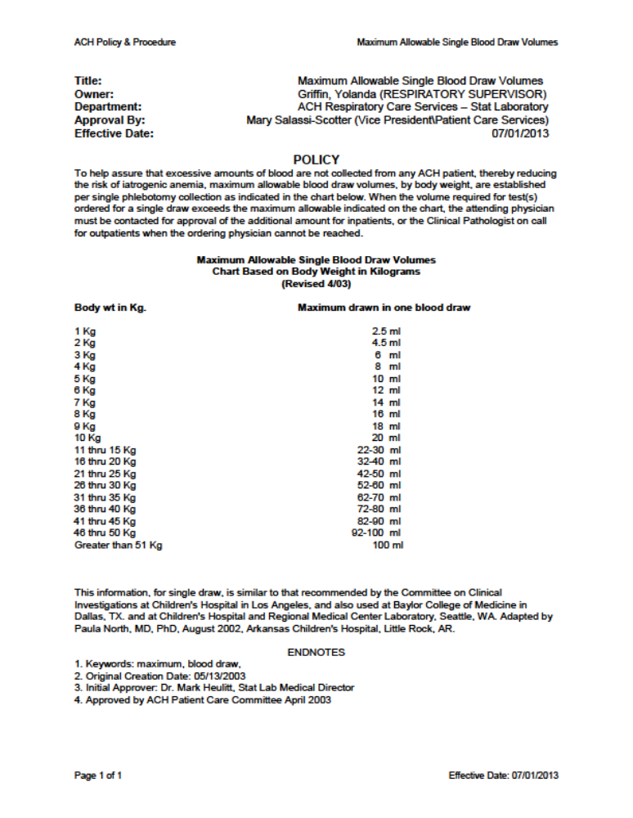

Attachment 2: Description of Survey/Questionnaire Tools

The tests described below will be attempted at least once at the specified time frames in the protocol, when possible.

Preschool Language Scale (PLS) – 5: The PLS will be used to measure auditory comprehension and expressive communication, in order to calculate a total language score. Other measures will not be obtained (e.g. articulation screener).

CELF Preschool – 2: This test measures a standard score in core language, receptive language, expressive language, language content, and language structure. Subtests that are not needed include recalling sentences in context and phonological awareness.

CELF 4 (5-8): This test measures a standard score in core language, receptive language, expressive language, language content, and language structure. A standard score will not be obtained for working memory. Subtests that are not necessary include understanding spoken paragraphs, phonological awareness, word association, number repetition, familiar sequences, rapid automatic naming, and pragmatic profile.

CELF-4 (9-21): This test measures a standard score in core language, receptive language, expressive language, language content, and language memory. A standard score for working memory will not be obtained. Phonological awareness, word associations, rapid automatic naming, and pragmatic profile sections will not be completed.

Adaptive Behavior: The Vineland Adaptive Behavior Scale (VABS) will measure functional abilities within several domains including: communication, daily living skills, socialization, and motor skills. The VABS has been used widely in ASD assessments and provides a measure of core symptoms and adaptive function across a wide age range. All sections of the VABS up through physical activity “using small muscles” will be completed. Subsequent sections consisting of problem behaviors will not be completed, as these are not needed in order to obtain an adaptive behavior composite score.

The Ohio Autism Clinical Impression Scale (OACIS): The OACIS was developed to be sensitive to possibly subtle, but clinically-meaningful changes in core and associated ASD behaviors. The OACIS is an instrument for assessing autistic improvement by means of change within core ASD symptomatology. Rather than emphasizing generalized global factors, the OACIS is a focused scaling system that assesses specificity in relation to ASD behaviors. The OACIS provides two types of summary scores: (a) a severity score and (b) an improvement score representing changes in ASD symptom severity. The OACIS has 10 items. These items represent core and associated symptoms of ASD including social relatedness, aberrant or abnormal behavior, hyperactivity, anxiety, sensory abnormalities, repetitive or ritualistic behavior, communication impairment, eye contact and gaze, self-injurious behavior, and aggressive behavior. At baseline visit 1, part 1 “severity” will be completed. At subsequent visits part 1 and part 2 “improvement” will be completed.

All questionnaires below will be attempted with the parent and teacher/therapist at least once at the specified time frames in the protocol, when possible.

Aberrant Behavior Checklist (ABC): The ABC is a behavioral questionnaire developed to rate symptoms of hyperactivity, irritability, lethargy, and stereotypic behavior in individuals with developmental disabilities. To be completed by parents and providers.

Social Responsiveness Scale (SRS): The SRS is a quantitative scale that measures the severity and type of social impairments that are characteristic of ASD. To be completed by parents only.

Autism symptoms questionnaire (ASQ): The Center for Autism and Related Disorders Autism Symptoms Questionnaire (ASQ) will be used to determine if the subject manifests delays in social interactions, communication, and stereotyped behavior. The ASQ algorithm provides a differentiation between Autistic Disorder (ASD), Asperger’s Disorder, and Pervasive Developmental Disorder – Not Otherwise Specified based on the Diagnostic and Statistical Manual of Mental Disorders – Fourth Edition – Text Revision. This new instrument provides simple standardized yes/no questions in order to reduce variability in diagnostic criteria. To be completed by parents and providers.

Health History and Mitochondrial Symptoms Questionnaire: ACHRI has developed this questionnaire to review signs, symptoms, laboratory abnormalities, and comorbid medical conditions that define mitochondrial disease. These questions will be derived from the major criteria used to define mitochondrial disease including the Modified Walker (3) and Morava (6, 7) criteria. We will provide a score based on the number of indicators endorsed. To be completed by parents only.

Repetitive Behavior Scale – Revised (RBS-R): In order to evaluate repetitive behaviors, we will use the RBS-R in order to account for this autism symptoms. The RBS-R measures a breadth of repetitive behaviors in children, adolescents, and adults with Autism Spectrum disorders. The RBS-R provides a quantitative, continuous measure of the full spectrum of repetitive behaviors. The RBS-R consists of six subscales including: Stereotyped Behavior, Self-injurious Behavior, Compulsive Behavior, Routine Behavior, Sameness Behavior, and Restricted Behavior, which have no overlap of item content. The RBS-R is a parent or provider report with a standardized Likert scale for a variety of stereotyped and repetitive behaviors. To be completed by parents and providers.

Attachment 3: Study Requirements Flowchart

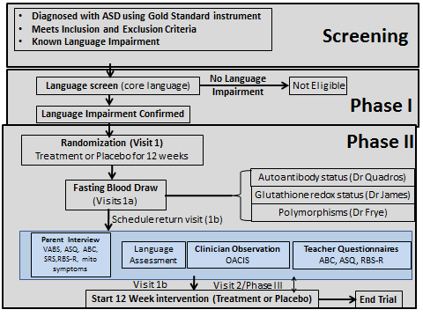

Attachment 4: Enrollment Flowchart

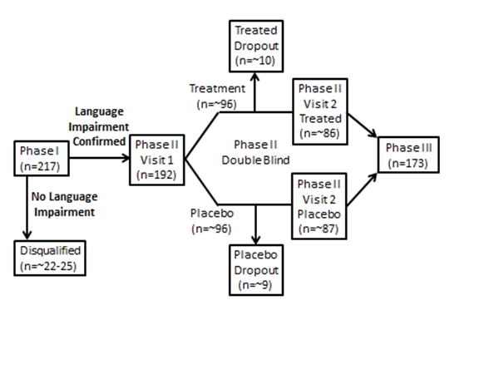

Attachment 5: Institute of Medicine (IOM) Tolerable Upper Daily Intake Levels of Vitamins and Elements

Vitamins | Vit A  μg | Vit C  mg | Vit D  μg | Vit E  mg | Niacin  mg | B6  mg | Folate  μg | Choline  gr
1-3 yr | 600 | 400 | 63 | 200 | 10 | 30 | 300 | 1.0
4-8 yr | 900 | 650 | 75 | 300 | 15 | 40 | 400 | 1.0
9-13 yr | 1,700 | 1,200 | 100 | 600 | 20 | 60 | 600 | 2.0
14-18 yr | 2,800 | 1,800 | 100 | 800 | 30 | 80 | 800 | 3.0

Elements | Boron  mg | Ca  mg | Cu  μg | Fluoride  mg | Iodine  μg | Iron  Mg | Mg  mg | Manganese  mg
1-3 yr | 3 | 2,500 | 1,000 | 1.3 | 200 | 40 | 65 | 2
4-8 yr | 6 | 2,500 | 1,000 | 2.2 | 300 | 40 | 110 | 3
9-13 yr | 11 | 3,000 | 5,000 | 10 | 600 | 40 | 350 | 6
14-18 yr | 17 | 3,000 | 8,000 | 10 | 900 | 45 | 350 | 9

Elements | Molybdenum  μg | Nickel  mg | Phosphorus  gr | Selenium  μg | Zinc  mg | Na  gr | Chloride  gr
1-3 yr | 300 | 0.2 | 3 | 90 | 7 | 1.5 | 2.3
4-8 yr | 600 | 0.3 | 3 | 150 | 12 | 1.9 | 2.9
9-13 yr | 1,100 | 0.6 | 4 | 280 | 23 | 2.2 | 3.4
14-18 yr | 1,700 | 1.0 | 4 | 400 | 34 | 2.3 | 3.6

