Supplementary Materials
Supplementary Figures S1-S7
Supplementary Tables S1-S7

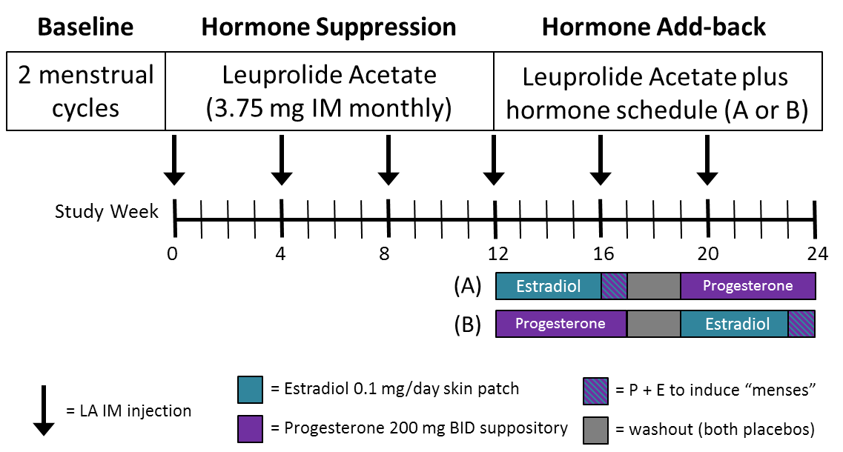
Clinical Trial Hormone Experimental Design

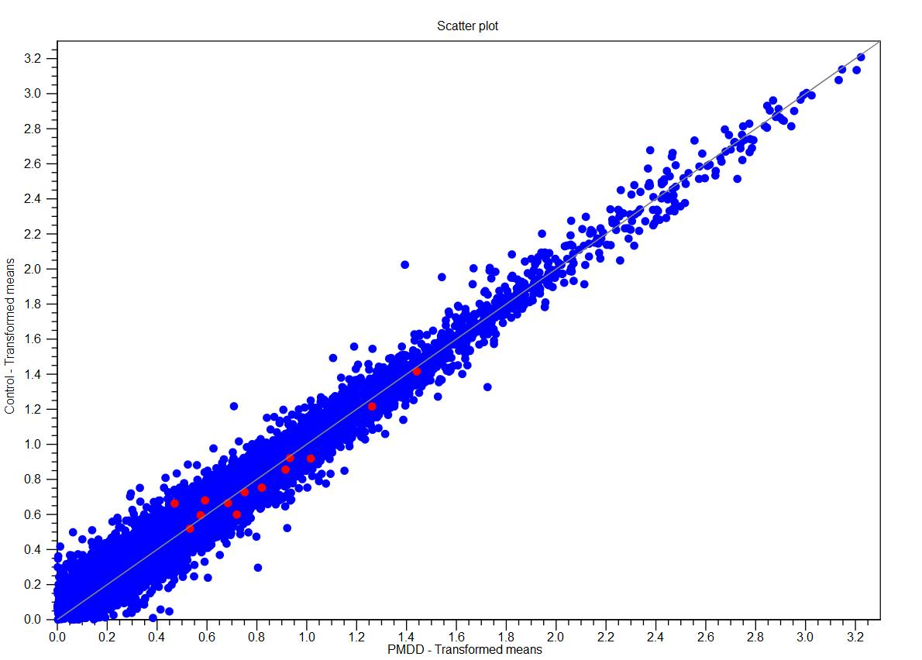
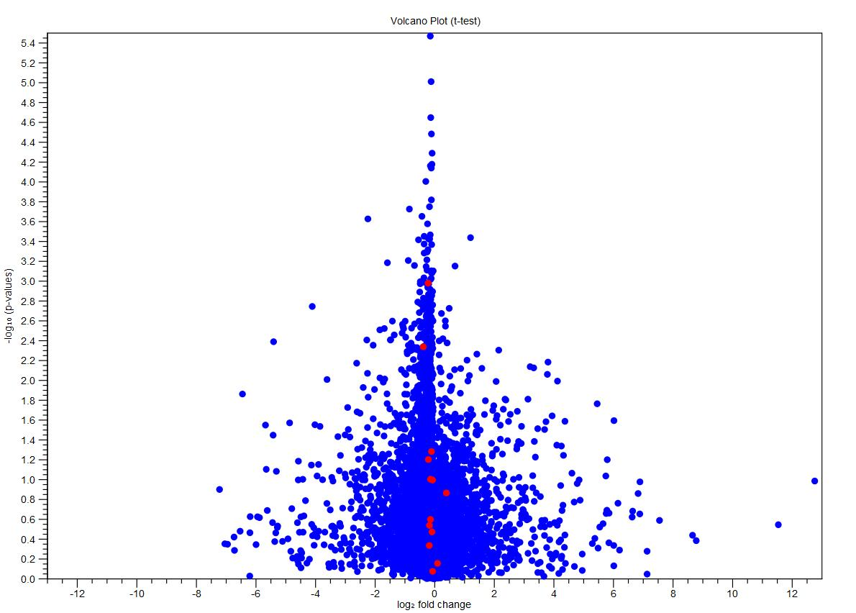
Control Baseline vs PMDD Baseline
A
B

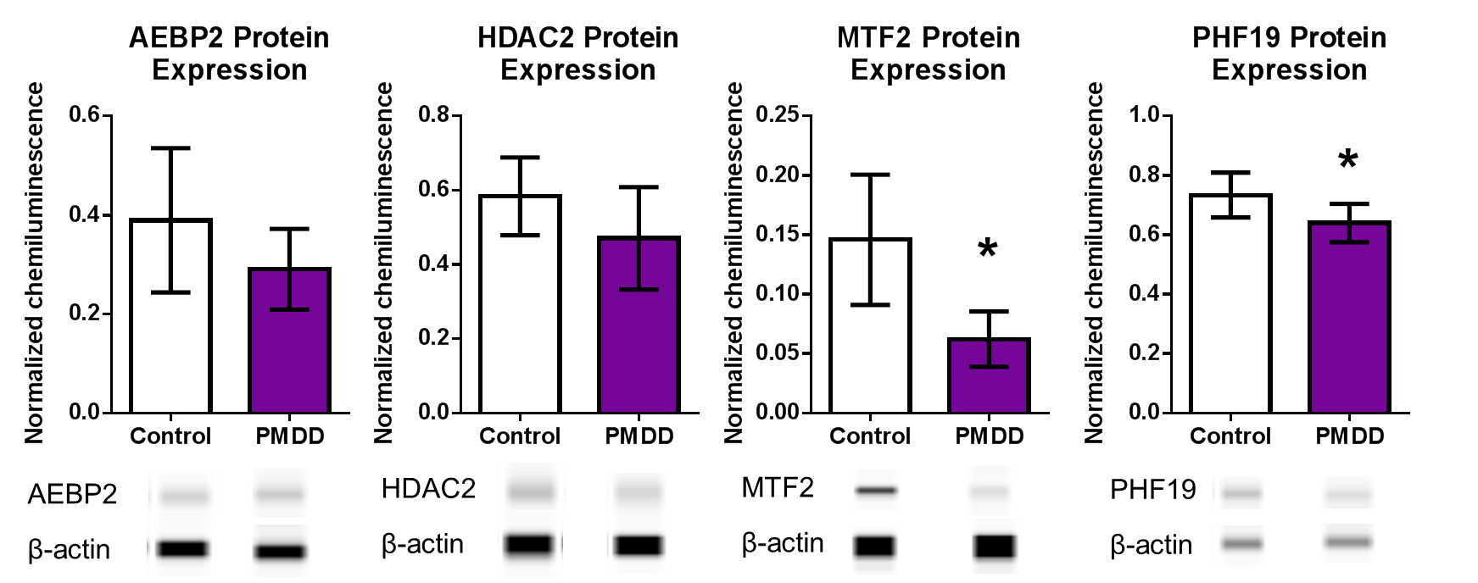
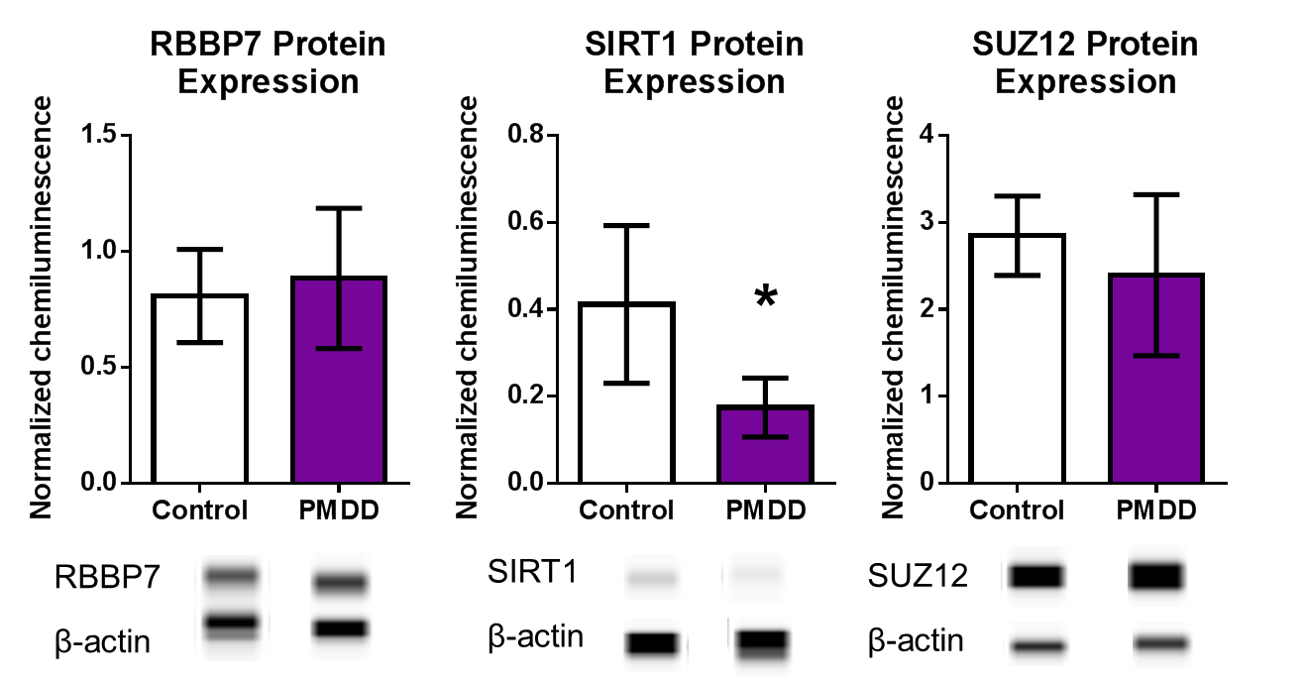
*
*
*
A
B
C
D
E
F
G
H
I

[Type a quote from the document or the summary of an interesting point. You can position the text box anywhere in the document. Use the Drawing Tools tab to change the formatting of the pull quote text box.]
[Type a quote from the document or the summary of an interesting point. You can position the text box anywhere in the document. Use the Drawing Tools tab to change the formatting of the pull quote text box.]
#
*
*
#
#
#
*
*
*
#
*

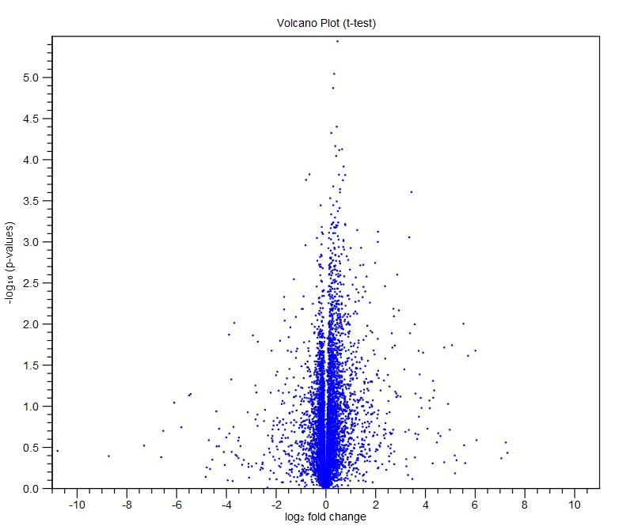
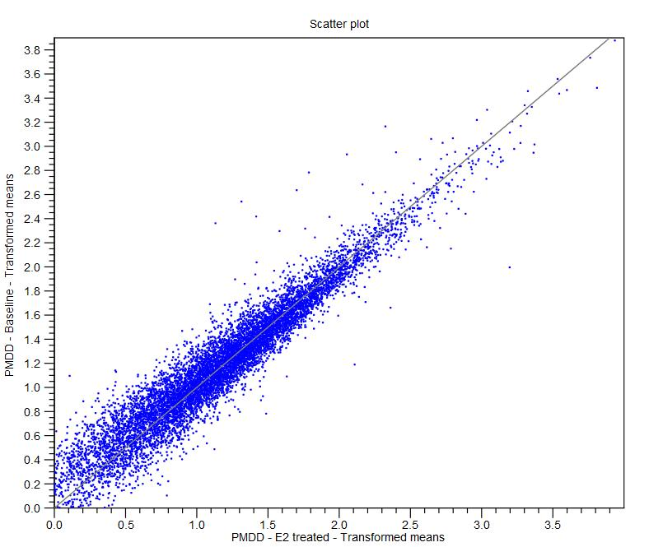
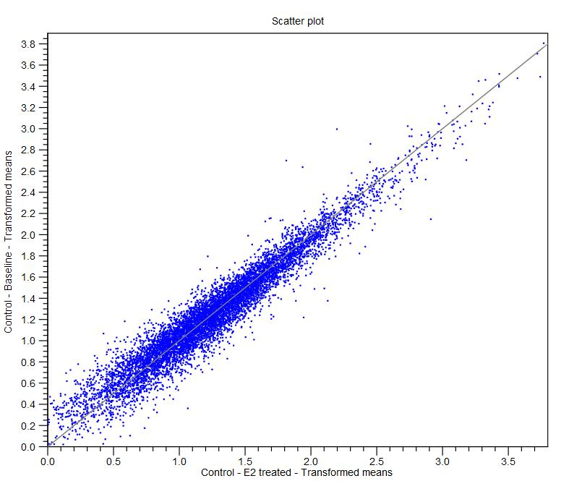
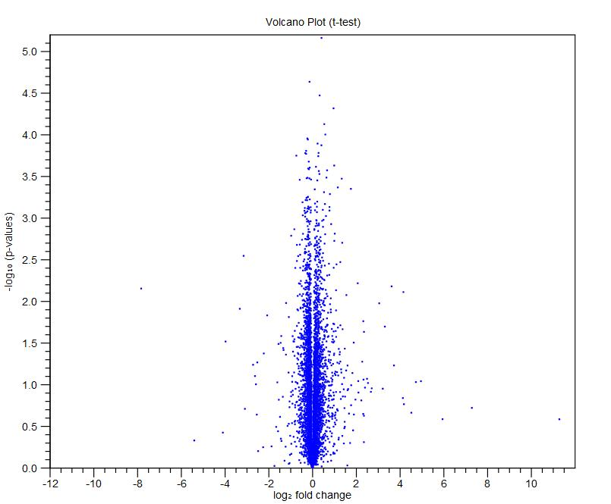
PMDD Baseline vs PMDD E2 treated
Control Baseline vs Control E2 treated
B
B
A
A

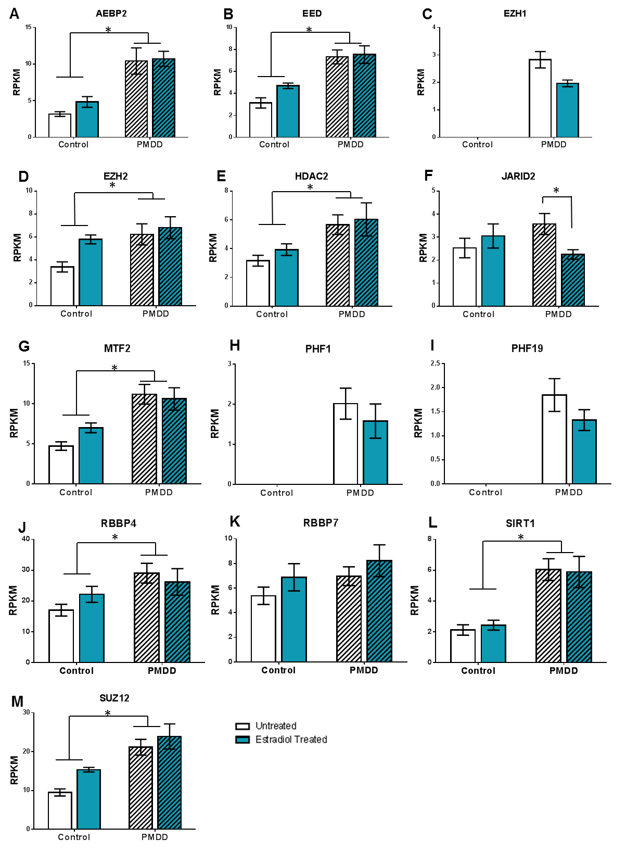
*
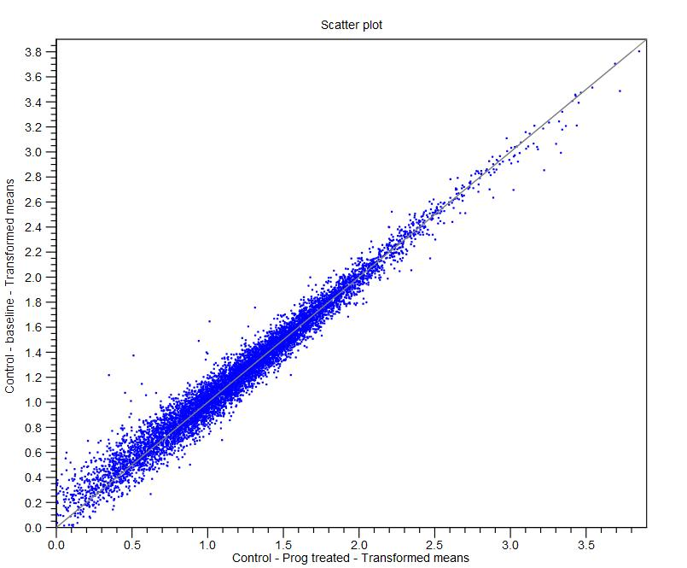
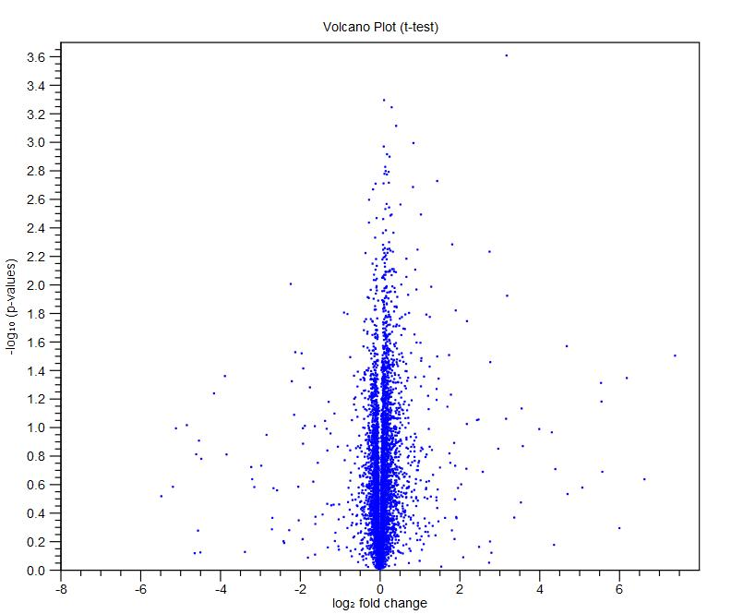
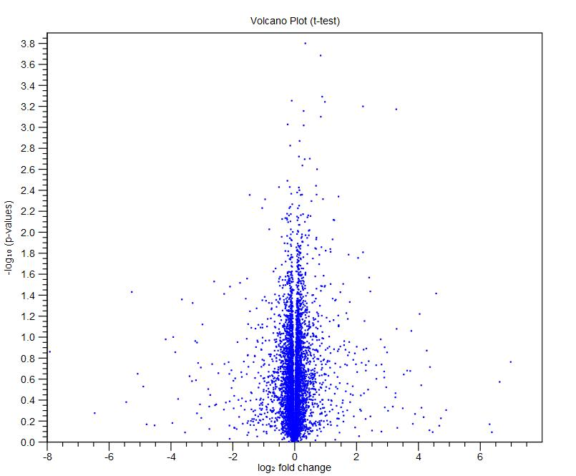
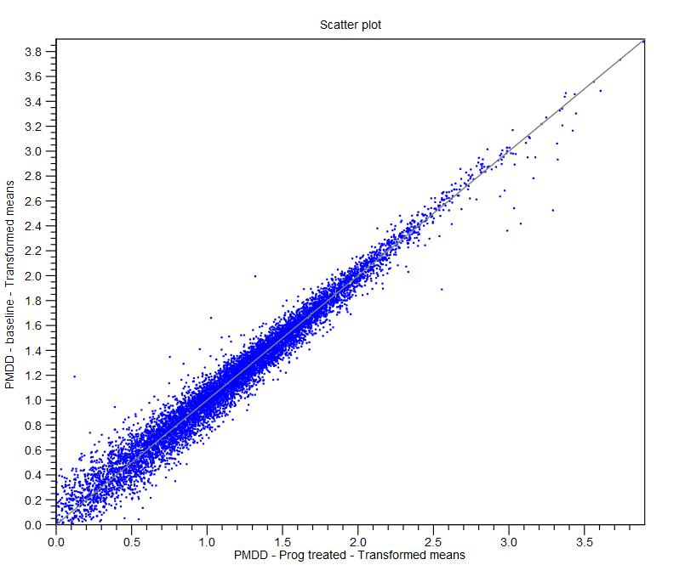
Control Baseline vs Control Progesterone treated
B
B
A
A
PMDD Baseline vs PMDD Progesterone treated
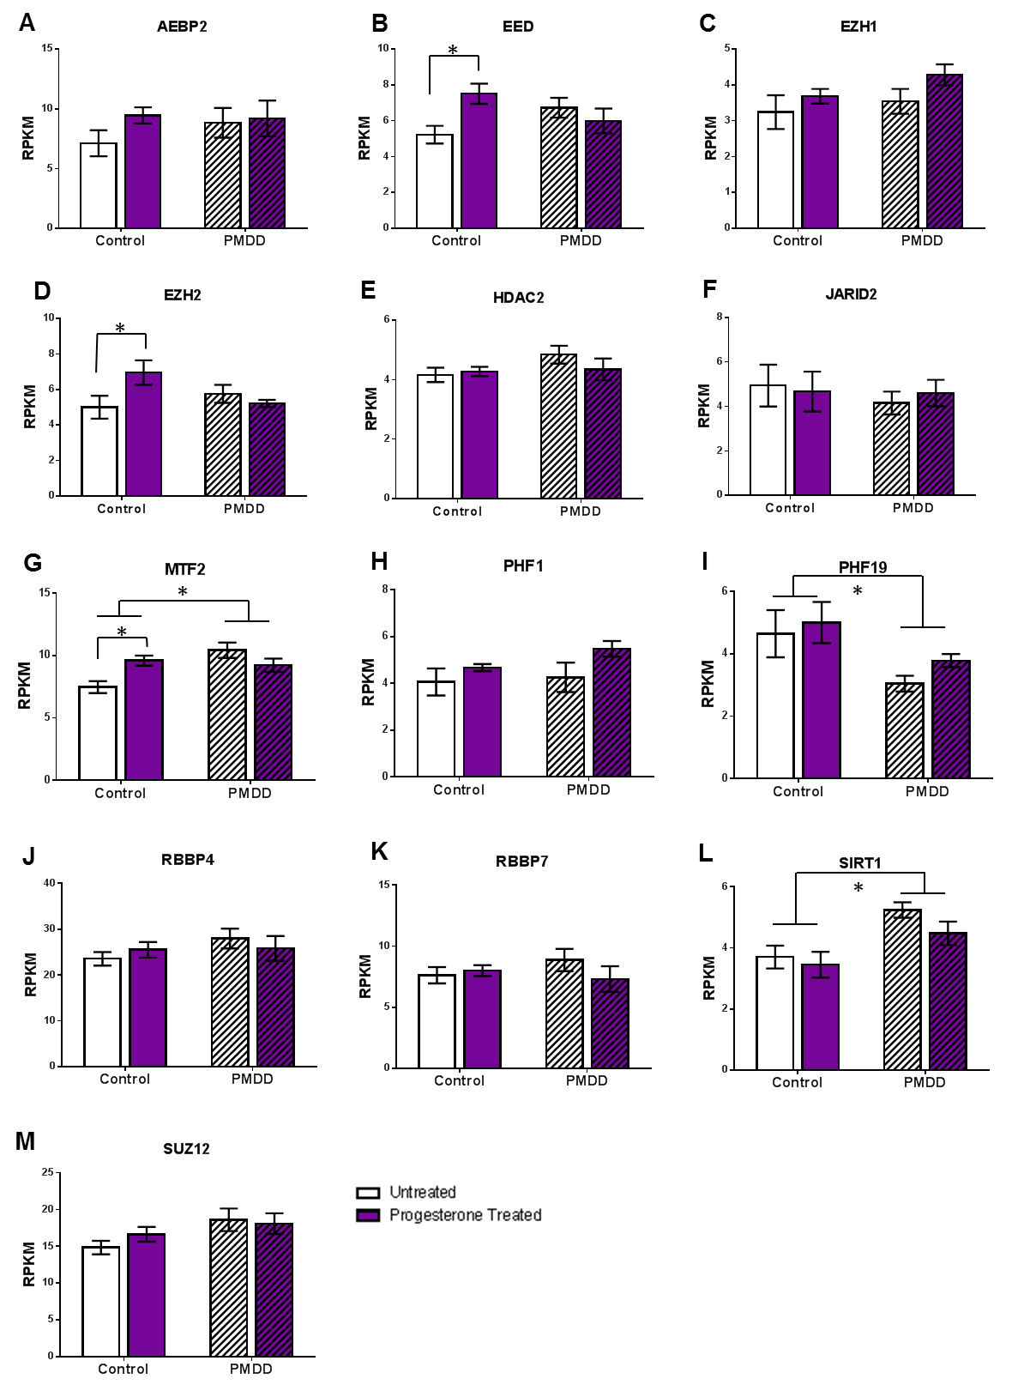

Table S1 – Primary antibody information

Target Protein | Source | Dilution | Alterations from ProteinSimple© default protocol
β-actin | Cell Signaling (3700-mouse; 4970-rabbit) | 1:1600 | Ran in conjunction with each target protein for normalization; see target protein cell in this table for indicated protocol alterations
AEBP2 | Abcam, (ab107892) | 1:25 | No change
ESR1 | Novus (MAB57151) | 1:300 | Ran with 1.5 µg protein instead of 3 µg; blocking time increased to 20 min
ESR2 | Novus (NB200-305) | 1:25 | No change
HDAC2 | Novus (MAB7679) | 1:100 | Blocking time increased to 15 min
MTF2 | Abcam (ab1738650) | 1:50 | Blocking time increased to 15 min
PGRMC1 | Novus (NBP1-83220) | 1:100 | No changes
PGRMC2 | Abcam (ab129603) | 1:25 | Blocking time increased to 15 min; Primary antibody time increased to 45 min
PHF19 | Abcam (ab68959) | 1:100 | No changes
RBBP7 | Novus (NB120-3535) | 1:50 | No changes
SIRT1 | Abcam (ab32441) | 1:50 | No changes
SUZ12 | Abcam (ab12073) | 1:100 | No changes

Table S2 – Number of genes mapped and nominally differentially expressed as determined by RNAseq comparing untreated Control and PMDD lymphoblastoid cell lines

Number of genes mapped
Dataset
All samples | 15,055
PMDD – untreated | 13,552
PMDD – estradiol treated | 12,365
PMDD – progesterone treated | 12,973
Control – untreated | 13,488
Control – estradiol treated | 13,218
Control – progesterone treated | 13,012
Genes nominally differentially expressed (non-FDR p<0.05)
Comparison | Gene Number
Control vs PMDD untreated | 1,000
Control – untreated vs estradiol treated | 308
Control – untreated vs progesterone treated | 381
PMDD – untreated vs estradiol treated | 538
PMDD – untreated vs progesterone treated | 404
Control-estradiol vs PMDD-estradiol | 1,349
Control-progesterone vs PMDD-progesterone | 643

Table S3 - Genes with nominally significant difference in expression (p<0.05) and a fold change of >│2.0│ comparing untreated Control and PMDD lymphoblastoid cell lines

Gene Summary
 |  | PMDD vs Controls
Genes differing in expression |  | 117
Genes up-regulated in PMDD versus Control |  | 57
Gene List
Feature ID | Fold Change | p-value
AC083899.3 | -2.038 | 1.04E-04
FAM83G | 3.451 | 1.26E-04
KRT10 | -2.072 | 1.57E-04
RP11-361L15.4 | 2.395 | 8.47E-04
RP11-366O20.5 | -3.008 | 1.09E-03
RP11-284F21.7 | 3.92 | 1.49E-03
RP11-713N11.5 | -2.052 | 1.59E-03
GDPGP1 | -2.205 | 2.42E-03
RP11-206L10.8 | -7.043 | 2.54E-03
AC006445.6 | -5.313 | 2.82E-03
SEPN1 | 2.354 | 2.95E-03
LILRA4 | 5.738 | 2.96E-03
DNAJC5B | -2.169 | 3.46E-03
IL4 | 3.429 | 3.64E-03
RHOD | -2.499 | 3.89E-03
CHL1 | 4.709 | 3.98E-03
PRSS51 | 4.944 | 4.05E-03
STAT4 | -4.692 | 4.62E-03
MTRNR2L10 | -9.719 | 4.79E-03
HNF1B | 2.867 | 7.39E-03
SLC12A7 | 2.218 | 7.50E-03
CXCR5 | 3.014 | 7.53E-03
U91319.1 | 2.431 | 7.66E-03
RP11-773H22.4 | 2.423 | 8.24E-03
LA16c-306E5.3 | 2.038 | 8.44E-03
AC104024.1 | -2.324 | 8.80E-03
NPM1P21 | -4.038 | 9.03E-03
IGFBP2 | 2.484 | 9.58E-03
RP11-693J15.5 | -2.074 | 0.01
ARHGAP6 | 2.448 | 0.01
AC009784.3 | -2.977 | 0.011
AC012487.2 | -2.157 | 0.011
GBP3 | -2.027 | 0.011
F8A3 | 2.564 | 0.011
IGHJ5 | 2.748 | 0.011
FGF2 | -2.042 | 0.012
SNHG9 | -2.297 | 0.013
XXYLT1-AS2 | 2.703 | 0.014
KIAA1217 | 2.148 | 0.016
CD1C | 3.355 | 0.016
CTSW | -2.232 | 0.017
TMEM220 | -2.151 | 0.017
CDC42BPA | 11.538 | 0.017
CTB-85P21.1 | -6.433 | 0.018
EEF1B2P4 | -5.142 | 0.018
FAM190A | -2.259 | 0.018
FAM27E3 | 2.765 | 0.018
STEAP2 | 3.238 | 0.018
C14orf105 | 6.404 | 0.018
RP11-824M15.3 | -2.313 | 0.019
AC002550.5 | 2.195 | 0.019
GRIA3 | 2.418 | 0.019
CPXM1 | 2.538 | 0.019
IGHV2-70 | 6.586 | 0.019
RP11-582E3.2 | -11.304 | 0.02
CTB-1048E9.7 | -2.11 | 0.02
C11orf63 | -2.017 | 0.02
ELOVL7 | -2.013 | 0.02
SPRY2 | 2.026 | 0.021
RP11-561C5.4 | 2.155 | 0.021
CTC-661I16.1 | -2.322 | 0.022
PHYHD1 | 11.891 | 0.022
FGF11 | 2.014 | 0.023
RP11-439L8.3 | 2.802 | 0.023
CTD-3094K11.1 | -3.444 | 0.024
RHOU | 5.417 | 0.024
RP5-890E16.4 | 15.769 | 0.024
AC005220.3 | -5.057 | 0.025
CDYL2 | -2.887 | 0.025
RP11-325B23.2 | -2.605 | 0.025
AC096582.7 | -2.448 | 0.026
ZNF415 | -2.101 | 0.026
RP11-553K8.2 | -3.858 | 0.028
ZNF222 | -2.327 | 0.028
IGHV4-59 | 7.459 | 0.028
PMS2P2 | -2.064 | 0.029
TRAJ35 | 2.949 | 0.029
RP1-28O10.1 | 3.681 | 0.029
TRAJ7 | 10.705 | 0.029
FLJ23152 | -5.092 | 0.03
CTD-2620I22.1 | -3.869 | 0.03
AC024084.1 | -3.846 | 0.03
RASGRP4 | 4.93 | 0.03
CHI3L1 | 5.562 | 0.03
HMGA1P4 | 3.425 | 0.031
DDO | -4.287 | 0.032
AXL | 17.295 | 0.032
SERINC2 | 3.53 | 0.033
KRTAP17-1 | 22.242 | 0.033
RP11-142L1.1 | -5.079 | 0.034
TPBG | -2.281 | 0.035
ATP4A | 2.419 | 0.035
CDCP1 | 6.842 | 0.035
BMS1P5 | -2.49 | 0.036
AP001816.1 | -2.056 | 0.036
CTB-129P6.11 | 4.272 | 0.036
AC005094.2 | -15.061 | 0.037
RP11-215P8.3 | 14.546 | 0.037
RNFT1 | -3.993 | 0.038
PDGFRL | -3.455 | 0.038
C21orf49 | -2.117 | 0.038
GIMAP7 | -2.499 | 0.039
MTRNR2L8 | -2.395 | 0.039
INPP4B | 2.269 | 0.039
RP11-498P14.3 | -2.155 | 0.04
TXLNB | -2.001 | 0.042
Z97634.5 | 2.673 | 0.042
TP53I3 | 2.858 | 0.043
HOTAIRM1 | -3.004 | 0.044
SOWAHA | 2.381 | 0.044
AL139819.1 | 7.981 | 0.045
AC110373.1 | 2.807 | 0.046
DLK2 | 2.388 | 0.047
IGHV3-64 | 7.204 | 0.047
CACNA1D | 2.177 | 0.048
AC010132.11 | -3.424 | 0.05
U47924.25 | 2.017 | 0.05

Table S4 – Full GSEA results from RNAseq comparing untreated Control and PMDD lymphoblastoid cell lines

Category | Description | Size | Test statistic | Lower tail
502 | proteasome complex (GO_REF:0000037 [IEA] UniProtKB-KW:KW-0647) | 51 | -9.245 | 0
5730 | nucleolus (GO_REF:0000052 [IDA]) | 1049 | -19.582 | 0
5654 | nucleoplasm (PMID:16687569 [IDA]) | 709 | -16.791 | 2.00E-05
15030 | Cajal body (PMID:16687569 [IDA]) | 40 | -7.516 | 5.00E-05
22624 | proteasome accessory complex (GO_REF:0000024 [ISS] UniProtKB:P62334) | 15 | -6.323 | 8.00E-05
5737 | cytoplasm (GO_REF:0000052 [IDA]) | 2521 | -25.887 | 4.20E-04
5634 | nucleus (GO_REF:0000052 [IDA]) | 3131 | -28.385 | 5.80E-04
5839 | proteasome core complex (GO_REF:0000019 [IEA] Ensembl:ENSMUSP00000129767) | 17 | -5.906 | 6.10E-04
5681 | spliceosomal complex (PMID:7935475 [TAS]) | 65 | -7.412 | 9.80E-04
781 | chromosome, telomeric region (PMID:12768206 [IDA]) | 30 | -5.967 | 1.89E-03
5669 | transcription factor TFIID complex (PMID:15899866 [IDA]) | 17 | -5.294 | 2.30E-03
5813 | centrosome (PMID:21399614 [IDA]) | 261 | -10.45 | 3.61E-03
19005 | SCF ubiquitin ligase complex (PMID:20347421 [IDA]) | 21 | -5.146 | 5.43E-03
151 | ubiquitin ligase complex (GO_REF:0000002 [IEA] InterPro:IPR003613) | 52 | -6.246 | 6.72E-03
35098 | ESC/E(Z) complex (PMID:20075857 [IDA]) | 13 | -4.622 | 6.92E-03
5720 | nuclear heterochromatin (PMID:10570185 [TAS]) | 14 | -4.604 | 7.62E-03
71013 | catalytic step 2 spliceosome (PMID:11991638 [IDA]) | 56 | -6.204 | 9.23E-03
31461 | cullin-RING ubiquitin ligase complex (GO_REF:0000002 [IEA] InterPro:IPR001373) | 10 | -4.275 | 9.69E-03
242 | pericentriolar material (PMID:21211617 [IDA]) | 15 | -4.576 | 9.87E-03
33116 | ER-Golgi intermediate compartment membrane (GO_REF:0000039 [IEA] UniProtKB-SubCell:SL-0099) | 24 | -4.945 | 0.012
31011 | Ino80 complex (PMID:21303910 [IDA]) | 13 | -4.172 | 0.018
5794 | Golgi apparatus (GO_REF:0000052 [IDA]) | 434 | -11.787 | 0.02
45335 | phagocytic vesicle (PMID:15470500 [ISS] UniProtKB:P70280) | 19 | -4.13 | 0.035
5829 | cytosol (Reactome:REACT_1442 [TAS]) | 1502 | -19.387 | 0.041
16235 | aggresome (PMID:14675537 [IDA]) | 14 | -3.746 | 0.044
31080 | Nup107-160 complex (PMID:17098863 [IDA]) | 10 | -3.472 | 0.045
16591 | DNA-directed RNA polymerase II, holoenzyme (PMID:22231121 [IDA]) | 13 | -3.632 | 0.048
32391 | photoreceptor connecting cilium (PMID:12417528 [IDA]) | 14 | -3.671 | 0.049
5689 | U12-type spliceosomal complex (PMID:21041408 [IDA]) | 15 | -3.751 | 0.049
5778 | peroxisomal membrane (PMID:21525035 [IDA]) | 23 | -4.152 | 0.05
33276 | transcription factor TFTC complex (PMID:15899866 [IDA]) | 14 | -3.604 | 0.056
16607 | nuclear speck (GO_REF:0000039 [IEA] UniProtKB-SubCell:SL-0186) | 127 | -6.942 | 0.06
5622 | intracellular (PMID:10542258 [TAS]) | 663 | -13.399 | 0.062
16605 | PML body (GO_REF:0000039 [IEA] UniProtKB-SubCell:SL-0465) | 67 | -5.48 | 0.067
5635 | nuclear envelope (PMID:9518481 [IDA]) | 78 | -5.736 | 0.07
5770 | late endosome (PMID:19109425 [IDA]) | 49 | -4.909 | 0.072
5643 | nuclear pore (GO_REF:0000019 [IEA] Ensembl:ENSMUSP00000010241) | 62 | -5.311 | 0.072
5852 | eukaryotic translation initiation factor 3 complex (PMID:9341143 [TAS]) | 15 | -3.478 | 0.076
30117 | membrane coat (GO_REF:0000002 [IEA] InterPro:IPR000804) | 18 | -3.601 | 0.081
5764 | lysosome (GO_REF:0000039 [IEA] UniProtKB-SubCell:SL-0158) | 123 | -6.524 | 0.099
30914 | STAGA complex (PMID:11564863 [IDA]) | 12 | -3.115 | 0.099
17119 | Golgi transport complex (GO_REF:0000002 [IEA] InterPro:IPR007255) | 10 | -2.953 | 0.101
5675 | holo TFIIH complex (PMID:11279242 [NAS]) | 10 | -2.959 | 0.101
31463 | Cul3-RING ubiquitin ligase complex (PMID:15983046 [IDA]) | 20 | -3.522 | 0.104
31514 | motile secondary cilium (GO_REF:0000019 [IEA] Ensembl:ENSMUSP00000026265) | 12 | -3.074 | 0.105
44297 | --- | 12 | -3.072 | 0.105
5777 | peroxisome (PMID:1347505 [IDA]) | 40 | -4.345 | 0.107
5657 | replication fork (GO_REF:0000019 [IEA] Ensembl:ENSMUSP00000019911) | 11 | -2.995 | 0.107
31982 | vesicle (PMID:2833496 [IDA]) | 16 | -3.292 | 0.108
5769 | early endosome (PMID:19109425 [IDA]) | 89 | -5.712 | 0.111
178 | exosome (RNase complex) (PMID:9562621 [TAS]) | 14 | -3.145 | 0.113
72372 | --- | 11 | -2.938 | 0.115
5814 | centriole (GO_REF:0000039 [IEA] UniProtKB-SubCell:SL-0046) | 50 | -4.618 | 0.116
31902 | late endosome membrane (GO_REF:0000039 [IEA] UniProtKB-SubCell:SL-0151) | 62 | -4.97 | 0.119
10008 | endosome membrane (Reactome:REACT_25318 [TAS]) | 117 | -6.219 | 0.13
31201 | SNARE complex (PMID:15133481 [ISS] UniProtKB:Q9JHW5) | 18 | -3.255 | 0.131
5783 | endoplasmic reticulum (PMID:12524539 [IDA]) | 361 | -9.872 | 0.134
71203 | --- | 11 | -2.805 | 0.14
43231 | intracellular membrane-bounded organelle (GO_REF:0000052 [IDA]) | 213 | -7.86 | 0.143
16580 | Sin3 complex (PMID:17827154 [IDA]) | 11 | -2.765 | 0.146
118 | histone deacetylase complex (PMID:12711221 [TAS]) | 22 | -3.336 | 0.156
32039 | integrator complex (PMID:16239144 [IDA]) | 12 | -2.738 | 0.163
5868 | cytoplasmic dynein complex (PMID:17994011 [IDA]) | 10 | -2.546 | 0.172
35267 | NuA4 histone acetyltransferase complex (PMID:14966270 [IDA]) | 11 | -2.584 | 0.18
16363 | nuclear matrix (PMID:10973986 [IDA]) | 55 | -4.432 | 0.181
45111 | intermediate filament cytoskeleton (GO_REF:0000052 [IDA]) | 32 | -3.542 | 0.204
60170 | cilium membrane (PMID:17574030 [IDA]) | 12 | -2.53 | 0.209
30670 | phagocytic vesicle membrane (GO_REF:0000039 [IEA] UniProtKB-SubCell:SL-0205) | 34 | -3.601 | 0.209
43240 | Fanconi anaemia nuclear complex (PMID:20347429 [IDA]) | 10 | -2.382 | 0.213
8023 | transcription elongation factor complex (PMID:9748214 [TAS]) | 11 | -2.427 | 0.217
5932 | microtubule basal body (GO_REF:0000039 [IEA] UniProtKB-SubCell:SL-0087) | 42 | -3.864 | 0.217
48471 | perinuclear region of cytoplasm (GO_REF:0000039 [IEA] UniProtKB-SubCell:SL-0198) | 255 | -8.116 | 0.222
5575 | cellular_component (GO_REF:0000015 [ND]) | 269 | -8.209 | 0.248
5929 | cilium (GO_REF:0000037 [IEA] UniProtKB-KW:KW-0969) | 38 | -3.586 | 0.249
31519 | PcG protein complex (PMID:16943429 [IDA]) | 21 | -2.87 | 0.251
30175 | filopodium (PMID:17599059 [IDA]) | 29 | -3.225 | 0.252
10494 | stress granule (PMID:16484376 [IDA]) | 18 | -2.66 | 0.264
16592 | mediator complex (PMID:17641689 [IMP]) | 30 | -3.216 | 0.266
5768 | endosome (Reactome:REACT_12015 [TAS]) | 82 | -4.82 | 0.267
145 | exocyst (GO_REF:0000002 [IEA] InterPro:IPR004140) | 10 | -2.154 | 0.268
42383 | sarcolemma (PMID:20639889 [IDA]) | 23 | -2.898 | 0.269
785 | chromatin (GO_REF:0000019 [IEA] Ensembl:ENSMUSP00000074236) | 62 | -4.274 | 0.274
30017 | sarcomere (GO_REF:0000039 [IEA] UniProtKB-SubCell:SL-0313) | 10 | -2.123 | 0.276
42470 | melanosome (GO_REF:0000039 [IEA] UniProtKB-SubCell:SL-0161) | 59 | -4.171 | 0.277
5671 | Ada2/Gcn5/Ada3 transcription activator complex (PMID:18838386 [IDA]) | 15 | -2.4 | 0.294
5637 | nuclear inner membrane (GO_REF:0000039 [IEA] UniProtKB-SubCell:SL-0179) | 22 | -2.758 | 0.296
80008 | CUL4 RING ubiquitin ligase complex (PMID:18381890 [IDA]) | 12 | -2.167 | 0.303
9898 | internal side of plasma membrane (PMID:7912851 [IDA]) | 22 | -2.727 | 0.304
19898 | extrinsic to membrane (PMID:23045692 [IDA]) | 19 | -2.51 | 0.324
5801 | cis-Golgi network (GO_REF:0000019 [IEA] Ensembl:ENSRNOP00000014810) | 24 | -2.713 | 0.335
1673 | male germ cell nucleus (GO_REF:0000019 [IEA] Ensembl:ENSMUSP00000127995) | 12 | -2.048 | 0.339
30176 | integral to endoplasmic reticulum membrane (PMID:11018465 [NAS]) | 40 | -3.33 | 0.344
5791 | rough endoplasmic reticulum (GO_REF:0000024 [ISS] UniProtKB:Q32PD3) | 11 | -1.95 | 0.348
5802 | trans-Golgi network (GO_REF:0000019 [IEA] Ensembl:ENSRNOP00000013629) | 60 | -3.946 | 0.352
8180 | signalosome (PMID:18850735 [IDA]) | 25 | -2.69 | 0.357
5793 | ER-Golgi intermediate compartment (GO_REF:0000039 [IEA] UniProtKB-SubCell:SL-0098) | 43 | -3.38 | 0.359
71564 | --- | 10 | -1.832 | 0.363
32588 | trans-Golgi network membrane (Reactome:REACT_120943 [TAS]) | 24 | -2.611 | 0.369
35145 | exon-exon junction complex (PMID:19410547 [IDA]) | 11 | -1.88 | 0.371
30126 | COPI vesicle coat (PMID:8335000 [IDA]) | 13 | -1.982 | 0.382
71339 | --- | 24 | -2.566 | 0.382
55037 | recycling endosome (PMID:19109425 [IDA]) | 35 | -3.001 | 0.388
5680 | anaphase-promoting complex (GO_REF:0000002 [IEA] InterPro:IPR024990) | 21 | -2.385 | 0.393
31901 | early endosome membrane (GO_REF:0000039 [IEA] UniProtKB-SubCell:SL-0093) | 58 | -3.733 | 0.401
5834 | heterotrimeric G-protein complex (GO_REF:0000002 [IEA] InterPro:IPR001770|InterPro:IPR015898) | 21 | -2.361 | 0.402
35102 | PRC1 complex (PMID:19636380 [IDA]) | 10 | -1.712 | 0.404
5815 | microtubule organizing center (GO_REF:0000039 [IEA] UniProtKB-SubCell:SL-0048) | 62 | -3.807 | 0.414
16581 | NuRD complex (PMID:17827154 [IDA]) | 16 | -2.053 | 0.416
159 | protein phosphatase type 2A complex (PMID:10318862 [TAS]) | 14 | -1.924 | 0.421
139 | Golgi membrane (Reactome:REACT_115635 [TAS]) | 302 | -8.035 | 0.432
123 | histone acetyltransferase complex (GO_REF:0000002 [IEA] InterPro:IPR026180) | 14 | -1.836 | 0.447
45177 | apical part of cell (PMID:22006950 [IDA]) | 38 | -2.866 | 0.471
14704 | intercalated disc (GO_REF:0000019 [IEA] Ensembl:ENSMUSP00000102009) | 11 | -1.56 | 0.475
228 | nuclear chromosome (PMID:10748112 [TAS]) | 17 | -1.853 | 0.496
30014 | CCR4-NOT complex (PMID:19558367 [IDA]) | 12 | -1.558 | 0.498
5856 | cytoskeleton (PMID:11171322 [TAS]) | 186 | -6.15 | 0.503
421 | autophagic vacuole membrane (GO_REF:0000039 [IEA] UniProtKB-SubCell:SL-0022) | 12 | -1.539 | 0.504
5765 | lysosomal membrane (GO_REF:0000039 [IEA] UniProtKB-SubCell:SL-0157) | 101 | -4.493 | 0.511
784 | nuclear chromosome, telomeric region (GO_REF:0000002 [IEA] InterPro:IPR011564) | 16 | -1.681 | 0.539
30658 | transport vesicle membrane (GO_REF:0000039 [IEA] UniProtKB-SubCell:SL-0245) | 17 | -1.691 | 0.552
5905 | coated pit (GO_REF:0000039 [IEA] UniProtKB-SubCell:SL-0072) | 27 | -2.154 | 0.562
795 | synaptonemal complex (PMID:8610150 [TAS]) | 10 | -1.229 | 0.564
45121 | membrane raft (GO_REF:0000039 [IEA] UniProtKB-SubCell:SL-0370) | 62 | -3.343 | 0.571
792 | heterochromatin (GO_REF:0000019 [IEA] Ensembl:ENSMUSP00000019911) | 14 | -1.476 | 0.571
5942 | phosphoinositide 3-kinase complex (GO_REF:0000033 [IBA] PANTHER:PTN000005674) | 10 | -1.197 | 0.573
5789 | endoplasmic reticulum membrane (GO_REF:0000039 [IEA] UniProtKB-SubCell:SL-0097) | 394 | -8.735 | 0.579
5665 | DNA-directed RNA polymerase II, core complex (GO_REF:0000002 [IEA] InterPro:IPR000684) | 12 | -1.305 | 0.58
5902 | microvillus (PMID:19366691 [IDA]) | 15 | -1.487 | 0.583
30018 | Z disc (GO_REF:0000039 [IEA] UniProtKB-SubCell:SL-0314) | 28 | -2.124 | 0.584
30131 | clathrin adaptor complex (GO_REF:0000002 [IEA] InterPro:IPR008152|InterPro:IPR013037|InterPro:IPR015151) | 15 | -1.486 | 0.585
2102 | podosome (PMID:18417249 [IDA]) | 12 | -1.273 | 0.592
5881 | cytoplasmic microtubule (PMID:23264731 [IDA]) | 31 | -2.228 | 0.593
30669 | clathrin-coated endocytic vesicle membrane (Reactome:REACT_121177 [TAS]) | 14 | -1.388 | 0.596
5776 | autophagic vacuole (PMID:15292400 [IDA]) | 20 | -1.712 | 0.597
793 | condensed chromosome (GO_REF:0000019 [IEA] Ensembl:ENSMUSP00000045667) | 16 | -1.499 | 0.599
71944 | --- | 10 | -1.107 | 0.605
31410 | cytoplasmic vesicle (PMID:17684057 [IDA]) | 56 | -3.045 | 0.607
31941 | filamentous actin (PMID:9395435 [NAS]) | 11 | -1.134 | 0.616
42734 | presynaptic membrane (GO_REF:0000033 [IBA] PANTHER:PTN000168464) | 13 | -1.269 | 0.616
5788 | endoplasmic reticulum lumen (Reactome:REACT_120939 [TAS]) | 79 | -3.635 | 0.621
31965 | nuclear membrane (GO_REF:0000052 [IDA]) | 116 | -4.479 | 0.626
1891 | phagocytic cup (GO_REF:0000039 [IEA] UniProtKB-SubCell:SL-0473) | 10 | -0.991 | 0.639
31225 | anchored to membrane (GO_REF:0000037 [IEA] UniProtKB-KW:KW-0336) | 20 | -1.571 | 0.644
1772 | immunological synapse (GO_REF:0000019 [IEA] Ensembl:ENSMUSP00000029842) | 15 | -1.241 | 0.661
51233 | spindle midzone (PMID:9763420 [NAS]) | 11 | -0.989 | 0.664
12506 | vesicle membrane (GO_REF:0000019 [IEA] Ensembl:ENSMUSP00000026135) | 10 | -0.899 | 0.665
55038 | recycling endosome membrane (GO_REF:0000039 [IEA] UniProtKB-SubCell:SL-0231) | 21 | -1.526 | 0.672
33017 | sarcoplasmic reticulum membrane (GO_REF:0000039 [IEA] UniProtKB-SubCell:SL-0241) | 13 | -1.045 | 0.684
31594 | neuromuscular junction (GO_REF:0000019 [IEA] Ensembl:ENSMUSP00000102009) | 16 | -1.198 | 0.693
932 | cytoplasmic mRNA processing body (PMID:12878161 [IDA]) | 36 | -2.067 | 0.705
17053 | transcriptional repressor complex (PMID:11804585 [IDA]) | 35 | -2.015 | 0.707
30496 | midbody (GO_REF:0000019 [IEA] Ensembl:ENSMUSP00000027931) | 68 | -2.97 | 0.735
35085 | cilium axoneme (GO_REF:0000039 [IEA] UniProtKB-SubCell:SL-0304) | 22 | -1.354 | 0.737
30140 | trans-Golgi network transport vesicle (PMID:12095985 [IDA]) | 10 | -0.644 | 0.739
16514 | SWI/SNF complex (PMID:8804307 [IDA]) | 12 | -0.798 | 0.739
30863 | cortical cytoskeleton (GO_REF:0000019 [IEA] Ensembl:ENSMUSP00000015877) | 11 | -0.726 | 0.74
8076 | voltage-gated potassium channel complex (PMID:8605869 [TAS]) | 10 | -0.641 | 0.743
30659 | cytoplasmic vesicle membrane (GO_REF:0000039 [IEA] UniProtKB-SubCell:SL-0089) | 52 | -2.467 | 0.745
794 | condensed nuclear chromosome (GO_REF:0000019 [IEA] Ensembl:ENSMUSP00000027931) | 20 | -1.207 | 0.75
31234 | extrinsic to internal side of plasma membrane (PMID:11904303 [IMP]) | 17 | -1.044 | 0.752
30666 | endocytic vesicle membrane (Reactome:REACT_18330 [TAS]) | 23 | -1.309 | 0.759
32420 | stereocilium (GO_REF:0000039 [IEA] UniProtKB-SubCell:SL-0302) | 10 | -0.574 | 0.759
72686 | --- | 15 | -0.89 | 0.763
790 | nuclear chromatin (PMID:21632880 [IDA]) | 66 | -2.8 | 0.764
42995 | cell projection (GO_REF:0000039 [IEA] UniProtKB-SubCell:SL-0280) | 30 | -1.6 | 0.765
31526 | brush border membrane (GO_REF:0000019 [IEA] Ensembl:ENSMUSP00000028403) | 12 | -0.662 | 0.772
1725 | stress fiber (GO_REF:0000019 [IEA] Ensembl:ENSMUSP00000035203) | 27 | -1.402 | 0.785
5876 | spindle microtubule (PMID:18326024 [IDA]) | 29 | -1.475 | 0.786
12505 | endomembrane system (GO_REF:0000039 [IEA] UniProtKB-SubCell:SL-0147) | 48 | -2.175 | 0.787
776 | kinetochore (PMID:17621308 [IDA]) | 52 | -2.292 | 0.787
1669 | acrosomal vesicle (GO_REF:0000024 [ISS] UniProtKB:P48830) | 23 | -1.206 | 0.788
5923 | tight junction (GO_REF:0000024 [ISS] UniProtKB:Q99NH2) | 39 | -1.783 | 0.805
16604 | nuclear body (GO_REF:0000019 [IEA] Ensembl:ENSMUSP00000102770) | 29 | -1.399 | 0.807
16324 | apical plasma membrane (GO_REF:0000039 [IEA] UniProtKB-SubCell:SL-0015) | 61 | -2.463 | 0.812
42613 | MHC class II protein complex (GO_REF:0000038 [IEA] UniProtKB-KW:KW-0491) | 13 | -0.542 | 0.816
30139 | endocytic vesicle (PMID:20682791 [IDA]) | 19 | -0.833 | 0.829
14069 | postsynaptic density (GO_REF:0000039 [IEA] UniProtKB-SubCell:SL-0297) | 47 | -1.952 | 0.829
5811 | lipid particle (PMID:14741744 [IDA]) | 22 | -0.982 | 0.831
16529 | sarcoplasmic reticulum (GO_REF:0000019 [IEA] Ensembl:ENSMUSP00000032192) | 10 | -0.26 | 0.834
777 | condensed chromosome kinetochore (GO_REF:0000039 [IEA] UniProtKB-SubCell:SL-0149) | 59 | -2.298 | 0.834
5795 | Golgi stack (PMID:19103756 [IDA]) | 19 | -0.798 | 0.835
16023 | cytoplasmic membrane-bounded vesicle (GO_REF:0000039 [IEA] UniProtKB-SubCell:SL-0088) | 63 | -2.366 | 0.845
8305 | integrin complex (PMID:10822899 [IDA]) | 13 | -0.361 | 0.854
12507 | ER to Golgi transport vesicle membrane (Reactome:REACT_75771 [TAS]) | 32 | -1.242 | 0.864
30133 | transport vesicle (GO_REF:0000054 [IDA]) | 21 | -0.633 | 0.883
5882 | intermediate filament (GO_REF:0000037 [IEA] UniProtKB-KW:KW-0403) | 19 | -0.517 | 0.887
5694 | chromosome (GO_REF:0000039 [IEA] UniProtKB-SubCell:SL-0468) | 50 | -1.739 | 0.889
16459 | myosin complex (GO_REF:0000038 [IEA] UniProtKB-KW:KW-0518) | 18 | -0.427 | 0.893
1726 | ruffle (GO_REF:0000024 [ISS] UniProtKB:Q9JKL5) | 56 | -1.85 | 0.898
30897 | HOPS complex (PMID:19109425 [IDA]) | 12 | -0.045 | 0.899
30136 | clathrin-coated vesicle (PMID:11331584 [IDA]) | 22 | -0.585 | 0.902
32580 | Golgi cisterna membrane (GO_REF:0000039 [IEA] UniProtKB-SubCell:SL-0136) | 46 | -1.501 | 0.904
30141 | secretory granule (GO_REF:0000019 [IEA] Ensembl:ENSMUSP00000075990) | 21 | -0.45 | 0.912
15630 | microtubule cytoskeleton (GO_REF:0000052 [IDA]) | 81 | -2.394 | 0.919
43235 | receptor complex (PMID:10948191 [IDA]) | 10 | 0.237 | 0.92
775 | chromosome, centromeric region (GO_REF:0000002 [IEA] InterPro:IPR009361) | 45 | -1.329 | 0.923
42612 | MHC class I protein complex (GO_REF:0000002 [IEA] InterPro:IPR001039) | 12 | 0.137 | 0.924
5581 | collagen (GO_REF:0000002 [IEA] InterPro:IPR000885) | 12 | 0.232 | 0.935
5796 | Golgi lumen (Reactome:REACT_12550 [TAS]) | 15 | 0.079 | 0.937
43204 | perikaryon (GO_REF:0000019 [IEA] Ensembl:ENSRNOP00000025282) | 12 | 0.268 | 0.938
15629 | actin cytoskeleton (GO_REF:0000054 [IDA]) | 117 | -3.023 | 0.94
5640 | nuclear outer membrane (PMID:9878250 [IDA]) | 10 | 0.415 | 0.941
922 | spindle pole (GO_REF:0000039 [IEA] UniProtKB-SubCell:SL-0448) | 68 | -1.821 | 0.944
16328 | lateral plasma membrane (GO_REF:0000024 [ISS] UniProtKB:E9Q612) | 13 | 0.332 | 0.95
8021 | synaptic vesicle (PMID:11809763 [IDA]) | 22 | -0.145 | 0.952
5938 | cell cortex (GO_REF:0000039 [IEA] UniProtKB-SubCell:SL-0138) | 57 | -1.346 | 0.957
43234 | protein complex (GO_REF:0000054 [IDA]) | 117 | -2.773 | 0.963
31012 | extracellular matrix (PMID:20551380 [IDA]) | 25 | -0.102 | 0.965
71556 | --- | 24 | -0.02 | 0.967
32154 | cleavage furrow (GO_REF:0000019 [IEA] Ensembl:ENSMUSP00000070876) | 30 | -0.288 | 0.968
5912 | adherens junction (PMID:12885915 [NAS]) | 18 | 0.351 | 0.972
30027 | lamellipodium (PMID:18325335 [IDA]) | 79 | -1.721 | 0.973
5819 | spindle (PMID:11943150 [IDA]) | 93 | -2.064 | 0.973
5604 | basement membrane (PMID:9015313 [TAS]) | 19 | 0.335 | 0.974
5884 | actin filament (GO_REF:0000019 [IEA] Ensembl:ENSRNOP00000018913) | 20 | 0.356 | 0.977
30425 | dendrite (GO_REF:0000019 [IEA] Ensembl:ENSMUSP00000064205) | 68 | -1.351 | 0.977
43005 | neuron projection (GO_REF:0000019 [IEA] Ensembl:ENSRNOP00000066289) | 50 | -0.821 | 0.977
43195 | terminal button (GO_REF:0000019 [IEA] Ensembl:ENSMUSP00000020420) | 10 | 0.961 | 0.978
30672 | synaptic vesicle membrane (GO_REF:0000039 [IEA] UniProtKB-SubCell:SL-0260) | 12 | 0.852 | 0.98
5667 | transcription factor complex (PMID:19303849 [IDA]) | 120 | -2.488 | 0.982
30426 | growth cone (GO_REF:0000039 [IEA] UniProtKB-SubCell:SL-0288) | 37 | -0.231 | 0.982
32587 | ruffle membrane (PMID:19151759 [IDA]) | 39 | -0.296 | 0.983
43197 | dendritic spine (GO_REF:0000019 [IEA] Ensembl:ENSRNOP00000025282) | 21 | 0.561 | 0.986
9897 | external side of plasma membrane (GO_REF:0000019 [IEA] Ensembl:ENSMUSP00000033161) | 90 | -1.646 | 0.986
43202 | lysosomal lumen (Reactome:REACT_115752 [TAS]) | 28 | 0.276 | 0.987
5911 | cell-cell junction (PMID:10588738 [TAS]) | 44 | -0.313 | 0.988
5874 | microtubule (PMID:21525035 [IDA]) | 161 | -3.046 | 0.988
30424 | axon (GO_REF:0000039 [IEA] UniProtKB-SubCell:SL-0279) | 61 | -0.857 | 0.988
9986 | cell surface (PMID:12493773 [IDA]) | 126 | -2.414 | 0.988
35097 | histone methyltransferase complex (GO_REF:0000019 [IEA] Ensembl:ENSMUSP00000106443) | 20 | 0.685 | 0.989
70062 | extracellular vesicular exosome (PMID:21362503 [IDA]) | 27 | 0.505 | 0.992
30054 | cell junction (GO_REF:0000039 [IEA] UniProtKB-SubCell:SL-0038) | 113 | -1.938 | 0.992
30173 | integral to Golgi membrane (GO_REF:0000002 [IEA] InterPro:IPR001675|InterPro:IPR012163) | 29 | 0.499 | 0.993
43025 | cell soma (GO_REF:0000019 [IEA] Ensembl:ENSMUSP00000064205) | 87 | -1.182 | 0.995
5925 | focal adhesion (GO_REF:0000019 [IEA] Ensembl:ENSMUSP00000042123) | 75 | -0.848 | 0.995
31252 | cell leading edge (PMID:12024216 [IDA]) | 18 | 1.33 | 0.997
45211 | postsynaptic membrane (GO_REF:0000019 [IEA] Ensembl:ENSMUSP00000008297) | 54 | -0.012 | 0.998
5901 | caveola (PMID:18356165 [IDA]) | 24 | 1.27 | 0.998
16323 | basolateral plasma membrane (PMID:17655843 [TAS]) | 53 | 0.137 | 0.998
45202 | synapse (PMID:16525042 [IDA]) | 54 | 0.327 | 0.999
5913 | cell-cell adherens junction (GO_REF:0000019 [IEA] Ensembl:ENSMUSP00000124282) | 18 | 1.652 | 0.999
31093 | platelet alpha granule lumen (Reactome:REACT_21351 [TAS]) | 13 | 2.442 | 1
5615 | extracellular space (PMID:12620974 [NAS]) | 207 | -1 | 1
5886 | plasma membrane (GO_REF:0000052 [IDA]) | 1237 | -8.944 | 1
5887 | integral to plasma membrane (PMID:16645049 [IDA]) | 338 | -2.097 | 1
5875 | microtubule associated complex (PMID:19228685 [IDA]) | 39 | 1.864 | 1
5576 | extracellular region (GO_REF:0000029 [NAS]) | 379 | -2.946 | 1
16021 | integral to membrane (GO_REF:0000037 [IEA] UniProtKB-KW:KW-0812) | 1468 | -12.336 | 1
16020 | membrane (PMID:8643456 [TAS]) | 555 | -6.585 | 1
5578 | proteinaceous extracellular matrix (GO_REF:0000029 [NAS]) | 41 | 1.772 | 1
786 | nucleosome (GO_REF:0000002 [IEA] InterPro:IPR005818) | 48 | 2.558 | 1

Table S5 – GSEA pathways differing between Control and PMDD lymphoblastoid cell lines

 | Control (UT)  vs  PMDD (UT) | Control (UT)  vs  Control (E2) | Control (UT)  vs  Control (P4) | PMDD (UT)  vs  PMDD (E2) | PMDD (UT)  vs  PMDD (P4) | Control (E2)  vs  PMDD (E2) | Control (P4)  vs  PMDD (P4)
Number of GO categories identified | 251 | 195 | 245 | 281 | 244 | 360 | 248
Number of differentially altered pathways | 76 | 19 | 53 | 76 | 40 | 63 | 64

Table S6 – Differential expression of ESC/E(Z) complex genes in comparing untreated (UT) and estradiol (E2)- or progesterone (P4)-treated Control and PMDD lymphoblastoid cell lines

 | Control (UT)  vs  PMDD (UT) | Control (UT)  vs  Control (E2) | Control (UT)  vs  Control (P4) | PMDD (UT)  vs  PMDD (E2) | PMDD (UT)  vs  PMDD (P4) | Control (E2)  vs  PMDD (E2) | Control (P4)  vs  PMDD (P4)
Permutation based p-value for ESC/E(Z) pathway | 0.0069 | 0.033 | 0.004 | 0.619 | 0.819 | 0.01 | 0.66

Table S7 – All ESC/E(Z) complex gene expressions from RNAseq: ANOVA interactions comparing untreated (UT) and estradiol (E2)- or progesterone (P4)-treated Control and PMDD lymphoblastoid cell lines

Control vs PMDD – untreated or estradiol treated
Gene | F-value of Interaction  (df = 1, 24) | p-value | Control (UT) | PMDD (UT) | Control (E2) | PMDD (E2)
AEBP2 | 0.289 | 0.5953ª | 3.18(0.85) | 10.42(5.08) | 4.83(1.62) | 10.72(2.90)
EED | 1.082 | 0.3086ª | 3.13(1.23) | 7.32(1.79) | 4.69(0.55) | 7.53(2.25)
EZH1 | Not Determined |  | Undetectable | 2.82(0.84) | Undetectable | 1.96(0.34)
EZH2 | 1.221 | 0.2802ª | 3.38(1.17) | 6.22(2.61) | 5.77(0.86) | 6.80(2.69)
HDAC2 | 0.059 | 0.8098ª | 3.16(1.00) | 5.67(1.93) | 3.93(0.90) | 6.03(3.25)
JARID2 | 5.130 | 0.0328 | 2.52(1.22) | 3.57(1.28) | 3.05(1.16) | 2.24(0.57)
MTF2 | 1.557 | 0.2241ª | 4.71(1.39) | 11.18(3.45) | 6.99(1.35) | 10.60(3.94)
PHF1 | Not Determined |  | Undetectable | 2.01(1.09) | Undetectable | 1.58(1.21)
PHF19 | Not Determined |  | Undetectable | 1.84(0.96) | Undetectable | 1.32(0.61)
RBBP4 | 1.342 | 0.2581ª | 17.00(5.06) | 29.00(9.12) | 22.14(5.84) | 26.19(12.17)
RBBP7 | 0.013 | 0.9093 | 5.37(1.86) | 6.96(2.15) | 6.87(2.47) | 8.22(3.63)
SIRT1 | 0.094 | 0.7606ª | 2.11(0.90) | 6.03(1.99) | 2.42(0.71) | 5.88(2.85)
SUZ12 | 0.452 | 0.5078ª | 9.49(2.41) | 21.15(5.72) | 15.35(1.31) | 23.92(9.15)
Control vs PMDD – untreated or progesterone treated
Gene | F-value of Interaction  (df = 1,29) | p-value | Control (UT) | PMDD (UT) | Control (P4) | PMDD (P4)
AEBP2 | 0.665 | 0.4214 | 7.12(3.26) | 8.83(3.93) | 9.45(1.78) | 9.20(3.95)
EED | 6.779 | 0.0144 | 5.22(1.47) | 6.73(1.75) | 7.51(1.48) | 5.99(1.82)
EZH1 | 0.158 | 0.6938 | 3.24(1.41) | 3.54(1.09) | 3.68(0.54) | 4.28(0.77)
EZH2 | 4.817 | 0.0363 | 5.00(1.93) | 5.75(1.61) | 6.95(1.81) | 5.21(0.53)
HDAC2 | 1.127 | 0.2972 | 4.16(0.72) | 4.84(0.95) | 4.27(4.66) | 4.34(0.96)
JARID2 | 0.219 | 0.6428 | 4.93(2.82) | 4.15(1.63) | 4.66(2.36) | 4.60(1.57)
MTF2 | 9.169 | 0.0051ª | 7.48(1.43) | 10.43(1.96) | 9.60(1.07) | 9.23(1.42)
PHF1 | 0.326 | 0.5719 | 4.06(1.72) | 4.25(1.97) | 4.67(0.39) | 5.47(0.89)
PHF19 | 0.122 | 0.7287ª | 4.64(2.69) | 3.04(0.79) | 5.00(1.74) | 3.78(0.55)
RBBP4 | 0.970 | 0.3328 | 23.55(4.49) | 27.97(6.85) | 25.52(4.48) | 25.84(7.18)
RBBP7 | 1.364 | 0.2524 | 7.26(2.00) | 8.87(2.87) | 8.01(1.18) | 7.32(2.76)
SIRT1 | 0.514 | 0.4789ª | 3.70(1.11) | 5.24(0.79) | 3.45(1.12) | 4.48(1.01)
SUZ12 | 0.794 | 0.3800 | 14.83(2.72) | 18.61(4.83) | 16.63(2.64) | 18.08(3.70)
Control (UT), PMDD (UT), Control (P4), and PMDD (P4) are given as mean(SD) of the group RPKM values.
ªalso has significant diagnosis effect (p<0.05)
^{b}also has significant treatment effect (p<0.05)

