Supplemental Material

Methods

Human Psychophysiology
The fear conditioning paradigm has been previously described ^{1, 2}. Briefly, acquisition began with a habituation phase during which the stimuli were presented without any reinforcement followed by three blocks with four trials of each type (a reinforced conditioned stimulus [CS+] paired with an aversive unconditioned stimulus [US]; a nonreinforced conditioned stimulus [CS-]; and the noise probe alone [NA]) for a total of four blocks of acquisition. After a 10-minute break, during which the participants engaged in a trauma-neutral task designed to assess attention, extinction began, and consisted of six blocks with four trials of each type (the previously reinforced CS+, CS-, and NA) and was divided into three phases: early (blocks 1 and 2), mid (blocks 3 and 4), and late (blocks 5 and 6). None of the CS presentations during extinction were reinforced with US ³. The CSs were colored shapes presented on a computer monitor and the US was an airblast directed at the larynx. Startle response was measured using electromyography of the eyeblink muscle contraction to a loud acoustic stimulus (106 dB). Fear-potentiated startle (FPS) was calculated as a difference score ([startle magnitude to the noise probe in the presence of a CS in each conditioning block] - [startle magnitude to NA]). Baseline startle was measured by comparing average startle magnitude of the NA.

Neuroimaging Acquisition and Amygdala Functional Connectivity
Magnetic resonance imaging (MRI) scans took place on a research-dedicated Siemens 3-Tesla TIM-Trio scanner (Siemens Medical Solutions, Malvern, PA) using a 12-channel head coil at Emory University Hospital. Structural images were acquired using a 3D T1-weighted magnetization-prepared rapid gradient echo imaging sequence (176 slices, 1 x 1 x 1 mm³, TR = 2600 ms, TE = 3.02 ms, flip angle = 8°). Resting state functional images were acquired using the Z-SAGA pulse sequence, which has been shown ⁴ to recover susceptibility signal losses including amygdala and prefrontal cortex. Volumes were acquired axially, parallel to the anterior-posterior commissure line (150 volumes, 30 slices, 3.44 x 3.44 x 4 mm³, repetition time TR = 2950 ms, echo time TE = 30/67ms, flip angle = 90°).
Data preprocessing was accomplished using a combination of tools from AFNI ⁵ and FSL ⁶ packages. Structure images were skull stripped, segmented, and then registered to the standard Montreal Neurological Institute (MNI) space using a nonlinear registration tool (AFNI’s 3dQwarp). Functional image preprocessing began with de-spiking, slice timing correction, motion correction, and spatial smoothing (full width at half maximum = 6 mm). The time series were additionally processed to minimize artifacts from head motion, respiration, cardiac pulsation, and hardware using the ANATICOR method ^{7, 8} by performing motion censoring, nuisance regression (motion parameters and averaged signal from eroded local white matter), and band-pass filtering (0.01 – 0.1 Hz) simultaneously in one regression model. Finally, functional images were registered to the MNI space via co-registration to the structure image using boundary-based registration ⁹ within the FSL package.
Functional connectivity estimates were computed using a seed-region-based approach to examine the effect of HDAC4 genotype on the amygdala functional connectivity at rest using functional MRI (fMRI). The binary mask of the bilateral amygdala was defined in the automated anatomical labeling-atlas (AAL) ¹⁰. The preprocessed time series were averaged across voxels within the amygdala mask. The Pearson’s correlation coefficient was calculated between the amygdala seed time series and other time series of the whole brain. Note that the motion censoring (“scrubbing”) procedure ¹¹ was performed by excluding frames with excessive head motion based on the Euclidian norm of the first time differences of motion estimates (> 0.25 mm) during the analysis. Then, these correlation coefficients were converted to z-values using Fisher’s transformation. Finally, these z-values were entered into second-level random-effects analyses (two-sample t-tests) to determine the regions showing significant group differences in amygdala functional connectivity. All resulting maps were family-wise error corrected at p < 0.05 for the whole brain via Monte-Carlo simulations with AFNI’s 3dClustSim program.

Estradiol Measurements
Fasting whole blood specimens were obtained by venipuncture between 8 and 9 AM by experienced nurses and kept at room temperature for 30 min to allow clotting prior to centrifugation. Serum was aliquoted and stored at −80°C until analysis. Estradiol assays were completed by the Yerkes Biomarkers Core Laboratory at Emory University using a commercially available radioimmunoassay kit (KE2D1; Siemens Healthcare Diagnostics). Samples whose coefficient of variation (CV) between the replicates exceeded 20% were repeated and the values averaged. The interassay CV% = 11.3% at 176.13 pg/mL, and 14.56% at 1308.09 pg/mL. The intraassay CV% = 17.61% at 31.40 pg/mL.

Nucleic Acid Extraction & Genetic Assays
Whole blood was collected in EDTA tubes for DNA extraction. The DNA was quantified using PicoGreen (Invitrogen) and the quality was checked on an agarose gel. DNA methylation was assessed as previously described ¹². Briefly, 1 microgram of DNA was bisulfite-treated, and methylation at >485,000 CpG sites was interrogated using the HumanMethylation450 BeadChip (Illumina). Beta values were generated with BeadStudio and were set to missing (no call) if detection p-values exceeded 0.001. CpGassoc ¹³ was used to remove samples with probe detection call rates <95% and those with an average intensity value of either <50% of the experiment-wide sample mean or <2,000 arbitrary units (AU). In addition, CpG sites with missing data for >10% of samples were excluded from analysis. Probes that cross-hybridize between autosomes and sex chromosomes were also removed ¹⁴. Beta Mixture Quantile dilation (BMIQ) was used to normalize each dataset ¹⁵. Data from leukocyte subtypes (GEO GSE35069) was used to identify CpG sites that are tissue-specific for certain cell types, and the method described by Houseman and colleagues was used to estimate the proportion of granulocytes and lymphocytes in our whole blood DNA samples ^{16, 17}.
Genotyping was performed using the Omni-Quad 1M or the Omni Express BeadChips (Illumina) as previously described ^{18, 19}. PLINK was used to perform quality control analyses such that SNPs that had a call rate < 95%, a minor allele frequency (MAF) < .05, or significant deviation from Hardy-Weinberg proportions (p < .00001) were excluded, as were samples with > 5% missing data. MaCH 1.0 ²⁰ was used to impute genotypes not near CpG sites of interest that were not directly typed on the arrays using unrelated individuals from HapMap ASW, CEU, LWK, MKK, TSI, and YRI Phase 3 reference samples. Imputed SNPs with an estimated r² < .3 between imputed and true genotypes and those with posterior probabilities < .9 for the most likely genotype were excluded from subsequent analysis. For each subject, genotype at rs7570903 was imputed from genome-wide data with MACH. Imputed SNPs with an estimated r² < .3 between imputed and true genotypes and those with posterior probabilities < .9 for the most likely genotype were excluded from subsequent analysis.
RNA was extracted from whole blood collected in Tempus tubes at about 8:30 AM for all participants. All samples had Bioanalyzer RNA Integrity Number (RIN) ≥ 6. Expression was assessed as part of a previous genome-wide expression study in this cohort ⁴⁶. Probes were considered sufficiently expressed if they had a detection p-value of < 0.01 in 5% of the samples. In total 15,877 probes, including the one interrogating HDAC4 (ILMN_1764396), met these criteria. The array was log₂ transformed and normalized using the Supervised Normalization Method ²¹.

Human Lymphoblastoid Cell Lines.

Epstein-Barr transformed lymphoblastoid cell lines (LCLs) were selected from the 1000Genomes Project ²² according to the HDAC4 rs7570903 genotype (Cell line stock numbers: GM18508, GM18501, GM19328, GM19385, GM19436, GM19448). Cells were routinely cultured in RMPI with stable L-Glutamine supplemented with 10% FBS and 1% Antibiotic-Antimycotic in T25 cell culture flasks under standard cell culture conditions. 250,000 cells were plated in 24 well cell culture plates. Twenty-four hours later cells were collected and RNA was extracted using the RNeasy Mini kit (Qiagen).

Immunohistochemistry
Perfused 40µM mouse brain tissue was washed vigorously in phosphate-buffered saline (PBS) before incubation for 1hr at room temperature in blocking solution consisting of PBS supplemented with 3% normal-goat serum, 1% BSA and 0.1%Triton-X100. Sections were then transferred into primary antibody solution which consisted of the same blocking solution supplemented with Hdac4 antibody (1:500; Millipore ABE262). The next day sections were washed in PBS prior to incubation in secondary antibody for 2h at room temperature (1:1K Alexa Fluor 568 goat anti-rabbit IgG; Life Technologies A11011). Sections were mounted on microscope slides using florescent mounting media and imaged using an epifluorescence microscope.

Hdac4 Expression in Mice
Brains were extracted and frozen on dry ice until processing. 1mm³ bilateral punches of the basal lateral nucleus of the amygdala (BLA) were taken from each brain using a sliding-freezing microtome and punches were stored at -80 until processed for RNA extraction. RNA was extracted from bilateral BLA punches using QIAGEN’s RNeasy extraction kit (74104). RLT buffer was added to each sample before being briefly homogenized using a probe homogenizer. RNA extraction then followed the standard protocol from the kit. Following extractions RNA was quantified using a Nanodrop spectrophotometer and the amount of RNA used for reverse transcription was standardized across all samples. RNA was reverse transcribed to cDNA using QIAGEN’s RT² First Strand kit (330421) and processed using the kit provided protocol. cDNA was then used for quantitative polymerase chain reaction (qPCR) analysis to determine gene transcription using Taqman primer assays. All primers were purchased from Life Technologies: for LCL qPCR Hdac4 (Hs01041638_m1) Gapdh (Hs02758991_g1) and for mouse Hdac4 (Mm01299557_m1) and Gapdh (Mm99999915_g1). qPCR conditions were as follows: 50-degrees for 2 mins, 95-degrees for 10 mins, and 40 cycles of 95-degrees for 15sec and 60-degrees for 1min. Ct values were normalized using the established 2^ delta delta Ct method and normalized to GAPDH Cts.

Naturally Cycling Female Experiment
Naturally-cycling female mice were habituated to the training context for 10min on 2 consecutive days. On the third day mice were returned to the training context and exposed to 5 trials of tone-shock pairing consisting of a 30s, 75db, 6khz tone conditioned stimulus which co-terminated with 1s, 0.7mA shock unconditioned stimulus administered through the grid floor. Animals were removed from the training context and placed in their cages for 2h before being rapidly sedated for decapitation and brain collection. Estrous phase at the time of fear conditioning in naturally cycling females was verified by vaginal smears taken at the time of decapitation, using well established. ^{23, 24} Vaginal smears were conducted by lavage technique which consisted of inserting a pipette tip containing 10µl of sterile saline into the vaginal opening. The vagina was flushed five times with the saline solution and the final flush was collected and applied to a microscope slide. Cell morphology was examined on a standard light microscope at 10x magnification. Mice that were observed to be in transitional phases, i.e. had cell morphologies which were between diestrous/proestrous or metestrous/diestrous were excluded from the subsequent analyses.

Results
Genotype-Dependent Alterations in HDAC4 Expression
To evaluate the likelihood that the association between rs7570903 HDAC4 expression is influenced by genotype-dependent variations in estradiol levels in the GTP women, we next examined the baseline expression of HDAC4 in lymphoblastoid cell lines (LCLs) from the Thousand Genomes Project. When HDAC4 expression was compared in cell lines with the CC versus TT genotypes at rs7570903, we confirmed that cultures from CC cell lines had lower HDAC4 mRNA levels than TT cell lines at baseline (t₍₄₎= 4.32, p = 0.012, Figure S1). Based on this, we hypothesize that those with the CC genotype are more likely to have lower expression of HDAC4, lower estrogen levels, and will be more likely to have dysregulation of fear learning when compared to those with the TC or TT genotypes.

Figure S1. rs7570903 genotype associates with HDAC4 expression. Baseline HDAC4 expression shows genotype-dependent differences in which the CC genotype has lower expression relative to the TT genotype.

Figure S2. Model Hypothesis for Estrogenic Influence of HDAC4 in PTSD. Our model suggests that higher methylation levels of HDAC4 cg22937171 in rs7570903 CC allele carriers is associated with lower estrogen levels, lower HDAC4 expression, more amygdala-cingulate cortex connectivity and sustained fear expression. In contrast TC/TT rs7570903 allele carriers have lower methylation of HDAC4 cg22937172, higher levels of HDAC4 expression, less amygdala-cingulate cortex connectivity and normal fear expression. Our model also hypothesizes that higher estrogenic tone at the time of fear memory formation may result in decreased HDAC4 mRNA in the amygdala and may be protective of fear memory formation, in contrast lower levels of estrogenic tone at the time of fear memory formation results in higher levels of HDAC4 mRNA in they amygdala. Further mechanistic studies will be required to examine the potential role of HDAC4 in mediating fear load and expression.

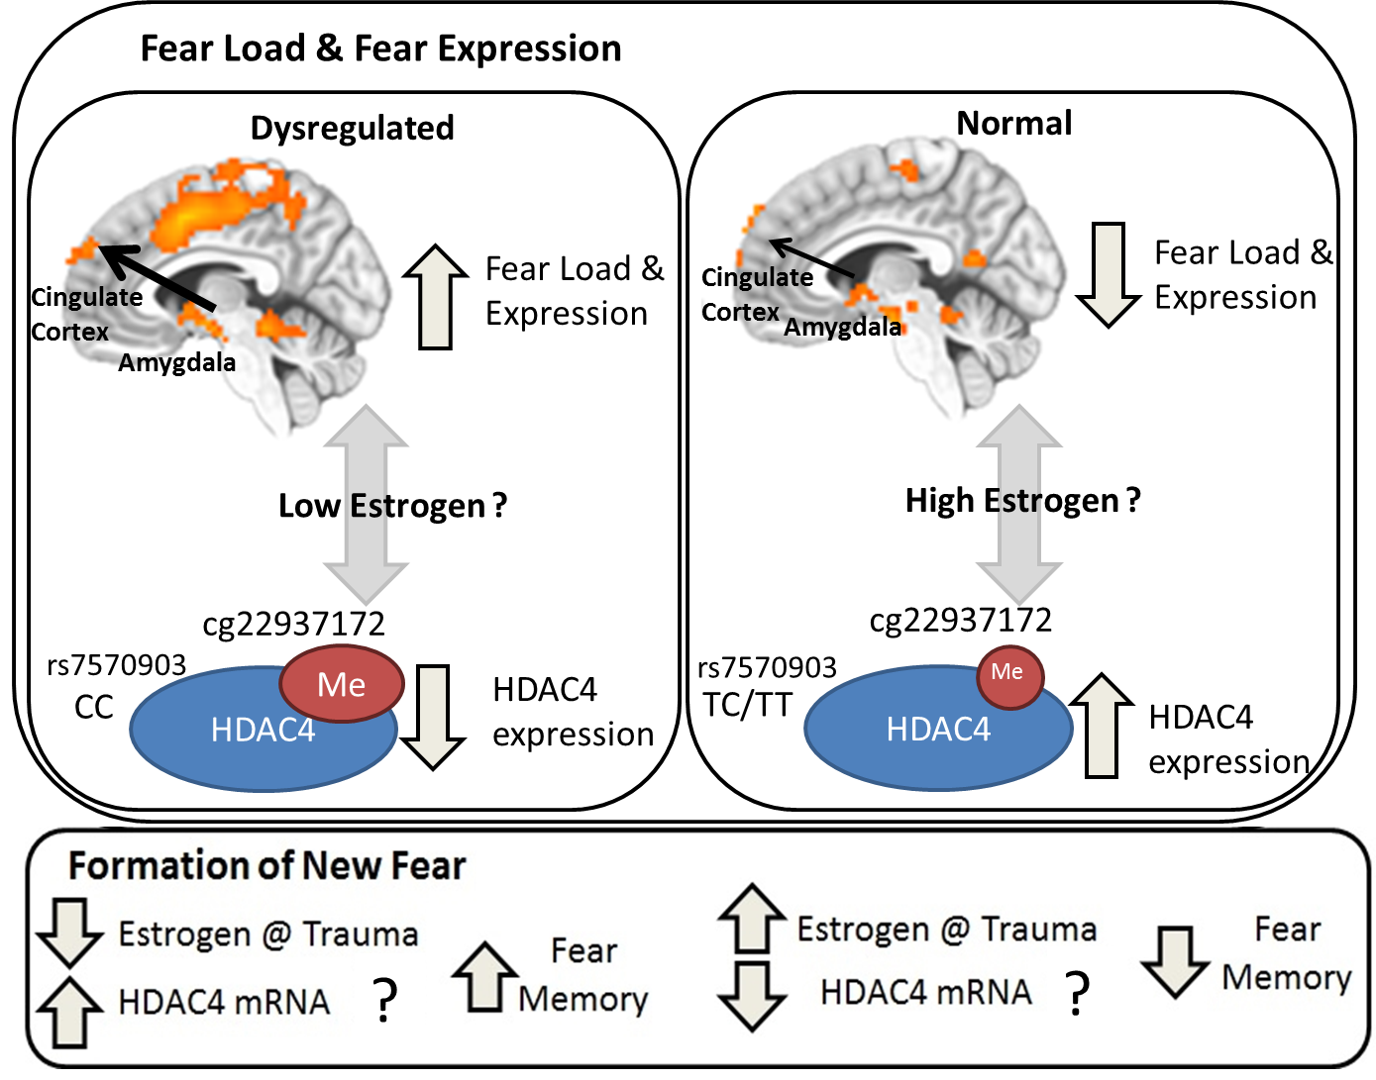
References

1. Jovanovic T, Norrholm SD, Blanding NQ, Davis M, Duncan E, Bradley B et al. Impaired fear inhibition is a biomarker of PTSD but not depression. Depress Anxiety 2010; 27(3): 244-251.

2. Norrholm SD, Vervliet B, Jovanovic T, Boshoven W, Myers KM, Davis M et al. Timing of extinction relative to acquisition: a parametric analysis of fear extinction in humans. Behavioral neuroscience 2008; 122(5): 1016-1030.

3. Norrholm SD, Jovanovic T, Olin IW, Sands LA, Karapanou I, Bradley B et al. Fear extinction in traumatized civilians with posttraumatic stress disorder: relation to symptom severity. Biol Psychiatry 2011; 69(6): 556-563.

4. Heberlein KA, Hu X. Simultaneous acquisition of gradient-echo and asymmetric spin-echo for single-shot z-shim: Z-SAGA. Magnetic resonance in medicine 2004; 51(1): 212-216.

5. Cox RW. AFNI: software for analysis and visualization of functional magnetic resonance neuroimages. Computers and biomedical research 1996; 29(3): 162-173.

6. Smith SM, Jenkinson M, Woolrich MW, Beckmann CF, Behrens TEJ, Johansen-Berg H et al. Advances in functional and structural MR image analysis and implementation as FSL. NeuroImage 2004; 23 Suppl 1: S208-219.

7. Jo HJ, Gotts SJ, Reynolds RC, Bandettini PA, Martin A, Cox RW et al. Effective Preprocessing Procedures Virtually Eliminate Distance-Dependent Motion Artifacts in Resting State FMRI. Journal of applied mathematics 2013; 2013: 1-9.

8. Jo HJ, Saad ZS, Simmons WK, Milbury LA, Cox RW. Mapping sources of correlation in resting state FMRI, with artifact detection and removal. NeuroImage 2010; 52(2): 571-582.

9. Greve DN, Fischl B. Accurate and robust brain image alignment using boundary-based registration. NeuroImage 2009; 48(1): 63-72.

10. Tzourio-Mazoyer N, Landeau B, Papathanassiou D, Crivello F, Etard O, Delcroix N et al. Automated anatomical labeling of activations in SPM using a macroscopic anatomical parcellation of the MNI MRI single-subject brain. NeuroImage 2002; 15(1): 273-289.

11. Power JD, Barnes KA, Snyder AZ, Schlaggar BL, Petersen SE. Spurious but systematic correlations in functional connectivity MRI networks arise from subject motion. NeuroImage 2012; 59(3): 2142-2154.

12. Mehta D, Klengel T, Conneely KN, Smith AK, Altmann A, Pace TW et al. Childhood maltreatment is associated with distinct genomic and epigenetic profiles in posttraumatic stress disorder. Proc Natl Acad Sci U S A 2013; 110(20): 8302-8307.

13. Barfield R, Kilaru V, Smith A, Conneely K. CpGassoc: An R function for analysis of DNA methylation microarray data. Bioinformatics 2012; in press.

14. Chen YA, Lemire M, Choufani S, Butcher DT, Grafodatskaya D, Zanke BW et al. Discovery of cross-reactive probes and polymorphic CpGs in the Illumina Infinium HumanMethylation450 microarray. Epigenetics 2013; 8(2): 203-209.

15. Teschendorff AE, Marabita F, Lechner M, Bartlett T, Tegner J, Gomez-Cabrero D et al. A beta-mixture quantile normalization method for correcting probe design bias in Illumina Infinium 450 k DNA methylation data. Bioinformatics 2013; 29(2): 189-196.

16. Houseman EA, Accomando WP, Koestler DC, Christensen BC, Marsit CJ, Nelson HH et al. DNA methylation arrays as surrogate measures of cell mixture distribution. BMC Bioinformatics 2012; 13: 86.

17. Reinius LE, Acevedo N, Joerink M, Pershagen G, Dahlen SE, Greco D et al. Differential DNA methylation in purified human blood cells: implications for cell lineage and studies on disease susceptibility. PLoS One 2012; 7(7): e41361.

18. Smith AK, Kilaru V, Klengel T, Mercer KB, Bradley B, Conneely KN et al. DNA extracted from saliva for methylation studies of psychiatric traits: evidence tissue specificity and relatedness to brain. Am J Med Genet B Neuropsychiatr Genet 2015; 168B(1): 36-44.

19. Sun YV, Smith AK, Conneely KN, Chang Q, Li W, Lazarus A et al. Epigenomic association analysis identifies smoking-related DNA methylation sites in African Americans. Hum Genet 2013; 132(9): 1027-1037.

20. Li Y, Willer CJ, Ding J, Scheet P, Abecasis GR. MaCH: using sequence and genotype data to estimate haplotypes and unobserved genotypes. Genet Epidemiol 2010; 34(8): 816-834.

21. Mecham BH, Nelson PS, Storey JD. Supervised normalization of microarrays. Bioinformatics 2010; 26(10): 1308-1315.

22. Genomes Project C, Abecasis GR, Auton A, Brooks LD, DePristo MA, Durbin RM et al. An integrated map of genetic variation from 1,092 human genomes. Nature 2012; 491(7422): 56-65.

23. McLean AC, Valenzuela N, Fai S, Bennett SA. Performing vaginal lavage, crystal violet staining, and vaginal cytological evaluation for mouse estrous cycle staging identification. J Vis Exp 2012; (67): e4389.

24. Caligioni CS. Assessing reproductive status/stages in mice. Curr Protoc Neurosci 2009; Appendix 4: Appendix 4I.

