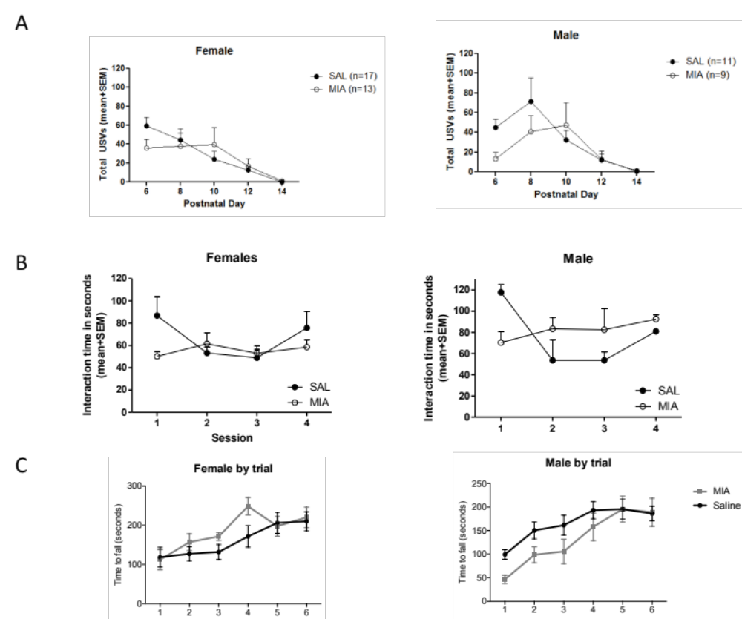

Supplemental Figure 1: (A) Both female and male MIA offspring have altered USVs. For the mice in main figure 1 for which the sex was known we have compared for sex effects. There was no main effect of sex F(1,46)=0.006, p=0.940, day x sex F(4,43)=1.427, p=0.241, and sex x condition interactions F(1,46)=0.418, p=0.521. (B) Both male and female MIA offspring displayed reduced social interaction. There was no significant main effect of sex F(1,14)=3.542, p=0.081, session x sex and F(3,12)=0.400, p=0.756 and sex x prenatal condition interactions F(1,14)=0.674, p=0.425. (C) No difference in the effect of MIA on rotarod in males and females. For the six-trial test (days 1 and 2), the four groups did not reveal difference in motor learning, as repeated measures ANOVA showed a significant main effect of Trial, F(3.310, 132.381) = 29.132, p < 0.0001, however, no significant main effect of prenatal condition, F(1, 40) = 0.065, p = 0.800, Sex, F(1, 40) = 2.135, p = 0.152, the sex × prenatal condition interaction, F(1, 40) = 2.758, p = 0.105, the trial × prenatal condition interaction, F(3.310, 132.381) = 1.088, p = 0.360, the trial × sex, F(3.310, 132.381) = 0.641, p = 0.669, nor the trial × sex × prenatal condition interaction, F(3.310, 132.381) = 2.266, p = 0.078.

