Supplementary Information for

Identification of cytotoxic T cells and their T cell receptor sequences targeting COVID-19 using MHC class I-binding peptides

Tetsuro Hikichi,* Michiko Sakamoto, Makiko Harada, Maki Saito, Yuka Yamane, Kimihisa Tokumura, Yusuke Nakamura
*Corresponding author. Email: t-hikichi@oncotherapy.co.jp

This file includes:
Fig. S1. Identification of HLA-A*02:06-binding peptides derived from SARS-CoV-2
Fig. S2. Establishment of peptide-specific CTL clones
Fig. S3. Locations of epitope peptides identified in this study, corresponding to SARS-CoV-2 viral proteins
Table S1. List of SARS-CoV-2-derived peptide sequences and their homology with other human coronaviruses
Table S2. List of mutations of SARS-CoV-2 omicron variant.

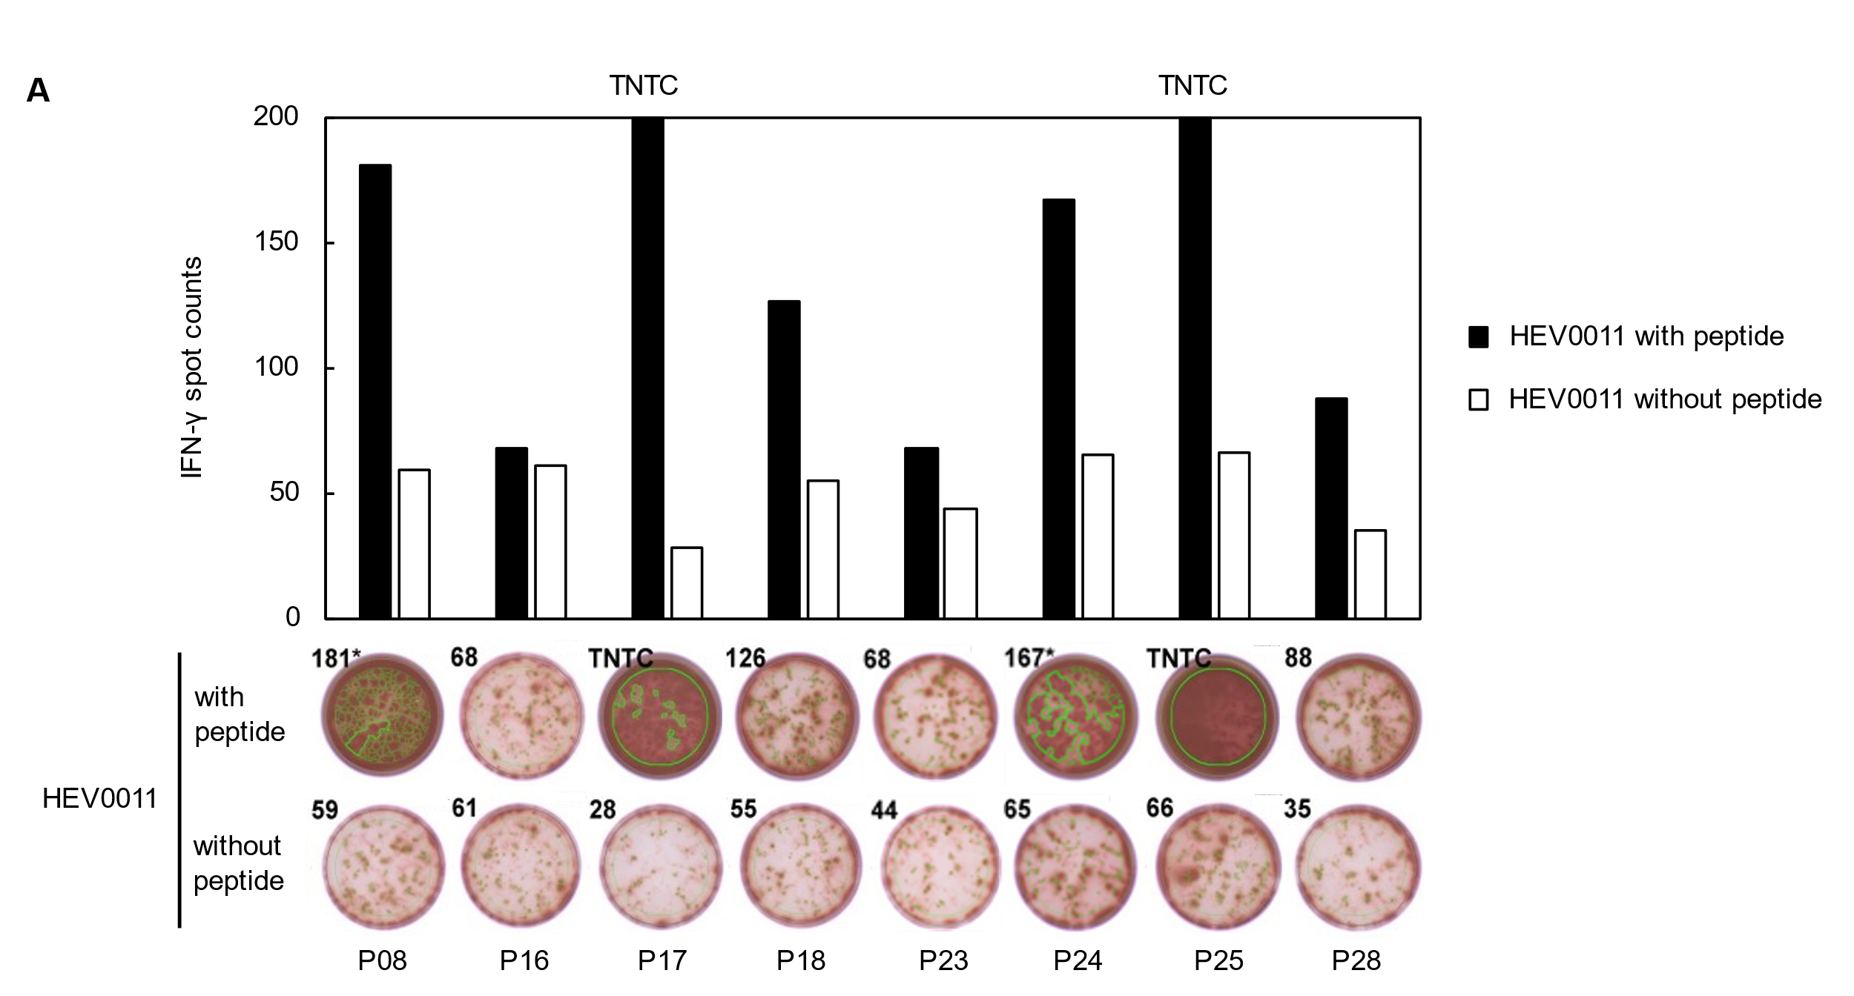
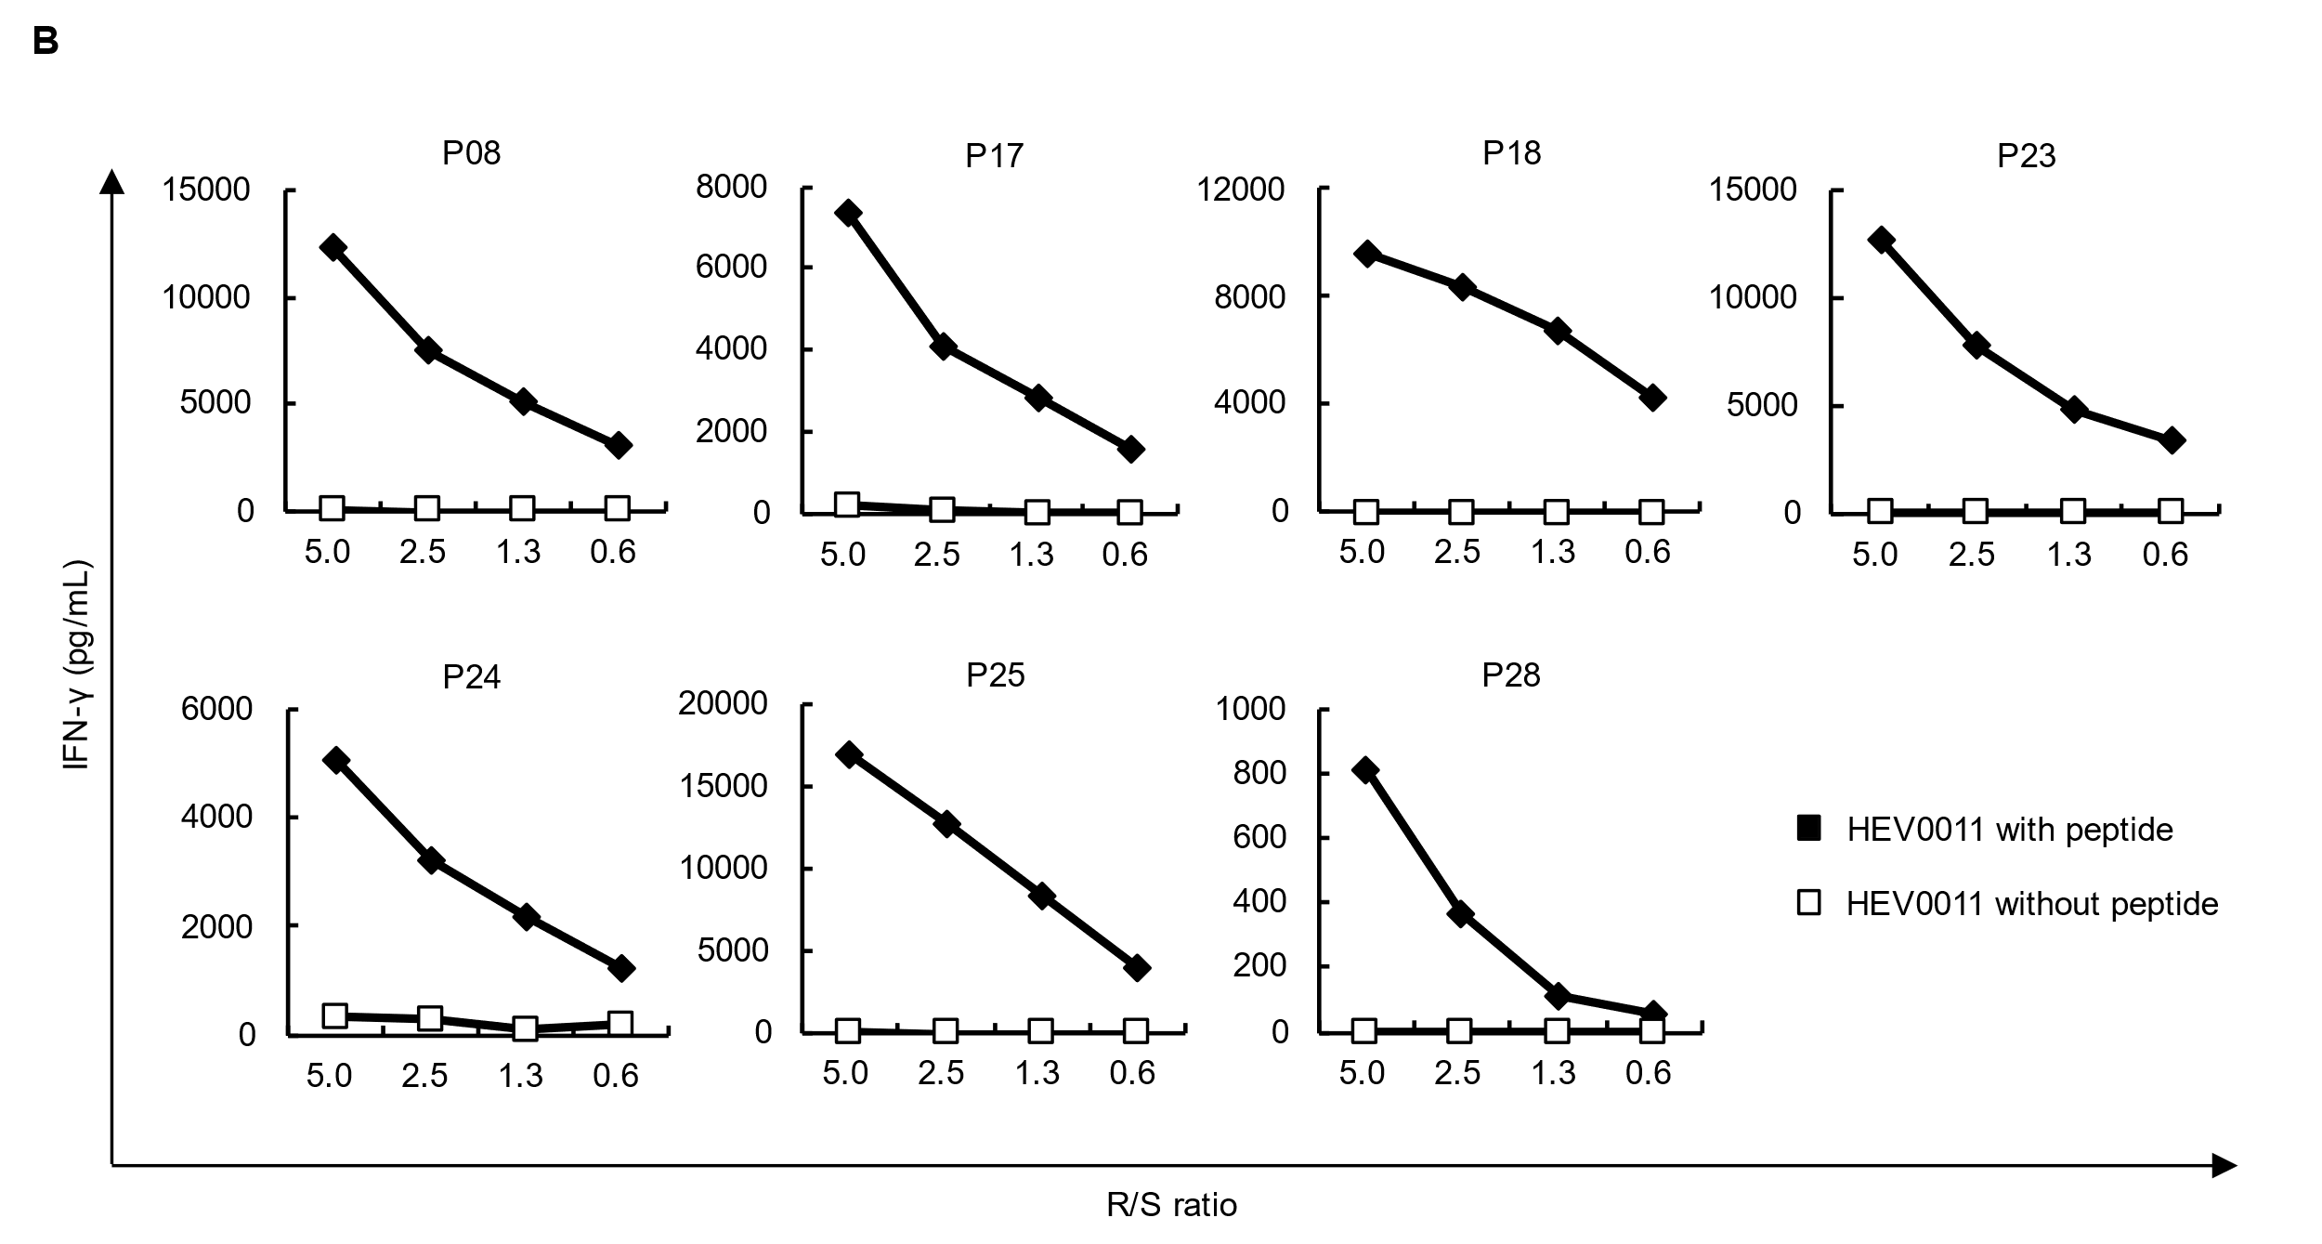
Fig. S1. Identification of HLA-A*02:06-binding peptides derived from SARS-CoV-2. (A) IFN-γ ELISPOT assay was performed after in vitro CTL induction. CD8⁺ T cells and HLA-A*02:06-positive HEV0011 cells pulsed with each peptide were co-cultured overnight. HEV0011 cells without the peptide were used as negative control. Bars represent the number of IFN-γ spots. CD8⁺ T cell responses were judged as positive when the number of IFN-γ spots were 1.5 times or higher than the negative control. In this study, spot counts higher than 200 are demonstrated as “too numerous to count (TNTC)”. (B) To confirm the response of CTLs to SARS-CoV-2-derived peptides, IFN-γ ELISA was performed. CTLs (Responders) were co-cultured overnight with HEV0011 cells (Stimulators) pulsed with or without the peptide at the indicated ratio of Responders to Stimulators (R/S ratio). IFN-γ secretion was measured by ELISA. CTLs that revealed the peptide-specific IFN-γ secretion for seven peptides are shown. Similar results were obtained in independent experiments using three CTLs in the respective peptides.

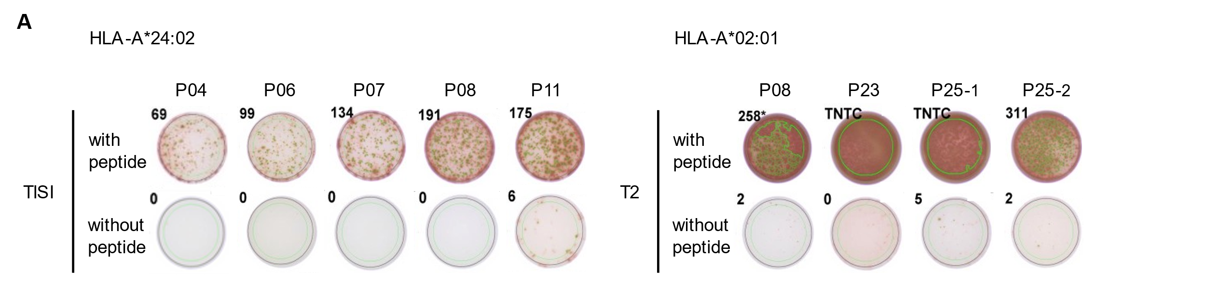
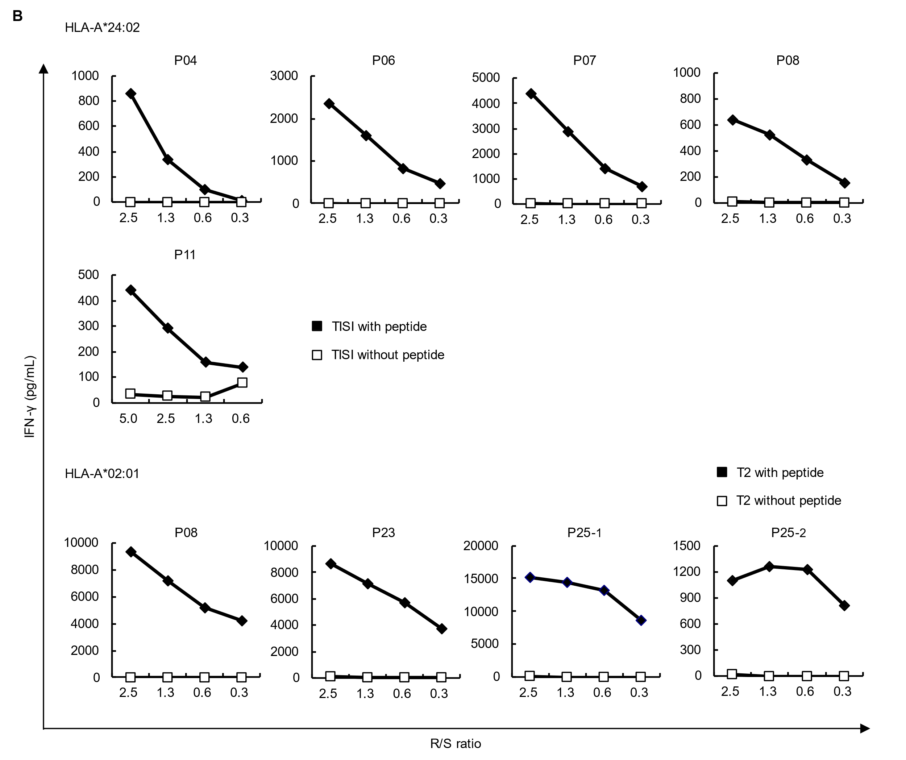
Fig. S2. Establishment of peptide-specific CTL clones. SARS-CoV-2-derived peptide-specific CTL clones were established from HLA-A*24:02- or HLA-A*02:01-positive donor-derived PBMCs. After in vitro CTL induction, CD8⁺ T cells were diluted to 0.5 cell per well in 96-well round-bottom plates (limiting dilution) and further cultured. (A) Peptide-specific CTL clones were screened by an IFN-γ ELISPOT assay after limiting dilution. (B) CTL clones revealing SARS-CoV-2-derived peptide-specific IFN-γ secretion in an ELISA after expansion culture are shown. We established two CTL clones that recognize P25.

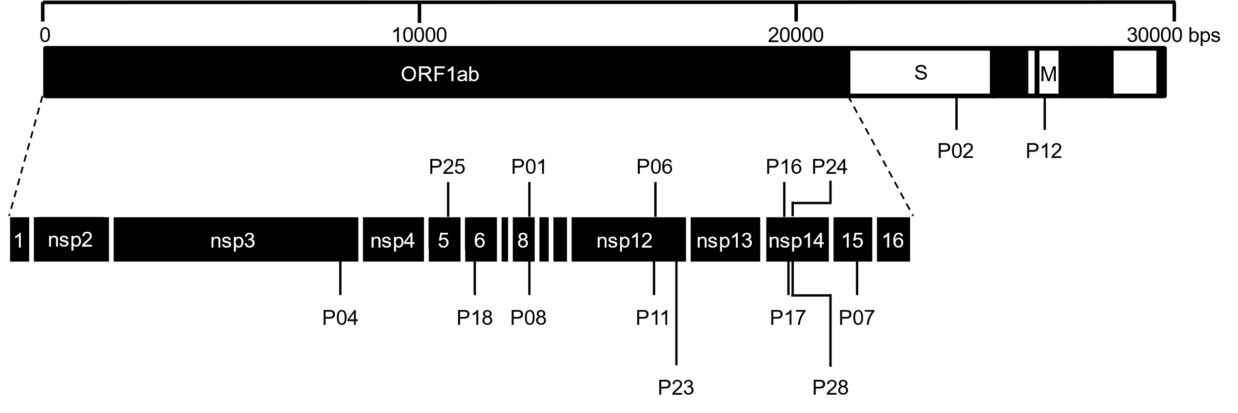
Fig. S3. Locations of epitope peptides identified in this study, corresponding to SARS-CoV-2 viral proteins. Abbreviations: S, spike protein; M, membrane glycoprotein; nsp, nonstructural protein.

Table S1. List of SARS-CoV-2-derived peptide sequences and their homology with other human coronaviruses.
Coronavirus | Amino acid sequence in peptide
SARS-CoV-2 | YYSQLMCQPI (P04) | AYANSVFNI (P06) | LWLLWPVTL (P12)
SARS-CoV | YYSQLMCQPI (P04) | AYANSVFNI (P06) | LWLLWPVTL (P12)
MERS-CoV | - | AYANSVFNI (P06) | -
HCoV-229E | - | AYANSVFNI (P06) | -
HCoV-NL63 | - | - | -
HCoV-HKU1 | - | - | -
HCoV-OC43 | - | - | -
Minus (-) means no significant homology (amino acid sequence identity is less than 100%).

Table S2. List of mutations of SARS-CoV-2 omicron variant.
Protein | Mutation | MHC class I-binding peptides
Protein | Mutation | P01 | P02 | P04 | P06 | P07 | P08 | P11 | P12 | P16 | P17 | P18 | P23 | P24 | P25 | P28
ORF1ab polyprotein | R24C | - | - | - | - | - | - | - | - | - | - | - | - | - | - | -
ORF1ab polyprotein | 82-86 del | - | - | - | - | - | - | - | - | - | - | - | - | - | - | -
ORF1ab polyprotein | G112S | - | - | - | - | - | - | - | - | - | - | - | - | - | - | -
ORF1ab polyprotein | 141-143 del | - | - | - | - | - | - | - | - | - | - | - | - | - | - | -
ORF1ab polyprotein | S142L | - | - | - | - | - | - | - | - | - | - | - | - | - | - | -
ORF1ab polyprotein | H374Y | - | - | - | - | - | - | - | - | - | - | - | - | - | - | -
ORF1ab polyprotein | K564N | - | - | - | - | - | - | - | - | - | - | - | - | - | - | -
ORF1ab polyprotein | G697R | - | - | - | - | - | - | - | - | - | - | - | - | - | - | -
ORF1ab polyprotein | A735T | - | - | - | - | - | - | - | - | - | - | - | - | - | - | -
ORF1ab polyprotein | K856R | - | - | - | - | - | - | - | - | - | - | - | - | - | - | -
ORF1ab polyprotein | Y947H | - | - | - | - | - | - | - | - | - | - | - | - | - | - | -
ORF1ab polyprotein | D983G | - | - | - | - | - | - | - | - | - | - | - | - | - | - | -
ORF1ab polyprotein | T999I | - | - | - | - | - | - | - | - | - | - | - | - | - | - | -
ORF1ab polyprotein | T1004I | - | - | - | - | - | - | - | - | - | - | - | - | - | - | -
ORF1ab polyprotein | L1130F | - | - | - | - | - | - | - | - | - | - | - | - | - | - | -
ORF1ab polyprotein | P1147S | - | - | - | - | - | - | - | - | - | - | - | - | - | - | -
ORF1ab polyprotein | M1193V | - | - | - | - | - | - | - | - | - | - | - | - | - | - | -
ORF1ab polyprotein | I1203T | - | - | - | - | - | - | - | - | - | - | - | - | - | - | -
ORF1ab polyprotein | A1352V | - | - | - | - | - | - | - | - | - | - | - | - | - | - | -
ORF1ab polyprotein | R1628H | - | - | - | - | - | - | - | - | - | - | - | - | - | - | -
ORF1ab polyprotein | P1786L | - | - | - | - | - | - | - | - | - | - | - | - | - | - | -
ORF1ab polyprotein | P1803S | - | - | - | - | - | - | - | - | - | - | - | - | - | - | -
ORF1ab polyprotein | T1822I | - | - | - | - | - | - | - | - | - | - | - | - | - | - | -
ORF1ab polyprotein | A1824V | - | - | - | - | - | - | - | - | - | - | - | - | - | - | -
ORF1ab polyprotein | L1853F | - | - | - | - | - | - | - | - | - | - | - | - | - | - | -
ORF1ab polyprotein | V1887I | - | - | - | - | - | - | - | - | - | - | - | - | - | - | -
ORF1ab polyprotein | S2083I | - | - | - | - | - | - | - | - | - | - | - | - | - | - | -
ORF1ab polyprotein | 2084 del | - | - | - | - | - | - | - | - | - | - | - | - | - | - | -
ORF1ab polyprotein | T2152I | - | - | - | - | - | - | - | - | - | - | - | - | - | - | -
ORF1ab polyprotein | S2285F | - | - | - | - | - | - | - | - | - | - | - | - | - | - | -
ORF1ab polyprotein | S2488F | - | - | - | - | - | - | - | - | - | - | - | - | - | - | -
ORF1ab polyprotein | A2710T | - | - | - | - | - | - | - | - | - | - | - | - | - | - | -
ORF1ab polyprotein | M2796T | - | - | - | - | - | - | - | - | - | - | - | - | - | - | -
ORF1ab polyprotein | V2857A | - | - | - | - | - | - | - | - | - | - | - | - | - | - | -
ORF1ab polyprotein | T3255I | - | - | - | - | - | - | - | - | - | - | - | - | - | - | -
ORF1ab polyprotein | V3261I | - | - | - | - | - | - | - | - | - | - | - | - | - | - | -
ORF1ab polyprotein | P3395H | - | - | - | - | - | - | - | - | - | - | - | - | - | - | -
ORF1ab polyprotein | P3395Y | - | - | - | - | - | - | - | - | - | - | - | - | - | - | -
ORF1ab polyprotein | L3606F | - | - | - | - | - | - | - | - | - | - | - | - | - | - | -
ORF1ab polyprotein | 3674-3676 del | - | - | - | - | - | - | - | - | - | - | - | - | - | - | -
ORF1ab polyprotein | 3674-3675 del | - | - | - | - | - | - | - | - | - | - | - | - | - | - | -
ORF1ab polyprotein | 3675-3676 del | - | - | - | - | - | - | - | - | - | - | - | - | - | - | -
ORF1ab polyprotein | I3758V | - | - | - | - | - | - | - | - | - | - | - | - | - | - | -
ORF1ab polyprotein | V3917I | - | - | - | - | - | - | - | - | - | - | - | - | - | - | -
ORF1ab polyprotein | Q4015R | - | - | - | - | - | - | - | - | - | - | - | - | - | - | -
ORF1ab polyprotein | T4158I | - | - | - | - | - | - | - | - | - | - | - | - | - | - | -
ORF1ab polyprotein | T4174I | - | - | - | - | - | - | - | - | - | - | - | - | - | - | -
ORF1ab polyprotein | G4178C | - | - | - | - | - | - | - | - | - | - | - | - | - | - | -
ORF1ab polyprotein | D4200A | - | - | - | - | - | - | - | - | - | - | - | - | - | - | -
ORF1ab polyprotein | T4249I | - | - | - | - | - | - | - | - | - | - | - | - | - | - | -
ORF1ab polyprotein | G4436S | - | - | - | - | - | - | - | - | - | - | - | - | - | - | -
ORF1ab polyprotein | D4545Y | - | - | - | - | - | - | - | - | - | - | - | - | - | - | -
ORF1ab polyprotein | I4615V | - | - | - | - | - | - | - | - | - | - | - | - | - | - | -
ORF1ab polyprotein | T4618M | - | - | - | - | - | - | - | - | - | - | - | - | - | - | -
ORF1ab polyprotein | P4715L | - | - | - | - | - | - | - | - | - | - | - | - | - | - | -
ORF1ab polyprotein | F5086Y | - | - | - | ● | - | - | ● | - | - | - | - | - | - | - | -
ORF1ab polyprotein | Q5267R | - | - | - | - | - | - | - | - | - | - | - | - | - | - | -
ORF1ab polyprotein | Y5593C | - | - | - | - | - | - | - | - | - | - | - | - | - | - | -
ORF1ab polyprotein | T5805M | - | - | - | - | - | - | - | - | - | - | - | - | - | - | -
ORF1ab polyprotein | A5877T | - | - | - | - | - | - | - | - | - | - | - | - | - | - | -
ORF1ab polyprotein | I5967V | - | - | - | - | - | - | - | - | - | - | - | - | - | - | -
ORF1ab polyprotein | P5968S | - | - | - | - | - | - | - | - | - | - | - | - | - | - | -
ORF1ab polyprotein | D6315E | - | - | - | - | - | - | - | - | - | - | - | - | - | - | -
ORF1ab polyprotein | R6316G | - | - | - | - | - | - | - | - | - | - | - | - | - | - | -
ORF1ab polyprotein | Y6317C | - | - | - | - | - | - | - | - | - | - | - | - | - | - | -
ORF1ab polyprotein | P6318H | - | - | - | - | - | - | - | - | - | - | - | - | - | - | -
ORF1ab polyprotein | Q6648H | - | - | - | - | - | - | - | - | - | - | - | - | - | - | -
ORF1ab polyprotein | A6669V | - | - | - | - | - | - | - | - | - | - | - | - | - | - | -
ORF1ab polyprotein | T6833I | - | - | - | - | - | - | - | - | - | - | - | - | - | - | -
ORF1ab polyprotein | L6924F | - | - | - | - | - | - | - | - | - | - | - | - | - | - | -
ORF1ab polyprotein | K6958R | - | - | - | - | - | - | - | - | - | - | - | - | - | - | -
ORF1ab polyprotein | P7013L | - | - | - | - | - | - | - | - | - | - | - | - | - | - | -
ORF1ab polyprotein | R7014N | - | - | - | - | - | - | - | - | - | - | - | - | - | - | -
ORF1ab polyprotein | S7089C | - | - | - | - | - | - | - | - | - | - | - | - | - | - | -
ORF1ab polyprotein | S7090R | - | - | - | - | - | - | - | - | - | - | - | - | - | - | -
ORF1ab polyprotein | D7091S | - | - | - | - | - | - | - | - | - | - | - | - | - | - | -
Spike protein | L5F | - | - | - | - | - | - | - | - | - | - | - | - | - | - | -
Spike protein | L18P | - | - | - | - | - | - | - | - | - | - | - | - | - | - | -
Spike protein | A67V | - | - | - | - | - | - | - | - | - | - | - | - | - | - | -
Spike protein | 69-70 del | - | - | - | - | - | - | - | - | - | - | - | - | - | - | -
Spike protein | 86 del | - | - | - | - | - | - | - | - | - | - | - | - | - | - | -
Spike protein | T95I | - | - | - | - | - | - | - | - | - | - | - | - | - | - | -
Spike protein | L141F | - | - | - | - | - | - | - | - | - | - | - | - | - | - | -
Spike protein | G142D | - | - | - | - | - | - | - | - | - | - | - | - | - | - | -
Spike protein | 142-144 del | - | - | - | - | - | - | - | - | - | - | - | - | - | - | -
Spike protein | 143-145 del | - | - | - | - | - | - | - | - | - | - | - | - | - | - | -
Spike protein | V193L | - | - | - | - | - | - | - | - | - | - | - | - | - | - | -
Spike protein | N211I | - | - | - | - | - | - | - | - | - | - | - | - | - | - | -
Spike protein | 211 del | - | - | - | - | - | - | - | - | - | - | - | - | - | - | -
Spike protein | 212 del | - | - | - | - | - | - | - | - | - | - | - | - | - | - | -
Spike protein | Q218H | - | - | - | - | - | - | - | - | - | - | - | - | - | - | -
Spike protein | E309Q | - | - | - | - | - | - | - | - | - | - | - | - | - | - | -
Spike protein | G339D | - | - | - | - | - | - | - | - | - | - | - | - | - | - | -
Spike protein | R346K | - | - | - | - | - | - | - | - | - | - | - | - | - | - | -
Spike protein | S371L | - | - | - | - | - | - | - | - | - | - | - | - | - | - | -
Spike protein | S373P | - | - | - | - | - | - | - | - | - | - | - | - | - | - | -
Spike protein | S375F | - | - | - | - | - | - | - | - | - | - | - | - | - | - | -
Spike protein | K417N | - | - | - | - | - | - | - | - | - | - | - | - | - | - | -
Spike protein | N440K | - | - | - | - | - | - | - | - | - | - | - | - | - | - | -
Spike protein | G446S | - | - | - | - | - | - | - | - | - | - | - | - | - | - | -
Spike protein | L452R | - | - | - | - | - | - | - | - | - | - | - | - | - | - | -
Spike protein | S477N | - | - | - | - | - | - | - | - | - | - | - | - | - | - | -
Spike protein | T478K | - | - | - | - | - | - | - | - | - | - | - | - | - | - | -
Spike protein | E484A | - | - | - | - | - | - | - | - | - | - | - | - | - | - | -
Spike protein | E484V | - | - | - | - | - | - | - | - | - | - | - | - | - | - | -
Spike protein | Q493R | - | - | - | - | - | - | - | - | - | - | - | - | - | - | -
Spike protein | G496S | - | - | - | - | - | - | - | - | - | - | - | - | - | - | -
Spike protein | Q498R | - | - | - | - | - | - | - | - | - | - | - | - | - | - | -
Spike protein | N501Y | - | - | - | - | - | - | - | - | - | - | - | - | - | - | -
Spike protein | Y505H | - | - | - | - | - | - | - | - | - | - | - | - | - | - | -
Spike protein | T547K | - | - | - | - | - | - | - | - | - | - | - | - | - | - | -
Spike protein | D614G | - | - | - | - | - | - | - | - | - | - | - | - | - | - | -
Spike protein | H655Y | - | - | - | - | - | - | - | - | - | - | - | - | - | - | -
Spike protein | N679K | - | - | - | - | - | - | - | - | - | - | - | - | - | - | -
Spike protein | P681H | - | - | - | - | - | - | - | - | - | - | - | - | - | - | -
Spike protein | P681R | - | - | - | - | - | - | - | - | - | - | - | - | - | - | -
Spike protein | A701V | - | - | - | - | - | - | - | - | - | - | - | - | - | - | -
Spike protein | N764K | - | - | - | - | - | - | - | - | - | - | - | - | - | - | -
Spike protein | D796Y | - | - | - | - | - | - | - | - | - | - | - | - | - | - | -
Spike protein | N856K | - | - | - | - | - | - | - | - | - | - | - | - | - | - | -
Spike protein | D950N | - | - | - | - | - | - | - | - | - | - | - | - | - | - | -
Spike protein | Q954H | - | - | - | - | - | - | - | - | - | - | - | - | - | - | -
Spike protein | N969K | - | - | - | - | - | - | - | - | - | - | - | - | - | - | -
Spike protein | L981F | - | - | - | - | - | - | - | - | - | - | - | - | - | - | -
Spike protein | I1081V | - | - | - | - | - | - | - | - | - | - | - | - | - | - | -
Spike protein | D1084E | - | - | - | - | - | - | - | - | - | - | - | - | - | - | -
Spike protein | V1264M | - | - | - | - | - | - | - | - | - | - | - | - | - | - | -
Membrane glycoprotein | D3G | - | - | - | - | - | - | - | - | - | - | - | - | - | - | -
Membrane glycoprotein | Q19E | - | - | - | - | - | - | - | - | - | - | - | - | - | - | -
Membrane glycoprotein | L29F | - | - | - | - | - | - | - | - | - | - | - | - | - | - | -
Membrane glycoprotein | A63T | - | - | - | - | - | - | - | - | - | - | - | - | - | - | -
Membrane glycoprotein | I82T | - | - | - | - | - | - | - | - | - | - | - | - | - | - | -
Data source is outbreak.info (https://outbreak.info/) based on data from GISAID database (https://www.gisaid.org/) as of 20th of December, 2021. Mutations, which are defined as nonsynonymous substitutions and deletions detected in 0.1% or more of 8,993 sequences of omicron variant (BA.1), are listed. Characteristic mutations that were detected in at least 75.0% of the sequences were marked in bold. Closed circle means that peptide sequence contains the mutation site in viral proteins of omicron variant. Minus (-) represents no mutation sites in the peptide sequence.

