Supplementary Table S1.
Scoring of systemic features according to the revised Ghent nosology.
 | Proband (III-8) | Father (II-4)
Wrist and thumb sign | 3 | 0
Pectus carinatum deformity | 1 (pectus excavatum) | 2
Hindfoot deformity | 1 (pes planus) | NA
Pneumothorax | 0 | 2
Dural ectasia | NA | NA
Protrusio acetabuli | 0 | NA
Reduced US/LS and increased arm/height and no severe scoliosis | 0 | 0
Scoliosis or thoracolumbar kyphosis | 1 | 0
Reduced elbow extension | 0 | NA
Facial features | 1 | 1
Skin striae | 0 | 1
Myopia > 3 diopters | 1 (4 diopters) | 1 (9 diopters)
Mitral valve prolapse | 1 | NA
Total | 9 | 7
Maximum total: 20 points; score ≥ 7 indicates systemic involvement; NA, not assessed or not available; US/LS, upper segment/lower segment ratio.

Supplementary Figure S1
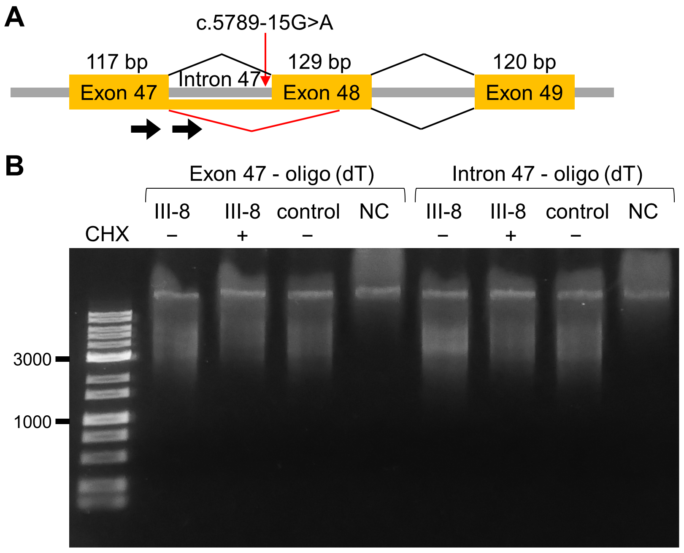
Reverse transcription polymerase chain reaction (RT-PCR) to confirm the possibility of the addition of poly adenylation adjacent to the intron 47. (A) Schematic presentation of aberrant splicing of FBN1. The two forward primers for RT-PCR are shown as solid arrows in exon 47 and intron 47. (B) The result of RT-PCR. RT-PCR was performed with two different primer sets: exon 47 and oligo(dT) primer, and intron 47 and oligo(dT) primer. No PCR amplicons were obtained, only non-specific bands. CHX, cycloheximide; NC, negative control.

