Supplementary information

Genetic Analysis of a Yayoi Individual from the Doigahama Site Provides Insights into the Origins of Immigrants to the Japanese Archipelago
Jonghyun Kim¹, Fuzuki Mizuno^{2, *}, Takayuki Matsushita³, Masami Matsushita³, Saki Aoto⁴, Koji Ishiya¹, Mami Kamio¹, Izumi Naka¹, Michiko Hayashi², Kunihiko Kurosaki², Shintaroh Ueda^{1, 2}, Jun Ohashi^{1, *}
1. Department of Biological Sciences, Graduate School of Science, The University of Tokyo, Tokyo, 113-0033, Japan.
2. Department of Legal Medicine, Toho University School of Medicine, Tokyo, 143-8540, Japan.
3. The Doigahama Site Anthropological Museum, Yamaguchi, 759-6121, Japan
4. Medical Genome Center, National Research Institute for Child Health and Development, Tokyo, 157-8535, Japan.

*To whom correspondence may be addressed:
Fuzuki Mizuno, Ph.D.
Department of Legal Medicine, Toho University School of Medicine, 5-21-16, Omori-Nishi, Ota-ku, Tokyo, 143-8540, Japan.
Email: fuzuki.mizuno@med.toho-u.ac.jp

Jun Ohashi, Ph.D.
Department of Biological Sciences, Graduate School of Science, The University of Tokyo, 7-3-1, Hongo, Bunkyo-ku, Tokyo, 113-0033, Japan.
Email: jun_ohashi@bs.s.u-tokyo.ac.jp
Table S1. A list of modern populations used in this study.
Regions | Populations (n=sample number)
Africa | BantuKenya(6), BantuSA(5), BantuSA_Herero(2), BantuSA_Ovambo(1), Biaka(19), Ju_hoan_North(5), Mandenka(17), Mbuti(10), Mozabite(22), Yoruba(21), Dinka(4), Esan(2), Gambian(2), Igbo(2), Khomani_San(2), Kongo(1), Lemande(2), Luhya(2), Luo(2), Masai(2), Mende(2), Saharawi(2), Somali(1)
West Eurasia | Adygei(13), Basque(21), BedouinA(25), BedouinB(19), Druze(39), French(25), Italian_North(19), Orcadian(15), Palestinian(35), Russian(24), Sardinian(27), Albanian(1), Armenian(2), Bulgarian(2), Chechen(1), Cretan(2), Czech(1), English(2), Estonian(2), Finnish(2), French(1), Georgian(2), Greek(2), Hungarian(2), Icelandic(2), Iranian(2), Jew_Iraqi(2), Jew_Yemenite(2), Jordanian(3), Lezgin(2), Norwegian(1), Polish(1), Russia_Abkhasian(2), Russia_NorthOssetian(2), Saami(2), Samaritan(1), Spanish(2), Tajik(2), Turkish(2)
Central South Asia | Balochi(20), Brahui(22), Burusho(22), Hazara(13), Kalash(21), Makrani(20), Pathan(17), Sindhi_Pakistan(14), Uyghur(10), Bengali(2), Brahmin(2), Irula(2), Kapu(2), Khonda_Dora(1), Kusunda(2), Madiga(2), Mala(2), Punjabi(3), Relli(2), Yadava(2)
Central Asia, Siberia | Yakut(20), Aleut(2), Altaian(1), Chukchi(1), Eskimo_Chaplin(1), Eskimo_Naukan(2), Eskimo_Sireniki(2), Even(2), Itelmen(1), Kyrgyz_Kyrgyzstan(2), Mansi(2), Tubalar(2), Ulchi(2)
East Asia | Cambodian(7), China_Lahu(7), Dai(9), Daur(8), Han(42), Hezhen(8), Japanese(28), Miao(10), Mongola(6), Naxi(7), Oroqen(9), She(10), Tu(10), Tujia(9), Xibo(7), Yi(10), Ami(2), Atayal(1), Burmese(2), Kinh(2), Korean(2), Naxi(1)
America | Karitiana(10), Mayan(18), Piapoco(6), Pima(11), Surui(5), Chane(1), Chipewyan(2), Cree(2), Mexico_Zapotec(2), Mixe(3), Mixtec(2), Nahua(1), Quechua(2)
Oceania | Nasioi(10), Papuan(14), Australian(2), Dusun(2), Hawaiian(1), Igorot(2), Maori(1)

Table S2. Information of ancient individuals used in this study.
Region (period) | Population name | Sample ID
Mainland of Japan (Jomon) | Japan_Shikoku_InitialJomon | JpKa6904
Mainland of Japan (Jomon) | Japan_Honshu_EarlyJomon_Funagara | JpFu1
Mainland of Japan (Jomon) | Japan_Honshu_EarlyJomon_Odake | JpOd274
Mainland of Japan (Jomon) | Japan_Honshu_EarlyJomon_Odake | JpOd6
Mainland of Japan (Jomon) | Japan_Honshu_EarlyJomon_Odake | JpOd181
Mainland of Japan (Jomon) | Japan_Honshu_EarlyJomon_Odake | JpOd282
Mainland of Japan (Jomon) | Japan_Honshu_MidLateJomon | JpKo2
Mainland of Japan (Jomon) | Japan_Honshu_MidLateJomon | JpKo13
Mainland of Japan (Jomon) | Japan_Shikoku_LateJomon | JpHi01
Mainland of Japan (Jomon) | Rokutsu_Jomon | I13882
Mainland of Japan (Jomon) | Rokutsu_Jomon | I13883
Mainland of Japan (Jomon) | Rokutsu_Jomon | I13884
Mainland of Japan (Jomon) | Rokutsu_Jomon | I13885
Mainland of Japan (Jomon) | Rokutsu_Jomon | I13886
Mainland of Japan (Jomon) | Funadomari_Jomon | Fun23
Mainland of Japan (Jomon) | Funadomari_Jomon | Fun5
Mainland of Japan (Jomon) | Ikawazu_Jomon | IK002
Mainland of Japan (Yayoi) | Doigahama_Yayoi | D1604
Mainland of Japan (Yayoi) | Japan_KumaNishioda_Yayoi | YAK002
Mainland of Japan (Yayoi) | Shimomotoyama_Yayoi | Shimomotoyama2
Mainland of Japan (Yayoi) | Shimomotoyama_Yayoi | Shimomotoyama3
Mainland of Japan (Kofun) | Japan_Honshu_Kofun | JpIw31
Mainland of Japan (Kofun) | Japan_Honshu_Kofun | JpIw32
Mainland of Japan (Kofun) | Japan_Honshu_Kofun | JpIw33
Ancient Ryukyu | Nagabaka_4000BP | NAG016
Ancient Ryukyu | Nagabaka_2800BP | NAG012
Ancient Ryukyu | Nagabaka_2800BP | NAG019
Ancient Ryukyu | Nagabaka_2800BP | NAG037
Ancient Ryukyu | Nagabaka_2800BP | NAG038
Ancient Ryukyu | Nagabaka_historic | NAG007
Ancient Ryukyu | Nagabaka_historic | NAG035
Ancient Ryukyu | Nagabaka_historic | NAG036
Ancient Ryukyu | Nagabaka_historic | NAG039
Korea | Korea_Yondaedo | TYD006
Korea | Korea_Yondaedo | TYD007
Korea | Korea_Ando | AND001
Korea | Korea_Ando | AND004
Korea | Korea_Changhang | GDI002
Korea | Korea_Changhang | GDI008
Korea | Korea_Yokchido | TYJ001
Korea | Korea_Taejungni | DAJ001
Korea | Korea_Gimhae_DaeseongDong | AKG_3421
Korea | Korea_Gimhae_DaeseongDong | AKG_10203
Korea | Korea_Gimhae_DaeseongDong | AKG_10204
Korea | Korea_Gimhae_DaeseongDong | AKG_10207
Korea | Korea_Gimhae_DaeseongDong | AKG_10209
Korea | Korea_Gimhae_DaeseongDong | AKG_10210
Korea | Korea_Gimhae_DaeseongDong | AKG_10218
Korea | Korea_Gimhae_YuhaRi | AKG_3420
Korea | Korean.ancient_Gunsan | GUC001
Korea | Korean.ancient_Gunsan | GUC002
Korea | Korean.ancient_Gunsan | GUC003
Korea | Korean.ancient_Gunsan | GUC004
Korea | Korean.ancient_Gunsan | GUC005
Korea | Korean.ancient_Gunsan | GUC007

Table S3. Number of mapped reads to sex chromosomes.
ID | X-chromosome | Y-chromosome | R_{Y} index | 95% CI
D1604 | 5,309,287 | 2,695 | 0.00051 | 0.00049-0.00053

Table S4. Summary of haploid genome calling using pileupcaller.
ID | Total Target Sites | Non Missing Calls | mean coverage of target sites
D1604 | 1150639 | 971776 | 2.085 x

Table S5. The models in which Z value of f4(Mbuti, Doigahama_Yayoi; Japanese or Korean, X) > -3.
Target | X | f4 | Z | nBABA | nABBA | nSNPs
Modern Korean | Modern Japanese | 0.000187 | 0.663 | 48874 | 48697 | 941715
Modern Korean | Japan_Honshu_Kofun | 0.000181 | 0.514 | 48917 | 48747 | 940838
Modern Korean | Japan_KumaNishioda_Yayoi | -0.001331 | -0.965 | 1161 | 1191 | 22911
Modern Korean | Korea_Ando | -0.000069 | -0.096 | 6225 | 6233 | 119841
Modern Korean | Korea_Gimhae_DaeseongDong | -0.000569 | -1.747 | 49098 | 49633 | 941664
Modern Korean | Korea_Gimhae_YuhaRi | -0.000518 | -1.079 | 46475 | 46940 | 898088
Modern Korean | Korean.ancient_Gunsan | -0.000282 | -0.707 | 40952 | 41177 | 796066
Modern Japanese | Modern Korean | -0.000187 | -0.663 | 48697 | 48874 | 941715
Modern Japanese | Japan_Honshu_Kofun | 0.000019 | 0.075 | 50056 | 50038 | 964163
Modern Japanese | Japan_KumaNishioda_Yayoi | -0.001850 | -1.484 | 1177 | 1220 | 23337
Modern Japanese | Korea_Ando | -0.000765 | -1.286 | 6245 | 6339 | 121926
Modern Japanese | Korea_Gimhae_YuhaRi | -0.000689 | -1.717 | 47692 | 48325 | 919666
Modern Japanese | Korean.ancient_Gunsan | -0.000428 | -1.440 | 41911 | 42258 | 812626

Table S6. The results of the f4 ratio test targeting Doigahama Yayoi.
Population | a=Modern Korean, b=East Asian |  |  | a=East Asian, b=Modern Korean
 | alpha | 1-alpha | SE | alpha | 1-alpha | SE
Ami | 1.238631 | -0.238631 | 0.072382 | 0.968314 | 0.031686 | 0.076369
Atayal | 1.209995 | -0.209995 | 0.090247 | 0.979587 | 0.020413 | 0.095206
Burmese | 2.726312 | -1.72631 | 0.325266 | 0.859635 | 0.140365 | 0.069661
Cambodian | 2.852454 | -1.85245 | 0.294429 | 0.818890 | 0.18111 | 0.060907
China_Lahu | 1.369675 | -0.369675 | 0.070892 | 0.904541 | 0.095459 | 0.056520
Dai | 1.274940 | -0.27494 | 0.063123 | 0.827373 | 0.172627 | 0.049468
Daur | 1.475406 | -0.475406 | 0.080952 | 0.995592 | 0.004408 | 0.044850
Han | 1.081213 | -0.081213 | 0.046930 | 0.896094 | 0.103906 | 0.037919
Hezhen | 1.379637 | -0.379637 | 0.072743 | 1.020386 | -0.020386 | 0.045709
Kinh | 1.281806 | -0.281806 | 0.077459 | 0.909492 | 0.090508 | 0.060913
Miao | 1.108948 | -0.108948 | 0.052526 | 0.867048 | 0.132952 | 0.043117
Mongola | 1.458288 | -0.458288 | 0.076877 | 0.958762 | 0.041238 | 0.045338
Naxi | 1.241008 | -0.241008 | 0.062607 | 0.882889 | 0.117111 | 0.042464
Oroqen | 1.588440 | -0.58844 | 0.086729 | 1.046531 | -0.046531 | 0.049848
She | 1.092731 | -0.092731 | 0.051736 | 0.954985 | 0.045015 | 0.044605
Thai | 2.102911 | -1.10291 | 0.195080 | 0.831584 | 0.168416 | 0.067221
Tu | 1.716581 | -0.716581 | 0.101780 | 0.903914 | 0.096086 | 0.039318
Tujia | 1.059241 | -0.059241 | 0.046679 | 0.882504 | 0.117496 | 0.040751
Xibo | 1.407177 | -0.407177 | 0.072443 | 0.970784 | 0.029216 | 0.043646
Yi | 1.231090 | -0.23109 | 0.057515 | 0.914960 | 0.08504 | 0.044185

Table S7. The result of qpAdm admixture modeling analysis for two-way admixture model.
Two-way admixture model (1: Jomon, 2: Han)
Target | P-value | c1 | c2 | c3 | SE1 | SE2 | SE3
Doigahama_Yayoi | 0.00385400732 | 0.170 | 0.830 | - | 0.038 | 0.038 | -
Japan_KumaNishioda_Yayoi | 0.105096888 | 0.305 | 0.695 | - | 0.110 | 0.110 | -
Shimomotoyama_Yayoi | 0.944799334 | 0.853 | 0.147 | - | 0.108 | 0.108 | -
Japan_Honshu_Kofun | 2.24898816e-08 | 0.152 | 0.848 | - | 0.023 | 0.023 | -
Modern Japanese | 2.48560586e-34 | 0.106 | 0.894 | - | 0.010 | 0.010 | -
Two-way admixture model (1: Jomon, 2: Modern Korean)
Target | P-value | c1 | c2 | c3 | SE1 | SE2 | SE3
Doigahama_Yayoi | 0.842802462 | 0.129 | 0.871 | - | 0.042 | 0.042 | -
Japan_KumaNishioda_Yayoi | 0.281292151 | 0.242 | 0.758 | - | 0.124 | 0.124 | -
Shimomotoyama_Yayoi | 0.905349491 | 0.866 | 0.134 | - | 0.120 | 0.120 | -
Japan_Honshu_Kofun | 0.159743651 | 0.121 | 0.879 | - | 0.029 | 0.029 | -
Modern Japanese | 0.0907712115 | 0.083 | 0.917 | - | 0.022 | 0.022 | -
The notation of ci (i=1 and 2) respectively indicates the admixture proportion from the i-th ancestry, and SEi indicates the standard error of ci.

Table S8. The result of qpAdm admixture modeling analysis for three-way admixture model.
Three-way admixture model (1: Jomon, 2: Han, and 3: China_HMMH_MN)
Target | P-value | c1 | c2 | c3 | SE1 | SE2 | SE3
Doigahama_Yayoi | 0.676729272 | -0.006 | 0.595 | 0.411 | 0.074 | 0.093 | 0.142
Japan_KumaNishioda_Yayoi | 0.363670302 | -1.463 | -0.686 | 3.149 | 7.928 | 5.197 | 13.086
Shimomotoyama_Yayoi | 0.996733416 | 1.094 | 0.228 | -0.323 | 0.238 | 0.166 | 0.255
Japan_Honshu_Kofun | 0.340903025 | -0.002 | 0.586 | 0.416 | 0.050 | 0.066 | 0.100
Modern Japanese | 0.389963923 | -0.016 | 0.682 | 0.334 | 0.025 | 0.035 | 0.051
Three-way admixture model (1: Jomon, 2: Modern Korean, and 3: China_HMMH_MN)
Target | P-value | c1 | c2 | c3 | SE1 | SE2 | SE3
Doigahama_Yayoi | 0.940134142 | 0.083 | 0.833 | 0.084 | 0.081 | 0.124 | 0.181
Japan_KumaNishioda_Yayoi | 0.643120491 | 2.294 | 2.184 | -3.478 | 7.712 | 6.259 | 13.930
Shimomotoyama_Yayoi | 0.99260954 | 1.154 | 0.231 | -0.386 | 0.246 | 0.186 | 0.299
Japan_Honshu_Kofun | 0.133146288 | 0.083 | 0.782 | 0.135 | 0.073 | 0.117 | 0.179
Modern Japanese | 0.0970374294 | 0.100 | 0.948 | -0.048 | 0.063 | 0.110 | 0.166
The notation of ci (i=1, 2, and 3) respectively indicates the admixture proportion from the i-th ancestry, and SEi indicates the standard error of ci.

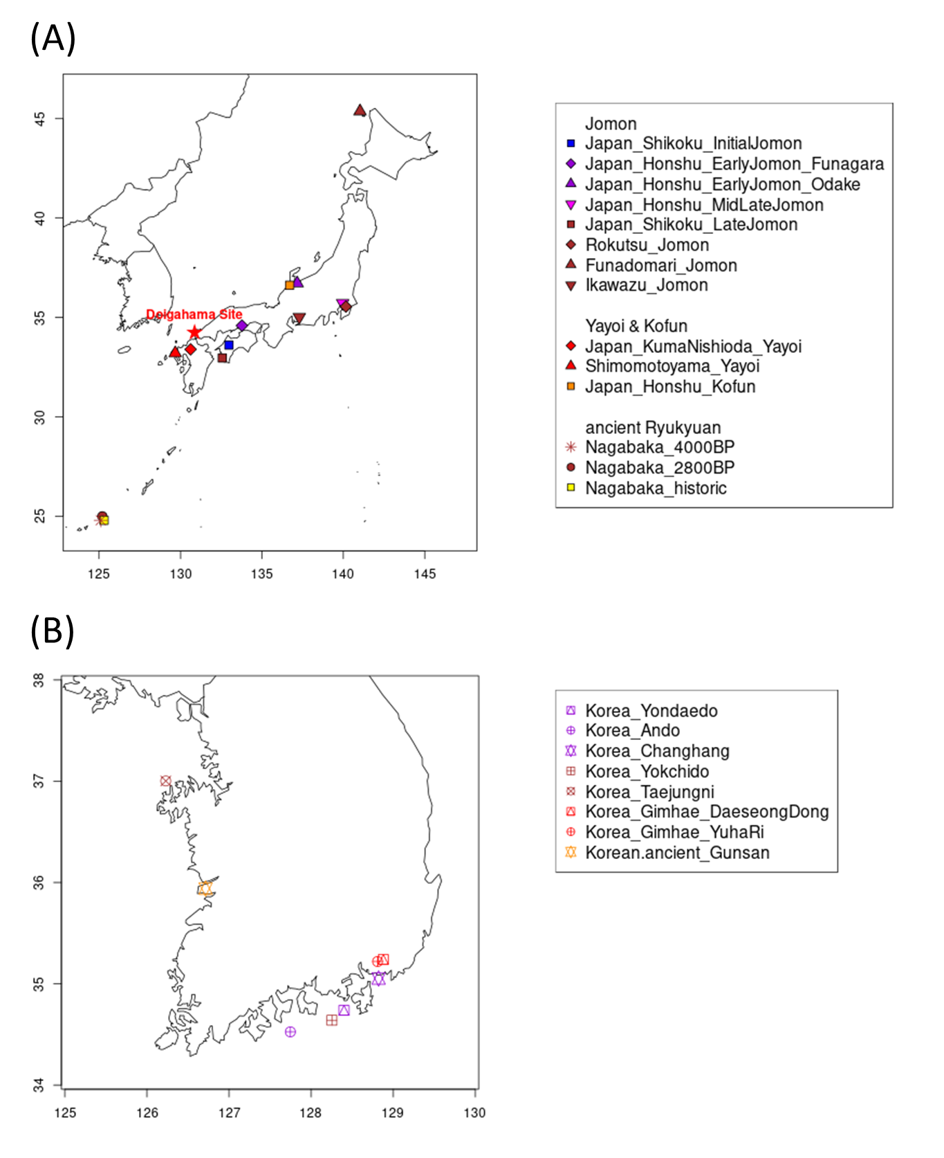
Figure S1. The location of Doigahama site.
We illustrated the location of the Doigahama site and other main archaeological sites where the ancient samples in Table S2 were excavated. The individuals are color-coded as follows: the Initial Jomon period (8500-5000 BC) in blue, the Early Jomon period (5000-3520 BC) in purple, the Middle Jomon period (3520-2470 BC) in pink, the Late-Final Jomon period (2470-500 BC) in brown, Yayoi period (500 BC-300 AC) in red, the Kofun period (300-538 AC) in orange, and Edo period (1603-1868 AC) in yellow.
(A) archaeological sites in mainland Japan and Ryukyu (B) archaeological sites in South Korea
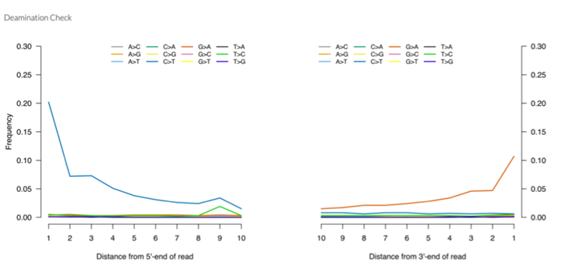
Figure S2. The deamination pattern of the double stranded library of D1604.
The mismatch frequency is relative to the reference as a function of read position; C to T in blue and G to A in red.

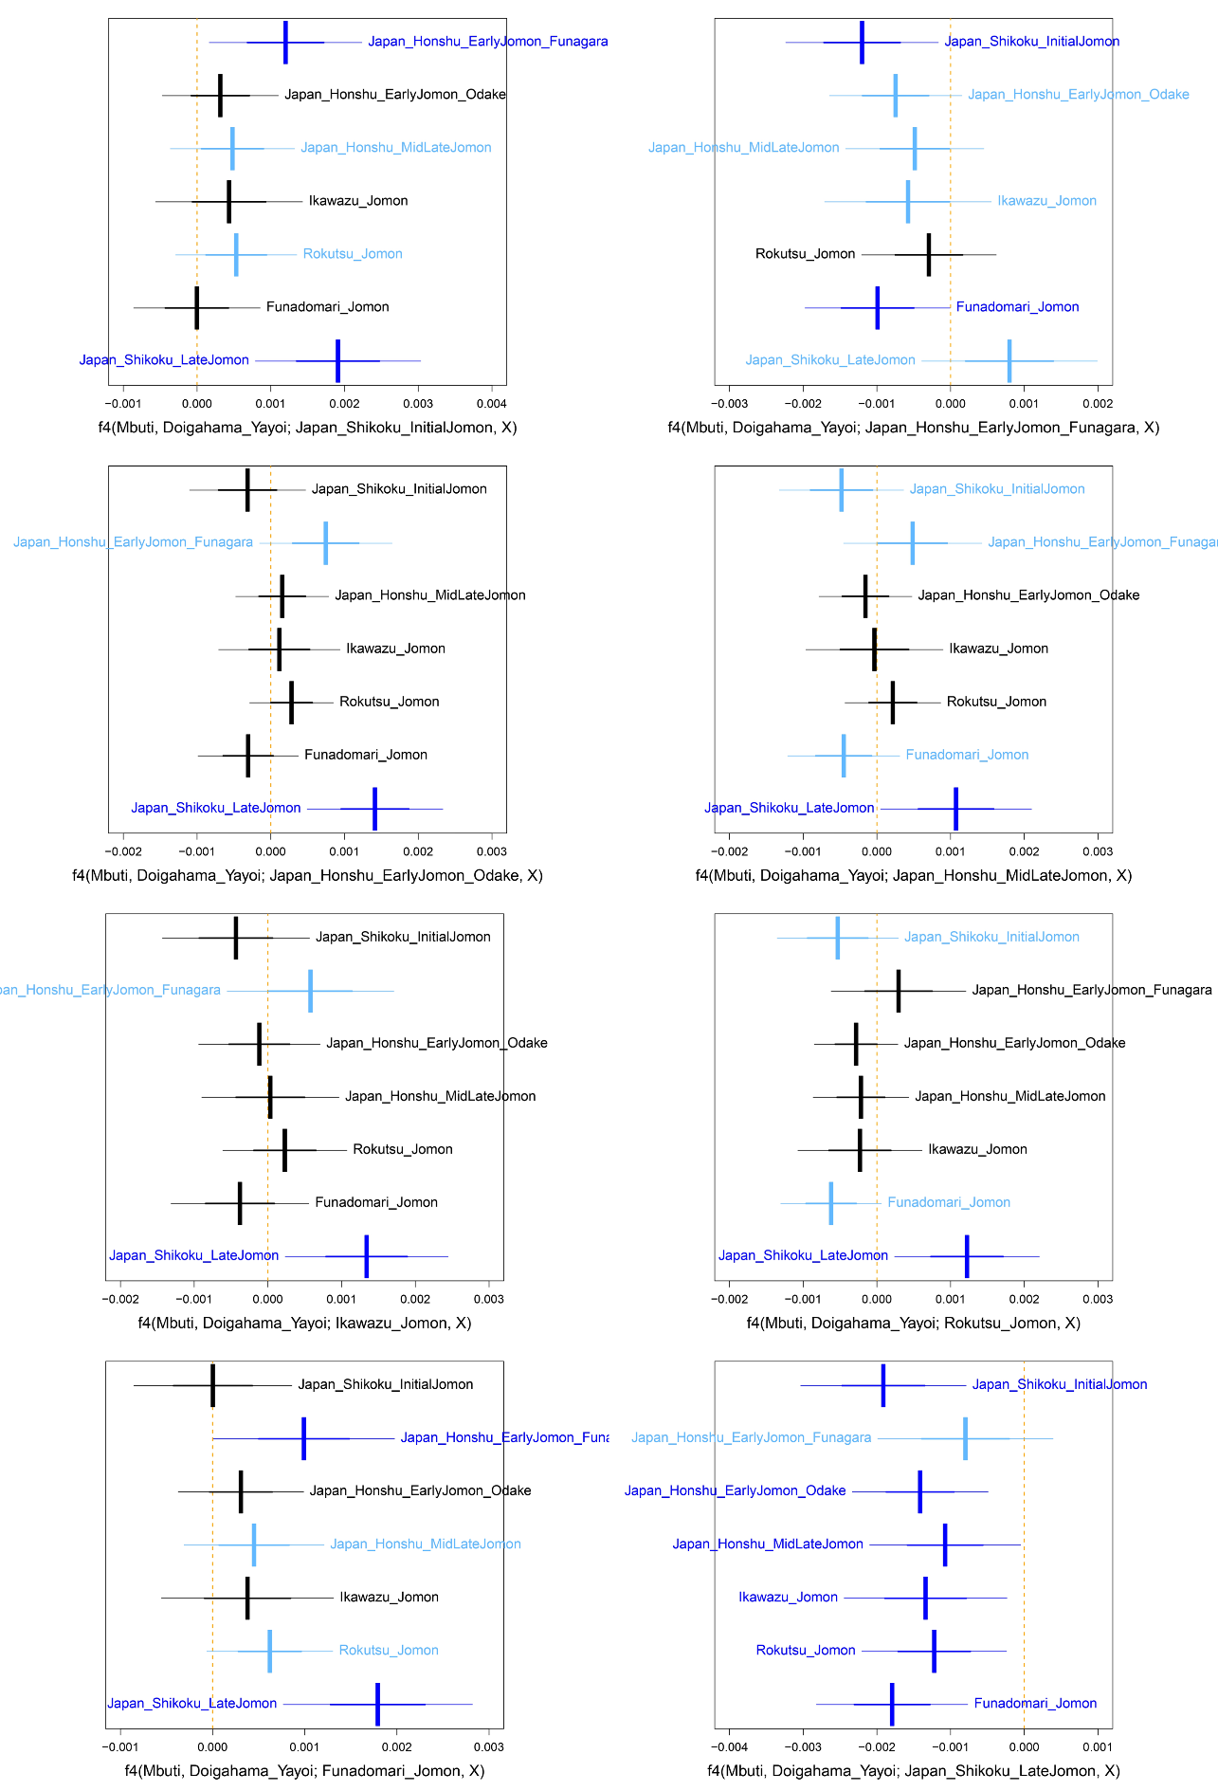
Figure S3. f4(Mbuti, Doigahama_Yayoi; Jomon1, Jomon2).
The thick error bars represent the range of |Z|≤1, and the thin error bars represent the range of |Z|≤2. The cases with |Z|≤1, 1< |Z|< 2, and |Z|≥2 are presented in black, sky blue, and deep blue, respectively.
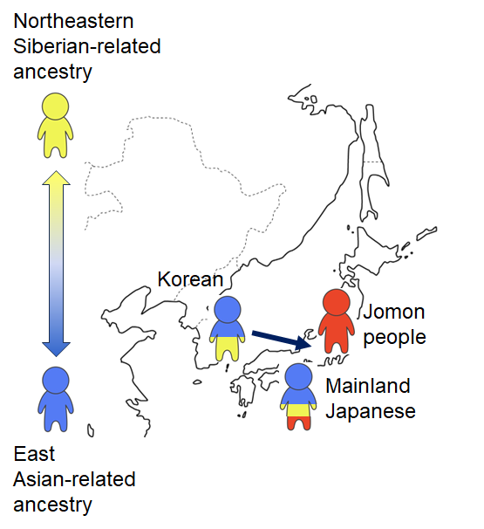
Figure S4. Two-way admixture model proposed in this study.
The Korean population, possessing both East Asian-related and Northeastern Siberian-related ancestries, migrated from the Korean Peninsula to the Japanese Archipelago, where they admixed with Jomon people. This pattern of migration and admixture continued from the Yayoi to the Kofun period. Modern Mainland Japanese are the descendants of this admixed population.
REFERENCE
- Cooke NP, Mattiangeli V, Cassidy LM, Okazaki K, Stokes CA, Onbe S, et al. Ancient genomics reveals tripartite origins of Japanese populations. Science advances. 2021;7(38):eabh2419.
- Gakuhari T, Nakagome S, Rasmussen S, Allentoft ME, Sato T, Korneliussen T, et al. Ancient Jomon genome sequence analysis sheds light on migration patterns of early East Asian populations. Communications biology. 2020;3(1):437.
- Gelabert P, Blazyte A, Chang Y, Fernandes DM, Jeon S, Hong JG, et al. Northeastern Asian and Jomon-related genetic structure in the Three Kingdoms period of Gimhae, Korea. Current Biology. 2022;32(15):3232-3244.
- Kanzawa-Kiriyama H, Jinam TA, Kawai Y, Sato T, Hosomichi K, Tajima A, et al. Late Jomon male and female genome sequences from the Funadomari site in Hokkaido, Japan. Anthropological Science. 2019;127(2):83-108.
- Lee DN, Jeon CL, Kang J, Burri M, Krause J, Woo EJ, Jeong C. Genomic detection of a secondary family burial in a single jar coffin in early Medieval Korea. American Journal of Biological Anthropology. 2022;179(4):585-597.
- Robbeets M, Bouckaert R, Conte M, Savelyev A, Li T, An DI, et al. Triangulation supports agricultural spread of the Transeurasian languages. Nature. 2021;599(7886):616-621.
- Shinoda KI, Kanzawa-Kiriyama H, Kakuda T, Adachi N. Genetic characteristics of Yayoi people in northwestern Kyushu: ancient genome analysis of human bones excavated from Shimomotoyama rock shelter, Sasebo, Nagasaki prefecture, Japan. Anthropological Science (Japanese Series). 2019;127:25-43.
- Wang CC, Yeh HY, Popov AN, Zhang HQ, Matsumura H, Sirak K, et al. Genomic insights into the formation of human populations in East Asia. Nature. 2021;591(7850):413-419.

