Supplementary Figures

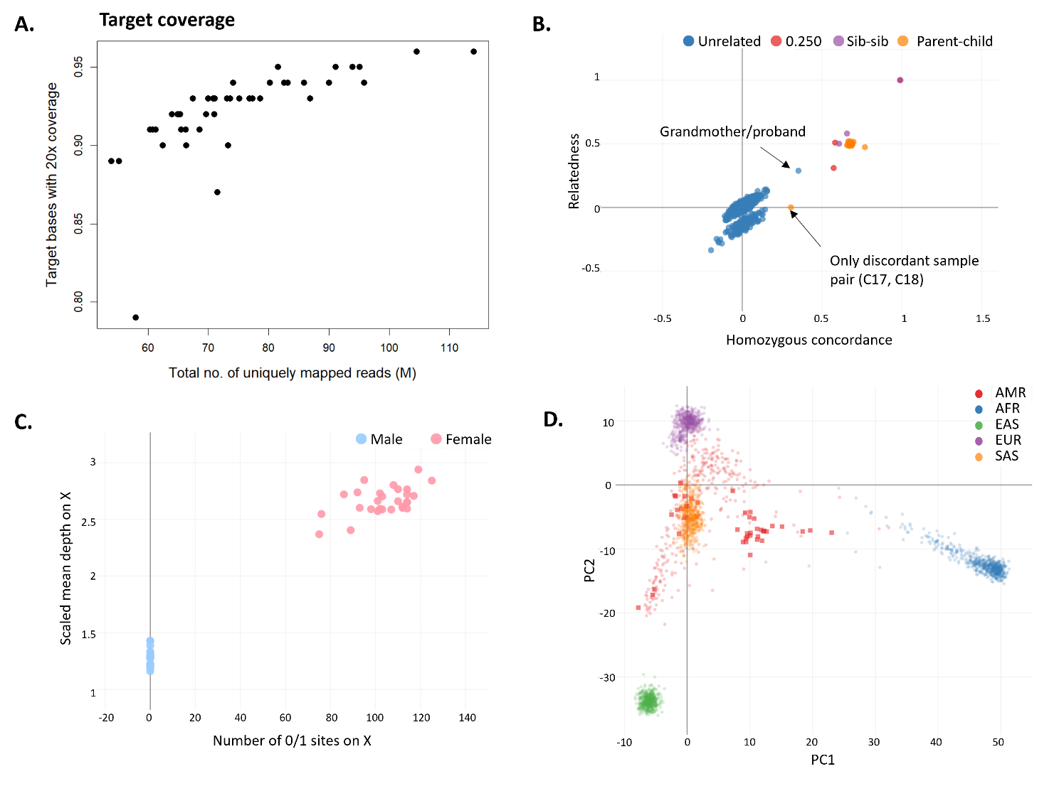
Figure S1. Quality assurance checks. A. Uniquely mapped reads vs percentage of target bases with 20x coverage, calculated using GATK’s DepthOfCoverage tool. B. Relatedness results by Somalier. All sample-sample pairs are plotted and coloured based on relatedness according to pedigree. Relatedness coefficient: 1=Identical twins/clones/duplicated; 0.5=parent/child/full sibling; 0.25 grandparent/grandchild; <0.20 distant relative/not related. Unrelated individuals are expected to have a homozygous concordance=0. C. Reported sex vs genotype inferred sex. Points are coloured based on reported sex. D. Principal Component Analysis (PCA) of ancestry estimation by Somalier. The PCA is generated using labelled samples from the 1000 Genomes project. Red squares represent our cohort (n=45) which cluster (labelled by Somalier) within the Admixed American Group (AMR: Red circles). African (AFR), East Asian (EAS), European (EUR), South Asian (SAS), and Admixed American (AMR).

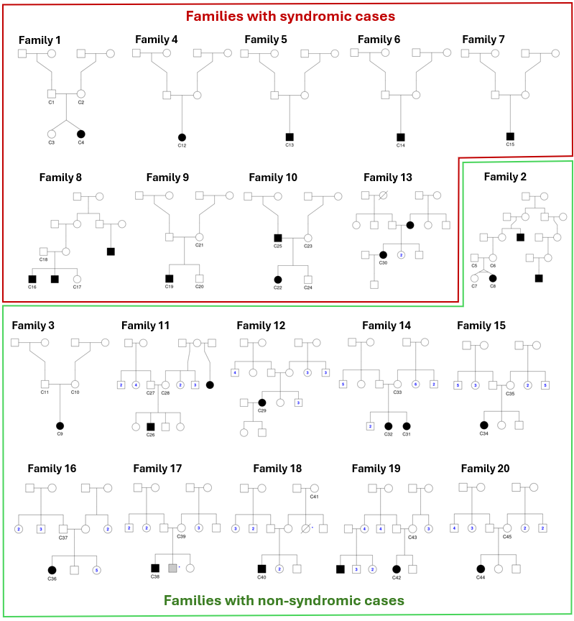
Figure S2. Pedigrees of recruited families. ID codes for research subjects appear under each square/circle, individuals whose DNA was collected and analysed. Symbols filled in black represent affected individuals. Numbers inside of circles and squares represent the number of brothers and sisters, respectively.

Supplementary Tables

Supplemental Table S1. HPO terms for affected individuals.
Subject ID | Family | HPO Terms
C4 | 1 | Orofacial cleft (HP:0000202), Cleft palate (HP:0000175), Cleft lip (HP:0410030), Cleft upper lip (HP:0000204), Non-midline cleft lip (HP:0100335), Cleft maxillary alveolar ridge (HP:0010289), Unilateral cleft lip (HP:0100333), Cleft soft palate (HP:0000185), Unilateral alveolar cleft of maxilla (HP:0410033), Cleft hard palate (HP:0410005), Median cleft palate (HP:0009099), Unilateral cleft palate (HP:0100334), Gingival cleft (HP:0030690), Complete unilateral cleft lip (HP:5201001), Complete cleft maxillary alveolar ridge (HP:5201008), Complete cleft hard palate (HP:5201003), Pulmonary arterial hypertension (HP:0002092), Pulmonary venous hypertension (HP:0030950), Patent ductus arteriosus (HP:0001643)
C7 | 2 | Orofacial cleft (HP:0000202), Cleft palate (HP:0000175), Cleft lip (HP:0410030), Cleft upper lip (HP:0000204), Non-midline cleft lip (HP:0100335), Cleft maxillary alveolar ridge (HP:0010289), Unilateral cleft lip (HP:0100333), Cleft soft palate (HP:0000185), Unilateral alveolar cleft of maxilla (HP:0410033), Cleft hard palate (HP:0410005), Median cleft palate (HP:0009099), Unilateral cleft palate (HP:0100334), Gingival cleft (HP:0030690), Complete unilateral cleft lip (HP:5201001), Complete cleft maxillary alveolar ridge (HP:5201008), Complete cleft hard palate (HP:5201003), Anemia (HP:0001903)
C9 | 3 | Orofacial cleft (HP:0000202), Cleft palate (HP:0000175), Cleft lip (HP:0410030), Cleft upper lip (HP:0000204), Non-midline cleft lip (HP:0100335), Cleft maxillary alveolar ridge (HP:0010289), Unilateral cleft lip (HP:0100333), Cleft soft palate (HP:0000185), Unilateral alveolar cleft of maxilla (HP:0410033), Cleft hard palate (HP:0410005), Median cleft palate (HP:0009099), Unilateral cleft palate (HP:0100334), Gingival cleft (HP:0030690), Complete unilateral cleft lip (HP:5201001), Complete cleft maxillary alveolar ridge (HP:5201008), Complete cleft hard palate (HP:5201003)
C12 | 4 | Abnormal palate morphology (HP:0000174), High palate (HP:0000218), Seizure (HP:0001250), Porencephaly (ORPHA:2940 ), Periventricular leukomalacia (HP:0006970), Neurodevelopmental delay (HP:0012758), Persistent head lag (HP:0032988), Generalized hypotonia (HP:0001290)
C13 | 5 | Orofacial cleft (HP:0000202), Cleft palate (HP:0000175), Cleft soft palate (HP:0000185), Cleft hard palate (HP:0410005), Median cleft palate (HP:0009099), Unilateral cleft palate (HP:0100334), Complete cleft hard palate (HP:5201003), Scoliosis (HP:0002650), Lower limb asymmetry (HP:0100559), Upper limb asymmetry (HP:0100560), Abnormal facial shape (HP:0001999)
C14 | 6 | Orofacial cleft (HP:0000202), Cleft palate (HP:0000175), Cleft lip (HP:0410030), Cleft upper lip (HP:0000204), Non-midline cleft lip (HP:0100335), Cleft maxillary alveolar ridge (HP:0010289), Unilateral cleft lip (HP:0100333), Cleft soft palate (HP:0000185), Unilateral alveolar cleft of maxilla (HP:0410033), Cleft hard palate (HP:0410005), Median cleft palate (HP:0009099), Unilateral cleft palate (HP:0100334), Gingival cleft (HP:0030690), Complete unilateral cleft lip (HP:5201001), Complete cleft maxillary alveolar ridge (HP:5201008), Complete cleft hard palate (HP:5201003), Seizure (HP:0001250), Neurodevelopmental delay (HP:0012758), Hydrocephalus (HP:0000238), Agenesis of corpus callosum (HP:0001274), Decreased body weight (HP:0004325)
C15 | 7 | Orofacial cleft (HP:0000202), Cleft palate (HP:0000175), Cleft lip (HP:0410030), Cleft upper lip (HP:0000204), Non-midline cleft lip (HP:0100335), Cleft maxillary alveolar ridge (HP:0010289), Unilateral cleft lip (HP:0100333), Cleft soft palate (HP:0000185), Unilateral alveolar cleft of maxilla (HP:0410033), Cleft hard palate (HP:0410005), Median cleft palate (HP:0009099), Unilateral cleft palate (HP:0100334), Gingival cleft (HP:0030690), Complete unilateral cleft lip (HP:5201001), Complete cleft maxillary alveolar ridge (HP:5201008), Complete cleft hard palate (HP:5201003), Abnormal central motor function (HP:0011442), Kyphosis (HP:0002808), Tooth malposition (HP:0000692), Premature birth (HP:0001622), Pneumonia (HP:0002090), Global developmental delay (HP:0001263), Speech apraxia (HP:0011098), Intellectual disability (HP:0001249), Decreased body weight (HP:0004325)
C16 | 8 | Orofacial cleft (HP:0000202), Cleft palate (HP:0000175), Cleft lip (HP:0410030), Cleft upper lip (HP:0000204), Non-midline cleft lip (HP:0100335), Cleft maxillary alveolar ridge (HP:0010289), Cleft soft palate (HP:0000185), Cleft hard palate (HP:0410005), Median cleft palate (HP:0009099), Gingival cleft (HP:0030690), Complete cleft maxillary alveolar ridge (HP:5201008), Complete cleft hard palate (HP:5201003), Bilateral alveolar cleft of maxilla (HP:0410034), Bilateral cleft lip and palate (HP:0002744), Bilateral cleft lip (HP:0100336), Bilateral cleft palate (HP:0100337), Delayed speech and language development (HP:0000750), Abnormal oral frenulum morphology (HP:0000190), Small for gestational age (HP:0001518), Speech articulation difficulties (HP:0009088), Abnormal oral frenulum morphology (HP:0000190), Posteriorly rotated ears (HP:0000358)
C19 | 9 | Orofacial cleft (HP:0000202), Cleft lip (HP:0410030), Cleft upper lip (HP:0000204), Non-midline cleft lip (HP:0100335), Unilateral cleft lip (HP:0100333), Complete unilateral cleft lip (HP:5201001), Inguinal hernia (HP:0000023), Systolic heart murmur (HP:0031664), Intrauterine growth retardation (HP:0001511), Premature birth (HP:0001622), Small for gestational age (HP:0001518), Jaundice (HP:0000952), Short stature (HP:0004322)
C22 | 10 | Orofacial cleft (HP:0000202), Cleft palate (HP:0000175), Cleft lip (HP:0410030), Cleft upper lip (HP:0000204), Non-midline cleft lip (HP:0100335), Cleft maxillary alveolar ridge (HP:0010289), Unilateral cleft lip (HP:0100333), Cleft soft palate (HP:0000185), Unilateral alveolar cleft of maxilla (HP:0410033), Cleft hard palate (HP:0410005), Median cleft palate (HP:0009099), Unilateral cleft palate (HP:0100334), Gingival cleft (HP:0030690), Complete unilateral cleft lip (HP:5201001), Complete cleft maxillary alveolar ridge (HP:5201008), Complete cleft hard palate (HP:5201003), Premature birth (HP:0001622), Patent foramen ovale (HP:0001655), Astigmatism (HP:0000483), Delayed speech and language development (HP:0000750)
C25 | 10 | Orofacial cleft (HP:0000202), Cleft palate (HP:0000175), Cleft lip (HP:0410030), Cleft upper lip (HP:0000204), Non-midline cleft lip (HP:0100335), Cleft maxillary alveolar ridge (HP:0010289), Unilateral cleft lip (HP:0100333), Cleft soft palate (HP:0000185), Unilateral alveolar cleft of maxilla (HP:0410033), Cleft hard palate (HP:0410005), Median cleft palate (HP:0009099), Unilateral cleft palate (HP:0100334), Gingival cleft (HP:0030690), Complete unilateral cleft lip (HP:5201001), Complete cleft maxillary alveolar ridge (HP:5201008), Complete cleft hard palate (HP:5201003), Volvulus (HP:0002580)
C26 | 11 | Orofacial cleft (HP:0000202), Cleft palate (HP:0000175), Cleft lip (HP:0410030), Cleft upper lip (HP:0000204), Non-midline cleft lip (HP:0100335), Cleft maxillary alveolar ridge (HP:0010289), Unilateral cleft lip (HP:0100333), Cleft soft palate (HP:0000185), Unilateral alveolar cleft of maxilla (HP:0410033), Cleft hard palate (HP:0410005), Median cleft palate (HP:0009099), Unilateral cleft palate (HP:0100334), Gingival cleft (HP:0030690), Complete unilateral cleft lip (HP:5201001), Complete cleft maxillary alveolar ridge (HP:5201008), Complete cleft hard palate (HP:5201003), Shawl scrotum (HP:0000049)
C29 | 12 | Orofacial cleft (HP:0000202), Cleft lip (HP:0410030), Cleft upper lip (HP:0000204), Non-midline cleft lip (HP:0100335), Unilateral cleft lip (HP:0100333), Complete unilateral cleft lip (HP:5201001)
C30 | 13 | Orofacial cleft (HP:0000202), Cleft palate (HP:0000175), Cleft lip (HP:0410030), Cleft upper lip (HP:0000204), Non-midline cleft lip (HP:0100335), Cleft maxillary alveolar ridge (HP:0010289), Unilateral cleft lip (HP:0100333), Cleft soft palate (HP:0000185), Unilateral alveolar cleft of maxilla (HP:0410033), Cleft hard palate (HP:0410005), Median cleft palate (HP:0009099), Unilateral cleft palate (HP:0100334), Gingival cleft (HP:0030690), Complete unilateral cleft lip (HP:5201001), Complete cleft maxillary alveolar ridge (HP:5201008), Complete cleft hard palate (HP:5201003), Clinodactyly of the 5th finger (HP:0004209), Dental crowding (HP:0000678)
C31 | 14 | Orofacial cleft (HP:0000202), Cleft palate (HP:0000175), Cleft lip (HP:0410030), Cleft upper lip (HP:0000204), Non-midline cleft lip (HP:0100335), Cleft maxillary alveolar ridge (HP:0010289), Unilateral cleft lip (HP:0100333), Cleft soft palate (HP:0000185), Unilateral alveolar cleft of maxilla (HP:0410033), Cleft hard palate (HP:0410005), Median cleft palate (HP:0009099), Unilateral cleft palate (HP:0100334), Gingival cleft (HP:0030690), Complete unilateral cleft lip (HP:5201001), Complete cleft maxillary alveolar ridge (HP:5201008), Complete cleft hard palate (HP:5201003)
C32 | 14 | Orofacial cleft (HP:0000202), Cleft lip (HP:0410030), Cleft upper lip (HP:0000204), Non-midline cleft lip (HP:0100335), Unilateral cleft lip (HP:0100333), Complete unilateral cleft lip (HP:5201001)
C34 | 15 | Orofacial cleft (HP:0000202), Cleft palate (HP:0000175), Cleft lip (HP:0410030), Cleft upper lip (HP:0000204), Non-midline cleft lip (HP:0100335), Cleft maxillary alveolar ridge (HP:0010289), Unilateral cleft lip (HP:0100333), Cleft soft palate (HP:0000185), Unilateral alveolar cleft of maxilla (HP:0410033), Cleft hard palate (HP:0410005), Median cleft palate (HP:0009099), Unilateral cleft palate (HP:0100334), Gingival cleft (HP:0030690), Complete unilateral cleft lip (HP:5201001), Complete cleft maxillary alveolar ridge (HP:5201008), Complete cleft hard palate (HP:5201003), Recurrent otitis media (HP:0000403)
C36 | 16 | Orofacial cleft (HP:0000202), Cleft palate (HP:0000175), Cleft lip (HP:0410030), Cleft upper lip (HP:0000204), Non-midline cleft lip (HP:0100335), Cleft maxillary alveolar ridge (HP:0010289), Cleft soft palate (HP:0000185), Cleft hard palate (HP:0410005), Median cleft palate (HP:0009099), Gingival cleft (HP:0030690), Complete cleft maxillary alveolar ridge (HP:5201008), Complete cleft hard palate (HP:5201003), Bilateral alveolar cleft of maxilla (HP:0410034), Bilateral cleft lip and palate (HP:0002744), Bilateral cleft lip (HP:0100336), Bilateral cleft palate (HP:0100337)
C38 | 17 | Orofacial cleft (HP:0000202), Cleft palate (HP:0000175), Cleft lip (HP:0410030), Cleft upper lip (HP:0000204), Non-midline cleft lip (HP:0100335), Cleft maxillary alveolar ridge (HP:0010289), Unilateral cleft lip (HP:0100333), Cleft soft palate (HP:0000185), Unilateral alveolar cleft of maxilla (HP:0410033), Cleft hard palate (HP:0410005), Median cleft palate (HP:0009099), Unilateral cleft palate (HP:0100334), Gingival cleft (HP:0030690), Complete unilateral cleft lip (HP:5201001), Complete cleft maxillary alveolar ridge (HP:5201008), Complete cleft hard palate (HP:5201003)
C40 | 18 | Orofacial cleft (HP:0000202), Cleft palate (HP:0000175), Cleft lip (HP:0410030), Cleft upper lip (HP:0000204), Non-midline cleft lip (HP:0100335), Cleft maxillary alveolar ridge (HP:0010289), Unilateral cleft lip (HP:0100333), Cleft soft palate (HP:0000185), Unilateral alveolar cleft of maxilla (HP:0410033), Cleft hard palate (HP:0410005), Median cleft palate (HP:0009099), Unilateral cleft palate (HP:0100334), Gingival cleft (HP:0030690), Complete unilateral cleft lip (HP:5201001), Complete cleft maxillary alveolar ridge (HP:5201008), Complete cleft hard palate (HP:5201003)
C42 | 19 | Orofacial cleft (HP:0000202), Cleft palate (HP:0000175), Cleft lip (HP:0410030), Cleft upper lip (HP:0000204), Non-midline cleft lip (HP:0100335), Cleft maxillary alveolar ridge (HP:0010289), Unilateral cleft lip (HP:0100333), Cleft soft palate (HP:0000185), Unilateral alveolar cleft of maxilla (HP:0410033), Cleft hard palate (HP:0410005), Median cleft palate (HP:0009099), Unilateral cleft palate (HP:0100334), Gingival cleft (HP:0030690), Complete unilateral cleft lip (HP:5201001), Complete cleft maxillary alveolar ridge (HP:5201008), Complete cleft hard palate (HP:5201003),
C44 | 20 | Orofacial cleft (HP:0000202), Cleft palate (HP:0000175), Cleft lip (HP:0410030), Cleft upper lip (HP:0000204), Non-midline cleft lip (HP:0100335), Cleft maxillary alveolar ridge (HP:0010289), Cleft soft palate (HP:0000185), Cleft hard palate (HP:0410005), Median cleft palate (HP:0009099), Gingival cleft (HP:0030690), Complete cleft maxillary alveolar ridge (HP:5201008), Complete cleft hard palate (HP:5201003), Bilateral alveolar cleft of maxilla (HP:0410034), Bilateral cleft lip and palate (HP:0002744), Bilateral cleft lip (HP:0100336), Bilateral cleft palate (HP:0100337)

Supplemental Table S2. Clinical information of each individual recruited in this study. The last two columns show other affected systems. 1. CNS&MA: Central Nervous System and Mental Abilities, 2. CV: Cardiovascular, 3. MS: Musculoskeletal, 4. RS: Respiratory system, 5. “Other” include: preterm birth, inguinal hernia, intrauterine growth retardation, jaundice, astigmatism and volvulus. A complete list of phenotypic terms (with HPO codes) per proband is included in Supplemental Table S1. OFC: orofacial cleft, sOFC: syndromic OFC, nsOFC: nonsyndromic OFC, CPO: cleft palate only.
Family ID | Subject ID | Sex | Kinship | Family history | Type | Cleft description | CNS&MA¹ | CV² | MS³ | RS⁴ | Other⁵
1 | C1 | M | Father | No |  | Unaffected
1 | C2 | F | Mother | No |  | Unaffected
1 | C3 | F | Twin sister | No |  | Unaffected
1 | C4 | F | Proband | No | sOFC | Right cleft lip and complete cleft palate |  | +
2 | C5 | M | Father | Yes |  | Unaffected
2 | C6 | F | Mother | Yes |  | Unaffected
2 | C7 | F | Proband | Yes | nsOFC | Right cleft lip and complete cleft palate
2 | C8 | F | Twin sister | Yes |  | Unaffected
3 | C9 | F | Proband | No | nsOFC | Right cleft lip and complete cleft palate
3 | C10 | F | Mother | No |  | Unaffected
3 | C11 | M | Father | No |  | Unaffected
4 | C12 | F | Proband | No | sOFC | Deep ogival palate (CPO) | + |  | +
5 | C13 | M | Proband | No | sOFC | Cleft palate (CPO) |  |  | +
6 | C14 | M | Proband | No | sOFC | Left cleft lip and complete cleft palate | + |  | +
7 | C15 | M | Proband | No | sOFC | Left cleft lip and complete cleft palate | + |  | + | + | +
8 | C16 | M | Proband | Yes | sOFC | Bilateral cleft lip and complete cleft palate | + |  | +
8 | C17 | F | Sister | Yes |  | Unaffected
8 | C18 | M | Father | Yes |  | Unaffected
9 | C19 | M | Proband | No | sOFC | Left cleft lip |  | + | + |  | +
9 | C20 | M | Twin brother | No |  | Unaffected
9 | C21 | F | Mother | No |  | Unaffected
10 | C22 | F | Proband | Yes | sOFC | Right cleft lip and complete cleft palate | + | + |  |  | +
10 | C23 | F | Mother | Yes |  | Unaffected
10 | C24 | M | Twin brother | Yes |  | Unaffected
10 | C25 | M | Father | Yes | sOFC | Left cleft lip and complete cleft palate |  |  |  |  | +
11 | C26 | M | Proband | Yes | nsOFC | Left cleft lip and complete cleft palate
11 | C27 | M | Father | Yes |  | Unaffected
11 | C28 | F | Mother | Yes |  | Unaffected
12 | C29 | F | Proband | No | nsOFC | Left cleft lip
13 | C30 | F | Proband | Yes | sOFC | Right cleft lip and complete cleft palate |  |  | +
14 | C31 | F | Proband | No | nsOFC | Right cleft lip and complete cleft palate
14 | C32 | F | Proband | No | nsOFC | Left cleft lip w/o alveolar cleft
14 | C33 | F | Mother | No |  | Unaffected
15 | C34 | F | Proband | No | nsOFC | Right cleft lip and complete cleft palate
15 | C35 | F | Mother | No |  | Unaffected
16 | C36 | F | Proband | No | nsOFC | Bilateral cleft lip and complete cleft palate
16 | C37 | M | Father | No |  | Unaffected
17 | C38 | M | Proband | No | nsOFC | Left cleft lip and complete cleft palate
17 | C39 | F | Mother | No |  | Unaffected
18 | C49 | M | Proband | No | nsOFC | Right cleft lip and complete cleft palate
18 | C41 | F | Grandmother | No |  | Unaffected
19 | C42 | F | Proband | Yes | nsOFC | Left cleft lip and complete cleft palate
19 | C43 | F | Mother | No |  | Unaffected
20 | C44 | F | Proband | No | nsOFC | Bilateral cleft lip and complete cleft palate
20 | C45 | F | Mother | No |  | Unaffected

Supplemental Table S3. ACMG classification of candidate variants
Variant | Symbol | Existing variation | HGMC criteria | HGMD Class
NM_001267550.2:c.15796C>T p.(Arg5266*) | TTN | rs372277017  COSV100633043  ClinVar ID: 130662 | PVS1, PS2, PM2_supporting | P
NM_004465.2:c.355G>A p.(Gly119Arg) | FGF10 | rs1740186895  COSV99240410 | PS2, PM2_supporting, PP3 | LP
NM_001170535.3:c.968G>T p.(Ser323Ile) | ATAD3A | - | PM2_supporting, BP4 | VUS
NM_006734.4:c.5312A>G p.(Glu1771Gly) | HIVEP2 | rs763685280 | PM2_supporting, BP1 | VUS
NM_182641.4:c.658G>A p.(Glu220Lys) | BPTF | - | PM2_supporting, PP3, BP1 | VUS
NM_000381.4:c.1354G>A p.(Gly452Ser) | MID1 | rs1556004404  ClinVar ID: 546092 | PM2_supporting, PP1, BP1 | VUS
NM_001110556.2:c.5069C>T p.(Thr1690Met) | FLNA | rs782352193  COSV61036621  ClinVar ID: 591330 | PM2_supporting | VUS
NM_002633.3:c.734C>T p.(Ala245Val) | PGM1 | rs929270819  ClinVar ID: 1302539 | PM2_supporting | VUS
NM_001287491.2:c.946C>T p.(Pro316Ser) | TET3 | - | PM2_supporting, BP4 | VUS
NM_024721.5:c.6677A>C p.(Lys2226Thr) | ZFHX4 | - | PM2_supporting, PP3, BP1 | VUS
NM_018677.4:c.1487T>C p.(Val496Ala) | ACSS2 | rs59088485  ClinVar ID: 617833 | PS4, PP1, PP3, BS2 | VUS
NM_000138.5:c.1125G>T p.(Glu375Asp) | FBN1 | rs2043845159 | PM2_supporting, PP2 | VUS
NM_138927.4:c.78-4_78del p.? | SON | - | PVS1, PM2_supporting | LP
NM_001329630.2:c.617T>C p.(Leu206Pro) | PLEKHA7 | rs776711368 | PM2_supporting, PP3 | VUS
NM_001256470.2:c.352C>T p.(Pro118Ser) | PLEKHA5 | rs911407536 | PM2_supporting, BP4 | VUS

Supplemental Table S4. Clinical information available for variants filtered in our cohort
Sample ID / Family ID | Type of OFC | Variant | Variant-specific publications | ClinVar Reports
C4 / 1 | sOFC | NM_001267550.2(TTN):c.15796C>T p.(Arg5266*) | PMID 25589632: mentioned in the supplemental material Table S8. TTN truncating variants in publicly available control populations | RCV000118735.6:Genetic Services Laboratory, University of Chicago: Tibial muscular dystrophy, tardive, Pathogenic  RCV000807735.8: Labcorp Genetics: Dilated cardiomyopathy 1G- Autosomal recessive limb-girdle muscular dystrophy type 2J, VUS
C16 / 8 | sOFC | NM_000381.4(MID1):c.1354G>A p.(Gly452Ser) | PMID:18360914 (Opitz Syndrome), PMID:15121778 (Opitz syndrome) | RCV000657884.3: GeneDx, does not provide any condition: Pathogenic
C22 / 10 | nsOFC | NM_001110556.2(FLNA):c.5069C>T p.(Thr1690Met) | No | RCV000722508.2: New York Genome Center, Generalized-onset seizure, VUS  Gharavi Laboratory, Columbia University, no condition provided, VUS  RCV001862119.6: Labcorp Genetics, Oto-palato-digital syndrome, type II, Heterotopia, periventricular, X-linked dominant, Frontometaphyseal dysplasia  Melnick-Needles syndrome, Benign
C29 / 12 | nsOFC | NM_002633.3(PGM1):c.734C>T p.(Ala245Val) | No | RCV002032757.5: Labcorp Genetics, PGM1-congenital disorder of glycosylation, VUS  RCV001754428.5: Mayo Clinic Laboratories, No condition provided, VUS
C31 / 14 | nsOFC | NM_018677.4(ACSS2):c.1487T>C p.(Val496Ala) | PMID:28543373 (Cleft lip and palate), PMID:27229527 (Nonsyndromic cleft lip and palate) | RCV000755123.1: Center for Mendelian Genomics, University of Washington, Nonsyndromic cleft lip palate, Pathogenic (Same variant present in 3 different families)  RCV004555874.1: Clinical Genomics Laboratory, Washington University in St. Louis, no condition provided, VUS

