Supplementary Materials

Quantitative real time PCR (qRT-PCR)
Total RNA was prepared using RNAiso Plus and cDNA was synthesized as described in Materials and Methods. Primers used for qRT-PCR are listed in Supplementary table 1.

Supplementary Table 1. Primers for qRT-PCR analysis.
Gene | Forward | Reverse
cyclophilin | TGGAGAGCACCAAGACAGACA | TGCCGGAGTCGACAATGAT
p15^{INK4b} | AGATCCCAACGCCCTGAAC | TGCCGGAGTCGACAATGAT
p16^{INK4a} | CGCCCCGAACTCTTTCG | GGGTTGTGAATCGCCAGTTT
p21^{Cip1} | GAATCTTCAGGCCGCTCAGA | CCCGTTGCTCAGCAGCAT
p27^{Kip1} | TCTTCGGCCCGGTCAA | CCGGCAGTGCTTCTCCAA

Supplementary Figure 1

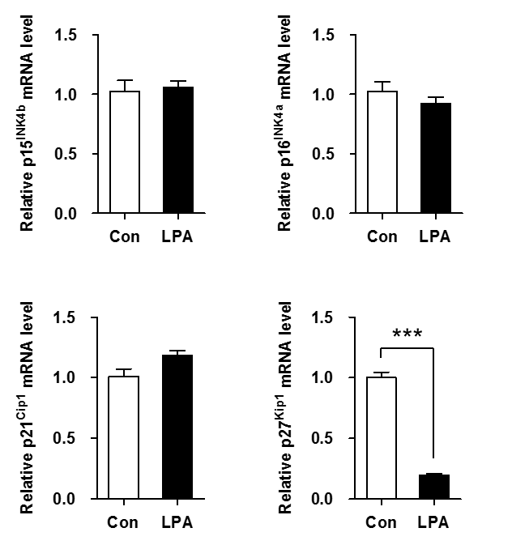

Supplementary Figure 1. LPA decreases the mRNA expression of p27^{Kip1}, but not p15^{INK4b}, p16^{INK4a}, and p21^{Cip1}. SV40 MES13 cells were seeded in a 6-well plate and starved in serum-free medium containing 0.1% fatty acid-free bovine serum albumin for 12–16 h. Cells were treated with LPA (10 μM) for 6 h, and the mRNA levels of p15^{INK4b}, p16^{INK4a}, p21^{Cip1}, and p27^{Kip1} were analyzed by qRT-PCR (n=3~4 independent experiments). ***p<0.001. Data represent the mean ± SEM.

Supplementary Figure 2
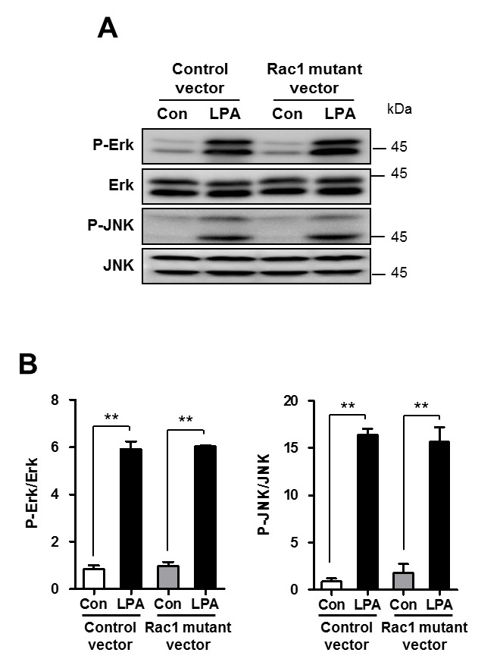
Supplementary Figure 2. LPA activates Erk and JNK through a Rho GTPase Rac1-independent pathway in SV40 MES13 cells. After the transfection of SV40 MES13 cells with the control vector or dominant-negative Rac1 mutant vector, cells were starved in serum-free medium containing 0.1% fatty acid-free bovine serum albumin for 12–16 h. Then, cells were treated with LPA (10 μM) for 15 min. (A) The protein levels of P-Erk, Erk, P-JNK, and JNK were determined by western blot analysis. (B) The relative expressions of P-Erk, and P-JNK were normalized to that of Erk or JNK, and quantified using the ImageJ software (n=3 independent experiments). **p<0.01. Data represent the mean ± SEM.

