SMURF1-mediated ubiquitination of ARHGAP26 promotes cell invasion and migration of ovarian cancer

Xuri Chen¹*, Shaoyun Chen²*, Yao Li¹, Yanling Gao¹, Shuying Huang¹, Hongping Li³, Yuanfang Zhu^{1,2}

¹Department of Obstetrics and Gynecology, Bao’an Maternity and Child Health Hospital, Jinan University, Shenzhen 518100, China
²Maternal-Fetal Medicine Institute, Bao’an Maternity and Child Health Hospital, Jinan University, Shenzhen 518100, China
³Shenzhen children's Hospital, Shenzhen 518000, China

* Contributed equally

Corresponding author

Hongping Li, Shenzhen children's Hospital, No. 7019 Yitian Road, Fu'tian District, Shenzhen 518000, China. Tel.: +86-0755-83009810, Fax.: +86-0755-83009810, E-mail: hongping_li@126.com
Yuanfang Zhu, Department of Obstetrics and Gynecology, Bao’an Maternity and Child Health Hospital, Jinan University, Shenzhen 518100, China; Maternal-Fetal Medicine Institute, Bao’an Maternity and Child Health Hospital, Jinan University, No. 56 Yulv Road, Bao’an District, Shenzhen 518100, China. Tel.: +86-0755-27812637, Fax.: +86-0755-27812637, E-mail: zhuzn0620@163.com

Running title: SMURF1/ARHGAP26/β-catenin signaling in ovarian cancer

Total number of words: 3016

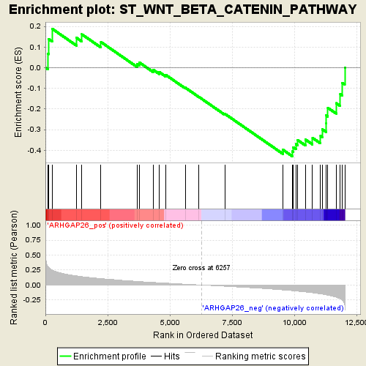
Figure S1. Enrichment plots of GSEA. GSEA demonstrated the genes of Wnt/β-catenin pathway were correlated with patients with ARHGAP26 low vs. ARHGAP26 high patients. P<0.001.

Figure S2. SMURF1, CBL, NEDD4, MDM2, and WWP1 overexpression in SKOV3 cells. SKOV3 cells were transduced with recombined pLVX-Puro-SMURF1, pLVX-Puro-CBL, pLVX-Puro-NEDD4, pLVX-Puro-MDM2, pLVX-Puro-WWP1 or control lentivirus (blank vector), and SMURF1, CBL, NEDD4, MDM2, and WWP1 expression was detected by Real-time PCR (A) and western blot (B, C). ***P<0.001 compared with control.

Figure S3. ARHGAP26 protein expression in SKOV3 cells. SKOV3 cells were transduced with recombined pLVX-Puro-SMURF1, pLVX-Puro-CBL, pLVX-Puro-NEDD4, pLVX-Puro-MDM2, pLVX-Puro-WWP1 or control lentivirus (blank vector), and AGRHAP26 expression was detected by western blot. *P<0.05, ***P<0.001 compared with control.

