Supplementary Information

Role of interleukin-23 in the development of nonallergic eosinophilic inflammation in a murine model of asthma

Hyun Seung Lee¹, Da-Eun Park¹, Ji-Won Lee², Kyung Hee Sohn³, Sang-Heon Cho^{1,4}, Heung-Woo Park^{1,4}

¹Institute of Allergy and Clinical Immunology, Seoul National University Medical Research Center, Seoul, Republic of Korea
²Division of Allergy and Clinical Immunology, Department of Asan Medical Center, University of Ulsan College of Medicine, Seoul, Republic of Korea
³Department of Internal Medicine, Kyung Hee University Medical Center, Seoul, Republic of Korea
⁴Department of Internal medicine, Seoul National University College of Medicine, Seoul, Republic of Korea
METHODS
Airway hyperresponsiveness measurement
Measurement of dynamic resistance was performed using a Flexivent system (Scireq, Montreal, Canada). Mice were anesthesia with ketamine (90 mg/kg body weight) and xylazine (10 mg/kg body weight), tracheostomized and connected to the flexivent ventilator via a 19-gauge cannula. Mice were ventilated using following settings; tidal volume of 10 ml/kg body weight, 150 breaths/minute, positive end-expiratory pressure 3 cm H2O. Mice were allowed to stabilize for 5 min before measurements started. Measurement of airway resistance (cm H2O/ml/s) was determined using snapshot-150 perturbation. MCh (acetyl-b-methylcholine chloride; Sigma-Aldrich) provocation testing started with PBS, followed by MCh aerosols with increasing concentrations (0, 12.5, 25, 50, and 100 mg/ml). The graphs show values of 50 mg/ml and 100 mg/ml.

ILC2 cell sorting
Mice were treated with recombinant IL-33 (0.5 μg/mouse; eBioscience) for 5 days. Lungs were harvested for ILC2 cell sorting; lineage-negative cells were gated as cells that did not express FITC-conjugated CD3, CD4, CD8, CD11b, CD11c, CD19, F4/80, FcεRI, and CD49b. PE-conjugated ST2 and APC-conjugated ICOS were also used for sorting. The lungs of several mice were pooled for ILC2 cell sorting. A FACSAria II was used (BD Biosciences) for cell sorting. Sorted lung ILC2s (1 × 10⁴/well) were expanded in vitro using 10% FBS RPMI complete medium containing IL-2 (10 ng/mL; BD Biosciences) and IL-33 (10 ng/mL, R&D) for 7 days.

IL23A and IL23R gene expression in induced sputum obtained from patients with asthma
A total of 17 patients with NAEA (male:female = 3:14, mean age [standard deviation] = 54.3 [15.7]), 63 patients with AEA (male:female = 11:52, mean age [standard deviation] = 55.2 [10.4]), and 13 normal controls (male:female = 4:9, mean age [standard deviation] = 47.4 [17.3]) were enrolled at Seoul National University Hospital. A diagnosis of asthma was made when a subject with symptoms of dyspnea or wheezing showed reversible airway obstruction after bronchodilator inhalation (200 mL and 12% or more improvement in forced expiratory volume in 1 second) or positive methacholine AHR. Patients with asthma who showed positive skin prick test results or in vitro specific-IgE test results when exposed to a panel of common allergens were regarded as “allergic”; otherwise, they were regarded as “nonallergic.” A normal control was defined as a subject who had no respiratory symptoms and showed negative results in both methacholine AHR test and skin prick test or in vitro specific-IgE test when exposed to a panel of common allergens. Processing of induced sputum was performed as previously described (Jung JW, et al. Tohoku J Exp Med 2014;233:49-56). Sputum eosinophilia was defined as the proportion of eosinophils greater than 3% of the total inflammatory cells. The cell pellet was mixed with Trizol (Gibco, Grand Island, NY, USA) for RNA extraction. After, RNA extraction, real-time polymerase chain reaction (RT-PCR) was performed using an RT-PCR kit (Promega, Madison, WI, USA). The mRNA expression levels of IL-23A (IL-23p19) and IL-23R were amplified using an ABI 7500 real-time PCR system and SYBR Green master mix (Applied Biosystems, Foster City, CA, USA). Expression levels of each gene within each sample were normalized against β-actin using the formula 2^{−ΔΔCt}, in which ΔΔCt = (Ct mRNA – Ct β-actin) and Ct is the cycle threshold. The primer sequences for IL-23A and IL-23R were as follows:
IL-23A Fwd: CTC AGG GAC AAC AGT CAG TTC
IL-23A Rev: ACA GGG CTA TCA GGG AGC A
IL-23R Fwd: AGC AGC AAT TAA GAA CTG CCA
IL-23R Rev: TAC CAA AGC CGA GCT GTT GTT
SUPPLEMENTARY FIGURE LEGENDS
Figure S1. Experimental protocol
polyI:C or DEP plus 0.1 μg/mouse rIL-23 were intranasally administered to mice (on days 1, 2, 3, 14, 15, 21, and 22) and methacholine airway hyperresponsiveness was measured at 24 h after the last instillation. MBPT, methacholine bronchial provocation test.

Figure S2. Gating strategy for flow cytometry analysis
Cells were first gated for lymphocytes (SSC-A vs. FSC-A) and singlets (FSC-H vs. FSC-A). a Singlets were further analyzed for CD4− versus CD4+ cells. b IL-13 or IL-17 intracellular expression was then determined in CD4+ cells. c For gating of ILC3s, IL-17 expression was determined in CD25+Lin-CD4−cells. d, e For gating of ILC2s, IL-13 or IL-5 expression was determined in ICOS+ Lin−cells. f For gating of eosinophils from BAL fluid, Siglec F expression was determined in CD11b+ CD11c−cells. IL-23R expression was determined in CD45−and CD45+ cells. g IL-23R expression was determined in EpCAM+ CD45−cells. H–I. IL-23R expression was determined in F4/80− CD45+or CD4+ CD45+ cells.

Figure S3. ILC2 sorting
a Experimental protocol (0.5 μg/mouse rIL-33 was intranasally administered to mice for 5 consecutive days). b To isolate ILC2s, ICOS+ ST2+ Lin− cells were identified.

Figure S4. Detection of IL-23R overexpression in MLE12 cells
Primary antibodies used were IL-23R (1:1000; R&D Systems) and β-actin (Abcam).

Figure S5. FACS plots of mice treated by rIL-23
a, b Gating of ILC2s, IL-13 or IL-5 expression was determined in ICOS+ in Lin- CD4−cells. c Gating of ILC3s, IL-17 expression was determined in CD25+ in Lin-CD4−cells. d, e IL-13 or IL-17 intracellular expression was determined in CD4+ cells.

Figure S6. FACS plots of polyI:C/rIL-23 model
a Gating of eosinophils from BAL fluid, Siglec F expression was determined in CD11b+ CD11c−cells. b, c Gating of ILC2s, IL-13 or IL-5 expression was determined in ICOS+ in Lin- CD4−cells. d Gating of ILC3s, IL-17 expression was determined in CD25+ in Lin-CD4−cells. e IL-13 or IL-17 intracellular expression was determined in CD4+ cells.

Figure S7. FACS plots of DEP/rIL-23 model
a Gating of eosinophils from BAL fluid, Siglec F expression was determined in CD11b+ CD11c−cells. b, c Gating of ILC2s, IL-13 or IL-5 expression was determined in ICOS+ in Lin- CD4−cells. d Gating of ILC3s, IL-17 expression was determined in CD25+ in Lin-CD4−cells. e IL-13 or IL-17 intracellular expression was determined in CD4+ cells.

Figure S8. IL-23R expression in cells from mouse lung tissue
a IL-23R+ EpCAM+ CD45− cells. b CD11+ F4/80− CD45+ cells. c CD4+ CD45+ cells. *P < 0.05 between groups; #P < 0.05 compared to the control mice.
Figure S1.
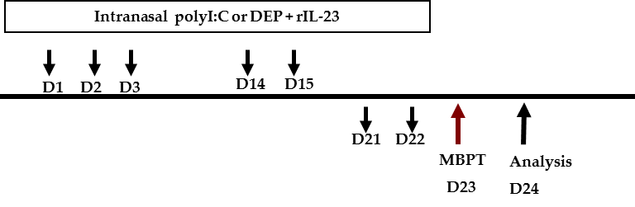
Figure S2.
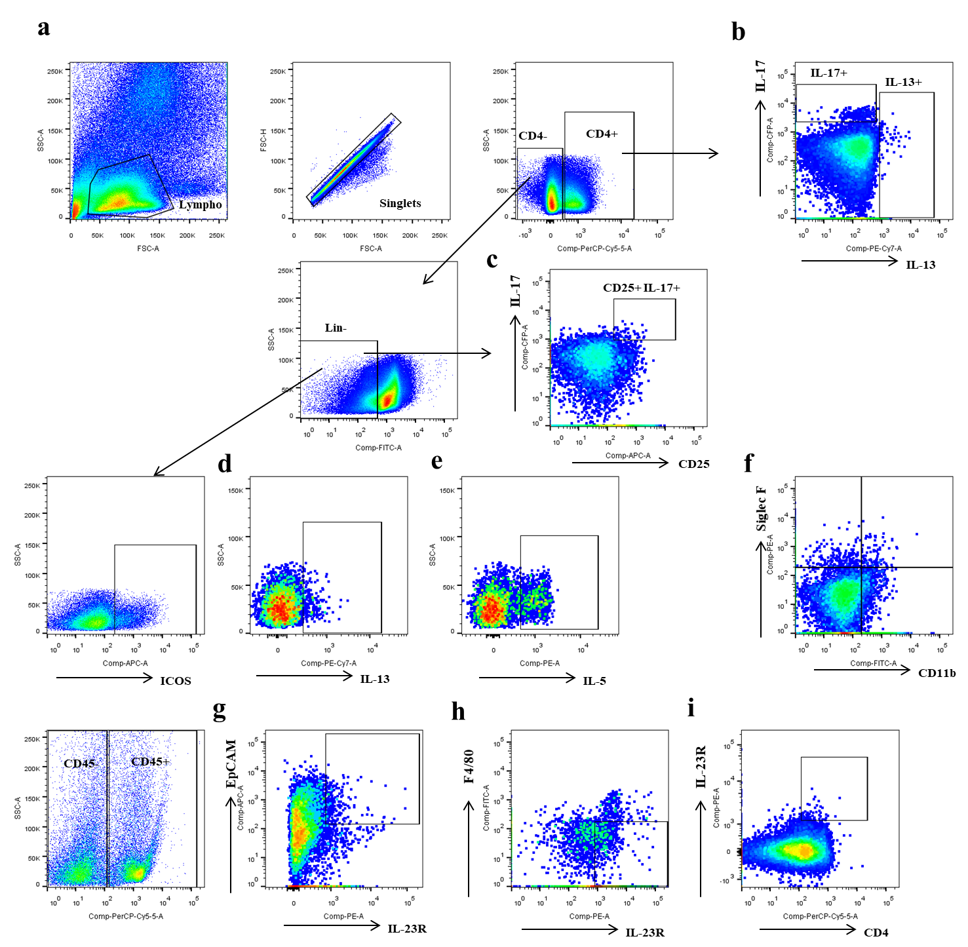
Figure S3.
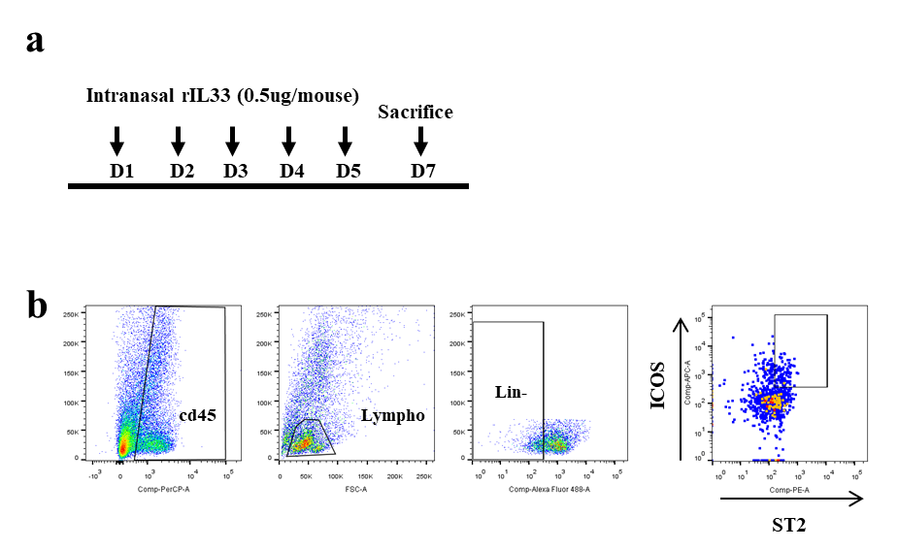
Figure S4.
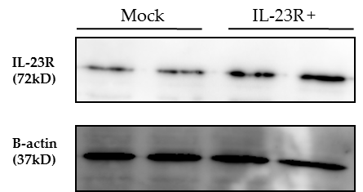
Figure S5.
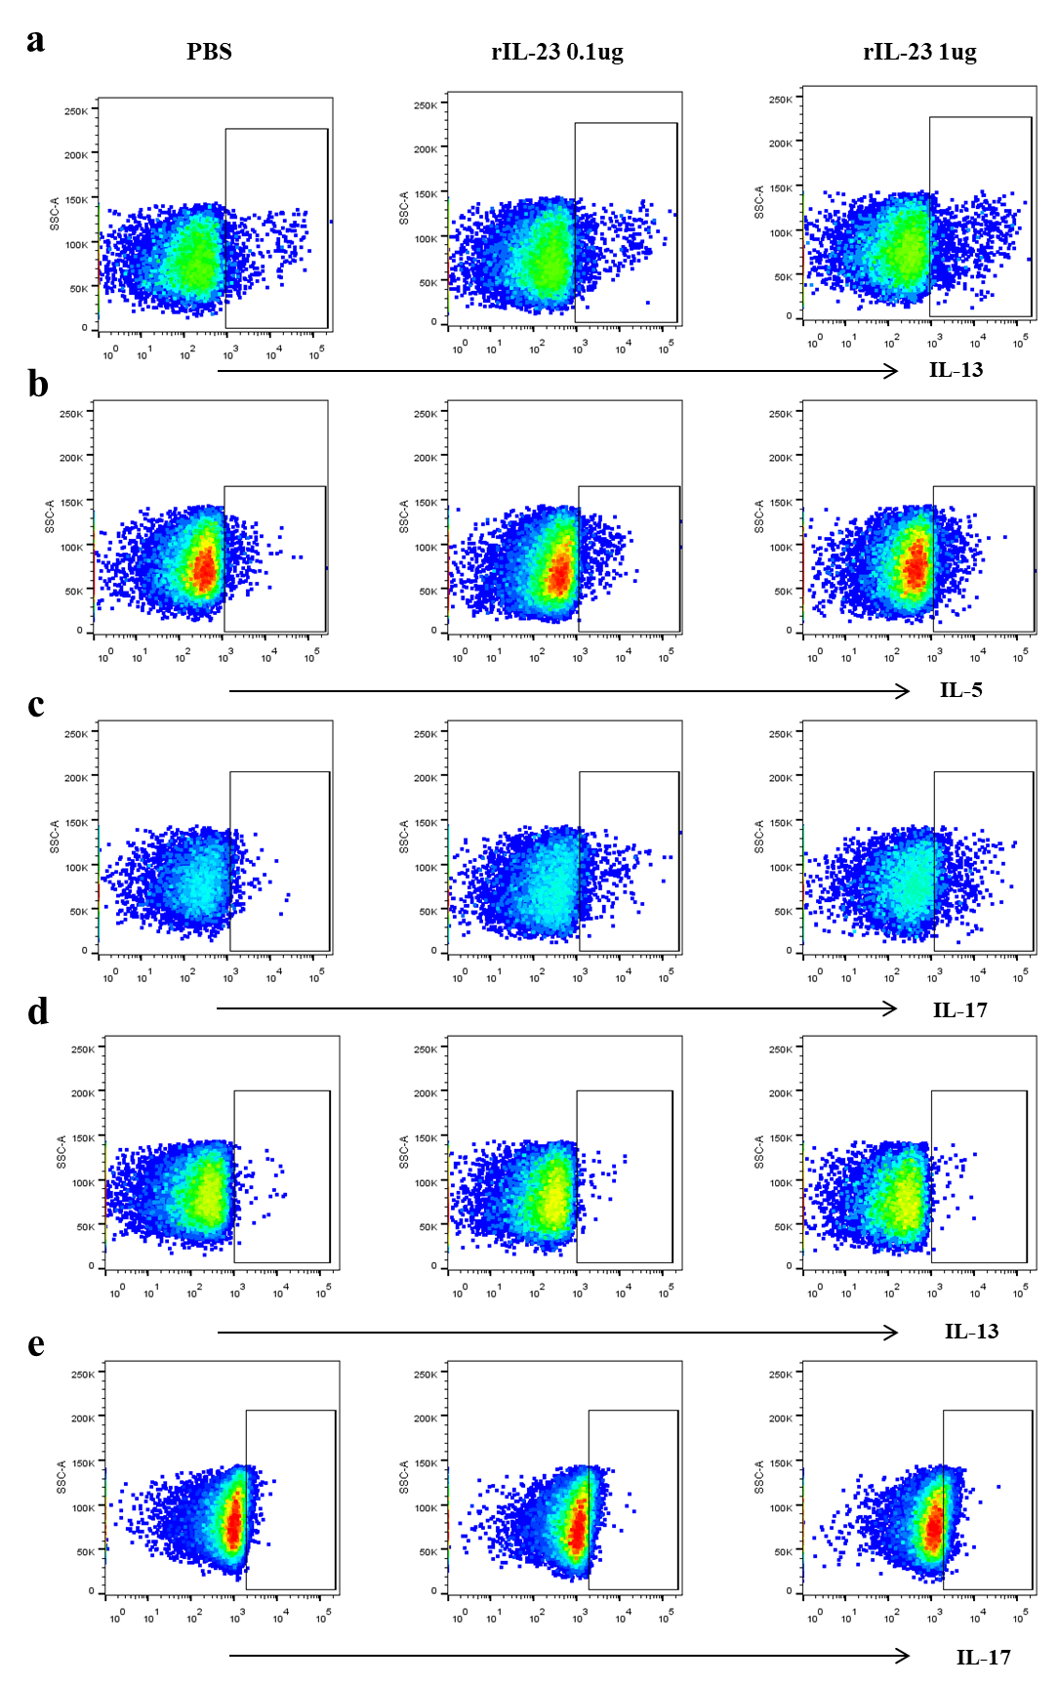
Figure S6.
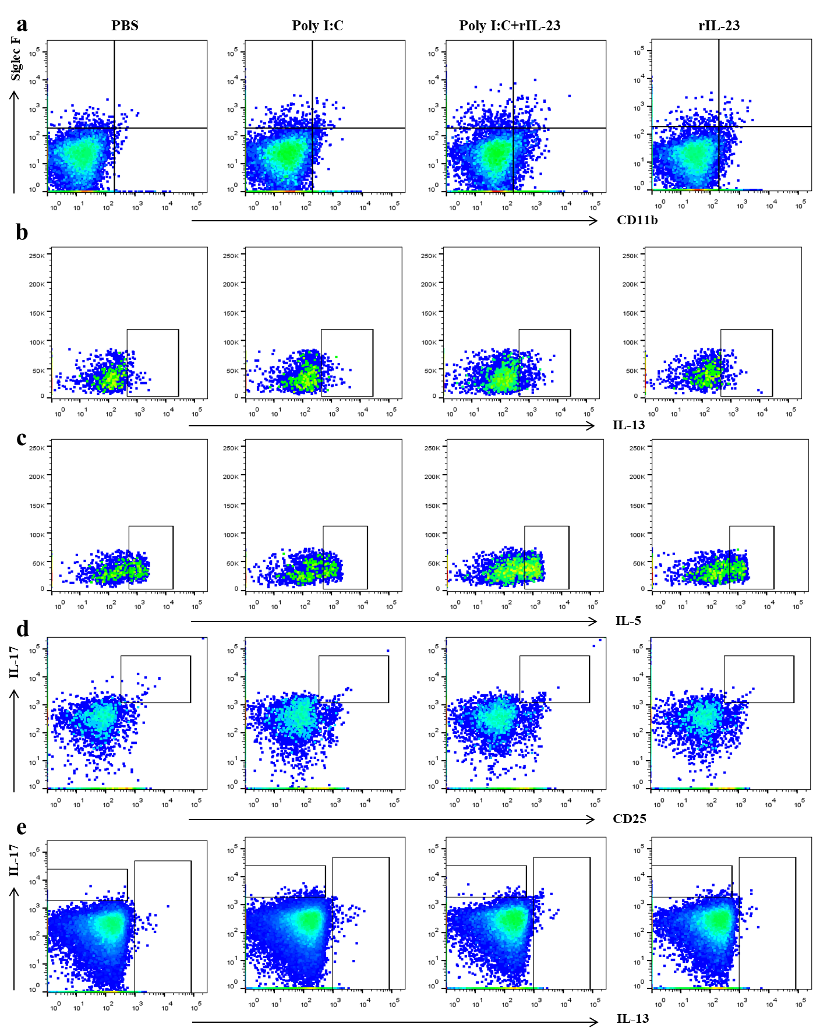
Figure S7.
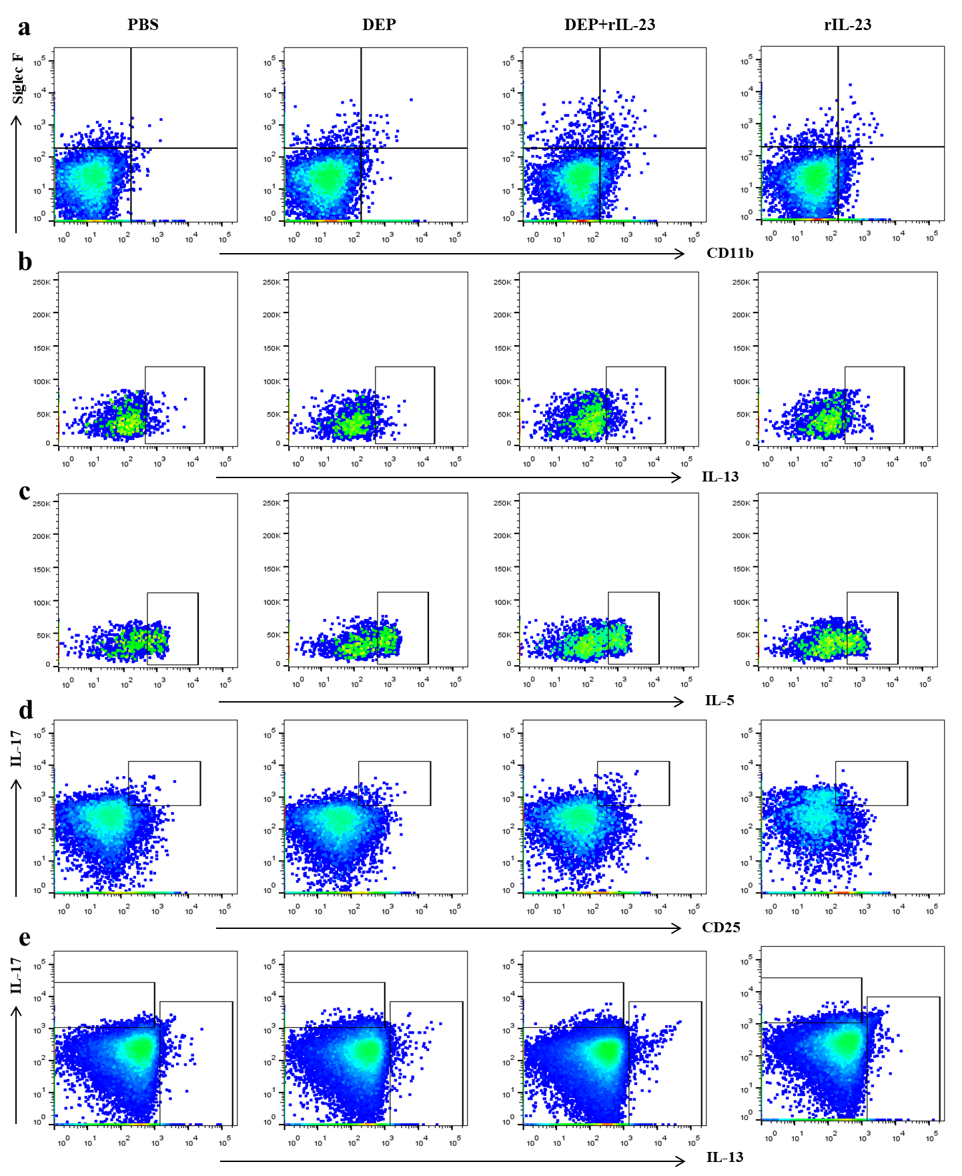
Figure S8.
