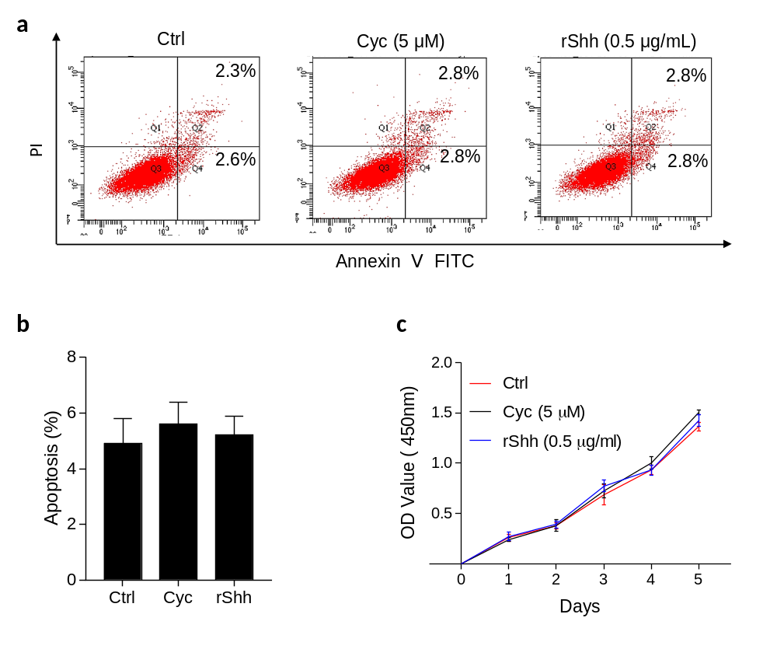
Fig. s1 Shh signaling does not affect trophoblast viability. a After treatment of 5 μM cyclopamine (Cyc) or 0.5 μg/ml recombinant human Shh (rShh) in JAR cells, apoptosis was analyzed by flow cytometry. b Quantitative apoptosis from a. c JAR cells were treated with Cyc or 0.5 μg/ml rShh for 24 h, and the cell viability was determined by the CCK-8 assay at 1,2,3,4 and 5 days.

