SUPPLEMENTARY MATERIALS
Histological analysis
BAT tissues were fixed in 4% paraformaldehyde and subsequently embedded in paraffin (4–5 μm sections) for haematoxylin and eosin (H&E) staining. H&E staining was performed using a standard protocol and stained sections were imaged with the Zeiss Axio Imager Z1 microscope.

Quantitative RT-PCR
Total RNA was prepared from tissue of WT and IDH2KO mice by the Trizol procedure (Invitrogen, Carlsbad, CA, USA) and cDNA was synthesized using cDNA superscript kit (Bio-Rad, Richmond, CA, USA) to use for qPCR with CFX96 Bio-Rad qPCR machine (Bio-Rad). mRNA levels were normalized for expression of ribosomal protein L32 mRNA as control and calculated by the comparative threshold cycle method. The primer sequences are listed in Table S2.

TG and cholesterol measurement in serum
Serum lipids (TG, cholesterol, HDL, LDL, and NEFA) and liver toxicity (AST and ALT) concentrations were measured by a Beckman Coulter AU480 automatic biochemistry analysis system (Model AU-480, Beckman Coulter, Krefeld, Germany).
Supplementary figures
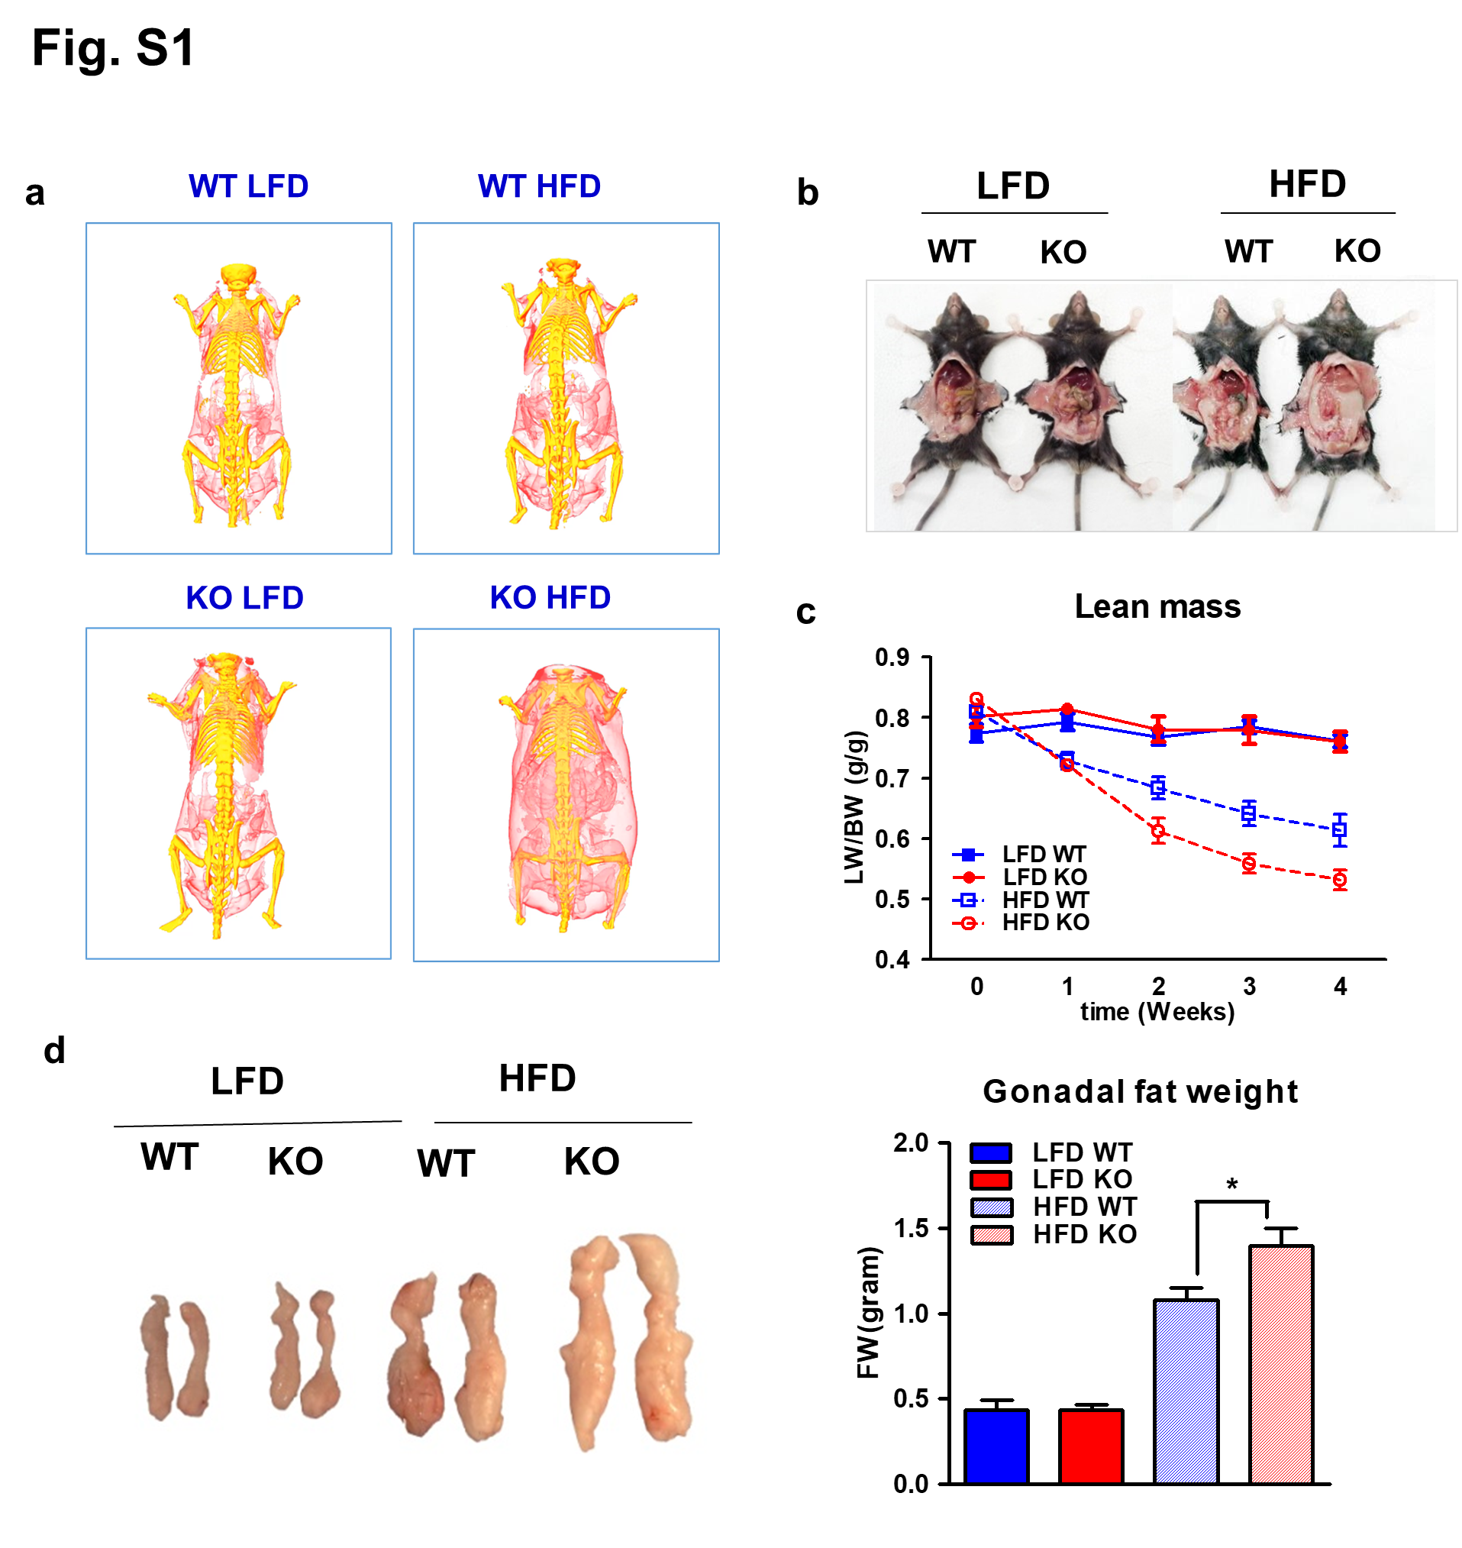
Fig. S1 Increase of fat accumulation by HFD in IDH2KO mice compared to WT mice. Increase of fat accumulation by HFD in IDH2KO mice compared to WT mice. a CT images of representative mice on LFD and HFD for 4 weeks (n = 6 per each group). Red color indicates fat mass. b Photographs of representative mice abdominal fat of each group (LFD-WT, LFD-IDH2KO, HFD-WT, and HFD-IDH2KO mice) after 4 weeks. c Time course of changes in lean mass. d Representative images and fat weight graph showing intra-abdominal fat deposits of b. *p < 0.05 vs. HFD-WT mice.
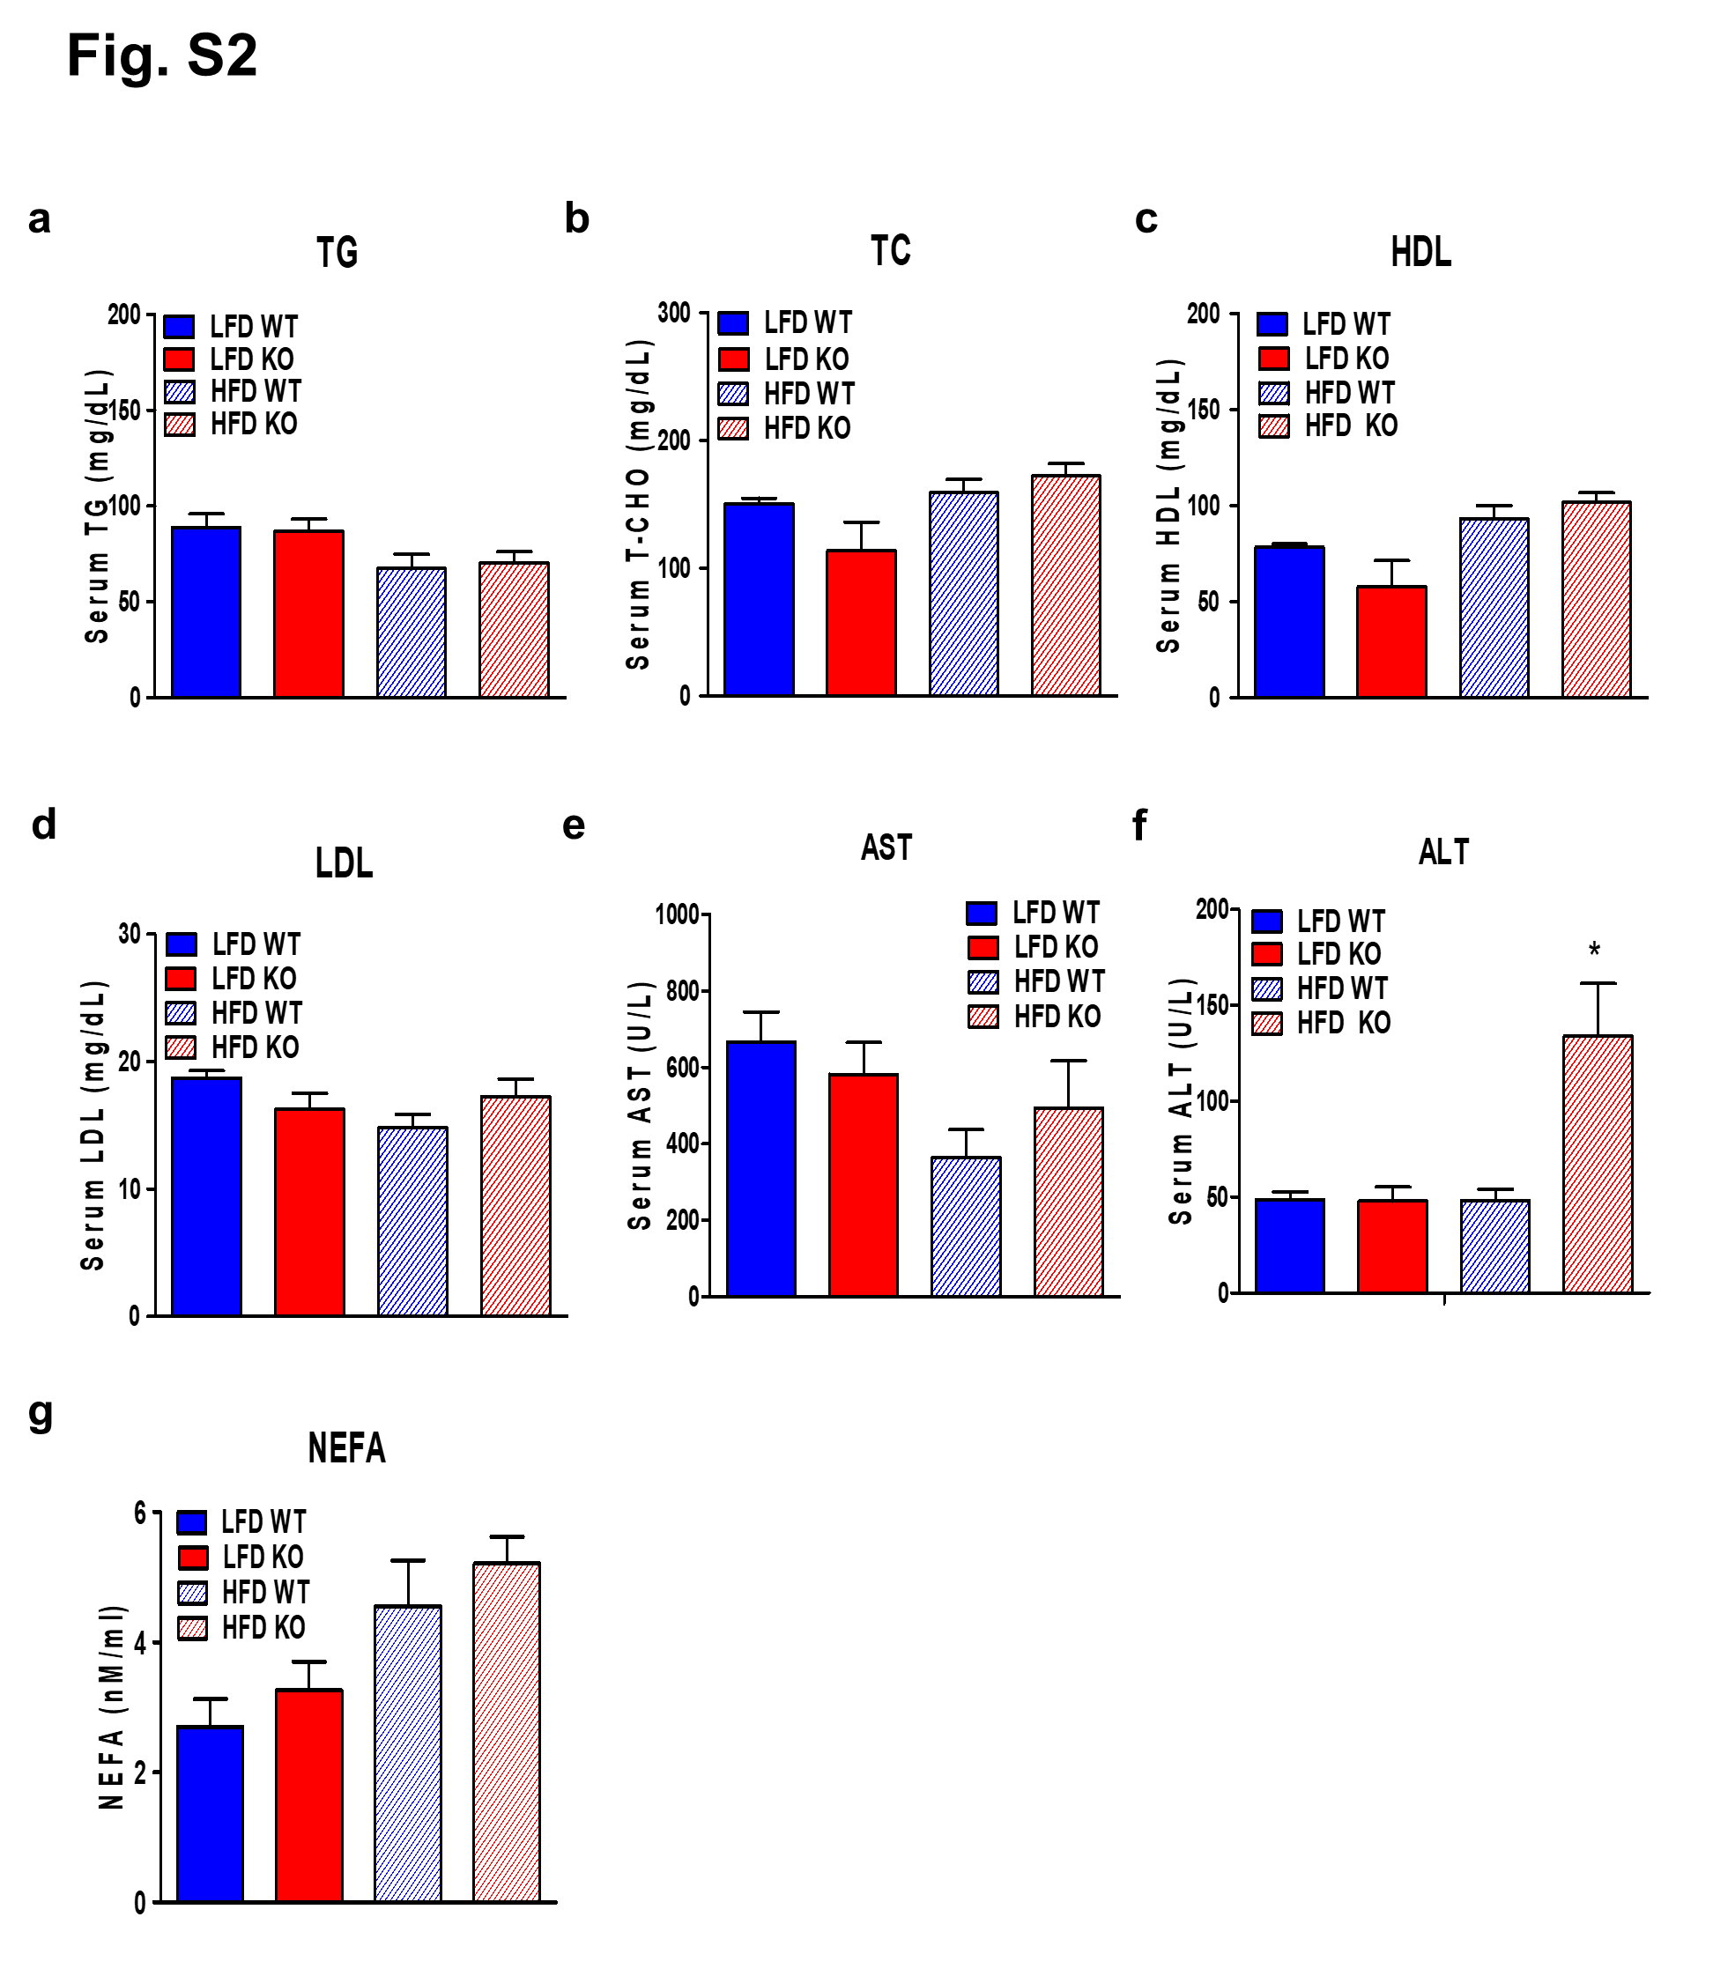
Fig. S2 Effect on serum lipid profiles on an LFD or HFD. a-g Serum lipid and liver toxicity marker profiling analysis of WT and IDH2KO mice after LFD and HFD. *p < 0.05 vs. HFD-WT mice (n = 6 per each group). TG: Total triglyceride, TC: Total cholesterol, HDL: High-density lipoprotein, LDL: Low-density lipoprotein, AST: Aspartate transaminase, ALT: Alanine transaminase, NEFA: Non-esterified fatty acids.

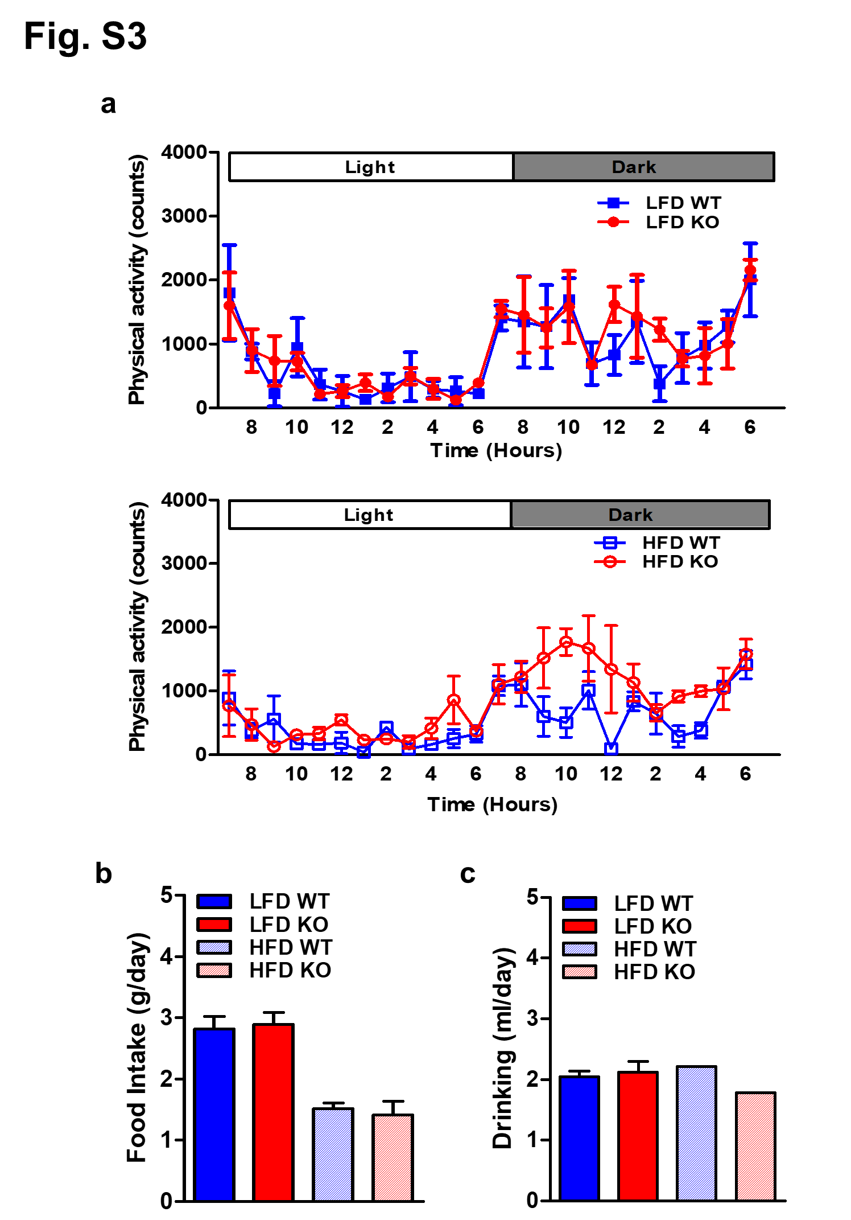
Fig. S3 period, WT and IDH2KO mice fed with LFD and HFD. a Physical activity during 12 h light and dark cycles recorded at the second day after acclimatization in WT and IDH2KO mice fed with LFD and HFD. b, c Average amount of food and water intake over a 24 h (n = 6 per each group).
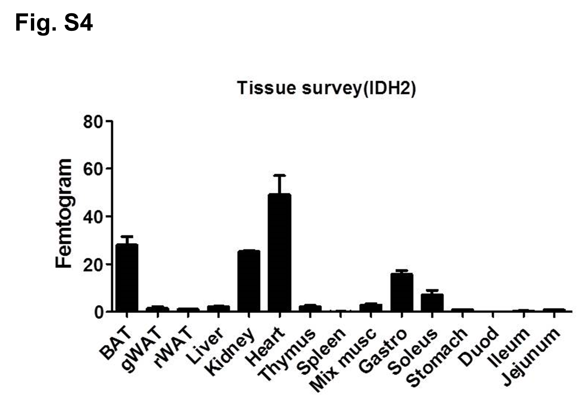
Fig. S4 Tissue survey of IDH2 gene expression level. Total RNA from the indicated tissues were used for qPCR with an internal control DNA standard for quantitation. Values are presented as fg of RNA/ mg total RNA. Data are from pooled RNA samples from WT (n = 5). BAT: brown adipose tissue, gWAT: gonadal white adipose tissue, rWAT: retroperitoneal white adipose tissue, Duod: duodenum.
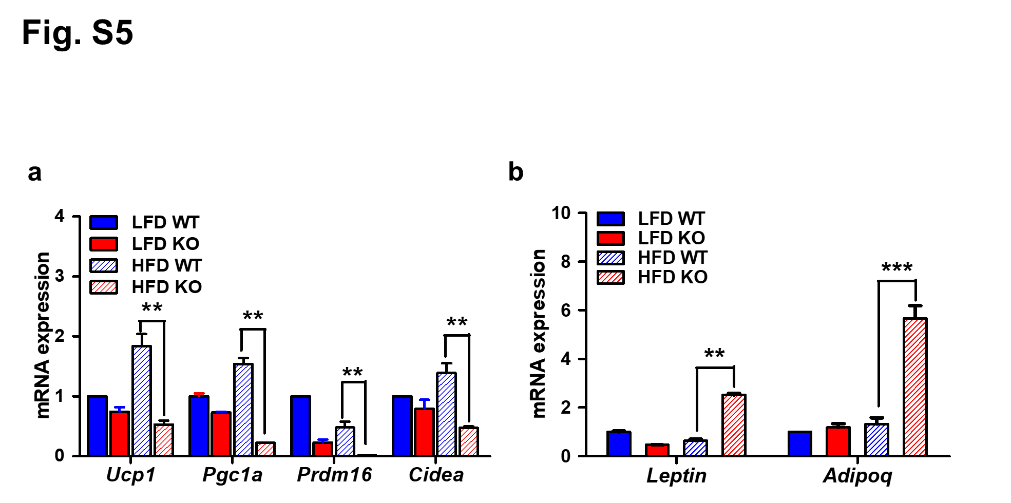
Fig. S5 Gene expression levels in iBAT of HFD-fed mice. a Expression levels of iBAT marker genes in iBAT were assessed by qPCR. b mRNA levels of genes related to WAT in iBAT. Total mRNAs were collected and were analyzed by qPCR with indicated primers. **p < 0.01 and ***p < 0.001 vs. HFD-WT mice. n = 6 per each group.

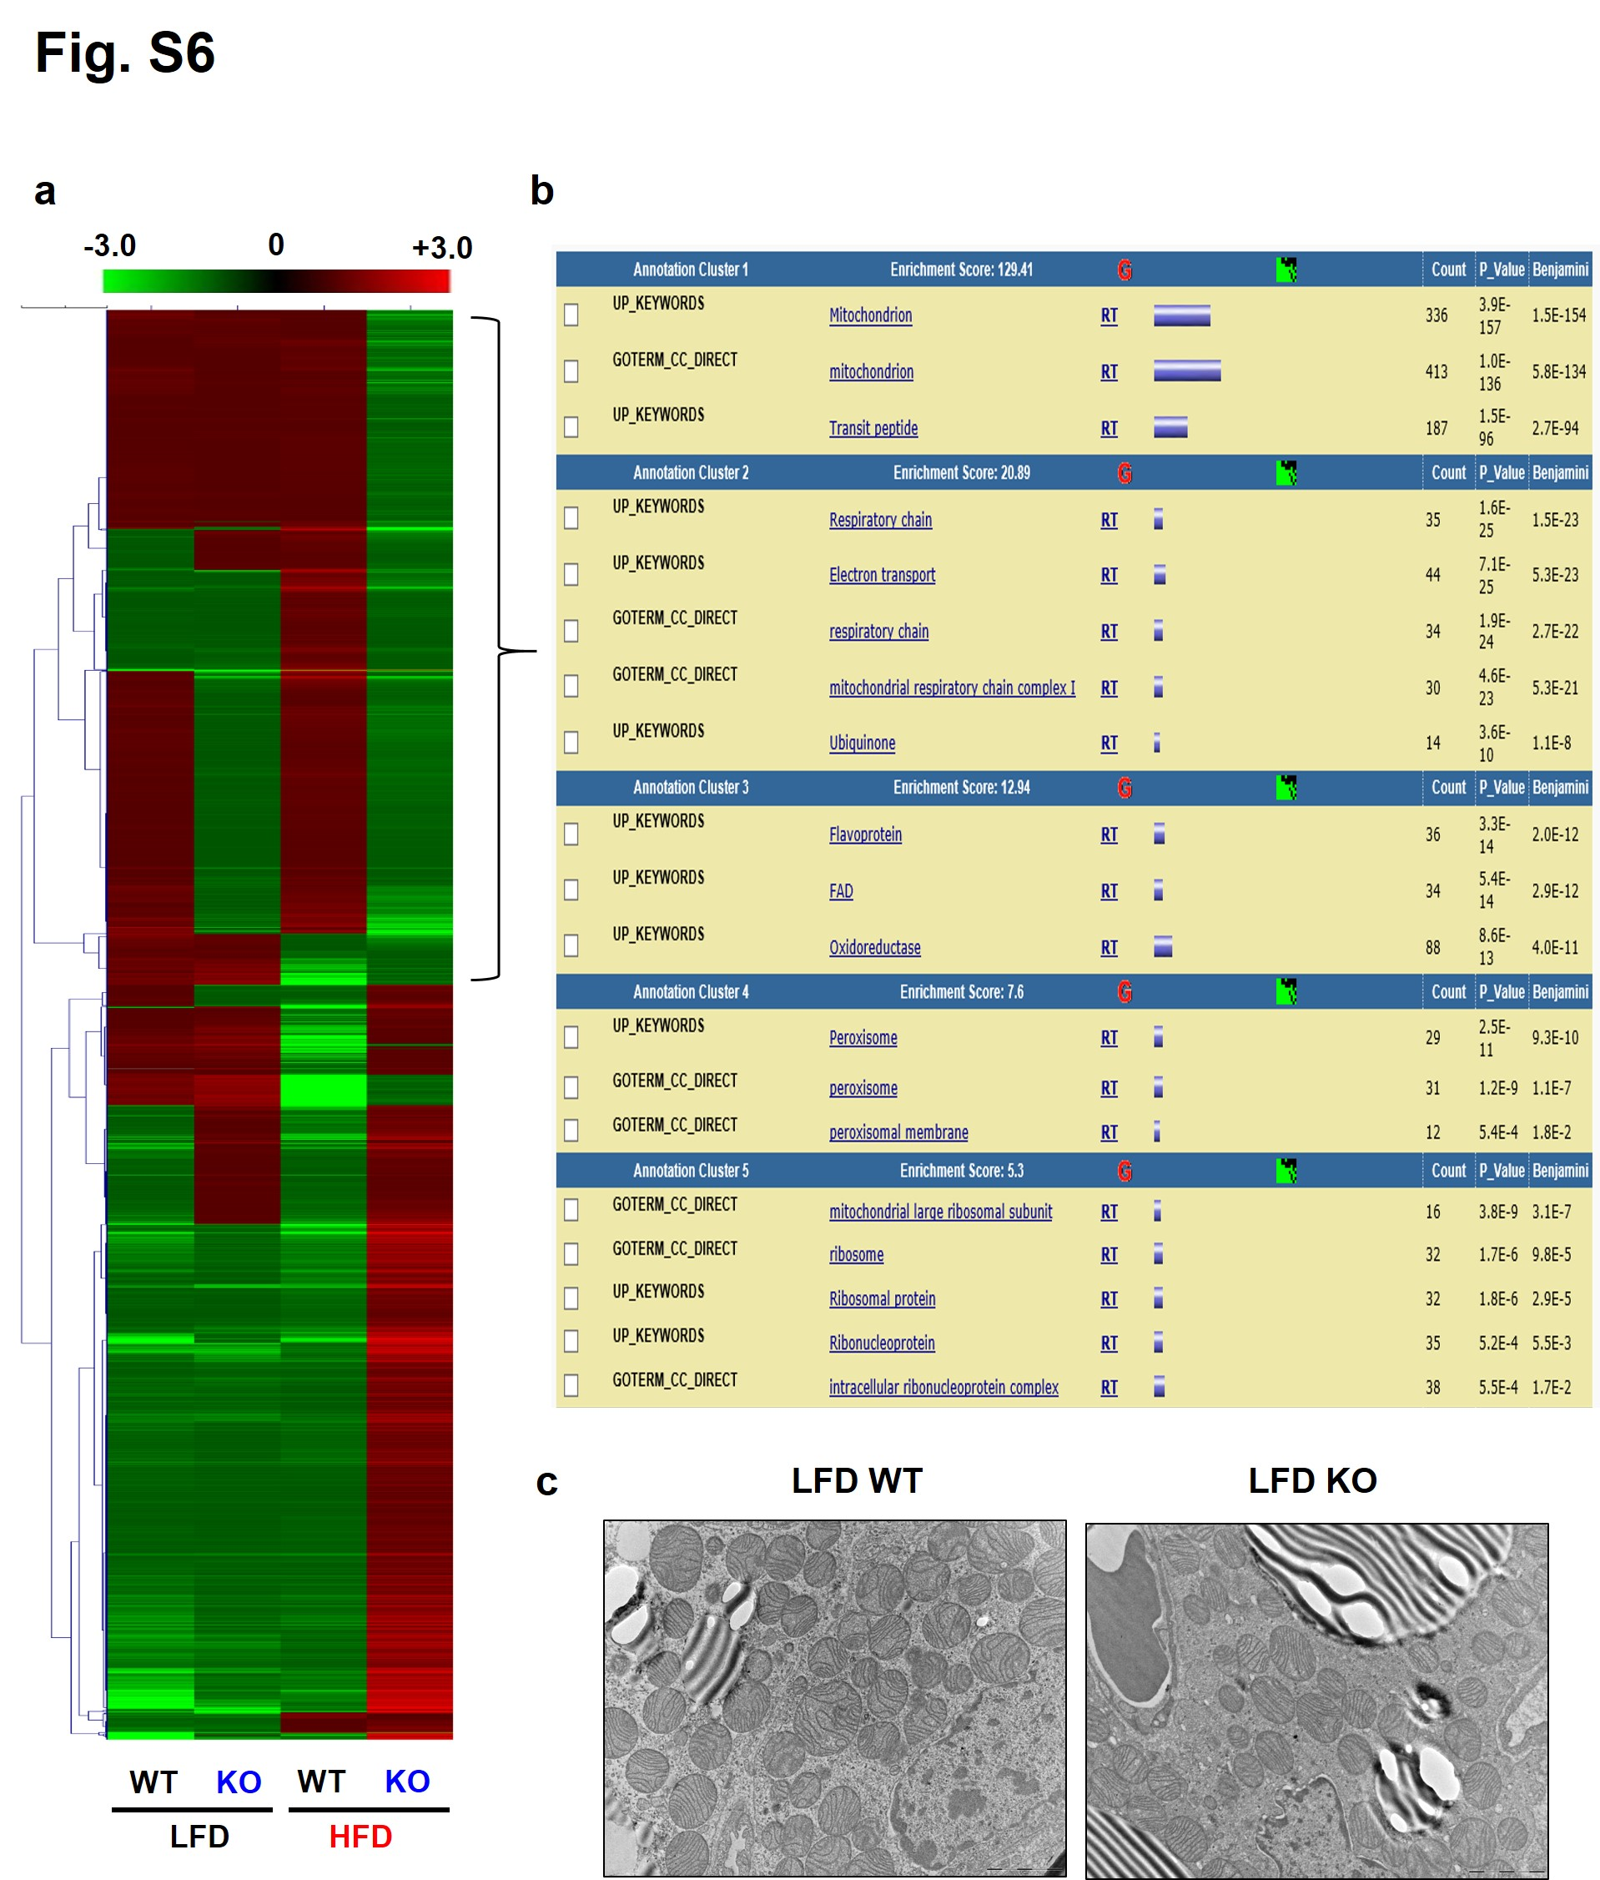
Fig. S6 Heatmap and gene ontology analysis from RNA-Seq data. a Heatmap representation of gene expression from iBAT of WT and IDH2KO mice fed LFD and HFD. b Gene ontology (GO) result in Biological Process (BP) categories. Decreased genes (1396 genes) in HFD KO vs HFD WT from the RNA-seq were imported into DAVID. GO term analysis was performed to identify biological processes enriched among decreased genes. (n = 6 per each group). c Transmission electron microscopy (TEM) showed multiple sphere-shaped mitochondria, which is characteristic of iBAT (n = 5).

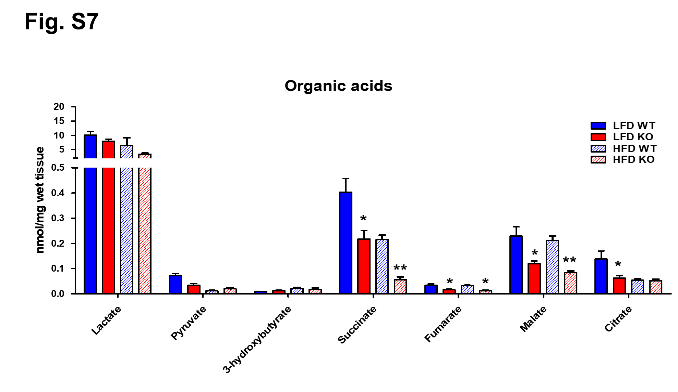
Fig. S7 Organic acids level. Organic acids levels were measured as detailed in materials and methods. *p < 0.05 vs. LFD-WT mice or HFD-WT mice, and **p < 0.001 vs. HFD-fed WT mice.

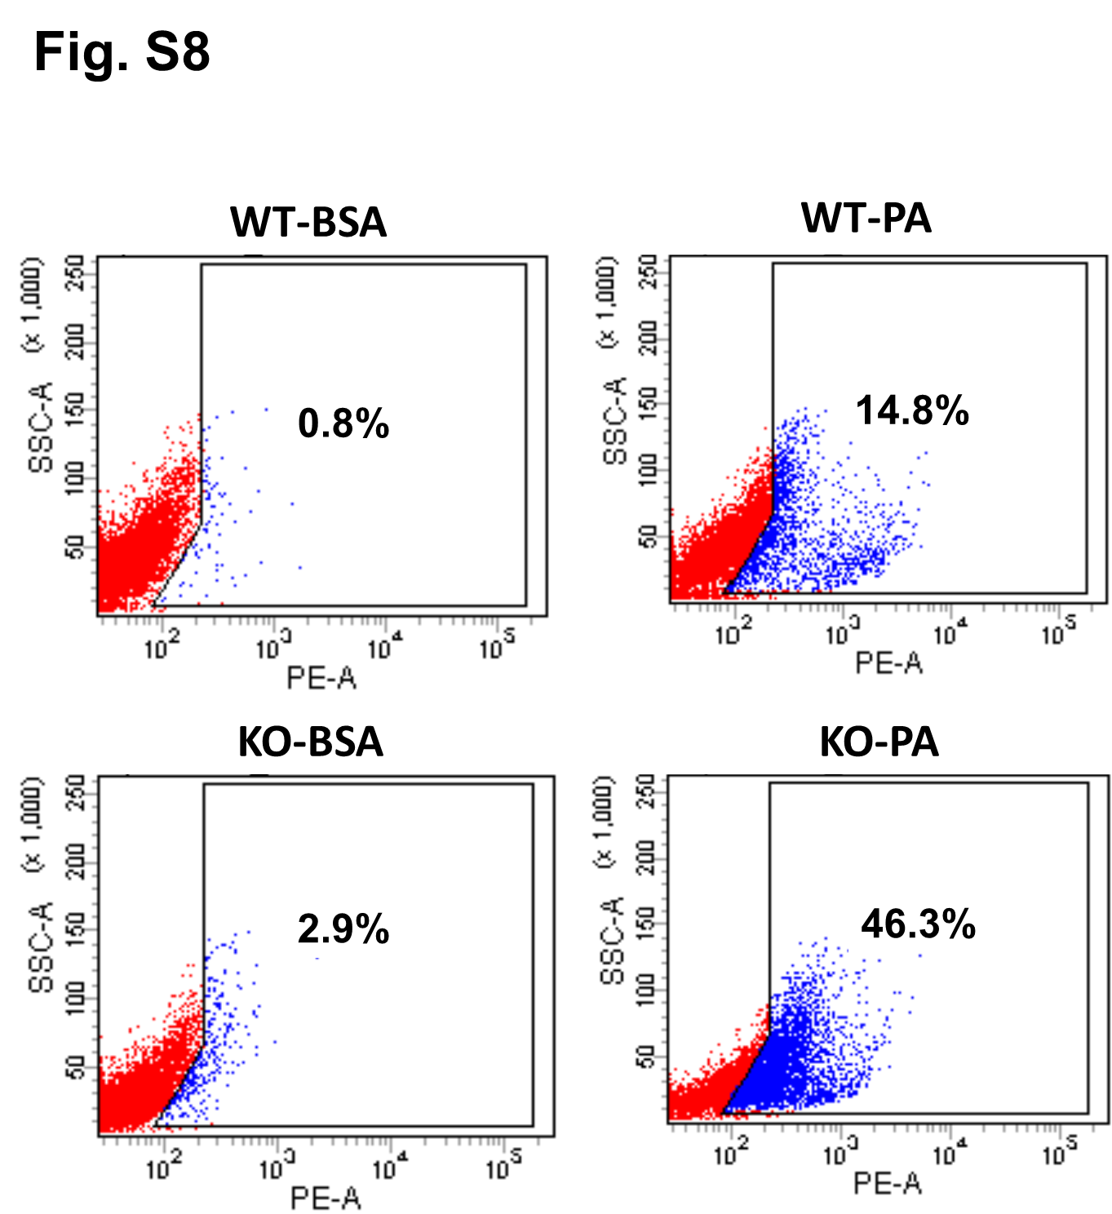
Fig. S8 FACS analysis. Primary brown adipocytes were isolated from WT and IDH2KO mice (n = 3 per each group) and treated with BSA or BSA plus palmitate and stained with MitoSOX Red followed by FACS analysis.

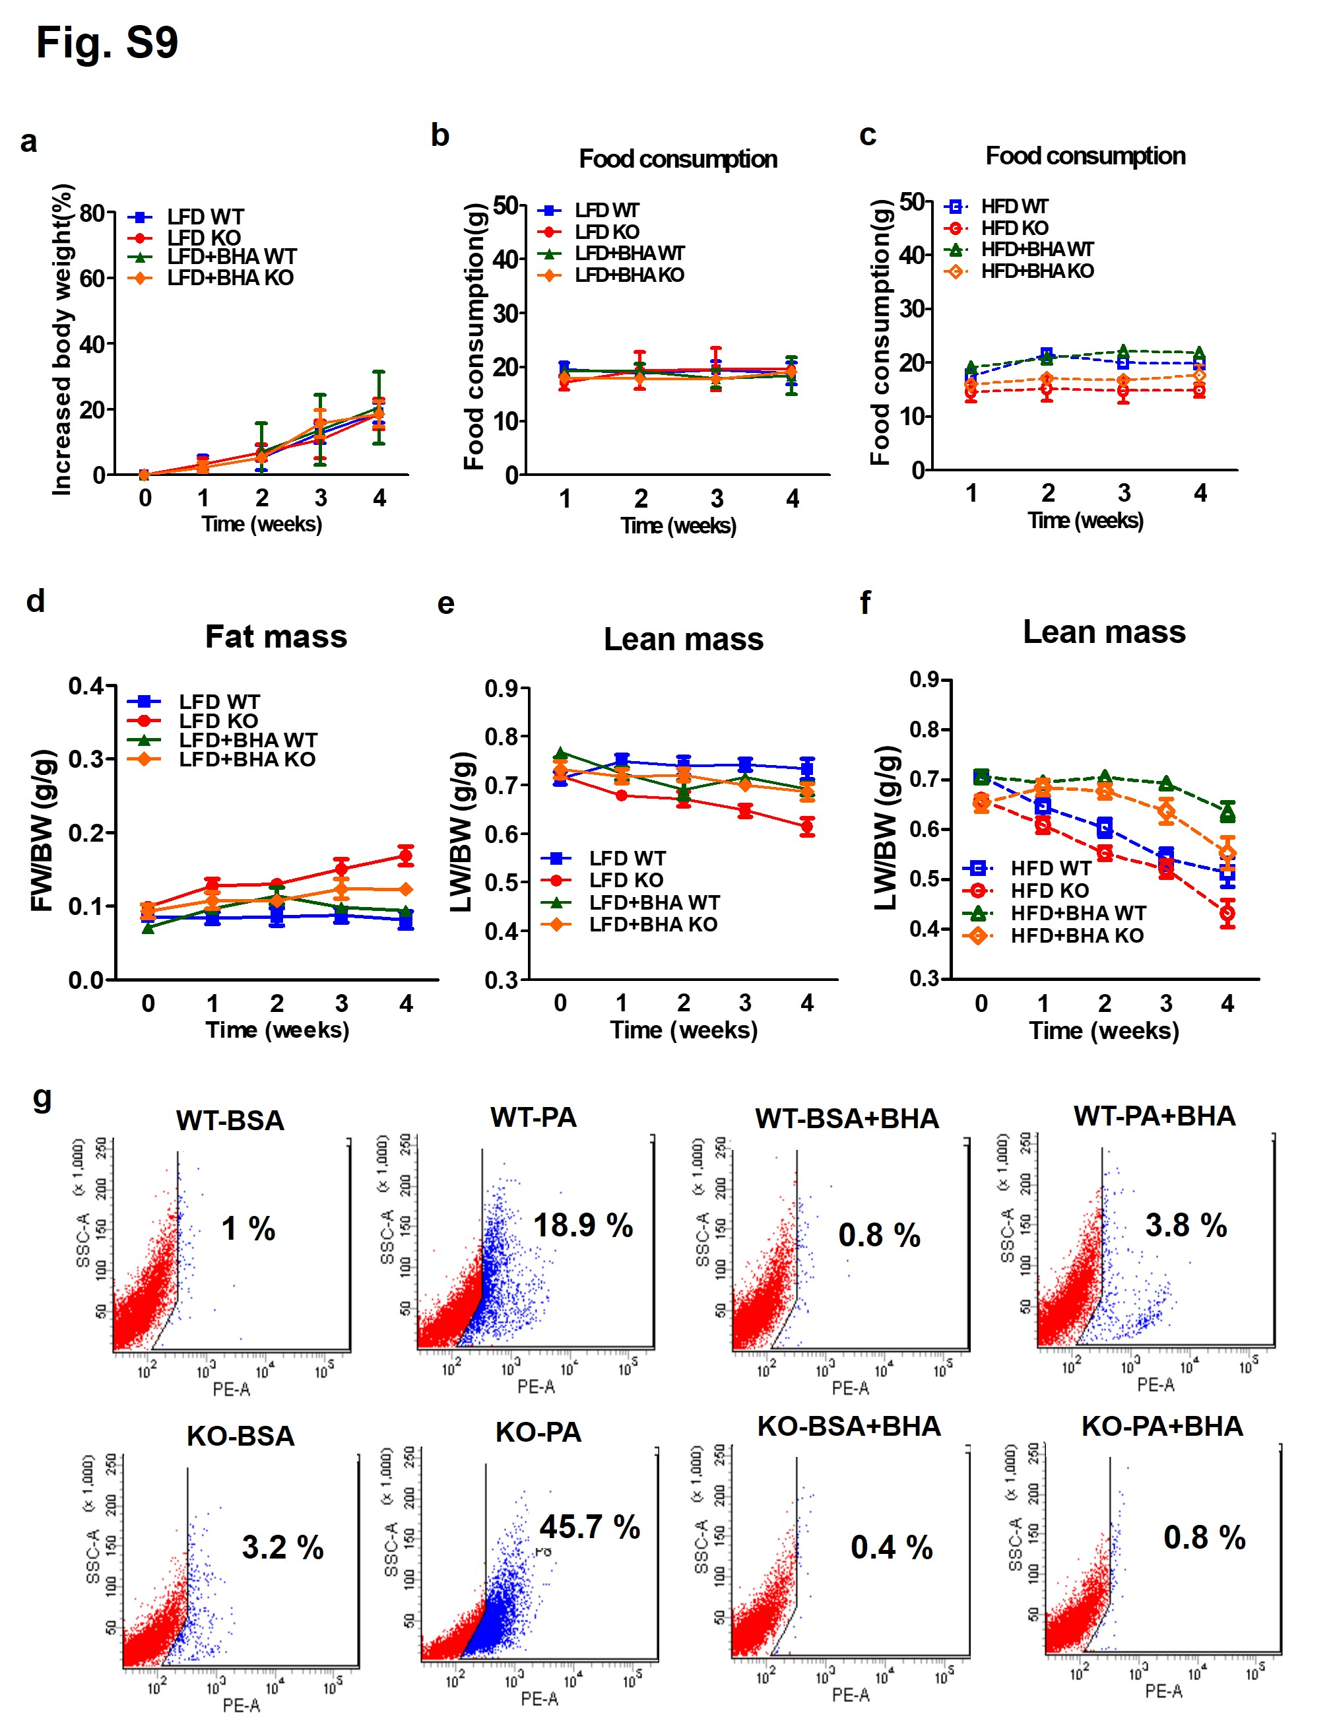
Fig. S9 Energy expenditures and body composition in response to BHA treatment in WT and IDH2KO mice. a Increased body weight. b Food consumption in LFD or LFD plus BHA-fed WT and IDH2KO mice groups. c Food consumption in HFD or HFD plus BHA-fed WT and IDH2KO mice. d-f Fat mass data in LFD and LFD plus BHA-fed WT and IDH2KO mice. Lean mass data in LFD or HFD with control or BHA-fed WT and IDH2KO mice (n = 6 per each group). g Primary brown adipocytes were isolated from WT and IDH2KO mice and treated with BSA or BSA plus palmitate and stained with MitoSOX Red followed by FACS analysis.
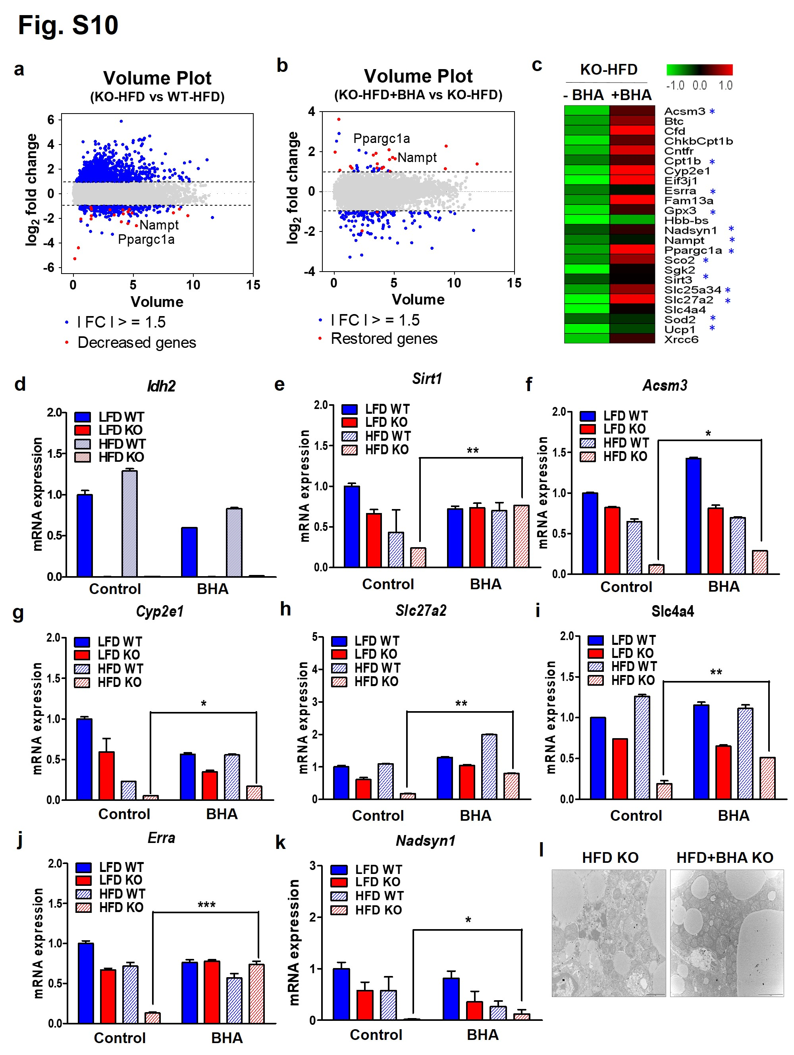
Fig. S10 Gene expression by BHA in BAT. Gene expression by BHA in BAT. RNA-seq was performed as described in methods. WT and IDH2KO mice were fed with HFD plus BHA for 4 weeks. a, b Scatterplot of the gene expression ratio in control versus BHA-treated LFD or HFD-IDH2KO mice. c Heatmap representation of gene expression differences between control and BHA-treated HFD-IDH2KO mice (n = 9 per each group) as determined by RNA sequencing of iBAT. RNAs were isolated from iBAT and gene expression levels for several genes listed in Table S1 were measured by qPCR. d-k Idh2, Sirt1, Acsm3, Cyp2e1, Slc27a2, Slc4a4, Erra, and Nadsyn1. l TEM showed multiple sphere-shaped mitochondria, which is characteristic of iBAT (n = 5). *p < 0.05, **p < 0.01, and ***p < 0.001 vs. HFD-fed WT mice.

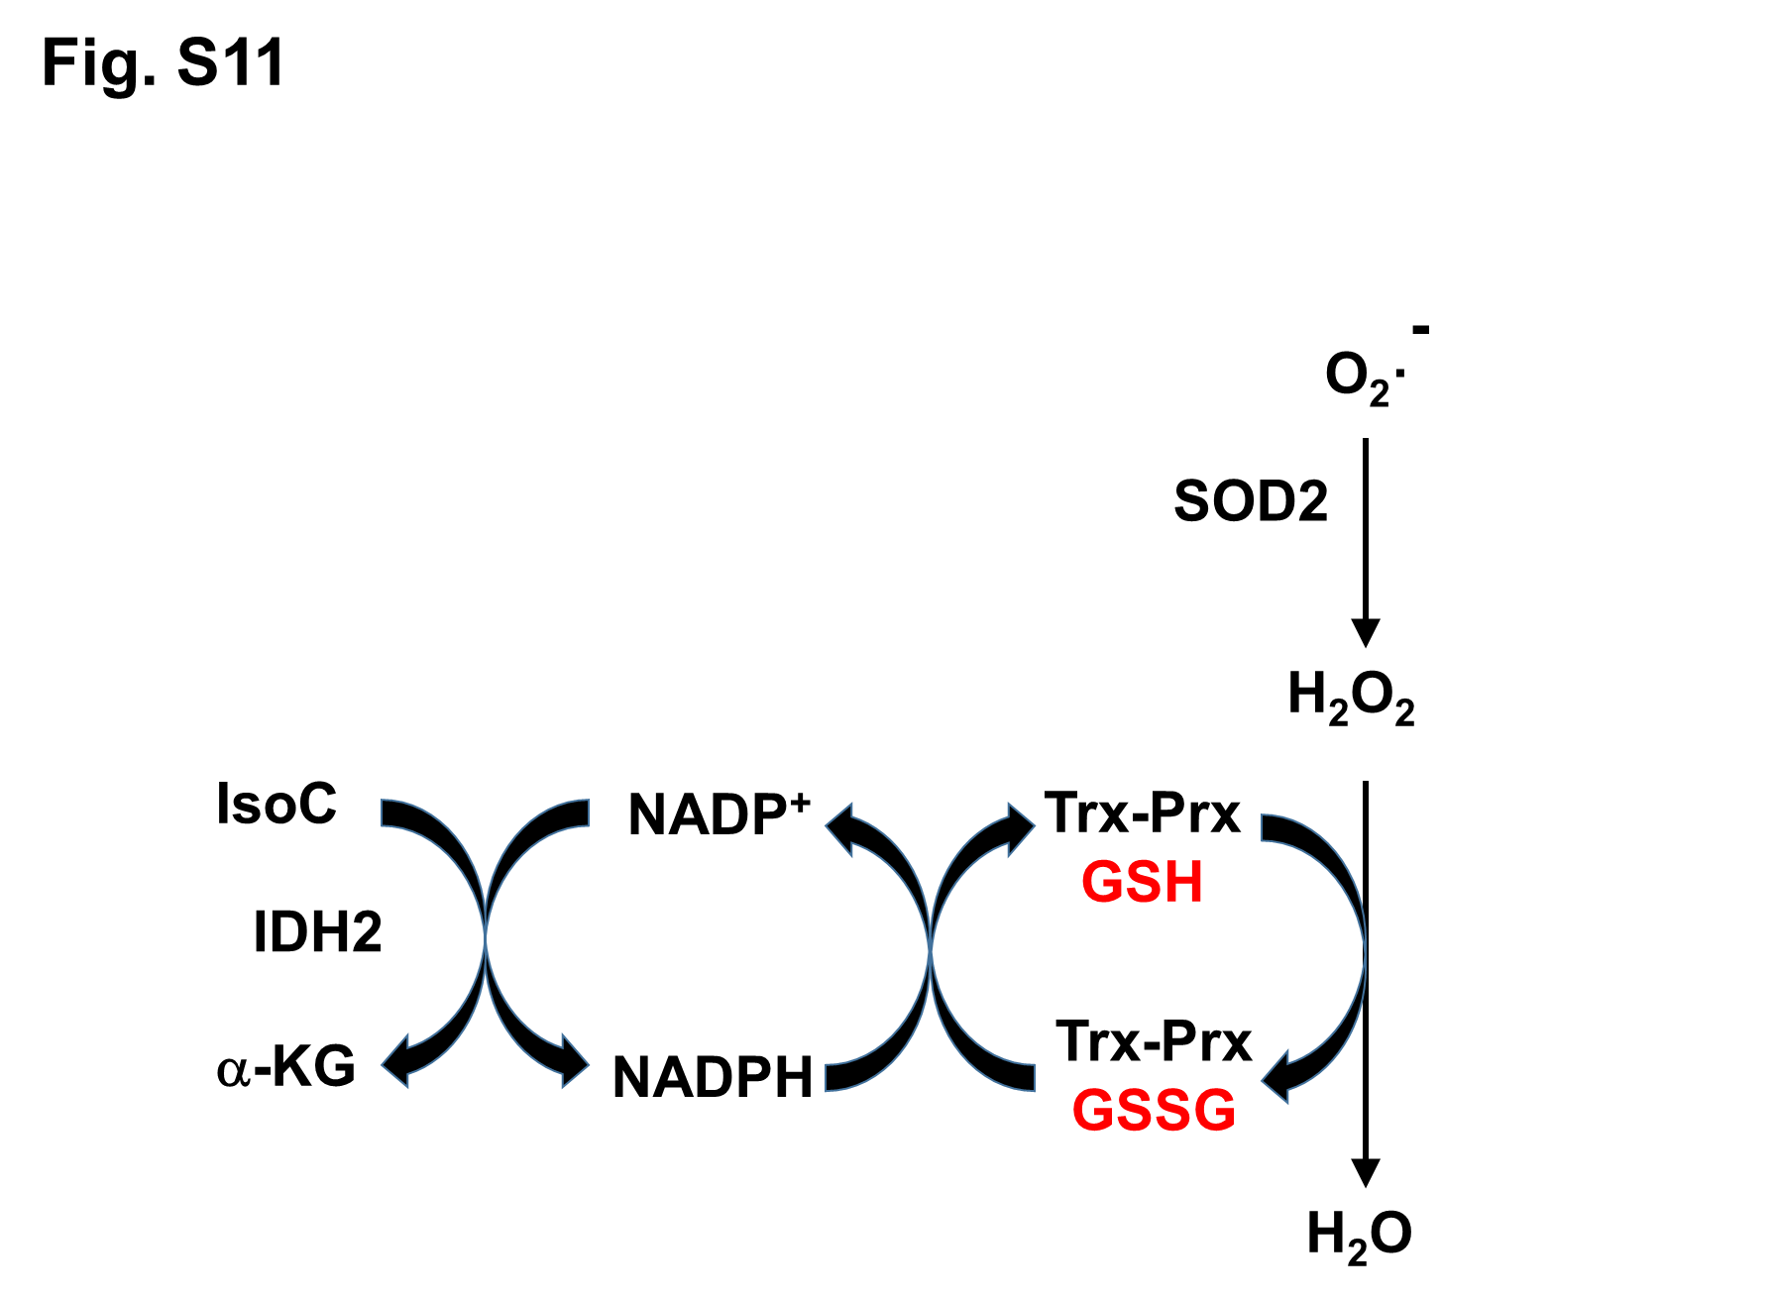
Fig. S11 Scheme of electron flow through thioredoxin and glutathione redox cycles.
Table S1 Genes decreased in HFD-fed KO BAT that were recovered by BHA supplementation.
Number | Transcript_ID | Gene_  Symbol | Gene_Description | HFD_KO/HFD_WT.fc | HFD_BHA_KO/HFD_KO.fc
1 | NM_016870, NM_212442, NM_212441 | Acsm3 | acyl-CoA synthetase medium-chain family member 3 | -3.104 | 2.226
2 | NM_007568 | Btc | betacellulin, epidermal growth factor family member | -2.413 | 2.246
3 | NM_001291915,NM_013459 | Cfd | complement factor D isoform 2 precursor | -2.37 | 4.854
4 | NR_004843 | ChkbCpt1b | Chkb-Cpt1b readthrough transcript (NMD candidate) | -3.458 | 2.398
5 | NM_001136056,NM_016673,NM_001146080 | Cntfr | ciliary neurotrophic factor receptor | -2.777 | 3.041
6 | NM_009948 | Cpt1b | carnitine palmitoyltransferase 1b, muscle | -1.98 | 1.713
7 | NM_021282 | Cyp2e1 | cytochrome P450, family 2, subfamily e, polypeptide 1 | -3.311 | 3.774
8 | NM_144545 | Eif3j1 | eukaryotic translation initiation factor 3, subunit J1 | -20.984 | 12.248
9 | NM_007953 | Esrra | estrogen related receptor, alpha | -1.995 | 1.344
10 | NM_153574 | Fam13a | family with sequence similarity 13, member A | -2.4 | 3.271
11 | NM_008161 | Gpx3 | glutathione peroxidase 3 | -3.44 | 2.208
12 | NM_001201391 | Hbb-bs | hemoglobin, beta adult s chain | -38.779 | 3.934
13 | NM_030221 | Nadsyn1 | NAD synthetase 1 | -1.593412 | 1.438193
14 | NM_021524 | Nampt | nicotinamide phosphoribosyltransferase | -2.023445 | 1.335968
15 | NR_027710, NM_008904 | Ppargc1a | peroxisome proliferative activated receptor, gamma, coactivator 1 alpha | -2.474 | 3.538
16 | NM_001111288 | Sco2 | SCO cytochrome oxidase deficient homolog 2 (yeast) | -2.163 | 2.252
17 | NM_013731, NM_001291152,NM_001291154 | Sgk2 | serine/threonine-protein kinase Sgk2 isoform c | -4.149 | 2.101
18 | NM_001177804,NM_022433,NM_001127351 | Sirt3 | sirtuin 3 | -1.587 | 1.279
19 | NM_001013780 | Slc25a34 | solute carrier family 25, member 34 | -2.472 | 2.324
20 | NM_011978 | Slc27a2 | solute carrier family 27 (fatty acid transporter), member 2 | -4.726 | 4.264
21 | NM_001136260,NM_001197147,NM_018760 | Slc4a4 | solute carrier family 4 (anion exchanger), member 4 | -4.864 | 2.273
22 | NM_013671 | Sod2 | superoxide dismutase 2, mitochondrial | -1.758 | 1.17
23 | NM_009463 | Ucp1 | uncoupling protein 1 (mitochondrial, proton carrier) | -3.82 | 1.618
24 | NM_010247 | Xrcc6 | X-ray repair complementing defective repair in Chinese hamster cells 6 | -2.967 | 2.02

Table S2 Primer sequences for qPCR.
Name |  | Sequence(5’→3’)
Ucp1 | F | GGATGGTGAACCCGACAACT
 | R | AACTCCGGCTGAGAAGATCTTG
Pgc1α | F | AACAAGCACTTCGGTCATCCCTG
 | R | TTACTGAAGTCGCCATCCCTTAG
Prdm16 | F | CAGCACGGTGAAGCCATTC
 | R | GCGTGCATCCGCTTGTG
Cidea | F | GCAGGAACTTATCAGCAAGA
 | R | CGTAACCAGGCCAGTTGTGAT
Leptin | F | ATTTCACACACGCAGTCGGTAT
 | R | GGTGAAGCCCAGGAATGAAG
Adipoq | F | GGCCGTTCTCTTCACCTACG
 | R | TGGAGGAGCACAGAGCCAG
Cpt1β | F | GCACACCAGGCAGTAGCTTT
 | R | CAGGAGTTGATTCCAGACAGGTA
Atp5β | F | GGTTCATCCTGCCAGAGACTA
 | R | AATCCCTCATCGAACTGGACG
Cox8b | F | TGTGGGGATCTCAGCCATAGT
 | R | AGTGGGCTAAGACCCATCCTG
Erra | F | CTCAGCTCTCTACCCAAACGC
 | R | CCGCTTGGTGATCTCACACTC
Sirt1 | F | GCAGATTAGTAGGCGGCTTG
 | R | TCTCCATCAGTCCCAAATCC
Sirt2 | F | GCCTGGGTTCCCAAAAGGAG
 | R | GAGCGGAAGTCAGGGATACC
Sirt3 | F | ATCCCGGACTTCAGATCCCC
 | R | CAACATGAAAAAGGGCTTGGG
Nampt | F | GCAGAAGCCGAGTTCAACATC
 | R | TTTTCACGGCATTCAAAGTAGGA
Nads1 | F | ACGGCTGCTCACTACTTGTTA
 | R | CTGAGAACCGAGGCAACTTC
Cat | F | AATCCTACACCATGTCGGACA
 | R | CGGTCTTGTAATGG AACTTGC
Gpx3 | F | CCTTTTAAGCAGTATGCAGGCA
 | R | CAAGCCAAATGGCCCAAGTT
Sod2 | F | GCACATTAACGCGCAGATCA
 | R | AGCCTCCAGCAACTCTCCTT
Idh1 | F | ATGCAAGGAGATGAAATGACACG
 | R | GCATCACGATTCTCTATGCCTAA
Idh2 | F | GGAGAAGCCGGTAGTGGAGAT
 | R | GGTCTGGTCACGGTTTGGAA
Idh3a | F | TGGGTGTCCAAGGTCTCTC
 | R | CTCCCACTGAATAGGTGCTTTG
Idh3β | F | TGGAGAGGTCTCGGAACATCT
 | R | AGCCTTGAACACTTCCTTGAC
Idh3γ | F | GGTGCTGCAAAGGCAATGC
 | R | TATGCCGCCCACCATACTTAG
Acsm3 | F | CTTTGGCCCCAGCAGTAGATG
 | R | GGCTGTCACTGGCATATTTCAT
Cyp2e1 | F | CGTTGCCTTGCTTGTCTGGA
 | R | AAGAAAGGAATTGGGAAAGGTCC
Slc27a2 | F | TCCTCCAAGATGTGCGGTACT
 | R | TAGGTGAGCGTCTCGTCTCG
Slc4a4 | F | GAAGGTCACCACACGATCTACA
 | R | TCCACATCAGATTTGTCGGAGT

