Supplementary Data
Supplementary Fig. 1 Experimental design. Experiment 1: FMT study. Experiment 2: Diet study. Experiment 3: FMT and Fiber diet study. Experiment 4: SCFAs study. CTL, control; E, emphysema; FMT, Fecal microbial transplantation; SCFAs, short chain fatty acids.

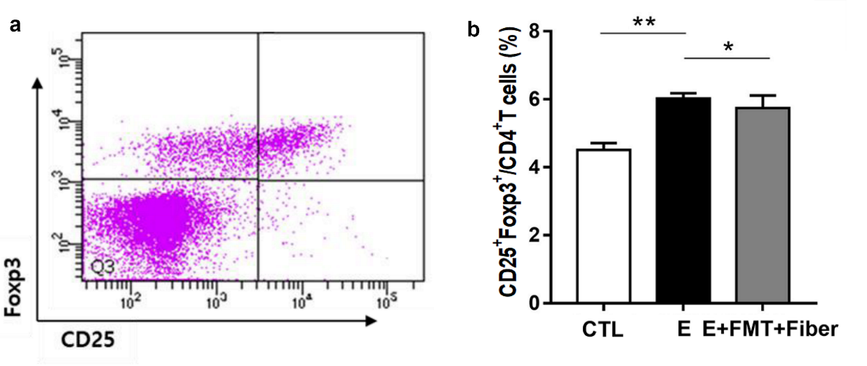
Supplementary Fig. 2 Fluorescence-assisted Cell Sorting (FACS) analysis. a Representative gating image are shown. b Percentage of CD25+Foxp3+ T cells retrieved from spleens. (n = 6 mice per group; n = 4 control mice. Values are expressed as the mean ± SE. *P < 0.05 and **P < 0.01. CTL = control; E = Emphysema; FMT = Fecal microbial transplantation.

Supplementary Table 1. Quantitative PCR primer sequences
Gene | Forward/reverse | Primer sequence 5′-3′
Actin | Forward
  AAGAGCTATGAGCTGCCTGA
Actin | Reverse
  CACAGGATTCCATACCCAAG
IFN-γ | Forward | AAGCGTCATTGAATCACACCTG
IFN-γ | Reverse | TGACCTCAAACTTGGCAATACTC
IL-1β | Forward | CCAAGCAACGACAAAATACC
IL-1β | Reverse | GTTGAAGACAAACCGTTTTTCC
TGF-β | Forward | CTGCTGACCCCCACTGATAC
TGF-β | Reverse | GTGAGCGCTGAATCGAAAGC
TNF-α | Forward | GACAGTGACCTGGACTGTGG
TNF-α | Reverse | TGAGACAGAGGCAACCTGAC
IL-6 | Forward | TGTGCAATGGCAATTCTGAT
IL-6 | Reverse | GGTACTCCAGAAGACCAGAGGA
IL-8 | Forward | TTGGTGATGCTGGTCATCTT
IL-8 | Reverse | TTTAGATGCAGCCCAGACAG
IL-18 | Forward | GCTGTGACCCTCTCTGTGAA
IL-18 | Reverse | GGCAAGCAAGAAAGTGTCCT
MMP-9 | Forward | CTGGACAGCCAGACACTAAAG
MMP-9 | Reverse | CTCGCGGCAAGTCTTCAGAG
MMP-12 | Forward | GGCCATTCCTTGGGGCTGCA
MMP-12 | Reverse | GGGGGTTTCACTGGGGCTCC
IRF-5 | Forward | GCTGGCTACAGGGTTCTGAG
IRF-5 | Reverse | CTGCTGGCTTCATTTCTTCC
Cathepsin S | Forward | GCCAGCCATTCCTCCTTCTT
Cathepsin S | Reverse | AGCCAACCACAAGAACACCA
IFN-γ, interferon-γ; IL, interleukin; TGF-β, transforming growth factor-β; TNF-α, tumor necrosis factor-α; MMP, matrix metalloproteinase; IRF-5, interferon regulatory factor-5

