Ahnak deficiency attenuates high-fat diet-induced fatty liver in mice through FGF21 induction
(Running title: Ahnak regulates hepatic lipid metabolism)
Yo Na Kim^{1,2}, Jae Hoon Shin^{1,2}, Dong Soo Kyeong^{1,2,3}, Soo Young Cho⁴, Mi-Young Kim², Hee Jung Lim^{1,2,6}, Maria Raquel Rojas Jimenez^{1,2}, Il Yong Kim^{1,2}, Mi-Ock Lee⁵, Yun Soo Bae⁶, Je Kyung Seong^{1,2,3}

Contents
- Supplementary table
- Supplementary figures

- Supplementary Table
Supplementary Table 1. Sequence of Primers Used for Real-Time Quantitative PCR.
Symbol | Primer sequence (5' to 3')
Acadm | GCAGCTGGCGCTGTCGGGCT
Acadm | CGGCGTCAGTGGCTAGCTGATTG
Acox1 | CCTGATTCAGCAAGGTAGGG
Acox1 | TCGCAGACCCTGAAGAAATC
Acsl1 | ACCATCAGTGGTACCCGCTA
Acsl1 | CGCTCACCACCTTCTGGTAT
Ahnak1 | GCCAAAGGAAACAAACACC
Ahnak1 | AAATAAGCCCACATCCCATC
Ahnak2 | ATGTCAAAGCAAAAGGCTTG
Ahnak2 | GTGTCCCACAGAGGATTCAG
ApoB100 | CGTGGGCTCCAGCATTCTA
ApoB100 | CCAATGGTCGGGCACTGCT
Ccl2 | ATTGGGATCATCTTGCTGGT
Ccl2 | CCTGCTGTTCACAGTTGCC
Ccl3 | ACTGCCTGCTTCTCCTACA
Ccl3 | AGGAAAATGACACCTGGCTGG
Cd36 | ATTGGTCAAGCCAGCT
Cd36 | TGTAGGCTCATCCACTAC
Cd68 | CTTCCCACAGGCAGCACAG
Cd68 | AATGATGAGAGGCAGCAAGAGG
Cpt1a | AGTGGCCTCACAGACTCCAG
Cpt1a | GCCCATGTTGTACAGCTTCC
Dgat1 | TCACCACACACCAATTCAGG
Dgat1 | GACGGCTACTGGGATCTGA
Dgat2 | TCTCAGCCCTCCAAGACATC
Dgat2 | GCCAGCCAGGTGAAGTAGAG
Elovl6 | GGAGCAGAGGCGCAGAGAAC
Elovl6 | GAGCGGCTTCCGAAGTTCAA
F4/80 | CTTTGGCTATGGGCTTCCAGTC
F4/80 | GCAAGGAGGACAGAGTTTATCGTG
Fabp1 | CCCGAGGACCTCATCCAGAA
Fabp1 | CCCCAGGGTGAACTCATTGC
Fabp4 | TTCGATGAAATCACCGCAGA
Fabp4 | AGGGCCCCGCCATCT
Fasn | GCTGCGGAAACTTCAGGAAAT
Fasn | AGAGACGTGTCACTCCTGGACTT
Gpam | GCCAGCAAGTCCTGCGCTAT
Gpam | CCTGCTCGTGTGGGTGATTG
Hmgcs2 | ATACCACCAACGCCTGTTATG
Hmgcs2 | CAATGTCACCACAGACCACCA
Il6 | ACCAGAGGAAATTTTCAATAGGCT
Il6 | GATGCACTTGCAGAAAACA
Mcp1 | CTTCTGGGCCTGCTGTTCA
Mcp1 | CCAGCCTACTTGGGATCA
Mgat1 | CCAGCGCAAAGGGTTTGTT
Mgat1 | CACCAAAAGAAAATACTGGAACCA
Mttp | GACCACCCTGGATCTCCATA
Mttp | AGCGTGGTGAAAGGGCTTAT
Pgc1α | AGCCGTGACCACTGACAACGA
Pgc1α | GCTGCATGGTTCTGAGTGCTA
Pparγ1 | TCTTCCATCACGGAGAGGTC
Pparγ1 | GATGCACTGCCTATGAGCAC
Pparγ2 | CCAGAGCATGGTGCCTTCGCT
Pparγ2 | CAGCAACCATTGGGTCAGCTC
Pparα | CAGTGGGGAGAGAGGACAGA
Pparα | AGTTCGGGAACAAGACGTTG
Tnfα | ATGGCGTTTCCGAATTCAC
Tnfα | GAGGCAACCTGACCACTCTC
36B4 | GAGGAATCAGATGAGGATATGGGA
36B4 | AAGCAGGCTGACTTGGTTGC

2. Supplementary Figures

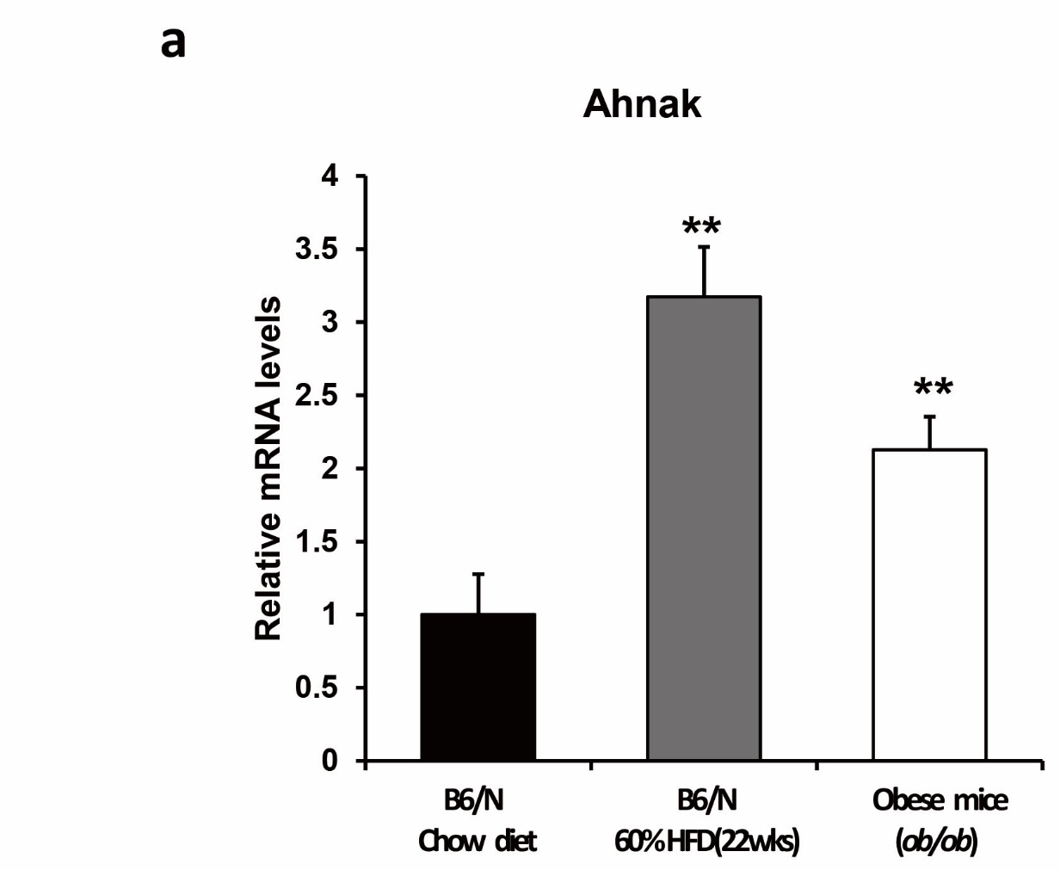
Supplementary Figure 1. Ahnak mRNA expression increases in the liver of diet-induced and genetically obese mice.
Relative mRNA expression of Ahnak was measured using quantitative real-time PCR in the liver of DIO and genetically obese mice.

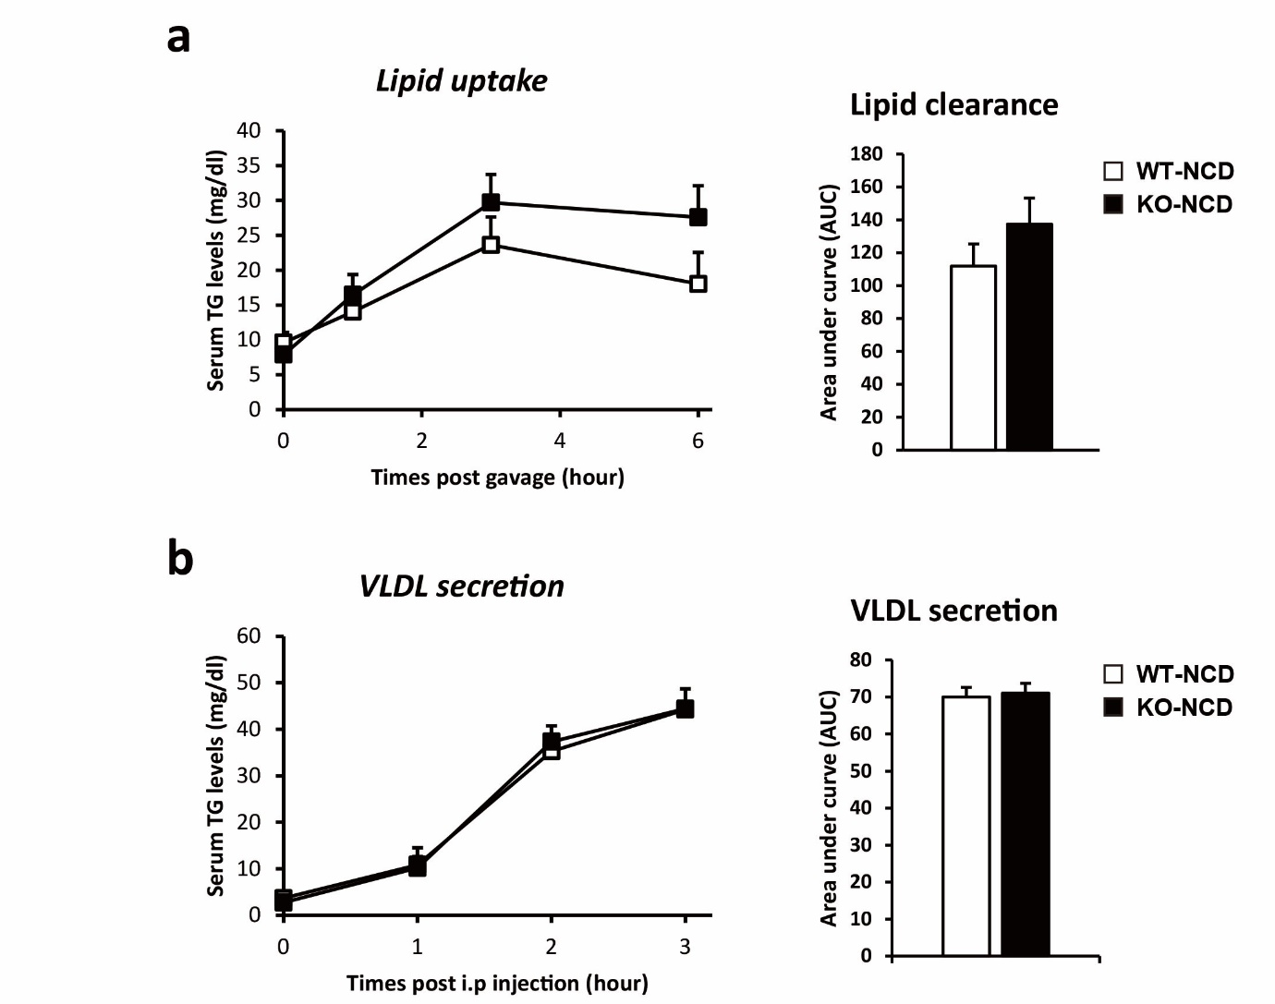
Supplementary Figure 2. Measurement of lipid clearance and VLDL secretion in NCD-fed Ahnak-deficient mice
(a) Lipid clearance was estimated by measuring blood TG levels after oral olive oil administration. (b) VLDL secretion. Mice were treated with Poloxamer 407 in order to block VLDL clearance, and VLDL secretion was estimated by measuring blood TG levels after Poloxamer 407 treatment. Data are presented as the means ±SEM. * p< 0.05; ** p<0.01.

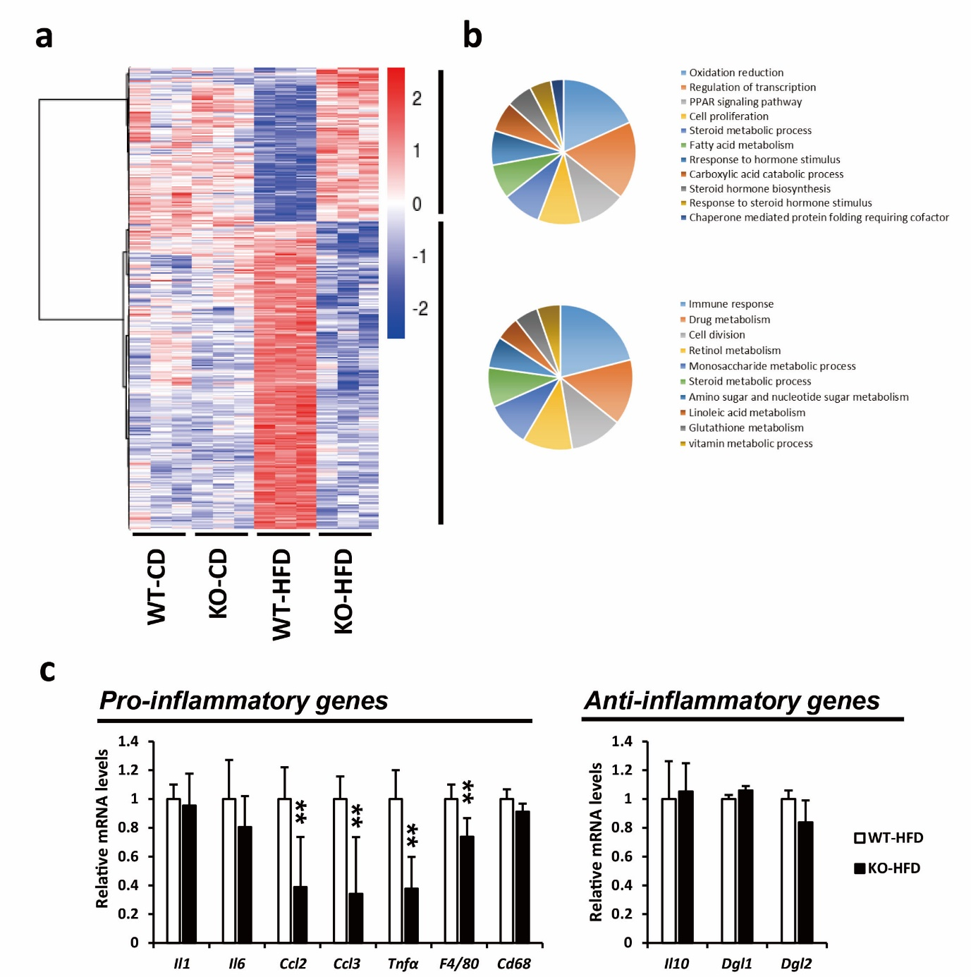
Supplementary Figure 3. Differential gene expression that is observed between the livers of NCD- and HFD-fed WT and Ahnak KO mice as determined by microarray analysis.
(a) Hierarchical clustering of samples using Ward with average linkage. Dendrogram and heat maps show replicate group similarity with differential and reproducible gene expression patterns between each group. (b) Ontology diagrams from up- and downregulated differential expression gene (DEG) greater than 1.5-fold in the liver of HFD-fed Ahnak KO mice compared with WT mice. The number of genes in each ontology category has been indicated. (c) Relative mRNA expression of hepatic genes involved in the inflammation response was measured using quantitative real-time PCR. Data are presented as the means ±SEM. * p < 0.05; ** p < 0.01.
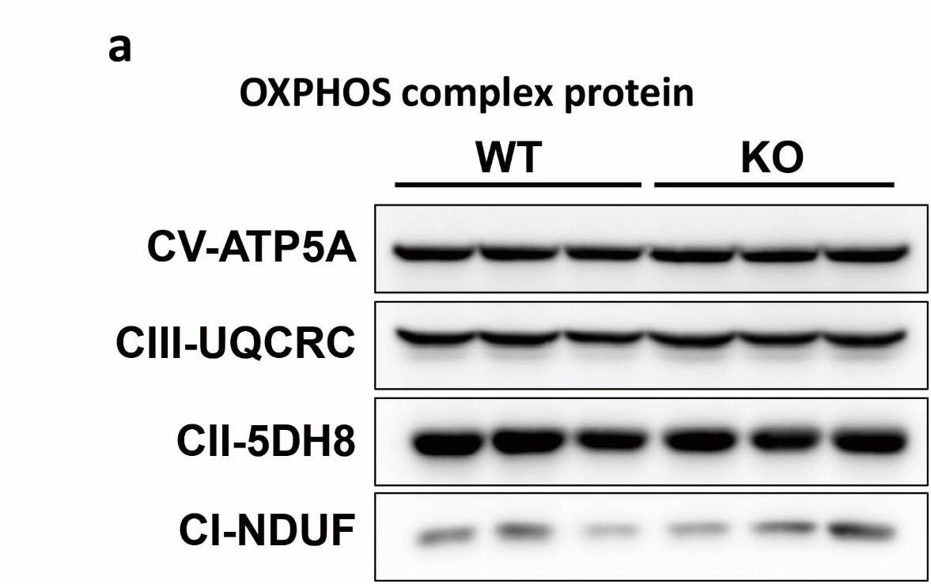
Supplementary Figure 4. Immunoblots of OXPHOS complex proteins
(a) Immunoblots for protein expression involved in the OXPHOS complex.

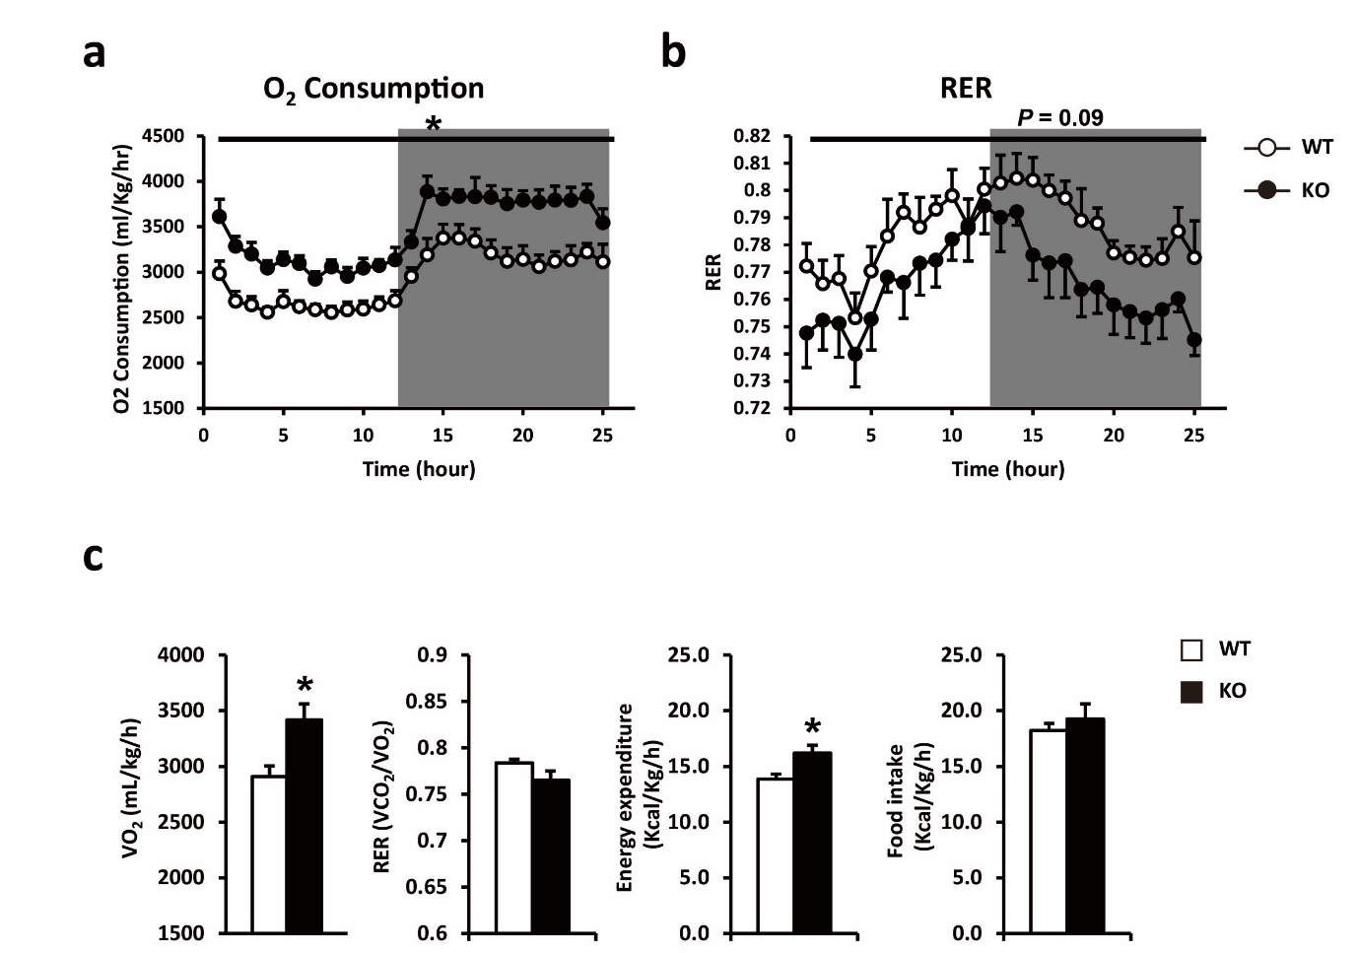
Supplementary Figure 5. Whole-body energy expenditure increases in HFD-fed Ahnak KO mice.
Metabolic parameters were determined using indirect calorimetry with Ahnak KO mice corresponding to wild-type littermates which were fed an HFD for 8 weeks. (a) O₂ consumption, (b) energy expenditure, and (c) quantitative values of VO₂, RER, energy expenditure, and food intake. Data are presented as the means ±SEM (n = 5). * p < 0.05

