SUPPLEMENTARY MATERIALS

Pan-Src kinase inhibitor treatment attenuates diabetic kidney injury via inhibition of Fyn kinase-mediated endoplasmic reticulum stress
Debra Dorotea¹, Songling Jiang¹, Eun Seon Pak¹, Jung Beom Son², Hwan Geun Choi², Sung-Min Ahn³, and and Hunjoo Ha^{1*}

Supplementary Fig. 1. Src kinase is not corellated to diabetic kidney disease. The corelation of Src transcript level with a albumin/creatinine ratio (ACR) and b plasma fasting blood glucose (FBG) from Hodgin dataset (GSE33744) that includes control and db/db mice.

Supplementary Fig. 2. Biochemical pathways enriched in human diabetic kidney. Dataset analysis of Woroniecka Tubulointl Diabetes Study (GSE30122). a mRNA expression of FYN and unfolded protein response (UPR)-related genes. b Statistically significant enrichment of Reactome pathways for differentially expressed genes in the diabetic tubules. FDR p-value < 0.05.

Supplementary Fig. 3. Knockdown of Fyn does not suppress phosphorylated PERK in HG-Pal-induced mProx24 cells. mProx24 cells were treated with HG-Pal for 10 h. Cell lysates were subject to immunoblot analysis. a Representative immunoblots of ATF6α and phosphorylated PERK. d The specificity of Fyn and e Lyn siRNA was examined. f Representative immunoblots of phospho- and total- PERK in mProx24 cells transfected with scrambled siRNA or Fyn siRNA with and/or without HG-Pal stimulation. b,c,g Expression levels of indicated protein were quantified with densitometry. Data are represented as means ± SE of 4 experiments. *p<0.05 vs. control.

Supplementary Fig. 4. Knockdown of Lyn does not affect HG-Pal-induced mTORC1/ER stress activation in mProx24 cells. mProx24 cells were transfected with scrambled siRNA or Lyn siRNA with and/or without HG-Pal stimulation. Cell lysates were subject to immunoblot analysis. a Representative immunoblots and b quantitative analyses of Lyn protein expression. c Representative immunoblots of phosphorylated P70S6 kinase (P70S6^{T389}), P70S6 kinase, phosphorylated JNK1/2^{T183, Y185}, JNK 1/2, CHOP, caspase 3, and cleaved caspase 3. d-h Expression levels of indicated protein were quantified with densitometry. Data are represented as means ± SE of 4 experiments. *p<0.05 vs. siCon, † p<0.05 vs. HG-Pal and siCon.

Supplementary Fig. 5. The potential cardiotoxicity of KF-1607. hERG automated patch clamping assay was performed to verify the potential cardiotoxicity of KF-1607 (4-methyl-3-((8-((1-(piperidin-4-yl)-1H-pyrazol-4-yl)amino)imidazo[1,2-a]pyridin-3-yl)ethynyl)-N-(3-(trifluoromethyl)phenyl) benza mide hydrochloride salt).

Supplementary Fig. 6. Src kinase inhibition decreases kidney oxidative stress in diabetic rats. a Representative photomicrographs of nitrotyrosine-stained kidney sections. The scale bar indicates 100 μm. b Quantitative analyses of positive staining area are depicted. Lipid peroxide (LPO) levels in the c plasma and d urine of experimental rats were measured. Values are expressed as means ± SE of 5 rats. *p<0.05 vs. control rats. †p<0.05 vs. control-STZ rats.

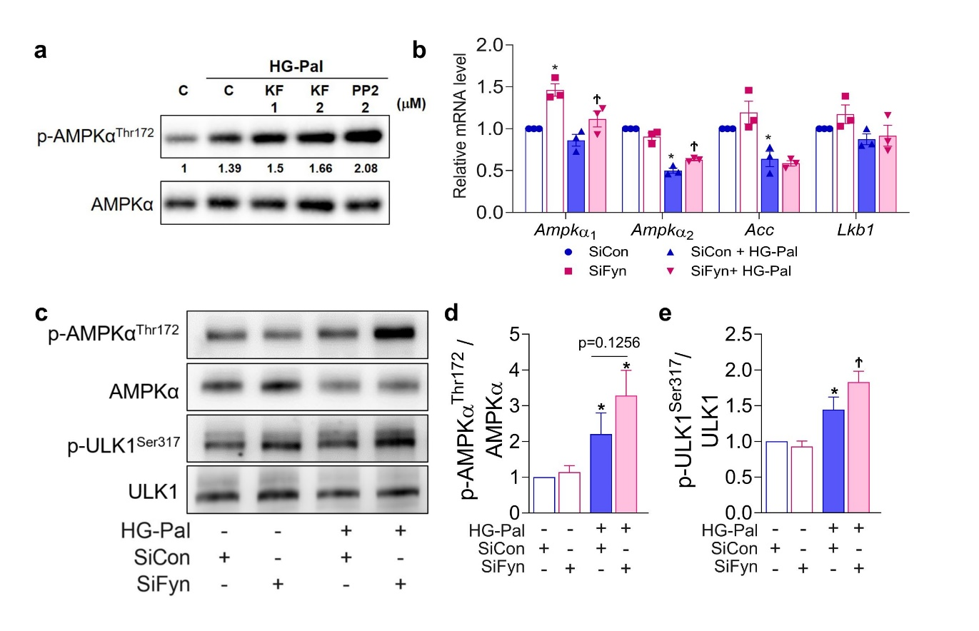

Supplementary Fig. 7. Src kinase inhibitor and knockdown of Fyn kinase modulate AMPK expression in HG-Pal-induced mProx24 cells. a mProx24 cells were treated with KF-1607, in comparison with PP2, under HG-Pal conditions. Protein expressions of phosphorylated AMPKα^{T172} and AMPKα were determined. b mProx24 cells were transfected with scrambled siRNA or Fyn siRNA with and/or without HG-Pal stimulation. Relative mRNA levels of Ampkα1, Ampkα2, Lkb1, and Acc. c Cell lysates were subject to immunoblot analysis. Representative immunoblots of phosphorylated AMPKα^{T172}, AMPKα, phosphorylated ULK1^{S317}, and ULK1. d, e Expression levels of indicated protein were quantified with densitometry. Data are represented as the mean ± SE of 4 experiments. *p<0.05 vs. siCon, † p<0.05 vs. HG-Pal and siCon.

Supplementary Fig. 8. Losartan suppresses HG-Pal-induced ER stress/ mTORC1 activation in mProx24 cells. mProx24 cells were treated with losartan 1 μM one hour prior to stimulation with HG-Pal. Cell lysates were subject to immunoblot analysis. a,f Representative immunoblots of phosphorylated IRE1α ^{S724}, phosphorylated JNK1/2^{T183, Y185}, JNK 1/2, CHOP, phosphorylated mTORC1^{S2448}, mTORC1, phosphorylated P70S6 kinase (P70S6^{T389}), and P70S6 kinase. b-e, g, h Expression levels of indicated protein were quantified with densitometry. Data are represented as means ± SE of 3 experiments. *p<0.05 vs. Con, † p<0.05 vs. HG-Pal.

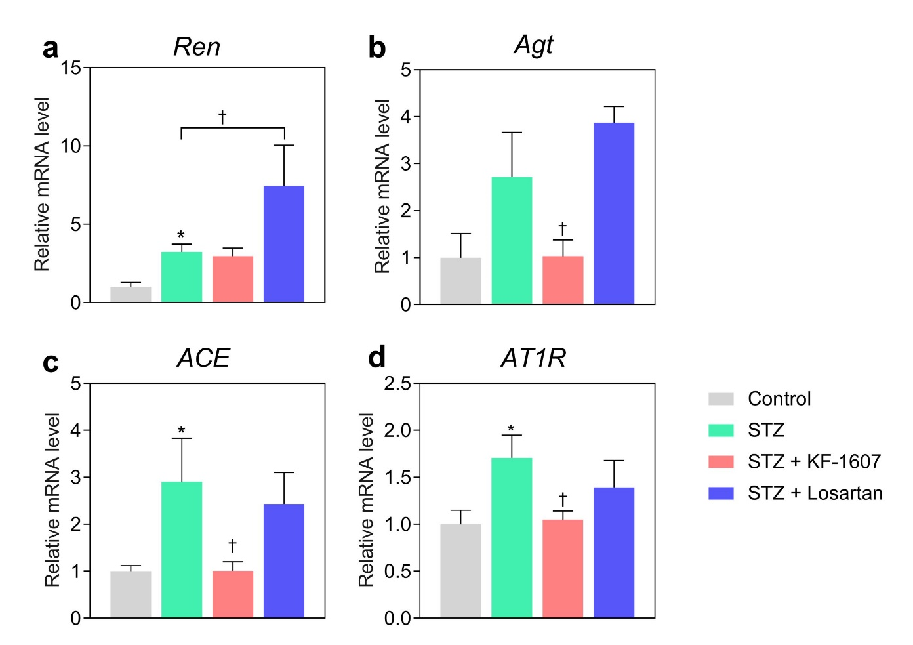

Supplemenary Fig. 9. The effect of Src kinase inhibition on renin-angiotensin system in the kidney. Relative mRNA levels of a renin (Ren), b angiotensinogen (Agt), c angiotensin converting enzyme (ACE), and d angiotensinogen II type 1 receptor (AT1R). *p<0.05 vs. control rats. †p<0.05 vs. control-STZ rats.

Supplementary Table 1. Primary antibodies used in the present study
Antibody | Use & dilution | Cat. number | Source
anti-AKT | WB 1:1000 | #9272 | Cell Signaling, Danvers, MA, USA
anti-AMPKα | WB 1:1000 | #2532 | Cell Signaling
anti-ATF6α | WB 1:1000 | sc166659 | Santa Cruz Biotechnology, CA, USA
anti-Caspase 3 | WB 1:1000 | #9662 | Cell Signaling
anti-CD68 | IHC 1:400 | sc13572 | Santa Cruz
anti-CHOP  (GADD 153) | WB 1:500; IHC 1:400; IF 1:200 | ab11419 | Abcam, Waltham, MA, USA
anti-Cleaved caspase 3 | WB 1:1000 | #9661 | Cell Signaling
anti-Collagen 1 | IHC 1:400 | 1310-01 | Southern Biotech, Birmingham, AL, USA
anti-Fyn | WB 1:400 | sc365913 | Santa Cruz
anti-GRP78 | WB 1:500; IHC 1:400 | sc166490 | Santa Cruz
anti-HSC70 | WB 1:2000 | sc7298 | Santa Cruz
anti-JNK | WB 1:1000 | #9252 | Cell Signaling
anti-LAMP1 | IF 1:500 | sc20011 | Santa Cruz
anti-LYN | WB 1:1000 | #2796 | Cell Signaling
anti-mTOR | IF 1:500 | #2972 | Cell Signaling
anti-Nitrotyrosine | IHC 1:400 | sc32757 | Santa Cruz
anti-P70SK | WB 1:1000 | #2708 | Cell Signaling
anti-p-AKT^{Ser473} | WB 1:1000 | #9271 | Cell Signaling
anti-p-AMPKα^{Thr172} | WB 1:1000 | #2531 | Cell Signaling
anti-PERK | WB 1:1000 | #3192 | Cell Signaling
anti-p-FYN | WB 1:500; IF 1:200 | sc377555 | Santa Cruz
anti-p-IRE1α^{Ser724} | WB 1:1000; IF 1:200 | NB100-2323 | Novus Biologicals, Centennial, CO, USA
anti-p-JNK^{Thr183, Tyr185} | WB 1:1000 | #9251 | Cell Signaling
anti-p-LYN | WB 1:1000; IF 1:200 | bs3251 | Bioss, Woburn, MA, USA
anti-p-P70S6K | WB 1:1000 | #9234 | Cell Signaling
anti-p-PERK | WB 1:1000 | #3179 | Cell Signaling
anti-p-ULK1^{Ser317} | WB 1:1000 | #12753 | Cell Signaling
anti-ULK1 | WB 1:1000 | A7481 | Sigma-Aldrich
anti-β actin | WB 1:2000 | A5411 | Sigma-Aldrich
*IHC immunohistochemistry, IF immunofluorescence, WB western blot.

Supplementary Table 2. Primer sequences used in the present study
Gene | Forward primer (5’-3’) | Reverse primer (5’-3’)
Mouse
18S | CGA AAGCAT TTGCCAAGA AT | AGT CGGCATCGTTTATGG TC
Acc | GTCCGCACTGACTGTAACCA | GCCAGACTCGTTTGTCAGGA
Ampkα1 | AACGCATTTGGAGGACATGA | TTGTCCGGAAATCAGTGCAT
Ampkα2 | AAAGGATGCCGCCTCTCATC | GGCTTCGTTGTGTTGAGTGC
Fyn | CTTTGGGGGTGTGAACTCCT | TTCTGCCTGGATGGAGTCAA
Il6 | AGTTGCCTTCTTGGGACTGA | TCCACGATTTCCCAGAGAAC
Kim1 | ACATATCGTGGAATCACAACGAC | ACAAGCAGAAGATGGGCATTG
Lkb1 | CTACTCCGAGGGATGTTGGA | GATAGGTACGAGCGCCTCAG
Lyn | AGCTCCAGAGGCCATCAACT | CACATCTGCGTTGGTTCTCC
Mcp1 | CTTCTGGGCCTGCTGTTCA | CCAGCCTACTCATTGGGATCA
Rats
18s | AGGAATTGACGGAAGGGCAC | GTGCAGCCCCGGACATCTAAG
ACE | AGGTTCGTGGAGGAGTATGA | TTGCTGCCCTCTATGGTAATG
Acta2 | GATCACCATCGGGAATGAACGC | CTTAGAAGCATTTGCGGTGGA
Agt | CACGGACAGCACCCTATTT | GTTGTCCACCCAGAACTCAT
AT1R | GCGCTCATCAGACTGTAGATAAT | CAGCTCCTGACTCTTCCTTTG
Cd68 | CGTTACCCGGAGACGACAAT | TCCTTGGTGGCCTACAGAGT
Col 1 | GGTTCACCACTGTTGCCTTT | AATGGTGCTCCTGGTATTGC
Fn | ACAACAGGAGAGTAGGGCGC | TGTGACCAGCAACACGGTG
Icam | TGCACGTCCCTGGTGATACTC | AAACGGGAGATGAATGGTACCTAC
Il1 | GACTTCACCATGGAACCCGT | GGAGACTGCCCATTCTCGAC
Il6 | TCTCTCCGCAAGAGACTTCCA | ATACTGGTCTGTTGTGGGTGG
Lo | GTAGCAGTACCCTGTGGTCATAGTC | TCCACGTACGTACAAAAGATGTCTA
Mcp1 | CTGTAGCATCCACGTGCTGT | CCGACTCATTGGGATCATCT
Mmp 2 | CTTTGTGCTGAAAGATACCC | AAGTTGTAGTTGGCCACATC
Mmp 9 | CCACCGAGCTATCCACTCAT | GTCCGGTTTCAGCATGTTTT
Pai1 | TCCGCCATCACCAACATTTT | GTCAGTCATGCCCAGCTTCTC
Ren | CTATGACTCCTCGGAATCCTCTA | CACCCACAGTTACCACATCTT
Tgfβ1 | GCTCCACAGTTGACTTGAAT | TGACAAAACCAAAGACATCA
Tnfα | CAGCAGATGGGCTGTACCTT | AAATGGCAAATCGGCTGACG
Vcam | TGCACGGTCCCTAATGTGTA | TGCCAATTTCCTCCCTTAAA

